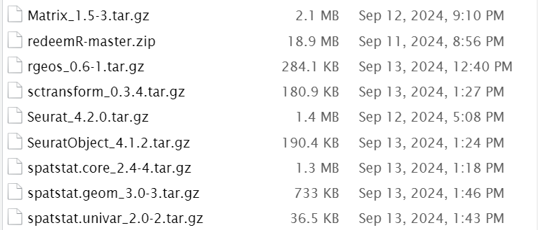
配置redeemR环境

$MyMultiome/MultiomeATAC_mito.sh -n Tutorial_Mito -1 Example.R1.fq.gz -2 Example.R2.fq.gz -i Example.i5.fq.gz -c 0 -t 8 -m $MyMultiome -b Genome/hg38.mitoMask
代码出错 得自己重新编
Read1=/disk2/cai099/Genome/Example.R1.fq.gz
Read2=/disk2/cai099/Genome/Example.R2.fq.gz
CORE=2
name=Tutorial_Mito

##Step 1 trim adaptor (Important)
cutadapt --cores=$CORE -a CTGTCTCTTATA -A CTGTCTCTTATA -o $Read1.trim -p $Read2.trim $Read1 $Read2

##Step2 Mapping
#bowtie2Index=/lab/solexa_weissman/cweng/Genomes/GRCH38/GRCH38_Bowtie2_MitoMask/hg38.mitoMask
bowtie2 -X 1200 --very-sensitive -p 2 -x hg38.mitoMask -1 $Read1.trim -2 $Read2.trim | samtools view -@ $CORE -bS - > $name.tmp.bam
注意这里修改完代码后记得保存
samtools sort -@ $CORE $name.tmp.bam > $name.bam
samtools index -@ $CORE $name.bam

然后直接莽

$MyMultiome/MultiomeATAC_mito.sh -n Tutorial_Mito -1 Example.R1.fq.gz -2 Example.R2.fq.gz -i Example.i5.fq.gz -c 0 -t 8 -m $MyMultiome -b Genome/hg38.mitoMask
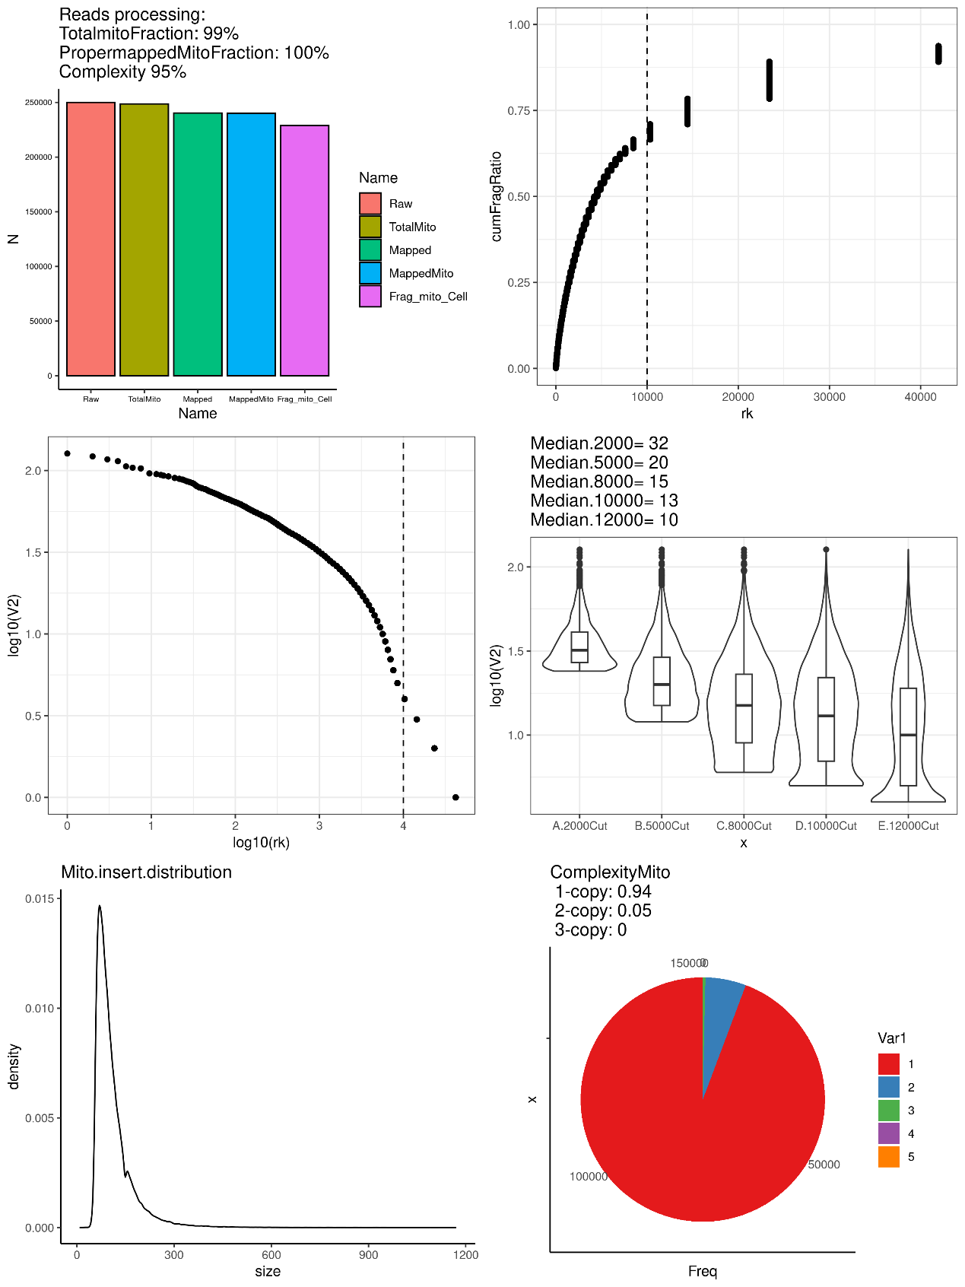
和他里面完全不一样啊
啊？ 老师说没关系 跑出来就行

for ((i=1;i<=$Threads;i++))
do
bsub python $mitoConsensus/mitoConsensus.py barcodes.$i $WD BC 30
done
提示：command bsub not found did you mean
下载安装bsub（可以先不用这个命令）

先看看能不能直接跑循环
for ((i=1;i<=24;i++)); do python $mitoConsensus/mitoConsensus.py barcodes.$i $WD BC 30; don

在$mitoConsensus/Finalize.sh $WD $Threads $mitoConsensus后面出结果
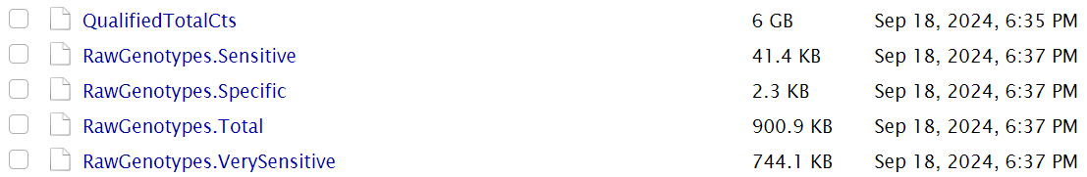
传说中的5的重点文件
但是这个图也是和他不一样啊
