Research Objective
The creativity paradox states that, with AI, users are more productive, and there is a sense of boosted creativity. This is because big tech companies unleashed GenAI systems to the public, powerful tools that can immensely help with creative work (i.e., the democratization of Generative AI). Thus, even users who were not so skilled in creative work can now produce creative output. Nevertheless, the output from LLMs and AI tools is just average, as it is poisoned within a lower and upper bound of quality. Such mediocrity means that our AI-aided creative work is of good-enough quality (i.e., it looks professional), but it does not generate masterpieces. Moreover, some argue that overreliance on generative AI makes people cognitively lazy and there is fear that, in the long run, certain skills will be lost (including human creativity).
Research questions (broad):
- What can improve creativity in human-ai mediated work?
- How can system interventions increase Metacognitive Skills for creativity?

Background
Improving creativity in human-AI mediated work requires a shift from viewing AI as a simple tool to treating it as a collaborative partner. While AI can automate routine tasks to free up mental space, true creative gains depend on how humans interact with and refine AI outputs.

The following strategies can enhance creative outcomes in human-AI workflows:
1. Cultivate Metacognitive Skills
Metacognition—the ability to plan, monitor, and evaluate the user’s own thinking—is the primary driver of AI-supported creativity.
- Reflective Engagement: Treat AI suggestions as starting points rather than final answers. Question, iterate, and probe for gaps in AI-generated content.
- Strategic Thinking: Focus on high-level decision-making, such as defining goals, evaluating novelty, and ensuring emotional or cultural relevance.
- Independent Judgment: Maintain a "critical filter" to avoid over-reliance on AI, which can lead to generic or biased outcomes.
2. Deepen the Interaction Model
Moving beyond "single-round" prompts to more complex interaction patterns can significantly boost creativity.
- Multi-round Deep Interaction: Engage in back-and-forth dialogue with AI to refine ideas through feedback loops and iterative co-development.
- AI as a "Provocateur": Use AI to intentionally challenge the user’s biases, suggest "non-human" perspectives, or provide "provoking" rather than just "pleasing" contributions.
- Evaluative Feedback: Reposition AI as an idea evaluator rather than just a generator. AI can provide real-time feedback on the originality and feasibility of the user’s own ideas.
3. Leverage "Generative Synesthesia"
This concept refers to the harmonization of human exploration and AI exploitation to discover new workflows.
- Cross-Domain Inspiration: Use AI’s vast database to find analogies and connections between unrelated fields (e.g., applying principles from biology to architectural design).
- Exploratory Prototyping: Use AI to rapidly generate dozens of diverse sketches or concepts early in the process to overcome "fixation" on a single initial idea.
- Focus on Intentionality: Leave repetitive "execution" (like drafting or formatting) to AI so one can focus on the "why" and the personal narrative of the work.
4. Optimize Workflow Design
Organizations can foster creativity by structuring how AI is integrated into the creative process.
- Task Decomposition: Break creative projects into sub-tasks (e.g., ideation, evaluation, selection) and decide where human vs. AI strengths are best utilized at each stage.
- Maintain Creative Self-Efficacy: Ensure users occupy the role of co-creator (directing the vision) rather than just an editor (cleaning up AI output), as the former promotes higher creative confidence.
- Incubation Periods: Intentionally design "AI-free" spaces for incubation (letting ideas sit) and human "wandering," which are often where original insights occur.

In the context of AI-mediated work, what techniques have been explored by research?
In human-AI collaborative work, AI systems can increase human metacognitive skills by transitioning from passive "answer-generating" tools to active "thinking partners" that provide structured cognitive support. Research has explored several techniques to embed these skills into the workflow:
- Evaluative Feedback (monitoring): Reposition AI as an idea evaluator rather than just a generator. AI can provide real-time feedback on the originality and feasibility of the user’s own ideas.
- AI as a "Provocateur": Use AI to intentionally challenge the user’s biases, suggest "non-human" perspectives, or provide "provoking" rather than just "pleasing" contributions.
- Designated "Friction" and Pause Points: Purposefully designing "friction" into the interface prevents "cognitive offloading" (where users stop thinking because the AI is too fast). These checkpoints require a critical review of AI content before moving to the next step.
- Cognitive Task Decomposition: Systems help users break down complex visions into manageable "chunks," which trains the metacognitive skill of task planning.
- Metacognitive Scaffolding (MAS): This is a core research technique where AI agents use structured prompts, guiding questions, and feedback frameworks to help users systematically plan, monitor, and evaluate their own thinking.
- Strategic Prompting and Cues: Instead of providing direct answers, systems use "reflective prompts" that force users to pause, assess their understanding, and consider multiple perspectives. Common cues include:
- Consolidation Cues: Encouraging users to summarize what they have learned so far.
- Socratic Questioning: Challenging user assumptions to spark deeper inquiry.

What are the benefits of these techniques?
Research indicates that these interventions lead to specific creative and cognitive gains:
- Shift from Execution to Arbitrating: Users move from being mere "editors" of AI output to acting as "Designer Arbiters" who evaluate and strategically integrate AI suggestions.
- Improved Critical Thinking: MAS-based agents have been shown to improve creative instructional design by first enhancing the user's critical thinking skills.
- Higher-Order Creativity: While AI often boosts "fluency" (quantity), metacognitive scaffolding specifically enhances the quality, novelty, and refinement of creative work.
- Self-Regulated Learning: Interactions with AI that require regular self-reflection help students and professionals become more self-directed and aware of their own learning bottlenecks.
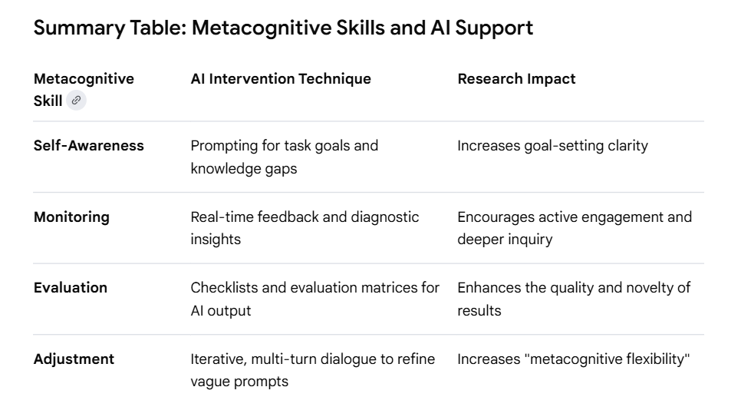

Categorization by cognitive areas
These techniques can also be categorized by different cognitive areas or mental processes. This is useful for planning interventions, since one may want to design a system that covers multiple cognitive processes at the same time.
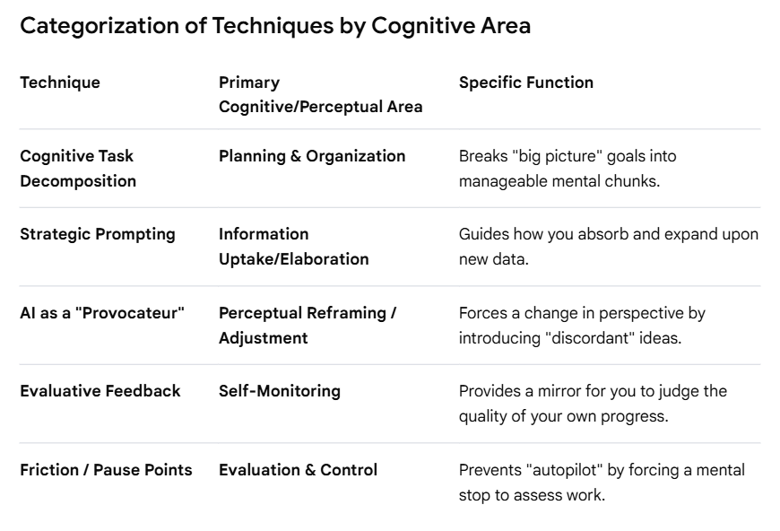

Research framework
The idea is to combine two distinct interventions that impact two different areas of human mental process. To create a balanced system that maximizes creativity, one should combine techniques that address the two distinct pillars of metacognition:
- Knowledge of Cognition (the "What" and "How"), obtained through the process of information uptake/reframing
- Regulation of Cognition (the "Action" and "Check") obtained through the process of self-monitoring/evaluation.
The most effective combination to cover two distinctive processes—Information Uptake/Reframing and Self-Monitoring/Evaluation—is pairing AI as a "Provocateur" with Friction (Designated Pause Points).

The Combination: "The Provocative Filter"
We call the combination of these two methods “the provocative filter”.
This system addresses both how users receive and process new ideas (Information Uptake) and how they regulate their creative output (Evaluation).
1. AI as a "Provocateur" (Addressing: Perception & Information Uptake)
- How it works: Instead of the AI agreeing with the user or completing the user’s sentences, it is programmed to intentionally introduce "creative tension." If the user suggests an idea, it might propose the opposite, or apply a completely unrelated domain's logic to the problem (e.g., "What if this software interface functioned like a forest ecosystem?").
- Creative Benefit: It breaks functional fixedness—the cognitive bias that limits the user to using an object only in the way it is traditionally used. It forces "conceptual blending," which is the heart of breakthrough creativity.
2. Friction / Pause Points (Addressing: Cognition & Self-Evaluation)
- How it works: The system prevents the user from simply "accepting" the AI’s provocative ideas immediately. At critical junctures, the system "locks" the next step and requires the user to write a brief justification or "metacognitive reflection" on why a specific direction was chosen.
- Creative Benefit: This combats cognitive offloading (letting the AI do the thinking). By forcing a pause, it shifts the user from a "passive consumer" of AI content to an "active arbiter." This ensures the final output is a result of the user’s own critical judgment, leading to higher "creative self-efficacy."
Why this pair?
- Provocateur expands the breadth of our search space (Perception).
- Friction ensures the depth and quality of our selection (Cognition/Evaluation).
- Together, they prevent the two biggest risks in human-AI work: Generic Output (fixed by the Provocateur) and Mindless Acceptance (fixed by Friction).
A simple way to understand this combination is that the Provocateur is the “Engine” for generating wild, divergent ideas, whereas Friction is the "Governor" that forces the user to critically evaluate those ideas.

Novelty/Contribution
While researchers have extensively studied AI as a "Provocateur" and Friction (deliberate pause points) as separate interventions, testing them together as a unified system is a relatively new and emerging area of focus.
Recent research into "Frictional AI" (2025–2026) suggests (without testing) that combining these two methods directly addresses the "Metacognitive Paradox"—where AI's speed and helpfulness inadvertently suppress the deep thinking required for true creativity.
Evidence of These Methods in Research (Molenaar et al., 2011; Fregosi et al., 2025; Westover, 2026):
- Problematizing Scaffolds (The Provocateur): Studies have tested "problematizing" scaffolds that intentionally increase task complexity or challenge user assumptions. These are found to be more effective than simple "structuring" aids because they force users to construct their own strategies rather than just following AI-led patterns.
- Cognitive Friction (The Pause): New frameworks for "Frictional AI" propose using deliberate design obstacles—like requiring a summary or a form before proceeding—to trigger System 2 (deliberative) thinking. Research shows this increases a user's sense of agency and prevents "cognitive offloading," where users mindlessly accept AI output.
- The Combined Approach: The most recent work in 2026 advocates for "Metacognitive Maintenance Intervals"—protected periods of independent work or forced reflection during AI-assisted tasks—specifically to counteract the risk that a "helpful" AI might homogenize a user's creative thinking.
Why This Combination Works
By pairing these two, we create a "Challenge-and-Check" loop:
- AI as a Provocateur expands the user’s perceptual field by offering non-intuitive or dissenting ideas, addressing Information Uptake.
- Friction ensures users don't just "blindly follow" those provocations. It forces them to stop and evaluate the merit of the AI's challenge, addressing Self-Monitoring and Evaluation (Malaguti et al., 2024).
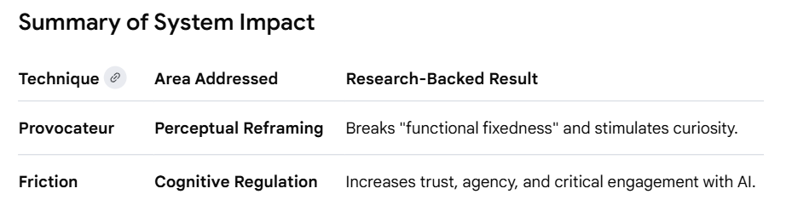
This combined intervention is currently considered a "best-practice" hypothesis for designing Pedagogical AI Agents that aim to reinforce, rather than replace, human metacognitive engagement (Ma et al., 2025).

References
Fregosi, C., Natali, C., & Cabitza, F. (2025). Judicial Protocols in Diagnostic AI: Contrastive Explanations to Preserve Human Agency.
Malaguti, Pauline; Karran, Alexander J.; Le, Di; Mortin, Hayley; Coursaris, Constantinos K.; Sénécal, Sylvain; and Léger, Pierre-Majorique, "Investigating Interaction Friction in Generative AI: Improving User Experience and Decision-Making" (2025). SIGHCI 2024 Proceedings. 26. https://aisel.aisnet.org/sighci2024/26
Ma, B., Li, H., Li, G., Chen, L., Tang, C., Xie, Y., ... & Konomi, S. I. (2025). Scaffolding Metacognition in Programming Education: Understanding Student-AI Interactions and Design Implications. arXiv preprint arXiv:2511.04144.
Molenaar, I., Chiu, M. M., Sleegers, P., & van Boxtel, C. (2011). Scaffolding of small groups’ metacognitive activities with an avatar. International journal of computer-supported collaborative learning, 6(4), 601-624.
Westover, J. H. (2026). The Metacognitive Paradox of AI-Assisted Creativity: A Theoretical Extension. Preprint. https://www.preprints.org/manuscript/202603.0121

