Mobile Expense Management System

Group Members

Haoyu Wang 104763720

Jinghua Long 104864306

Kerun Pan 104895029

Liangliang Xu 104760963

Rui Liu 104766936

Xiaoshuai Geng 104845608

Zekun Zhang 104947128

Table of Contents

Entity Relationship Diagram: (Xiaoshuai Geng) 3

Software and Hardware Specifications: (Liangliang Xu) 4

Design Class Diagram: (Jinhua Long & Kerun Pan) 4

Design Sequence Diagram: (Jinhua Long & Kerun Pan) 5

Three-Layer Design Class Diagram: (Haoyu Wang) 10

Interface Design: (Rui Liu) 11

Table Diagram: (Zekun Zhang) 12

# Entity Relationship Diagram: (Xiaoshuai Geng)

# Software and Hardware Specifications: (Liangliang Xu)

|  |  |
| --- | --- |
| Operating system | Android 9 or later |
| Processor | Intel Atom® Processor Z2520 1.2 GHz, or faster processor |
| Storage | At least 40 mb |
| RAM | 512 mb or larger |
| Hard Disk | * 100mb of available hard-disk space for installation; extra free space is required during installation. * You cannot install using a removable flash storage device. |
| API | Jetpack APIs, APK |
| Browser/Internet | * This application is designed to work offline. * Some functions are requiring WIFI-connected or cellular data to use. * To download and launch Google Play* Store apps within the application, a high-speed Internet connection is recommended. |

# Design Class Diagram: (Jinhua Long & Kerun Pan)

104864306 JINHUA LONG

(responsible for design class diagram, Create Record Sequence Diagram, ExpenseSummary Record Sequence Diagram)

104895029 Kerun Pan

(responsible for design class diagram, Login Sequence Diagram, Edit Record Sequence Diagram, Erase Record Sequence Diagram, ExpenseSummary Record Sequence Diagram)

This class diagram displays the basic relationship and interaction between classes in this program

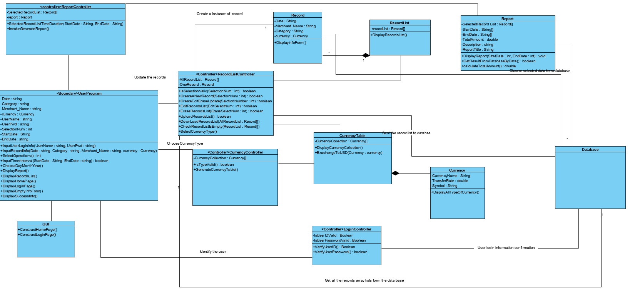

# Design Sequence Diagram: (Jinhua Long & Kerun Pan)

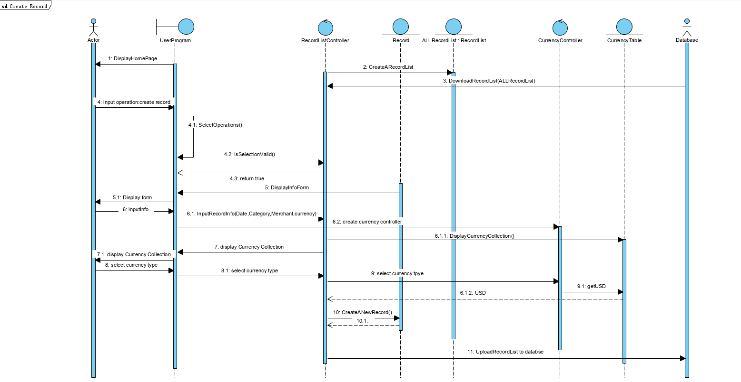Create Record Sequence Diagram

This sequence diagram shows the process of create record, users should provide some basic information to this expense this time (on the sequence diagram like consumption date, category and cost of each items) to user program. User program collect this information to create record and then add them into the recordList controller. After recording, upload the information to database.

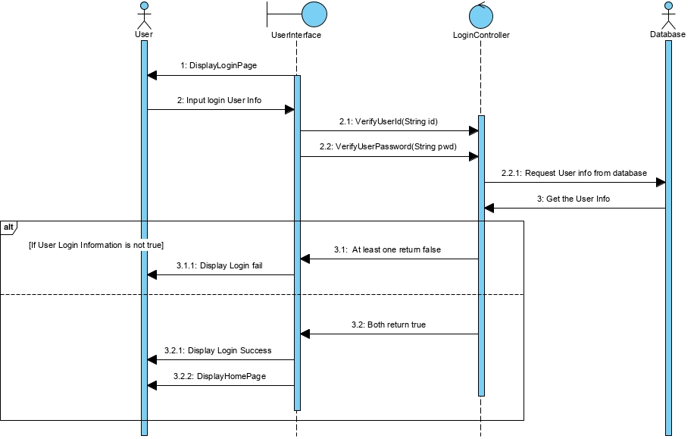Login Sequence Diagram

This Sequence diagram shows the function Login User enter the username and password to “UserInterface”, “UserInterface” send the data to “LoginController” to check if the username and password is valid. LoginController will bring them to Database to check can user name be found and whether the password can be matched If it is a valid username-password. (return fail if the information provided is invalid or username can not be found). When all things correct, “UserInterface” gonna have two true Boolean value from LoginController, and “UserInterface” then display homepage

Edit Record Sequence Diagram

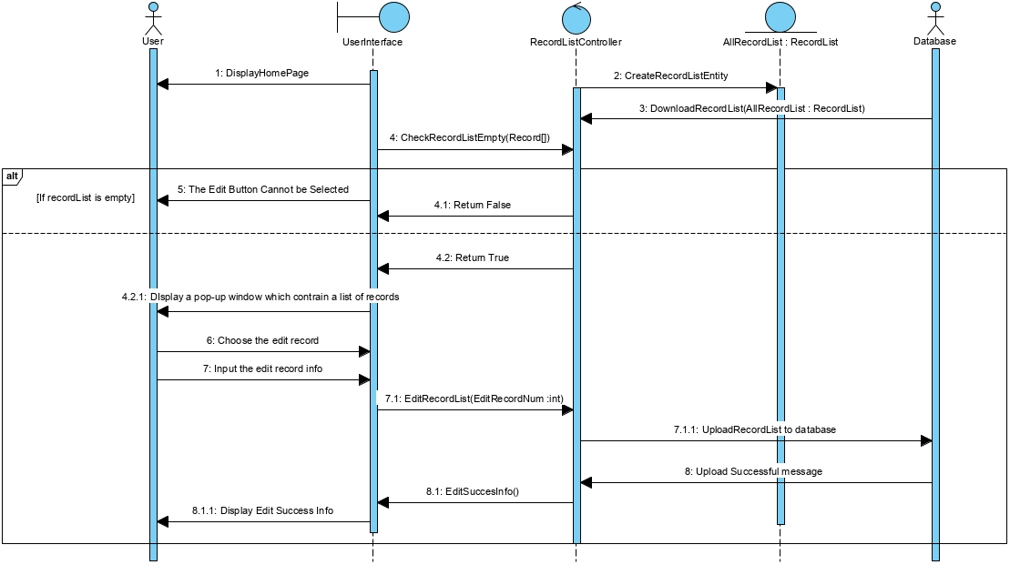

The Sequence diagram “EditRecord” shows the way to erase the appoint record. User Interface check if the list is empty if user want to edit some records from Record List, and the “RecordController” visit database to make sure the record list is empty or not. If the record list is empty, user interface return “The Edit record bottom cannot be selected” and sequence end. when the record list is not empty, “UserInterface” go back to “RecordController”, gain all of records and display it to user. In this time, users need to select the record which they want to edit in “UserInterface”. “UserInterface” give a feedback to “RecordController”, and it will upload new data to database. When uploading successfully, user can get a success tip from “UserInterface”.

Erase Record Sequence Diagram

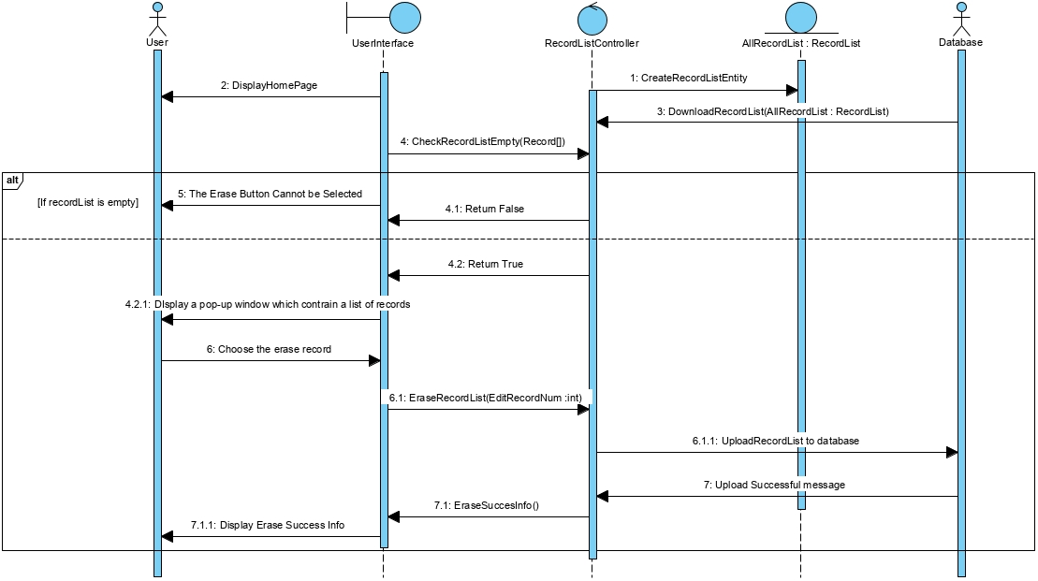

The Sequence diagram “EraseRecord” shows the way to erase the appoint record. User Interface check if the list is empty if user want to erase some records from RecordList, and the “RecordController” visit database to make sure the record list is empty or not.

If the record list is empty, user interface return “The Edit record bottom cannot be selected” and sequence end. when the record list is not empty, “UserInterface” go back to “RecordController”, gain all of records and display it to user. In this time, users need to select the record which they want to erase in “UserInterface”. “UserInterface” give a feedback to “RecordController” and “RecordController” upload new data to database. When uploading successful, user can get a success tip from “UserInterface”.

ExpenseSummary Record Sequence Diagram

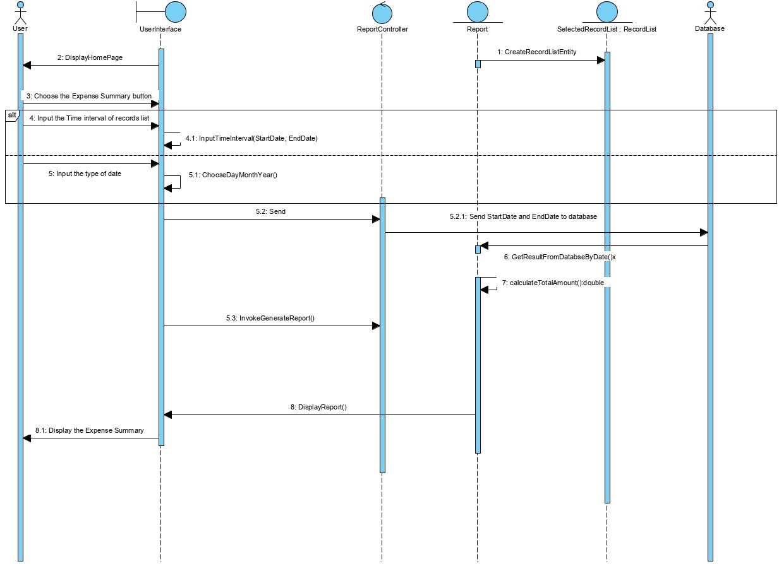

This sequence diagram is about record generation. It allowed user to get the record list and summary in a period of time. User should provide the time slot to user program (it also allowed user to give a title and description to this record list). User program send time interval to “ReportController” and “ReportController” send this message as request to database, database then calculate the expense sum in given date interval and sent back to report. There is no need to transfer total sum into USD because in the create record phase the input currency value is already transfer to USD by currency rates

# Three-Layer Design Class Diagram: (Haoyu Wang)

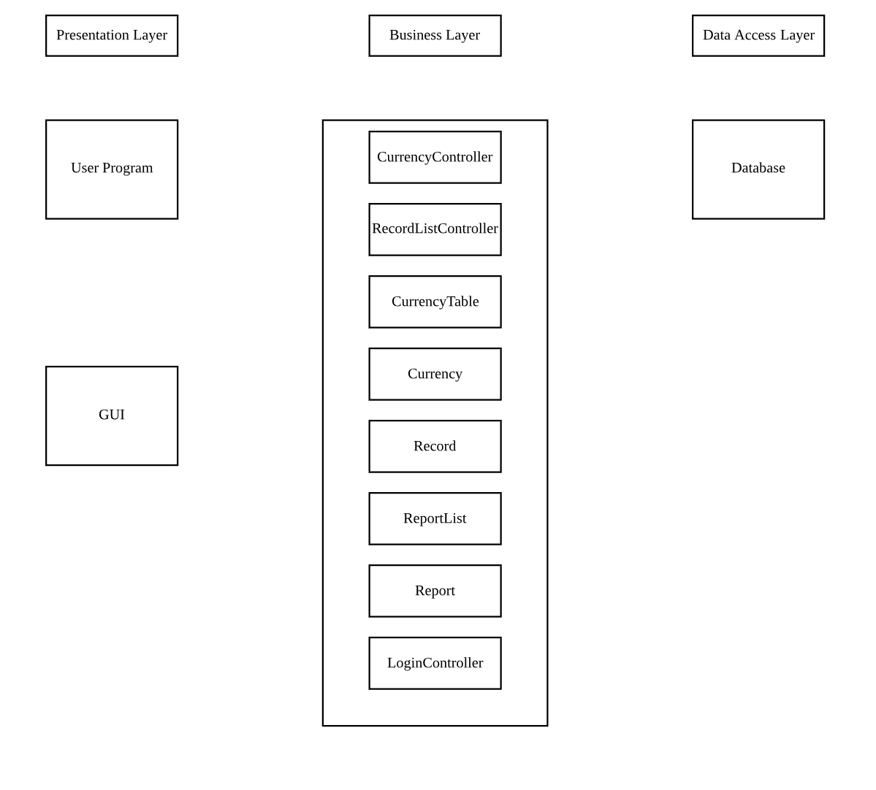

# Interface Design: (Rui Liu)

Homepage

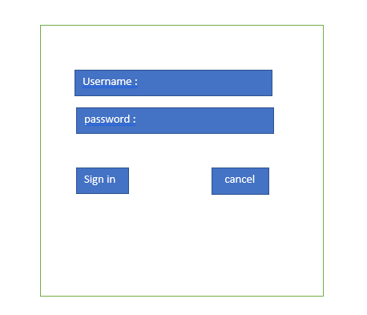

Login

Navigation

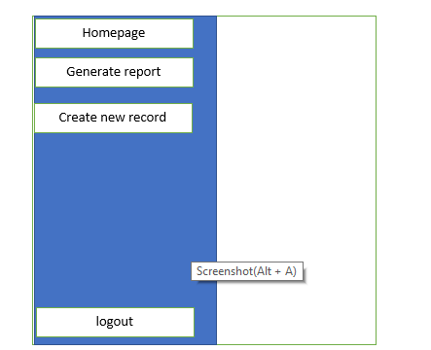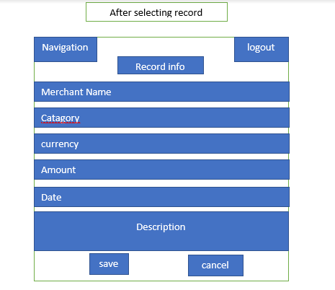

# Table Diagram: (Zekun Zhang)