List the modified as below:

1. Clear the conf/tomcat-user.xml.

Status: modify

Operation:

remove the webapp/manage directory

1. Add the customer error page, modified /conf/web.xml as below:

Status: modify

Operation1:

cd /usr/local/apache-tomcat-7.0.42/conf/

vi web.xml

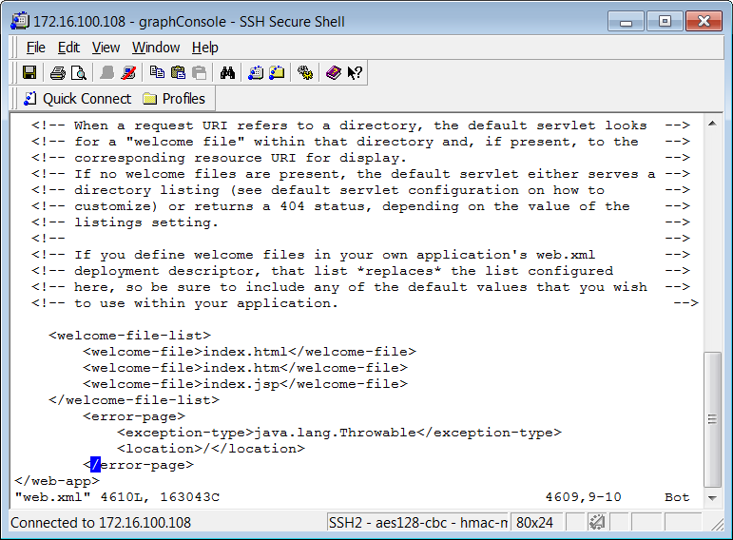

Restart tomcat.

Operation2(post-optimization):

Status: testing

Chang the /lib/catalina/valves/ErrorReportValves.

1. Hide the version information.

Status: modify

Operation:

[root@localhost ~]# cd /usr/local/apache-tomcat-7.0.53/lib

[root@localhost lib]# mkdir -p org/apache/catalina/util

[root@localhost lib]# cd org/apache/catalina/util

[root@localhost util]# vim ServerInfo.properties

server.info=security 1.0 //change the version to nolinux.

1. Shield directory files are automatically listed. Maybe it need to modify before tomcat7.0 version.

Status: modify

Operation:

<servlet>

        <servlet-name>default</servlet-name>

        <servlet-class>org.apache.catalina.servlets.DefaultServlet</servlet-class>

        <init-param>

            <param-name>debug</param-name>

            <param-value>0</param-value>

        </init-param>

        <init-param>

            <param-name>listings</param-name>

            <param-value>false</param-value>

        </init-param>

        <load-on-startup>1</load-on-startup>

    </servlet>

<param-value>false</param-value>