Here is download link: <http://www.ej-technologies.com/download/jprofiler/files>

jprofiler_linux_7_2_3.rpm for linux

jprofiler_windows-x64_7_2_3.exe for windows

Please choose jprofiler7.

Steps for windows client to add new session.

1.choose “New Server Integration”

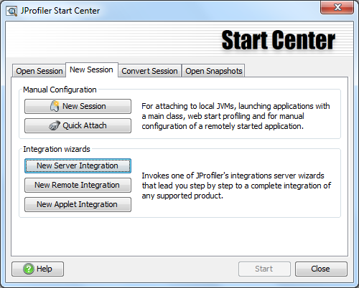

2.

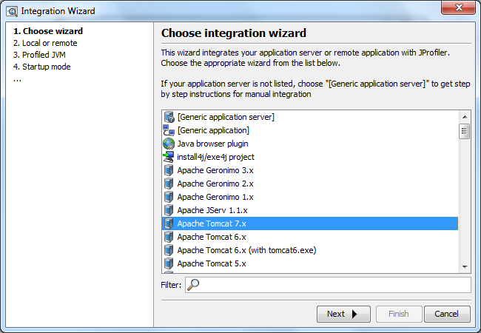

3.

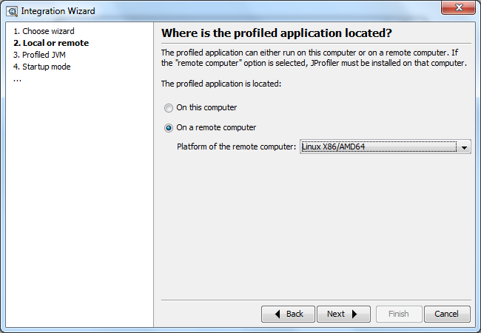

4.

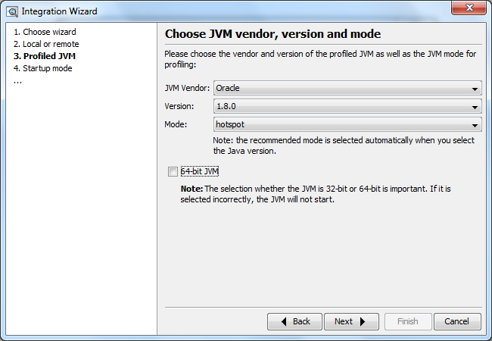

5.

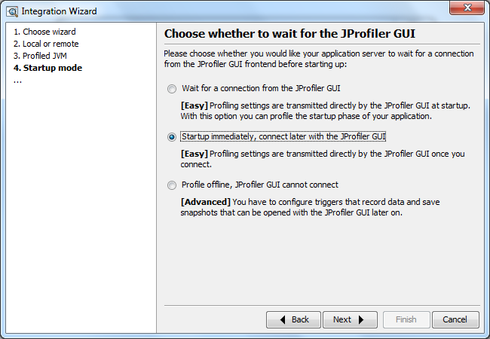

6.hqd-graphapi-01 in SH office, hqd-graphapi-01.telenav.com outside office

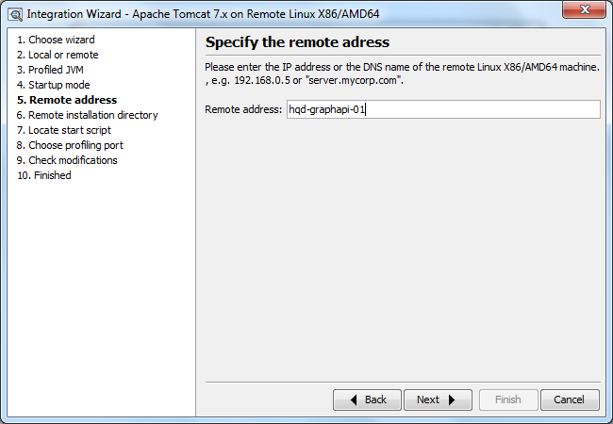

7.choose jprofiler config document

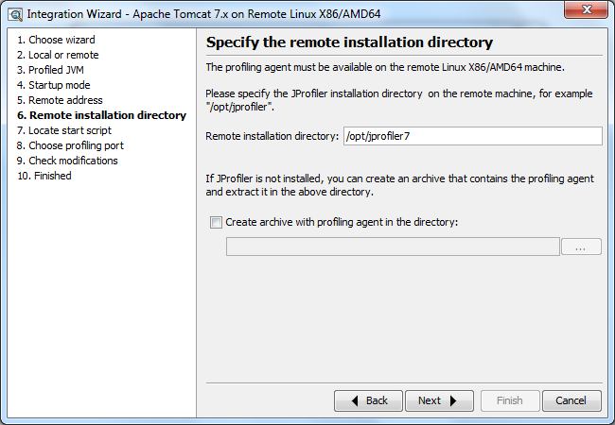

8.locate startup.sh of your server, in order to create a shell script which can start up tomcat and jprofiler on linux in the same time

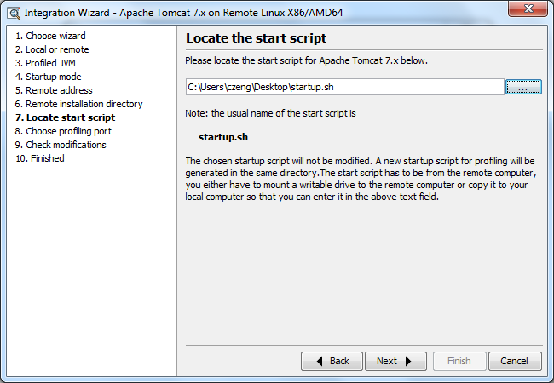

9.default port

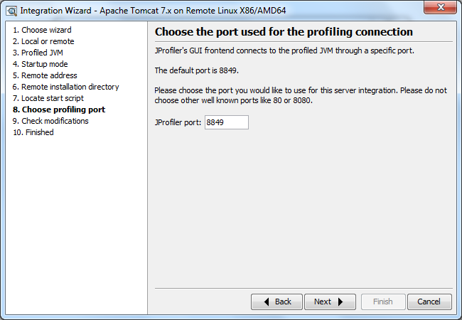

Install jprofiler on linux.

1.Shell command: rpm –ivh jprofiler.rpm

2.Add the configuration below into /etc/profile

for bit 32 system

JPROFILER_HOME=/opt/jprofiler7/bin/linux-x86

export LD_LIBRARY_PATH=$LD_LIBRARY_PATH:$JPROFILER_HOME

for bit 64 system

JPROFILER_HOME=/opt/jprofiler7/bin/linux-x64

export LD_LIBRARY_PATH=$LD_LIBRARY_PATH:$JPROFILER_HOME

By the way, hqd-graphapi-01 is a bit 64 system. And these config can be added by administrator(chen zhe in sh office has admin account).

3.Add config in tomcat/bin/catalina.sh

CATALINA_OPTS="-Dcom.sun.management.jmxremote

-Djava.rmi.server.hostname=192.168.160.129

-Dcom.sun.management.jmxremote.port=9999

-Dcom.sun.management.jmxremote.ssl=false

-Dcom.sun.management.jmxremote.authenticate=false

-agentpath:/opt/jprofiler7/bin/linux-x86/libjprofilerti.so=port=8849,nowait"

4.start up command: ./startup_jprofiler.sh & tail -f ../logs/catalina.out

Since jprofiler has been installed in hqd-graphapi-01, you start it after installing your windows client.