ssa的版本：
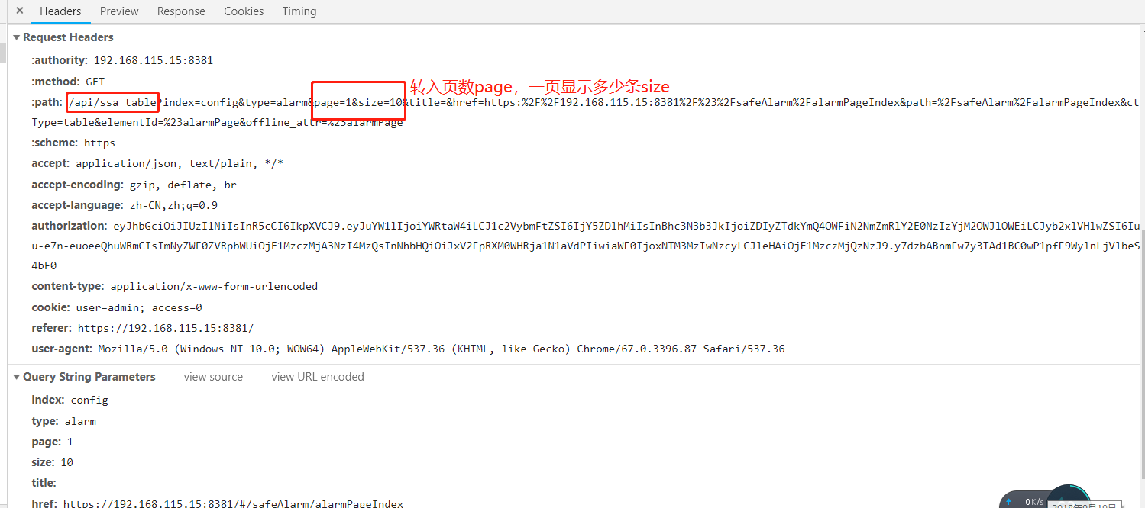
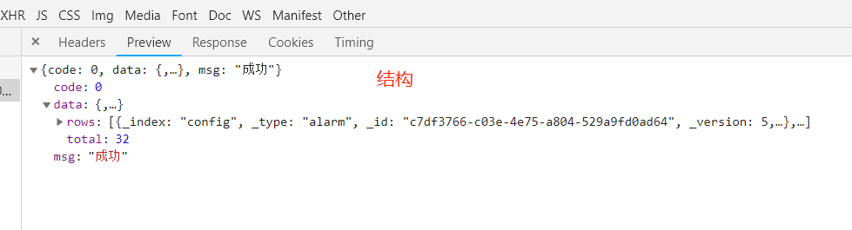

具体列表中的字段：
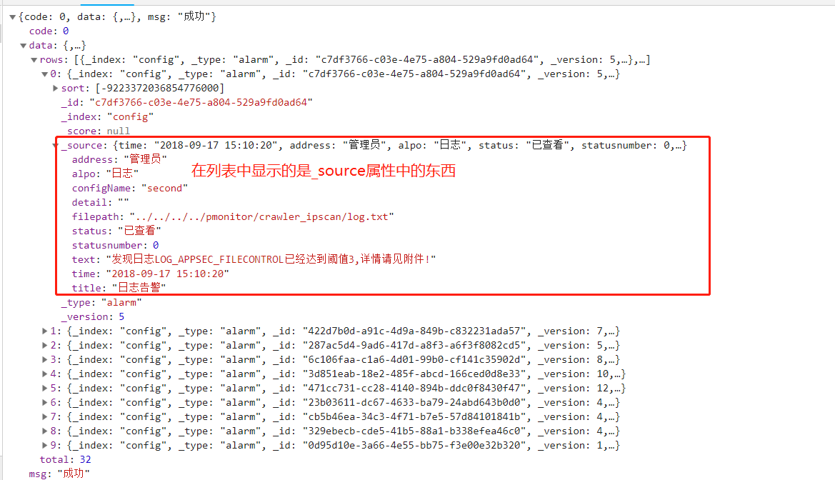

sort:[-9223372036854776000]
_id:"c7df3766-c03e-4e75-a804-529a9fd0ad64"
_index:"config"
_score:null
_source:{time: "2018-09-17 15:10:20", address: "管理员", alpo: "日志", status: "已查看", statusnumber: 0,…}
address:"管理员"
alpo:"日志"
configName:"second"
detail:""
filepath:"../../../../pmonitor/crawler_ipscan/log.txt"
status:"已查看"
statusnumber:0
text:"发现日志LOG_APPSEC_FILECONTROL已经达到阈值3,详情请见附件!"
time:"2018-09-17 15:10:20"
title:"日志告警"
_type:"alarm"
_version:5

蜜罐版本：
{
"code": 0,
"data": [
{"username": "zhang", "auth": 2},
{"username": "ddd", "auth": 0},
{"username": "user1", "auth": 1},
{"username": "zhang", "auth": 2},
{"username": "zhang", "auth": 2},
{"username": "zhang", "auth": 2},
{"username": "zhang", "auth": 2},
{"username": "zhang", "auth": 2},
{"username": "zhang", "auth": 2},
{"username": "zhang", "auth": 2},

],
“total”:100,
"msg": "success"}

