Appendix 2 Supplementary Figures
Figure S1. Continuous-score direction and scoring status for all 57 formula-reproducible signatures across nine GEO cohorts. Panels A and B divide the 57 signatures alphabetically by audit identifier. Blue indicates HR >1; red indicates HR <=1. Gray indicates an unavailable estimate, gold indicates excluded source-training overlap, and purple indicates insufficient gene coverage. Asterisks denote nominal two-sided continuous-score Cox P<0.05, not a test of the C-index. These are 513 signature-cohort combinations, not 513 independent cohorts. Source: the Continuous_Cox worksheet indexed in Appendix 3.
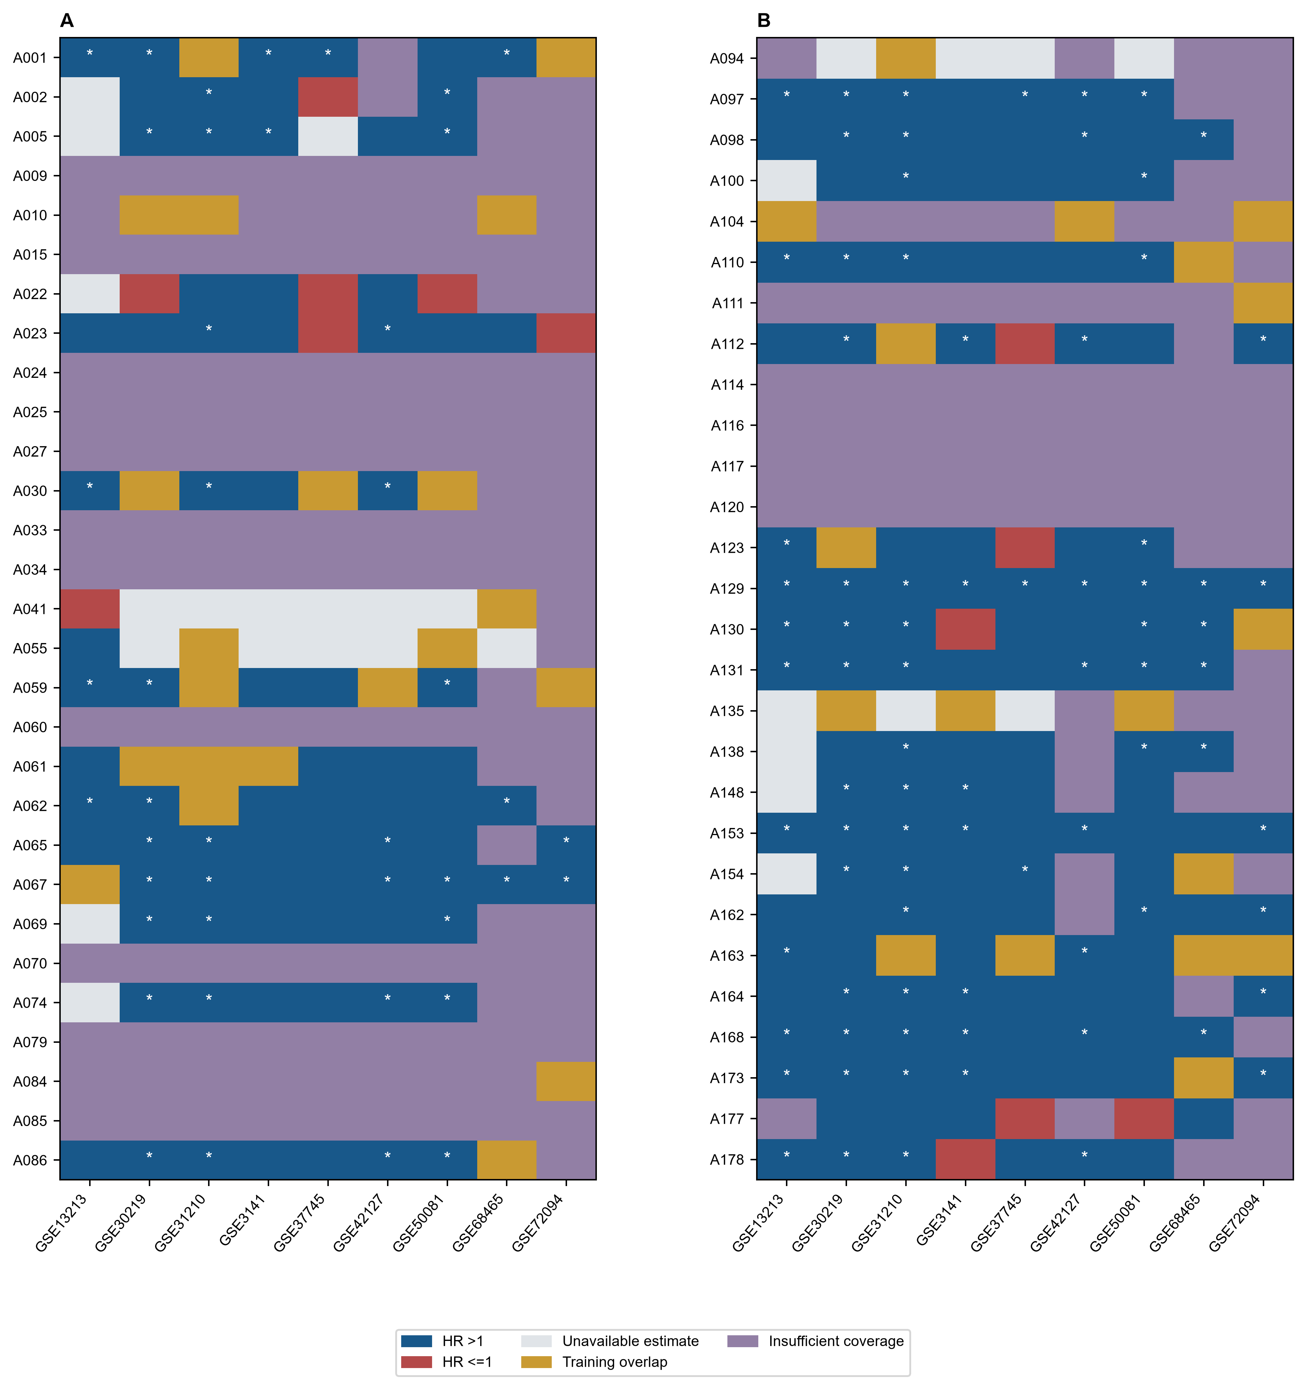

Figure S2. Supplementary reporting and cohort context. (a) Reporting-completeness score distributions for formula-reproducible and non-reproducible articles. (b) Numbers of externally scored samples for the 10 primary candidates; the same cohorts contribute to multiple candidates, so these counts must not be added across signatures. The leave-one-cohort-out check retained the risk direction for each candidate. (c) External sample counts grouped by the platform categories recorded in the audit. This panel summarizes scoring availability rather than platform-specific predictive accuracy. Source data and cohort annotations are in Appendix 3.
