**ECE 244 Programming Fundamentals Lab 6**

**Lab #6: Inheritance and Virtual Functions**

**1. Objectives**

In this lab you will gain experience with inheritance and virtual functions, which are powerful aspects of C++ that allow new types of code re-use. You will do this by enhancing a program that can store, manipulate, and draw a database of shapes.

**2. Problem Statement**

The bulk of the processing necessary to manage the database of shapes already exists, and without changing this code you will add new functionality simply by adding two new classes (Circle and Rectangle). This is an example of adding new features to an existing *framework.* The framework provides the “higher-level” decision making of the program, and you add new features by creating new classes that the framework will call when appropriate, via virtual functions. This is a powerful form of code re-use; the framework is making use of objects that did not exist when it was originally written.

**3. Command Reference**

Your program should accept and execute the commands listed below. The parsing code and the general “framework” processing code has already been written for you. The framework code checks the input for basic errors and outputs appropriate messages, which are not listed below. Then the framework code executes the commands by calling appropriate functions on Shape objects.

In the commands below, console font indicates a keyword that must be typed exactly as shown, while *italics* indicate arguments that should be replaced by the appropriate strings or numbers.

* tri *name colour x1 y1 x2 y2 x3 y3*: Creates a new Triangle object, with the specified name and colour, and with 3 vertices given by (*x1, y1*), (*x2, y2*) and (*x3, y3*). *name* and *colour* are strings, while *x1* through *y3* are floats. *name* can be any string, and is used to identify the object. *colour* must be one of *"white", "black", "grey55", "grey75", "blue", "green", "yellow", "cyan", "red", "darkgreen", or "magenta"*.
* circ *name colour xcen ycen radius*: Creates a new Circle object, with the specified *name* and *colour*, and with a center at (*xcen,* ycen) and the specified *radius.* name and *colour* are strings, while *xcen, ycen* and *radius* are floats.
* rect *name colour xcen ycen width height*: Creates a new Rectangle object, with the specified name and colour, a center at (*xcen,* ycen) and the specified *width* and *height.* name and *colour* are strings, while *xcen, ycen, width* and *height* are floats.
* printall: Prints out all the shapes in the database. See Section 5 for example output. For each shape, the following should be printed, all on one line. Text in console font should be output exactly as shown, while values in *italics* should be replaced by the appropriate data in the output. All floating point numbers should be printed with **1 digit** after the decimal place and all spaces shown in the text below are single spaces.
  + *name*, followed by a space
  + *colour*, followed by a space
  + center: (*xcen*,*ycen*) followed by a space.
  + For a circle: radius: *radius*
  + For a rectangle: width: *width* height: *height*
* remove *name:* Removes the shape with the specified *name* from the database, or prints an error message if no shape with that name exists.
* scale *name scaleFactor:* Scales the size of the shape with the specified *name* by the specified *scaleFactor*. *name* is a string, while *scaleFactor* is a float. A *scaleFactor* of 2 would make a rectangle twice as wide and twice as tall, or would double the radius of a Circle, for example. The center of the object does not move.
* translate *findX findY Xshift Yshift:* All parameters are floats. This command executes in two parts. First it determines if location (*findX, findY*) falls within any shape. If the location falls within a shape, that shape is moved by shifting its center by (*Xshift, Yshift)*. If the location does not fall within a shape, an error message is printed. If multiple shapes overlap at *(findX, findY)* the shape which was inserted in the database last is considered to be “on top” and is the one moved.
* area: Computes the total area of all the shapes in the database and outputs this sum. The computation is done in floating point, and is printed out with one digit after the decimal point.
* perimeter: Computes the total perimeter of all the shapes in the database and outputs this sum. The computation is done in floating point, and is printed out with one digit after the decimal point.
* draw: Creates (if it doesn’t exist yet) a graphics window, and draws all the shapes to that window. The graphics window is then “in control” of the program until the ***Proceed*** button is pressed – no more commands can be entered until the ***Proceed*** button is pressed in the graphics window.

**4. Graphics Reference**

When the draw command is entered for the first time, the graphics window below will be created, as shown in Figure 1. The shapes that have been entered will be drawn and control will pass to the graphics window. You can click on a shape, then click on where you would like to move its center, and the shape will move – basically this is invoking the same functionality as the translate command. You can also click on the various buttons on the right hand side of the window to pan and zoom the display of shapes; Figure 2 gives a description of what each button does.

While the graphics window is active, you cannot enter more commands in the regular command window. Your program is not waiting for “events”, or data, from cin – instead it is waiting for events (mouse clicks, etc.) from the graphics window. When you click the **Proceed** button, the shape program will resume processing keyboard input from cin, and the graphics window will no longer respond to mouse clicks.

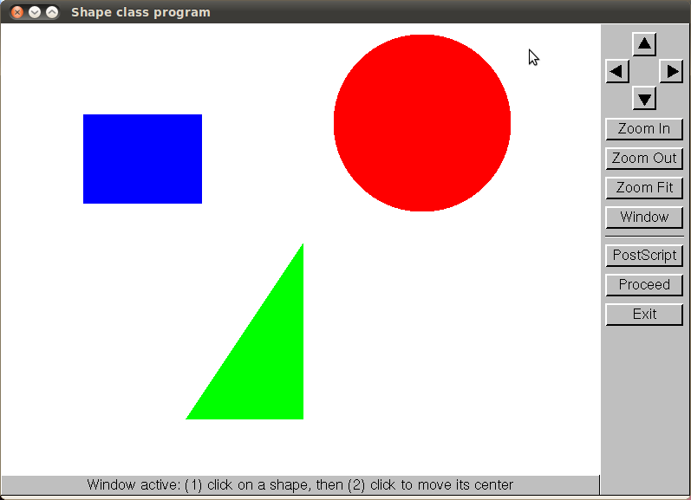

Figure 1: Graphics window; click on a shape, then click where you would like to move its center.

.

Arrow Buttons: pan (shift) image.

Zoom In: focuses on center of image.

Zoom Out: shows more image.

Zoom Fit: shows entire image (as defined by the maximum and minimum world coordinates in the last set_world_coordinates).

Window: Click on the diagonally-opposite corners of a box in which to zoom.

Postscript: writes image to pic1.ps (first click), pic2.ps (2nd click) etc.

Proceed: returns from gl_event_loop ().

Exit: Ends program.

Figure 2: Graphics buttons and their functions.

**5. Sample Session Output**

> circ tri t1 red -2 0 -1 0 -1.5 1

Success

> circ c1 blue 2 3 0.8

Success

> rect r1 green -2 2 1.5 1.2

Success

> printall

t1 red center: (-1.5,0.3) vertices relative to center: (-0.5,-0.3) (0.5,-0.3) (0.0,0.7)

c1 blue center: (2.0,3.0) radius: 0.8

r1 green center: (-2.0,2.0) width: 1.5 height: 1.2

> area

Total area: 4.3

> perimeter

Total perimeter: 13.7

> translate 2 2.8 3 4

Success

> scale r1 0.5

Success

> remove t1

Success

> printall

c1 blue center: (5.0,7.0) radius: 0.8

r1 green center: (-2.0,2.0) width: 0.8 height: 0.6

> draw

Passing control to graphics window. Click Proceed to return control to this command window

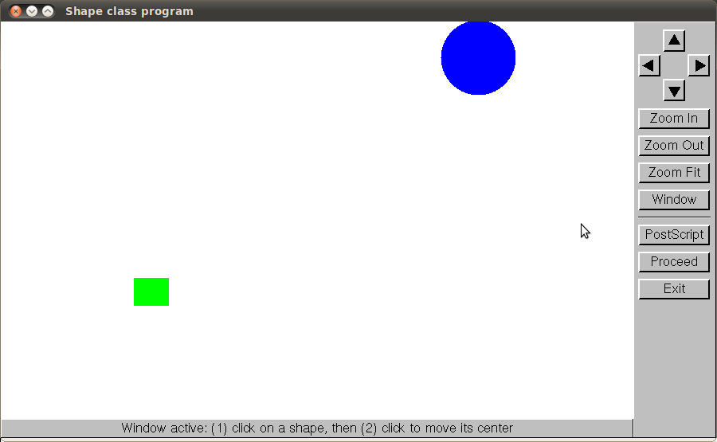

Control returned to command window

<Ctrl+D>

**5. Coding Specification**

Download the files listed below from blackboard. You are to implement two classes, Rectangle and Circle in the files specified. You will also have to add a small amount of code to Main.cpp to create new Rectangle and Circle objects when the rect and circ commands are parsed, respectively. The code to parse those commands is already in Main.cpp – you need only create the appropriate objects.

**Files that must not be changed:**

* **Shape.h and Shape.cpp:** Base class for shapes. It contains the data common to all shapes: name, colour, and the shape center (xcen, ycen). It also contains definitions of functions that will work for all Shape objects, such as getName(). Finally, it contains pure virtual functions defining the interface that derived classes must provide; for example draw and computeArea functions.
* **ShapeArray.h and ShapeArray.cpp:** Stores the array of shapes, as an array of Shape* pointers. This class stores the shapes, parses most commands, and manipulates the array of shapes and outputs text and graphics by calling the appropriate Shape functions (some regular and some virtual).
* **Triangle.h and Triangle.cpp:** A derived class that inherits from Shape, and extends it to implement Triangles. Triangle adds data members for 3 vertices (all stored relative to the Shape center). All virtual functions defined by Shape are implemented in Triangle, in a way appropriate for Triangles.
* **easygl.h, easygl_constants.h, graphics.h, easygl.cpp and graphics.cpp:** Define the graphics library used to display graphics, handle panning and zooming and so on.

**Files you must modify or create:**

* **Main.cpp:** Basic parsing and setup code. You must add a small amount of code to construct a Circle and a Rectangle in the place indicated in the file, when a circ or rect command has been parsed, respectively.
* **Rectangle.h and Rectangle.cpp**: Create these files and implement the Rectangle class. This class must inherit from the Shape class. You will have to add appropriate data members (which must be of private type), and implement Rectangle versions of all the virtual functions defined in Shape.
* **Circle**.**h and Circle.cpp:** Create these files and implement the Circle class. It must also inherit from Shape. You will have to add appropriate data members (private only) and implement Circle versions of all the virtual functions defined in Shape.

Shape

Circle

Triangle

Rectangle

Figure 3: Inheritance Hierarchy.

**Shape.h listing:**

#define PI 3.141593 // This constant may be useful to you

#include <string>

#include "easygl.h" // To get at graphics.

using namespace std;

class Shape {

private:

string name; // Name of this shape, can be used as its identifier

// A string giving the colour of the shape. Valid values are:

// "white", "black", "grey55", "grey75" "blue", "green", "yellow",

// "cyan", "red", "darkgreen", "magenta"

string colour;

float xcen, ycen; // x and y coordinates of the center of the shape.

public:

// Accessor and mutator functions implemented by Shape

string getName () const;

void setName (string _name);

string getColour () const;

void setColour (string _colour);

float getXcen () const;

void setXcen (float _xcen);

float getYcen () const;

void setYcen (float _ycen);

// Shift the object's center by the specified amount. Derived classes

// should be defined so that shifting the object center shifts where the

// whole object is drawn.

// Implemented by Shape.

void translate (float xShift, float yShift);

// Below are virtual interface functions; these *must* be implemented in each

// class derived from Shape.

// Print out the object. Shape::print() will print the basic info contained

// in the Shape base class. Made virtual so you get the right print method

// (print extra info) for derived classes.

virtual void print () const;

// Scale the object size by the specified factor.

// E.g. a scaleFac of 1 would change nothing, 0.5 would shrink the object

// to half its original size, and 2 would grow the object to twice its

// original size. The object stays centered at the same xcen, ycen point.

virtual void scale (float scaleFac) = 0;

// Returns the area of the Shape.

virtual float computeArea () const = 0;

// Returns the perimeter of the Shape.

virtual float computePerimeter () const = 0;

// Draws the object, using the easygl drawing commands.

virtual void draw (easygl* window) const = 0;

// Returns true if the given (x,y) point is inside the Shape.

// Otherwise returns false.

virtual bool pointInside (float x, float y) const = 0;

// virtual destructor, in case we have different data to clean up in

// different derived classes.

virtual ~Shape ();

protected:

// Constructors protected, so they can only be invoked from Derived

// classes as part of building a Derived object. No other classes can

// create a Shape anyway, since it is an abstract base class (cannot be

// instantiated).

Shape ();

Shape (string _name, string _colour, float _xcen, float _ycen);

};

**6. Compiling with Graphics**

Since this program includes graphics, it requires the compiler (specifically the *link* step of compilation) to include the low-level graphics library, which is called the X11 library, in the list of libraries it searches on Linux. This requires one extra option to be passed to the compiler.

* **NetBeans on Linux (e.g. ECF):** As shown in **Figure 4**, type **–lX11** in the *File | Project Properties | Build | Linker | Additional Options* field.
* **Command line on Linux (e.g. ECF):**

g++ -g –Wall –lX11 *.cpp –o shape

* **Apple MacIntosh:** add –lX11 to your linker options, in the same way as for Linux computers.
* **Microsoft Windows with Visual Studio:** X11 is not needed; instead you should enter WIN32 in the *Project | Properties | Preprocessor | Configuration Properties | C/C++ | Preprocessor | Preprocessor Definitions* box in your MS Visual Studio project.
* **Microsoft Windows with NetBeans:**
  1. Tell the easygl graphics package you are compiling for MS Windows by adding **WIN32** to *File | Project Properties | C++ Compiler | Proceprocessor Definitions*.
  2. Tell NetBeans where to find the low-level MS Windows graphics library to which easygl interfaces. Click on *File | Project Properties | Linker | Libraries | Add Library* and select the path to your gdi32 library. With the default cygwin installation this would be in c:\cygwin\lib\w32api\libgdi32.a.

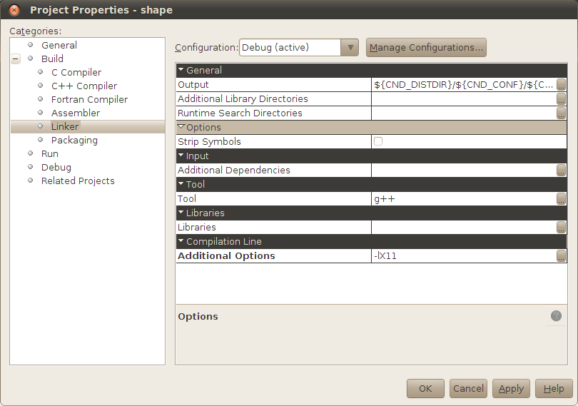**Figure 4: Compiling with graphics in NetBeans on a Linux system: make the circled setting.**

**7. Deliverables and Suggested Approach**

* Create a lab6 directory, download all the files from blackboard, and create a NetBeans project called **shape**. Enter the **–lX11** setting in your Project Properties as described in Section 6. Compile and run the shape program; you should be able to enter, scale, translate, draw etc. Triangles (but not Circles or Rectangles yet).
* Read the Shape.h and Triangle.h files carefully. Shape.h defines the class and interface you must extend, and Triangle gives a good example of how to extend that class.
* Implement the Rectangle class, and the small amount of code in Main.cpp needed to create Rectangles. Test your program thoroughly. To draw a Rectangle, the following graphics functions will be helpful:

easygl* window; // A pointer to the window object (passed into draw)

window->gl_setcolor(colorStr); // Sets color for subsequent drawing commands

window->gl_fillrect (xleft, ybottom, xright, ytop);

* Implement the Circle class, and the small amount of code in Main.cpp needed to create Circles. Test your program thoroughly. To draw a Circle, the following graphics functions will be helpful:

easygl* window; // A pointer to the window object (handily passed into draw)

window->gl_setcolor(colorStr); // Sets color for subsequent drawing commands

window->gl_fillarc (xcen, ycen, radius, 0, 360);

* Your program should pass exercise and other text-based tests, and also should draw shapes and respond to mouse clicks properly.
* Your program must not leak memory; use exercise and valgrind to test. Note that when the graphics are invoked with the draw command during a run, some memory deep in the graphics library is still on the heap at the end of the program, so valgrind will report that some heap memory is still in use at exit. However, no memory leaks occur, and valgrind should report **definitely lost: 0 bytes** for your program in all cases.
* Submit your program using the command

~ece244i/public/submit 6

**8. (Optional) To Go Further**

With the winter break approaching, we are sure many students are wondering how they will avoid boredom without programming assignments. Fear not! You can extend this lab in many ways if you get bored over the holidays.

1. Add a general Polygon class to the program; this polygon could contain an arbitrary number of vertices.
2. Add an Ellipse to the program.
3. Add a Composite shape that contains an arbitrary list of other shapes (Circles, Rectangles and Triangles).
4. Add the ability to click on a shape and then type in a number to scale the object.
5. And many more ...

To do these optional assignments, you will have to learn more about the graphics library (easygl) you are using. You can download a manual giving an overview of easygl’s use and capabilities (and an intro to event-driven graphics) from <http://www.eecg.toronto.edu/~vaughn/easygl/easygl.html>. The easygl.h and easygl_constants.h header files give a highly commented list of the funtions available to set up and interact with the graphics.