# CS 420/527 Project 3 — Hopfield Net

1. **Introduction**

In this project, the associative memory capacity of Hopefield network is investigated and discussion is given based on experiments.

Generally, the neural network has 100 neurons with no self-coupling, which means weights between the neuron and itself is zero. And general number of imprinted pattern is set to be 50. After observing stable and unstable imprinted patterns from this neural network, we also increase/decrease number of imprinted patterns and neurons in order to explore other interesting phenomenon.

Basin structure we use to implement Hopfield network is given in table 1.

Table 1. Pseudo code for Hopfield network implementation

|  |
| --- |
| *Initialize data structures for keeping statistics*  *for i from 0 to number of runs*  *generatePatterns()*  *for p from 1 to 50*  *imprintPatterns(p)*  *testPatterns(p)*  *Compute averages over number of runs*  *Normalize data for basins of attraction*  *Write data file* |

1. **Stable imprints**
   * 1. Fraction if unstable imprints as a function of the number of imprints p.

According to algorithm in Table 1, we run the experiments for 10 times and average the unstable fractions in terms of number of imprinted patterns. The results are shown in Figure 1. Note that in this experiments, number of imprinted patterns are 50, and number of neurons are 100. When *h*=0, *σ(h)* is set to be +1 or -1 with equal probability.

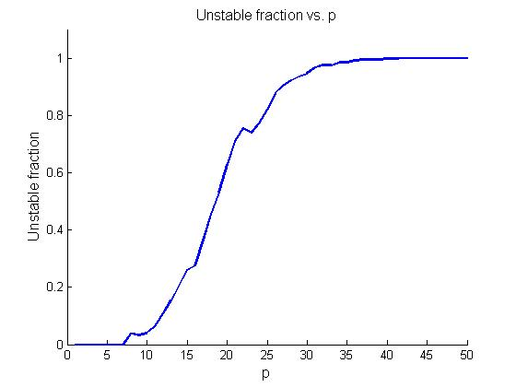

Figure 1. Unstable fraction vs. number of imprinted patterns (p = 50, neuron # = 100)

As the number of imprinted patterns (p) increase, unstable fraction also increases. For *p* less than 10 the stability of all of the stored patterns is perfect. But after p = 30, the stability is almost 0, which means all patterns are unstable.

1. Number of stable imprints as a function of the number of imprints p

If we do not normalize the data, but plot stable numbers vs. number of imprinted patterns, we can get results displayed in Figure 2. For p less than 10, all patterns are stable. The maximum number of stable imprinted patterns is a little bit less than 12. Above 15 imprints the number of stable patterns decreases gradually to zero.

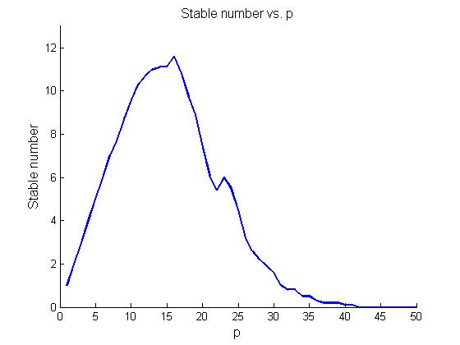

Figure 2. Stable counter vs. number of imprinted patterns.

From the above analysis, for a 100 neuron network, 10 imprinted patterns are guaranteed so that the system is stable as a memory.

1. Effect of size of neuron network

To evaluate the relation of stability and the number of imprinted patterns, we did experiments with various neurons and number of patterns.

Figure 2 shows stability in terms of number of imprinted patterns in condition of *p* = 50, *neurons number* = 50. From this experiment, it is obvious that as size of neural network shrinks, stable imprinted patterns are less. The left sub figure indicates only when p is less than 8, stability can be guaranteed. The right sub figure shows stable number almost decreases to zero after p = 20.

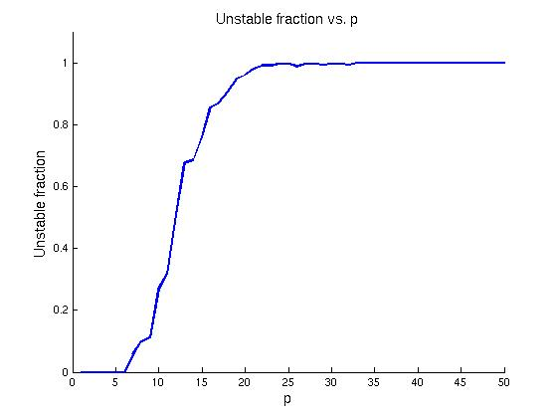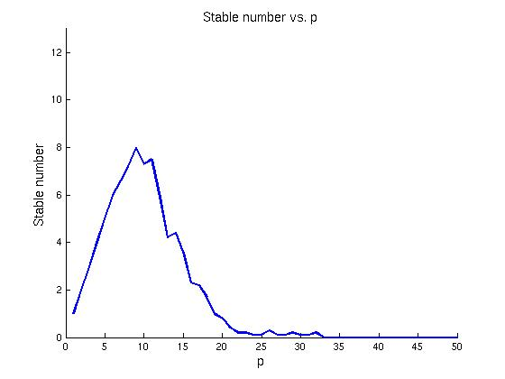

Figure 2. Stability vs. number of imprinted patterns (p = 50, neuron # = 50)

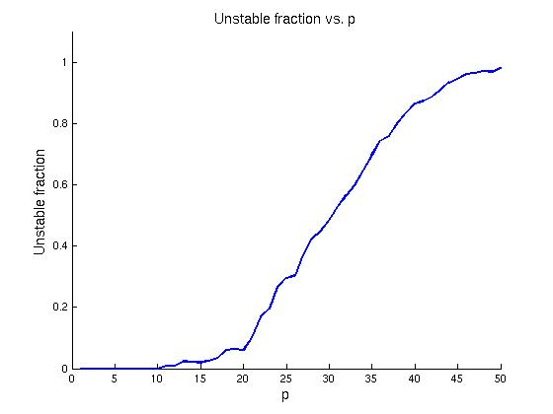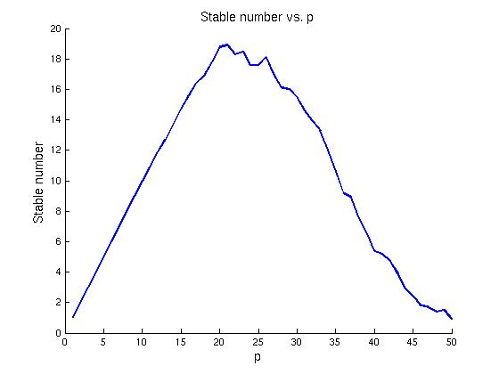

Figure 3. Stability vs. number of imprinted patterns (p = 50, neuron # = 200)

Figure 3 shows stability in terms of number of imprinted patterns in condition of *p* = 50, *neurons number* = 200. From this experiment, it is obvious that as size of neural network increases, stable imprinted patterns also increase. The left sub figure indicates when p is less than 20, stability can be guaranteed. The right sub figure shows instability is almost zero after p = 45.

Those experiments indicate that as neural network size increases, more patterns can be stably imprinted to the system, regarded as stable memory.

1. Effect of number of imprinted patterns

For certain neural network, the number of stable imprinted patterns is limited, which means after a certain threshold, no more patterns can be imprinted stably. This speculation is proved by Figure 4 and Figure 5, which has 100 and 200 imprinted patterns respectively. The number of stable patterns is fixed to 10, in spite of the number of imprinted patterns.

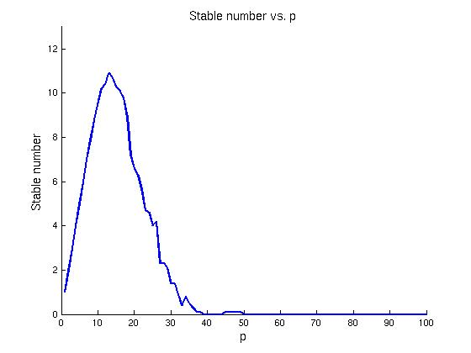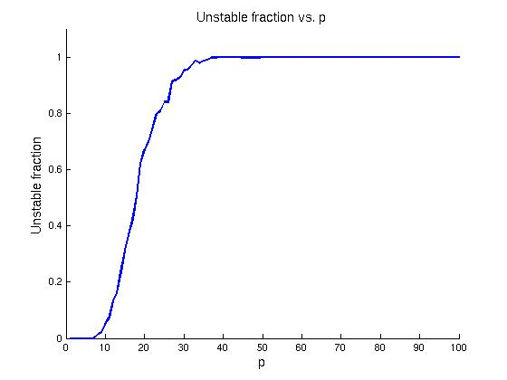

Figure 4. Stability vs. number of imprinted patterns (p = 100, neuron # = 100)

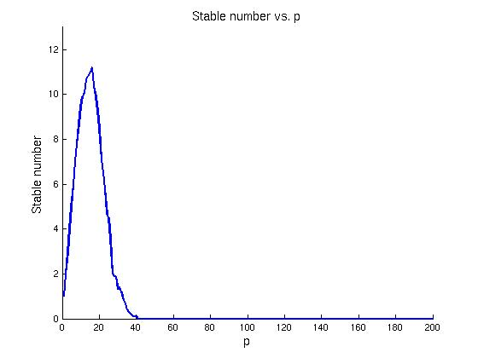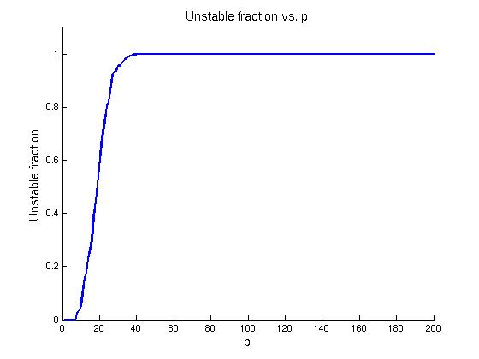

Figure 5. Stability vs. number of imprinted patterns (p = 200, neuron # = 100)

1. **Basin of attraction**

Measuring the size of the basin of attraction is important because the the associative memory based on neural network depends on it. Consider a particular stable state of neural network {*Si*}, the basin of attraction of { *Si* } indicates the size of the region of possible network states which is “attracted” to { *Si* }. If after couple of updates, state { *Sj* } evolves to { *Si* }, it is said to be attracted to { *Si* }.

* 1. Probability distribution of the size of basin of attraction

Still considering the base experiment where number of imprinted patterns is 50, and number of neurons is 100. Obviously, the maximum size of basin of attraction is 50, half of the number of neurons in the network. The probability distributions of basin of attraction are normalized to 1 as Figure 6 shows. Each curve is for a different number of imprinted patterns as shown. From Figure 6, where each value is normalized to p, the average size of basin of attraction decreases as the number of imprints increase, which is consistent with conclusion in section II. The larger the number of imprinted patterns, more unstable the system is.

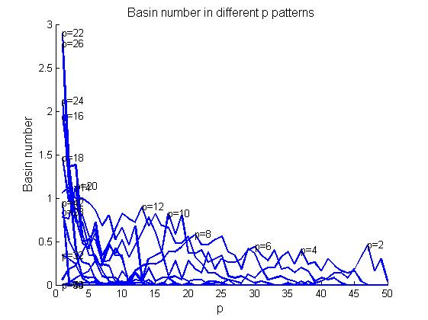

Figure 6. Number of imprinted patterns with certain basins of attraction

* 1. Number of imprinted patterns with a particular basin of attraction

From Figure 7, the probability distribution also broads as the size of basin of attraction decreases, which means given state is less likely to be attracted to certain basin. Therefore, more states are unstable as the number of imprints increases.

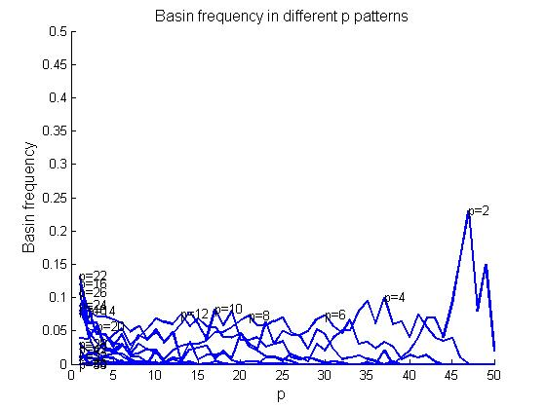

Figure 7. Probability distribution of the size of basin of attraction

* 1. Effect of number of imprinted patterns

As we claimed in the last section, the maximum size of basin of attraction is half of neurons number. This is proved by Figure 8 and Figure 9, when number of imprints is more than half of number of neurons. Both the probability distribution and basin number show that when pattern number is over half of the number of neurons, basins are always zero.

In Figure 8 and Figure 10, numbers of neurons are both 200, and number of imprinted patterns is 200 and 100 respectively. Basin of attraction in Figure 8 is almost the same with Figure 10, despite of the different number of imprints.

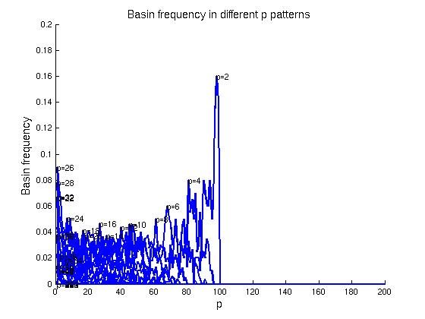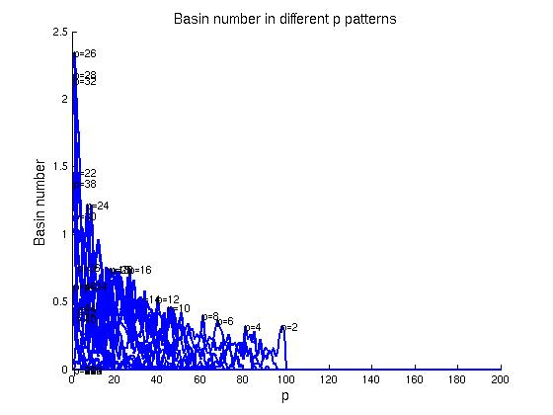

Figure 8. Basin of attraction (p = 200, neuron # = 200)

* 1. Effect of number of neurons

To evaluate the effect of neural network size, experiments with 100 and 200 neurons are run. Tendency of Figure 9 and Figure 10 are consistent with conclusion we draw from Figure 6 and Figure 7. The average size of basin of attraction decreases as the number of imprints increase, and the probability distribution also broads as the size of basin of attraction decreases.

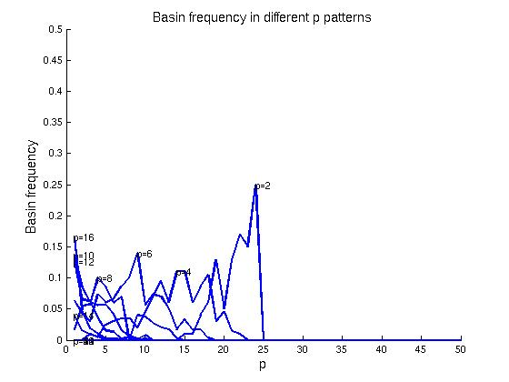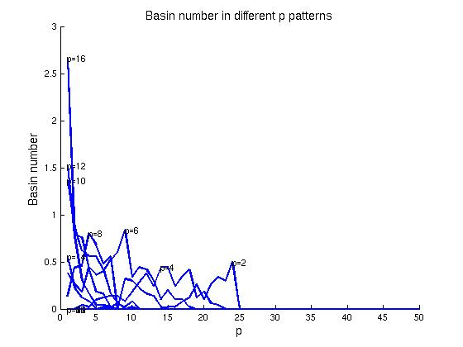

Figure 9. Basin of attraction (p = 50, neuron # = 50)

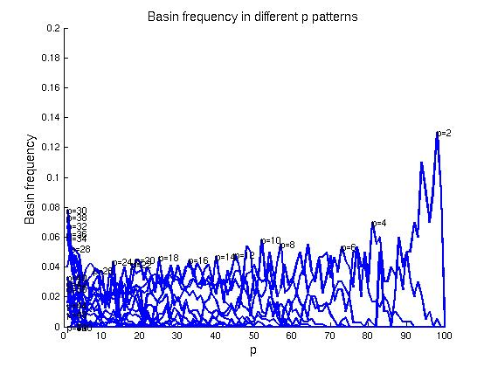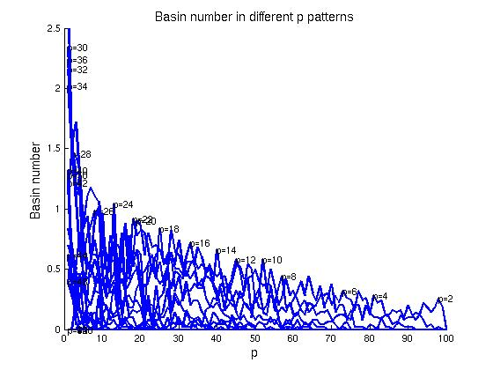

Figure 10. Basin of attraction (p = 100, neuron # = 200)

* 1. Odd values of *p*

Besides of the required even values of *p* figure, we also plot the odd value of *p* in Figure 11, and both odd and even values in Figure 12. The p = 1 line in x = 50, the frequency of basin of attraction is 1, and basin counter is also 1, which means if only one pattern is imprinted to neural network, it will always converge to that patter. If the network converges for all 50 iterations of the permutation array (that is, it never does not converge), then the size of the basin of attraction for that pattern is 50, since that is the maximum size of a basin of attraction. This is true when we refer to results in section II, that stability is always true when p = 1.

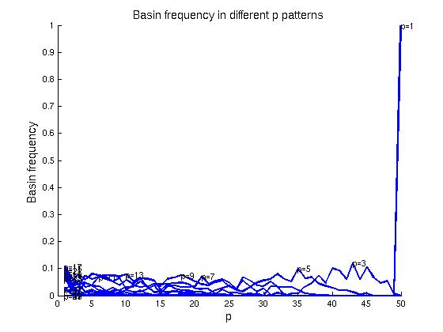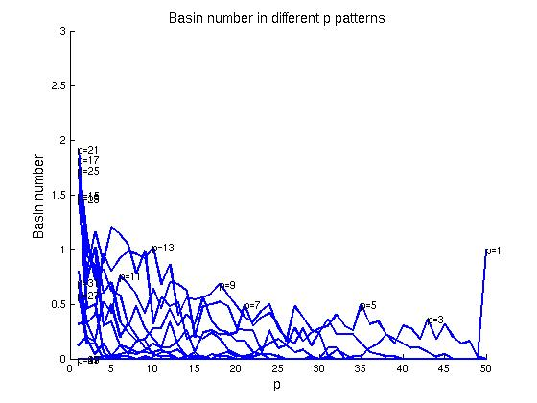

Figure 11. Basin of attraction with odd *p* values (p = 50, neuron # = 100)

The following figure shows lines with all p values. It is obvious that basin frequency and basin counter increase when p value decreases.

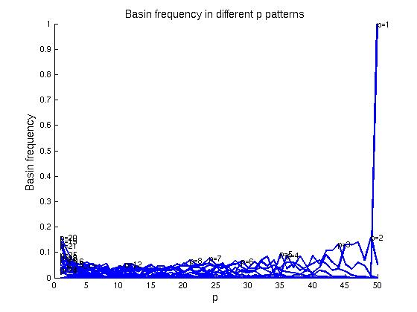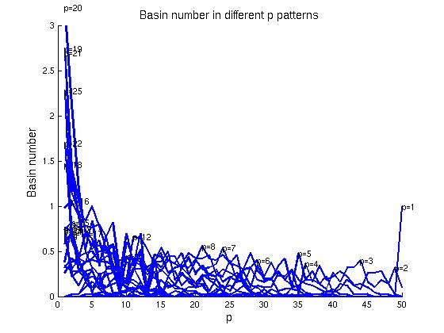

Figure 12. Basin of attraction with all *p* values (p = 50, neuron # = 100)