### **Hong Kong Baptist University**

### Department of Computer Science

*COMP 7990 Principles and Practices of data analytics (2022-23)*

*Assignment 3b*

Name: _______ZhangChi______ SID:___22407987_

**Exercise 1**

1. Download the **Financial Sample.xlsx** and import it to **Tableau Desktop**. Use **Live** connection. You may need to check the box as shown below to clean the data first.

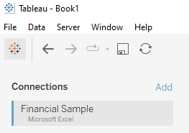

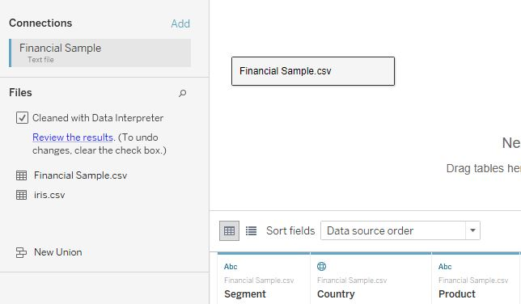

**Data Interpreter** can give you a head start when cleaning your data. It can detect things like titles, notes, footers, empty cells, and so on and bypass them to identify the actual fields and values in your data set.

1. Save the Tableau file with the name **lab3b-assignment-ans.twbx (Don’t use .twb).** Create the following charts, capture the screenshots and paste them in the boxes provided, and answer the questions. You may use the visualization type as sheet name.

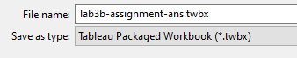

1. Create a stacked column chart to show SUM of sales for different segments in different countries. Use different colors to represent different segments. Sort the sum of sales in **descending** order. Add **data labels**. Use **Entire View**.

|  |
| --- |
| **Screenshot for the stacked column chart:** |
| Questions:   1. From the stacked column chart, which country has the highest SUM of sales? ______________ United States of America ________________________ 2. What is the sum of sales in Government segment in Mexico? _______9,791,603_____ 3. Which segment has the least sum of sales in Germany? _________ Midmarket _____ |

1. Create a line chart to show the monthly sum of sales in 2014. Add **data labels**. Use **Entire View**.

|  |
| --- |
| **Screenshot for the line chart:** |
| Questions:   1. From the line chart, what is the sum of sales in June 2014? ______9,518,894________ 2. Which month has the highest sum of sales in 2014? ______ October _________ |

1. Create a calculated field named **Profit** by using the formula: [Sales] – [COGS], create a tree map to show the average profit for different products. Darker color means higher average profit. Add **data labels** **to show the average profit**. Use **Entire View**.

|  |
| --- |
| **Screenshot for the tree map:** |
| Questions:   1. From the tree map, which product has the highest average profit? __Amarilla_ _ 2. The average profit for the product Velo is ____29,937____________ |

1. Create a pie chart to show the percentage sum of sales for different countries. Add **data labels** (percentage) and **category labels** to the pie chart. Use **Entire View**.

|  |
| --- |
| **Screenshot for the pie chart:** |
| Question:   1. From the pie chart, what is the percentage sum of sales in Canada? _______20.962%_________ |

1. Create a filled map to show the average sales in different countries. Show only the countries in Europe (by using Filters shelf). Use different colors for different countries. Add **data labels**. (Hint: Use Map mark type <https://help.tableau.com/current/pro/desktop/en-us/maps_howto_filledpiechart.htm>)

|  |
| --- |
| **Screenshot for the filled map:** |
| Questions:   1. From the filled map, which European country has the highest average sales? _ France_ 2. What are the average sales for that country? ________173,958_______________ |

1. Create a scatterplot to show the relationship between Profit(Y) and Sales(X) [use Dimension] in USA. Use different colors for different segments. Then create different mark shapes for different segments. Add some linear trendlines to show the trend for different segments. (There will be 5 trendlines) Use **Entire View**.

|  |
| --- |
| **Screenshot for the scatterplot:** |
| Question:   1. Which segment shows decreasing trend of profit with increasing sales? _ Enterprise |

**Assignment Submission**

Submit the following filesto bulearning website:

* lab3b-assignment-ans.docx
* lab3b-assignment-ans.twbx