LSCI-DiffRec: LLM-Guided Semantic Causal Intervention Diffusion for Out-of-Distribution Recommendation
Consolidated English Manuscript Draft
[Author names and affiliations to be inserted]
Draft status: the method, equations, theory, algorithms, and evaluation protocol are consolidated. Numerical results, significance tests, and final bibliographic metadata must be completed after implementation.
2026-07-21

Abstract
Graph neural network (GNN)-based recommender systems exploit high-order collaborative signals from user-item interaction graphs, but their performance can deteriorate sharply when training and test distributions differ. The central difficulty is that observed interactions mix stable preference mechanisms with environment-dependent correlations induced by time, popularity, exposure, and other latent factors. Existing causal diffusion recommenders model environmental confounding from graph structure, yet they lack semantic knowledge about why an interaction may reflect a persistent preference. In parallel, large language models (LLMs) provide rich semantic reasoning but are not, by themselves, guaranteed to preserve collaborative signals or causal invariance. We propose LSCI-DiffRec, an LLM-guided semantic causal intervention diffusion framework for out-of-distribution (OOD) recommendation. The method first learns edge-level causal stability scores and infers latent environments from the variant part of the graph. It then uses a frozen LLM to summarize long-term user interests and item semantics, projecting the summaries into semantic causal priors. Finally, the structural environment variable and the LLM-derived semantic prior jointly condition the reverse diffusion process, while a contrastive semantic alignment objective preserves compatibility between semantic and collaborative spaces. The manuscript develops the complete model, optimization objectives, training and inference algorithms, theoretical motivation, and a reproducible evaluation protocol covering temporal, popularity, and exposure shifts.
Keywords—out-of-distribution recommendation; causal representation learning; diffusion models; large language models; invariant learning; semantic intervention.

1 Introduction
Graph neural networks have become a dominant paradigm for collaborative recommendation because they propagate information over user-item interaction graphs and capture high-order behavioral dependencies [1], [2]. Their success, however, is commonly established under an independent and identically distributed assumption. In real systems, user preferences evolve, item popularity changes, exposure policies are updated, and external events modify user behavior. Consequently, the distribution observed during training can differ substantially from the distribution encountered at deployment.
A useful causal view is that a latent environment E affects both the observed interaction graph G and the target behavior Y, creating the backdoor path G ← E → Y. A recommender trained only to optimize P(Y|G) may exploit correlations that are predictive in the source environment but unstable after a distribution shift. This explains why strong graph recommenders can suffer pronounced degradation under temporal, popularity, or exposure shifts.
Recent OOD recommendation methods address this problem through causal representation learning, invariant learning, distributionally robust optimization, or graph augmentation [6]–[10]. CausalDiffRec is particularly relevant: it constructs a structural causal model, infers latent environments, and uses conditional diffusion to learn environment-invariant graph representations [10]. Nevertheless, its causal evidence is primarily structural. Graph topology can suggest which interactions are stable, but it does not always reveal why they are stable. For example, different movies may reflect the same persistent preference for complex narratives, historical themes, or moral ambiguity—semantics that are difficult to recover from topology alone.
Large language models offer a complementary source of knowledge. Given user histories and item descriptions, an LLM can summarize high-level preference factors and distinguish persistent interests from temporary trends. Directly using LLM outputs as recommendation scores or ordinary input features is insufficient, however. LLMs do not observe fine-grained collaborative signals, their outputs may contain irrelevant or hallucinated content, and simple feature concatenation provides no explicit mechanism for suppressing environment-dependent correlations.
This work asks: how can semantic knowledge from an LLM be integrated into causal diffusion without replacing graph collaborative filtering or reducing the method to feature augmentation? We answer this question with LSCI-DiffRec, which treats the LLM as an offline semantic causal prior generator. Instead of editing the graph or producing final recommendations, the LLM supplies a stable semantic condition to the reverse diffusion process. The graph model retains responsibility for collaborative structure, latent environment inference, and ranking.
LSCI-DiffRec contains three stages. First, a data-driven causal environment discovery module assigns each observed edge a stability score, decomposes the graph into stable and variant components, and infers a latent environment variable. Second, a frozen LLM summarizes stable user preferences and item semantics; trainable projection heads map these summaries into the collaborative latent dimension. Third, the environment variable and semantic prior jointly condition a diffusion denoiser that reconstructs invariant node representations. A semantic contrastive objective aligns the denoised collaborative embeddings with the corresponding priors without forcing the two spaces to be identical.
The main contributions are summarized as follows:
- We formulate semantic causal intervention diffusion for OOD recommendation, using an LLM-derived semantic prior as a condition of reverse diffusion rather than as a direct predictor or graph editor.
- We develop a dual-source invariance mechanism that combines data-driven environmental structure with semantic preference knowledge, together with a contrastive alignment objective that preserves recommendation-specific information.
- We provide a complete optimization and deployment design in which semantic priors are generated and cached offline, so online recommendation requires no per-request LLM call. We further specify theory-driven and empirical tests for temporal, popularity, and exposure shifts.

2 Related Work

2.1 Graph-Based Recommendation
Graph-based recommenders model users and items as a bipartite graph and learn representations through neighborhood aggregation. NGCF introduced graph convolution into collaborative filtering [2], while LightGCN removed nonlinear transformations and feature projections to emphasize the collaborative signal itself [1]. Self-supervised extensions such as SGL, SimGCL, and LightGCL construct auxiliary views or perturbations to regularize graph representations [3]–[5]. These methods are effective under IID evaluation, but their objectives do not explicitly separate environment-sensitive correlations from stable preference mechanisms.

2.2 OOD Recommendation and Causal Invariant Learning
OOD recommendation methods seek predictors that remain reliable under changes in exposure, popularity, time, or user composition. InvCF learns preference factors invariant to popularity distributions [6], DR-GNN applies distributionally robust optimization to graph recommendation [7], and causal representation approaches use latent variables, counterfactual reasoning, or invariant risk principles to suppress unstable paths [8], [9]. CausalDiffRec combines backdoor-inspired environment modeling with latent diffusion [10]. LSCI-DiffRec retains the structural causal motivation but adds semantic intervention to address preference factors that are weakly identifiable from interactions alone.

2.3 Diffusion Models for Recommendation
Denoising diffusion probabilistic models learn a reverse Markov process that reconstructs data from progressively corrupted samples [11]. In recommendation, diffusion has been used to model interaction vectors, sequences, graph embeddings, and noisy preferences [12]. Diffusion is attractive for OOD learning because the reverse process can be explicitly conditioned on auxiliary variables. Unlike standard diffusion recommenders, LSCI-DiffRec conditions denoising on both a graph-derived environment representation and an LLM-derived semantic prior.

2.4 LLM-Enhanced Recommendation
LLM-based recommenders use language models as predictors, profile generators, semantic encoders, reasoning agents, or graph augmentation tools [13]–[15]. InvGCLLM is closely related because it combines invariant edge scores with LLM-guided graph refinement and causal contrastive learning [13]. Our method differs in two respects: it does not ask the LLM to make discrete KEEP/REMOVE/ADD decisions, and it does not use graph contrastive learning as the principal representation generator. Instead, semantic knowledge acts as a continuous intervention condition inside causal diffusion.

2.5 Positioning of LSCI-DiffRec
Method | Causal / Invariant | Diffusion | LLM Knowledge | Role of Semantics
LightGCN [1] | No | No | No | —
SGL / SimGCL [3], [4] | Implicit robustness | No | No | Augmentation only
InvCF [6] | Yes | No | No | —
CausalDiffRec [10] | Yes | Yes | No | Structural condition
InvGCLLM [13] | Yes | No | Yes | Graph refinement
LSCI-DiffRec | Yes | Yes | Yes | Continuous semantic intervention

3 Method

3.1 Overview
Figure 1 presents the overall framework. Stage I discovers stable structural patterns and latent environments from observed interactions. Stage II generates node-level semantic causal priors from user histories and item text. Stage III encodes the stable graph into a latent variable and performs semantic intervention-guided reverse diffusion. The final denoised user and item representations are optimized for pairwise ranking.
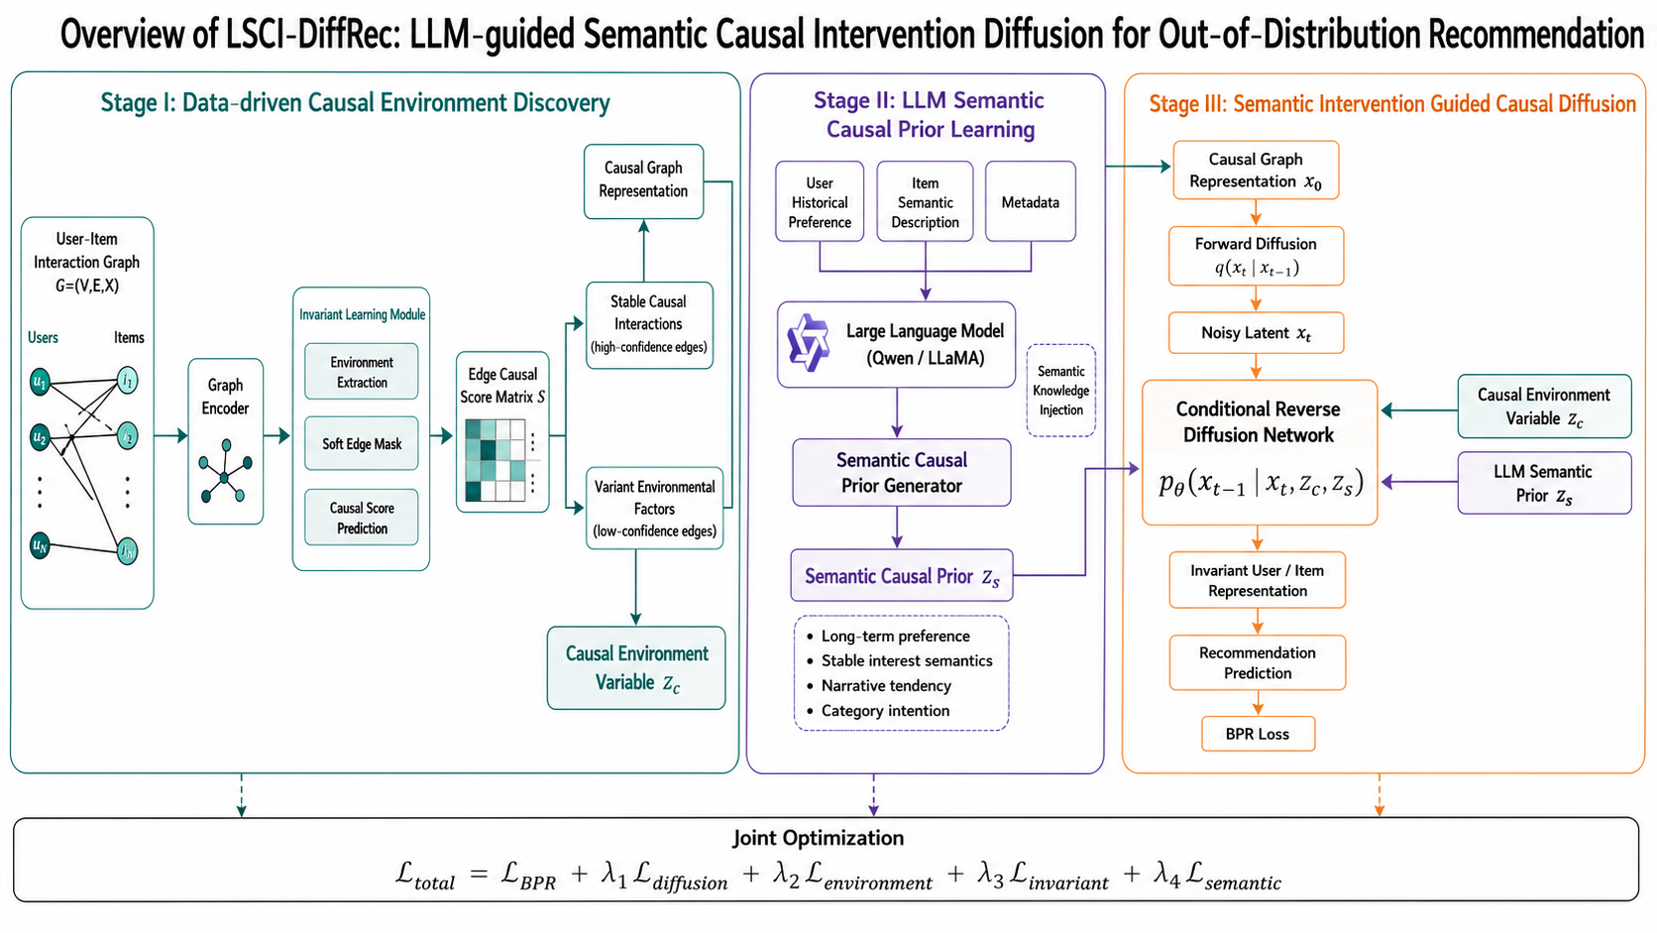
Figure 1. Overall framework of LSCI-DiffRec.

3.2 Problem Formulation
Let U = {u₁, …, u_m} and I = {i₁, …, i_n} denote the user and item sets. The observed implicit-feedback graph is G = (V, E, X), where V = U ∪ I, E contains observed user-item interactions, A is the corresponding adjacency matrix, and X denotes available node attributes. For a user u, a positive item i, and an unobserved item j, the recommender predicts scores ŷ_ui and ŷ_uj.
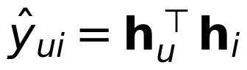 | (1)
Training and test data may be generated under different latent environment distributions. Denoting the environment by E_env to avoid confusion with the edge set, the OOD setting satisfies:
(2)
The objective is to learn representations H that retain preference-relevant information while reducing sensitivity to E_env. Operationally, the method combines structural invariance, semantic consistency, and ranking accuracy rather than assuming that the true environment or causal graph is directly observed.
Symbol | Meaning
G = (V, E, X) | Observed user-item interaction graph
A, Aᶜ, Aᵛ | Original, stable, and variant weighted adjacencies
S = [s_ui] | Edge-level causal stability score matrix
zᶜ | Graph-derived latent environment condition
zˢ | LLM-derived semantic causal prior
x_t | Graph latent variable at diffusion step t
h_u, h_i | Final denoised user and item embeddings

3.3 Data-Driven Causal Environment Discovery

3.3.1 Edge Stability Scoring
A masking GNN f_m encodes the original graph. For an observed edge (u, i), its stability score is predicted from the endpoint embeddings and their interaction:
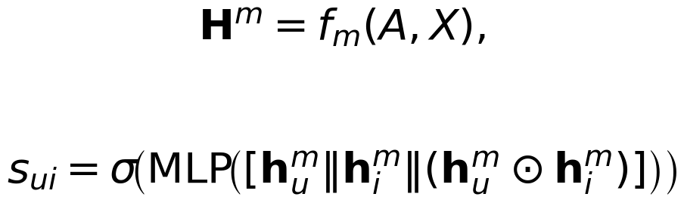 | (3)
The score s_ui ∈ (0, 1) should be high for interactions that remain predictive across inferred environments and low for environment-sensitive interactions. We use weighted adjacencies during optimization:
(4)
At evaluation time, a sparse stable graph can be obtained by retaining the top ρ fraction of edges per user or by applying a validated threshold. Weighted training avoids non-differentiable hard selection in early epochs.

3.3.2 Latent Environment Inference
A variant-graph encoder f_v produces node embeddings from Aᵛ. Each observed edge is represented by r_ui = [hᵛ_u ∥ hᵛ_i ∥ |hᵛ_u − hᵛ_i|]. K-means provides an initialization of K pseudo-environments, after which a categorical posterior q_φ(E_env | r_ui) refines the assignment:
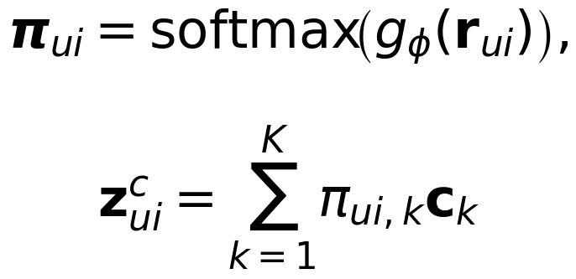 | (5)
Here c_k is a learnable environment prototype. A node-level environment condition is obtained by averaging the incident edge conditions, weighted by the corresponding posterior confidence. The environment objective combines pseudo-label consistency and a balanced-assignment regularizer:
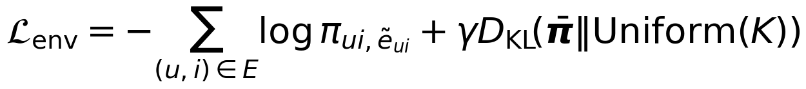 | (6)

3.3.3 Invariant Learning Objective
Let D_k denote ranking triplets whose positive interaction is assigned to environment k, and let R_k be the BPR risk computed with stable-graph embeddings. We minimize the average risk and penalize environment-specific gradient fluctuations:
L_inv = (1/K)Σ_k R_k + α(1/K)Σ_k ‖∇_ωR_k − (1/K)Σ_l∇_ωR_l‖²₂ + βL_mask | (7)
The mask regularizer prevents the trivial all-zero or all-one solution:
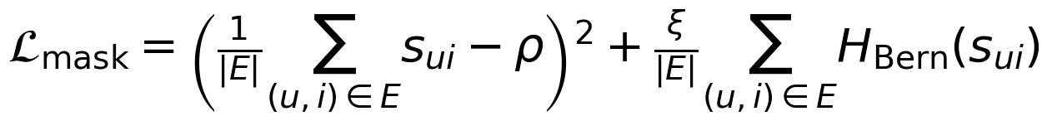 | (8)
The target retention ratio ρ is selected on validation data, and minimizing the Bernoulli entropy encourages confident edge scores.

3.4 LLM-Based Semantic Causal Prior Learning

3.4.1 Stable Preference Prompt Construction
For each user, the prompt is constructed from high-scoring historical interactions, item titles or descriptions, and available metadata. The instruction explicitly asks the LLM to identify persistent preference factors and ignore temporary popularity, seasonal demand, one-off events, and exposure artifacts. For each item, a separate prompt summarizes core content, functional attributes, target audience, and semantics that are unlikely to depend on short-term popularity.
A typical user prompt contains four fields: (i) stable interaction history selected by s_ui; (ii) optional timestamps and environment cues; (iii) a request for a concise structured summary; and (iv) a prohibition against predicting a specific next item. The LLM therefore supplies an explanatory prior rather than a recommendation label.

3.4.2 Prior Encoding and Projection
The LLM is frozen during recommender training. Its structured outputs are encoded once and cached. Let eᴸ_u and eᴸ_i denote the resulting user and item semantic vectors. Trainable projection heads map them into the collaborative dimension:
(9)
The set zˢ = {a_v | v ∈ V} is the node-level semantic causal prior. The term “causal prior” is used in an operational sense: the prompt and filtering procedure are designed to emphasize stable preference mechanisms, but the LLM output is not assumed to be ground-truth causality. Its reliability is evaluated through stability, encoder-comparison, and ablation studies in Section 5.

3.5 Semantic Intervention-Guided Causal Diffusion

3.5.1 Graph Latent Encoding
A variational graph encoder maps the stable weighted graph into a continuous latent representation:
(10)
(11)
The graph reconstruction term and KL regularization are denoted by L_VGAE.

3.5.2 Standard Forward Diffusion
The forward process remains a standard Gaussian diffusion and is deliberately not conditioned on the semantic prior:
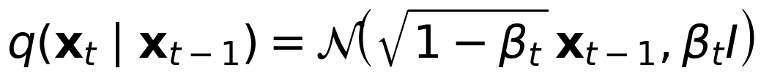 | (12)
(13)
Keeping the corruption process fixed preserves the standard diffusion likelihood and makes the semantic contribution identifiable in the reverse process.

3.5.3 Causal-Semantic Conditional Reverse Process
For each node v, the denoiser receives its noisy latent, time embedding, graph-derived environment condition zᶜ_v, and semantic prior a_v. The conditional reverse transition is:
(14)
In implementation, the two conditions are projected and injected through feature-wise modulation or cross-attention. The noise-prediction objective is:
(15)
 | (16)
A denoised estimate can be recovered as x̂₀ = (x_t − √(1−ᾱ_t)ε_θ)/√ᾱ_t. The corresponding rows provide the user and item embeddings used for ranking.

3.5.4 Semantic Alignment Without Space Collapse
Direct mean-squared-error alignment would force semantic and collaborative spaces to coincide and may discard interaction-specific information. We instead use separate user and item InfoNCE losses. For a user mini-batch B_U:
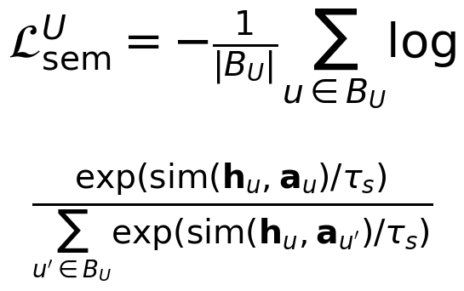 | (17)
The item loss L_sem^I is defined analogously, and L_sem = L_sem^U + L_sem^I. This objective encourages semantic consistency while allowing collaborative geometry to remain task-specific.

3.6 Recommendation Objective and Joint Optimization
For each triplet (u, i, j), the pairwise ranking objective is:
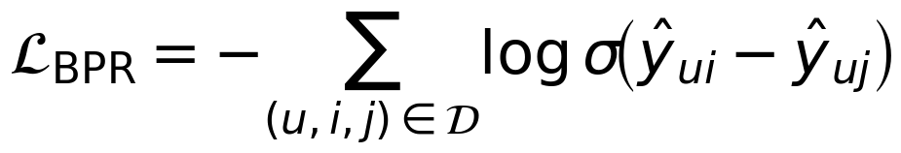 | (18)
The complete differentiable objective is:
(19)
The LLM itself is not updated by L_total. Only the graph encoders, environment posterior, projection heads, diffusion denoiser, and recommendation parameters receive gradients.

3.7 Training and Inference Algorithms
Training uses a warm-up and caching schedule. The causal scorer is first stabilized, semantic priors are then generated offline, and the differentiable modules are jointly optimized. This avoids end-to-end backpropagation through the LLM and makes experiments reproducible.
Algorithm 1. Training LSCI-DiffRec
Input: Interaction graph G=(V,E,X); user/item text T; number of environments K; diffusion steps T_d.
Output: Trained graph, environment, projection, and diffusion parameters; cached semantic priors zˢ.
1 | Initialize masking GNN, stable/variant encoders, environment posterior, projection heads, VGAE, and denoiser.
2 | Warm up the graph modules for E_w epochs using L_BPR + λ₂L_env + λ₃L_inv.
3 | Compute S; construct weighted Aᶜ=A⊙S and Aᵛ=A⊙(1−S).
4 | Infer initial pseudo-environments from variant-edge embeddings and initialize q_φ(E_env|r_ui).
5 | Build stable-history prompts; query the frozen LLM; encode and cache eᴸ_u and eᴸ_i.
6 | Project cached semantics to a_u and a_i; set zˢ={a_v}.
7 | For each training epoch and mini-batch, update zᶜ from q_φ and encode x₀~q_ψ(x₀|Aᶜ,X).
8 | Sample t and ε; form x_t=√ᾱ_t x₀+√(1−ᾱ_t)ε.
9 | Predict ε̂=ε_θ(x_t,t,zᶜ,zˢ) and recover denoised embeddings H.
10 | Compute L_BPR, L_diff, L_env, L_inv, and L_sem.
11 | Update all differentiable parameters with Adam; keep the LLM frozen.
12 | Optionally refresh S and pseudo-environments every R epochs; refresh LLM priors only when the stable history changes materially.

Algorithm 2. Inference with Cached Semantic Priors
Input: Target graph G′; trained modules; cached semantic priors zˢ; adaptation noise level t*.
Output: Ranked recommendation list for each user.
1 | Score target interactions and construct Aᶜ′ and Aᵛ′ without gradient updates.
2 | Infer the target environment condition zᶜ′ from the variant graph.
3 | Encode the stable target graph to a base latent x₀′.
4 | Corrupt x₀′ to x_{t*}′ using the fixed forward process.
5 | Run deterministic or stochastic reverse steps conditioned on zᶜ′ and cached zˢ.
6 | Obtain denoised user and item embeddings h_u and h_i.
7 | Compute ŷ_ui=h_uᵀh_i, mask previously observed items, and rank candidates.
8 | For a genuinely new user or item, create its semantic prior once during onboarding or an offline refresh—not per recommendation request.

3.8 Complexity and Deployment
Let |E| be the number of interactions, d the latent dimension, L the number of graph layers, and T_s the number of reverse diffusion steps used at inference. Graph encoding is O(L|E|d), while denoising is approximately O(T_s|V|d²) for an MLP-style denoiser. LLM generation is an offline preprocessing cost and the resulting priors are cached. Therefore, the online serving path does not require an LLM call; latency is governed by graph encoding, a truncated diffusion sampler, and inner-product retrieval.

4 Theoretical Analysis

4.1 Causal Motivation and Assumptions
Assume that an invariant preference variable I and an environment variable E_env jointly generate the observed graph and target behavior. The semantic prior A_s is constructed from text associated with stable interactions. The analysis uses three explicit assumptions: (A1) the LLM prior contains non-zero information about I; (A2) conditioned on I, its distribution changes less across environments than the raw interaction graph; and (A3) the denoiser and projection functions have sufficient capacity. These assumptions are testable only approximately, so the theory motivates the objectives rather than declaring LLM outputs to be ground-truth causal variables.

4.2 Lemma 1: Additional Semantic Conditioning Cannot Increase Optimal Denoising MSE
Under squared-error noise prediction, the Bayes-optimal denoiser is the conditional expectation of ε. Because conditioning on (x_t,zᶜ,zˢ) reveals at least as much information as conditioning on (x_t,zᶜ), the optimal risk satisfies:
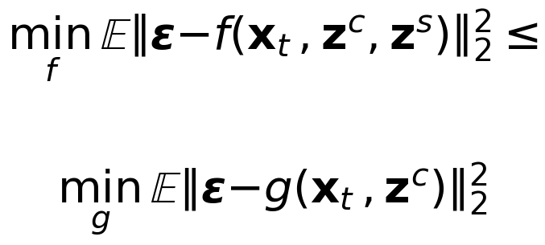 | (20)
Proof sketch. The minimum squared error equals the expected conditional variance. The law of total variance implies E Var(ε|x_t,zᶜ,zˢ) ≤ E Var(ε|x_t,zᶜ). The inequality concerns the optimum; finite-data estimation and low-quality priors can still hurt, which motivates the ablation and stability tests.

4.3 Proposition 1: Semantic Alignment Controls Cross-Environment Representation Discrepancy
Let P_s(H) and P_t(H) be the source- and target-environment distributions of denoised representations, and P_s(A_s), P_t(A_s) the corresponding prior distributions. If the alignment objective ensures E_s‖H−A_s‖≤δ_s and E_t‖H−A_s‖≤δ_t, then the 1-Wasserstein distance obeys the triangle inequality:
(21)
Thus, when semantic priors are more stable than raw graph representations, reducing the alignment errors provides a direct surrogate for reducing source-target representation discrepancy. The result also clarifies why semantic stability must be measured empirically.

4.4 OOD Risk Bound
For a Lipschitz predictor and loss, standard domain adaptation arguments bound target risk by source risk, a representation discrepancy term, and the irreducible joint error [17]. Combining that form with (21) yields the qualitative bound:
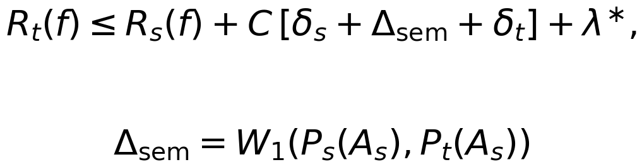 | (22)
The invariant environment objective is intended to reduce the structural part of the discrepancy, while semantic alignment controls the semantic part. The bound does not guarantee strict improvement for every LLM or dataset; it identifies the quantities that the experiments must verify.

5 Experiments

5.1 Research Questions
- RQ1: Does LSCI-DiffRec outperform strong IID, contrastive, robust, causal, diffusion, and LLM-enhanced baselines under multiple OOD shifts?
- RQ2: Does the LLM-derived semantic prior provide information beyond ordinary text encoders and graph embeddings?
- RQ3: Which components—edge invariance, environment inference, semantic conditioning, alignment, and diffusion—are responsible for performance?
- RQ4: Are the learned semantic priors and denoised representations stable across environments?
- RQ5: What are the computational and serving-time costs of the method?

5.2 Datasets and OOD Protocols
To preserve comparability with CausalDiffRec, the primary protocol uses Food for temporal shift, KuaiRec for exposure shift, and Yelp2018 and Douban for popularity shift [10]. The processed statistics below follow the published baseline split and must be rechecked against the final code release before submission.
Dataset | Users | Items | Interactions | Primary Shift
Food | 7,809 | 6,309 | 216,407 | Temporal
KuaiRec | 7,175 | 10,611 | 1,153,797 | Exposure
Yelp2018 | 8,090 | 13,878 | 398,216 | Popularity
Douban | 8,735 | 13,143 | 354,933 | Popularity

Temporal shift uses the most recent interactions as the OOD test set. Popularity shift constructs an approximately uniform item-popularity test distribution while retaining the naturally skewed training distribution. Exposure shift evaluates on a fully exposed or less biased matrix while training on logged platform exposure. Validation and IID test sets are retained to report the OOD–IID trade-off.

5.3 Baselines
- Graph collaborative filtering: LightGCN and NGCF.
- Graph self-supervision: SGL, SimGCL, and LightGCL.
- OOD and debiasing: InvCF, InvPref, AdvDrop/AdvInfoNCE where applicable, and DR-GNN.
- Causal diffusion: CausalDiffRec, the principal baseline.
- LLM-enhanced graph recommendation: InvGCLLM and a simple LLM-feature concatenation baseline.
- Semantic encoder controls: BERT, Sentence-BERT, and the same LLM without the causal prompt.

5.4 Metrics and Implementation Protocol
Report Recall@10/20 and NDCG@10/20 under full-ranking evaluation. Use the same negative-sampling and graph backbone across compatible methods. Hyperparameters should be selected on the validation set rather than the OOD test set. Each experiment should be repeated with at least five random seeds, reporting mean ± standard deviation and a paired significance test against the strongest baseline.
A practical starting configuration is a 64-dimensional LightGCN backbone, K ∈ {2,3,4} environments, diffusion steps T ∈ {50,100,200}, a truncated inference sampler of 10–50 steps, and semantic temperature τ_s ∈ {0.05,0.1,0.2}. The final paper should report the complete search ranges, hardware, LLM version, prompt, tokenizer, caching policy, and token cost.

5.5 Overall Performance
Table 2 is a manuscript template. Numerical cells must be filled only after the implementation is complete.
Method | Food T-N@20 | KuaiRec E-N@20 | Yelp P-N@20 | Douban P-N@20
LightGCN | TBD | TBD | TBD | TBD
SGL | TBD | TBD | TBD | TBD
SimGCL | TBD | TBD | TBD | TBD
InvCF | TBD | TBD | TBD | TBD
DR-GNN | TBD | TBD | TBD | TBD
CausalDiffRec | TBD | TBD | TBD | TBD
InvGCLLM | TBD | TBD | TBD | TBD
LSCI-DiffRec | TBD | TBD | TBD | TBD

5.6 Ablation Study
Variant | Removed / Replaced Component | Question Answered
w/o zˢ | No LLM semantic condition | Is semantic conditioning useful?
w/o L_sem | No semantic contrastive alignment | Is alignment necessary beyond conditioning?
w/o zᶜ | No environment condition | Are semantic priors sufficient alone?
w/o diffusion | Replace denoiser with GNN/MLP | Is generative denoising necessary?
Text concat. | Concatenate semantic vector to graph embedding | Is the gain more than feature augmentation?
w/o invariant scorer | Use the original graph directly | Does stable-history filtering matter?

5.7 Semantic Causal Prior Analysis
Semantic stability is measured by splitting a user history into chronological windows, generating a prior from each window, and averaging cosine similarity between adjacent priors. Compare ID embeddings, BERT, Sentence-BERT, a generic LLM prompt, and the proposed stable-preference prompt. A useful prior should remain stable while still discriminating users with different long-term interests.
Encoder comparison keeps all recommender components fixed and changes only the semantic source. This isolates the contribution of reasoning and prompt design from dimensionality or parameter count. Report OOD metrics, stability, token cost, and latency.

5.8 Intervention and Diffusion Necessity
Compare four reverse-process conditions: zᶜ only, zˢ only, naive concatenation, and the full modulation/attention intervention. Separately replace diffusion with an autoencoder, VAE, or deterministic GNN refiner. These experiments test whether improvement comes from a conditional generative process rather than an additional feature vector.

5.9 Representation Visualization and Case Study
Visualize source and target representations with t-SNE or UMAP, and quantify discrepancy with MMD or Wasserstein distance. Popular and long-tail items, early and recent interactions, or logged and fully exposed interactions should be color-coded. The case study should report the input history, the structured stable-preference summary, the top recommendations, and failure cases. Do not treat a plausible natural-language explanation as causal evidence; use it only as qualitative support.

5.10 Efficiency and Reproducibility
Report preprocessing time, number of LLM calls, average tokens per user/item, cache size, training throughput, inference steps, peak memory, and online latency. The main deployment comparison should distinguish one-time offline semantic generation from per-request serving cost. Release the prompts, cached-prior construction script, data splits, and random seeds.

6 Conclusion
This manuscript proposes LSCI-DiffRec, an LLM-guided semantic causal intervention diffusion framework for OOD recommendation. The method combines edge-level structural invariance, latent environment inference, offline semantic preference priors, and conditional reverse diffusion. Its central design choice is to use the LLM as a source of stable semantic conditions rather than as a direct recommender or graph editor.
The resulting framework preserves collaborative filtering as the ranking mechanism, keeps the standard diffusion forward process, avoids direct MSE collapse between semantic and collaborative spaces, and removes the need for online LLM calls for existing users and items. Theoretical analysis identifies the denoising and domain-discrepancy quantities that semantic conditioning can improve under explicit assumptions.
The next required step is empirical: implement the method, verify semantic stability, complete all ablations, and replace every TBD result with reproducible measurements. Future work may extend semantic intervention to heterogeneous, multimodal, and online recommendation while developing stronger reliability controls for LLM-generated priors.

References
[1] X. He, K. Deng, X. Wang, Y. Li, Y. Zhang, and M. Wang, “LightGCN: Simplifying and Powering Graph Convolution Network for Recommendation,” in Proc. SIGIR, 2020, pp. 639–648.
[2] X. Wang, X. He, M. Wang, F. Feng, and T.-S. Chua, “Neural Graph Collaborative Filtering,” in Proc. SIGIR, 2019, pp. 165–174.
[3] J. Wu, X. Wang, F. Feng, X. He, L. Chen, J. Lian, and X. Xie, “Self-Supervised Graph Learning for Recommendation,” in Proc. SIGIR, 2021, pp. 726–735.
[4] J. Yu, H. Yin, X. Xia, T. Chen, L. Cui, and Q. V. H. Nguyen, “Are Graph Augmentations Necessary? Simple Graph Contrastive Learning for Recommendation,” in Proc. SIGIR, 2022, pp. 1294–1303.
[5] X. Cai, C. Huang, L. Xia, and X. Ren, “LightGCL: Simple Yet Effective Graph Contrastive Learning for Recommendation,” arXiv:2302.08191, 2023.
[6] A. Zhang, J. Zheng, X. Wang, Y. Yuan, and T.-S. Chua, “Invariant Collaborative Filtering to Popularity Distribution Shift,” in Proc. WWW, 2023, pp. 1240–1251.
[7] B. Wang et al., “Distributionally Robust Graph-Based Recommendation System,” in Proc. WWW, 2024, pp. 3777–3788.
[8] W. Wang, X. Lin, F. Feng, X. He, M. Lin, and T.-S. Chua, “Causal Representation Learning for Out-of-Distribution Recommendation,” in Proc. WWW, 2022, pp. 3562–3571.
[9] Z. Wang, Y. He, J. Liu, W. Zou, P. S. Yu, and P. Cui, “Invariant Preference Learning for General Debiasing in Recommendation,” in Proc. KDD, 2022, pp. 1969–1978.
[10] C. Zhao et al., “Graph Representation Learning via Causal Diffusion for Out-of-Distribution Recommendation,” in Proc. WWW, 2025, pp. 334–346.
[11] J. Ho, A. Jain, and P. Abbeel, “Denoising Diffusion Probabilistic Models,” in Advances in Neural Information Processing Systems, 2020.
[12] W. Wang, Y. Xu, F. Feng, X. Lin, X. He, and T.-S. Chua, “Diffusion Recommender Model,” in Proc. SIGIR, 2023, pp. 832–841.
[13] J. Liang et al., “Large Language Model Enhanced Graph Invariant Contrastive Learning for Out-of-Distribution Recommendation,” arXiv:2511.18282, 2025.
[14] W. Wei et al., “LLMRec: Large Language Models with Graph Augmentation for Recommendation,” in Proc. WSDM, 2024, pp. 806–815.
[15] Y. Wang et al., “LLMRG: Improving Recommendations through Large Language Model Reasoning Graphs,” in Proc. AAAI, 2024, pp. 19189–19196.
[16] S. Rendle, C. Freudenthaler, Z. Gantner, and L. Schmidt-Thieme, “BPR: Bayesian Personalized Ranking from Implicit Feedback,” in Proc. UAI, 2009, pp. 452–461.
[17] S. Ben-David et al., “A Theory of Learning from Different Domains,” Machine Learning, vol. 79, pp. 151–175, 2010.
[18] E. Creager, J.-H. Jacobsen, and R. Zemel, “Environment Inference for Invariant Learning,” in Proc. ICML, 2021, pp. 2189–2200.
[19] J. Devlin, M.-W. Chang, K. Lee, and K. Toutanova, “BERT: Pre-Training of Deep Bidirectional Transformers for Language Understanding,” in Proc. NAACL-HLT, 2019.
[20] N. Reimers and I. Gurevych, “Sentence-BERT: Sentence Embeddings Using Siamese BERT-Networks,” in Proc. EMNLP-IJCNLP, 2019.

