EBU6304 Software Engineering Group Project

2025-26
Group number: 013
Member | QM no. | Name | Primary responsibility
member 1 | 231221674 | Dingyi Zhang | Web / Controller — Servlets, URLs, session, filters/listeners, deployment; partial prototype design
member 2 | 231220286 | Kuozhi Guo | GUI — JSP, CSS, page interaction
member 3 | 231221124 | Yuwei Zhang | Business logic — Service layer, rules, algorithms
member 4 | 231221168 | Bingrui Liu | Documentation & requirements — SRS/use cases, PRD, README, reports
member 5 | 231221179 | Zhuoran Wang | Data — models, JSON, Storage, data-file conventions
member 6 | 231220954 | Wenbo Dang | Testing — test cases, execution, regression, acceptance checklist

Final short report
Document structure (per coursework template)
Part | Sections | Page limit
I — Group report | System overview, Design, Implementation, Testing, GenAI | Maximum 10 pages (includes tables, Figure 1, and other diagrams in this part only)
II — Individual contribution | Six members: main contribution + reflective statement each | Not counted in the 10 pages (≤300 words per member, both paragraphs combined)

Part I — Group report (maximum 10 pages)
The subsections below through GenAI form the graded group report. Stop counting pages at the end of GenAI.

System overview and functional description

Purpose
The BUPT International School TA Recruitment System is a lightweight web application that replaces spreadsheet-based TA hiring with a single platform for job posting, applications, screening, communication, and workload oversight. It targets teaching/demo use: Servlet/JSP, JSON file storage, bilingual UI (Chinese/English), and optional AI features that remain explainable and under human control.

Roles and main functions
Role | Main capabilities
TA (applicant) | Register/login; maintain profile and skill tags; upload/edit CV (txt, pdf, docx); browse and filter open jobs; apply once per job; track status (pending → interview → accepted / rejected / cancelled); confirm or reschedule interviews; forum; direct messages; optional AI assistant for CV/process help
MO (module organiser) | Register/login; post/edit/close jobs (course TA, invigilation, events, etc.); view applicants per job with match score, matched skills, and skill gaps; schedule interviews; hire or reject; aggregate match statistics (mean, median, score buckets); messages and forum
Admin | Login; global view of TA workload (accepted assignments per person, avg/min/max, high/low hints); expand per-TA job list; cancel or transfer accepted assignments to balance load (with operational caveat in README)
Visitor | Home, forum read, language switch; sign-in required for apply/post/DM
Cross-cutting: /personal-center role routing; forum; friend links and friend requests; DM with read state; LocaleFilter i18n; session timeout (30 min); password hashing (PasswordUtil).

End-to-end recruitment flow
- MO publishes a job with title, description, type, and required skills.
- TA finds the job, submits an application (optional note).
- MO opens Job applicants: system ranks candidates by match score and lists gaps.
- MO may set interview, then accept or reject; TA responds to interview slots.
- Accepted rows feed admin workload; admin may rebalance assignments.
- All state is persisted in JSON under data/ (no database).

Skill matching and AI-assisted algorithms
Matching supports MO screening (“who fits this job?”) and is implemented in MatchHelper, SkillExtractor, and optionally SemanticMatchService.
Step 1 — Candidate skill set (rule-based extraction)
- Profile skills: tags stored on the applicant record.
- Résumé skills: SkillExtractor scans plain-text CV against the job’s required-skill list using synonym maps (e.g. Java/JDK, Python/py, Communication/沟通) and word-boundary rules (Latin tokens use \b; Chinese phrases use substring match).
- These sets are unioned before scoring.
Step 2 — Rule match score (0–100, default and always available)
- If the job has no required skills → score 100.
- Otherwise: score = (number of required skills found in candidate set / total required) × 100.
- Skill gaps = required skills not present in profile + résumé extraction (shown to MO; not auto-reject).
Step 3 — Optional semantic score (embeddings, off by default)
- When match.semantic.enabled=true and API keys are configured, SemanticMatchService builds text from applicant skills + résumé and from job title/description/skills, calls an OpenAI-compatible embeddings endpoint (Kimi / Qwen / OpenAI per config), and computes cosine similarity → 0–100 via VectorUtil.
- Vectors are cached in data/embeddings.json (keyed by entity id + model) to avoid repeat API cost.
Step 4 — Fusion (hybrid score)
- If semantic score is unavailable → final score = rule score only (fully deterministic, suitable for viva/demo without API).
- If both exist → weighted blend: default 50% rule + 50% semantic; weight shifts to 80% semantic when rule < 30 and semantic > 70 (résumé implies hidden fit), or 20% semantic when rule > 70 and semantic < 30 (trust explicit tags).
- MO UI still shows gaps from rule logic so results stay interpretable.
Step 5 — Ranking and job-level stats
- recommendApplicantsForJob sorts applicants by final score descending.
- computeJobMatchStats gives MO cohort average, median, min/max, score histogram buckets, and top collective gaps/strengths.
Intelligent assistant (separate from match score)
- /assistant uses chat completions (not embeddings) for Q&A and CV wording, guarded by AssistantScopeGuard (recruitment/site topics only). Optional quota/WeChat pay. Documented further under GenAI below.

Functional scope summary
Area | Implemented highlights
Core hiring | Auth, jobs, applications, interview, hire/reject, status tracking
AI / matching | Rule + synonym extraction; optional embedding fusion; explainable gaps
Social | Forum, DM, friends
i18n | zh/en UI toggle
Admin | Workload dashboard and assignment adjustment

Design
We adopted a lightweight three-tier architecture aligned with the coursework constraints (Java Servlet/JSP, no database).
Presentation layer: JSP views and Servlet controllers, organised by role (TA, MO, Admin) and feature (forum, assistant, personal centre). Examples include TAAuthServlet, MODashboardServlet, AdminServlet, and ForumServlet.
Business layer: Service classes encapsulate recruitment rules—ApplicantService, JobService, ApplicationService, MatchHelper, ForumService, MessageService, and the assistant sub-package for LLM integration.
Data layer: A single Storage class persists entities as JSON/text under {webapp}/data/, using Gson and ReentrantReadWriteLock for basic concurrent access safety.
Actors and flows: Teaching Assistants apply for jobs; Module Organisers publish jobs and manage applicants; Administrators view workload and may transfer accepted assignments. Application states include pending, interview, accepted, rejected, and cancelled.
Cross-cutting concerns: AppListener initialises the data directory; LocaleFilter supports bilingual UI; NoStoreSensitivePagesFilter reduces back-button exposure after logout; AssistantConfigListener loads optional AI configuration.
Design principles: Simplicity, modularity, extensibility. Functional behaviour and matching pipelines are summarised in System overview above; architecturally, skill matching defaults to deterministic rules with optional semantic fusion behind the same MO screen. Passwords use salted SHA-256 (PasswordUtil) with legacy hash compatibility.
Patterns used: Layered architecture; Front Controller (Servlet mappings); Service layer; Repository-style Storage; strategy-like switching between rule-based and embedding-based scores; server-side scope guard (AssistantScopeGuard) before external LLM calls.
Figure 1 — System architecture (three-tier + optional AI APIs)
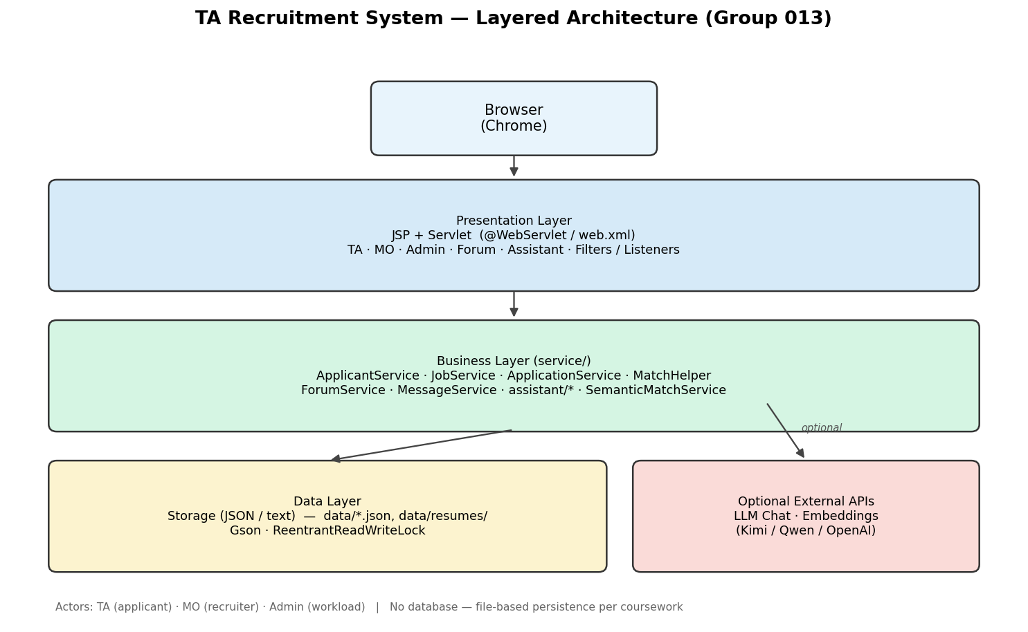
Figure 1: TA Recruitment System architecture

Implementation
Strategy: Incremental delivery over four iterations (Sprints), documented on GitHub with feature branches and pull requests to master.
Iteration | Focus (summary)
v1 / 1.1 | Core TA/MO auth, jobs, applications, JSON persistence
v2.0–2.1 | Forum, DMs, friends, personal centre, assistant (initial)
v2.2 | Mock data for demo and manual testing
v2.3 | Bilingual UI (i18n bundles, LocaleFilter)
v4+ | Admin workload transfer, password salting, resume skill extraction + semantic match fusion
Build: Maven builds ta-recruitment.war (Java 11). Stack: Servlet 4.0, JSP, JSTL, Gson, PDFBox, POI. Run locally with mvn tomcat7:run (port 8082) or deploy WAR to Tomcat webapps/.
Configuration: AI keys and feature flags in assistant.properties or environment variables (ASSISTANT_PROPERTIES_PATH, provider API keys, MATCH_SEMANTIC_ENABLED).
Version control: GitHub is the collaboration hub. Members use named branches and integrate via pull requests. Work was split by layer: data (models/Storage), services (rules and matching), web layer (Servlets, filters, deployment), presentation (JSP/CSS), testing, and documentation—see individual statements below.
Team build plan (agreed division):
Area | Scope | Owner (QM no.)
Web / Controller | Servlets, URL mapping, session, web.xml, filters/listeners, deployment; partial prototype design | Dingyi Zhang (231221674)
GUI | JSP views, css/, bilingual UI and interaction | Kuozhi Guo (231220286)
Business logic | service/*, recruitment rules, skill matching algorithms | Yuwei Zhang (231221124)
Docs & requirements | SRS/use cases, PRD, README, reports, backlog | Bingrui Liu (231221168)
Data | Domain models, JSON persistence, Storage, data/ files | Zhuoran Wang (231221179)
Testing | Test cases, manual/regression runs, pre-release checks | Wenbo Dang (231220954)
Core delivered functions: TA register/login, profile, resume upload (txt/pdf/docx), job browse/apply, application status; MO post/manage jobs, applicant list with match % and skill gaps, hire/reject/interview; Admin workload view and transfer; forum and messaging; optional intelligent assistant and semantic match.

Testing
Strategy: Manual black-box testing with a formal test-case document, suitable for a teaching prototype without a project-wide JUnit suite.
Techniques: Equivalence classes and boundary values for login; positive/negative application paths; file-type validation for resumes; role-based access control; regression after each sprint merge.
Documentation: 助教招聘系统_测试用例文档_v1.docx (detailed cases); 测试用例说明.md (Group 013 summary).
Environment: Windows/macOS, Chrome, Java 11, Maven, Tomcat; persistence via JSON under data/.
Scope: Authentication; role dashboards; job application; personal centre; resume upload/extract/download; forum/social; data persistence.
Example results:
- Login: Valid TA/MO credentials → role dashboard; invalid password → error; empty fields → validation; unauthenticated access to /ta/dashboard → redirect to auth.
- Applications: First apply succeeds; duplicate apply for same job blocked; MO sees applicant with match score and missing skills aligned with MatchHelper.
- Resume: Valid .txt stored under data/resumes/; empty upload rejected; PDF/Word text extraction via ResumeTextExtractor / assistant API.
- Admin: /admin/workload requires admin session; counts match applications.json accepted records.
Limitations: No automated unit tests in repo; limited load/concurrency testing; AI-assisted features need manual verification when enabled.

The use of Generative AI (GenAI)

Development (off-line)
Tools such as Cursor and general LLMs assisted brainstorming, user-story drafting, JSP/CSS snippets, Servlet boilerplate, debugging, and README/PRD writing. All outputs were reviewed and adapted to our package layout (com.bupt.ta), session attributes, and Storage APIs. Team members can explain what AI suggested and how it was changed (required for viva).

Product (runtime)
Feature | Description
Intelligent assistant | /assistant, REST /api/assistant/chat, /api/assistant/extract-resume; providers Kimi/Qwen/OpenAI (OpenAI-compatible)
Skill matching | Rule-based default; optional embeddings via SemanticMatchService
Scope guard | AssistantScopeGuard blocks off-topic/sensitive prompts before upstream calls
Quota / pay | AssistantQuotaService; optional WeChat Native pay—logic remains in Java, not blind model trust

Effectiveness
- Faster UI and documentation iteration.
- Embeddings improve paraphrased skill matching when configured.
- Rule-based matcher remains the explainable baseline for demonstrations.

Limitations
- Models may invent policies or dates → mitigated by scope guard and static UI text.
- Privacy: resume/job text sent to third parties only when chat or semantic match is enabled.
- Non-deterministic scores require human judgment by MO.
- Course demo video must use live operation and human English narration—no post-edited or AI-generated video content.
- Generic AI code often misses session checks or locking—we added Storage locks and role checks in review.
— End of Part I (Group report). The 10-page limit applies to content above this line only. —

Part II — Individual contribution and reflection
Not included in the 10-page group report limit. Each member: maximum 300 words total for Main contribution and Reflective statement combined.

Member 1 — Dingyi Zhang (Web / Controller)
QM no: 231221674
Name: Dingyi Zhang
Main contribution:
Owned the web/controller layer: Servlets under web/ (TA/MO/Admin auth and dashboards, job applicants, forum, assistant APIs), URL design, HttpSession usage, request parameters and JSP forwarding. Configured web.xml, LocaleFilter, NoStoreSensitivePagesFilter, AppListener, and assistant config listeners. Drove deployment and integration (mvn package, Tomcat WAR, port/context troubleshooting) so the team could run a single deployable build. Contributed to low/medium-fidelity prototype ideas aligned with backlog stories.
Reflective statement:
Integration—not individual classes—was often the hardest part (context path, session attributes, filter order). Coordinating with GUI and service owners via GitHub PRs mirrored real Agile handoffs. I improved skills in tracing HTTP flows and documenting URLs for README and demos.

Member 2 — Kuozhi Guo (GUI)
QM no: 231220286
Name: Kuozhi Guo
Main contribution:
Responsible for presentation: JSP pages (ta/, mo/, admin/, forum/, assistant.jsp, home and personal-centre gates), shared css/style.css and assistant styles, and page-level interaction (forms, tabs, tables for applicants and workload). Implemented bilingual UI with JSTL/I18n and language switch links. Ensured role-specific dashboards and error messages are readable and consistent across TA, MO, and Admin journeys.
Reflective statement:
Balancing Chinese and English layouts required early agreement on keys in messages_*.properties. Reusing CSS variables kept the UI cohesive. Feedback from testing (e.g. login validation, mobile-width headers) led to iterative polish before intermediate and final demos.

Member 3 — Yuwei Zhang (Business logic)
QM no: 231221124
Name: Yuwei Zhang
Main contribution:
Led business logic in service/: applicant/job/application flows, MatchHelper and SkillExtractor for rule-based skill match and gap analysis, optional SemanticMatchService, and related helpers (ApplicantService, JobService, ApplicationService, ForumService, MessageService, etc.). Defined application status rules (pending, interview, accepted, rejected, cancelled) and MO hire/reject behaviour. Iterated on resume skill extraction (synonyms, regex boundaries) and integration with matching scores.
Reflective statement:
I learned to keep algorithms explainable for demos while allowing optional AI enhancement. Trade-offs between keyword matching and embeddings were discussed with the team. Debugging cross-service state (e.g. hire → workload) improved my understanding of end-to-end recruitment workflows.

Member 4 — Bingrui Liu (Documentation & requirements)
QM no: 231221168
Name: Bingrui Liu
Main contribution:
Owned documentation and requirements not tied to a single code module: product backlog alignment, docs/PRD.md, SRS/use-case style descriptions, terminology, architecture explanation for reports, README (setup, URLs, data files, assistant config), first/intermediate brief reports, and this final short report structure. Kept written deliverables consistent with implemented scope and coursework constraints (Servlet/JSP, no DB).
Reflective statement:
Requirements drifted as sprints added forum, assistant, and i18n—documentation had to be updated incrementally. Writing for both markers and teammates improved my ability to separate “shall” requirements from nice-to-have features. Supporting the group report and submission packaging taught me release discipline beyond coding.

Member 5 — Zhuoran Wang (Data)
QM no: 231221179
Name: Zhuoran Wang
Main contribution:
Responsible for the data layer: domain classes in model/ (e.g. Applicant, Job, Application), Gson-based JSON persistence in Storage, and conventions for files under data/ (applicants.json, jobs.json, applications.json, forum/messages, resume text files, optional embeddings.json). Implemented read–write locking for safe concurrent access, path helpers (dataPath, resumesPath), and consistency between entity fields and on-disk JSON. Supported other layers by keeping persistence simple and coursework-compliant (no database).
Reflective statement:
Designing file-based storage taught me to think explicitly about schema evolution and backup. The main challenge was avoiding corrupted JSON under parallel requests—solved with locks and clear read/write patterns. I gained confidence in separating persistence from business rules so services stay testable.

Member 6 — Wenbo Dang (Testing)
QM no: 231220954
Name: Wenbo Dang
Main contribution:
Led testing: authored 助教招聘系统_测试用例文档_v1.docx and summary 测试用例说明.md (Group 013). Planned and ran manual black-box tests—login, role access, job apply/duplicate apply, profile and resume upload, forum/social modules, JSON persistence checks. Organised regression after sprint merges (v2.2 mock data, bilingual build). Prepared acceptance-style checklists and pre-release smoke tests for demonstration and viva.
Reflective statement:
Without a mandated JUnit suite, we relied on structured cases and repeatable demo accounts. I learned to trace failures to the right layer (filter vs service vs data). Testing early mock data accelerated MO applicant-list demos and reduced last-minute integration risk.
— End of Part II (Individual contribution). —

