集成RESTful  Service In CodeIgniter

1. download code from：

<https://github.com/chriskacerguis/codeigniter-restserver>

1. 添加code 到codeIgniter上

Mu1/application

|-- library/

|-------Format.php

|-------REST_Controller.php

|--config/

|-------rest.php

|--controllers/

|-------api/

|----------Example.php

|----------Key.php

1. Example.php访问：

http://192.168.50.16/mu1/api/Example/users

| |

Controller Resources

缺省返回的是xml：

<xml>

<item>

<id>1</id>

<name>Some Guy</name>

<email>example1@example.com</email>

</item>

<item>

<id>2</id>

<name>Person Face</name>

<email>example2@example.com</email>

</item>

<item>

<id>3</id>

<name>Scotty</name>

<email>example3@example.com</email>

<fact>

<hobbies>

<hobby>fartings</hobby>

<hobby>bikes</hobby>

</hobbies>

</fact>

</item>

</xml>

如果需要json格式，那么为：

<http://192.168.50.16/mu1/api/Example/users/format/json>

| | |

Controller Resources format：json

返回内容为：

{"0":{"id":1,"name":"Some Guy","email":"example1@example.com"},"1":{"id":2,"name":"Person Face","email":"example2@example.com"},"3":{"id":3,"name":"Scotty","email":"example3@example.com","fact":{"hobbies":["fartings","bikes"]}}}

http://192.168.50.16/mu1/api/Example/user/id/1

Controller Resources parameter

返回结果为：

<xml>

<id>1</id>

<name>Some Guy</name>

<email>example1@example.com</email>

<fact>Loves swimming</fact>

</xml>

需要返回为json：

http://192.168.50.16/mu1/api/Example/user/id/1/format/json

format

Controller Resources parameter

目前支持三种格式：

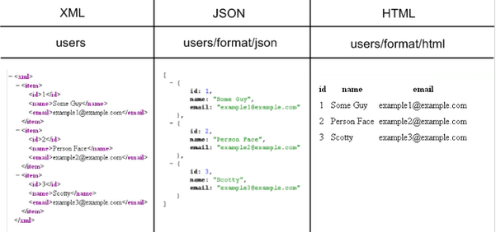

1. 安全
2. 修改config/rest.php

$config['rest_auth'] = 'basic';

2) 访问：

<http://192.168.50.16/mu1/api/Example/users/format/json>

将弹出：

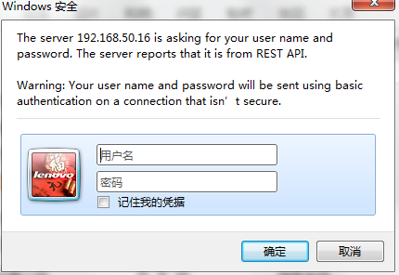

输入用户名：admin， 密码： 1234

发生错误：

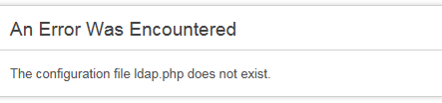

修改

$config['auth_source'] = 'ldap';为

$config['auth_source'] = '';