实验一

软件工程教务4班 张丰露

# 雷劈数：

## 代码：

#include <iostream>

#include <algorithm>

using namespace std;

int main(){

for(int i=2;i<10000;i++){

int square=i*i;

int ten=1;

int deal=0;

while(square!=0){

deal+=(square%10)*ten;

square/=10;

ten*=10;

//if(deal==0)

//continue;

if(deal+square==i){

cout<<i*i<<endl;

break;

}

}

}

return 0;

}

## 运行结果：

共19个雷劈数

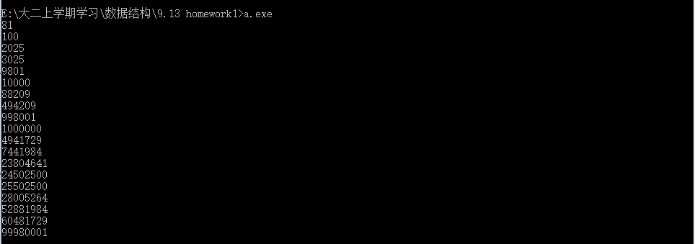

# P2 The magic square

## 1.

### 代码：

#include <iostream>

#include <algorithm>

using namespace std;

const int maxn=10000;

int s[maxn][maxn]={};

int main(){

cout<<"Please set the length of the square(must be integer and less than 10000):";

int n=0;

cin>>n;

for(int i=0;i<n;i++){

for(int j=0;j<n;j++){

cin>>s[i][j];

}

}

int aim=-1;

bool ok=true;

for(int i=0;i<n;i++){

int temp1=0;

int temp2=0;

for(int j=0;j<n;j++){

temp1+=s[i][j];

temp2+=s[j][i];

}

if(i==0){

aim=temp1;

if(temp1!=temp2){

ok=false;

break;

}

}

else{

if(temp1!=aim || temp2!=aim){

ok=false;

break;

}

}

}

if(ok){

int temp1=0;

int temp2=0;

for(int i=0;i<n;i++){

temp1+=s[i][i];

temp2+=s[n-i-1][i];

}

if(temp1!=aim || temp2!=aim)

ok=false;

}

if(ok)

cout<<"Yes\n";

else

cout<<"No\n";

return 0;

}

### 运行结果：

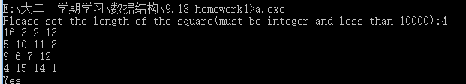

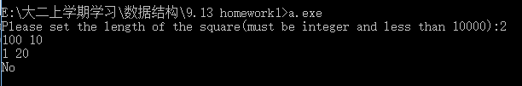

## 2.

### 代码：

#include <iostream>

#include <algorithm>

using namespace std;

const int maxn=10000;

int s[maxn][maxn]={};

int main(){

int n=0;

cout<<"Please input the length of the square(must be an odd integer and less than 9999):";

cin>>n;

int aim=n*n;

int now=1;

int x=0;

int y=n/2;

while(now<=aim){

if(x<0){

x+=n;

}

if(y<0){

y+=n;

}

if(x>=n){

x-=n;

}

if(y>=n){

y-=n;

}

if(s[x][y]==0){

s[x][y]=now;

x--;

y++;

now++;

}

else{

//cout<<now<<endl;

x++;

y--;

x++;

}

}

for(int i=0;i<n;i++){

for(int j=0;j<n;j++){

cout<<s[i][j]<<" ";

}

cout<<endl;

}

return 0;

}

### 运行结果：

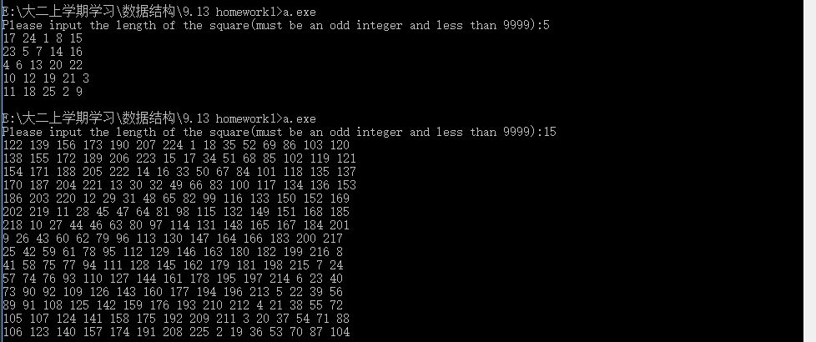

# P3

## 代码：

#include <iostream>

#include <algorithm>

using namespace std;

int mp[]={0,31,28,31,30,31,30,31,31,30,31,30,31};

int mr[]={0,31,29,31,30,31,30,31,31,30,31,30,31};

int main(){

int y=0;

cout<<"Please input the current year:";

cin>>y;

cout<<"Year:"<<y<<endl;

int isrun=0;

if(y%4==0 && y%100!=0)

isrun=1;

else if(y%400==0){

isrun=1;

}

for(int i=1;i<=12;i++){

cout<<"Month:"<<i<<endl;

int maxday=0;

if(isrun){

maxday=mp[i];

}

else{

maxday=mr[i];

}

for(int j=1;j<=maxday;j++){

cout<<j<<" ";

if(j%7==0)

cout<<endl;

}

cout<<endl;

}

return 0;

}

## 运行结果：

