1. Rancher

|  |
| --- |
| <https://www.rancher.cn/> |



|  |
| --- |
| sudo docker run -d --restart=unless-stopped -p 80:80 -p 443:443 -v <主机路径>:/var/lib/rancher/ rancher/rancher:stable |

本地

|  |
| --- |
| sudo docker run -d --restart=unless-stopped -p 5001:80 -p 5003:443 -v /home/deployer/zhanggf/jar/rancher:/var/lib/rancher/ rancher/rancher:stable |

2.

2.1

访问 <https://ip>:port



2.2



Named cluster

3.问题

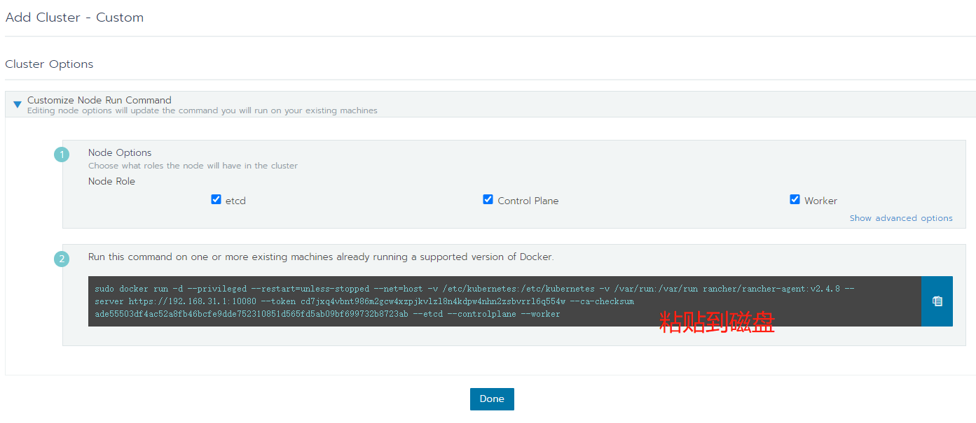

<https://192.168.31.3:9031/g/clusters>

|  |
| --- |
| [controlPlane] Failed to upgrade Control Plane: [[[controlplane] Error getting node 01b16304: "01b16304" not found]] |

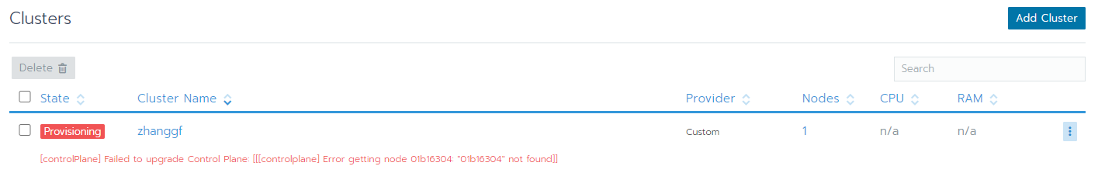

<https://192.168.31.1:10080/g/clusters>

|  |
| --- |
| [etcd] Failed to bring up Etcd Plane: etcd cluster is unhealthy: hosts [192.168.31.1] failed to report healthy. Check etcd container logs on each host for more information |

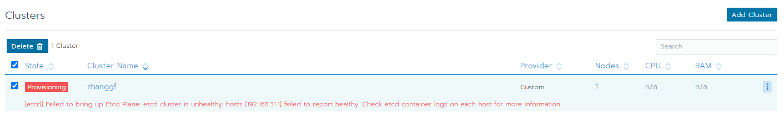

4.由于不正宗的搭建方式，不打算继续探究问题解决方式。