Step 1:
Follow this document:
https://docs.microsoft.com/en-us/dynamics365/commerce/dev-itpro/consume-retail-server-api
to create :
- App registration for the Retail Server
- Create the app registration for the client
- Add a client secret
- In Commerce Headquarters, go to Retail and Commerce > Headquarters setup > Parameters > Commerce shared parameters.
2. Step 2:

3. Create console application, set
<appSettings>
<add key="aadClientId" value="****-7097-***-81ba-****" />
<add key="aadClientSecret" value=".j******** " />
<add key="aadAuthority" value="https://sts.windows.net/***/" />
<add key="retailServerUrl" value="https://pu*****devret.cloudax.dynamics.com/Commerce" />
<add key="resource" value="api://***" />
<!-- //Application ID URI generated during the Retail Server app registration -->
<add key="operatingUnitNumber" value="128" />
</appSettings>
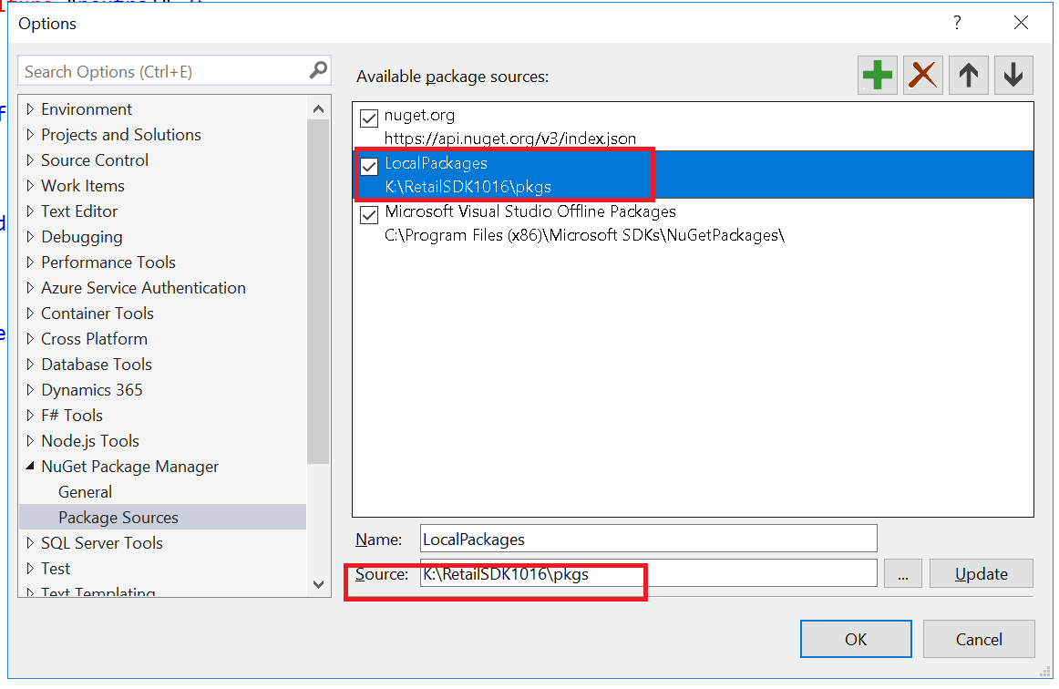

3. Add nugget package reference:
- Microsoft.IdentityModel.Clients.ActiveDirectory
- Microsoft.Dynamics.Commerce.RetailProxy

4. Run the code, you can call retail server from external application, such
GetOrderHistort,.
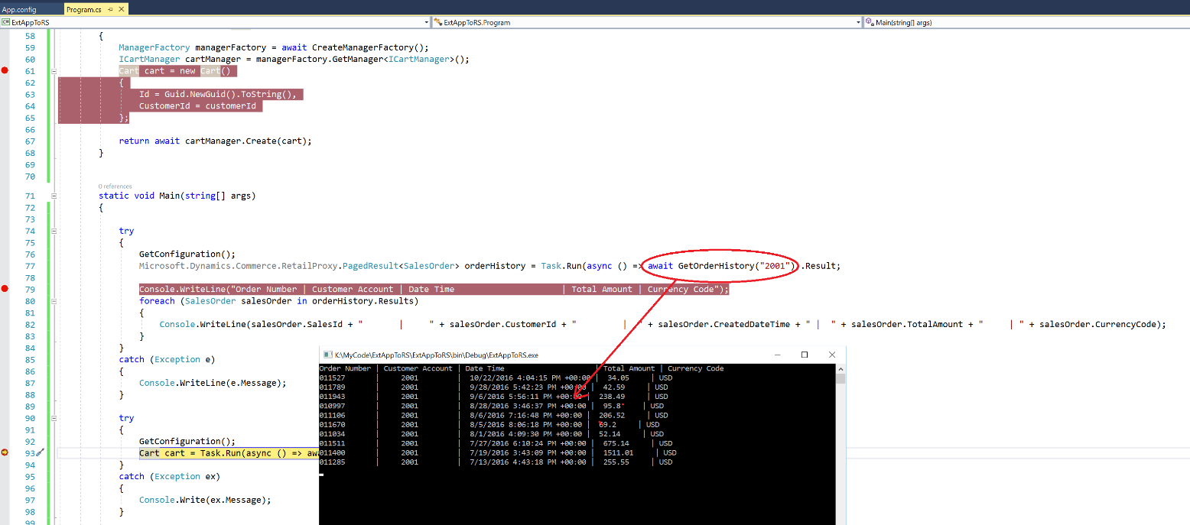

Create Cart etc.
