Table of Content
PART 1 1
1.XML Database 1
1.1 Description of case: 1
1.2 Description of selected entities: 2
1.3 The files that involve the development and analysis of the XML DATABASE are following: 3
PART 2 (Neo4j 4.1.3) 3
1. ﻿Graph Database Modelling 3
2. ﻿Import Data 4
3. Query: 5
﻿3.1 comparing the output of SQL queries with the output of queries.cypher: 5
3.2 additional Cypher queries 10
3.3 Graph Similarity algorithm 17

PART 1

1.XML Database

1.1 Description of case:
To accomplish with current assignment requirement we should update previous assignment’s case and to take under consideration a weak entity in the new graph. The updated case description is according to following ( Changes were made in paragraph 2 and 3):

1)A parking car company belongs to many parking sites in Sydney, they require to collect data from their operations in order to improve their service and assess, and according to many factors. Every car parking location has a denomination (NAME), an address, and a specific number of car spots (COUNTPARKINGSPACE) which can be updated according to availability of them (SURPLUSPARKINGSPACE) during a day. Every location manages specific fee rates (HOURLYPRICE) which also makes the distinction of the type of service. In addition the car parking company can provide service for cars and trucks where it is required to register the number of seats (SEATS) and load capacity (LOADCAPACITY).

2)Once a car moves into the car parking, a process is activated (CARPASS) that registers (PAASNo) to identify it. Every parking location has a specific set of PASSNo assigned, therefore, they are exclusively per each location and are assigned, when a car enter to the parking building and it is released when cars leave it . In addition, the CARPASS process records car’s information related entry (RECORDIN) and exit (RECORDOUT). On both stages information of the time, of entry (INTIME) and time of exit (OUTTIME), are also recorded, however in the time of entry they record the time and date of this transaction (TIMEIN and DAYIN). The attribute of payment (MONEY) is also recorded in the last stage.

3)The next process is the record of Car’s information (REGISTRATION) which is made manually by 4 employees in every parking building and , besides every car’s information they also record the parking spot location. After that, they enter these information and a registration number (REGID) is issued .

4)The information of cars (CARINFO), should include car number (CARNO), owner’s name (OWNERNAME) , owner’s phone information (OWNERPHONE) and type of car (TYPE) which record the kind of service the car is being provided and register the expiring date (CUTOFF) of this type. We should consider that FEERULES depend on the type of car , location and time they spend into the building car.
In this case, once a car enters to the car parking a new (CARPASS) is issued , therefore, the clients record is taken per each entry.
The EER related is as following:

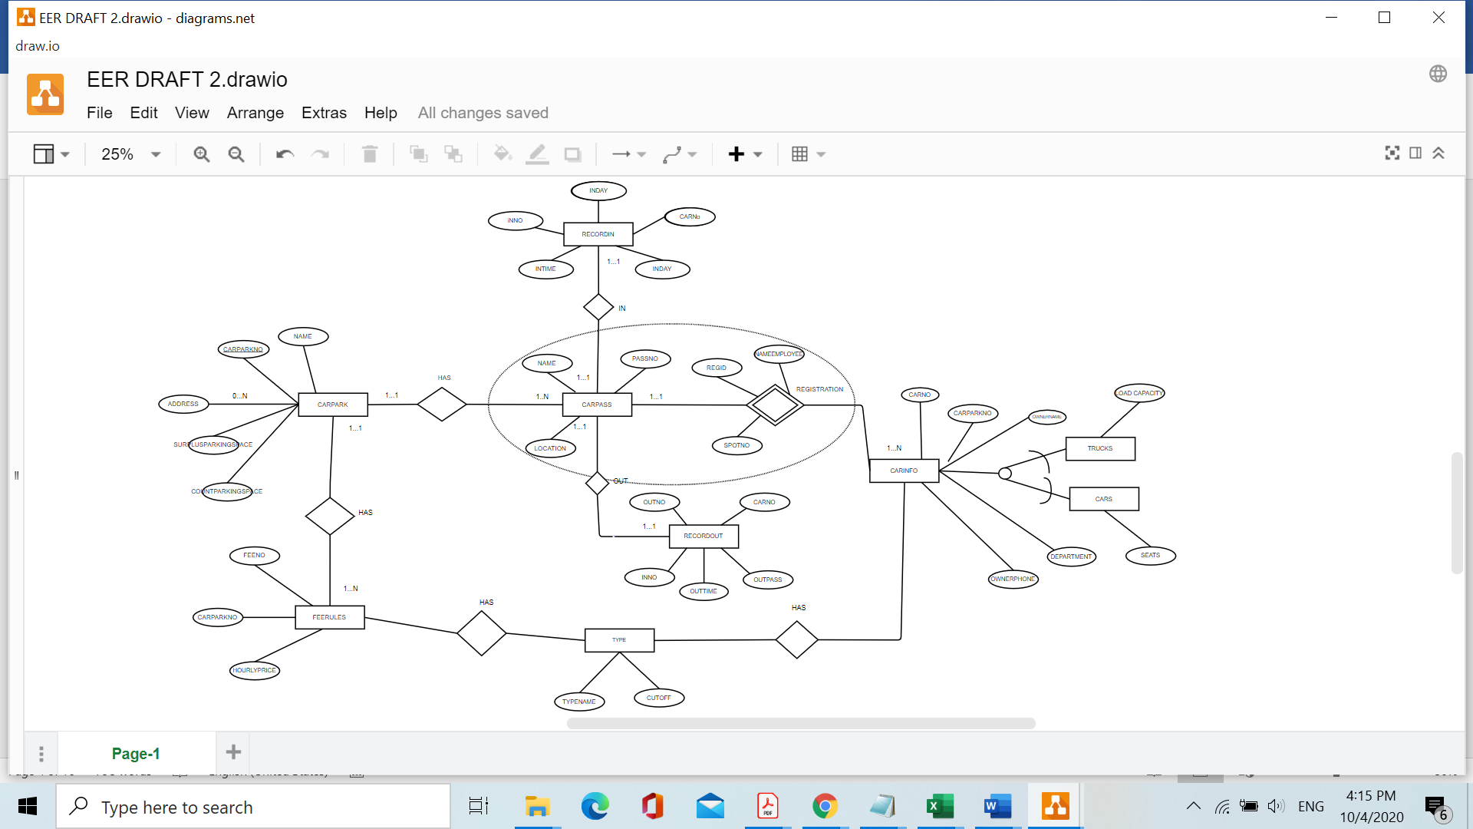

1.2 Description of selected entities:

The chosen entities are CARPASS and REGISTRATION( In prior assignment’s case this last entity was called through)
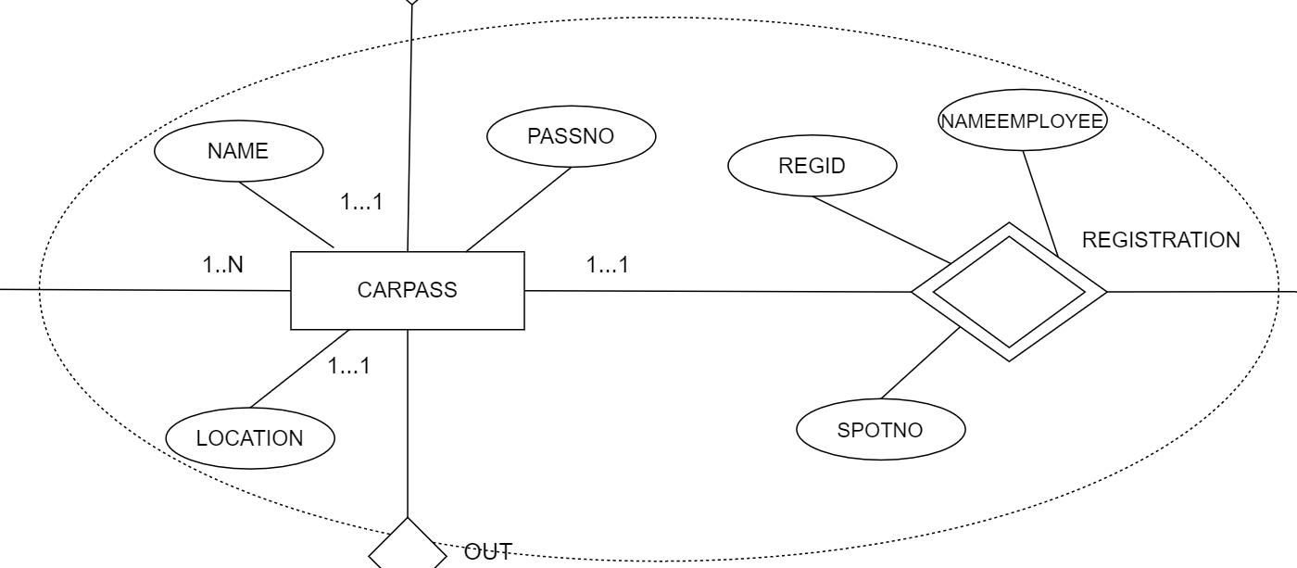

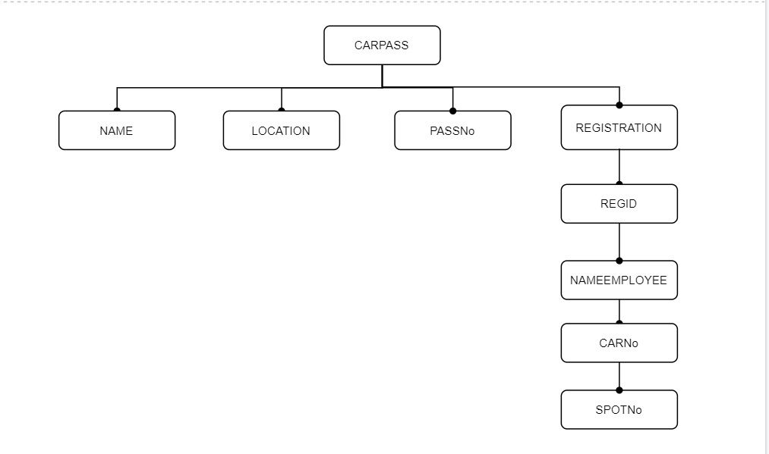

1.3 The files that involve the development and analysis of the XML DATABASE are following:

- my_xml.XML
- my_schema.XSD
- my_xml-valid-DTD
- my_xml-valid-XSD

And following queries :

- insert.xq
- delete.xq
- query 1.xq
- query 2.xq
- query 3.xq
- query 4.xq
- query 5.xq

PART 2 (Neo4j 4.1.3)

1. ﻿Graph Database Modelling

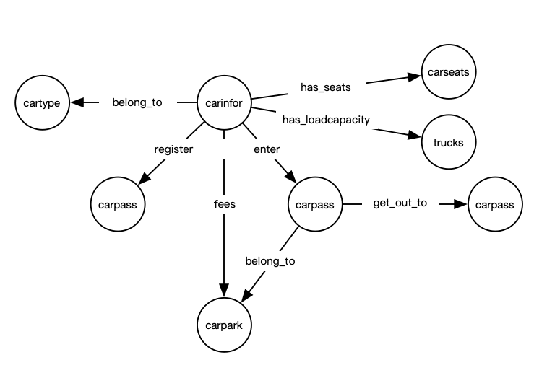

2. ﻿Import Data

﻿Importing relational data from .csv files into Neo4j database (including scripts for creating nodes
and relationships), and creating indexes (Refer to the import.cypher).
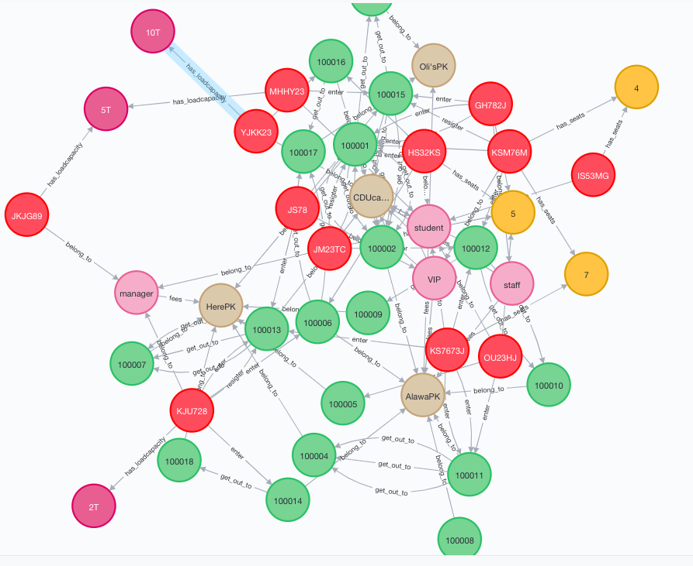

3. Query:

﻿3.1 comparing the output of SQL queries with the output of queries.cypher:

Find out how much money the cars spent on and the day that went out to the parking pass between May 2, 2020, and July 5, 2020
SQL:
select money
from recordout
where outday between '2020/05/02' and '2020/07/05’;
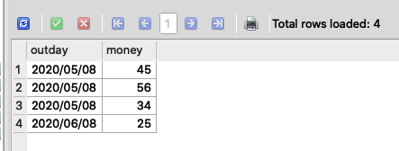
Cypher:
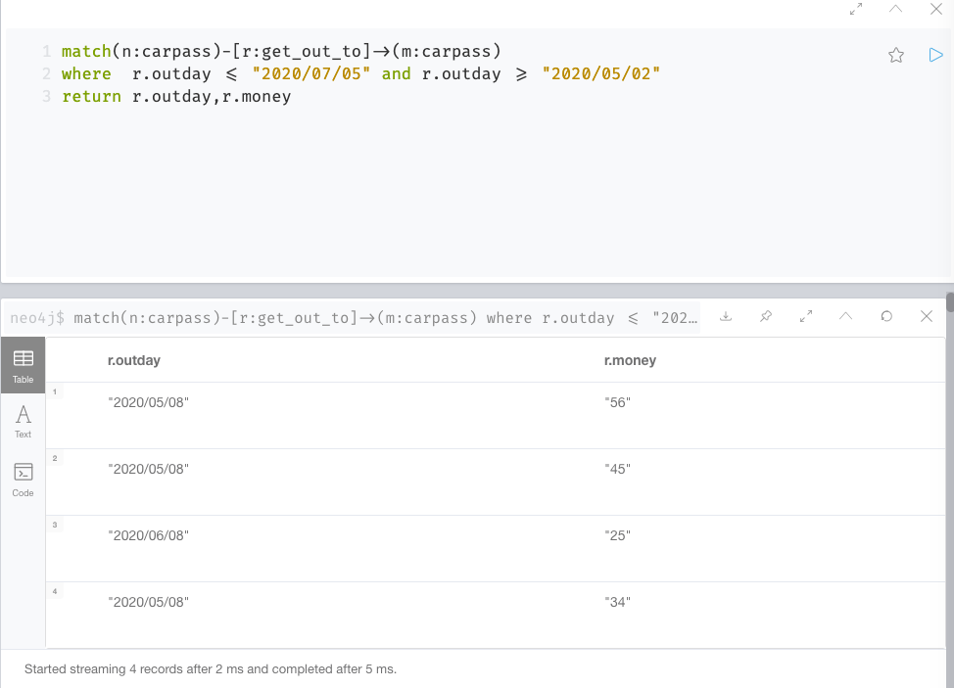

Query the owner name and pass number of all vehicles entered the pass
SQL:
select cf.ownerName,ri.inPass
from recordin ri left join
carinfo cf on ri.carNo=cf.CarNo ;
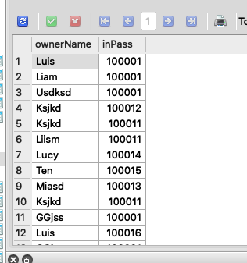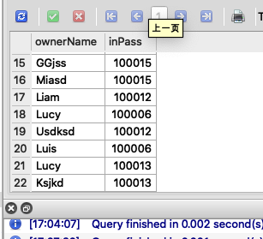

Cypher:
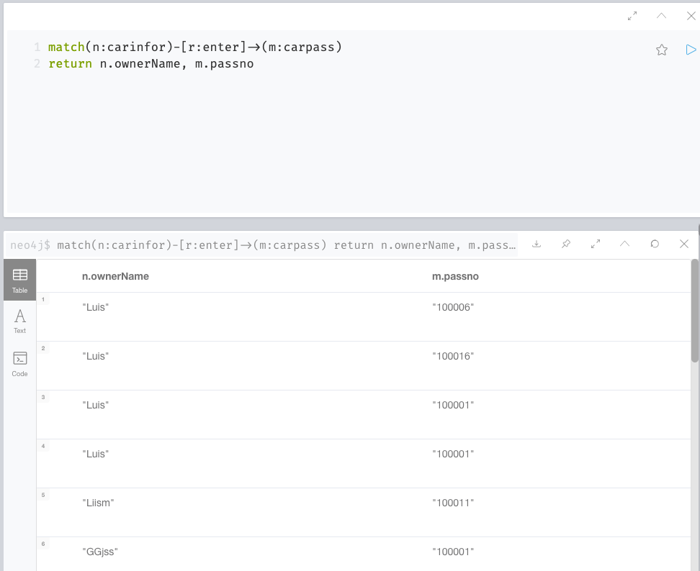
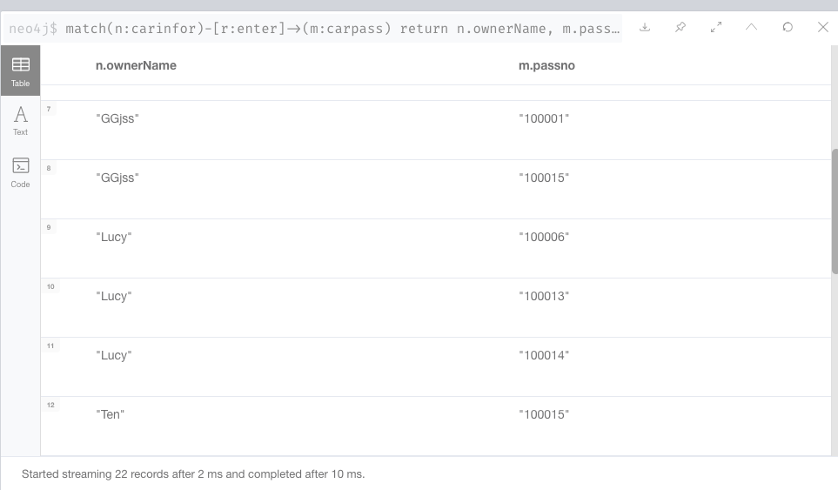
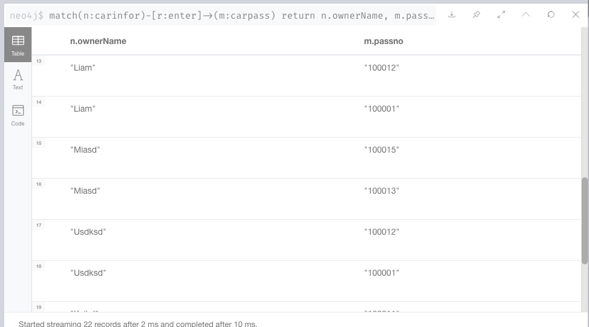
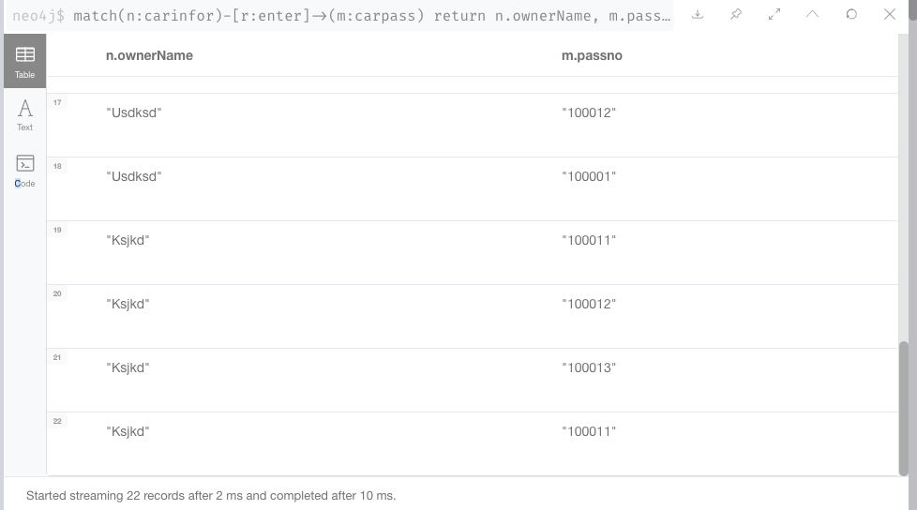

Query all cars entering the channel between April 2, 2020 and April 5, 2020
SQL:
select * from carinfo
where carno in
(
select carno
from recordin
where inday between '2020/04/02' and '2020/04/05'
);
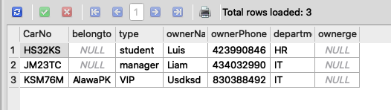

Cypher:
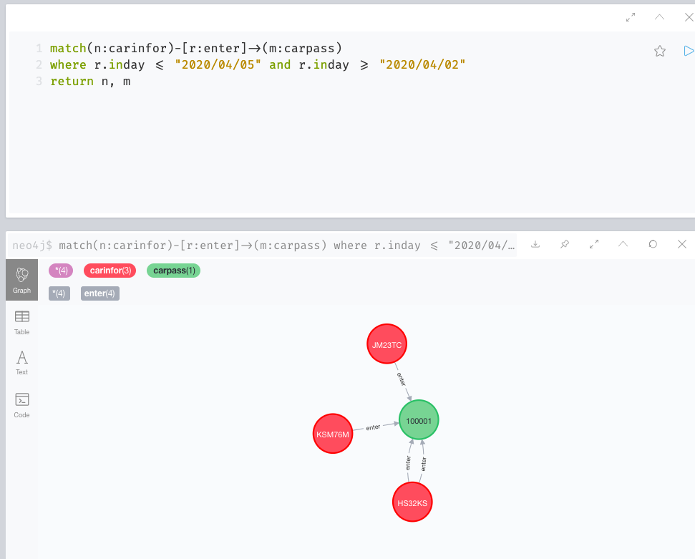

3.2 additional Cypher queries

a. Search vehicle information whose type is ‘student’
MATCH (n:carinfor) WHERE n.type="student"
RETURN n
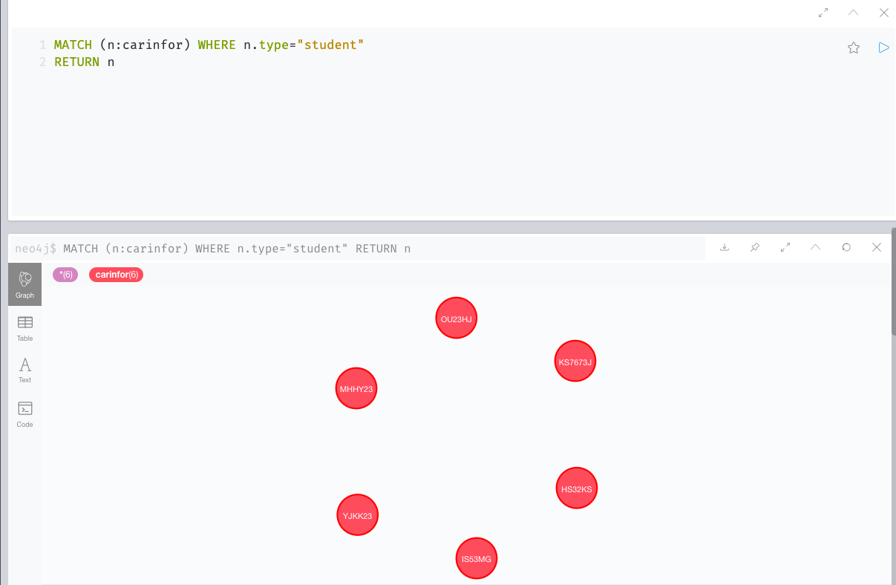

b. Use “limit”
Find the cars which enter the carpasses including their car park:
MATCH (ci:carinfor)-[rel:enter]->(cp:carpass)-[rel2:belong_to]->(p:carpark)
RETURN ci, rel, cp, rel2, p LIMIT 25;

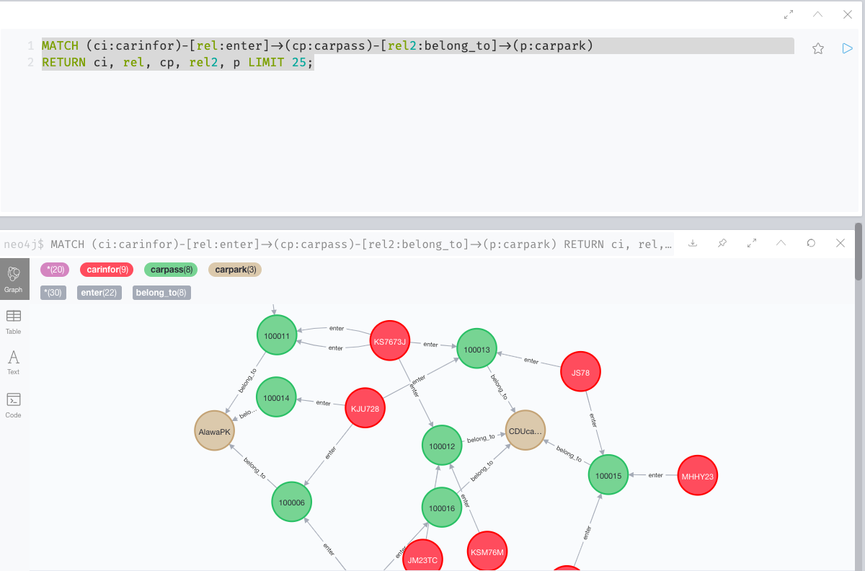

C. Use “Count”
Count which car park have the most traffic coming in
MATCH (carinfor)-[:enter]->(carpass)-[:belong_to]->(other:carpark)
RETURN other.name as otherpark, count(distinct carpass) as count;
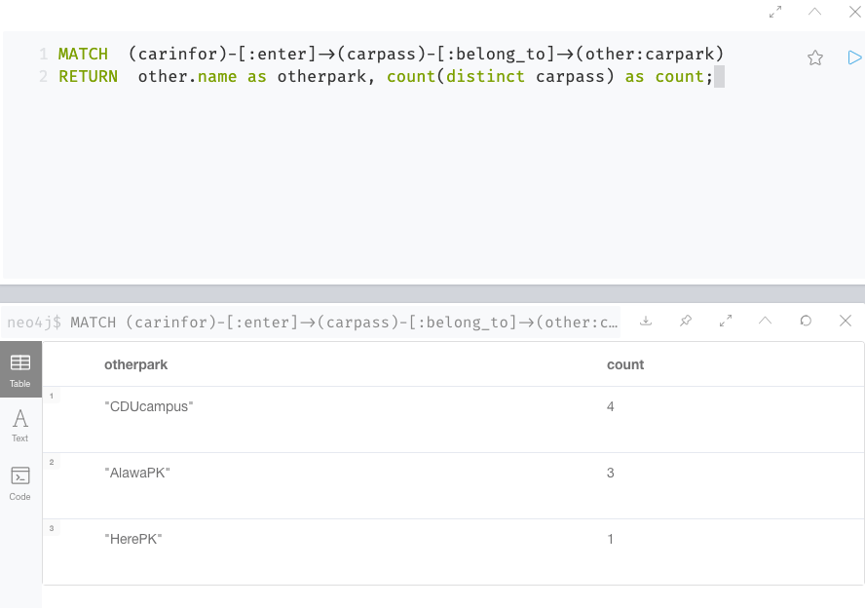

Looks like CDUcampus was the busiest.

D. Use Regular expression
Find out the license plate starts with K and entered the west car pass before 9:30.

match (cinfor: carinfor)-[r:enter]->(cpass: carpass)
where cinfor.CarNo=~"K.+" and cpass.position= "west" and r.intime<"9:30"
return cinfor,r,cpass
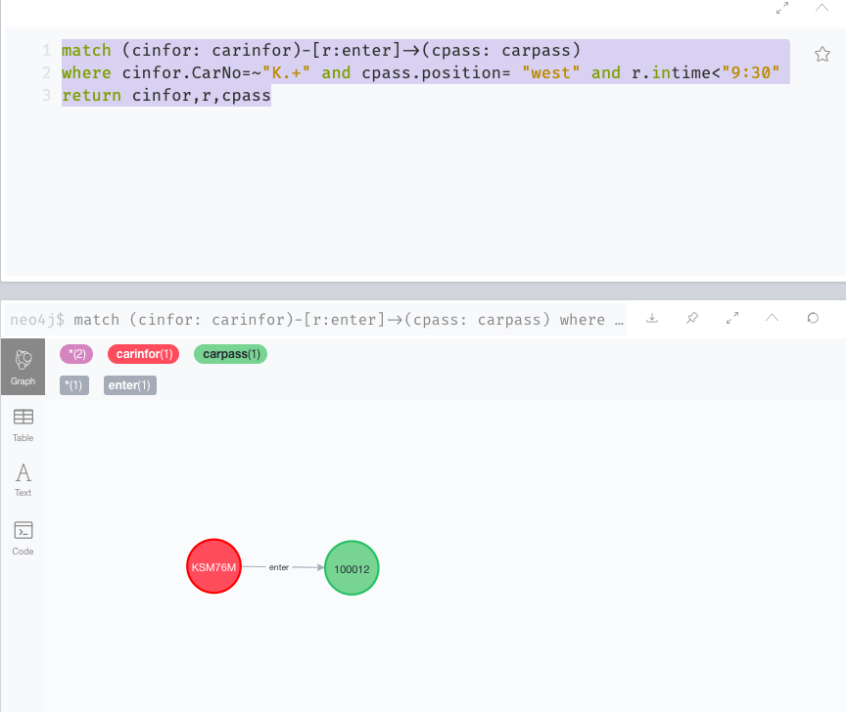

E. Use “with”
Query the vehicle information starting with the word “K” that has entered the CARPASS more than three times

MATCH (carinfor)-[:enter]-(carpass)
WHERE carinfor.CarNo =~ 'K.*'
WITH carinfor, count(carpass) AS in
WHERE in > 3
RETURN carinfor
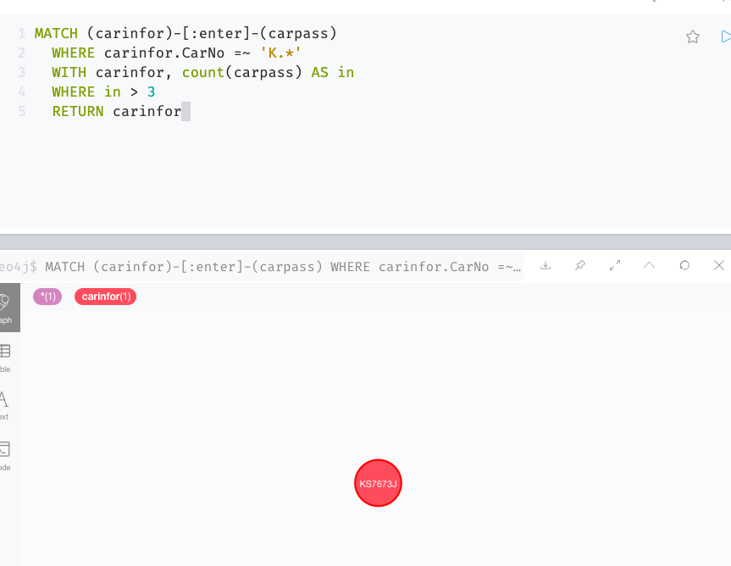

F. Zero length paths
Returns the type itself as well as cars and car parks one relationship away
MATCH (students:cartype { cartype:'student'}) - [*0..1]- (x)
RETURN x
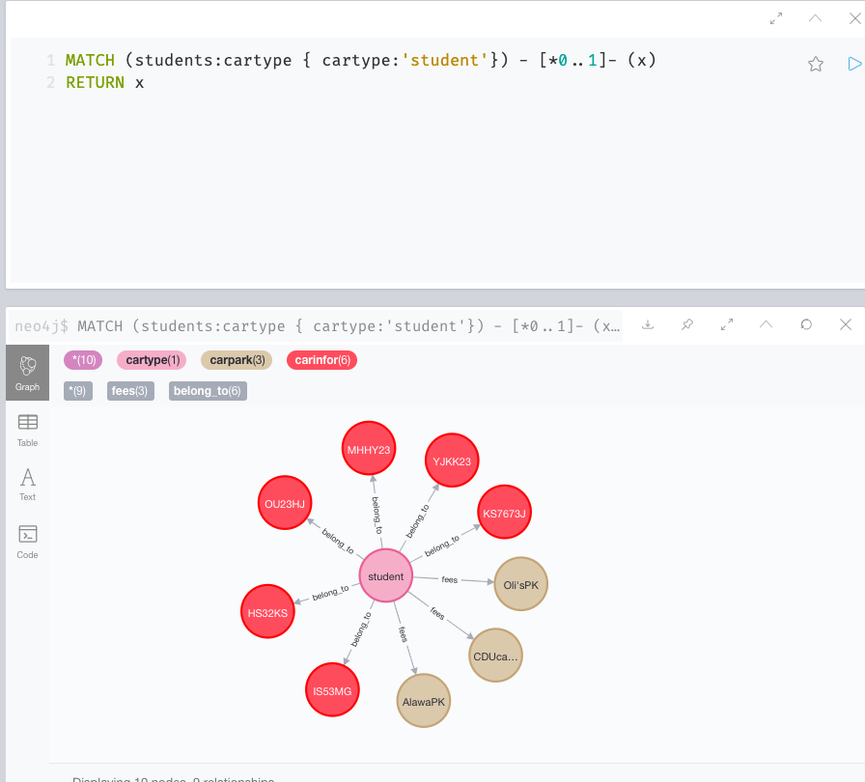

G. OPTIONAL MATCH

MATCH (cinfo:carinfor {CarNo:'JKJG89'})
OPTIONAL MATCH (cinfo)-[r:enter]->()
RETURN r
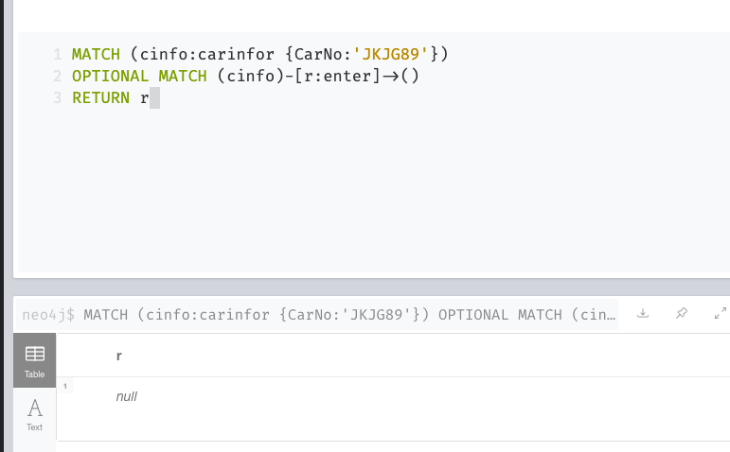

The null relationship is returned because the car does not enter any Carpass

3.3 Graph Similarity algorithm

Jaccard Similarity:

The following will return the Jaccard Similarity of car “KS7673J” and “GH782J”:

MATCH (c1:carinfor {CarNo: 'KS7673J'})-[:enter]->(carpass1)
WITH c1, collect(id(carpass1)) AS c1Carpass
MATCH (c2:carinfor {CarNo: "OU23HJ"})-[:enter]->(carpass2)
WITH c1, c1Carpass, c2, collect(id(carpass2)) AS c2Carpass
RETURN c1.CarNo AS from,
c2.CarNo AS to,
gds.alpha.similarity.jaccard(c1Carpass, c2Carpass) AS similarity
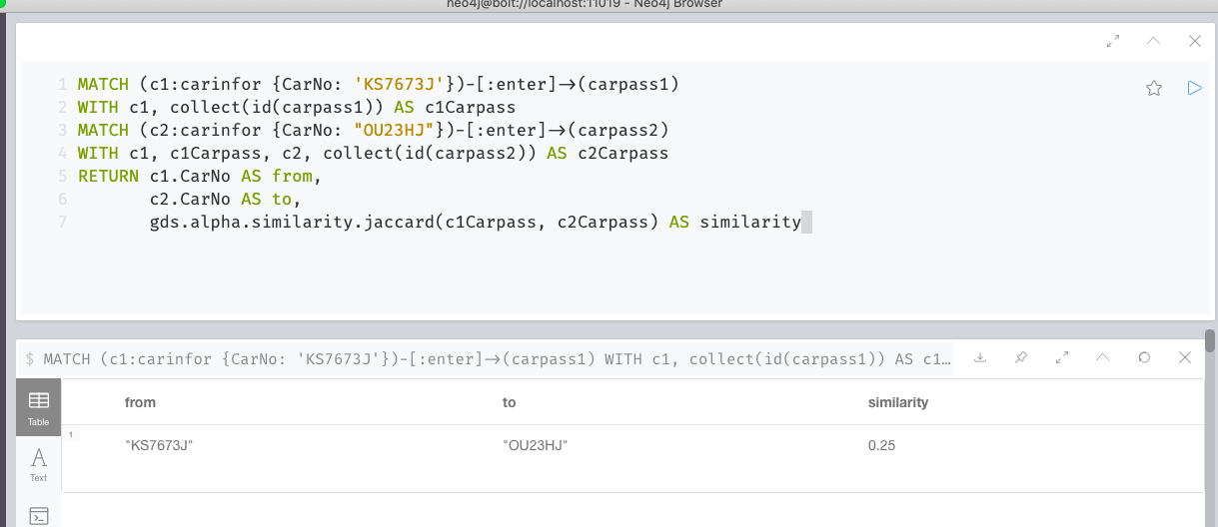

The following will return the Jaccard Similarity of car “KS7673J” and the other car that enter a carpass in common:

MATCH (c1:carinfor {CarNo: 'KS7673J'})-[:enter]->(carpass1)
WITH c1, collect(id(carpass1)) AS c1Carpass
MATCH (c2:carinfor)-[:enter]->(carpass2) where c1<>c2
WITH c1, c1Carpass, c2, collect(id(carpass2)) AS c2Carpass
RETURN c1.CarNo AS from,
c2.CarNo AS to,
gds.alpha.similarity.jaccard(c1Carpass, c2Carpass) AS similarity
ORDER BY to, similarity DESC
