CS325

Guangyu Zhang

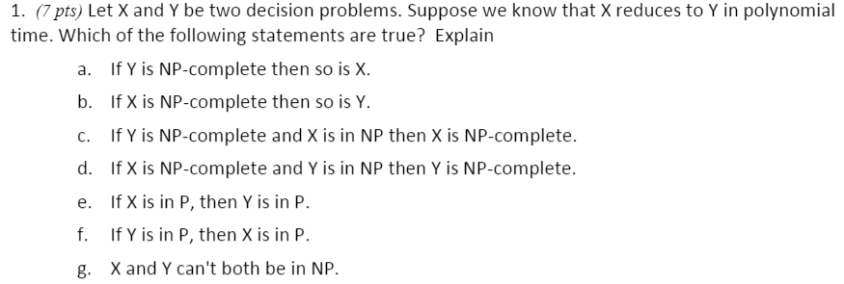

Since X reduces to Y in polynomial time, X is subset of Y.

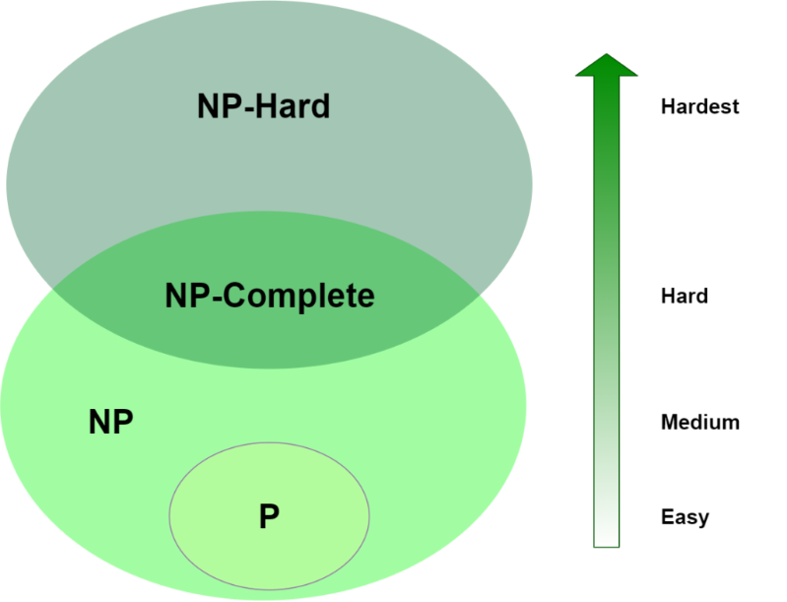

Ref: <https://www.baeldung.com/cs/p-np-np-complete-np-hard>

a).

False. If Y is NP-complete, X can be NP-complete or NP.

b).

False. If X is NP-complete, Y can be NP-complete or HP-hard.

c).

False. If Y is NP-complete, X in NP, X can be NP-complete or NP.

d).

True. If X is NP-complete, Y in NP, Y can only be NP-complete.

e).

False. If X in P, Y can be P or NP.

f).

True. If Y in P, X can only be P.

g).

False. X is subset of Y, so X, Y can both in NP.

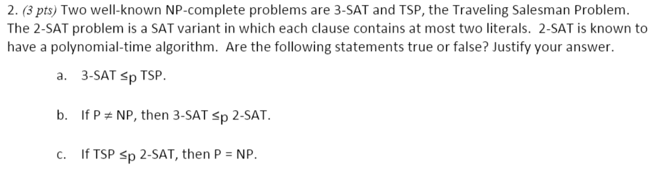a).

True. Since 3-SAT and TSP are NP-complete problem. If 3-SAT can be solved in polynomial time, TSP can also be solved in polynomial time.

b).

False. Since 3-SAT is NP-complete, and 2-SAT is in P, and P is not equal to NP, 3-SAT does not have a polynomial time.

c).

True. Since 2-SAT can be solved in polynomial time, and if TSP which is NP-complete can be solved in polynomial time, P=NP. Thus, proved.

The graphs shows the HAM-PATH and HAM-CYCLE. Since HAM-PATH go through all vertices only once, it can be solved in polynomial time. So, HAM-PATH is in NP. Then, assume there is a point $a$ that has an edge to the start point, and a point $b$ that has an edge to the end point in HAM-CYCLE, the HAM-CYCLE can be reduced to HAM-PATH in polynomial time because it only adds some points and edges. Therefore, HAM-CYCLE is subset of HAM-PATH. And since HAM-CYCLE is NP-complete, and HAM-PATH is in NP, HAM-PATH is NP-complete.

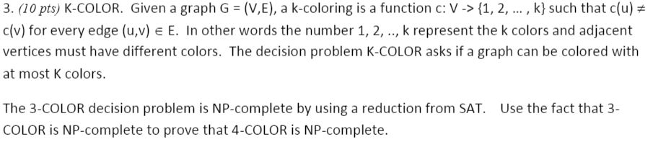

Since 4-COLOR colors every vertex only once, it can be solved in polynomial time by changing some colors to satisfy 4-COLOR. So, 4-COLOR is in NP. Then, 3-COLOR can be reduced to 4-COLOR in polynomial time by changing some colors, here, assume we change half of blue point to green point. Therefore, since 4-COLOR reduces to 3-COLOR, 4-COLOR is subset of 3-COLOR, and 4-COLOR is in NP, 4-COLOR is NP-complete.

4-color

3-color