**Foundation**

原文链接：<https://x.com/cookiedotfun/status/1899856991323091427>

Previous acts of the Cookie DAO vision established how and why we are creating a decentralised and indefinitely scalable data layer, which DeFAI and the automated (AI) crypto economy will build upon. We laid out the infrastructure we are building to achieve this vision and how every part of our tech constitutes a building block of our ecosystem.

In this Act, we focus on the next element inherent to making the Cookie DAO ecosystem work and build in a decentralized way: ensuring continuity of the organization so that it can continue to build and scale while rewarding those who contribute to creating our data layer in line with the InfoFi philosophy.

To enable this, the $COOKIE token operates as the backbone of Cookie DAO's infrastructure, permeating every component of the ecosystem and being a binding force across all elements of the Cookie DAO. It is the gatekeeper to the Cookie DAO products and platforms, and the carrier of value that Cookie DAO’s data layer has.

**In this Act, we cover everything related to the $COOKIE token, from its utilities through technical infrastructure to tokenomics.**

**Core Utilities**

Serving as the carrier of value of information within the crypto economy, the $COOKIE token has numerous utilities throughout the ecosystem.

**Together the utilities create a coherent InfoFi economy, where:**

(i) the $COOKIE token rewards those who contribute data to the ecosystem, powering our Cookie DataSwarm and Cookie Deep Research engines, building the largest and indefinitely scalable crypto data layer for the AI-driven economy.

Data contribution can take a direct or indirect form:

* Direct: directly contributing data to the Cookie Data Layer, by providing databases or allowing Cookie Data Crawlers to tap into information sources (such as TG groups) to look for data.
* Indirect: indirectly contributing to the data layer by being active on X and creating viral posts that generate smart engagement. This allows the Cookie DataSwarm to understand better what content and viewpoints get high attention, hence allowing it to weigh better and filter the content used and presented in the Cookie Deep Research. [More will be revealed in act four of the Cookie DAO vision].

Both direct and indirect ways of contributing data to the Cookie Data Layer, result in contributors being rewarded with $COOKIE.

(ii) The $COOKIE token is used to exchange access to information available through the Cookie DAO’s data layer.

(iii) The $COOKIE token can lock value contributed by those who support the ecosystem long term and reward them for their support.

(iv) $COOKIE is regularly burnt to ensure a deflationary supply.

(v) $COOKIE is a governance token, regulating the operations of the Cookie DAO in line with the Constitution.

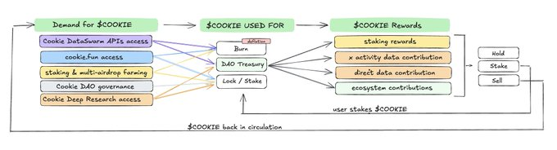

**1. $COOKIE as means for exchange for the information & data access**

**a) cookie.fun premium access**

Cookie.fun is the first index of AI Agents, DeFAI, and soon all crypto projects that integrate onchain and social data metrics for more informed and data-driven decisions. (The full infrastructure of cookie.fun has been described in previous acts.)

$COOKIE plays a crucial role as the information gatekeeper within the cookie.fun ecosystem.

Currently, cookie.fun implements an early access and subscription model for access to the premium, more data-rich version of cookie.fun. Users who wish to access the premium version need to lock 10,000 $COOKIE in a smart contract. Access is granted until a user initiates unbonding of the locked $COOKIE.

The current model is an early pricing version and as the platform develops further a new pricing structure will be introduced, including:

* **subscription tiers with different data depth access**
* **slow burn mechanism on $COOKIE locked in access pools**
* **pay-for-use subscription models that require spending $COOKIE for access (with an in-built fiat to crypto ramp)**

This model introduces $COOKIE as the carrier of value cookie.fun users derive from using the platform’s premium data, while the burn mechanisms ensure the deflationary supply of the token.

**b) Cookie DataSwarm APIs access**

The Cookie DataSwarm represents a significant advancement in market intelligence infrastructure, requiring sophisticated access control to manage its processing capabilities. Projects accessing these capabilities through the DataSwarm APIs participate in a straightforward system requiring $499 to $5,000 monthly in $COOKIE, depending on an API subscription tier chosen.

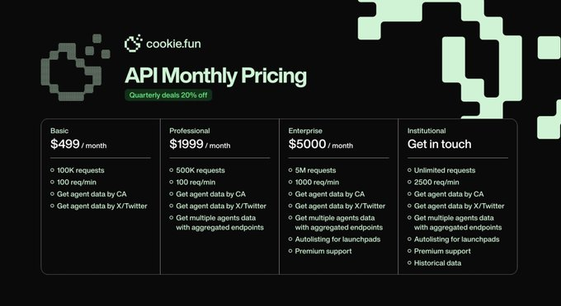

The DataSwarm API access system creates two parallel effects. From the monthly API access:

* 50% flows to the DAO Treasury to support continued infrastructure development, engineering, and technical maintenance;
* the other 50% is burned, continuously reducing the total circulating supply.

Once a significant number of projects integrate Cookie DataSwarm APIs, burns will start happening regularly, monthly. To prevent significant moves around the $COOKIE token before the burn, the Cookie DAO Chef’s Council will initiate the burn and announce it straight after it has happened.

This model ensures a deflationary supply of $COOKIE, while subscriptions paid in the $COOKIE token further contribute to its role as the carrier for the value of information that can be accessed via the Cookie DAO’s Data Layer.

**c) Agent Cookie Terminal & Deep Research access**

Agent Cookie represents autonomous intelligence powered by comprehensive data infrastructure. The terminal integrating Cookie Deep Research enables interaction with crypto intelligence that implements sophisticated access management that balances resource availability with system performance.

$COOKIE will enable access to the terminal's and deep research advanced features, where users can directly engage with Agent Cookie's intelligence and research from within cookie.fun. Users will need to first lock $COOKIE and then $COOKIE tokens will be spent as credits to access the Agent Cookie Swarm’s collective intelligence & deep research.

1. **$COOKIE as long-term ecosystem supporter rewards token: Staking and Multi-Airdrop Farming**

To show their support for the ecosystem and what Cookie DAO is building, our community member show their support and faith in the ecosystem by locking their $COOKIE tokens in a staking contract.

**By staking, users receive two benefits:**

**(i) staking rewards** → users receive additional rewards in $COOKIE token depending on the amount and time they have decided to lock their tokens for. The longer and the higher the amounts locked, the larger the support and stronger the faith in the project’s future. Hence, higher rewards are generated for higher and longer stakes.

**(ii) access to Multi-Airdrop Farming** → due to the strategic partnership between Cookie DAO and Cookie3 based around both companies’ mission to build a data layer and empower data-driven decision making in crypto, $COOKIE stakers get access to airdrops from projects that are benefiting from Cookie3 tools and join their Growth Partner Program. Projects that join the program dedicate part of their token supply to an airdrop aimed at $COOKIE stakers. To participate in such an airdrop, stakers must complete several tasks determined by the project (such as Twitter follow or RT) and lock additional $COOKIE in the farming pool. Stakers participating in Multi-Airdrop Farming can claim their airdrop in line with the official partner project’s schedule.

Full information and rules related to Multi-Airdrop Farming can be found here.

1. **$COOKIE as rewards for data and ecosystem contributors**

Our vision is to create an indefinitely scalable data layer, feeding off multiple private and public data sources delivered by independent decentralised contributors. In its early phase, the Cookie DAO data layer is being built together with core contributors from Cookie3, but in the future, an infrastructure will be put in place that will enable an indefinite number of independent contributors to build this data layer. Contributions to the ecosystem will be done by providing access to new data sources to enrich the data layer, or building data gathering, analytics, and processing solutions for the Cookie DAO to enhance our data layer. On top of data contributors, a data-accuracy validation layer will also need to be put in place to ensure that data processed and added to the data layer is fully accurate and fault-free.

**Contributors to the data layer or general infrastructure of the Cookie DAO Ecosystem will receive $COOKIE rewards for their contribution paid from DAO Treasury, where $COOKIE from users that use the token to access Cookie DAO services are partially directed. This will create a sustainable circular economy where those building and enriching the ecosystem are rewarded for their work.**

Data contribution can take a direct or indirect form:

* **Direct:** directly contributing data to the Cookie Data Layer, by providing databases or allowing Cookie Data Crawlers to tap into information sources (such as TG groups) to look for data.
* **Indirect:** indirectly contributing to the data layer by being active on X and creating viral posts that generate smart engagement. This allows the Cookie DataSwarm to understand better what content and viewpoints get high attention, hence allowing it to weigh better and filter the content used and presented in the Cookie Deep Research. [More will be revealed in act four of the Cookie DAO vision].

Other contributions to the ecosystem might involve (these are not live yet but there will be a process put in place this year):

* community moderation
* bug detection
* content contribution
* content translations
* features building
* and more.

Both direct and indirect ways of contributing data to the Cookie Data Layer as well as other contributions result in contributors being rewarded with $COOKIE.

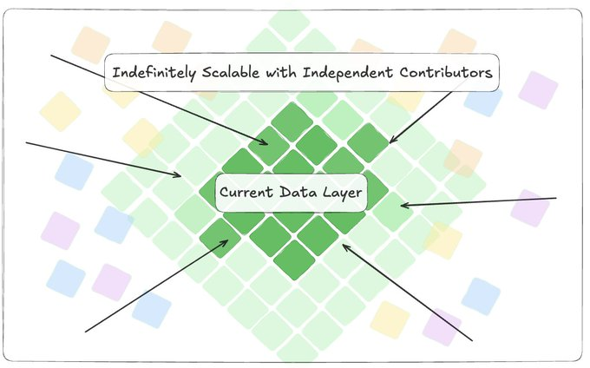

The full roadmap for a deep learning decntralized Cookie DAO data layer will be laid out in the last Act (Act Four) of the Cookie DAO Vision.

**4. $COOKIE as the Governance Token**

Cookie DAO's infrastructure requires coordinated development input to ensure optimal evolution. Through $COOKIE, the community participates directly in this process. Token holders engage in proposal voting and treasury management decisions, helping guide infrastructure development in alignment with ecosystem needs.

In line with the Cookie DAO Constitution, which was passed on Sunday, February 16th, 2025, with over 99% votes in favor of adopting the Constitution, the Chef's Council establishes a representative body that oversees daily operations. For major decisions and announcements, a proposal will be submitted, and a vote will be held across $COOKIE stakers, where 1 $COOKIE staked = 1 vote. This creates additional token utility while ensuring engaged community governance.

This governance system will scale naturally with increased participation, as more governance activity leads to more tokens being actively used in the ecosystem.

**Technical Infrastructure**

**Token Ticker:** $COOKIE

**Contract Address:** 0xc0041ef357b183448b235a8ea73ce4e4ec8c265f

**Chains supported**（撰写本文时）：币安智能链（BNB）、Base (at the time of writing): Binance Smart Chain (BNB), Base

**TGE:** June 13th 2024

The $COOKIE token represents an advanced implementation of the ERC20 standard, enhanced with cross-chain capabilities through LayerZero's Omnichain Fungible Token (OFT) protocol. This implementation facilitates seamless token operations across multiple blockchain networks through a sophisticated dual-contract architecture. The system incorporates gasless token approvals via Permit functionality and leverages LayerZero's V2 protocol for secure cross-chain message passing.

**Technical Architecture**

**Core Components**

The token system consists of two primary smart contracts that work in tandem to enable cross-chain functionality. The main $COOKIE contract is the primary token contract, while the OmnichainToken contract facilitates cross-chain representations.

The Cookie contract extends the standard ERC20 implementation by incorporating OpenZeppelin's Ownable pattern and LayerZero's OFT protocol. It maintains an initial supply of 100,000,000 tokens with 18 decimal places, following the ERC20 standard. The contract's constructor accepts parameters for token name, symbol, initial supply, LayerZero endpoint address, and delegate address.

Upon deployment, it automatically minted the initial supply to the deployer's address, with the amount adjusted for decimal places through multiplication by 10^18.

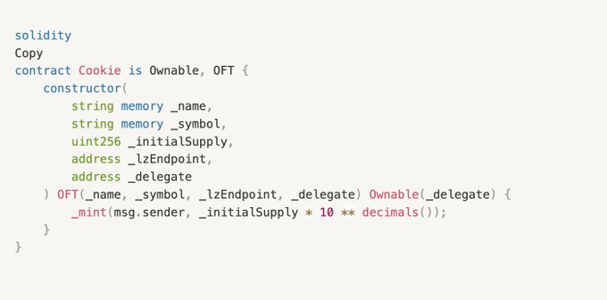

The OmnichainToken contract mirrors the inheritance structure of the main contract but operates without initial supply minting. This contract serves as the cross-chain representation of the token, maintaining synchronized balances across different networks through LayerZero's messaging protocol.

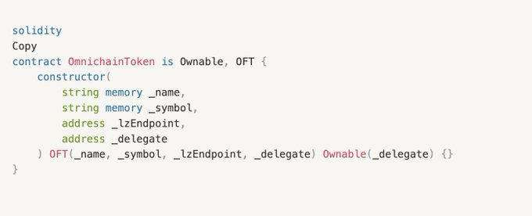

**Cross-Chain Infrastructure**

The implementation utilizes LayerZero V2 protocol for cross-chain communication, with specific endpoint integrations on both Sepolia (0x6EDCE65403992e310A62460808c4b910D972f10f) and Base Sepolia networks. The system employs unique network identifiers, with Sepolia assigned EID 40161 and Base Sepolia assigned EID 40245.

The bridging mechanism implements a sophisticated message passing system through LayerZero's Ultra Light Node protocol. Cross-chain transactions are constructed using a standardized parameter structure that includes the target network EID, recipient address (zero-padded to 32 bytes), token amounts, and execution options. The system handles gas management automatically, calculating native fees and implementing a default gas limit of 2,000,000 units, with executor options configured for 200,000 gas units.

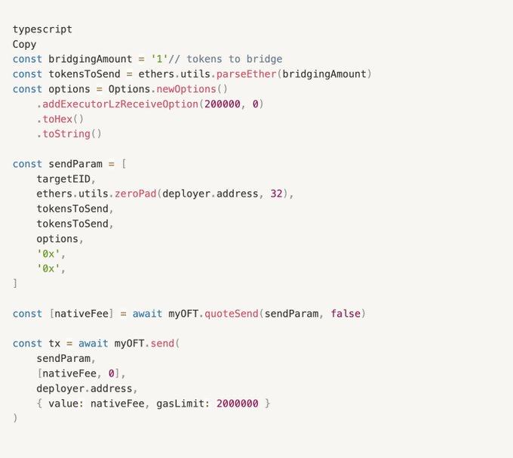

**Security Architecture**

The security framework implements a multi-layered approach to access control and transaction safety. Access management utilizes OpenZeppelin's Ownable pattern with delegated administration capabilities, initially configured with the delegate address 0xD74b911C89aeE02637D4b9B3C8D9bB9CE30a4389. The implementation leverages Solidity version 0.8.22's built-in overflow protection and incorporates comprehensive transaction verification mechanisms for cross-chain messages.

Contract optimization employs the Foundry framework for compilation and testing, ensuring gas efficiency and operational reliability. The system includes a specialized mock contract (MyOFTMock) for testing scenarios, enabling controlled validation of token functionalities:

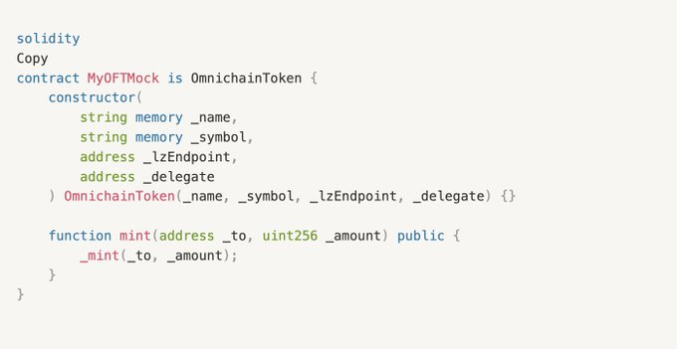

**Network Deployment Structure**

The deployment architecture spans two networks with distinct contract implementations. On Base Sepolia, the primary $COOKIE contract is deployed at address 0x6367235AbFCc7f49F9efD3cB0e31186e86d64224, handling initial supply and core token operations. The Sepolia network hosts the OmnichainToken contract at address 0xCdF494D472c0Fe908488164ed2A73A2f42D549F2, managing cross-chain representations and bridge operations.

The deployment configuration is maintained in a structured JSON format:

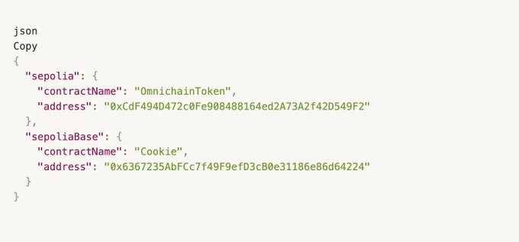

Network communication implements bidirectional bridging with automatic peer verification and native fee management. The system integrates directly with LayerZero endpoints on each network, ensuring secure and reliable cross-chain message delivery.

**Development Infrastructure**

The development environment employs a comprehensive toolchain centered around pnpm for package management, with Foundry handling compilation and testing operations. The deployment process utilizes Hardhat with specialized LayerZero plugins, supported by architecture-specific tools including @nomicfoundation/edr-darwin-arm64 for MacOS deployments.

Testing infrastructure incorporates a specialized mock implementation that extends the OmnichainToken contract with additional minting capabilities for testing purposes. The testing framework utilizes Foundry's robust testing capabilities, enabling comprehensive validation of both standard token operations and cross-chain functionalities.

The deployment process follows a structured approach, beginning with environment configuration through .env setup, followed by network selection and deployer account initialization. The complete deployment workflow was executed through the following commands:

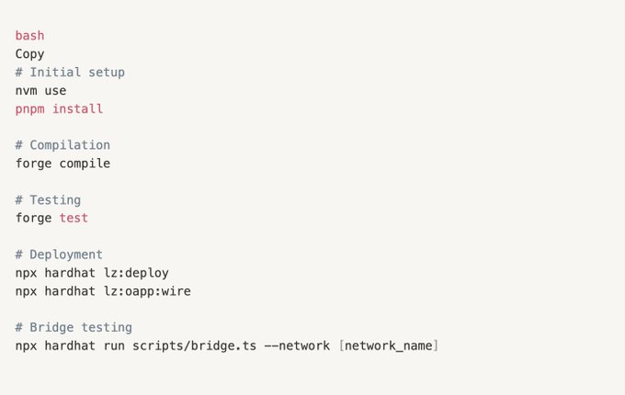

The $COOKIE token implementation represents a sophisticated approach to cross-chain token operations, leveraging advanced blockchain interoperability through LayerZero V2 technology. The dual-contract architecture ensures consistent token economics and security guarantees across networks, while comprehensive testing infrastructure and deployment processes maintain system reliability and operational efficiency. This implementation sets a high standard for cross-chain token operations, combining security, efficiency, and usability in a robust technical framework.

Staking

The $COOKIE staking contract is provided and powered by Decubate for seamless operation. The contract and tech operate entirely on Decubate’s systems and standards.

**Tokenomics**

The $COOKIE token tokenomics have been designed to fuel the entire ecosystem. The present distribution and token allocations are a result of 3+ years of building our data layer in stealth with support from early backers and contributors.

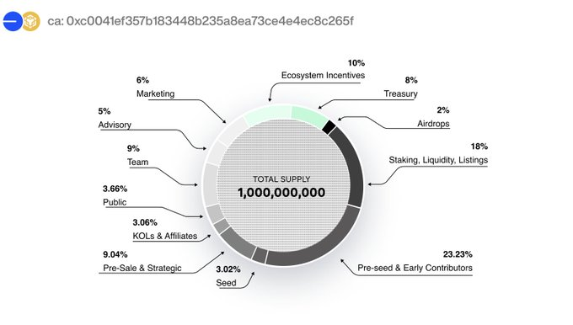

**The total supply of the $COOKIE token in 1B $COOKIE.**

**I: Ecosystem Incentives**

TGE: 0% - Cliff: 1m - Vesting: 35 months

10% of the $COOKIE supply is reserved for ecosystem incentives, which will empower the growth of Cookie DAO’s data layer and be used to incentives anyone who is building and participating in the Cookie Ecosystem.

**II: Treasury**

TGE: 0% - Cliff: 12 months - Vesting: 36 months

8% of $COOKIE is going straight to the Cookie DAO Treasury to empower the community and provide enough resources for shaping its future.

**III: Airdrops**

TGE: 20% or 4 months of vesting

Airdrops will reward users building & support of the Cookie ecosystem.

**IV: Staking, Liquidity, Listings**

TGE: 18% - Vesting: Locked Until Required

18% of the $COOKIE supply has been put aside to ensure there that every person interested in joining the Cookie ecosystem has access to $COOKIE.

**V-VIII: Pre-seed & Early Contributors, Seed, Strategic**

TGE: 2-3%, Cliff: 4-6 months, Vesting: 8-14 months

$COOKIE tokens have been allocated to early contributors, investors, and VCs.

**IX: KOLs & Affiliates**

TGE: 10% - Cliff: 1 month - Vesting: 7 months

To spread the word across the Web3 space and establish proper awareness of $COOKIE and the Cookie DAO, 2.04% of the total supply has been allocated for a round targeting key opinion leaders (KOLs) and promoters of the project.

**X: Public**

TGE: 12.5% - Cliff: 1 month - Vesting: 6 months

$COOKIE token launched in June 2024, with a public pre-sale round conducted in the week prior to listing on Polkastarter and ChainGPT Pad, as well as an IDO on Bybit.

**XI: Team**

TGE: 0% - Cliff: 12 months - Vesting: 24 months

The core team building the Cookie DAO is partially remunerated in $COOKIE token to ensure their dedication to the project.

**XII: Advisory**

TGE: 0% - Cliff: 9 months - Vesting: 27 months

$COOKIE is being used to remunerate advisors building the Cookie DAO and its ecosystem.

**XIII: Marketing**

TGE: 0% - Cliff: 12 months - Vesting: 24 months

7% of the $COOKIE supply had been put aside to fuel marketing activities.

**Path Forward**

The $COOKIE token serves as the essential utility mechanism that enables Cookie DAO's infrastructure operation. From powering market intelligence through cookie.fun to enabling data processing via the DataSwarm APIs to facilitating autonomous operations through Agent Cookie, the token implements straightforward utility that grows naturally with the ecosystem.

Our systematic development demonstrates how proper infrastructure access mechanisms enable increasingly sophisticated autonomous operations. Through contributor rewards, sustainable growth mechanisms, and clear utility implementation, the token exists purely to power and expand the technical foundation necessary for the agentic economy's growth.

The technical foundation exists. The utility mechanisms function. The infrastructure continues evolving.