# 小区车辆出入登记系统详细设计

## 一．具体类图

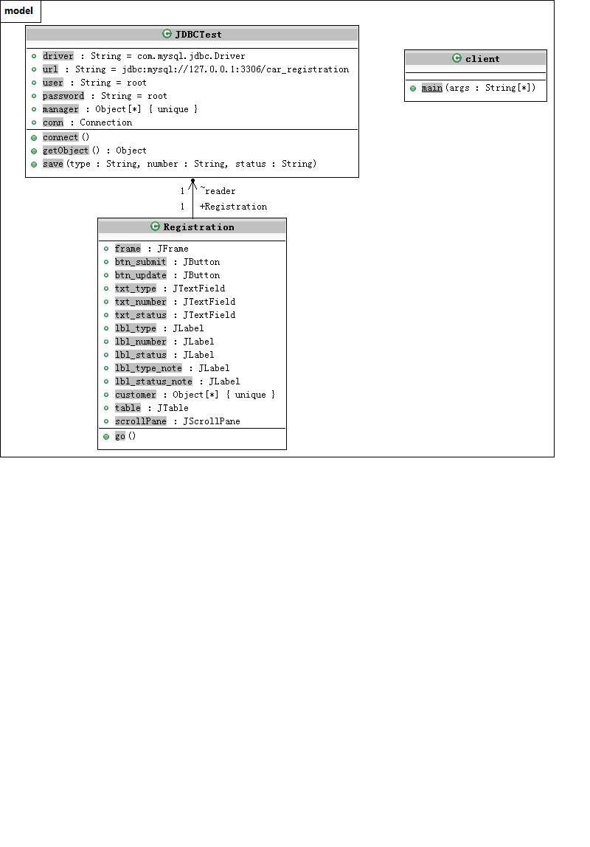

## 二．详细代码

import java.awt.*;

import java.awt.event.ActionEvent;

import java.awt.event.ActionListener;

import java.sql.SQLException;

import javax.swing.*;

import javax.swing.table.DefaultTableModel;

public class Registration{

private JFrame frame;

private JButton btn_submit;

private JButton btn_update;

private JTextField txt_type;

private JTextField txt_number;

private JTextField txt_status;

private JLabel lbl_type;

private JLabel lbl_number;

private JLabel lbl_status;

private JLabel lbl_type_note;

private JLabel lbl_status_note;

Object[][] customer;

JTable table;

private JScrollPane scrollPane;

static JDBCTest reader = new JDBCTest();

void go(){

frame = new JFrame("车辆登记系统");

Container contentPane = frame.getContentPane();

contentPane.setLayout(null);

btn_submit = new JButton("提交");

btn_submit.setBounds(300,125,110,25);

btn_submit.addActionListener(

new ActionListener(){

public void actionPerformed(ActionEvent e){

String type = txt_type.getText();

String number = txt_number.getText();

String status = txt_status.getText();

try {

reader.connect();

} catch (SQLException e1) {

// TODO Auto-generated catch block

e1.printStackTrace();

}

reader.save(type, number, status);

}

}

);

btn_update = new JButton("更新");

btn_update.setBounds(300,400,110,25);

btn_update.addActionListener(

new ActionListener(){

public void actionPerformed(ActionEvent e){

try {

reader.connect();

} catch (SQLException e1) {

// TODO Auto-generated catch block

e1.printStackTrace();

}

customer= reader.getObject();

table=new JTable();

table.setModel(new DefaultTableModel(customer,

new String[] {

" 类型", "时间", " 车牌号", " 状态"}) );

scrollPane.setViewportView(table);

}

}

);

txt_type = new JTextField();

txt_type.setText("小汽车");

txt_type.setColumns(15);

txt_type.setBounds(150,15,110,25);

txt_number = new JTextField();

txt_number.setText("鲁AQW123");

txt_number.setColumns(15);

txt_number.setBounds(150,55,110,25);

txt_status = new JTextField();

txt_status.setText("进入");

txt_status.setColumns(15);

txt_status.setBounds(150,95,110,25);

lbl_type = new JLabel("请输入车辆类型：");

lbl_type.setBounds(30,15,110,20);

lbl_type_note = new JLabel("（小汽车、大型货车、中型客车）");

lbl_type_note.setBounds(260,18,200,20);

lbl_number = new JLabel("请输入车牌号码：");

lbl_number.setBounds(30,55,110,20);

lbl_status = new JLabel("请输入车辆状态：");

lbl_status.setBounds(30,95,110,20);

lbl_status_note = new JLabel("（离开或进入）");

lbl_status_note.setBounds(260,95,110,20);

customer= reader.getObject();

table=new JTable();

table.setModel(new DefaultTableModel(customer,

new String[] {

" 类型", "时间", " 车牌号", " 状态"}) );

scrollPane = new JScrollPane();

scrollPane.setViewportView(table);

scrollPane.setBounds(15,180,400,200);

contentPane.add(btn_submit);

contentPane.add(btn_update);

contentPane.add(txt_type);

contentPane.add(txt_number);

contentPane.add(txt_status);

contentPane.add(lbl_type);

contentPane.add(lbl_number);

contentPane.add(lbl_status);

contentPane.add(lbl_status_note);

contentPane.add(lbl_type_note);

contentPane.add(scrollPane);

frame.setSize(500,510);

frame.setVisible(true);

}

}