# Docker学习笔记

# 安装配置Docker

## centos6安装docker：

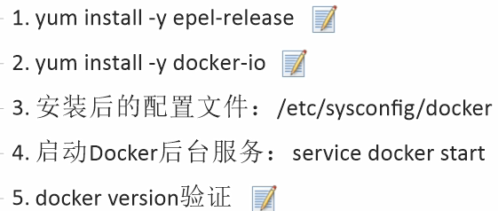

## centos7安装docker

|  |  |
| --- | --- |
| 步骤 | 操作 |
| 查看版本 | cat /etc/redhat-release |
| 安装依赖 | yum -y install gcc/gcc-c++ |
| 卸载旧版本 |  |
| 安装require | yum install -y yum-utils device-mapper-persistent-data lvm2 |
| 安装stable | yum-config-manager https://mirrors.aliyun.com/docker-ce/linux/centos/docker-ce.repo |
| 更新yum索引 | yum makecache fast |
| 下载docker rpm | https://download.docker.com/linux/centos/7/x86_64/stable/Packages/ |
| 安装docker | yum install /opt/docker-ce-18.03.1.ce-1.el7.centos.x86_64.rpm |
| 启动docker | systemctl start docker |
| 测试docker | docker version/docker run hello-world |
| 阿里云镜像加速 | https://cr.console.aliyun.com/cn-hangzhou/mirrors |
| 配置加速 | {"registry-mirrors":["https://1u5ptclc.mirror.aliyuncs.com"]} |
| 重启 | systemctl daemon-reload  systemctl restart docker |

## Ubuntu安装docker：

|  |  |
| --- | --- |
| **步骤** | **操作** |
| **更新apt** | sudo apt-get install update |
| **更新https** | sudo apt-get install apt-transport-https ca-certificates |
| **安装docker** | sudo apt install docker.io -y |
| **查看版本** | docker -v/docker version |
| **阿里云加速器** | https://1u5ptclc.mirror.aliyuncs.com |
| **修改配置** | 添加：/etc/default/docker  DOCKER_OPTS="--registry-mirror=https://registry.docker-cn.com"  查看：docker info |

# 基本操作

|  |  |
| --- | --- |
| **操作** | **命令** |
| **检查内核(3.10+)** | uname -r |
| **安装** | yum install docker |
| **启动** | systemctl start docker |
| **开机自启** | systemctl enable docker |
|  |  |
|  |  |
|  |  |
| **检索镜像** | docker search mysql |
| **拉取镜像** | docker pull mysql:5.5 |
| **查看镜像** | docker images [-a -q –digests –no-trunc] |
| **删除镜像** | docker rmi id |
| **运行镜像** | docker run --name zhpmysql –d mysql:latest –p 3306:3306 mysql:5.5 |
| **提交镜像** | docker commit -a=”作者” -m=”描述” id 新镜像名:版本 |
|  |  |
| **查看运行容器** | docker ps |
| **查看所有容器** | docker ps –a |
| **启动容器** | docker start id |
| **停止容器** | docker stop id |
| **删除容器** | docker rm id |

# 镜像原理

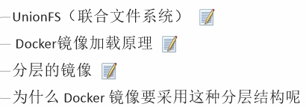

# 容器数据卷

## 命令添加

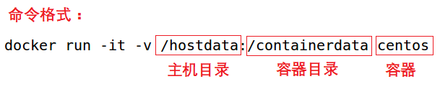

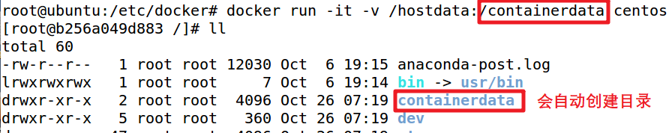

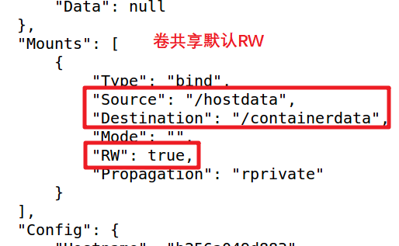

## DockerFile添加

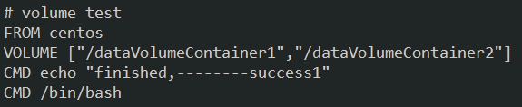

## --volumes-from

# DockerFile指令

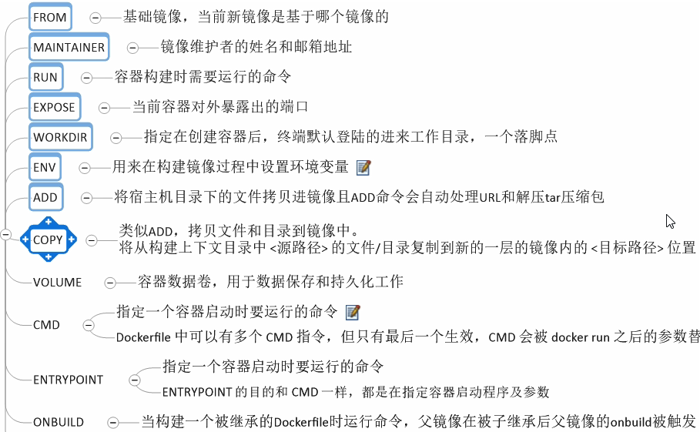

# 案例

## 步骤：

编写docker file

构建镜像：docker build -f /DockerFile/mycentos -t zhpcentos:1.1 .

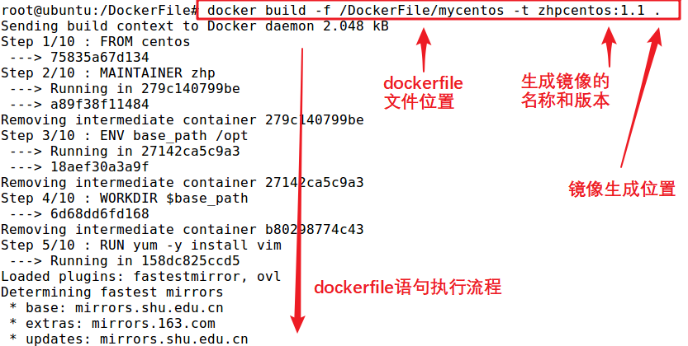

创建容器：docker run -it zhpcentos:1.1

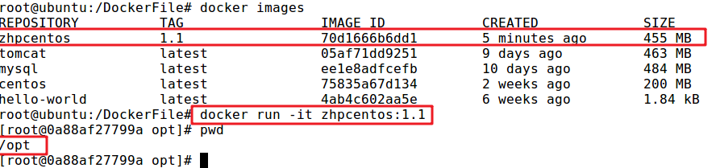

dockerfile语句：

|  |  |  |
| --- | --- | --- |
| **zhpcentos** |  |  |
| **FROM centos**  **MAINTAINER zhp**  **ENV base_path /opt**  **WORKDIR $base_path**  **RUN yum -y install vim**  **RUN yum -y install net-tools**  **EXPOSE 80**  **CMD echo $base_path**  **CMD echo "----success----"**  **CMD /bin/bash** |  |  |