# Jenkins学习笔记

# 安装配置Jenkins

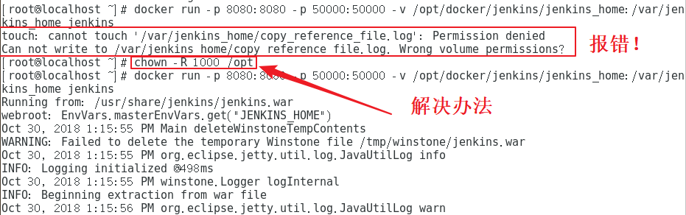

启动Jenkins容器：docker run -p 8080:8080 -p 50000:50000 -v /opt/docker/jenks/jenkins_home:/var/jenkins_home -v /opt/jdk1.8.0_191:/opt/jdk8 -v /usr/bin/git:/opt/git -v /opt/apache-maven-3.3.9:/opt/maven3.3.9 jenkins

启动tomcat容器：docker run -d --name tomcat01 -p 8888:8080 -v /opt/docker/tomcat01/webapps:/usr/local/tomcat/webapps -v /opt/docker/tomcat01/logs:/usr/local/tomcat/logs tomcat

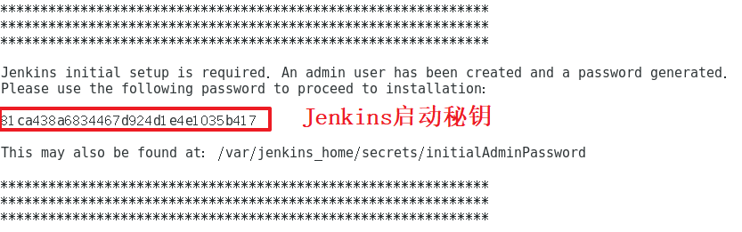

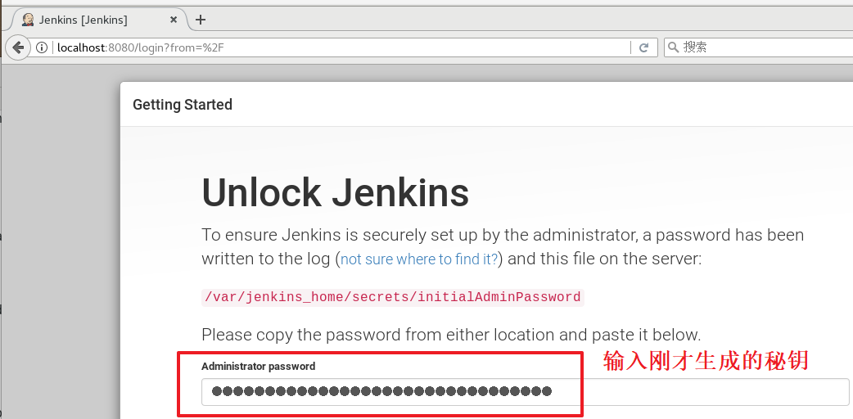

# 系统管理

## Global Tool Configuration

docker run -p 8080:8080 -p 50000:50000 -v /opt/docker/jenks/jenkins_home:/var/jenkins_home -v /opt/jdk1.8.0_191:/opt/jdk8 -v /usr/bin/git:/opt/git -v /opt/apache-maven-3.3.9:/opt/maven3.3.9 jenkins

docker run -d --name tomcat01 -p 8888:8080 -v /opt/docker/tomcat01/webapps:/usr/local/tomcat/webapps -v /opt/docker/tomcat01/logs:/usr/local/tomcat/logs tomcat

#!/bin/bash

tomcat_path=/opt/docker/tomcat01

project=easy-springmvc-maven

war_name=easy-springmvc-maven.war

war_path=http://http://192.168.56.128:8080/docker/jenkins/jenkins_home/job/jeekins-test/ws/target

server_port=8888

file_path=/docker/jenkins/jenkins_home/jobs/jenkins-test/workspace/target

now=$(date +"%Y%m%d%H%M%S")

echo "the shell execute time is ${now}"

echo `lsof -n -P -t -i :${server_port}`

tomcat_pid=`lsof -n -P -t -i :${server_port}`

echo "the tomcat_pid is ${tomcat_pid}"

if [ "${tomcat_pid}" != "" ]; then

kill -9 $tomcat_pid

echo "kill the server"

fi

echo "rm ${tomcat_path}/webapps/${war_name}"

rm ${tomcat_path}/webapps/${war_name}

echo "rm -rf ${tomcat_path}/webapps/${project}"

rm -rf ${tomcat_path}/webapps/${project}

cd $file_path

if [ -f ${war_name} ]; then

cp ${war_name} ${tomcat_path}/webapps

else

echo "${war_name} unexists"

fi

export JAVA_HOME=/data/jdk7

export CATALINA_HOME2=/usr/local/apache-tomcat-2

export CATALINA_BASE2=/usr/local/apache-tomcat-2

$tomcat_path/bin/startup.sh

echo "server restarted"