济南移动高校支付系统

机器运维文档

张浩

2013-06-12

目录

部署结构 3

基础环境安装有效命令 3

安装jdk 3

修改环境变量 3

Apache编译、安装、配置 4

编译安装(httpd-2.2.20.tar.gz) 4

conf/httpd.conf 4

conf/extra/httpd-vhost.conf 4

Tomcat配置 5

下载安装 5

config/server.xml 5

创建文件夹 6

应用存放文件夹 6

linux防火墙配置 6

方案一 6

方案二 6

# 部署结构

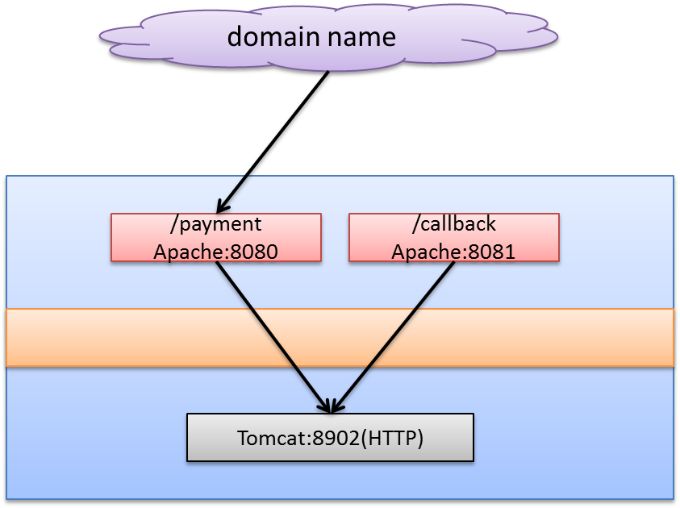

说明：

1. 目前tomcat和apache都是2个点的集群。apache采用mod_proxy方式连接支付系统。通信协议http。
2. 前端业务系统根据需要，指向支付系统的apache集群完成对支付服务（资源）的调用。

# 基础环境安装有效命令

## 安装jdk

|  |
| --- |
| jdk1.6.0_32 |

## 修改环境变量

|  |
| --- |
| vi ~/.bash_profile  JAVA_HOME=/home/kaoshi/jdk1.6.0_32/  export JAVA_HOME  PATH=$JAVA_HOME/bin:$PATH  export PATH  export JRE_HOME=/home/kaoshi/jdk1.6.0_32/jre  CLASSPATH=.:$JAVA_HOME/lib/dt.jar:$JAVA_HOME/lib/tools.jar  export CLASSPATH |

# Apache编译、安装、配置

## 编译安装(httpd-2.2.20.tar.gz)

|  |
| --- |
| cd httpd-2.2.20  ./configure --prefix=/home/gongyu/gongyu --enable-mods-shared=all --enable-cgi --enable-rewrite --with-mpm=prefork --enable-module=most --enable-proxy --enable-proxy-ajp --enable-forward --enable-proxy-connect --enable-proxy-http --enable-so --enable-deflate --enable-headers --enable-include  make  make install |

## conf/httpd.conf

备份httpd.conf文件

将http.conf修改为如下内容：

|  |
| --- |
| Listen 8080  Listen 8081  # Virtual hosts  Include conf/extra/httpd-vhosts.conf |

## conf/extra/httpd-vhost.conf

备份httpd-vhost.conf文件

将http-vhost.conf修改为如下内容：

|  |
| --- |
| NameVirtualHost *:8080  <VirtualHost *:8080>  ProxyPreserveHost On  ProxyRequests Off  ProxyPass / http://localhost:8902/  ProxyPassReverse / http://localhost:8902/  <Location /callback/>  Order allow,deny  Deny from all  </Location>  </VirtualHost>  NameVirtualHost *:8081  <VirtualHost *:8081>  ProxyPreserveHost On  ProxyRequests Off  ProxyPass /callback http://localhost:8902/callback  ProxyPassReverse /callback http://localhost:8902/callback  </VirtualHost> |

# Tomcat配置

## 下载安装

|  |
| --- |
| tar -zxvf apache-tomcat-6.0.35.tar.gz  mv apache-tomcat-6.0.35 ~/tomcat_gongyu |

## config/server.xml

备份。

修改shutdown，http， ajp，端口。修改后的整个文件为：

配置端口：shutdown、http、ajp-8901、8902、8903

|  |
| --- |
| <Engine name="Catalina" defaultHost="localhost">  <Context path="" docBase="/home/gongyu/gongyu" reloadable="true" crossContext="true"></Context> |

# 创建文件夹

## 应用存放文件夹

|  |
| --- |
| cd /home/gongyu  mkdir gongyu |

# linux防火墙配置

## 方案一

|  |
| --- |
| vi /etc/sysconfig/iptables  -A RH-Firewall-1-INPUT -m state --state NEW -m tcp -p tcp --dport 8080 -j ACCEPT  -A RH-Firewall-1-INPUT -m state --state NEW -m tcp -p tcp --dport 8081 -j ACCEPT  service iptables restart |

## 方案二

|  |
| --- |
| iptables -I INPUT -i eth0 -p tcp --dport 8080 -j ACCEPT  iptables -I OUTPUT -o eth0 -p tcp --sport 8080 -j ACCEPT  iptables -I INPUT -i eth0 -p tcp --dport 8081 -j ACCEPT  iptables -I OUTPUT -o eth0 -p tcp --sport 8081 -j ACCEPT  service iptables save |