

**期末项目设计报告**

|  |  |  |  |
| --- | --- | --- | --- |
| 题 目 | 基于Oracle的图书商城数据库设计 | | |
| 课程 | Oracle数据库应用 | | |
| 学 院 | 计算机学院 | | |
| 专 业 | 软件工程 | 年级 | 2018级 |
| 学生姓名 | 张洪 | 学号 | 201810414326 |
| 指导教师 | 赵卫东 | 职称 | 副教授 |

|  |  |  |  |
| --- | --- | --- | --- |
| **评分项** | **评分标准** | **满分** | **得分** |
| 文档整体 | 文档内容详实、规范，美观大方 | 10 |  |
| 表设计 | 表，表空间设计合理，数据合理 | 20 |  |
| 用户管理 | 权限及用户分配方案设计正确 | 20 |  |
| PL/SQL设计 | 存储过程和函数设计正确 | 30 |  |
| 备份方案 | 备份方案设计正确 | 20 |  |
| **得分合计** | | |  |

2021 年 6 月 1 日

目录

1. 环境搭建 3

2. 创建表空间 4

3. 创建角色及用户，并进行分配： 6

4. 在用户zhanghong01下创建相关的表： 8

5. 批量插入六万多条数据： 17

6. 创建程序包及存储过程并进行执行计划分析 19

7. 备份 22

## 1. 环境搭建

在本地安装Oracle 12C，并创建数据库ZHANG，添加监听器，并启动相应的服务。

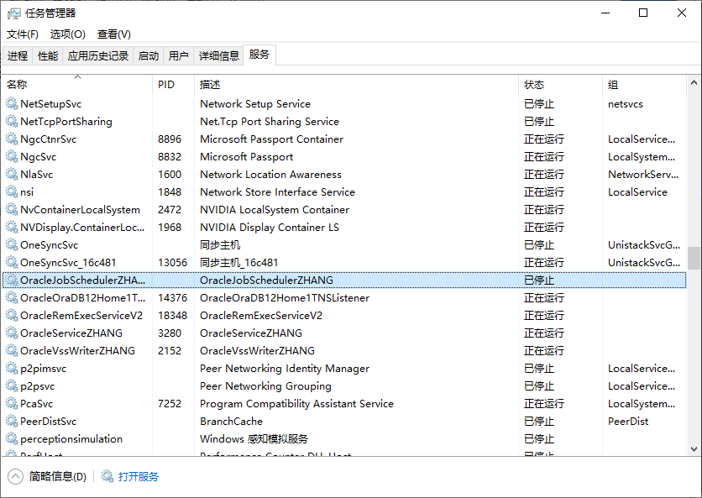

ER图设计：

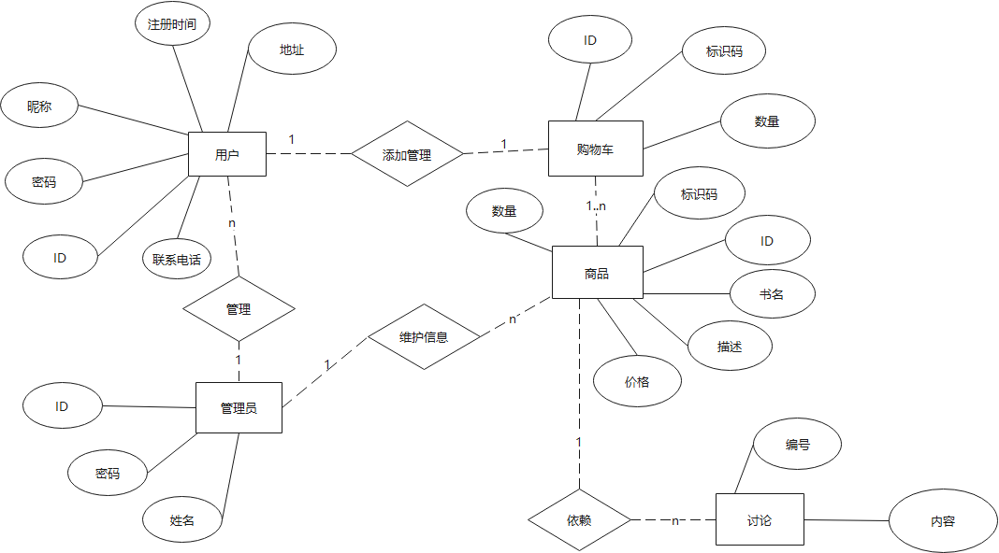

## 2. 创建表空间

-- 创建表空间space1  
 CREATE TABLESPACE space1  
 datafile  
 'H:\app\myoracle\oradata\ZHANG\pdborcl\pdb_01_1.dbf' SIZE 100M AUTOEXTEND ON NEXT 256M maxsize unlimited,  
 'H:\app\myoracle\oradata\ZHANG\pdborcl\pdb_01_2.dbf' SIZE 100M AUTOEXTEND ON NEXT 256M maxsize unlimited  
 EXTENT MANAGEMENT LOCAL SEGMENT SPACE MANAGEMENT AUTO;  
   
 -- 创建表空间space2  
 CREATE TABLESPACE space2  
 datafile  
 'H:\app\myoracle\oradata\ZHANG\pdborcl\pdb_02_1.dbf' SIZE 100M AUTOEXTEND ON NEXT 256M maxsize unlimited,  
 'H:\app\myoracle\oradata\ZHANG\pdborcl\pdb_02_2.dbf' SIZE 100M AUTOEXTEND ON NEXT 256M maxsize unlimited  
 EXTENT MANAGEMENT LOCAL SEGMENT SPACE MANAGEMENT AUTO;

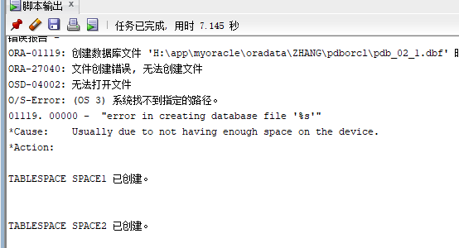

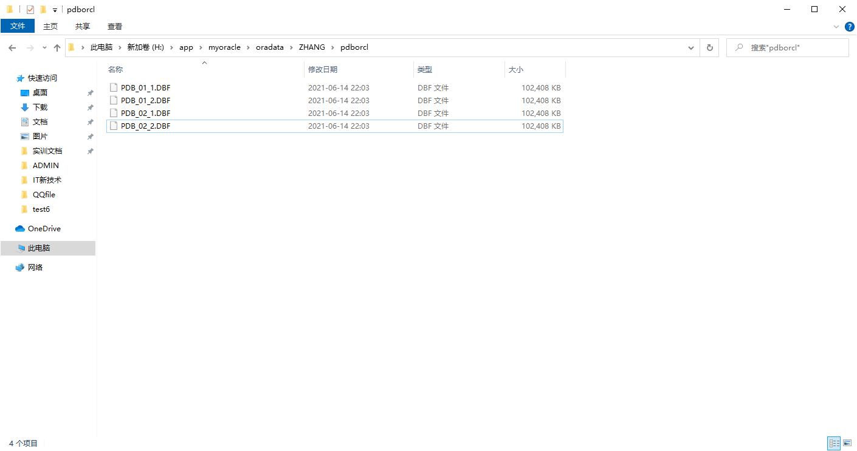

## 3. 创建角色及用户，并进行分配：

创建角色zhang01将connect，resource，create view授权给zhang01。创建用户zhanghong01。分配60M空间给zhanghong01并将角色zhang01授权给用户zhanghong01

CREATE ROLE zhang01;  
 GRANT connect,resource,CREATE VIEW TO zhang01;  
 -- 使用space1  
 CREATE USER zhanghong01 IDENTIFIED BY 123 DEFAULT TABLESPACE space1 TEMPORARY TABLESPACE temp;  
 ALTER USER zhanghong01 QUOTA 60M ON space1;  
 GRANT zhang01 TO zhanghong01;

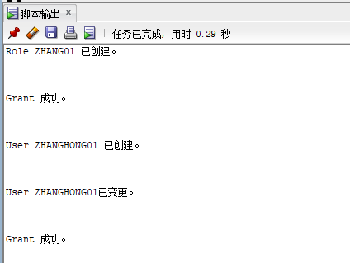

创建角色zhang02,将connect，resource，create view授权给zhang02。创建用户zhanghong02，分配60M空间给zhanghong02并将角色zhang02授权给用户zhanghong02：

CREATE ROLE zhang02;  
 GRANT connect,resource,CREATE VIEW TO zhang02;  
 CREATE USER zhanghong02 IDENTIFIED BY 123 DEFAULT TABLESPACE space1 TEMPORARY TABLESPACE temp;  
 ALTER USER zhanghong02 QUOTA 60M ON space1;  
 GRANT zhang02 TO zhanghong02;

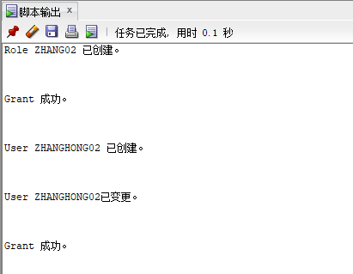

## 4. 在用户zhanghong01下创建相关的表：

管理员表：ID表示编号，PASSWORD表示密码，ADMIN表示管理员姓名，并添加索引

CREATE TABLE ADMINISTRATOR   
(  
 ID NUMBER(*, 0) NOT NULL   
, PASSWORD VARCHAR2(20 BYTE) NOT NULL   
, ADMIN VARCHAR2(20 BYTE) NOT NULL   
, CONSTRAINT ADMINISTRATOR_PK PRIMARY KEY   
 (  
 ID   
 )  
 USING INDEX   
 (  
 CREATE UNIQUE INDEX ADMINISTRATOR_PK ON ADMINISTRATOR (ID ASC)   
 LOGGING   
 TABLESPACE space1  
 PCTFREE 10   
 INITRANS 2   
 STORAGE   
 (   
 BUFFER_POOL DEFAULT   
 )   
 NOPARALLEL   
 )  
 ENABLE   
)   
LOGGING   
TABLESPACE space1  
PCTFREE 10   
INITRANS 1   
STORAGE   
(   
 BUFFER_POOL DEFAULT   
)   
NOCOMPRESS   
NO INMEMORY   
NOPARALLEL;

用户表：id表示编号（设为主键），password表示密码，username表示用户名，phone表示联系电话，address表示用户地址，registrationdate表示注册日期，cart_id表示购物车id

CREATE TABLE BOOKUSER   
(  
 ID NUMBER(*, 0) NOT NULL   
, PASSWORD VARCHAR2(20 BYTE) NOT NULL   
, USERNAME VARCHAR2(50 BYTE) NOT NULL   
, PHONE VARCHAR2(20 BYTE) NOT NULL   
, ADDRESS VARCHAR2(30 BYTE) NOT NULL   
, REGISTRATIONDATE DATE NOT NULL   
, CART_ID NUMBER(*, 0) NOT NULL   
, CONSTRAINT U_PK PRIMARY KEY   
 (  
 ID   
 )  
 USING INDEX   
 (  
 CREATE UNIQUE INDEX U_PK ON BOOKUSER (ID ASC)   
 LOGGING   
 TABLESPACE space1   
 PCTFREE 10   
 INITRANS 2   
 STORAGE   
 (   
 BUFFER_POOL DEFAULT   
 )   
 NOPARALLEL   
 )  
 ENABLE   
)   
TABLESPACE space1  
PCTFREE 10   
INITRANS 1   
STORAGE   
(   
 BUFFER_POOL DEFAULT   
)   
NOCOMPRESS   
NOPARALLEL   
PARTITION BY RANGE (REGISTRATIONDATE)   
SUBPARTITION BY RANGE (REGISTRATIONDATE)   
(  
 PARTITION DATE2018 VALUES LESS THAN (TO_DATE(' 2018-12-31 00:00:00', 'SYYYY-MM-DD HH24:MI:SS', 'NLS_CALENDAR=GREGORIAN'))   
 TABLESPACE space1  
 PCTFREE 10   
 INITRANS 1   
 STORAGE   
 (   
 BUFFER_POOL DEFAULT   
 )   
 NOCOMPRESS NO INMEMORY   
 (  
 SUBPARTITION DATE2018_3 VALUES LESS THAN (TO_DATE(' 2018-03-31 00:00:00', 'SYYYY-MM-DD HH24:MI:SS', 'NLS_CALENDAR=GREGORIAN'))   
 NOCOMPRESS NO INMEMORY   
 , SUBPARTITION DATE2018_6 VALUES LESS THAN (TO_DATE(' 2018-06-30 00:00:00', 'SYYYY-MM-DD HH24:MI:SS', 'NLS_CALENDAR=GREGORIAN'))   
 NOCOMPRESS NO INMEMORY   
 , SUBPARTITION DATE2018_9 VALUES LESS THAN (TO_DATE(' 2018-09-30 00:00:00', 'SYYYY-MM-DD HH24:MI:SS', 'NLS_CALENDAR=GREGORIAN'))   
 NOCOMPRESS NO INMEMORY   
 , SUBPARTITION DATE2018_12 VALUES LESS THAN (TO_DATE(' 2018-12-31 00:00:00', 'SYYYY-MM-DD HH24:MI:SS', 'NLS_CALENDAR=GREGORIAN'))   
 NOCOMPRESS NO INMEMORY   
 )   
, PARTITION DATE2019 VALUES LESS THAN (TO_DATE(' 2019-12-31 00:00:00', 'SYYYY-MM-DD HH24:MI:SS', 'NLS_CALENDAR=GREGORIAN'))   
 TABLESPACE space1   
 PCTFREE 10   
 INITRANS 1   
 STORAGE   
 (   
 BUFFER_POOL DEFAULT   
 )   
 NOCOMPRESS NO INMEMORY   
 (  
 SUBPARTITION DATE2019_3 VALUES LESS THAN (TO_DATE(' 2019-03-31 00:00:00', 'SYYYY-MM-DD HH24:MI:SS', 'NLS_CALENDAR=GREGORIAN'))   
 NOCOMPRESS NO INMEMORY   
 , SUBPARTITION DATE2019_6 VALUES LESS THAN (TO_DATE(' 2019-06-30 00:00:00', 'SYYYY-MM-DD HH24:MI:SS', 'NLS_CALENDAR=GREGORIAN'))   
 NOCOMPRESS NO INMEMORY   
 , SUBPARTITION DATE2019_9 VALUES LESS THAN (TO_DATE(' 2019-09-30 00:00:00', 'SYYYY-MM-DD HH24:MI:SS', 'NLS_CALENDAR=GREGORIAN'))   
 NOCOMPRESS NO INMEMORY   
 , SUBPARTITION DATE2019_12 VALUES LESS THAN (TO_DATE(' 2019-12-31 00:00:00', 'SYYYY-MM-DD HH24:MI:SS', 'NLS_CALENDAR=GREGORIAN'))   
 NOCOMPRESS NO INMEMORY   
 )   
);

创建商品表：id表示编号（主键），pid表示标识码，booksname表示图书名字，price表示价格，describe表示图书描述，num表示数量，admin_id表示管理员id

CREATE TABLE COMMODITY   
(  
 ID NUMBER(*, 0) NOT NULL   
, PID NUMBER(*, 0) NOT NULL   
, BOOKSNAME VARCHAR2(20 BYTE) NOT NULL   
, PRICE NUMBER NOT NULL   
, DESCRIBE VARCHAR2(50 BYTE) NOT NULL   
, NUM NUMBER(*, 0) NOT NULL   
, ADMIN_ID NUMBER(*, 0) NOT NULL   
, CONSTRAINT COMMODITY_PK PRIMARY KEY   
 (  
 ID   
 )  
 USING INDEX   
 (  
 CREATE UNIQUE INDEX COMMODITY_PK ON COMMODITY (ID ASC)   
 LOGGING   
 TABLESPACE space1  
 PCTFREE 10   
 INITRANS 2   
 STORAGE   
 (   
 BUFFER_POOL DEFAULT   
 )   
 NOPARALLEL   
 )  
 ENABLE   
)   
LOGGING   
TABLESPACE space1  
PCTFREE 10   
INITRANS 1   
STORAGE   
(   
 BUFFER_POOL DEFAULT   
)   
NOCOMPRESS   
NO INMEMORY   
NOPARALLEL;

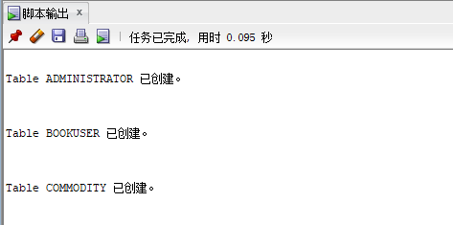

创建购物车表：id表示购物车编号（主键），amount表示数量，pid表示标识码，bookuser_id表示用户ID

CREATE TABLE CART  
(  
 ID NUMBER(*, 0) NOT NULL   
, AMOUNT NUMBER(*, 0) NOT NULL   
, PID NUMBER(*, 0) NOT NULL   
, BOOKUSER_ID NUMBER(*, 0) NOT NULL   
, CONSTRAINT CART_PK PRIMARY KEY   
 (  
 ID   
 )  
 USING INDEX   
 (  
 CREATE UNIQUE INDEX CART_PK ON CART (ID ASC)   
 LOGGING   
 TABLESPACE space1  
 PCTFREE 10   
 INITRANS 2   
 STORAGE   
 (   
 BUFFER_POOL DEFAULT   
 )   
 NOPARALLEL   
 )  
 ENABLE   
, CONSTRAINT CART_BOOKUSER FOREIGN KEY  
 (  
 BOOKUSER_ID   
 )  
 REFERENCES BOOKUSER  
 (  
 ID   
 )  
 ENABLE   
)   
PCTFREE 10   
PCTUSED 40   
INITRANS 1   
STORAGE   
(   
 BUFFER_POOL DEFAULT   
)   
NOCOMPRESS   
NOPARALLEL   
PARTITION BY REFERENCE (CART_BOOKUSER)   
(  
 PARTITION DATE2018_3   
 LOGGING   
 TABLESPACE space1  
 PCTFREE 10   
 INITRANS 1   
 STORAGE   
 (   
 BUFFER_POOL DEFAULT   
 )   
 NOCOMPRESS NO INMEMORY   
, PARTITION DATE2018_6   
 LOGGING   
 TABLESPACE space1  
 PCTFREE 10   
 INITRANS 1   
 STORAGE   
 (   
 BUFFER_POOL DEFAULT   
 )   
 NOCOMPRESS NO INMEMORY   
, PARTITION DATE2018_9   
 LOGGING   
 TABLESPACE space1  
 PCTFREE 10   
 INITRANS 1   
 STORAGE   
 (   
 BUFFER_POOL DEFAULT   
 )   
 NOCOMPRESS NO INMEMORY   
, PARTITION DATE2018_12   
 LOGGING   
 TABLESPACE space1  
 PCTFREE 10   
 INITRANS 1   
 STORAGE   
 (   
 BUFFER_POOL DEFAULT   
 )   
 NOCOMPRESS NO INMEMORY   
, PARTITION DATE2019_3   
 LOGGING   
 TABLESPACE space1  
 PCTFREE 10   
 INITRANS 1   
 STORAGE   
 (   
 BUFFER_POOL DEFAULT   
 )   
 NOCOMPRESS NO INMEMORY   
, PARTITION DATE2019_6   
 LOGGING   
 TABLESPACE space1  
 PCTFREE 10   
 INITRANS 1   
 STORAGE   
 (   
 BUFFER_POOL DEFAULT   
 )   
 NOCOMPRESS NO INMEMORY   
, PARTITION DATE2019_9   
 LOGGING   
 TABLESPACE space1  
 PCTFREE 10   
 INITRANS 1   
 STORAGE   
 (   
 BUFFER_POOL DEFAULT   
 )   
 NOCOMPRESS NO INMEMORY   
, PARTITION DATE2019_12   
 LOGGING   
 TABLESPACE space1  
 PCTFREE 10   
 INITRANS 1   
 STORAGE   
 (   
 BUFFER_POOL DEFAULT   
 )   
 NOCOMPRESS NO INMEMORY   
);

创建论坛表：id表示编号，content表示编号

CREATE TABLE TABLE1   
(   
 ID INT NOT NULL   
, CONTENT NVARCHAR2(50) NOT NULL   
, CONSTRAINT TABLE1_PK PRIMARY KEY   
 (   
 ID   
 )   
 ENABLE   
);

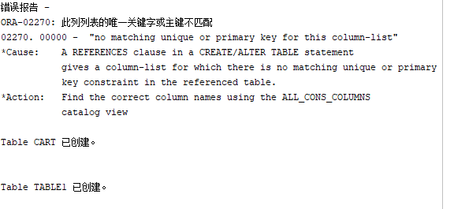

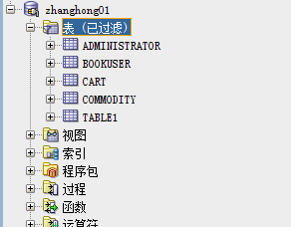

更改用户zhanghong01的空间大小：

ALTER USER zhanghong01 QUOTA 90M ON space1;

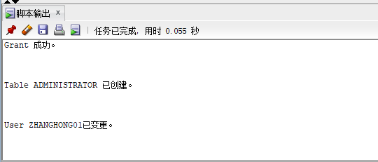

## 5. 批量插入六万多条数据：

declare  
 id number(38,0);  
 username varchar2(50);  
 phone varchar2(20);  
 address varchar2(30);  
 REGISTRATIONDATE date;  
 booksname varchar2(50);  
 price number(5,2);  
 num number(38,0);  
 amount number(38,0);  
   
begin  
 for i in 1..20000  
 loop  
 if i mod 2 =0 then  
 REGISTRATIONDATE:=to_date('2018-5-6','yyyy-mm-dd')+(i mod 60);  
 else  
 REGISTRATIONDATE:=to_date('2019-5-6','yyyy-mm-dd')+(i mod 60);  
 end if;  
  
 --插入用户  
 id:=i;  
 username := 'aa'|| 'aa';  
 username := 'wang' || i;  
 phone := '131785693' || i;  
 booksname := '数据库原理' || i;  
 address :='成都'|| '四川';  
 price :=(dbms_random.value() * 100);  
 num :=(i mod 5);  
 insert /*+append*/ into bookuser (id,password,username,phone,address,REGISTRATIONDATE,cart_id)  
 values (id,username,username,phone,address,REGISTRATIONDATE,id);  
 --插入货品  
   
 insert into commodity(id,pid,booksname,price,describe,num,admin_id)  
 values (id,id,booksname,price,'good',num,1);  
 --插入购物车  
 amount :=(id mod 3 ) + 1;  
 insert into cart(id,amount,pid,bookuser_id)  
 values (id,amount,id,id);  
  
 IF I MOD 1000 =0 THEN  
 commit; --每次提交会加快插入数据的速度  
 END IF;  
 end loop;  
end;

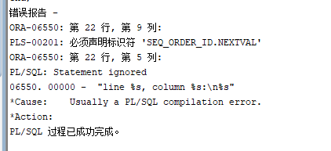

查看bookuser表，数据已存在：

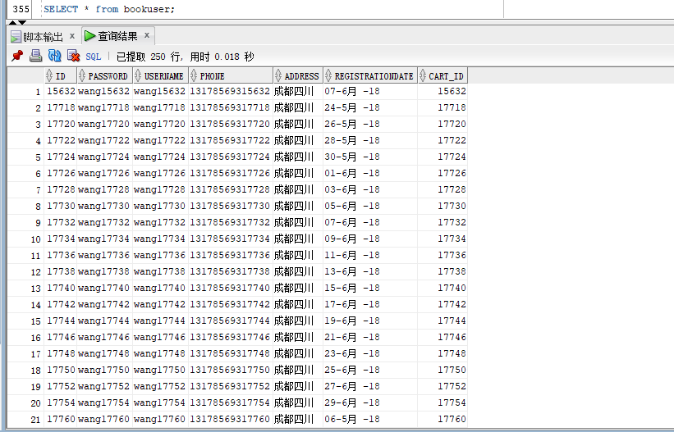

## 6. 创建程序包及存储过程并进行执行计划分析

create or replace PACKAGE book_package Is  
 function getcartsumprice(user_id number) return number;  
 procedure adduser(password varchar2,username varchar2,phone varchar2,address varchar2,registerdate VARCHAR2);  
end book_package;  
create or replace PACKAGE body book_package Is  
 function getcartsumprice(user_id number) return number as  
 begin  
 declare cart_sum number;  
 query_sql varchar2(200);  
 begin  
 query_sql:='select sum(pricesum) from view_SinglePriceSum where ID=' || user_id;  
 execute immediate query_sql into cart_sum;  
 return cart_sum;  
 end;  
 end;  
 procedure addUser(password varchar2,username varchar2,phone varchar2,address varchar2,registerdate varchar2) as  
 begin  
 declare maxId number;  
 begin  
 select max(id) into maxId from bookuser;  
 insert into bookuser values(maxId+1,password,username,phone,address,to_date(registerdate,'yyyy-mm-dd'),maxId+1);  
 commit;  
 end;  
 end;  
end;

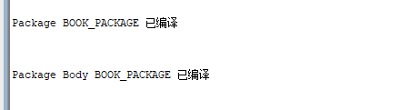

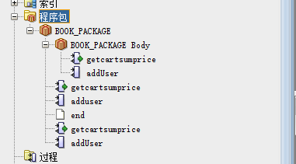

使用自定义函数getcartsumprice（）查询id号为6666的用户购物车商品总价

select BOOK_PACKAGE.getcartsumprice(6666) from dual;

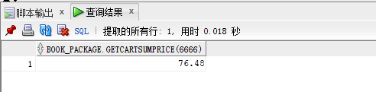

使用存储过程adduser插入用户数据:

select BOOK_PACKAGE.getcartsumprice(6666) from dual;  
set serveroutput on  
declare  
begin  
BOOK_PACKAGE.addUser('131','cwd','125626','hongkong','2019-05-02');  
end;



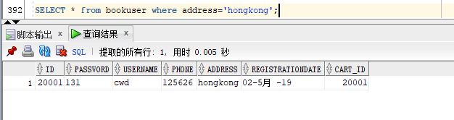

执行计划分析:

select * from BOOKUSER b,COMMODITY co,CART ca where b.id=ca.BOOKUSER_ID and ca.PID=co.PID and  
b.REGISTRATIONDATE between to_date('2018-1-1','yyyy-mm-dd') and to_date('2018-6-1','yyyy-mm-dd');

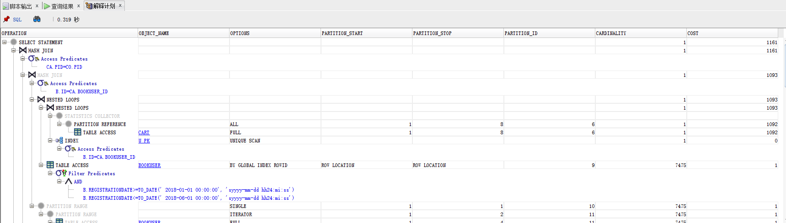查看表空间使用情况：

SELECT SUM(bytes) / (1024 * 1024) AS free_space, tablespace_name  
FROM dba_free_space  
GROUP BY tablespace_name;  
SELECT a.tablespace_name,  
a.bytes total,  
b.bytes used,  
c.bytes free,  
(b.bytes * 100) / a.bytes "% USED ",  
(c.bytes * 100) / a.bytes "% FREE "  
FROM sys.sm$ts_avail a, sys.sm$ts_used b, sys.sm$ts_free c  
WHERE a.tablespace_name = b.tablespace_name  
AND a.tablespace_name = c.tablespace_name;

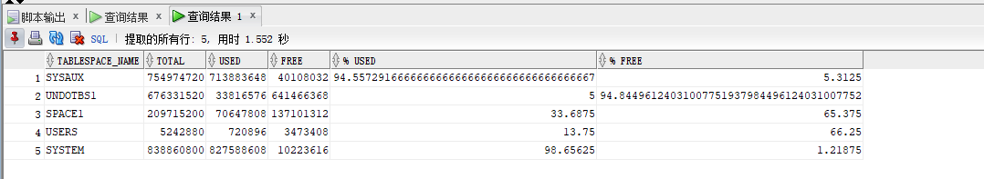

## 7. 备份

-- 数据备份  
create directory dpdata1 as 'H:\dataTemp';  
select * from dba_directories;  
-- 开始备份  
-- 授权给用户  
grant read,write on directory dpdata1 to zhanghong01;

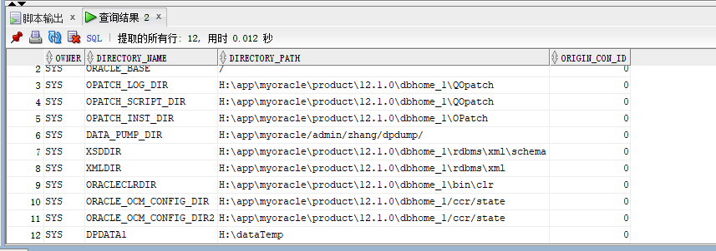

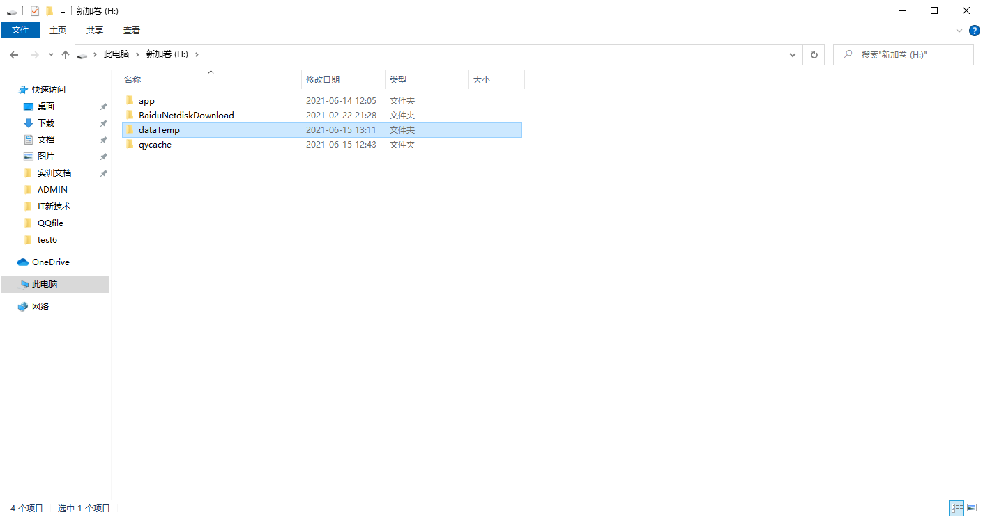

expdp system/Zhang123@ZHANG directory=dpdata1 dumpfile=beifen.dmp logfile=beifen.log schemas=zhanghong01

