New Orleans Climate Aware Recommender
Project Proposal

Developer: Hongbo Zhang
Target Audience: New Orleans, LA residents and visitors
Technology Stack: Python, Dash, Plotly, Open-Meteo API

1. Introduction
This project proposes the development of an interactive climate-aware application that delivers personalized activity recommendations based on daily weather forecasts for New Orleans, Louisiana. Known for its subtropical climate, New Orleans experiences intense heat and humidity in summer, frequent heavy rainfall, and heightened hurricane risk from June through November, conditions that significantly shape residents' and visitors' daily routines. The application will integrate the Open-Meteo API to retrieve accurate, real-time meteorological data and apply an intelligent recommendation algorithm to suggest suitable activities based on current and forecasted weather conditions.

2. Business Problem Statement
Favorable weather conditions play a significant role in driving tourism and stimulating the local economy of New Orleans. However, many visitors fail to adequately research the city's climate in advance, missing out on the wide range of attractions and events the city has to offer. This application seeks to address that gap, keeping both visitors and local communities actively engaged with what New Orleans has to offer, regardless of the weather.

3. Objectives
- Design an end-to-end data pipeline that retrieves, processes, and visualizes climate data from the API
- Develop an interactive dashboard using Python, Dash, and Plotly to support real-time climate monitoring
- Develop activity recommendation algorithms based on climate parameters
- Provide users with daily activity suggestions optimized for climate conditions
- Promote outdoor activities when climate conditions are favorable
- Demonstrate practical applications of business analytics and pipeline architecture in solving local economic problems

4. Technical Approach

4.1 Data Collection and API Integration

Data Retrieval Process
- Send API requests using Python
- Retrieve JSON-based weather forecast data
- Validate API response quality
- Store raw weather data for preprocessing

Key Climate Variables
- Temperature
- Precipitation and rainfall probability
- Humidity
- Wind speed
- Cloud cover
- Solar radiation
- Weather condition codes

4.2 Climate Dashboard
- Current Conditions Display: Real-time temperature, rain, snowfall, and precipitation
- 16-Day Forecast: Extended weather outlook with daily summaries
- Climate Code Integration: Human-readable weather descriptions (e.g., "Clear sky", "Light rain")
- Visual Climate Timeline: Interactive charts showing temperature trends and precipitation patterns

4.3 Recommendation Engine

Recommendation Workflow
- Analyze processed climate variables
- Evaluate weather suitability conditions
- Match weather profiles with activity categories
- Rank activities using weather favorability scores
- Return customized recommendations to users

Activity Categories
- Outdoor Sports (hiking, biking, kayaking and boating along the Mississippi)
- Indoor Activities (museums, shopping, jazz venues, and dining)
- Weather-Dependent Events (street parades, crawfish boils, outdoor festivals, and open-air concerts)
- Seasonal Activities (fall cultural events and holiday season activities)

4.4 Interactive User Interface
- Interactive Charts: Plotly visualizations for climate data
- Activity Filtering: Filter recommendations by activity type, duration, and climate tolerance

4.5 Technical Architecture
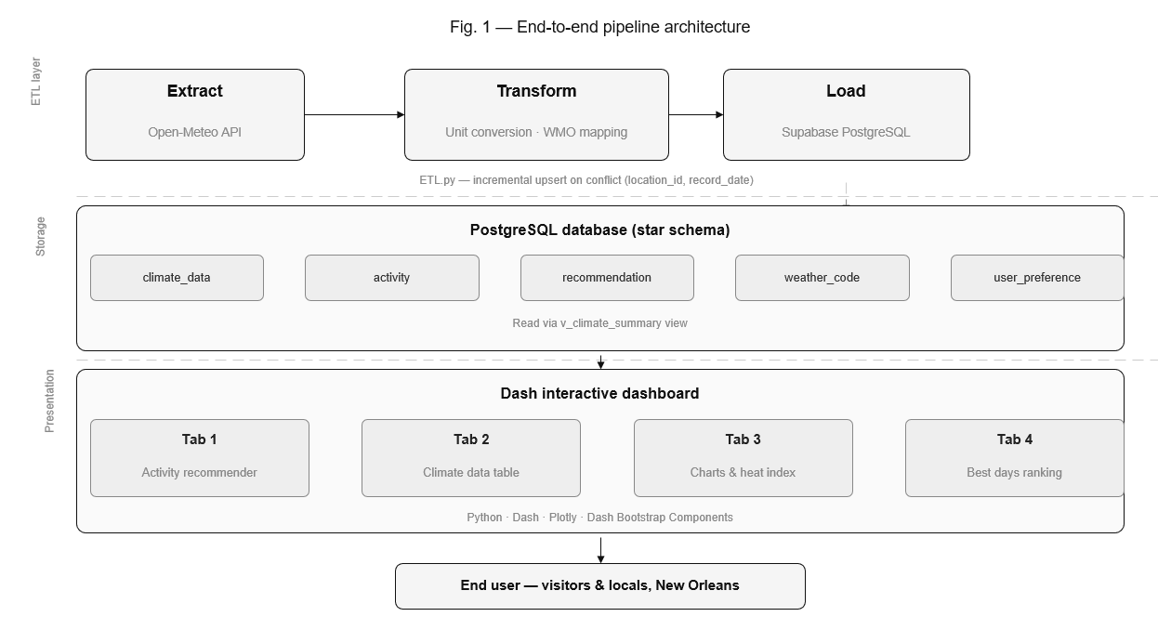
Fig. 1 — End-to-end pipeline architecture

Backend Components
- Data Retrieval: Open-Meteo API integration for real-time weather and climate forecast data
- Data Processing: Pandas for raw API response transformation, cleaning, and data manipulation
- Recommendation Engine: Rule-based algorithms for activity suggestions
- Data Storage: Local CSV storage for weather data, weather codes, and user activity preferences

Frontend Components
- Web Framework: Dash for web application development and routing
- Visualization: Plotly for dynamic charts including temperature trends, precipitation bars, and forecast timelines
- UI Components: Dash Bootstrap Components for responsive design
- Styling: Custom CSS with New Orleans themed branding and color palette

Data Flow
- API Integration: Fetch daily weather forecast data from the Open-Meteo API for New Orleans
- Data Processing: Transform raw API data into user-friendly formats
- Recommendation Logic: Apply weather-based rules to generate activity suggestions
- User Interface: Display weather data and recommendations through interactive dashboard
- User Interaction: Allow filtering and personalization of recommendations

4.6 Data Sources and APIs
Primary Data Source: Open-Meteo API
- Endpoint: https://open-meteo.com/en/docs/climate-api?latitude=29.9547&longitude=-90.0751
- Location: New Orleans, LA (29.9547°N, 90.0751°W)
- Data Parameters: temperature_2m_max/min/mean; cloud_cover_mean; relative_humidity_2m_max/min/mean; soil_moisture_0_to_10cm_mean; precipitation_sum; rain_sum; snowfall_sum; wind_speed_10m_mean/max; pressure_msl_mean; shortwave_radiation_sum

Climate Code Reference
- Excel-based lookup table mapping numeric codes to descriptions
- Supports multiple codes per description (comma-separated expansion)
- Enables human-readable weather condition display

4.7 Activity Recommendation Logic

Temperature
- < 32°F: Indoor activities, winter sports
- 32–50°F: Light outdoor activities, indoor dining
- 50–70°F: Moderate outdoor activities, hiking
- 70–85°F: Full outdoor activities, water sports
- > 85°F: Indoor activities, shaded outdoor options

Precipitation
- 0%: Full outdoor activities
- 0–30%: Light outdoor activities with rain gear
- 30–70%: Indoor activities, covered outdoor options
- > 70%: Strictly indoor activities

Wind Speed
- < 10 mph: All activities suitable
- 10–20 mph: Water sports caution, cycling suitable
- > 20 mph: Indoor activities recommended

Humidity
- < 60%: Comfortable for all outdoor activities
- 60–80%: Moderate discomfort
- > 80%: Heat index elevated; limit strenuous outdoor activities

Cloud Cover
- < 30%: Sunny; promote outdoor events and rooftop venues
- 30–70%: Partly cloudy; suitable for most outdoor activities
- > 70%: Overcast; prioritize indoor cultural activities

5. Timeline and Plan

Week | Phase | Key Tasks
Week 1 | Foundation & API Integration | Set up Dash app structure; implement Open-Meteo API integration; create basic climate data display; design ETL pipeline
Week 2 | Core Features | Develop recommendation engine; build Plotly climate visualizations; implement responsive UI; add climate code lookup
Week 3 | Enhancement & Refinement | Add user personalization (MVP); implement activity filtering and search; optimize API caching; begin user testing
Week 4 | Testing & Optimization | Cross-device testing; performance optimization; integrate user feedback; finalize technical documentation
Week 5 | Deployment & Launch | Deploy to Heroku; monitor API reliability; create deployment documentation; prepare final presentation

6. Conclusion
This Climate Activity Recommender App represents a valuable opportunity to combine data science, API integration, machine learning logic, and interactive web development into a practical consumer-focused solution for residents and visitors in New Orleans, Louisiana. By leveraging the Open-Meteo Climate API, the application can continuously retrieve reliable climate and forecast data, process the information through a structured ETL and recommendation pipeline, and transform complex weather conditions into user-friendly activity suggestions.

7. Expected Outcomes
- A working end-to-end climate analytics pipeline
- Automated weather data extraction from the Open-Meteo API
- Interactive Dash dashboard with climate visualizations for New Orleans
- Rule-based activity recommendation system
- User-friendly weather analytics interface
- Presentation and Project proposal submission

