# Spring下载

<https://repo.spring.io/libs-release-local/>

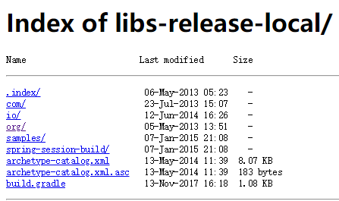

<https://repo.spring.io/libs-release-local/org/springframework/>

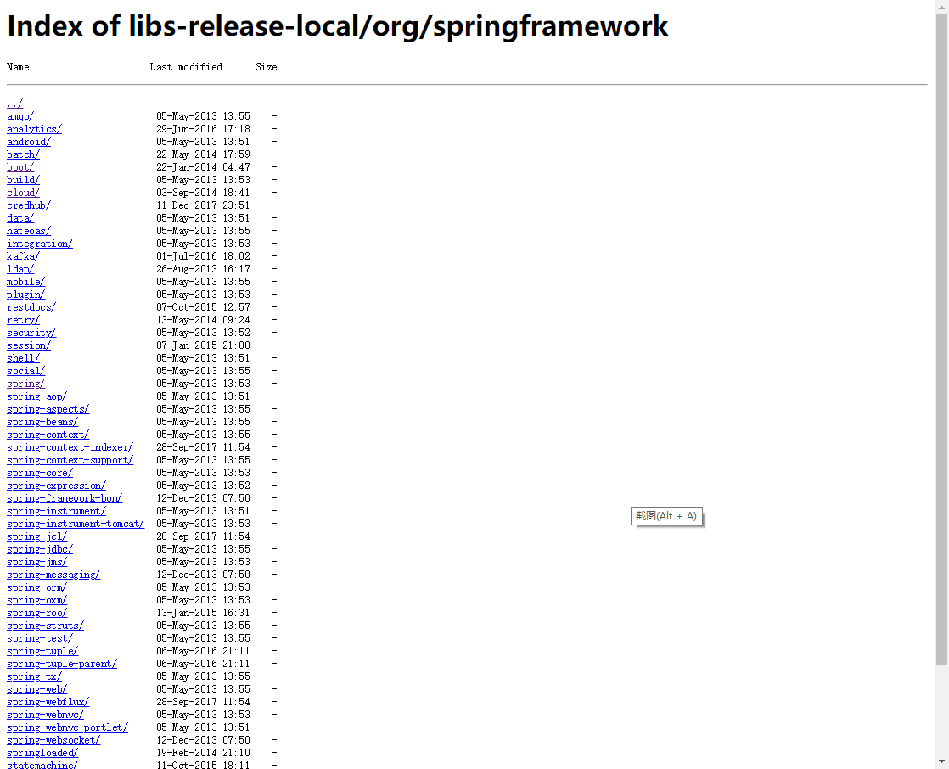

<https://repo.spring.io/libs-release-local/org/springframework/spring/>

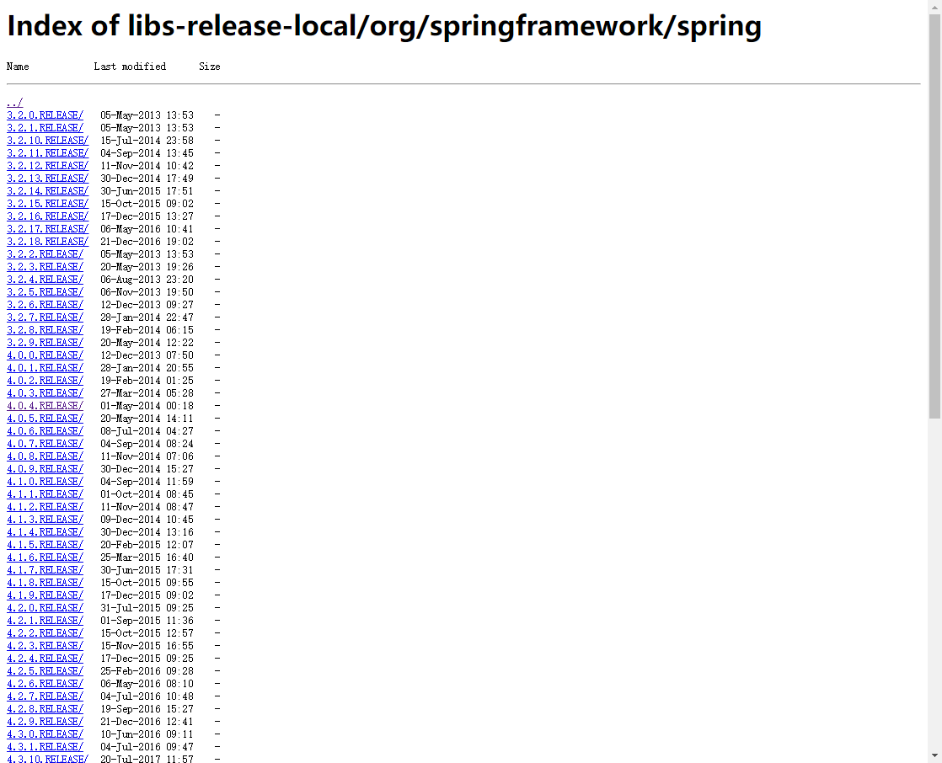

<https://repo.spring.io/libs-release-local/org/springframework/spring/4.0.4.RELEASE/>

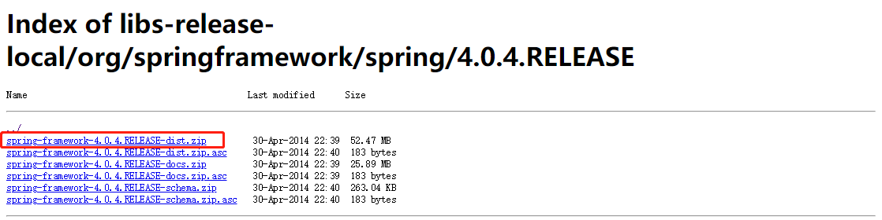

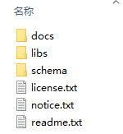

libs文件夹

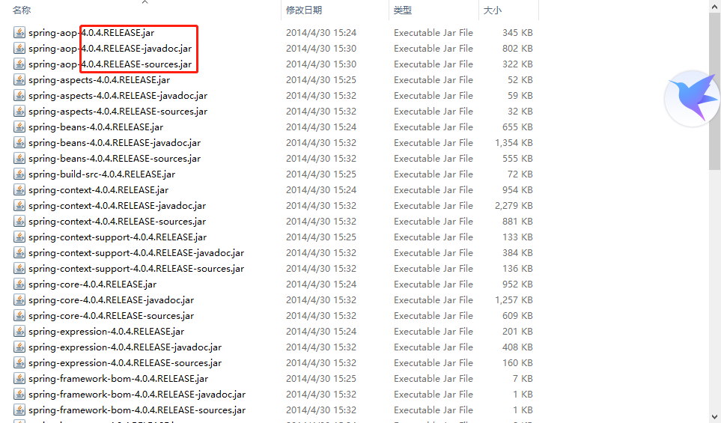

一共64个文件，63/3=21的jar包

Javadoc API文档

Sources 源码

# Spring依赖下载

Spring依赖common-logging

<http://commons.apache.org/downloads/index.html>

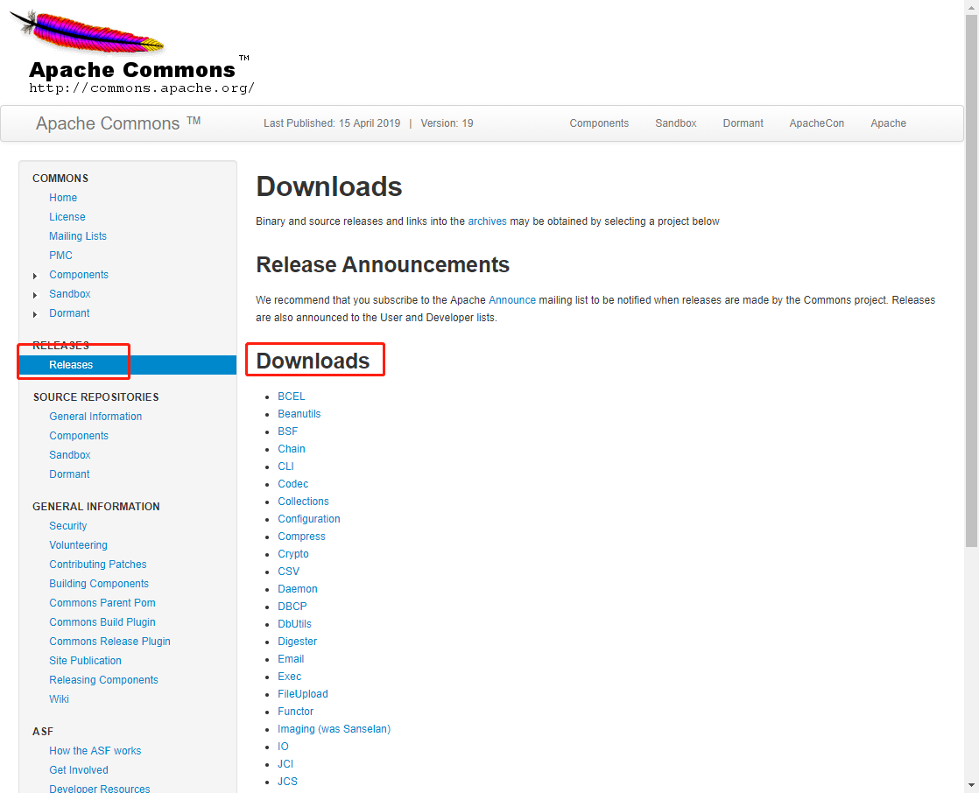

# Maven依赖

<dependency>

<groupId>org.springframework</groupId>

<artifactId>spring-core</artifactId>

<version>${spring.version}</version>

</dependency>

<dependency>

<groupId>org.springframework</groupId>

<artifactId>spring-beans</artifactId>

<version>${spring.version}</version>

</dependency>

<dependency>

<groupId>org.springframework</groupId>

<artifactId>spring-context</artifactId>

<version>${spring.version}</version>

</dependency>

