**1.学生表(student):**

create table student (

id varchar(20),

Name varchar(20),

age int,

sex varchar(20)

);

Insert into student (id,Name,age,sex) values('001','张三',18,'男');

Insert into student values('002','李四',20,'女');

select *from student

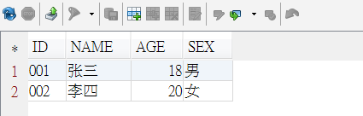

**2. 考试科目表(subject)：**

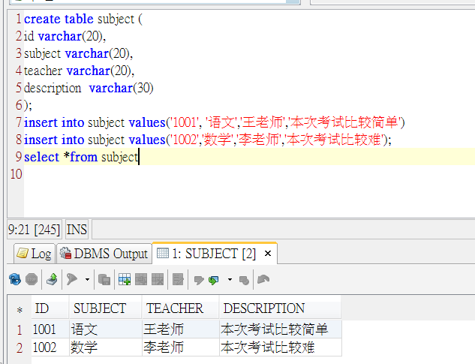

**3. 成绩表(score)：**

