**1.学生表(student):**

create table student (

id int,

Name varchar(20),

age int,

sex varchar(20)

);

Insert into student (id,Name,age,sex) values(001,'张三',18,'男');

Insert into student values(002,'李四',20,'女');

select *from student;

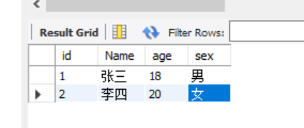

**2. 考试科目表(subject)：**

create table subject (

id int,

subject varchar(20),

teacher varchar(20),

description varchar(30)

);

insert into subject values(1001, '语文','王老师','本次考试比较简单'),(1002,'数学','老3师','本次考试比较难');

select *from subject

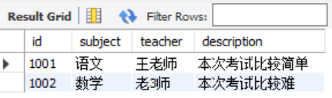

**3. 成绩表(score)：**

create table score (

id int,

student_id int,

subject_id int,

score double

);

insert into score values(1,001,1001,80),(2,002,1002,60),(3,001,1001,70),(4,002,1002,60.5);

select *from score;

