**private** String mLuckyMoneyReceive = "com.tencent.mm.plugin.luckymoney.ui.LuckyMoneyReceiveUI";

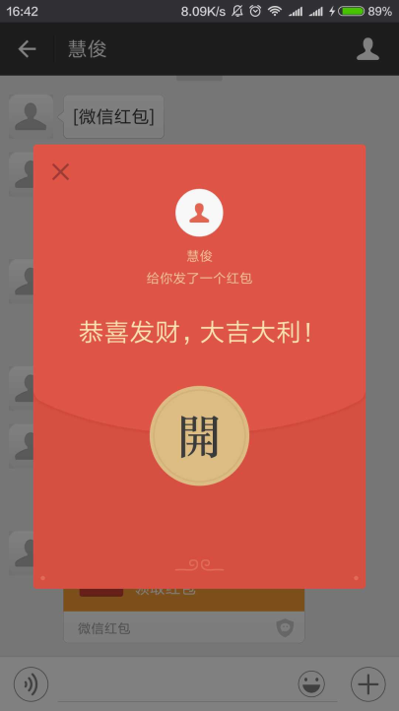

**private** String mLuckyMoneyDetail = "com.tencent.mm.plugin.luckymoney.ui.LuckyMoneyDetailUI";

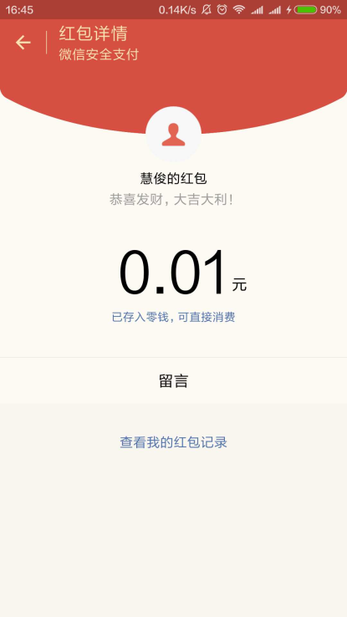

**private** String mLauncherUI = "com.tencent.mm.ui.LauncherUI";// 聊天界面（从桌面进去）

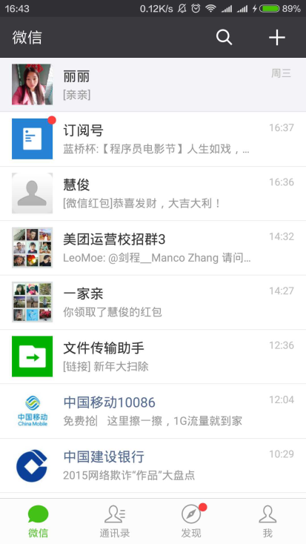

**private** String mListView = "android.widget.ListView";// 聊天界面（从联系人界面进去）

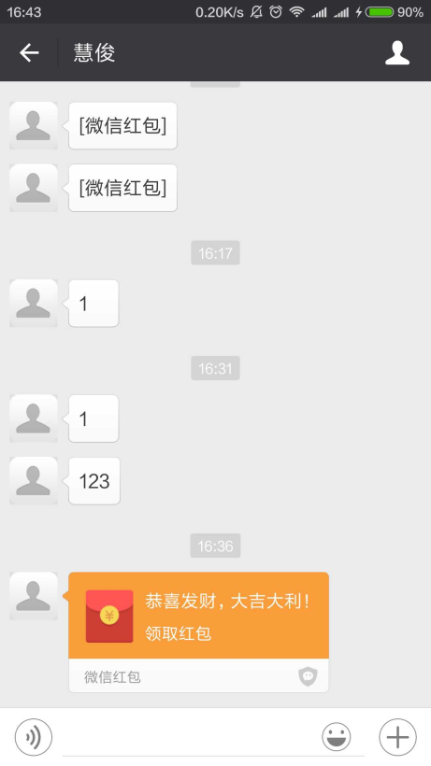

com.tencent.mm.ui.base.p