**Ashley’s comment**

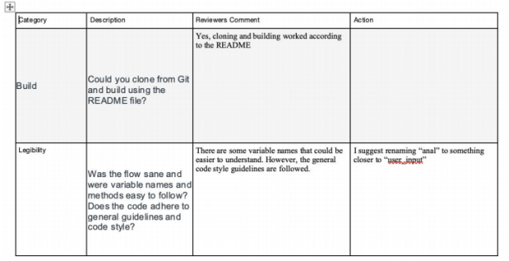

**Response: Yes, we should change the “anal” for the char input to “charin”**

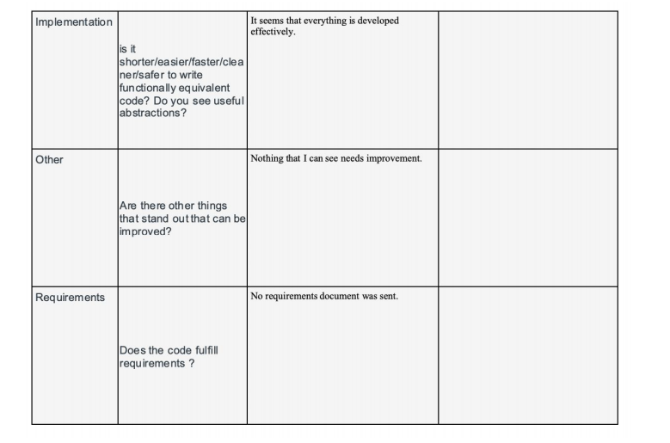

**Response:**

**We basically scheduled the requirements and made a todo list on Basecamp, which we cannot share. Thank you for the comment.**

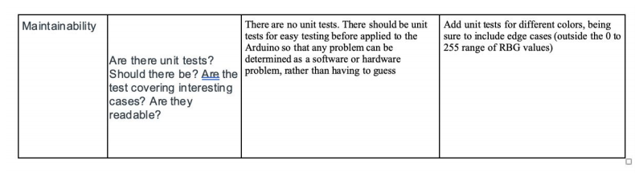

**Response: We haven’t implemented any unit tests, but the colors are tested and verified by testing them on actual Optron**

**Winston’s comment**

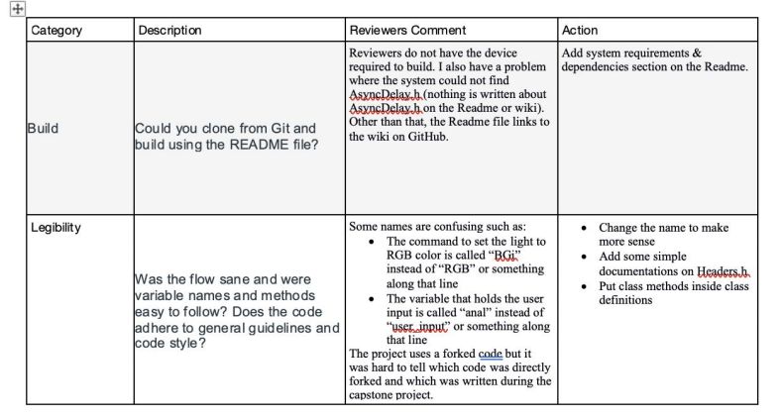

**Response: We should change our command names to something more self explanatory. Additionally, we will still change our variable name “anal”. We can add to the Readme to add some clarification for future users.**

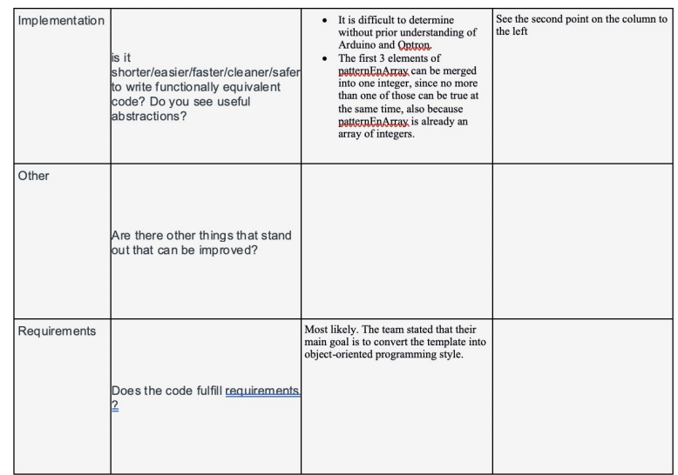

**Response: Cleaning up the code by merging things will be helpful and resourceful.**

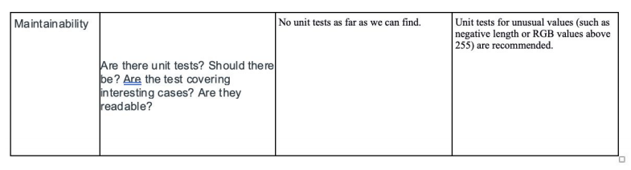

**Response: We have not implemented any user tests, but have extensively tested our own Optron device.**

**Chase’s comment**

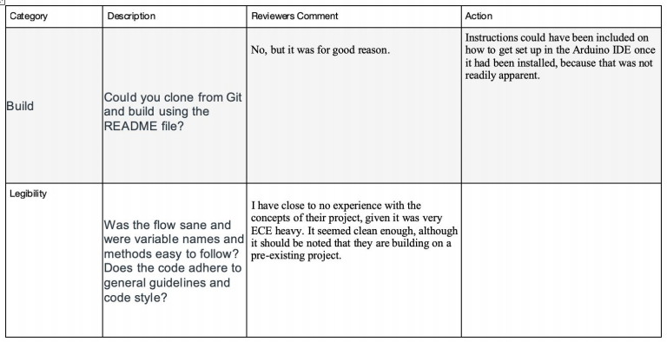

**Response:**

**We did include an explanatory section in the guide document, once you installed the Arduino IDE, you will need to install dependencies and libraries, some are really technical that you have to have extensive knowledge of the electronics used in advance.**

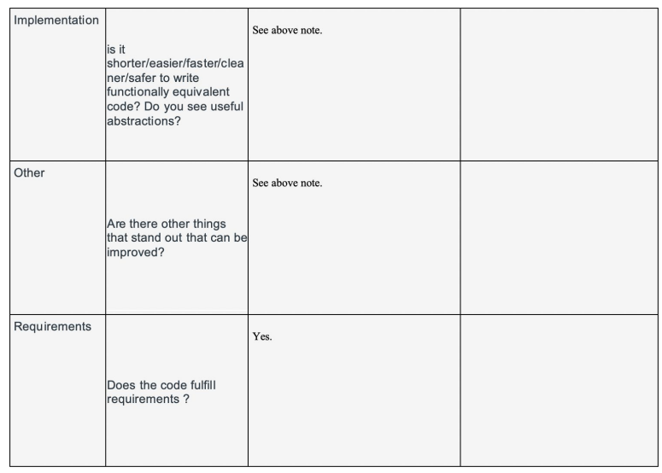

**Response:**

**Thank you.**

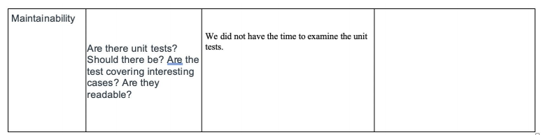

**Response:**

**Ok, take your time.**