Chinese word segmentation (CWS) to divide text into sequences of words,
thus avoiding word segmentation error,
it does not rely on CWS,
Second,
the model size.
thus reducing
Char based vocab is smaller,
First,
The advantages of char based models are clear.
arXiv:2011.08539v1 [cs.CL] 17 Nov 2020
vocab a Chinese NLP model should adopt.
There are a lot of arguments on which
vocab in NLP models Xu et al. (2015); Zou et al. (2013).
and use a word based
which
a part of the literature on Chinese natural language processing (NLP) first do
the pre-BERT era,
In
Bert is a character (char) based model, since it splits the Chinese characters with blank spaces.
Google Chinese
use the vocabulary (vocab) provided by Google Chinese Bert Devlin et al. (2018).
Despite they brings amazing improvements for Chinese NLP tasks, most of the Chinese PLMs still
Chinese and many other languages.
on English,
(2015),
language inference (NLI) Bowman et al.
(2018) and natural
with a word based model,
1
three approaches to build a vocab for Chinese PLMs: (1) following Devlin et al. (2018), separate the
there are
In this article,
provides alternative approaches for building a vocab for Chinese PLMs.
In this article, we try to strike a balance between the char based model and word based model and
(2016).
combining word based embedding with character based embedding Yin et al. (2016); Dong et al.
Another branch of literature try to strike a balance between the two by
tasks (Zhao et al. (2013)).
generation
exposure biases may be reduced in text
al.
Third,
of words.
Second, words are less ambiguous, thus may be helpful for models to learn the semantic meanings
First, it will result in shorter sequences than char based counterparties, thus are faster.
advantages.
word based model has its
However,
(2019)).
and thus less prone to over-fitting (Li et al.
words,
Third, char-based models are less vulnerable to data sparsity or the presence of out-of-vocab (OOV)
can directly result in performance gain in span based tasks such as named entity recognition (NER).
Department of Computer Science
Google Chinese Bert Devlin et al. (2018), which is based on Chinese characters.
the vocabulary for these Chinese PLMs remain to be the one provided by
tasks,
language processing (NLP)
raise the performances of various Chinese natural
of pre-trained language models (PLMs) significantly
Despite the development
BSTRACT
A
52205901018@stu.ecnu.edu.cn
Shanghai, China
East China Normal University
Second, the masked language model pre-training is based on a single vocabulary,
Wei Zhu
VOCAB PRETRAINING
AND MULTI
NESE
-
BERT
OCABULARIES FOR CHI
EDESIGNING
-
V
MVP-BERT: R
level tasks, it can also improve efficiency; (b) MVP improves PLMs’ downstream
question answering Rajpurkar et
classification,
such as text
(NLP) tasks,
et al. (2019); Liu et al. (2019b) have been proven beneficial for many natural language processing
The pretrained language models (PLMs) including BERT Devlin et al. (2018) and its variants Yang
NTRODUCTION
I
1
ing tasks.
performance, especially it can improve seg tok’s performances on sequence label-
Published as a conference paper at ICLR 2021
seg tok does not only improves the performances of Chinese PLMs on sentence
(a) compared with char based vocabulary,
Experiments show that:
pressiveness.
three versions of multi-vocabulary pretraining (MVP) to improve the models ex-
Then we propose
Chinese word segmentation (CWS) and subword tokenization.
novel method, seg tok, to form the vocabulary of Chinese BERT, with the help of
In this work, we first propose a
which limits its downstream task performances.
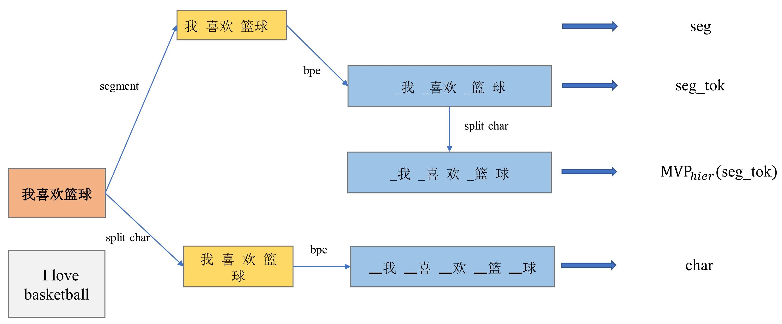
) is depicted in Figure 2(b). In MVP
1
2
V
i = e
is kept for finetuning (single vocab model), and
means both encoders are kept (ensemble
1
model).
The third version of MVP (denoted as MVP
2
, the sentence
obj
obj
is encoded only once with a fine-grained vocab, and MLM task with that vocab is conducted.
As in
喜欢
the figure, he word ”
” (like) is masked, and under the vocab of char, the PLM has to predict
V
Note that after pre-training,
one can either keep
one of the encoder or both encoders for downstream finetuning.
We will denote this strategy as
(V
, V
, i)
V
喜
i = s
MVP
, where
and
are two different vocabs,
means only the encoder with
pair
1
1
V
V
V
and
are a pair of vocabs and
is the more fine-grained one.
1
2
2
Figure 1:
An illustration of how to process input sentence into tokens under different methods we
define.
1
https://github.com/fxsjy/jieba
2
欢
”
” and ”
” for the two masked tokens.
As additional training objective, we will employ a more
喜
coarse-grained vocab like seg tok and ask the model to use the starting token (”
”)’s representation
thus enhancing its expressiveness.
(V
, V
)
to predict the original word under seg tok.
We will denote this strategy as MVP
, where
pair
1
by splitting the Chinese words in the word based vocab into Chinese chars, and non-Chinese tokens
the vector representations of multi-gram words or tokens,
which then are fed into transformer en-
coders, and then the word based vocab will be used in masked language model (MLM) training. We
will denote this version of MVP as MVP
.
Note that in MVP
, the char based vocab is built
hier
hier
the viewpoint of model forward pass, the embeddings of Chinese characters are aggregated to form
(V )
V
are kept the same. We will denote this strategy as MVP
, where
is a word based vocab.
hier
The second version of MVP (denoted as MVP
) is to employ a pair of vocabs in MLM. Due to
See Figure 1 for their workflow of processing an input
Chinese characters with white spaces, and then learn a sub-word tokenizer (denote as char); (2) first
1
segment the sentences with a CWS toolkit like jieba
, and then learn a sub-word tokenizer (denoted
as seg tok); (3) do CWS and kept the high-frequency words as tokens and low-frequency words will
be tokenized by seg tok (denoted as seg).
pair
sentence. Note that the first one is essentially the same with the vocab of Google Chinese BERT.
Inspired by the previous work that incorporate multiple vocabularies (vocabs) or combine multiple
vocabs in an natural wayYin et al. (2016); Dong et al. (2016), we also investigate a series of strate-
gies, which we will call Multi-Vocab Pretraining (MVP) strategies.
The first version of MVP is to
incorporate a hierarchical structure to combine the char based vocab and word based vocab.
From
”
” (basketball) is masked.
The left encoder, which is
篮球
with seg tok, has to predict the single masked token is ”
”, and the right encoder has to predict
篮
球
For example, the word ”
” and ”
” for two masked tokens.
MLM loss from both sides will
be added with weights.
With MVP
, parameter sharing enables the single vocab model to absorb information from the
pair
other vocab,
,
limited resources,
in this article we only consider the pair between seg tok and char.
MVP
is
pair
depicted in Figure 2(c).
In MVP
Published as a conference paper at ICLR 2021
a sentence (or a concatenation of multiple sentences in pre-
pair
training), is processed and tokenized both in seg tok and char, and the two sentences are encoded
by two parameter-sharing transformer encoders.
Whole word masking Cui et al. (2019b) is applied
篮球
for pretraining.
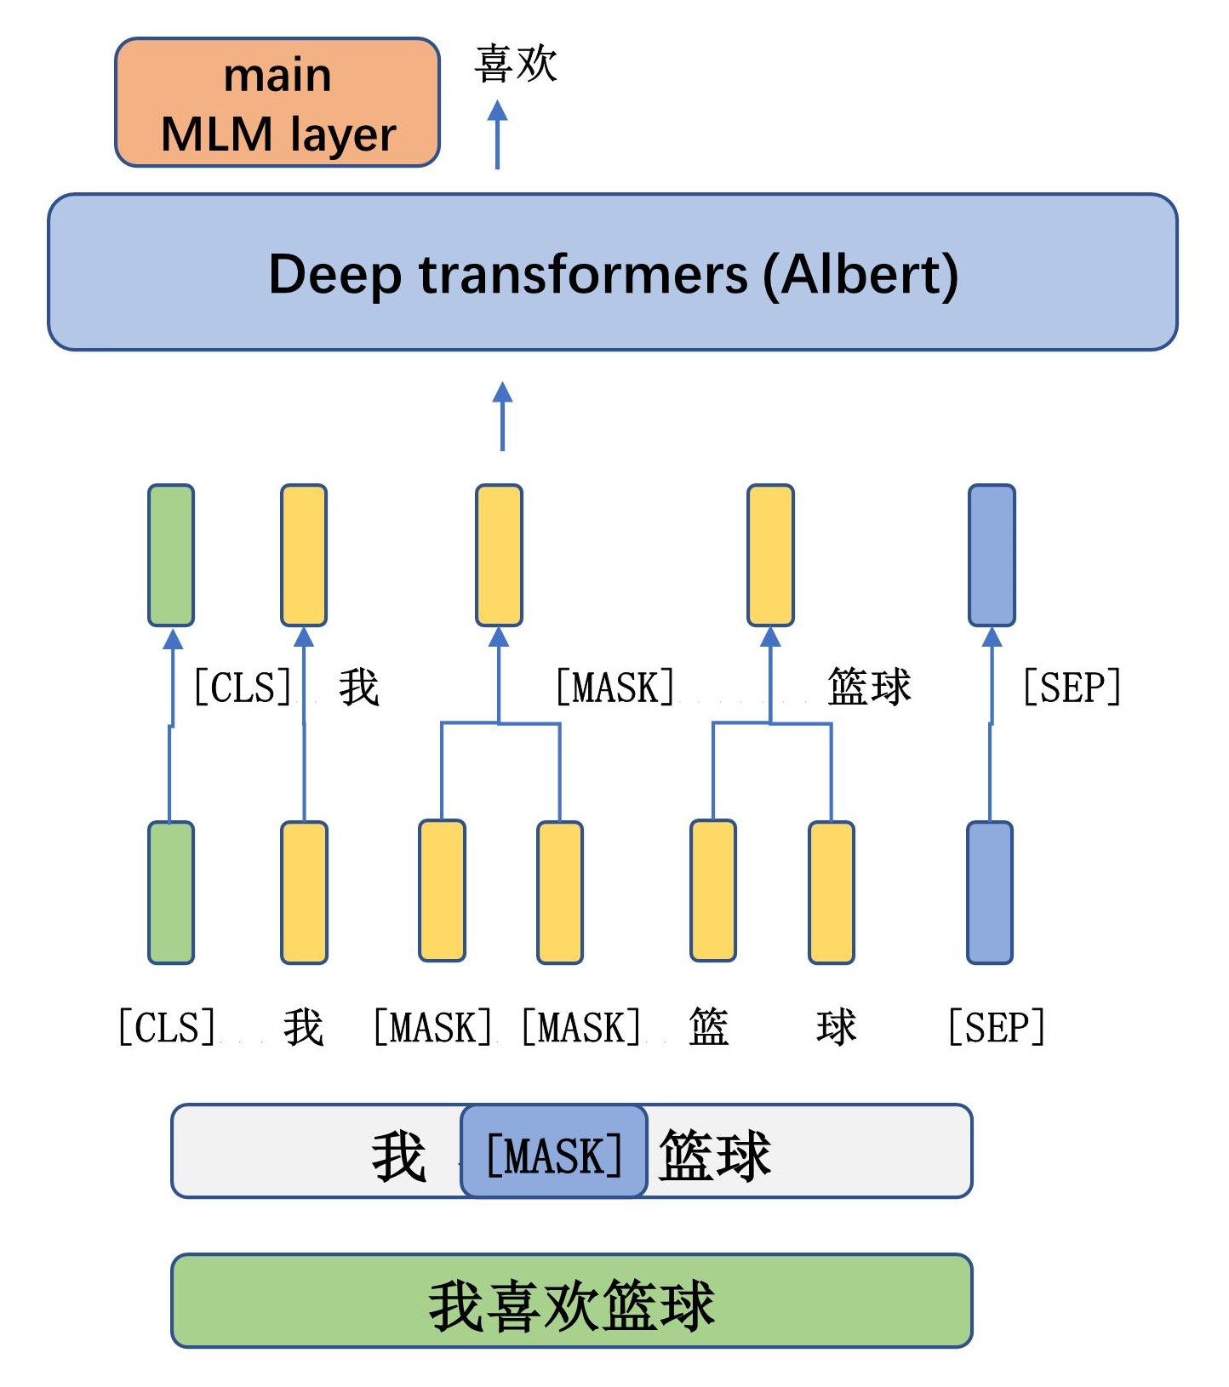
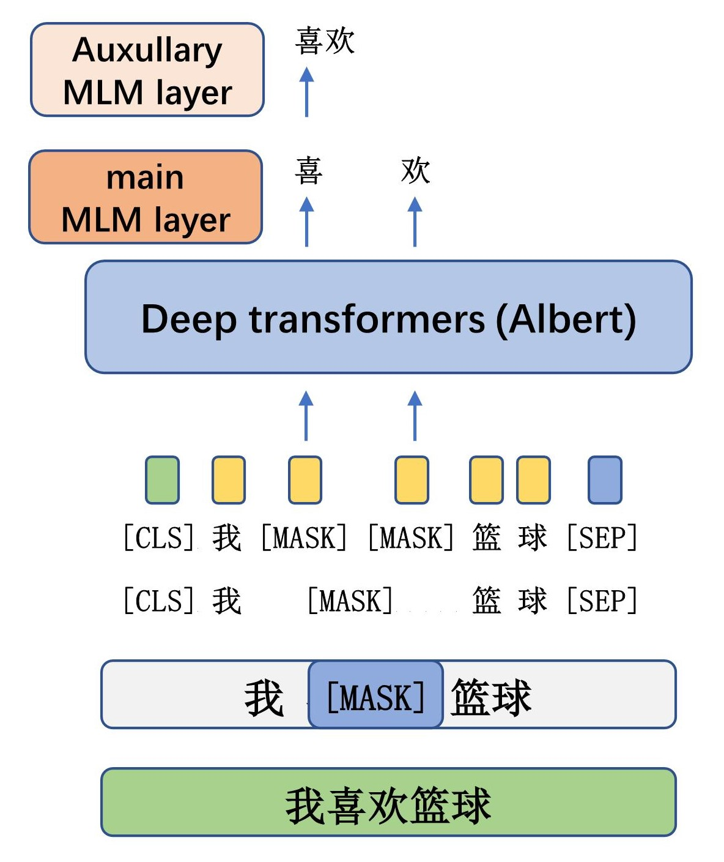
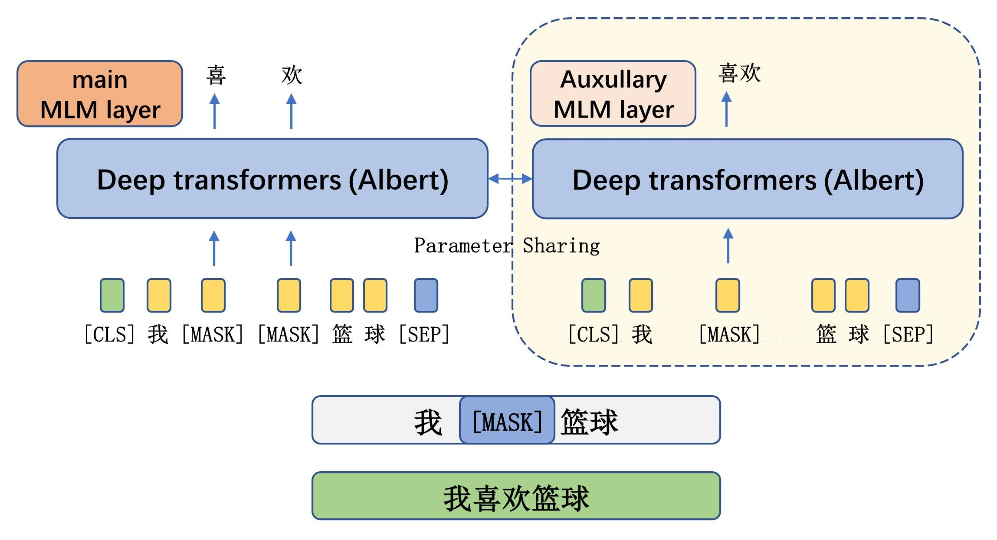
combination of CWS and subword tokenization is novel.
help seg tok on sequence labeling tasks; 4) MVP
ensemble are the best model, but it comes with
pair
a higher inference time; 5) MVP
help to provide a better single vocab model than MVP
.
obj
pair
We now summaries the following contributions in this work.
•
experiments on three ways of building new vocab for Chinese BERT,
and seg tok,
the
3) MVP strategies can help to improve a single vocab model on both types of tasks, especially it can
•
We propose 3 MVP strategies for enhancing the Chinese PLMs.
2
RELATED WORK
Before and since Devlin et al.
(2018),
a large amount of literature on pretrained language model
appear and push the NLP community forward with a speed that
has never been witnessed be-
2
https://github.com/google/sentencepiece
3
https://dumps.wikimedia.org/zhwiki/latest/
3
as the sub-word model, and Albert Lan et al. (2019) (base model) as our PLM. Pre-training
(a) MVP
(b) MVP
hier
obj
(c) MVP
pair
Figure 2: The architectures for the three versions of MVP strategies.
Extensive experiments and ablation studies are conducted.
We select BPE implemented by senten-
2
cepiece
Published as a conference paper at ICLR 2021
3
is done on Chinese Wikipedia corpus
,
which is also the corpus on which we build the different
vocabs. After pretraining, the three vocab building methods and three MVP strategies are compared
on a series of Chinese benchmark datasets,
4 of which are sentence classification tasks,
3 are se-
quence labeling tasks.
The experimental results demonstrate the following take-aways:
1) directly
use Chinese words as vocab (seg) does not perform well;
2) seg tok based ALBERT consistently
performs better than char and seg on sentence classification tasks, but not sequence labeling tasks;
Note that in seg tok, some natural word will be splitted into pieces, but there are still many tokens
tokenize them into subword
c) for long tail Chinese words and non-Chinese tokens,
frequency 0;
and add the tokens from seg tok with
b) count the words’ frequency,
a) do CWS on the corpus;
is built with the following procedures:
seg with size
Finally,
that have multiple Chinese chars.
N
tokens with seg tok, and the words’ frequencies are added to the sub-word tokens’ frequencies; d)
corpus to be segmented and a sub-word tokenizer like BPE are learned on the segmented sentences.
seg tok requires the sentences in
separated with blank spaces and a sub-word tokenizer is learned.
For char based vocab char, Chinese characters in the corpus are treated as words in English and are
(or a group of vocabs) (Figure 1). We first introduce the single vocab models, char, seg tok and seg.
We investigate four work-flows to process the text inputs, each corresponding to a different vocab
UILDING THE VOCABS
B
3.1
our series of MVP strategies.
introduce MVP,
4
common, that is, they require more than one vocab to implement pre-training.
pair
obj
hier
, all of which have one thing in
and MVP
, MVP
MVP has three versions, MVP
(2018).
al.
which is a derivation of MLM task by Devlin et
In this section, we present our methods for rebuilding the vocab for Chinese PLMs, and introduce
we will
In this subsection,
VOCAB PRETRAINING
ULTI
(MVP)
-
M
3.2
corpus, then take them as vocab. Note that some of the tokens from seg tok will be dropped.
sort the vocab via frequency, and if the most frequent N words or tokens can cover 99.95% of the
BERT,
ERNIE 2.0 Sun et al.
for learning of better representations of tokens and sentences.
et al. (2019) designs two novel pre-training tasks, word structural task and sentence structural task,
ing tasks. ALBERT Lan et al. (2019) introduce sentence order prediction (SOP). StructBERT Wang
More work have focused on new language pretrain-
prove the training of BERT with larger corpus.
The second branch of literature improve the training of BERT. Liu et al. (2019b) stabilize and im-
BERT’s performance on longer sequences by employing sparser attention.
Zaheer et al. (2020) improve
bedding factorization and progressive cross layer parameter sharing.
model architecture of BERT. ALBERT Lan et al. (2019) makes BERT more light-weighted by em-
The first branch of literature improves the
a series of improvements have been proposed.
(2019) pro-
Since
modeling (MLM) and next sentence prediction (NSP), where the former is more important.
In its core, what makes BERT so powerful are the pretraing tasks, i.e., Mask language
input text.
auto-regressive manner, and BERT is bi-directional and make prediction on the whole or part of the
GPTs are uni-directional and make prediction on the input text in an
former Vaswani et al. (2017).
GPTs Radford et al. (2018; 2019) and BERT Devlin et al. (2018) take advantages of Trans-
words.
Peters et al. (2018) is one of the earliest PLMs that learns contextualized representations of
fore.
training and the learned model can substantially enhance the performances of span selection tasks.
UR METHODS
O
3
segmentation and sub-word tokenizations.
we propose to re-design the vocabulary of the Chinese BERT by combining word
to literature,
compared
In this work,
of single Chinese characters can significantly improve Chinese PLMs.
and Sun et al. (2019) both show that masking tokens in the units of natural Chinese words instead
Cui et al. (2019a)
It is indicated that word segmentation is especially important for Chinese PLMs.
Published as a conference paper at ICLR 2021
text spans are masked in pre-
is effective for pretraining BERT. In SpanBERT Joshi et al. (2019),
Devlin et al. (2018), the authors propose whole word masking in their open-source repository, which
Although not mentioned in
Another branch of literature look into the role of words in pre-training.
contextual learning, and it can be easily incorporated with other sentence structural tasks like SOP.
Our proposed tasks focus on intra-sentence
ing objective by incorporating multiple vocabularies.
training. Our work is closely related to this branch of literature by design a series of novel pretrain-
TRA Clark et al. (2020) has a GAN-style pretraining task for efficiently utilizing all tokens in pre-
ELEC-
poses a series of pretraining tasks and applies continual learning to incorporate these tasks.
x
, which is the most resource-demanding version of MVP, but it will be
Now we introduce MVP
the auxiliary MLM task.
is the coefficient which measures the relative importance of
Here
respectively.
and
sequence
λ
y
pair
i
i
-th token is masked in
are variables with binary values indicating whether the
and
in which
i
I
I
2
喜
token on the right sequence are masked. The left encoder and MLM layer is tasked to recover the two
”
example in Figure 2(c),
and thus two tokens on the left sequence and(or) one
” is masked,
喜欢
For
Transformer encoders will share the same parameters, but the embedding layers are separate.
x
1
, which will be fed into separate transformer encoders.
and
and embedded with two vocabs,
V
V
encoder with another vocab and a corresponding MLM task. In this strategy, a sentence is tokenized
Our goal is to enhance the model with a single vocab, by introducing additional
proven beneficial.
mask
−
|x) ≈ min
, y
(x
− log P
min
mask
mask
x
mask
I
y
x
y
X
X
l
l
obj
c
θ
y
i=1
i=1
θ
θ
i
i
i
i
欢
θ
θ
|x),
(y
log P
I
|x) − λ ∗
(x
log P
If after MVP
pair
pair
For single mode
.
Otherwise, we can call the model as ensemble MVP
.
single vocab MVP
pair
we will call this model
pretraining we decide to only keep one of the encoder,
MVP
i=1
i=1
θ
θ
i
i
i
i
θ
When doing sequence labeling tasks,
5
can bring improvements.
Due to limited resources available, we leave to future work to investigate whether alternative aggregators
4
approach is to concatenate the features from fine-grained encoder to the coarse-grained encoder.
The first
ensemble can be conducted, which we will use the example from Figure 2(c) to illustrate.
two ways of
θ
nated to be the feature vector of the classifier.
the pooled vectors on both [CLS] tokens will be concate-
For sentence classification,
is different.
pair
pair
Finetuning for ensemble mode MVP
finetuning is the same with vanilla ALBERT.
,
parameter sharing, self-supervised signals from one vocab is transferred to the model with the other
y
x
y
X
X
l
l
pair
is
vocab. Formally, Thus the loss function for MVP
mask
Through
”.
And on the right, the other MLM layer needs to recover ”
”.
” and ”
tokens ”
喜欢
−
θ
|y),
(y
log P
I
|x) − λ ∗
(x
log P
I
is as follows:
|x, y) ≈ min
, y
(x
− log P
min
mask
mask
x
mask
欢
and
Let
.
which is from
”,
l
l
y
x
V
denote the sequences of tokens with length
a classifier is designated to predict the masked word token ”
At the MLM task,
word tokens.
喜
Then an aggregator will combine the embeddings into the vectors of
” are masked.
” and ”
x
. The loss function for MVP
tokens under
V
f
c
as the masked
, in which a part of tokens are masked. Denote
and
same sentence under
”
V
V
mask
y
x
c
for the
,
and
a fine-grained vocab
, and then the Chinese tokens
Sequences are first tokenized via
combined in a hierarchical way.
V
c
f
are
,
and a more coarse-grained vocab
,
c
Two vocab,
sentences.
input
V
V
hier
and Figure 2(a) depicts its procedure for processing
Figure 2(a) depicts the architecture of MVP
.
欢
喜
c
two tokens
thus in the char sequence,
” (like) is masked,
”
For example in Figure 2(a),
is
喜欢
V
During MLM task, whole word masking is applied, that is, we will mask 15% of the tokens in the
which is further fed into the transformer encoder.
aggregated into the representation of this word,
Then representations of chars inside a word is
and non-Chinese tokens are embedded into vectors.
Chinese characters
(if containing multiple Chinese characters) are splitted into single characters.
c
V
” is aggregated to the vector representation of the
” inside the word ”
” and ”
chars ”
喜欢
欢
喜
word,
encoded representations of the
For example,
is added.
based on a more coarse-grained vocab
V
f
However, different from the vanilla MLM, another MLM task
is conducted.
and MLM task on
y
respectively. The loss function for MVP
V
f
and
as the masked tokens under
and
Denote
represent the word’s representation.
V
V
x
4
mask
mask
in the example, we adopt BERT-style pooler, which is to use the starting token’s representation to
c
For the aggregator
.
and an auxiliary MLM layer is tasked to predict the word based on
(x
i
θ
i
θ
|x, y),
(x
log P
I
−
|x, y) ≈ min
θ
− log P
min
mask
mask
x
X
l
hier
c
.
f
obj
a char based vocab),
(e.g.,
a sentence is tokenized and embedded in a fine-grained
,
In MVP
V
i
Published as a conference paper at ICLR 2021
-th token is masked in
is a variable with binary values indicating whether the
in which
x
i
I
x
i=1
θ
2.0,
10.0.
Note that to maintain the consistency for non-Chinese tokens,
the char based
(seg tok)
(char, seg tok)
(char, seg tok)
vocab in MVP
, MVP
and MVP
is derived from
hier
obj
pair
1.0,
seg tok by splitting Chinese characters of seg tok tokens into characters, not exactly the same with
char.
For pretraining,
whole word masking is adopted,
and total 15% of the words (from CWS) in the
corpus are masked,
which are then tokenized into different
tokens under different
vocabs.
For
(char, seg tok)
we consider
(seg tok, seg)
λ
and MVP
,
with
equal
to 0.1,
0.5,
1.0,
2.0,
10.0.
For MVP
,
(char, seg tok)
obj
pair
(char, seg tok)
λ
MVP
,
the combination of seg tok and char based vocab,
with
equal to 0.1,
pair
0.5,
by Liu et al. (2019a). For sentence
the sequence length is 256,
the learning rate is 2e-5,
the
optimizer is Adam Kingma & Ba (2015) and the batch size is set as the power of 2 and so that each
epoch contains less than 1000 steps. Each model is run on a given task for 10 times and the average
performance scores and standard deviations are reported for reproducibility.
4.2
BENCHMARK TASKS
6
For downstream tasks, we select 4 text classification tasks: (1) ChnSentiCorp (chn)
, a hotel review
7
8
dataset; (2) Book review
(book review), collected from Douban
For finetuning,
5
Despite there are more sophisticated CWS toolkits avalable,
and using them may lead to better perfor-
mances, jieba is efficient and good enough to prove the importance of word segmentation in the vocab design
of Chinese BERT.
6
https://github.com/pengming617/bert classification
7
https://embedding.github.io/evaluation/
8
https://book.douban.com/
6
The maximum sequence length is 512.
MVP
and MVP
, 1/3 of the time only tokens seg tok are pre-
obj
pair
dicted, and 1/3 of the time only tokens from the derived char based vocab are predicted, and for the
rest of the time, tokens from both vocabs are predicted.
In this article, all models use the ALBERT as encoder. We make use of a smaller parameter settings,
that is, the number of layer is 3, the embedding size is 128 and the hidden size is 256. Other ALBERT
configurations remain the same with ALBERT Lan et al. (2019).
The pretraining hyper-parameters
are almost the same with ALBERT Lan et al. (2019).
obj
Here,
the sequence length is counted under the coarse-grained vocab for MVP
, fine-grained vocab for
hier
MVP
,
and the longer one of the two sequences under the two vocabs for MVP
.
The batch
obj
pair
size is 1024, and all the model are trained for 12.5k steps.
The pretraining optimizer is LAMB and
the learning rate is 1e-4.
(V
strategy and vocab
hier
V
(V )
V
V
as MVP
. MVP
with a fine-grained vocab
and a coarse-grained vocab
are denoted
hier
obj
f
c
For notational convenience, we will denote the model pretrained with MVP
, V
)
V
V
(V
, V
, i, j)
as MVP
. MVP
with two vocab
and
is denoted as MVP
, where
obj
喜欢
喜
欢
喜欢
That is,
representations of ”
” and ”
” are aggregated to the representation of ”
”,
and it
will be concatenated to the representation from the coarse-grained encoder on the right. We will call
this approach fine-to-coarse ensemble.
The other approach is coarse-to-fine ensemble, which is to
f
喜
欢
concatenate the representation of ”
” from the coarse-grained encoder to ”
” and ”
” from
喜
欢
the fine-grained encoder. Then the labels of ”
” and ”
” are predicted.
, we will
pair
j
neglect the parameter
.
4
E
XPERIMENTS
4.1
S
ETUP
For pre-training corpus, we use Chinese Wikipedia.
The vocab size is 21128 for char and seg tok.
50.38% of seg tok are Chinese tokens with length more than 1.
equals
5
In this article, we adopt jieba as our CWS tool.
To keep 70% of the vocab as natural words from
CWS, and cover 99.95% of the corpus, seg is built with vocab size 69341.
(seg tok)
(char, seg tok)
For MVP
, we consider MVP
.
For MVP
, we consider MVP
hier
hier
obj
or
c
pair
1
2
pair
1
2
i
single
V
ensemble
can be
,
meaning only keep the encoder from
for finetuning,
Published as a conference paper at ICLR 2021
,
meaning
1
j
f tc
ctf
keep both encoders, and
can be
(short for fine-to-coarse) or
(coarse-to-fine), which is two
i
single
approaches for finetuning MVP
on sequence labeling tasks. Note that if
87.85
0.54
±
±
±
pair
-
-
-
-
-
MVP
(char, seg tok, e, ctf )
0.47
74.32
82.28
0.36
0.56
0.65
0.94
0.29
0.32
0.18
0.37
±
E
4.3
medical records.
(ccks) is collected from
(fin) is from financial domain, and CCKS NER
domain, Finance NER
11
10
MSRA NER (msra) Levow (2006) is from open
We also investigate three NER tasks.
domain.
matching task in the open domain; (4) Law QA Liu et al. (2019a), a QA matching task in the legal
±
(nlpcc dbqa), a question-answer
(2018); (2) LCQMC (lcqmc) Liu et al. (2018); (3) NLPCC-DBQA
9
(1) XNLI (xnli) from Conneau et al.
pair classification tasks, we include the following 4 datasets:
ments are repeated for 10 times, and the average and standard deviation of the scores are reported.
For each task and each model, experi-
Main results on the Chinese benchmark datasets.
Table 1:
0.32
73.17
±
±
±
±
±
±
±
±
pair
MVP
(seg tok, char, s)
85.45
0.41
80.03
64.79
60.25
80.05
79.43
87.22
0.45
0.78
0.43
1.28
0.47
65.94
±
±
±
±
±
±
pair
MVP
(seg tok, char, e, f tc)
86.27
73.97
81.89
XPERIMENTAL RESULTS
60.86
80.56
80.05
87.96
0.47
1.18
0.85
1.03
0.52
0.44
0.31
(seg tok, char, e)
obj
achieve performances that are close to
than fine-to-coarse ensemble. Fourth, MVP
(seg tok, seg)
pair
pair
and coarse-to-fine ensemble is more effective
,
performs better than single MVP
ble MVP
MVP
pair
ensem-
note that for NER tasks,
Third,
on sentence level tasks.
vided by MVP
(seg tok, seg)
but the improvements are less than that pro-
provides improvements on sequence labeling tasks,
pair
obj
could be a more suitable choice.
7
CWS errors accounts for only less than 0.3% of the errors on CCKS.
12
https://biendata.com/competition/CCKS2017 2/
11
https://embedding.github.io/evaluation/#extrinsic
10
http://tcci.ccf.org.cn/conference/2016/dldoc/evagline2.pdf
9
obj
keeping only one encoder
limited scenarios, MVP
obj
pair
Thus, for resources
.
takes almost twice the resources and time than MVP
finetuning, MVP
Notice that for pretraining and
But the model’s improvements on NER tasks are less significant.
pair
on lcqmc, with less than half of the time in pre-training and fine-tuning.
i.e.,
The lower rows of Table 1 also demonstrates the effectiveness of MVP training.
than seg tok. we can observe a 1.35x speed up when changing the vocab from char to seg tok.
In addition, seg tok is more efficient
Chinese PLMs in sentence level tasks via vocab re-designing.
we show that both CWS and subword tokenization are important to improve the expressiveness of
From the above results,
thus are less well trained for token level classification.
training samples,
each token has less
Note that
its disadvantages on sequence labeling tasks is due to sparcity of tokens,
We believe that
.
where these performance gaps are only partially explained by the CWS errors
12
However, seg tok is worse than or comparable to char on three NER tasks,
having less parameters.
form better than char on all sentence classification tasks, and seg tok outperforms seg even though
We first compare the three single vocab models. We find that word based vocabs seg tok and seg per-
First,
seg tok,
for
Second,
.
and ensemble MVP
come from MVP
improvements
among which the largest
MVPs consistently improve the models’ performances,
pair
obj
we can see
0.63
.
with
and MVP
,
with
MVP
we report
this table,
λ = 1.0
λ = 2.0
in
±
79.27
78.53
87.06
0.74
1.26
0.81
1.15
0.43
0.42
0.20
0.46
59.71
±
±
±
±
±
±
±
seg tok
84.79
72.12
79.81
64.02
±
59.89
79.64
78.67
87.06
0.93
1.64
1.17
1.83
0.59
0.68
0.43
0.78
60.19
±
±
±
±
±
±
±
seg
83.96
71.24
79.07
63.32
acc
59.22
77.85
77.83
86.61
exact F1
exact F1
exact F1
macro F1
acc
acc
acc
62.09
metric
ccks
fin
msra
nlpcc
xnli
lcqmc
br
chn
task
±
79.79
79.08
87.17
0.28
0.61
0.61
2.57
0.76
0.78
0.55
1.12
±
64.06
±
±
±
±
±
±
char
85.63
73.43
81.14
±
1.24
0.36
0.39
0.21
0.32
±
±
±
±
±
±
±
0.77
obj
MVP
(seg tok, seg)
85.56
73.47
81.05.
65.48
60.57
80.44
79.67
87.55
tok, s)
0.68
0.66
±
±
±
±
±
±
±
±
pair
MVP
0.35
(char, seg
85.97
73.78
81.47
63.78
60.23
78.63
78.56
87.04
0.68
1.23
±
87.26
0.98
1.07
0. 75
1.32
0.53
0.59
0.53
0.48
±
±
78.45
±
±
±
±
±
hier
MVP
(seg tok)
84.88
72.36
80.57
±
0.58
0.56
1.22
0.48
0.56
0.64
0.52
±
±
±
±
±
Published as a conference paper at ICLR 2021
±
±
obj
MVP
(char, seg tok)
86.10
73.95
81.56
63.67
59.98
78.92
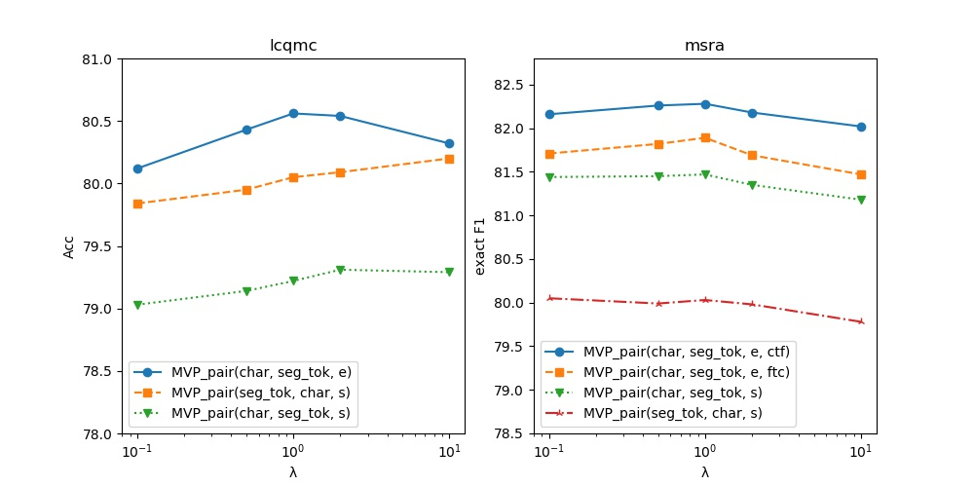
August 2015.
Christopher Potts,
and Christopher D.
Manning.
A large an-
notated corpus for learning natural language inference.
arXiv e-prints,
art.
arXiv:1508.05326,
Gabor Angeli,
Kevin Clark,
Minh-Thang Luong,
Quoc V.
Le,
and Christopher
D.
Manning.
ELECTRA:
Bowman,
Samuel R.
EFERENCES
R
sequence labeling tasks.
can improve seg tok’s performances on
especially it
improves PLMs’ downstream performance,
(b) MVP
it can also improve efficiency;
performances of Chinese PLMs on sentence level tasks,
seg tok does not only improves the
(a) compared with char based vocabulary,
guistics.
In
Proceedings of the 2018 Conference on Empirical Methods in Natural Language Processing, pp.
2475–2485,
Brussels,
Belgium,
October-November 2018.
Association for Computational
Lin-
XNLI: Evaluating cross-lingual sentence representations.
doi:
10.18653/v1/D18-1269.
URL
https://www.aclweb.org/anthology/
.
D18-1269
8
iments show that:
and Veselin Stoyanov.
Schwenk,
Holger
Bowman,
Samuel
Adina Williams,
Guillaume Lample,
Ruty Rinott,
Alexis Conneau,
arXiv:2003.10555, March 2020.
art.
arXiv e-prints,
Than Generators.
Encoders as Discriminators Rather
Pre-training Text
We set
downstream performances.
Here for
MVP
,
is assigned to
pair
λ
the loss term from coarse-grained vocab.
affects the ALBERT models’
equal
to 0.1,
0.5,
1,
2,
10,
and run per-
training under each of the setting.
λ
pair
for MVP
In this section, we investigate how the relative importance coefficient
(char, seg tok)
λ
affects the models’ downstream performances.
Figure 3: How the value of coefficient
λ
FFECTS OF RELATIVE IMPORTANCE COEFFICIENT
E
4.4
pair
Exper-
three versions of multi-vocabulary pretraining (MVP) to improve the models’ performance.
Then we propose
with the help of Chinese word segmentation (CWS) and subword tokenization.
In this work, we first propose a novel method, seg tok, to re-build the vocabulary of Chinese BERT,
ONCLUSIONS
C
5
pair
.
level tasks, and vice versa for MVP
(seg tok, char, s)
Published as a conference paper at ICLR 2021
worsen the performance on NER, but not on sentence
, increasing
for MVP
λ
(char, seg tok, s)
pair
And
provides the best performances.
,
For ensemble MVP
ure 3.
λ = 1.0
(char, seg tok, e)
Finetuning results on lcqmc and msra are reported in Fig-
URL
LCQMC:a large-scale Chinese question matching corpus.
In Proceedings of the 27th Interna-
tional Conference on Computational Linguistics, pp. 1952–1962, Santa Fe, New Mexico, USA,
August
2018.
Association for
Computational
Linguistics.
and Buzhou Tang.
https://www.aclweb.
.
org/anthology/C18-1166
Yinhan Liu,
Myle Ott,
Naman Goyal,
Jingfei Du,
Mandar Joshi,
arXiv e-prints,
Zhe Zhao,
Zhiruo Wang,
Qi
Ju,
Haotang Deng,
and Ping Wang.
K-BERT:
Enabling Language Representation with Knowledge Graph.
Danqi Chen,
art.
arXiv:1909.07606, September 2019a.
Xin Liu,
Qingcai Chen,
Chong Deng,
Huajun Zeng,
Jing Chen,
Dongfang Li,
tions for SQuAD.
David Luan,
Dario Amodei,
and Ilya Sutskever.
Language
models are unsupervised multitask learners.
arXiv e-prints, 2019.
Pranav Rajpurkar, Robin Jia, and Percy Liang.
Know What You Don’t Know: Unanswerable Ques-
Rewon Child,
arXiv e-prints, art. arXiv:1806.03822, June 2018.
Yu Sun, Shuohuan Wang, Yukun Li, Shikun Feng, Xuyi Chen, Han Zhang, Xin Tian, Danxiang Zhu,
Hao Tian, and Hua Wu.
Ernie:
Enhanced representation through knowledge integration.
arXiv
preprint arXiv:1904.09223, 2019.
9
Luke Zettlemoyer.
Omer Levy,
Mike
Lewis, Luke Zettlemoyer, and Veselin Stoyanov.
RoBERTa:
A Robustly Optimized BERT Pre-
training Approach.
arXiv e-prints, art. arXiv:1907.11692, July 2019b.
Matthew E. Peters, Mark Neumann, Mohit Iyyer, Matt Gardner, Christopher Clark, Kenton Lee, and
Peng Zhou,
Deep contextualized word representations.
In Proc. of NAACL, 2018.
Alec Radford, Karthik Narasimhan, Tim Salimans, and Ilya Sutskever.
Improving language under-
standing by generative pre-training.
arXiv e-prints, 2018.
Alec Radford,
Jeff Wu,
Yinhan Liu,
arXiv preprint arXiv:1810.04805, 2018.
C. Dong, Jiajun Zhang, C. Zong, M. Hattori, and Hui Di. Character-based lstm-crf with radical-level
features for chinese named entity recognition.
In NLPCC/ICCPOL, 2016.
Mandar
Joshi,
Danqi
Chen,
bidirectional transformers for language understanding.
Daniel
S.
Weld,
Luke Zettlemoyer,
and Omer
Levy.
SpanBERT:
Improving pre-training by representing and predicting spans.
Training with Whole Word Masking for Chinese BERT.
Yiming Cui, Wanxiang Che, Ting Liu, Bing Qin, Ziqing Yang, Shijin Wang, and Guoping Hu.
Pre-
Training with Whole Word Masking for Chinese BERT.
arXiv e-prints, art. arXiv:1906.08101,
June 2019a.
Yiming Cui, Wanxiang Che, Ting Liu, Bing Qin, Ziqing Yang, Shijin Wang, and Guoping Hu.
Pre-
arXiv preprint
arXiv e-prints, art. arXiv:1906.08101,
June 2019b.
Jacob Devlin,
Ming-Wei Chang,
Kenton Lee,
and Kristina Toutanova.
Bert:
Pre-training of deep
Arianna Yuan,
URL
.
https://www.aclweb.org/anthology/W06-0115
Xiaoya Li,
Yuxian Meng,
Xiaofei
Sun,
Qinghong Han,
Linguistics.
and Jiwei
Li.
Is Word
Segmentation Necessary for Deep Learning of Chinese Representations?
arXiv e-prints,
art.
arXiv:1905.05526, May 2019.
Weijie Liu,
arXiv preprint
arXiv:1907.10529, 2019.
Diederik P. Kingma and Jimmy Ba.
Adam: A method for stochastic optimization.
In ICML, 2015.
Zhenzhong Lan, Mingda Chen, Sebastian Goodman, Kevin Gimpel, Piyush Sharma, and Radu Sori-
cut.
Albert:
A lite bert for self-supervised learning of language representations.
Published as a conference paper at ICLR 2021
arXiv:1909.11942, 2019.
Gina-Anne Levow.
The third international Chinese language processing bakeoff:
Word segmenta-
tion and named entity recognition.
In Proceedings of the Fifth SIGHAN Workshop on Chinese
Language Processing, pp. 108–117, Sydney, Australia, July 2006. Association for Computational
for Longer Sequences.
Zou,
Will Y.
cessing and Computational Linguistics, pp. 248–263. Springer, 2013.
In International Conference on Intelligent Text Pro-
mentation for chinese machine translation.
An empirical study on word seg-
Hai Zhao, Masao Utiyama, Eiichiro Sumita, and Bao-Liang Lu.
arXiv e-prints, art. arXiv:2007.14062, July 2020.
Richard Socher,
Transformers
Big Bird:
Philip Pham, Anirudh Ravula, Qifan Wang, Li Yang, and Amr Ahmed.
Manzil Zaheer, Guru Guruganesh, Avinava Dubey, Joshua Ainslie, Chris Alberti, Santiago Ontanon,
https://www.aclweb.org/anthology/D16-1100
.
URL
10.18653/v1/D16-1100.
Seattle,
10
anthology/D13-1141
.
https://www.aclweb.org/
URL
tober 2013. Association for Computational Linguistics.
USA, Oc-
Washington,
ing, pp. 981–986, Austin, Texas, November 2016. Association for Computational Linguistics. doi:
pp. 1393–1398,
ical Methods in Natural Language Processing,
In Proceedings of the 2013 Conference on Empir-
dings for phrase-based machine translation.
Bilingual word embed-
Manning.
and Christopher D.
Daniel Cer,
arXiv:1907.12412, July 2019.
Łukasz Kaiser, and Illia Polosukhin.
Aidan N Gomez,
Llion Jones,
Jakob Uszkoreit,
Parmar,
Niki
Noam Shazeer,
Ashish Vaswani,
Attention is all you need.
art.
arXiv e-prints,
Pre-training Framework for Language Understanding.
A Continual
2.0:
ERNIE
Yu Sun, Shuohuan Wang, Yukun Li, Shikun Feng, Hao Tian, Hua Wu, and Haifeng Wang.
Cognitive Computation, 7, 02
ding. In Proceedings of the 2016 Conference on Empirical Methods in Natural Language Process-
Rongchao Yin, Quan Wang, Peng Li, Rui Li, and Bin Wang. Multi-granularity Chinese word embed-
arXiv:1906.08237, June 2019.
arXiv e-prints, art.
XLNet: Generalized Autoregressive Pretraining for Language Understanding.
Zhilin Yang, Zihang Dai, Yiming Yang, Jaime Carbonell, Ruslan Salakhutdinov, and Quoc V. Le.
doi: 10.1007/s12559-015-9319-y.
2015.
Published as a conference paper at ICLR 2021
sition for data imbalances in sentiment and emotion classification.
Word embedding compo-
Ruifeng Xu, Tao Chen, Yunqing Xia, Qin Lu, Bin Liu, and Xuan Wang.
arXiv e-prints, art. arXiv:1908.04577, August 2019.
BERT: Incorporating Language Structures into Pre-training for Deep Language Understanding.
Struct-
Wei Wang, Bin Bi, Ming Yan, Chen Wu, Zuyi Bao, Jiangnan Xia, Liwei Peng, and Luo Si.
In NIPS, 2017.

