

USER GUIDE

v2023.3.1 | September 2023

User Manual

TABLE OF CONTENTS

Chapter 1. Profiling from the CLI 1
  - Installing the CLI on Your Target 1
  - Command Line Options 1
    - CLI Global Options 2
  - CLI Command Switches 2
    - CLI Analyze Command Switch Options 4
    - CLI Cancel Command Switch Options 10
    - CLI Export Command Switch Options 12
    - CLI Launch Command Switch Options 15
    - CLI Profile Command Switch Options 37
    - CLI Sessions Command Switch Subcommands 77
      - CLI Sessions List Command Switch Options 77
    - CLI Shutdown Command Switch Options 78
    - CLI Start Command Switch Options 79
    - CLI Stats Command Switch Options 98
    - CLI Status Command Switch Options 107
    - CLI Stop Command Switch Options 108
  - Example Single Command Lines 109
  - Example Interactive CLI Command Sequences 112
  - Example Stats Command Sequences 118
  - Example Output from --stats Option 119
  - Importing and Viewing Command Line Results Files 122
  - Using the CLI to Analyze MPI Codes 124
    - Tracing MPI API calls 124
    - Using the CLI to Profile Applications Launched with mpirun 124
Chapter 2. Profiling from the GUI 127
  - Profiling Linux Targets from the GUI 127
    - Connecting to the Target Device 127
    - System-Wide Profiling Options 129
      - Linux x86_64 129
      - Linux for Tegra 131
    - Target Sampling Options 131
Target Sampling Options for Workstation 132
Target Sampling Options for Embedded Linux 133
    - Hotkey Trace Start/Stop 133
    - Launching Processes 134
  - Profiling Windows Targets from the GUI 134
Remoting to a Windows Based Machine 134
Hotkey Trace Start/Stop 134
Target Sampling Options on Windows 135
Symbol Locations 136
  - Profiling QNX Targets from the GUI 136
Chapter 3. Container Support on Linux Servers 138
GUI VNC container 139
GUI WebRTC container 141
Chapter 4. Migrating from NVIDIA nvprof 145
Using the Nsight Systems CLI nvprof Command 145
CLI nvprof Command Switch Options 145
Next Steps 148
Chapter 5. Direct3D Trace 149
  - D3D11 API trace 149
  - D3D12 API Trace 149
Chapter 6. WDDM Queues 154
Chapter 7. WDDM HW Scheduler 156
Chapter 8. Vulkan API Trace 157
  - Vulkan Overview 157
  - Pipeline Creation Feedback 159
  - Vulkan GPU Trace Notes 159
Chapter 9. Stutter Analysis 160
  - FPS Overview 160
  - Frame Health 164
  - GPU Memory Utilization 164
  - Vertical Synchronization 164
Chapter 10. OpenMP Trace 165
Chapter 11. OS Runtime Libraries Trace 167
  - Locking a Resource 168
  - Limitations 168
  - OS Runtime Libraries Trace Filters 169
  - OS Runtime Default Function List 170
Chapter 12. NVTX Trace 173
Chapter 13. CUDA Trace 177
  - CUDA GPU Memory Allocation Graph 180
  - Unified Memory Transfer Trace 181
Unified Memory CPU Page Faults 182
Unified Memory GPU Page Faults 183
  - CUDA Graph Trace 184
  - CUDA Python Backtrace 185
  - CUDA Default Function List for CLI 187
  - cuDNN Function List for X86 CLI 189
Chapter 14. OpenACC Trace 191
Chapter 15. OpenGL Trace 193
  - OpenGL Trace Using Command Line 195
Chapter 16. Custom ETW Trace 197
Chapter 17. GPU Metrics 199
Overview 199
Launching GPU Metric from the CLI 202
Launching GPU Metrics from the GUI 203
Sampling frequency 203
Available metrics 204
Exporting and Querying Data 207
Limitations 208
Chapter 18. CPU Profiling Using Linux OS Perf Subsystem 210
Chapter 19. NVIDIA Video Codec SDK Trace 218
  - NV Encoder API Functions Traced by Default 219
  - NV Decoder API Functions Traced by Default 220
  - NV JPEG API Functions Traced by Default 221
Chapter 20. Network Communication Profiling 222
  - MPI API Trace 223
  - OpenSHMEM Library Trace 226
  - UCX Library Trace 227
  - NVIDIA NVSHMEM and NCCL Trace 228
  - NIC Metric Sampling 228
  - InfiniBand Switch Metric Sampling 230
Chapter 21. Python Profiling 231
  - Python Backtrace Sampling 231
  - Python NVTX Annotations 232
Chapter 22. Reading Your Report in GUI 234
  - Generating a New Report 234
  - Opening an Existing Report 234
  - Sharing a Report File 234
  - Report Tab 234
  - Analysis Summary View 235
  - Timeline View 235
    - Timeline 235
Timeline Navigation 235
Row Height 238
Row Percentage 239
    - Events View 239
    - Function Table Modes 241
    - Function Table Notes 244
    - Filter Dialog 246
    - Example of Using Timeline with Function Table 246
  - Diagnostics Summary View 252
  - Symbol Resolution Logs View 252
Chapter 23. Adding Report to the Timeline 253
  - Time Synchronization 253
  - Timeline Hierarchy 255
  - Example: MPI 256
  - Limitations 257
Chapter 24. Post-Collection Analysis 258
  - Available Export Formats 258
    - SQLite Schema Reference 258
    - SQLite Schema Event Values 261
    - Common SQLite Examples 267
    - Arrow Format Description 281
    - JSON and Text Format Description 282
  - Statistical Analysis 282
Statistical Reports Shipped With Nsight Systems 283
cuda_api_gpu_sum[:base|:mangled] -- CUDA Summary (API/Kernels/MemOps) 283
cuda_api_sum -- CUDA API Summary 284
cuda_api_trace -- CUDA API Trace 284
cuda_gpu_kern_gb_sum[:base|:mangled] -- CUDA GPU Kernel/Grid/Block Summary 284
cuda_gpu_kern_sum[:base|:mangled] -- CUDA GPU Kernel Summary 285
cuda_gpu_mem_size_sum -- CUDA GPU MemOps Summary (by Size) 285
cuda_gpu_mem_time_sum -- CUDA GPU MemOps Summary (by Time) 286
cuda_gpu_sum[:base|:mangled] -- CUDA GPU Summary (Kernels/MemOps) 286
cuda_gpu_trace[:base|:mangled] -- CUDA GPU Trace 287
cuda_kern_exec_sum[:base|:mangled] -- CUDA Kernel Launch & Exec Time Summary 287
cuda_kern_exec_trace[:base|:mangled] -- CUDA Kernel Launch & Exec Time Trace 288
dx11_pix_sum -- DX11 PIX Range Summary 289
dx12_gpu_marker_sum -- DX12 GPU Command List PIX Ranges Summary 290
dx12_pix_sum -- DX12 PIX Range Summary 290
nvtx_gpu_proj_trace -- NVTX GPU Projection Trace 291
nvtx_gpu_proj_sum -- NVTX GPU Projection Summary 291
nvtx_kern_sum[:base|:mangled] -- NVTX Range Kernel Summary 292
nvtx_pushpop_sum -- NVTX Push/Pop Range Summary 293
nvtx_pushpop_trace -- NVTX Push/Pop Range Trace 293
nvtx_startend_sum -- NVTX Start/End Range Summary 294
nvtx_sum -- NVTX Range Summary 294
nvvideo_api_sum -- NvVideo API Summary 295
openacc_sum -- OpenACC Summary 295
opengl_khr_gpu_range_sum -- OpenGL KHR_debug GPU Range Summary 295
opengl_khr_range_sum -- OpenGL KHR_debug Range Summary 296
openmp_sum -- OpenMP Summary 296
osrt_sum -- OS Runtime Summary 297
um_cpu_page_faults_sum -- Unified Memory CPU Page Faults Summary 297
um_sum[:rows=<limit>] -- Unified Memory Analysis Summary 297
um_total_sum -- Unified Memory Totals Summary 298
vulkan_api_sum -- Vulkan API Summary 298
vulkan_api_trace -- Vulkan API Trace 298
vulkan_gpu_marker_sum -- Vulkan GPU Range Summary 299
vulkan_marker_sum -- Vulkan Range Summary 299
wddm_queue_sum -- WDDM Queue Utilization Summary 300
Report Formatters Shipped With Nsight Systems 300
Column 300
Table 301
CSV 301
TSV 302
JSON 302
HDoc 302
HTable 303
  - Expert Systems Analysis 303
Using Expert System from the CLI 303
Using Expert System from the GUI 303
Expert System Rules 304
CUDA Synchronous Operation Rules 304
GPU Low Utilization Rules 305
Other Rules 306
  - Multi-Report Analysis 307
Available Recipes 308
Opening in Jupyter Notebook 313
Configuring Dask 314
Tutorial: Create a User-Defined Recipe 315
Chapter 25. Import NVTXT 320
Commands 321
Chapter 26. Visual Studio Integration 323
Chapter 27. Troubleshooting 325
  - General Troubleshooting 325
  - CLI Troubleshooting 326
  - Launch Processes in Stopped State 326
LD_PRELOAD 327
Launcher 327
  - GUI Troubleshooting 328
Ubuntu 18.04/20.04/22.04 and CentOS 7/8/9 with root privileges 328
Ubuntu 18.04/20.04/22.04 and CentOS 7/8/9 without root privileges 329
Other platforms, or if the previous steps did not help 329
  - Symbol Resolution 329
Broken Backtraces on Tegra 331
Debug Versions of ELF Files 332
  - Logging 333
Verbose Remote Logging on Linux Targets 333
Verbose CLI Logging on Linux Targets 333
Verbose Logging on Windows Targets 334
Chapter 28. Other Resources 335
Training Seminars 335
Blog Posts 335
Feature Videos 335
Conference Presentations 336
For More Support 336

Chapter 1.
PROFILING FROM THE CLI

Installing the CLI on Your Target
The Nsight Systems CLI provides a simple interface to collect on a target without using the GUI. The collected data can then be copied to any system and analyzed later.
The CLI is distributed in the Target directory of the standard Nsight Systems download package. Users who want to install the CLI as a standalone tool can do so by copying the files within the Target directory. If you want the CLI output file (.qdstrm) to be auto- converted (to .nsys-rep) after the analysis is complete, you will need to copy the host directory as well.
If you wish to run the CLI without root (recommended mode), you will want to install in a directory where you have full access.
Note that you must run the CLI on Windows as administrator.

Command Line Options
The Nsight Systems command lines can have one of two forms:
nsys [global_option]
or
nsys [command_switch][optional command_switch_options][application] [optional application_options]
All command line options are case sensitive. For command switch options, when short options are used, the parameters should follow the switch after a space; e.g. -s
process-tree. When long options are used, the switch should be followed by an equal sign and then the parameter(s); e.g. --sample=process-tree.
For this version of Nsight Systems, if you launch a process from the command line to begin analysis, the launched process will be terminated when collection is complete, including runs with --duration set, unless the user specifies the --kill none option (details

below). The exception is that if the user uses NVTX, cudaProfilerStart/Stop, or hotkeys to control the duration, the application will continue unless --kill is set.
The Nsight Systems CLI supports concurrent analysis by using sessions. Each Nsight Systems session is defined by a sequence of CLI commands that define one or more collections (e.g. when and what data is collected). A session begins with either a start, launch, or profile command. A session ends with a shutdown command, when a profile command terminates, or, if requested, when all the process tree(s) launched in the session exit. Multiple sessions can run concurrently on the same system.

CLI Global Options

Short | Long | Description
-h | --help | Help message providing information about available command switches and their options.
-v | --version | Output Nsight Systems CLI version information.

CLI Command Switches
The Nsight Systems command line interface can be used in two modes. You may launch your application and begin analysis with options specified to the nsys profile command. Alternatively, you can control the launch of an application and data collection using interactive CLI commands.

Command | Description
analyze | Post process existing Nsight Systems result, either in .nsys-rep or SQLite format, to generate expert systems report.
cancel | Cancels an existing collection started in interactive mode. All data already collected in the current collection is discarded.
export | Generates an export file from an existing .nsys-rep file. For more information about the exported formats see the /documentation/nsys-exporter directory in your Nsight Systems installation directory.
launch | In interactive mode, launches an application in an environment that supports the requested options. The

Command | Description
launch command can be executed before
or after a start command.
nvprof | Special option to help with transition from legacy NVIDIA nvprof tool. Calling nsys nvprof [options] will provide the best available translation of nvprof [options] See Migrating from NVIDIA nvprof topic for details. No additional functionality of nsys will be available when using this option. Note: Not available on IBM Power targets.
profile | A fully formed profiling description requiring and accepting no further input.  The command switch options used (see below table) determine when the  collection starts, stops, what collectors are used (e.g. API trace, IP sampling, etc.), what processes are monitored, etc.
recipe | PREVIEW FEATURE Post process multiple existing Nsight Systems results, in .nsys-rep or SQLite to generate statistical information and create various plots. See Multi-Node Analysis topic for details.
sessions | Gives information about all sessions running on the system.
shutdown | Disconnects the CLI process from the launched application and forces the CLI process to exit. If a collection is pending or active, it is cancelled
start | Start a collection in interactive mode. The start command can be executed before or after a launch command.
stats | Post process existing Nsight Systems result, either in .nsys-rep or SQLite format, to generate statistical information.
status | Reports on the status of a CLI-based collection or the suitability of the profiling environment.
stop | Stop a collection that was started in interactive mode. When executed, all active collections stop, the CLI process

Command | Description
terminates but the application continues
running.

CLI Analyze Command Switch Options
The nsys analyze command generates and outputs to the terminal a report using expert system rules on existing results. Reports are generated from an SQLite export of a .nsys-rep file. If a .nsys-rep file is specified, Nsight Systems will look for an
accompanying SQLite file and use it. If no SQLite export file exists, one will be created.
After choosing the analyze command switch, the following options are available. Usage:
nsys [global-options] analyze [options] [input-file]

Short | Long | Possible Parameters | Default | Switch Description
 | --help | <tag> | none | Print the help message. The option can take one optional argument that will be used as a tag. If a tag is provided, only options relevant to the tag will be printed.
-f | --format | column, table, csv, tsv, json, hdoc, htable, . |  | Specify the output format. The special name "." indicates the default format for the given output. The default format for console  is column, while files and process  outputs default to csv. This option may be used multiple times. Multiple formats

).
Short | Long | Possible Parameters | Default | Switch Description
may also be
specified using a comma- separated list (<name[:args...]
[,name[:args...]...]> See Report Scripts for options
available with each format.
 | --force-export | true, false | false | Force a re- export of the SQLite file from the  specified .nsys- rep file, even if an SQLite file already exists.
 | --force- overwrite | true, false | false | Overwrite any existing output files.
 | --help-formats | <format_name>, ALL, [none] | none | With no argument, list a summary of the available  output formats. If a format name is given, a more detailed explanation of the the format is displayed. If ALL is given, a more detailed explanation of all available formats is displayed.
 | --help-rules | <rule_name>, ALL, [none] | none | With no argument, list available rules with a short description.

Short | Long | Possible Parameters | Default | Switch Description
If a rule name
is given, a more detailed explanation of the rule is displayed. If
ALL is given, a more detailed explanation of all available rules is displayed.
-o | --output | -, @<command>,  <basename>, . | - | Specify the output  mechanism. There are three output mechanisms:  print to console, output to file, or output to command. This option may be used multiple times. Multiple outputs  may also be specified using a comma- separated list. If the given output name is "-", the output will be displayed on the console.  If the output name starts with "@", the output designates a command to  run. The nsys command will be executed and the analysis

lysis&args>.<
Short | Long | Possible Parameters | Default | Switch Description
output will be
piped into the command. Any other output
is assumed to be the base
path and name for a file. If a file basename is given, the filename
used will be:
<basename>_<ana The default
base (including path) is the name of the SQLite file
(as derived from the input file or --sqlite option), minus the extension. The output "." can be used
to indicate the analysis should be output to
a file, and the default basename
should be used. To write one or more analysis outputs to
files using the default
basename, use the option: "-- output .". If the output starts with "@", the nsys command output is piped to the given command.

Short | Long | Possible Parameters | Default | Switch Description
The command
is run, and the output is piped to the command's
stdin (standard- input). The command's stdout and stderr remain attached to the console, so any output will
be displayed directly to the console. Be aware there are some limitations
in how the command string is parsed. No shell expansions (including *, ?, [], and ~) are supported.
The command cannot be piped to another command, nor redirected to
a file using shell syntax. The command and command arguments
are split on whitespace, and no quotes (within the command syntax) are supported. For commands that
require complex

Short | Long | Possible Parameters | Default | Switch Description
command line
syntax, it is suggested that the command be put into a shell script file, and the script designated
as the output command.
-q | --quiet |  |  | Do not display verbose messages, only display errors.
-r | --rule | cuda_memcpy_a cuda_memcpy_sy cuda_memset_syn cuda_api_sync, gpu_gaps, gpu_time_util, dx12_mem_ops | saylnl c, nc,  c, | Specify the rules(s) to execute, including any arguments. This option may be used multiple times. Multiple rules may also be specified using a comma- separated list.  See Expert Systems section and --help- rules switch for details on all rules.
 | --sqlite | <file.sqlite> |  | Specify the SQLite export filename. If this file exists, it will be used. If this file doesn't exist (or if --force- export was given) this file will be created from the specified .nsys- rep file before

Short | Long | Possible Parameters | Default | Switch Description
processing. This
option cannot be used if the specified input file is also an SQLite file.
 | --timeunit | nsec, nanoseconds, usec, microseconds, msec, milliseconds, seconds | nanoseconds | Set basic unit of time. The argument of the switch  is matched by using the longest prefix matching.  Meaning that it is not necessary to write a whole word  as the switch argument.  It is similar to passing a  ":time=<unit>" argument to every formatter, although the formatter  uses more strict naming conventions. See "nsys analyze -- help-formats column" for more detailed  information on unit conversion.

CLI Cancel Command Switch Options
After choosing the cancel command switch, the following options are available. Usage:
nsys [global-options] cancel [options]

Short | Long | Possible Parameters | Default | Switch Description
 | --help | <tag> | none | Print the help message. The option can take one optional argument that will be used as a tag. If a tag is provided, only options relevant to the tag will be printed.
 | --session | <session identifier> | none | Cancel the collection in the given session. The option argument must represent a valid session name or ID  as reported by nsys  sessions list. Any  %q{ENV_VAR}  pattern in the option  argument will be substituted with the value of the environment variable. Any  %h pattern in the option  argument will be substituted with the hostname of the system.  Any %% pattern in the option argument will be substituted with %.

CLI Export Command Switch Options
After choosing the export command switch, the following options are available. Usage:
nsys [global-options] export [options] [nsys-rep-file]

Short | Long | Possible Parameters | Default | Switch Description
-f | --force- overwrite | true, false | false | If true, overwrite all existing result files with same output filename (QDSTRM,  nsys-rep, SQLITE, HDF, TEXT, ARROW, JSON).
 | --help | <tag> | none | Print the help message. The option can take one optional argument that will be used as a tag. If a tag is provided, only options relevant to the tag will be printed.
-l | --lazy | true, false | true | Controls if table creation is lazy or not. When true, a table will only be created when it contains data.  This option will be deprecated in the future, and all exports will be non- lazy. This affects SQLite, HDF5, and Arrow exports only.

Short | Long | Possible Parameters | Default | Switch Description
-o | --output | <filename> | <inputfile.ext> | Set the .output filename.  The default is the input  filename with the extension for the chosen format.
-q | --quiet | true, false | false | If true, do not display progress bar
 | --separate- strings | true,false | false | Output stored strings and thread names separately, with one value per line. This affects JSON and text output only.
-t | --type | arrow, hdf, info, json, sqlite, text | sqlite | Export format type. HDF format is supported only on x86_64 Linux and Windows
 | --ts-normalize | true, false | false | If true, all timestamp values in the report will be shifted to UTC wall- clock time, as  defined by the UNIX epoch. This option can be used in conjunction with the --ts- shift option, in  which case both adjustments will be applied. If this option is

Short | Long | Possible Parameters | Default | Switch Description
used to align a
series of reports from a cluster or distributed system, the accuracy of the alignment is limited by the synchronization precision of the system clocks. For detailed analysis, the use of PTP
or another high-precision
synchronization methodology is recommended. NTP is unlikely to produce desirable results. This option only applies to Arrow, HDF5, and SQLite exports.
 | --ts-shift | signed integer, in nanoseconds | 0 | If given, all timestamp values in the report will be shifted by the given amount. This option can be used in conjunction with the --  ts-normalize option, in which case both adjustments will be applied.  This option can be used to "hand-align"

Short | Long | Possible Parameters | Default | Switch Description
report files
captured at different times, or reports captured on distributed systems
with poorly synchronized system clocks. This option only applies to Arrow, HDF5, and SQLite exports.

CLI Launch Command Switch Options
After choosing the launch command switch, the following options are available. Usage:
nsys [global-options] launch [options] <application> [application-arguments]

Short | Long | Possible Parameters | Default | Switch Description
-b | --backtrace |  |  | WARNING:  This switch is no longer supported. Please set the  --backtrace switch when using the start command instead.
 | --clock- frequency- changes | true, false | false | Collect clock frequency changes.  Available in Nsight Systems Embedded Platforms Edition only.
 | --cpu-cluster- events | 0x16, 0x17, ...,  none | none | Collect per- cluster Uncore PMU counters. Multiple values

Short | Long | Possible Parameters | Default | Switch Description
can be selected,
separated by commas only (no spaces). Use the -- cpu-cluster- events=help switch to see the full list
of values. Available in Nsight Systems Embedded Platforms Edition only.
 | --command-file | < filename > | none | Open a file that contains  launch switches and parse the switches. Note additional switches on the command line will override switches in the file. This flag can be specified more than once.
 | --cpu-core- events (Nsight Systems Embedded Platforms Edition) | 0x11,0x13,...,none | none | Collect per-core PMU counters. Multiple values can be selected, separated by commas only (no spaces).  Use the --  cpu-core- events=help  switch to see  the full list of values.
 | --cpu-socket- events | 0x2a, 0x2c, ...,  none | none | Collect per- socket Uncore PMU counters. Multiple values

Short | Long | Possible Parameters | Default | Switch Description
can be selected,
separated by commas only (no spaces). Use the -- cpu-socket- events=help switch to see the full list
of values. Available in Nsight Systems Embedded Platforms Edition only.
 | --cpuctxsw |  |  | WARNING:  This switch is no longer supported. Please set the  --cpuctxsw switch when using the start command instead.
 | --cuda-flush- interval | milliseconds | See description | Set the interval, in milliseconds, when buffered CUDA data is automatically saved to storage. CUDA data buffer saves may cause profiler overhead.  Buffer save behavior can be controlled with this switch. If the CUDA flush interval is set  to 0 on systems running CUDA  11.0 or newer,

Short | Long | Possible Parameters | Default | Switch Description
buffers are
saved when they fill. If a flush interval is set to a non- zero value on such systems, buffers are saved only when the flush interval expires. If a flush interval is set and the profiler runs
out of available buffers before the flush interval expires, additional buffers will
be allocated as needed. In this case,
setting a flush interval can reduce buffer save overhead but increase memory use by the profiler. If the flush interval is set to 0 on systems running older versions of CUDA, buffers are saved at the end of the
collection. If the profiler runs out of available buffers, additional buffers are allocated as

Short | Long | Possible Parameters | Default | Switch Description
needed. If a
flush interval is set to a non- zero value on such systems, buffers are
saved when the flush interval expires. A cuCtxSynchronize call may be inserted into
the workflow before the buffers are saved which will cause application overhead. In this case, setting a flush interval can reduce memory use by the profiler but may increase save overhead. For collections over 30 seconds an interval of
10 seconds is recommended. Default is 10000 for Nsight Systems Embedded Platforms Edition and 0 otherwise.
 | --cuda- memory-usage | true, false | false | Track the GPU memory usage by  CUDA kernels. Applicable only when CUDA tracing is enabled. Note:

Short | Long | Possible Parameters | Default | Switch Description
This feature
may cause significant runtime overhead.
 | --cuda-um-cpu- page-faults | true, false | false | This switch tracks the page faults that occur when CPU code tries to access a memory page that resides on the device. Note that this feature may cause significant runtime overhead. Not available on Nsight Systems Embedded Platforms Edition.
 | --cuda-um-gpu- page-faults | true, false | false | This switch tracks the page faults that occur when GPU code tries to access a memory page that resides on the host. Note that this feature may cause significant runtime overhead. Not available on Nsight Systems Embedded Platforms Edition.
 | --cudabacktrace | all, none, kernel, memory, sync, other | none | When tracing CUDA APIs,  enable the collection of

Short | Long | Possible Parameters | Default | Switch Description
a backtrace
when a CUDA API is invoked. Significant runtime overhead
may occur. Values may be combined using ','. Each value except 'none' may be
appended with a threshold after ':'.
Threshold is duration, in nanoseconds, that CUDA APIs must execute before backtraces are collected, e.g. 'kernel:500'.
Default value for each threshold is 1000ns (1us). Note: CPU sampling must be enabled.
Note: Not available on IBM Power targets.
 | --cuda-graph- trace | graph, node | graph | If 'graph' is selected, CUDA graphs will  be traced as a whole and node activities will not be collected. This will reduce overhead to  a minimum, but requires

pterRemovalS
Short | Long | Possible Parameters | Default | Switch Description
CUDA driver
version 515.43 or higher.
If 'node' is selected, node activities will be collected, but CUDA graphs will not be traced as a whole.
This may cause significant runtime overhead.
Default is 'graph' if available, otherwise default is 'node'.
 | --dx-force- declare- adapter- removal- support | true, false | false | The Nsight Systems trace initialization involves creating a D3D device and discarding  it. Enabling this flag makes a call to  DXGIDeclareAda before device creation.
 | --dx12-gpu- workload | true, false, individual, batch, none | individual | If individual or true, trace each DX12 workload's GPU activity individually. If batch, trace DX12 workloads'  GPU activity in ExecuteCommand

Lists

Short | Long | Possible Parameters | Default | Switch Description
call batches.
If none or false, do not trace DX12 workloads' GPU activity. Note that this switch
is applicable only when -- trace=dx12 is specified.
This option is only supported on Windows targets.
 | --dx12-wait- calls | true, false | false | If true, trace wait calls that block on fences for DX12. Note that this switch is applicable only when -- trace=dx12  is specified. This option is only supported on Windows targets.
-e | --env-var | A=B | NA | Set environment variable(s) for the application process to  be launched. Environment variables should be defined as A=B. Multiple environment variables can be specified as A=B,C=D.

Short | Long | Possible Parameters | Default | Switch Description
 | --help | <tag> | none | Print the help message. The option can take one optional argument that will be used as a tag. If a tag is provided, only options relevant to the tag will be printed.
 | --hotkey- capture | 'F1' to 'F12' | 'F12' | Hotkey to trigger the profiling session. Note that this switch is applicable only when  --capture- range=hotkey is specified at the start of the  profiled session.
-n | --inherit- environment | true, false | true | When true, the current environment variables and the tool’s environment  variables will be specified for the launched process. When false, only  the tool’s environment variables will be specified for the launched process.
 | --injection-use- detours | true,false | true | Use detours for injection. If false, process  injection will be

Short | Long | Possible Parameters | Default | Switch Description
performed by
windows hooks which allows
to bypass anti- cheat software.
 | --isr | true,false | Trace Interrupt Service Routines (ISRs) and Deferred Procedure Calls (DPCs). Requires administrative privileges.  Available only on Windows devices. | false
 | --mpi-impl | openmpi,mpich | openmpi | When using  --trace=mpi to trace MPI  APIs use --mpi- impl to specify which MPI implementation the application is using.  If no MPI implementation is specified, nsys tries to automatically detect it based on the dynamic linker's search path. If this fails, 'openmpi' is used. Calling  --mpi-impl without -- trace=mpi is not supported.
-p | --nvtx-capture | range@domain, range, range@* | none | Specify NVTX range and domain to trigger the

Short | Long | Possible Parameters | Default | Switch Description
profiling
session. Note that this switch is applicable only when
--capture- range=nvtx is specified at the start of the
profiled session.
 | --nvtx-domain- exclude | default,  <domain_names> |  | Choose to exclude NVTX events from  a comma separated list of domains. 'default' filters the NVTX  default domain.  A domain with this name or commas  in a domain name must be escaped with '\'. Note: Only one of --nvtx- domain-include and --nvtx- domain-exclude can be used.  This option is only applicable when -- trace=nvtx is specified.
 | --nvtx-domain- include | default,  <domain_names> |  | Choose to only include NVTX events from a comma separated list of domains. 'default' filters the NVTX  default domain.

Short | Long | Possible Parameters | Default | Switch Description
A domain
with this name or commas
in a domain name must be escaped with '\'. Note: Only one of --nvtx- domain-include and --nvtx- domain-exclude can be used.
This option is only applicable when -- trace=nvtx is specified.
 | --python-nvtx- annotations | <json_file> |  | Specify the path to the JSON  file containing the requested NVTX  annotations.
 | --opengl-gpu- workload | true, false | true | If true, trace the OpenGL workloads' GPU activity. Note that this switch  is applicable only when -- trace=opengl is specified. This option is not supported on IBM Power targets.
 | --osrt-backtrace- depth | integer | 24 | Set the depth for the backtraces collected for OS runtime  libraries calls.

Short | Long | Possible Parameters | Default | Switch Description
 | --osrt-backtrace- stack-size | integer | 6144 | Set the stack dump size, in bytes, to generate  backtraces for OS runtime libraries calls.
 | --osrt-backtrace- threshold | nanoseconds | 80000 | Set the duration, in nanoseconds, that all OS runtime libraries  calls must execute before backtraces are collected.
 | --osrt-threshold | < nanoseconds > | 1000 ns | Set the duration, in nanoseconds, that Operating System Runtime (osrt) APIs must execute before they are traced. Values much less than 1000 may cause significant overhead  and result in extremely large result  files. Default is 1000 (1  microsecond). Note: Not available for IBM Power targets.
 | --python- backtrace | cuda, none, false | none | Collect Python backtrace event when tracing

Short | Long | Possible Parameters | Default | Switch Description
the selected
API's trigger. This option is supported on Arm
server (SBSA) platforms and x86 Linux targets. Note: the selected API tracing must
be enabled. For example, -- cudabacktrace must be set when using
--python- backtrace=cuda.
 | --python- sampling | true, false | false | Collect Python backtrace sampling events. This option is supported  on Arm server (SBSA) platforms, x86 Linux and Windows targets. Note:  When profiling Python-only workflows, consider disabling the CPU sampling option to reduce overhead.
 | --python- sampling- frequency | 1 < integers < 2000 | 1000 | Specify the Python sampling frequency.  The minimum supported

:wide,_NTO_ O_TRACE_C
Short | Long | Possible Parameters | Default | Switch Description
frequency
is 1Hz. The maximum supported frequency is 2KHz. This option is ignored if the --python- sampling
option is set to false.
 | --qnx-kernel- events | class/ event,event,class/ event:mode,class: | none mode,help,none | Multiple values can be selected, separated by commas only (no spaces).  See the --qnx- kernel-events- mode switch description for ':mode'  format. Use the '--qnx-kernel- events=help' switch to see the full list  of values. Example: '-- qnx-kernel-  events=8/1:system  KER_BAD,_NT  Collect QNX kernel events.
 | --qnx-kernel- events-mode | system,process,fa | ssty,wstiedme:fast | Values are separated by a colon (':') only (no spaces). 'system' and 'process' cannot be specified  at the same time. 'fast' and 'wide' cannot be specified

Short | Long | Possible Parameters | Default | Switch Description
at the same
time. Please check the QNX documentation to determine when to select the 'fast' or 'wide' mode.
Specify the default mode for QNX kernel events collection.
 | --resolve- symbols | true,false | true | Resolve symbols of captured samples and backtraces.
 | --run-as | < username > | none | Run the target application as the specified username. If not specified, the target application will be run by the same user as Nsight Systems. Requires root privileges.  Available for Linux targets only.
-s | --sample |  |  | WARNING:  This switch is no longer supported.  Please set the -- sample switch when using the start command instead.
 | --samples-per- backtrace |  |  | WARNING:  This switch

Short | Long | Possible Parameters | Default | Switch Description
is no longer
supported. Please set the
--samples- per-backtrace switch when using the start command instead.
 | --sampling- frequency |  |  | WARNING:  This switch is no longer supported. Please set the  --sampling- frequency switch when using the start command instead.
 | --sampling- period |  |  | WARNING:  This switch is no longer supported. Please set the  --sampling- period switch when using the start command instead.
 | --sampling- trigger |  |  | WARNING:  This switch is no longer supported. Please set the  --sampling- trigger switch when using the start command instead.
 | --session | session identifier | none | Launch the application in the indicated session.

Short | Long | Possible Parameters | Default | Switch Description
The option
argument must represent a valid session name or ID
as reported by nsys
sessions list. Any
%q{ENV_VAR}
pattern will be substituted with the value of the environment variable. Any
%h pattern will be substituted with the hostname of the system. Any %
% pattern will be substituted with %.
 | --session-new | [a-Z][0-9,a-  Z,spaces] | [default] | Launch the application in a new session. Name must start with an alphabetical character followed by printable  or space characters. Any  %q{ENV_VAR}  pattern will be substituted with the value of the environment variable. Any  %h pattern will be substituted with the hostname of the

Short | Long | Possible Parameters | Default | Switch Description
system. Any %
% pattern will be substituted with %.
-w | --show-output | true, false | true | If true, send target process's stdout and stderr streams to both the console and stdout/stderr files which  are added to the report file. If false, only send target process stdout and stderr streams to the stdout/stderr files which are added to the report file.
-t | --trace | cuda, nvtx, cublas, cublas- verbose, cusparse, cusparse- verbose, cudnn, opengl, opengl- annotations, openacc, openmp, osrt, mpi, nvvideo, vulkan, vulkan- annotations, dx11, dx11- annotations, dx12, dx12- annotations, oshmem,  ucx, wddm, nvmedia, none | cuda, opengl, nvtx, osrt | Select the API(s) to be traced. The osrt switch controls the OS runtime libraries tracing. Multiple APIs can be selected, separated  by commas only (no spaces). Since OpenACC, cuDNN and cuBLAS  APIs are tightly linked with CUDA, selecting one of those APIs will automatically enable CUDA

Short | Long | Possible Parameters | Default | Switch Description
tracing. Reflex
SDK latency markers will be automatically collected when DX or vulkan API trace is enabled. See information
on --mpi-impl option below if mpi is selected. If '<api>- annotations' is selected, the corresponding API will also be traced. If the none option
is selected, no APIs are traced and no other API can be selected.
Note: cublas, cudnn, nvvideo, opengl, and vulkan are not available on IBM Power target.
 | --trace-fork- before-exec | true, false | false | If true, trace any child process after fork and before they call one  of the exec functions. Beware, tracing in this interval relies on undefined behavior  and might cause your application

Short | Long | Possible Parameters | Default | Switch Description
to crash or
deadlock. Note: This option is only available on Linux target platforms.
 | --vulkan-gpu- workload | true, false, individual, batch, none | individual | If individual or true, trace each Vulkan workload's GPU activity individually. If batch, trace Vulkan workloads'  GPU activity in vkQueueSubmit call batches.  If none or false, do not trace Vulkan workloads' GPU activity. Note that this switch  is applicable only when -- trace=vulkan is specified. This option is not supported on QNX.
 | --wait | primary,all | all | If primary, the CLI will wait on the application process termination. If all, the CLI will additionally wait on re- parented processes created by the application.

Short | Long | Possible Parameters | Default | Switch Description
 | --wddm- additional- events | true, false | true | If true, collect additional range of ETW events, including  context status, allocations, sync wait and signal events, etc. Note that this switch  is applicable only when -- trace=wddm is specified.  This option is only supported on Windows targets.
 | --wddm- backtraces | true, false | false | If true, collect backtraces of WDDM events. Disabling this data collection can reduce overhead for certain target applications.  Note that this switch is applicable only when -- trace=wddm is specified.  This option is only supported on Windows targets.

CLI Profile Command Switch Options
After choosing the profile command switch, the following options are available. Usage:
nsys [global-options] profile [options] <application> [application-arguments]

Short | Long | Possible Parameters | Default | Switch Description
 | --accelerator- trace | none,tegra- accelerators | none | Collect other accelerators workload trace from the hardware engine units. Available in  Nsight Systems Embedded Platforms Edition only.
 | --auto-report- name | true, false | false | Derive report file name from collected data uses details  of profiled graphics application. Format: [Process Name] [GPU Name] [Window Resolution] [Graphics API]  Timestamp .nsys- rep If true, automatically generate report file names.
-b | --backtrace | auto,fp,lbr,dwarf, | none | Select the backtrace method to use while sampling. The option 'lbr' uses Intel(c) Corporation's Last Branch Record registers, available  only with Intel(c) CPUs codenamed Haswell and later. The

Short | Long | Possible Parameters | Default | Switch Description
option 'fp' is
frame pointer and assumes that frame pointers were enabled during compilation.
The option 'dwarf' uses DWARF's CFI
(Call Frame Information). Setting the value to 'none' can reduce collection overhead.
-c | --capture-range | none, cudaProfilerApi, hotkey, nvtx | none | When --  capture-range is used, profiling will start  only when appropriate start API or hotkey is invoked. If  --capture- range is set to none, start/stop API calls and hotkeys will be ignored. Note: Hotkey works for graphic applications only.
 | --capture-range- end | none, stop,  stop-shutdown, repeat[:N], repeat- shutdown:N | stop-shutdown | Specify the desired behavior when a capture range ends.  Applicable only when used along with --capture-

Short | Long | Possible Parameters | Default | Switch Description
range option. If
none, capture range end will be ignored. If stop, collection will stop at capture range end. Any subsequent capture ranges will be ignored.
Target app will continue running.
If stop- shutdown, collection will stop at capture range end and session will be shutdown. If repeat[:N], collection will stop at capture range end and subsequent capture
ranges will trigger more collections. Use the optional
:N to specify max number of capture ranges to be honored. Any subsequent capture ranges will be ignored once N capture ranges are collected.
If repeat- shutdown:N, same behavior as repeat:N but session will

Short | Long | Possible Parameters | Default | Switch Description
be shutdown
after N ranges. For stop- shutdown and repeat- shutdown:N, as always, use
--kill option to specify
whether target app should
be terminated when shutting down session.
 | --clock- frequency- changes | true, false | false | Collect clock frequency changes.  Available only in Nsight Systems Embedded Platforms Edition  and Arm server (SBSA) platforms
 | --command-file | < filename > | none | Open a file that contains  profile switches and parse the switches. Note additional switches on the command line will override switches in the file. This flag can be specified more than once.
 | --cpu-cluster- events | 0x16, 0x17, ...,  none | none | Collect per- cluster Uncore PMU counters. Multiple values can be selected, separated by

Short | Long | Possible Parameters | Default | Switch Description
commas only
(no spaces). Use the -- cpu-cluster- events=help switch to see the full list of values.
Available in Nsight Systems Embedded Platforms Edition only.
 | --cpu-core- events (Nsight Systems Embedded Platforms Edition) | 0x11,0x13,...,none | none | Collect per-core PMU counters. Multiple values can be selected, separated by commas only (no spaces).  Use the --  cpu-core- events=help  switch to see  the full list of values.
 | --cpu-core- events (not Nsight Systems Embedded Platforms Edition) | 'help' or the end users selected events in the format 'x,y' | '2' i.e.  Instructions Retired | Select the CPU Core events to sample. Use the  --cpu-core- events=help  switch to see  the full list of events and the number of  events that can be collected simultaneously. Multiple values can be selected, separated by commas only (no spaces).  Use the --event-

Short | Long | Possible Parameters | Default | Switch Description
sample switch
to enable.
 | --cpu-socket- events | 0x2a, 0x2c, ...,  none | none | Collect per- socket Uncore PMU counters. Multiple values can be selected, separated by commas only (no spaces).  Use the -- cpu-socket- events=help switch to see the full list of values.  Available in Nsight Systems Embedded Platforms Edition only.
 | --cpuctxsw | process-tree, system-wide, none | process-tree | Trace OS thread scheduling activity. Select 'none' to disable tracing CPU context switches.  Depending on the platform, some values may require admin or root privileges.  Note: if the -- sample switch is set to a value other than 'none', the  --cpuctxsw setting is hardcoded to the same value as the --sample switch. If --

Short | Long | Possible Parameters | Default | Switch Description
sample=none
and a target application is launched, the default is
'process-tree', otherwise the default is 'none'. Requires --
sampling- trigger=perf
switch in
Nsight Systems Embedded Platforms Edition
 | --cuda-flush- interval | milliseconds | See Description | Set the interval, in milliseconds, when buffered CUDA data is automatically saved to storage. CUDA data buffer saves may cause profiler overhead.  Buffer save behavior can be controlled with this switch. If the CUDA flush interval is set  to 0 on systems running CUDA  11.0 or newer, buffers are saved when they fill. If a flush interval is set to a non- zero value on such systems, buffers are saved only when the

Short | Long | Possible Parameters | Default | Switch Description
flush interval
expires. If a flush interval is set and the profiler runs out of available buffers before the flush
interval expires, additional buffers will
be allocated as needed. In this case,
setting a flush interval can reduce buffer save overhead but increase memory use by the profiler. If the flush interval is set to 0 on systems running older versions of CUDA, buffers are saved at the end of the
collection. If the profiler runs out of available buffers, additional buffers are allocated as needed. If a flush interval
is set to a non- zero value on such systems, buffers are saved when the flush interval expires. A
cuCtxSynchronize

Short | Long | Possible Parameters | Default | Switch Description
call may be
inserted into the workflow before the buffers are saved which will cause application overhead. In this case, setting a flush interval can reduce memory use by the profiler but may increase save overhead. For collections over 30 seconds an interval of
10 seconds is recommended. Default is 10000 for Nsight Systems Embedded Platforms Edition and 0 otherwise.
 | --cuda-graph- trace | graph, node | graph | If 'graph' is selected, CUDA graphs will  be traced as a whole and node activities will not be collected. This will reduce overhead to  a minimum, but requires CUDA driver version 515.43 or higher.  If 'node' is selected, node activities will be collected,

Short | Long | Possible Parameters | Default | Switch Description
but CUDA
graphs will not be traced as a whole.
This may cause significant runtime overhead.
Default is 'graph' if available, otherwise default is 'node'.
 | --cuda- memory-usage | true, false | false | Track the GPU memory usage by  CUDA kernels. Applicable only when CUDA tracing is enabled. Note: This feature may cause significant runtime overhead.
 | --cuda-um-cpu- page-faults | true, false | false | This switch tracks the page faults that occur when CPU code tries to access a memory page that resides on the device. Note that this feature may cause significant runtime overhead. Not available on Nsight Systems Embedded Platforms Edition.

Short | Long | Possible Parameters | Default | Switch Description
 | --cuda-um-gpu- page-faults | true, false | false | This switch tracks the page faults that occur when GPU code tries to access a memory page that resides on the host. Note that this feature may cause significant runtime overhead. Not availalbe on Nsight Systems Embedded Platforms Edition.
 | --cudabacktrace | all, none, kernel, memory, sync, other | none | When tracing CUDA APIs,  enable the collection of a backtrace  when a CUDA API is invoked. Significant runtime overhead  may occur. Values may be combined using ','. Each value except 'none' may be  appended with a threshold after ':'.  Threshold is duration, in nanoseconds, that CUDA APIs must execute before backtraces are collected, e.g.

Short | Long | Possible Parameters | Default | Switch Description
'kernel:500'.
Default value for each threshold is 1000ns (1us). Note: CPU sampling must be enabled.
Note: Not available on IBM Power targets.
-y | --delay | < seconds > | 0 | Collection start delay in seconds.
-d | --duration | < seconds > | NA | Collection duration in seconds,  duration must be greater than zero.  The launched process will be terminated when the specified profiling duration expires unless the user specifies the --  kill none option (details below).
 | --duration- frames | 60 <= integer |  | Stop the recording session after this many frames have been captured.  Note when it is selected  cannot include any other stop options. If  not specified,

pterRemovalS
Short | Long | Possible Parameters | Default | Switch Description
the default is
disabled.
 | --dx-force- declare- adapter- removal- support | true, false | false | The Nsight Systems trace initialization involves creating a D3D device and discarding  it. Enabling this flag makes a call to  DXGIDeclareAda before device creation.  Requires DX11 or DX12 trace to be enabled.
 | --dx12-gpu- workload | true, false, individual, batch, none | individual | If individual or true, trace each DX12 workload's GPU activity individually. If batch, trace DX12 workloads'  GPU activity in ExecuteCommand call batches.  If none or false, do not trace DX12 workloads' GPU activity. Note that this switch  is applicable only when -- trace=dx12 is specified.  This option is only supported on Windows targets.

Lists

Short | Long | Possible Parameters | Default | Switch Description
 | --dx12-wait- calls | true, false | true | If true, trace wait calls that block on fences for DX12. Note that this switch is applicable only when -- trace=dx12  is specified. This option is only supported on Windows targets.
 | --el1-sampling | true, false | false | Enable EL1 sampling. Available in Nsight Systems Embedded Platforms Edition only.
 | --el1-sampling- config | < filepath config.json > | none | EL1 sampling config.  Available in Nsight Systems Embedded Platforms Edition only.
-e | --env-var | A=B | NA | Set environment variable(s) for the application process to  be launched. Environment variables should be defined as A=B. Multiple environment variables can be specified as A=B,C=D.

Short | Long | Possible Parameters | Default | Switch Description
 | --etw-provider | "<name>,<guid>", or path to JSON file | none | Add custom ETW trace provider(s). If you want to specify more attributes than Name and GUID,  provide a JSON configuration file as as outlined below.  This switch can be used multiple times  to add multiple providers.  Note: Only available for Windows targets.
 | --event-sample | system-wide, none | none | Use the -- cpu-core- events=help and the --os- events=help  switches to see the full list of events. If event sampling is enabled and no events are selected, the  CPU Core event 'Instructions Retired' is selected by default. Not available on Nsight Systems Embedded Platforms Edition.

)
Short | Long | Possible Parameters | Default | Switch Description
 | --event- sampling- frequency | Integers from 1  to 20 Hz | 3 | The sampling frequency used to collect event counts. Minimum event sampling frequency is 1 Hz. Maximum event sampling frequency is  20 Hz. Not available in Nsight Systems Embedded Platforms Edition.
 | --export | arrow, hdf, json, sqlite, text, none | none | Create additional output file(s) based on the data collected. This option can be given  more than once. WARNING: If  the collection captures a large amount of data, creating the export file may take several minutes to complete.
 | --flush-on- cudaprofilerstop | true, false | true | If set to true, any call to  cudaProfilerStop( will cause the CUDA trace buffers to be flushed. Note that the CUDA trace buffers  will be flushed when the collection ends,

Short | Long | Possible Parameters | Default | Switch Description
irrespective of
the value of this switch.
-f | --force- overwrite | true, false | false | If true, overwrite all existing result files with same output filename (.qdstrm, .nsys-  rep, .arrows, .h5,
 | --ftrace |  |  | Collect ftrace events.  Argument should list events to collect as: subsystem1/  event1,subsystem event2.  Requires root. No ftrace events are collected by default. Note: Not available on IBM Power targets.
 | --ftrace-keep- user-config |  |  | Skip initial ftrace setup and collect already configured events. Default resets the ftrace configuration.
 | --gpu-metrics- device | GPU ID, help, all, none | none | Collect GPU Metrics from specified devices.  Determine GPU IDs by using --  gpu-metrics- device=help  switch.
 | --gpu-metrics- frequency | integer | 10000 | Specify GPU Metrics sampling

.json, .sqlite, .t

2/

Short | Long | Possible Parameters | Default | Switch Description
frequency.
Minimum supported frequency is 10 (Hz). Maximum supported frequency is 200000 (Hz).
 | --gpu-metrics- set | index, alias |  | Specify metric set for GPU Metrics. The argument must be one of indices or  aliases reported  by--gpu- metrics- set=help switch. If not specified, the default is the first metric set that supports all selected GPUs.
 | --gpuctxsw | true,false | false | Trace GPU context switches.  Note that this requires driver r435.17 or  later and root permission. Not supported on IBM Power targets.
 | --help | <tag> | none | Print the help message. The option can take one optional argument that will be used as a tag. If a tag is provided, only options relevant

Short | Long | Possible Parameters | Default | Switch Description
to the tag will
be printed.
 | --hotkey- capture | 'F1' to 'F12' | 'F12' | Hotkey to trigger the profiling session. Note that this switch is applicable only when  --capture- range=hotkey is specified.
 | --ib-switch- metrics | <IB switch GUIDs> | none | Trigger the collection of IB switch  performance metrics. Takes a comma separated list of Infiniband switch GUIDs. To get a list Infiniband switches connected to the machine, use sudo  ibnetdiscover  -S
-n | --inherit- environment | true, false | true | When true, the current environment variables and the tool’s environment  variables will be specified for the launched process. When false, only  the tool’s environment variables will be specified for

Short | Long | Possible Parameters | Default | Switch Description
the launched
process.
 | --injection-use- detours | true,false | true | Use detours for injection. If false, process  injection will be performed by windows hooks which allows  to bypass anti- cheat software.
 | --isr | true, false | false | Trace Interrupt Service Routines (ISRs) and Deferred Procedure Calls (DPCs). Requires administrative privileges.  Available only on Windows devices.
 | --kill | none, sigkill, sigterm, signal number | sigterm | Send signal to the target application's  process group. Can be used with --duration or range markers.
 | --mpi-impl | openmpi,mpich | openmpi | When using  --trace=mpi to trace MPI  APIs use --mpi- impl to specify which MPI implementation the application is using.  If no MPI implementation is specified, nsys tries to

Short | Long | Possible Parameters | Default | Switch Description
automatically
detect it based on the dynamic linker's search path. If this fails, 'openmpi' is used. Calling
--mpi-impl without -- trace=mpi is not supported.
 | --nic-metrics | true, false | false | Collect metrics from supported NIC/HCA  devices. Not available on Nsight Systems Embedded Platforms Edition.
-p | --nvtx-capture | range@domain, range, range@* | none | Specify NVTX range and domain to trigger the profiling session. This option is applicable only when used along with --capture- range=nvtx.
 | --nvtx-domain- exclude | default,  <domain_names> |  | Choose to exclude NVTX events from  a comma separated list of domains. 'default' excludes NVTX events without a domain. A domain with this name  or commas

Short | Long | Possible Parameters | Default | Switch Description
in a domain
name must be escaped with '\'. Note: Only one of --nvtx- domain-include and --nvtx- domain-exclude can be used.
This option is only applicable when -- trace=nvtx is specified.
 | --nvtx-domain- include | default,  <domain_names> |  | Choose to only include NVTX events from a comma separated list of domains. 'default' filters the NVTX  default domain.  A domain with this name or commas  in a domain name must be escaped with '\'. Note: Only one of --nvtx- domain-include and --nvtx- domain-exclude can be used.  This option is only applicable when -- trace=nvtx is specified.
 | --python-nvtx- annotations | <json_file> |  | Specify the path to the JSON  file containing the requested

Short | Long | Possible Parameters | Default | Switch Description
NVTX
annotations.
 | --opengl-gpu- workload | true, false | true | If true, trace the OpenGL workloads' GPU activity. Note that this switch  is applicable only when -- trace=opengl is specified. This option is not supported on IBM Power targets.
 | --os-events | 'help' or the end users selected events in the format 'x,y' | none | Select the OS events to sample.  Use the --os- events=help switch to see the full list of events. Multiple values can  be selected, separated by commas only (no spaces). Use the --event- sample switch to enable. Not available on Nsight Systems Embedded Platforms Edition.
 | --osrt-backtrace- depth | integer | 24 | Set the depth for the backtraces collected for OS runtime  libraries calls.

Short | Long | Possible Parameters | Default | Switch Description
 | --osrt-backtrace- stack-size | integer | 6144 | Set the stack dump size, in bytes, to generate  backtraces for OS runtime libraries calls.
 | --osrt-backtrace- threshold | nanoseconds | 80000 | Set the duration, in nanoseconds, that all OS runtime libraries  calls must execute before backtraces are collected.
 | --osrt-threshold | < nanoseconds > | 1000 ns | Set the duration, in nanoseconds, that Operating System Runtime  (osrt) APIs must execute before they are traced. Values significantly less than 1000 may cause significant overhead  and result in extremely large result  files. Note: Not available for IBM Power targets.
-o | --output | < filename > | report# | Set report file name. Any  %q{ENV_VAR}  pattern in the filename will

rows,json}
Short | Long | Possible Parameters | Default | Switch Description
be substituted
with the value of the environment variable.
Any %h pattern in the filename will be substituted with the
hostname of the system. Any %p pattern in the filename will
be substituted with the PID of the target process or the PID of the root process if there is a process tree. Any %% pattern in the filename will be substituted
with %. Default is report#.
{qdstrm,nsys- rep,sqlite,h5,txt,ar in the working directory.
 | --process-scope | main, process- tree, system- wide | main | Select which process(es) to trace.  Available in Nsight Systems Embedded Platforms Edition only.  Nsight Systems Workstation Edition will always trace system-wide in

Short | Long | Possible Parameters | Default | Switch Description
this version of
the tool.
 | --python- backtrace | cuda, none, false | none | Collect Python backtrace event when tracing the selected API's trigger.  This option is supported on Arm  server (SBSA) platforms and x86 Linux targets. Note: the selected API tracing must  be enabled. For example, -- cudabacktrace must be set when using  --python- backtrace=cuda.
 | --python- sampling | true, false | false | Collect Python backtrace sampling events. This option is supported  on Arm server (SBSA) platforms, x86 Linux and Windows targets. Note:  When profiling Python-only workflows, consider disabling the CPU sampling option to reduce overhead.

:wide,_NTO_ ERCALLENT O_TRACE_C
Short | Long | Possible Parameters | Default | Switch Description
 | --python- sampling- frequency | 1 < integers < 2000 | 1000 | Specify the Python sampling frequency.  The minimum supported frequency  is 1Hz. The maximum supported frequency is 2KHz. This option is ignored if the --python- sampling  option is set to false.
 | --qnx-kernel- events | class/ event,event,class/ event:mode,class: | none mode,help,none | Multiple values can be selected, separated by commas only (no spaces).  See the --qnx- kernel-events- mode switch description for ':mode'  format. Use the '--qnx-kernel- events=help' switch to see the full list  of values. Example: '-- qnx-kernel-  events=8/1:system  _NTO_TRACE_K  KER_BAD,_NT  Collect QNX kernel events.
 | --qnx-kernel- events-mode | system,process,fa | ssty,wstiedme:fast | Values are separated by a colon (':') only (no spaces).

Short | Long | Possible Parameters | Default | Switch Description
'system' and
'process' cannot be specified
at the same time. 'fast' and 'wide' cannot be specified
at the same time. Please check the QNX documentation to determine when to select the 'fast' or 'wide' mode.
Specify the default mode for QNX kernel events collection.
 | --resolve- symbols | true,false | true | Resolve symbols of captured samples and backtraces.
 | --retain-etw- files | true, false | false | Retain ETW files generated by the trace, merge and move the files to the output directory.
 | --run-as | < username > | none | Run the target application as the specified username. If not specified, the target application will be run by the same user as Nsight Systems. Requires root privileges.  Available for

Short | Long | Possible Parameters | Default | Switch Description
Linux targets
only.
-s | --sample | process-tree, system-wide, none | process-tree | Select how to collect CPU IP/backtrace samples.  If 'none' is selected, CPU sampling  is disabled. Depending on the platform, some values may require admin or root privileges.  If a target application is launched, the default is  'process-tree', otherwise, the default is 'none'. Note: 'system- wide' is not available on  all platforms. Note: If set to 'none', CPU context switch data will still be collected unless the --cpuctxsw switch is set to 'none'.
 | --samples-per- backtrace | integer <= 32 | 1 | The number of CPU IP samples collected for every CPU IP/backtrace sample collected. For example, if set to 4, on the fourth CPU

Short | Long | Possible Parameters | Default | Switch Description
IP sample
collected, a backtrace will also be collected. Lower values increase the amount of
data collected. Higher values can reduce collection overhead and reduce the number of CPU IP samples dropped.
If DWARF
backtraces are collected, the default is 4, otherwise the default is 1.
This option is not available on Nsight Systems Embedded Platforms Edition or on non-Linux targets.
 | --sampling- frequency | 100 < integers < 8000 | 1000 | Specify the sampling/ backtracing frequency. The minimum supported frequency is 100 Hz. The maximum supported frequency  is 8000 Hz. This option is supported  only on QNX,

Short | Long | Possible Parameters | Default | Switch Description
Linux for Tegra,
and Windows targets.
 | --sampling- period (Nsight Systems Embedded Platforms Edition) | integer | determined dynamically | The number of CPU Cycle  events counted before a CPU instruction pointer (IP) sample is collected. If configured, backtraces may also be collected.  The smaller the sampling period, the higher the sampling rate. Note that smaller sampling periods will increase overhead and significantly  increase the size of the result file(s). Requires  --sampling- trigger=perf  switch.
 | --sampling- period (not Nsight Systems Embedded Platforms Edition) | integer | determined dynamically | The number of events counted before a CPU instruction pointer (IP) sample is collected. The event used  to trigger the collection of a sample is determined

Short | Long | Possible Parameters | Default | Switch Description
dynamically.
For example, on Intel based platforms, it will probably be "Reference Cycles" and on AMD platforms, "CPU Cycles". If configured, backtraces may also be collected.
The smaller the sampling period, the higher the sampling rate. Note that smaller sampling periods will increase overhead and significantly increase the size of the result file(s).
This option is available
only on Linux targets.
 | --sampling- trigger | timer, sched, perf, cuda | timer,sched | Specify backtrace collection trigger.  Multiple APIs can be selected, separated by commas only (no spaces).  Available on Nsight Systems Embedded Platforms

Short | Long | Possible Parameters | Default | Switch Description
Edition targets
only.
 | --session-new | [a-Z][0-9,a-  Z,spaces] | profile-<id>-  <application> | Name the session created by the command.  Name must start with an alphabetical character followed by printable  or space characters. Any  %q{ENV_VAR}  pattern will be substituted with the value of the environment variable. Any  %h pattern will be substituted with the hostname of the system. Any %  % pattern will be substituted with %.
-w | --show-output | true, false | true | If true, send target process's stdout and stderr streams to both the console and stdout/stderr files which  are added to the report file. If false, only send target process stdout and stderr streams to the stdout/stderr

Short | Long | Possible Parameters | Default | Switch Description
files which are
added to the report file.
 | --soc-metrics | true,false | false | Collect SOC Metrics.  Available in Nsight Systems Embedded Platforms Edition only.
 | --soc-metrics- frequency | integer | 10000 | Specify SOC Metrics sampling frequency.  Minimum supported frequency is '100' (Hz).  Maximum supported frequency is '1000000' (Hz).  Available in Nsight Systems Embedded Platforms Edition only.
 | --soc-metrics-set | see description | see description | Specify metric set for SOC Metrics sampling.  The option argument must be one of indices or  aliases reported by --soc-  metrics- set=help  switch. Default  is the first supported set. Available in Nsight Systems Embedded

Short | Long | Possible Parameters | Default | Switch Description
Platforms
Edition only.
 | --start-frame- index | 1 <= integer |  | Start the recording session when the frame index reaches the frame number preceding the start frame index. Note when it is selected cannot include any other start options. If  not specified, the default is disabled.
 | --stats | true, false | false | Generate summary statistics after the collection. WARNING:  When set to true, an SQLite database will be created after the collection. If the collection captures a large amount of data, creating the database file may take several minutes to complete.
-x | --stop-on-exit | true, false | true | If true, stop collecting automatically when the launched process has exited or when the duration

Short | Long | Possible Parameters | Default | Switch Description
expires -
whichever occurs first. If false, duration must be set and the collection stops only when the duration expires. Nsight Systems does not officially support runs longer than 5 minutes.
-t | --trace | cuda, nvtx, cublas, cublas- verbose, cusparse, cusparse- verbose, cudnn, opengl, opengl- annotations, openacc, openmp, osrt, mpi, nvvideo, vulkan, vulkan- annotations, dx11, dx11- annotations, dx12, dx12- annotations, oshmem, ucx, wddm, tegra- accelerators, none | cuda, opengl, nvtx, osrt | Select the API(s) to be traced. The osrt switch controls the OS runtime libraries tracing. Multiple APIs can be selected, separated  by commas only (no spaces). Since OpenACC, cuDNN and cuBLAS  APIs are tightly linked with CUDA, selecting one of those APIs will automatically enable CUDA tracing. Reflex SDK latency markers will be automatically collected when DX or vulkan API trace is enabled. See information

Short | Long | Possible Parameters | Default | Switch Description
on --mpi-impl
option below if mpi is selected. If '<api>- annotations' is selected, the corresponding API will also be traced. If the none option
is selected, no APIs are traced and no other API can be selected.
Note: cublas, cudnn, nvvideo, opengl, and vulkan are not available on IBM Power target.
 | --trace-fork- before-exec | true, false | false | If true, trace any child process after fork and before they call one  of the exec functions. Beware, tracing in this interval relies on undefined behavior  and might cause your application to crash or  deadlock. Note: This option is only available on Linux target platforms.
 | --vsync | true, false | false | Collect vsync events. If

Short | Long | Possible Parameters | Default | Switch Description
collection of
vsync events is enabled, display/
display_scanline ftrace events will also be captured.
Available in Nsight Systems Embedded Platforms Edition only.
 | --vulkan-gpu- workload | true, false, individual, batch, none | individual | If individual or true, trace each Vulkan workload's GPU activity individually. If batch, trace Vulkan workloads'  GPU activity in vkQueueSubmit call batches.  If none or false, do not trace Vulkan workloads' GPU activity. Note that this switch  is applicable only when -- trace=vulkan is specified. This option is not supported on QNX.
 | --wait | primary,all | all | If primary, the CLI will wait on the application process termination. If all, the CLI will

Short | Long | Possible Parameters | Default | Switch Description
additionally
wait on re- parented processes created by the application.
 | --wddm- additional- events | true, false | true | If true, collect additional range of ETW events, including  context status, allocations, sync wait and signal events, etc. Note that this switch  is applicable only when -- trace=wddm is specified.  This option is only supported on Windows targets.
 | --wddm- backtraces | true, false | false | If true, collect backtraces of WDDM events. Disabling this data collection can reduce overhead for certain target applications.  Note that this switch is applicable only when -- trace=wddm is specified.  This option is only supported on Windows targets.

Short | Long | Possible Parameters | Default | Switch Description
 | --xhv-trace | < filepath pct.json > | none | Collect hypervisor trace. Available in Nsight Systems Embedded Platforms Edition only.
 | --xhv-trace- events | all, none, core, sched, irq, trap | all | Available in Nsight Systems Embedded Platforms Edition only.

CLI Sessions Command Switch Subcommands
After choosing the sessions command switch, the following subcommands are available. Usage:
nsys [global-options] sessions [subcommand]

Subcommand | Description
list | List all active sessions including ID, name, and state information

CLI Sessions List Command Switch Options
After choosing the sessions list command switch, the following options are available. Usage:
nsys [global-options] sessions list [options]

Short | Long | Possible Parameters | Default | Switch Description
 | --help | <tag> | none | Print the help message. The option can take one optional argument that will be used as a tag. If a tag is provided, only options relevant to the tag will be printed.

Short | Long | Possible Parameters | Default | Switch Description
-p | --show-header | true, false | true | Controls whether a header should appear in the output.

CLI Shutdown Command Switch Options
After choosing the shutdown command switch, the following options are available. Usage:
nsys [global-options] shutdown [options]

Short | Long | Possible Parameters | Default | Switch Description
 | --help | <tag> | none | Print the help message. The option can take one optional argument that will be used as a tag. If a tag is provided, only options relevant to the tag will be printed.
 | --kill | On Linux: one, sigkill, sigterm, signal number  On Windows: true, false | On Linux: sigterm  On Windows: true | Send signal to the target application's  process group when shutting down session.
 | --session | session identifier | none | Shutdown the indicated session.  The option argument must represent a valid session name or ID  as reported by nsys  sessions list. Any  %q{ENV_VAR}

Short | Long | Possible Parameters | Default | Switch Description
pattern will
be substituted with the value of the environment variable. Any
%h pattern will be substituted with the hostname of the system. Any %
% pattern will be substituted with %.

CLI Start Command Switch Options
After choosing the start command switch, the following options are available. Usage:
nsys [global-options] start [options]

Short | Long | Possible Parameters | Default | Switch Description
 | --accelerator- trace | none,tegra- accelerators | none | Collect other accelerators workload trace from the hardware engine units.  Only available on Nsight Systems Embedded Platforms Edition.
-b | --backtrace | auto,fp,lbr,dwarf, | none | Select the backtrace method to use while sampling. The option 'lbr' uses Intel(c) Corporation's Last Branch Record registers, available

Short | Long | Possible Parameters | Default | Switch Description
only with
Intel(c) CPUs codenamed Haswell and later. The option 'fp' is frame pointer and assumes that frame pointers were enabled during compilation.
The option 'dwarf' uses DWARF's CFI
(Call Frame Information). Setting the value to 'none' can reduce collection overhead.
-c | --capture-range | none, cudaProfilerApi, hotkey, nvtx | none | When --  capture-range is used, profiling will start  only when appropriate start API or hotkey is invoked. If  --capture- range is set to none, start/stop API calls and hotkeys will be ignored. Note: hotkey works for graphic applications only. CUDA  or NVTX tracing must be enabled on the target application

Short | Long | Possible Parameters | Default | Switch Description
for '-c
cudaProfilerApi' or '-c nvtx' to work.
 | --capture-range- end | none, stop,  stop-shutdown, repeat[:N], repeat- shutdown:N | stop-shutdown | Specify the desired behavior when a capture range ends.  Applicable only when used along with --capture- range option. If none, capture range end will be ignored. If stop, collection will stop at capture range end. Any subsequent capture ranges will be ignored.  Target app will continue running.  If stop- shutdown, collection will stop at capture range end and session will be shutdown. If repeat[:N], collection will stop at capture range end and subsequent capture  ranges will trigger more collections. Use the optional  :N to specify max number of

Short | Long | Possible Parameters | Default | Switch Description
capture ranges
to be honored. Any subsequent capture ranges will be ignored once N capture ranges are collected.
If repeat- shutdown:N, same behavior as repeat:N but session will be shutdown after N ranges. For stop-
shutdown and repeat- shutdown:N, as always use
--kill option to specify
whether target app should
be terminated when shutting down session.
 | --cpu-core- events (not Nsight Systems Embedded Platforms Edition) | 'help' or the end users selected events in the format 'x,y' | '2' i.e.  Instructions Retired | Select the CPU Core events to sample. Use the  --cpu-core- events=help  switch to see  the full list of events and the number of  events that can be collected simultaneously. Multiple values can be selected, separated by commas only (no spaces).  Use the --event-

Short | Long | Possible Parameters | Default | Switch Description
sample switch
to enable.
 | --cpuctxsw | process-tree, system-wide, none | process-tree | Trace OS thread scheduling activity. Select 'none' to disable tracing CPU context switches.  Depending on the platform, some values may require admin or root privileges.  Note: if the -- sample switch is set to a value other than 'none', the  --cpuctxsw setting is hardcoded to the same value as the --sample switch. If -- sample=none and a target application  is launched, the default is 'process-tree', otherwise the  default is 'none'. Requires --  sampling- trigger=perf  switch in  Nsight Systems Embedded Platforms Edition.
 | --el1-sampling | true, false | false | Enable EL1 sampling. Available in

Short | Long | Possible Parameters | Default | Switch Description
Nsight Systems
Embedded Platforms Edition only.
 | --el1-sampling- config | < filepath config.json > | none | EL1 sampling config.  Available in Nsight Systems Embedded Platforms Edition only.
 | --etw-provider | "<name>,<guid>", or path to JSON file | none | Add custom ETW trace provider(s). If you want to specify more attributes than Name and GUID,  provide a JSON configuration file as as outlined below.  This switch can be used multiple times  to add multiple providers.  Note: Only available for Windows targets.
 | --event-sample | system-wide, none | none | Use the -- cpu-core- events=help and the --os- events=help  switches to see the full list of events. If event sampling is enabled and no events are selected, the  CPU Core event

)
Short | Long | Possible Parameters | Default | Switch Description
'Instructions
Retired' is selected by default. Not available in Nsight Systems Embedded Platforms Edition.
 | --event- sampling- frequency | Integers from 1  to 20 Hz | 3 | The sampling frequency used to collect event counts. Minimum event sampling frequency is 1 Hz. Maximum event sampling frequency is  20 Hz. Not available in Nsight Systems Embedded Platforms Edition.
 | --export | arrow, hdf, json, sqlite, text, none | none | Create additional output file(s) based on the data collected. This option can be given  more than once. WARNING: If  the collection captures a large amount of data, creating the export file may take several minutes to complete.
 | --flush-on- cudaprofilerstop | true, false | true | If set to true, any call to  cudaProfilerStop(

.json, .sqlite,
Short | Long | Possible Parameters | Default | Switch Description
will cause the
CUDA trace buffers to be flushed. Note that the CUDA trace buffers will be flushed when the collection ends, irrespective of the value of this switch.
-f | --force- overwrite | true, false | false | If true, overwrite all existing result files with same output filename (.qdstrm, .nsys-  rep, .arrows, .hdf,
 | --ftrace |  |  | Collect ftrace events.  Argument should list events to collect as: subsystem1/  event1,subsystem event2.  Requires root. No ftrace events are collected by default. Note: Not supported on IBM Power targets.
 | --ftrace-keep- user-config | true, false | false | Skip initial ftrace setup and collect already configured events. Default resets the ftrace configuration.
 | --gpu-metrics- device | GPU ID, help, all, none | none | Collect GPU Metrics from specified

2/

Short | Long | Possible Parameters | Default | Switch Description
devices.
Determine GPU IDs by using -- gpu-metrics- device=help switch.
 | --gpu-metrics- frequency | integer | 10000 | Specify GPU Metrics sampling frequency.  Minimum supported frequency is 10 (Hz). Maximum supported frequency is 200000(Hz).
 | --gpu-metrics- set | index | first | Specify metric set for GPU Metrics sampling.  The argument must be one of indices reported by --gpu-  metrics- set=help  switch. Default  is the first metric set that supports selected GPU.
 | --gpuctxsw | true,false | false | Trace GPU context switches.  Note that this requires driver r435.17 or  later and root permission. Not supported on IBM Power targets.

Short | Long | Possible Parameters | Default | Switch Description
 | --help | <tag> | none | Print the help message. The option can take one optional argument that will be used as a tag. If a tag is provided, only options relevant to the tag will be printed.
 | --isr | true, false | false | Trace Interrupt Service Routines (ISRs) and Deferred Procedure Calls (DPCs). Requires administrative privileges.  Available only on Windows devices.
 | --nic-metrics | true, false | false | Collect metrics from supported NIC/HCA  devices
 | --os-events | 'help' or the end users selected events in the format 'x,y' | none | Select the OS events to sample.  Use the --os- events=help switch to see the full list of events. Multiple values can  be selected, separated by commas only (no spaces). Use the --event- sample switch to enable. Not available in

rows,json}
Short | Long | Possible Parameters | Default | Switch Description
Nsight Systems
Embedded Platforms Edition.
-o | --output | < filename > | report# | Set report file name. Any  %q{ENV_VAR}  pattern in the filename will be substituted with the value of the environment variable.  Any %h pattern in the filename will be substituted with the  hostname of the system. Any %p pattern in the filename will  be substituted with the PID of the target process or the PID of the root process if there is a process tree. Any %% pattern in the filename will be substituted  with %. Default is report#.{nsys-  rep,sqlite,h5,txt,ar in the working directory.
 | --process-scope | main, process- tree, system- wide | main | Select which process(es) to trace.  Available in Nsight Systems Embedded

Short | Long | Possible Parameters | Default | Switch Description
Platforms
Edition only. Nsight Systems Workstation Edition will always trace system-wide in this version of the tool.
 | --retain-etw- files | true, false | false | Retain ETW files generated by the trace, merge and move the files to the output directory.
-s | --sample | process-tree, system-wide, none | process-tree | Select how to collect CPU IP/backtrace samples.  If 'none' is selected, CPU sampling  is disabled. Depending on the platform, some values may require admin or root privileges.  If a target application is launched, the default is  'process-tree', otherwise, the default is 'none'. Note: 'system- wide' is not available on  all platforms. Note: If set to 'none', CPU context switch data will still be

Short | Long | Possible Parameters | Default | Switch Description
collected unless
the --cpuctxsw switch is set to 'none'.
 | --samples-per- backtrace | integer <= 32 | 1 | The number of CPU IP samples collected for every CPU IP/backtrace sample collected. For example, if set to 4, on the fourth CPU  IP sample collected, a backtrace will also be collected. Lower values increase the amount of  data collected. Higher values can reduce collection overhead and reduce the number of CPU IP samples dropped.  If DWARF  backtraces are collected, the default is 4, otherwise the default is 1.  This option is not available on Nsight Systems Embedded Platforms Edition or on non-Linux targets.

Short | Long | Possible Parameters | Default | Switch Description
 | --sampling- frequency | integers between 100  and 8000 | 1000 | Specify the sampling/ backtracing frequency. The minimum supported frequency is 100 Hz. The maximum supported frequency  is 8000 Hz. This option is supported  only on QNX, Linux for Tegra, and Windows targets.  Requires --  sampling- trigger=perf  switch in  Nsight Systems Embedded Platforms Edition
 | --sampling- period (Nsight Systems Embedded Platforms Edition) | integer | determined dynamically | The number of CPU Cycle  events counted before a CPU instruction pointer (IP) sample is collected. If configured, backtraces may also be collected.  The smaller the sampling period, the higher the sampling rate. Note that smaller

Short | Long | Possible Parameters | Default | Switch Description
sampling
periods will increase overhead and significantly increase the size of the result file(s). Requires
--sampling- trigger=perf
switch.
 | --sampling- period (not Nsight Systems Embedded Platforms Edition) | integer | determined dynamically | The number of events counted before a CPU instruction pointer (IP) sample is collected. The event used  to trigger the collection of a sample is determined dynamically. For example,  on Intel based platforms, it will probably be "Reference Cycles" and on AMD platforms, "CPU Cycles". If configured, backtraces may also be collected.  The smaller the sampling period, the higher the sampling rate. Note that smaller sampling periods will

Short | Long | Possible Parameters | Default | Switch Description
increase
overhead and significantly increase the size of the result file(s).
This option is available
only on Linux targets.
 | --sampling- trigger | timer, sched, perf, cuda | timer,sched | Specify backtrace collection trigger.  Multiple APIs can be selected, separated by commas only (no spaces).  Available on Nsight Systems Embedded Platforms Edition targets only.
 | --session | session identifier | none | Start the application in the indicated session.  The option argument must represent a valid session name or ID  as reported  by nsys sessions list. Any  %q{ENV_VAR}  pattern will be substituted with the value of the environment variable. Any

Short | Long | Possible Parameters | Default | Switch Description
%h pattern will
be substituted with the hostname of the system. Any %
% pattern will be substituted with %.
 | --session-new | [a-Z][0-9,a-  Z,spaces] | [default] | Start the application in a new session. Name must start with an alphabetical character followed by printable  or space characters. Any  %q{ENV_VAR}  pattern will be substituted with the value of the environment variable. Any  %h pattern will be substituted with the hostname of the system. Any %  % pattern will be substituted with %.
 | --soc-metrics | true,false | false | Collect SOC Metrics.  Available in Nsight Systems Embedded Platforms Edition only.
 | --soc-metrics- frequency | integer | 10000 | Specify SOC Metrics sampling frequency.

Short | Long | Possible Parameters | Default | Switch Description
Minimum
supported frequency is '100' (Hz).
Maximum supported frequency is '1000000' (Hz).
Available in Nsight Systems Embedded Platforms Edition only.
 | --soc-metrics-set | see description | see description | Specify metric set for SOC Metrics sampling.  The option argument must be one of indices or  aliases reported by --soc-  metrics- set=help  switch. Default  is the first supported set. Available in Nsight Systems Embedded Platforms Edition only.
 | --stats | true, false | false | Generate summary statistics after the collection. WARNING:  When set to true, an SQLite database will be created after the collection. If the collection captures a large

Short | Long | Possible Parameters | Default | Switch Description
amount of
data, creating the database file may take several minutes to complete.
-x | --stop-on-exit | true, false | true | If true, stop collecting automatically when all tracked processes have exited or when stop command is issued - whichever occurs first.  If false, stop only on stop command.  Note: When this is true, stop command is optional. Nsight Systems does not officially support runs longer than 5 minutes.
 | --vsync | true, false | false | Collect vsync events. If collection of vsync events is enabled, display/  display_scanline ftrace events will also be captured.  Available in Nsight Systems Embedded Platforms Edition only.

Short | Long | Possible Parameters | Default | Switch Description
 | --xhv-trace | < filepath pct.json > | none | Collect hypervisor trace. Available in Nsight Systems Embedded Platforms Edition only.
 | --xhv-trace- events | all, none, core, sched, irq, trap | all | Available in Nsight Systems Embedded Platforms Edition only.

CLI Stats Command Switch Options
The nsys stats command generates a series of summary or trace reports. These reports can be output to the console, or to individual files, or piped to external processes. Reports can be rendered in a variety of different output formats, from human readable columns of text, to formats more appropriate for data exchange, such as CSV.
Reports are generated from an SQLite export of a .nsys-rep file. If a .nsys-rep file is specified, Nsight Systems will look for an accompanying SQLite file and use it. If no SQLite file exists, one will be exported and created.
Individual reports are generated by calling out to scripts that read data from the SQLite file and return their report data in CSV format. Nsight Systems ingests this data and formats it as requested, then displays the data to the console, writes it to a file, or pipes it to an external process. Adding new reports is as simple as writing a script that can read the SQLite file and generate the required CSV output. See the shipped scripts as an example. Both reports and formatters may take arguments to tweak their processing. For details on shipped scripts and formatters, see Report Scripts topic.
Reports are processed using a three-tuple that consists of 1) the requested report (and any arguments), 2) the presentation format (and any arguments), and 3) the output (filename, console, or external process). The first report specified uses the first format specified, and is presented via the first output specified. The second report uses the second format for the second output, and so forth. If more reports are specified than formats or outputs, the format and/or output list is expanded to match the number of provided reports by repeating the last specified element of the list (or the default, if nothing was specified).
nsys stats is a very powerful command and can handle complex argument structures, please see the topic below on Example Stats Command Sequences.
After choosing the stats command switch, the following options are available. Usage:
nsys [global-options] stats [options] [input-file]

).
Short | Long | Possible Parameters | Default | Switch Description
 | --help | <tag> | none | Print the help message. The option can take one optional argument that will be used as a tag. If a tag is provided, only options relevant to the tag will be printed.
-f | --format | column, table, csv, tsv, json, hdoc, htable, . |  | Specify the output format. The special name "." indicates the default format for the given output. The default format for console  is column, while files and process  outputs default to csv. This option may be used multiple times. Multiple formats  may also be specified using a comma- separated list (<name[:args...]  [,name[:args...]...]> See Report Scripts for options  available with each format.
 | --force-export | true, false | false | Force a re- export of the SQLite file from the

Short | Long | Possible Parameters | Default | Switch Description
specified .nsys-
rep file, even if an SQLite file already exists.
 | --force- overwrite | true, false | false | Overwrite any existing report file(s).
 | --help-formats | <format_name>, ALL, [none] | none | With no argument, give a summary of the available output formats. If a format name is given, a more detailed explanation of that format is displayed. If ALL is given, a more detailed explanation of all available formats is displayed.
 | --help-reports | <report_name>, ALL, [none] | none | With no argument, list a summary of the available summary and trace reports. If a report name is given, a more detailed explanation of the report is displayed. If ALL is given, a more detailed explanation of all available reports is displayed.
-o | --output | -, @<command>,  <basename>, . | - | Specify the output

lysis&args>.<
Short | Long | Possible Parameters | Default | Switch Description
mechanism.
There are three output mechanisms:
print to console, output to file, or output to command. This option may be used multiple times. Multiple outputs
may also be specified using a comma- separated list. If the given output name is "-", the output will be displayed on the console.
If the output name starts with "@", the output designates a command to
run. The nsys command will be executed and the analysis output will be piped into the command. Any other output
is assumed to be the base
path and name for a file. If a file basename is given, the filename
used will be:
<basename>_<ana The default

Short | Long | Possible Parameters | Default | Switch Description
base (including
path) is the name of the SQLite file (as derived
from the input file or --sqlite option), minus the extension. The output "." can be used
to indicate the analysis should be output to
a file, and the default basename
should be used. To write one or more analysis outputs to
files using the default
basename, use the option: "-- output .". If the output starts with "@", the nsys command output is piped to the given command.
The command is run, and the output is piped to the command's
stdin (standard- input). The command's stdout and stderr remain attached to the console, so any output will
be displayed

Short | Long | Possible Parameters | Default | Switch Description
directly to the
console. Be aware there are some limitations in how the command
string is parsed. No shell expansions (including *, ?, [], and ~) are supported.
The command cannot be piped to another command, nor redirected to
a file using shell syntax. The command and command arguments
are split on whitespace, and no quotes (within the command syntax) are supported. For commands that
require complex command line syntax, it is suggested that the command be put into a shell script file, and the script designated
as the output command.
-q | --quiet |  |  | Do not display verbose

).
Short | Long | Possible Parameters | Default | Switch Description
messages, only
display errors.
-r | --report | See Report Scripts |  | Specify the report(s) to generate, including any arguments. This option may be used multiple times. Multiple reports  may also be specified using a comma- separated list (<name[:args...]  [,name[:args...]...]> If no reports are specified, the following will  be used as the default report set: nvtx_sum, osrt_sum, cuda_api_sum, cuda_gpu_kern_s  cuda_gpu_mem_t cuda_gpu_mem_s openmp_sum, opengl_khr_range opengl_khr_gpu_ vulkan_marker_s vulkan_gpu_mark dx11_pix_sum, dx12_gpu_marke dx12_pix_sum, wddm_queue_su um_sum, um_total_sum, um_cpu_page_fau openacc_sum.  See Report Scripts section for details about existing built-in scripts

um, ime_sum, ize_sum,
_sum, range_sum, um, er_sum,
r_sum, m,
lts_sum,

PORT_PATH
Short | Long | Possible Parameters | Default | Switch Description
and how to
make your own.
 | --report-dir | <path> |  | Add a directory to the path used to find report scripts. This is usually only needed  if you have one or more  directories with personal scripts. This option may be used multiple times.  Each use adds a new directory to the end of the path. A search path can also be defined using the environment variable  "NSYS_STATS_RE  Directories added this way will be added after the application flags. The last two entries in the path will always be the  current working directory, followed by  the directory containing the shipped nsys reports.
 | --sqlite | <file.sqlite> |  | Specify the SQLite export filename. If this file exists, it will

Short | Long | Possible Parameters | Default | Switch Description
be used. If this
file doesn't exist (or if --force- export was given) this file will be created from the specified .nsys- rep file before processing. This option cannot be used if the specified input file is also an SQLite file.
 | --timeunit | nsec, nanoseconds, usec, microseconds, msec, milliseconds, seconds | nanoseconds | Set basic unit of time. The argument of the switch  is matched by using the longest prefix matching.  Meaning that it is not necessary to write a whole word  as the switch argument.  It is similar to passing a  ":time=<unit>" argument to every formatter, although the formatter  uses more strict naming conventions. See "nsys stats  --help-formats column" for more detailed information on unit conversion.

CLI Status Command Switch Options
The nsys status command returns the current state of the CLI. After choosing the
status command switch, the following options are available. Usage:
nsys [global-options] status [options]

Short | Long | Possible Parameters | Default | Switch Description
-e | --environment |  |  | Returns information about the system regarding suitability of the profiling environment.
 | --help | <tag> | none | Print the help message. The option can take one optional argument that will be used as a tag. If a tag is provided, only options relevant to the tag will be printed.
 | --session | session identifier | none | Print the status of the indicated session.  The option argument must represent a valid session name or ID as reported by  nsyssessions list. Any  %q{ENV_VAR}  pattern will be substituted with the value of the environment variable. Any  %h pattern will

Short | Long | Possible Parameters | Default | Switch Description
be substituted
with the hostname of the system. Any %
% pattern will be substituted with %.

CLI Stop Command Switch Options
After choosing the stop command switch, the following options are available. Usage:
nsys [global-options] stop [options]

Short | Long | Possible Parameters | Default | Switch Description
 | --help | <tag> | none | Print the help message. The option can take one optional argument that will be used as a tag. If a tag is provided, only options relevant to the tag will be printed.
 | --session | session identifier | none | Stop the indicated session.  The option argument must represent a valid session name or ID  as reported by nsys  sessions list. Any  %q{ENV_VAR}  pattern will be substituted with the value of the environment variable. Any

Short | Long | Possible Parameters | Default | Switch Description
%h pattern will
be substituted with the hostname of the system. Any %
% pattern will be substituted with %.

Example Single Command Lines

Version Information
nsys -v
Effect: Prints tool version information to the screen.

Run with elevated privilege
sudo nsys profile <app>
Effect: Nsight Systems CLI (and target application) will run with elevated privilege.
This is necessary for some features, such as FTrace or system-wide CPU sampling. If you don't want the target application to be elevated, use `--run-as` option.

Default analysis run
nsys profile <application> [application-arguments]
Effect: Launch the application using the given arguments. Start collecting immediately and end collection when the application stops. Trace CUDA, OpenGL, NVTX, and
OS runtime libraries APIs. Collect CPU sampling information and thread scheduling information. With Nsight Systems Embedded Platforms Edition this will only analysis the single process. With Nsight Systems Workstation Edition this will trace the process tree. Generate the report#.nsys-rep file in the default location, incrementing the report number if needed to avoid overwriting any existing output files.

Limited trace only run
nsys profile --trace=cuda,nvtx -d 20
--sample=none --cpuctxsw=none -o my_test <application> [application-arguments]
Effect: Launch the application using the given arguments. Start collecting immediately and end collection after 20 seconds or when the application ends. Trace CUDA and NVTX APIs. Do not collect CPU sampling information or thread scheduling information. Profile any child processes. Generate the output file as my_test.nsys-rep in the current working directory.

Delayed start run
nsys profile -e TEST_ONLY=0 -y 20
<application> [application-arguments]

Effect: Set environment variable TEST_ONLY=0. Launch the application using the given arguments. Start collecting after 20 seconds and end collection at application exit. Trace CUDA, OpenGL, NVTX, and OS runtime libraries APIs. Collect CPU sampling and thread schedule information. Profile any child processes. Generate the report#.nsys-rep file in the default location, incrementing if needed to avoid overwriting any existing output files.

Collect ftrace events
nsys profile --ftrace=drm/drm_vblank_event
-d 20
Effect: Collect ftrace drm_vblank_event events for 20 seconds. Generate the report#.nsys-rep file in the current working directory. Note that ftrace event collection requires running as root. To get a list of ftrace events available from the kernel, run the following:
sudo cat /sys/kernel/debug/tracing/available_events

Run GPU metric sampling on one TU10x
nsys profile --gpu-metrics-device=0
--gpu-metrics-set=tu10x-gfxt <application>
Effect: Launch application. Collect default options and GPU metrics for the first GPU (a TU10x), using the tu10x-gfxt metric set at the default frequency (10 kHz). Profile any
child processes. Generate the report#.nsys-rep file in the default location, incrementing if needed to avoid overwriting any existing output files.

Run GPU metric sampling on all GPUs at a set frequency
nsys profile --gpu-metrics-device=all
--gpu-metrics-frequency=20000 <application>
Effect: Launch application. Collect default options and GPU metrics for all available GPUs using the first suitable metric set for each and sampling at 20 kHz. Profile any child processes. Generate the report#.nsys-rep file in the default location, incrementing if needed to avoid overwriting any existing output files.

Collect CPU IP/backtrace and CPU context switch
nsys profile --sample=system-wide --duration=5
Effect: Collects both CPU IP/backtrace samples using the default backtrace mechanism and traces CPU context switch activity for the whole system for 5 seconds. Note that it requires root permission to run. No hardware or OS events are sampled. Post processing of this collection will take longer due to the large number of symbols to be resolved caused by system-wide sampling.

Get list of available CPU core events
nsys profile --cpu-core-events=help
Effect: Lists the CPU events that can be sampled and the maximum number of CPU events that can be sampled concurrently.

Collect system-wide CPU events and trace application
nsys profile --event-sample=system-wide
--cpu-core-events='1,2' --event-sampling-frequency=5 <app> [app args]

Effect:Collects CPU IP/backtrace samples using the default backtrace mechanism, traces CPU context switch activity, and samples each CPU's “CPU Cycles” and “Instructions Retired” event every 200 ms for the whole system. Note that it requires root permission to run. Note that CUDA, NVTX, OpenGL, and OSRT within the app launched by Nsight Systems are traced by default while using this command. Post processing of this collection will take longer due to the large number of symbols to be resolved caused by system-wide sampling.

Collect custom ETW trace using configuration file
nsys profile --etw-provider=file.JSON
Effect: Configure custom ETW collectors using the contents of file.JSON. Collect data for 20 seconds. Generate the report#.nsys-rep file in the current working directory.
A template JSON configuration file is located at in the Nsight Systems installation directory as \target-windows-x64\etw_providers_template.json. This path will show up automatically if you call
nsys profile --help
The level attribute can only be set to one of the following:
- TRACE_LEVEL_CRITICAL
- TRACE_LEVEL_ERROR
- TRACE_LEVEL_WARNING
- TRACE_LEVEL_INFORMATION
- TRACE_LEVEL_VERBOSE
The flags attribute can only be set to one or more of the following:
- EVENT_TRACE_FLAG_ALPC
- EVENT_TRACE_FLAG_CSWITCH
- EVENT_TRACE_FLAG_DBGPRINT
- EVENT_TRACE_FLAG_DISK_FILE_IO
- EVENT_TRACE_FLAG_DISK_IO
- EVENT_TRACE_FLAG_DISK_IO_INIT
- EVENT_TRACE_FLAG_DISPATCHER
- EVENT_TRACE_FLAG_DPC
- EVENT_TRACE_FLAG_DRIVER
- EVENT_TRACE_FLAG_FILE_IO
- EVENT_TRACE_FLAG_FILE_IO_INIT
- EVENT_TRACE_FLAG_IMAGE_LOAD
- EVENT_TRACE_FLAG_INTERRUPT
- EVENT_TRACE_FLAG_JOB
- EVENT_TRACE_FLAG_MEMORY_HARD_FAULTS
- EVENT_TRACE_FLAG_MEMORY_PAGE_FAULTS
- EVENT_TRACE_FLAG_NETWORK_TCPIP
- EVENT_TRACE_FLAG_NO_SYSCONFIG
- EVENT_TRACE_FLAG_PROCESS
- EVENT_TRACE_FLAG_PROCESS_COUNTERS

- EVENT_TRACE_FLAG_PROFILE
- EVENT_TRACE_FLAG_REGISTRY
- EVENT_TRACE_FLAG_SPLIT_IO
- EVENT_TRACE_FLAG_SYSTEMCALL
- EVENT_TRACE_FLAG_THREAD
- EVENT_TRACE_FLAG_VAMAP
- EVENT_TRACE_FLAG_VIRTUAL_ALLOC

Typical case: profile a Python script that uses CUDA
nsys profile --trace=cuda,cudnn,cublas,osrt,nvtx
--delay=60 python my_dnn_script.py
Effect: Launch a Python script and start profiling it 60 seconds after the launch, tracing CUDA, cuDNN, cuBLAS, OS runtime APIs, and NVTX as well as collecting thread schedule information.

Typical case: profile an app that uses Vulkan
nsys profile --trace=vulkan,osrt,nvtx
--delay=60 ./myapp
Effect: Launch an app and start profiling it 60 seconds after the launch, tracing Vulkan, OS runtime APIs, and NVTX as well as collecting CPU sampling and thread schedule information.

Example Interactive CLI Command Sequences

Collect from beginning of application, end manually
nsys start --stop-on-exit=false
nsys launch --trace=cuda,nvtx --sample=none <application> [application- arguments]
nsys stop
Effect: Create interactive CLI process and set it up to begin collecting as soon as an application is launched. Launch the application, set up to allow tracing of CUDA and NVTX as well as collection of thread schedule information. Stop only when explicitly requested. Generate the report#.nsys-rep in the default location.

If you start a

Note:
collection and
fail to stop the
collection (or
if you are
allowing

it to stop on
exit, and the
application runs
for too long) your
system’s storage space may
be filled with
collected data causing significant issues
for the
system. Nsight Systems will collect a
different amount of
data/ sec
depending on options, but
in general Nsight Systems does not support runs
of more than 5
minutes duration.

Run application, begin collection manually, run until process ends
nsys launch -w true <application> [application-arguments] nsys start
Effect: Create interactive CLI and launch an application set up for default analysis. Send application output to the terminal. No data is collected until you manually start collection at area of interest. Profile until the application ends. Generate the report#.nsys-rep in the default location.

If you

Note:
launch an
application and
that application and
any descendants exit
before start is called Nsight
Systems will create a
fully
formed .nsys- rep
file containing no
data.

Run application, start/stop collection using cudaProfilerStart/Stop
nsys start -c cudaProfilerApi
nsys launch -w true <application> [application-arguments]
Effect: Create interactive CLI process and set it up to begin collecting as soon as a cudaProfileStart() is detected. Launch application for default analysis, sending
application output to the terminal. Stop collection at next call to cudaProfilerStop, when the user calls nsys stop, or when the root process terminates. Generate the report#.nsys-rep in the default location.

If you call nsys

Note:
launch
before

nsys start
-
c cudaProfilerApi and
the code contains a
large number of short
duration cudaProfilerStart/ Stop
pairs, Nsight Systems may
be unable to process them
correctly, causing
a fault. This will be
corrected in
a future version.

The Nsight Systems CLI

Note:
does not support multiple calls
to the
cudaProfilerStart/ Stop
API
at this

time.

Run application, start/stop collection using NVTX
nsys start -c nvtx
nsys launch -w true -p MESSAGE@DOMAIN <application> [application-arguments]
Effect: Create interactive CLI process and set it up to begin collecting as soon as an NVTX range with given message in given domain (capture range) is opened. Launch application for default analysis, sending application output to the terminal. Stop collection when all capture ranges are closed, when the user calls nsys stop, or when the root process terminates. Generate the report#.nsys-rep in the default location.

The Nsight Systems CLI

Note:
only triggers the profiling session for
the first capture range.

NVTX capture range can be specified:
- Message@Domain: All ranges with given message in given domain are capture ranges. For example:
nsys launch -w true -p profiler@service ./app
This would make the profiling start when the first range with message "profiler" is opened in domain "service".
- Message@*: All ranges with given message in all domains are capture ranges. For example:
nsys launch -w true -p profiler@* ./app
This would make the profiling start when the first range with message "profiler" is opened in any domain.
- Message: All ranges with given message in default domain are capture ranges. For example:
nsys launch -w true -p profiler ./app
This would make the profiling start when the first range with message "profiler" is opened in the default domain.

- By default only messages, provided by NVTX registered strings are considered to avoid additional overhead. To enable non-registered strings check please launch your application with NSYS_NVTX_PROFILER_REGISTER_ONLY=0 environment:
nsys launch -w true -p profiler@service -e NSYS_NVTX_PROFILER_REGISTER_ONLY=0 ./app

The separator '@'

Note:
can be
escaped with backslash '\'.
If multiple separators without escape character are specified, only
the last one is
applied, all others are
discarded.

Run application, start/stop collection multiple times
The interactive CLI supports multiple sequential collections per launch.
nsys launch <application> [application-arguments] nsys start
nsys stop nsys start nsys stop
nsys shutdown --kill sigkill
Effect: Create interactive CLI and launch an application set up for default analysis. Send application output to the terminal. No data is collected until the start command is executed. Collect data from start until stop requested, generate report#.qstrm in the current working directory. Collect data from second start until the second stop request, generate report#.nsys-rep (incremented by one) in the current working directory.
Shutdown the interactive CLI and send sigkill to the target application's process group.

Calling nsys cancel after

Note:

nsys start will cancel the collection without
generating a
report.

Example Stats Command Sequences

Display default statistics
nsys stats report1.nsys-rep
Effect: Export an SQLite file named report1.sqlite from report1.nsys-rep (assuming it does not already exist). Print the default reports in column format to the console.
Note: The following two command sequences should present very similar information:
nsys profile --stats=true <application>
or
nsys profile <application> nsys stats report1.nsys-rep

Display specific data from a report
nsys stats --report cuda_gpu_trace report1.nsys-rep
Effect: Export an SQLite file named report1.sqlite from report1.nsys-rep (assuming it does not already exist). Print the report generated by the cuda_gpu_trace script to the console in column format.

Generate multiple reports, in multiple formats, output multiple places
nsys stats --report cuda_gpu_trace --report cuda_gpu_kern_sum -- report cuda_api_sum --format csv,column --output .,- report1.nsys- rep
Effect: Export an SQLite file named report1.sqlite from report1.nsys-rep (assuming it does not already exist). Generate three reports. The first, the cuda_gpu_trace report, will be output to the file report1_cuda_gpu_trace.csv in CSV format. The other two reports, cuda_gpu_kern_sum and cuda_api_sum, will be output to the console as columns of data. Although three reports were given, only two formats and outputs are given. To reconcile this, both the list of formats and outputs is expanded to match the list of reports by repeating the last element.

Submit report data to a command
nsys stats --report cuda_api_sum --format table \ --output @“grep -E (-|Name|cudaFree” test.sqlite

Effect: Open test.sqlite and run the cuda_api_sum script on that file. Generate table data and feed that into the command grep -E (-|Name|cudaFree). The grep command will filter out everything but the header, formatting, and the cudaFree data, and display the results to the console.
Note: When the output name starts with @, it is defined as a command. The command is run, and the output of the report is piped to the command's stdin (standard-input). The command's stdout and stderr remain attached to the console, so any output will be displayed directly to the console.
Be aware there are some limitations in how the command string is parsed. No shell expansions (including *, ?, [], and ~) are supported. The command cannot be piped to another command, nor redirected to a file using shell syntax. The command and command arguments are split on whitespace, and no quotes (within the command
syntax) are supported. For commands that require complex command line syntax, it is suggested that the command be put into a shell script file, and the script designated as the output command

Example Output from --stats Option
The nsys stats command can be used post analysis to generate specific or personalized reports. For a default fixed set of summary statistics to be automatically generated, you can use the --stats option with the nsys profile or nsys start command to generate a fixed set of useful summary statistics.
If your run traces CUDA, these include CUDA API, Kernel, and Memory Operation statistics:

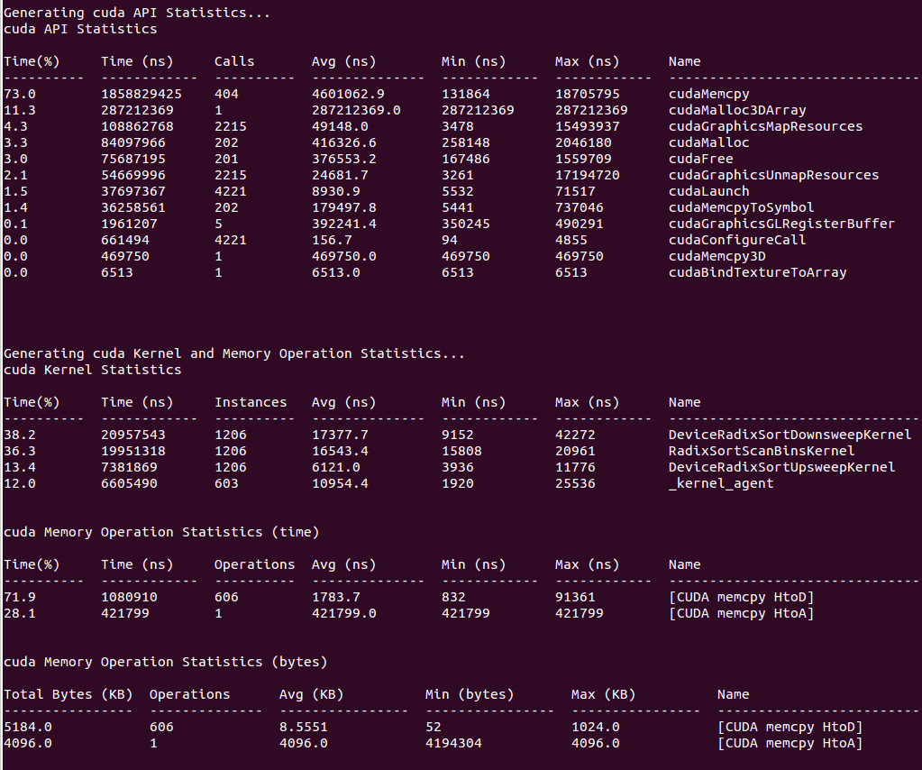
If your run traces OS runtime events or NVTX push-pop ranges:

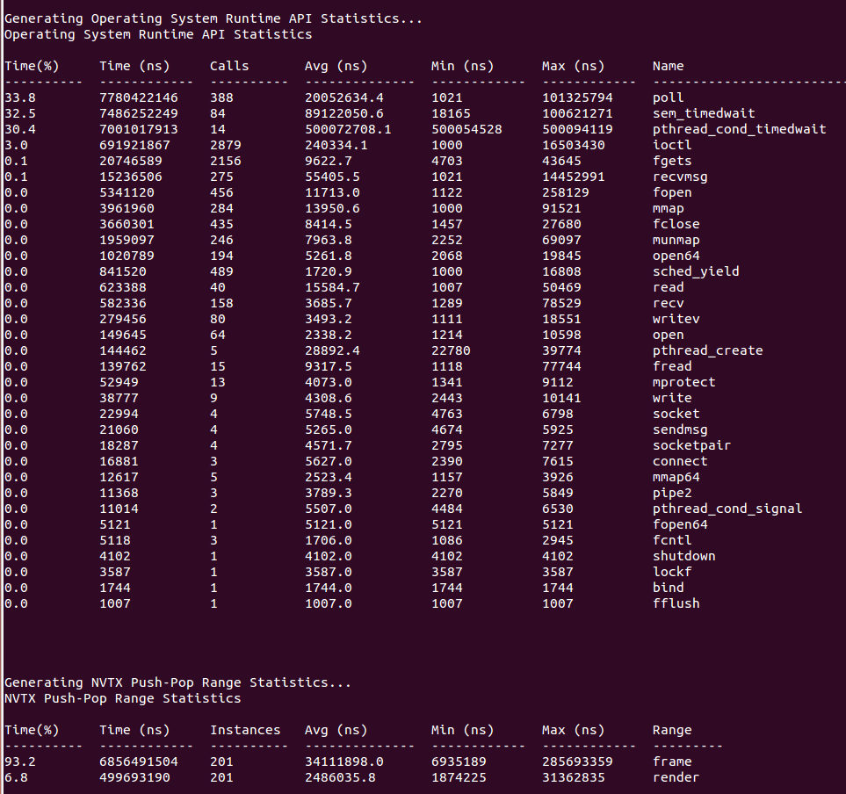
If your run traces graphics debug markers these include DX11 debug markers, DX12 debug markers, Vulkan debug markers or KHR debug markers:

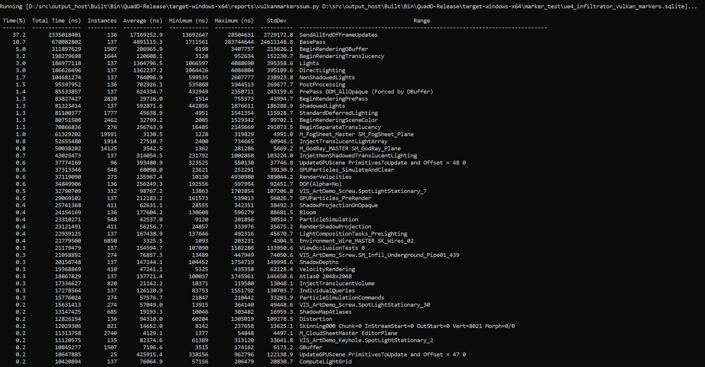
Recipes for these statistics as well as documentation on how to create your own metrics will be available in a future version of the tool.

Importing and Viewing Command Line Results Files
The CLI generates a .qdstrm file. The .qdstrm file is an intermediate result file, not intended for multiple imports. It needs to be processed, either by importing it into the GUI or by using the standalone QdstrmImporter to generate an optimized .nsys-rep file. Use this .nsys-rep file when re-opening the result on the same machine, opening the result on a different machine, or sharing results with teammates.
This version of Nsight Systems will attempt to automatically convert the .qdstrm file to a .nsys-rep file with the same name after the run finishes if the required libraries are available. The ability to turn off auto-conversion will be added in a later version.

Import Into the GUI
The CLI and host GUI versions must match to import a .qdstrm file successfully. The host GUI is backward compatible only with .nsys-rep files.
Copy the .qdstrm file you are interested in viewing to a system where the Nsight Systems host GUI is installed. Launch the Nsight Systems GUI. Select File->Import... and choose the .qdstrm file you wish to open.

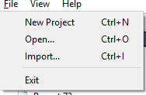
The import of really large, multi-gigabyte, .qdstrm files may take up all of the memory on the host computer and lock up the system. This will be fixed in a later version.

Importing Windows ETL files
For Windows targets, ETL files captured with Xperf or the log.cmd command supplied with GPUView in the Windows Performance Toolkit can be imported to create reports as if they were captured with Nsight Systems's "WDDM trace" and "Custom ETW trace" features. Simply choose the .etl file from the Import dialog to convert it to a .nsys-rep file.

Create .nsys-rep Using QdstrmImporter
The CLI and QdstrmImporter versions must match to convert a .qdstrm file into a .nsys- rep file. This .nsys-rep file can then be opened in the same version or more recent versions of the GUI.
To run QdstrmImporter on the host system, find the QdstrmImporter binary in the Host- x86_64 directory in your installation. QdstrmImporter is available for all host platforms. See options below.
To run QdstrmImporter on the target system, copy the Linux Host-x86_64 directory to the target Linux system or install Nsight Systems for Linux host directly on the target. The Windows or macOS host QdstrmImporter will not work on a Linux Target. See options below.

Short | Long | Parameter | Description
-h | --help |  | Help message providing information about available options and their parameters.
-v | --version |  | Output QdstrmImporter version information
-i | --input-file | filename or path | Import .qdstrm file from this location.
-o | --output-file | filename or path | Provide a different file name or path for the resulting .nsys-

Short | Long | Parameter | Description
rep file. Default is
the same name and path as the .qdstrm file

Using the CLI to Analyze MPI Codes

Tracing MPI API calls
The Nsight Systems CLI has built-in API trace support for Open MPI and MPICH based MPI implementations via --trace=mpi. It traces a subset of the MPI API, including blocking and non-blocking point-to-point and collective communication as well as MPI one-sided communication, file I/O and pack operations (see MPI functions traced).
If you require more control over the list of traced APIs or if you are using a different MPI implementation, you can use the NVTX wrappers for MPI on GitHub. Choose an NVTX domain name other than "MPI", since it is filtered out by Nsight Systems when MPI tracing is not enabled. Use the NVTX-instrumented MPI wrapper library as follows:
nsys profile -e LD_PRELOAD=${PATH_TO_YOUR_NVTX_MPI_LIB} --trace=nvtx

Using the CLI to Profile Applications Launched with mpirun
The Nsight Systems CLI supports concurrent use of the nsys profile command.
Each instance will create a separate report file. You cannot use multiple instances of the interactive CLI concurrently, or use the interactive CLI concurrently with nsys profile in this version.
Nsight Systems can be used to profile applications launched with mpirun or mpiexec. Since concurrent use of the CLI is supported only when using the nsys profile command, Nsight Systems cannot profile each node from the GUI or from the interactive CLI.
Profile all MPI ranks on a single node: nsys can be prefixed before mpirun/mpiexec. Only a single report file will be created.
nsys [nsys options] mpirun [mpirun options]
Profile multi-node runs: nsys profile has to be prefixed before the program to be profiled. One report file will be created for each MPI rank. This works also for single- node runs.
mpirun [mpirun options] nsys profile [nsys options]
You can use %q{OMPI_COMM_WORLD_RANK} (Open MPI), %q{PMI_RANK} (MPICH) or
%q{SLURM_PROCID} (Slurm) with the -o option to appropriately name the report files.

Profile a single MPI process or a subset of MPI processes: Use a wrapper script similar to the following script (called "profile_rank0.sh").
#!/bin/bash
# Use $PMI_RANK for MPICH and $SLURM_PROCID with srun. if [ $OMPI_COMM_WORLD_RANK -eq 0 ]; then
nsys profile -e NSYS_MPI_STORE_TEAMS_PER_RANK=1 -t mpi "$@" else
"$@"
fi
The script runs nsys on rank 0 only. Add appropriate profiling options to the script and execute it with mpirun [mpirun options] ./profile_rank0.sh ./myapp [app options].

If only a

Note:
subset of
MPI
ranks is
profiled, set
the environment variable
NSYS_MPI_STORE_TEAMS_PER_RANK=1
to store all
members of custom MPI
communicators per
MPI
rank. Otherwise, the execution might hang
or fail with an MPI
error.

Avoid redundant GPU and NIC metrics collection: If multiple instances of nsys profile are executed concurrently on the same node and GPU and/or NIC metrics collection is enabled, each process will collect metrics for all available NICs and tries to

collect GPU metrics for the specified devices. This can be avoided with a simple bash script similar to the following:
#!/bin/bash
# Use $SLURM_LOCALID with srun.
if [ $OMPI_COMM_WORLD_LOCAL_RANK -eq 0 ]; then
nsys profile --nic-metrics=true --gpu-metrics-device=all "$@" else
nsys profile "$@" fi
This above script will collect NIC and GPU metrics only for one rank, the node-local rank 0. Alternatively, if one rank per GPU is used, the GPU metrics devices can be specified based on the node-local rank in a wrapper script as follows:
#!/bin/bash
# Use $SLURM_LOCALID with srun.
nsys profile -e CUDA_VISIBLE_DEVICES=${OMPI_COMM_WORLD_LOCAL_RANK} \
--gpu-metrics-device=${OMPI_COMM_WORLD_LOCAL_RANK} "$@"

Chapter 2.
PROFILING FROM THE GUI

Profiling Linux Targets from the GUI

Connecting to the Target Device
Nsight Systems provides a simple interface to profile on localhost or manage multiple connections to Linux or Windows based devices via SSH. The network connections manager can be launched through the device selection dropdown:
On x86_64:
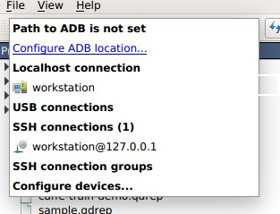
On Tegra:

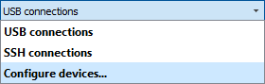
The dialog has simple controls that allow adding, removing, and modifying connections:
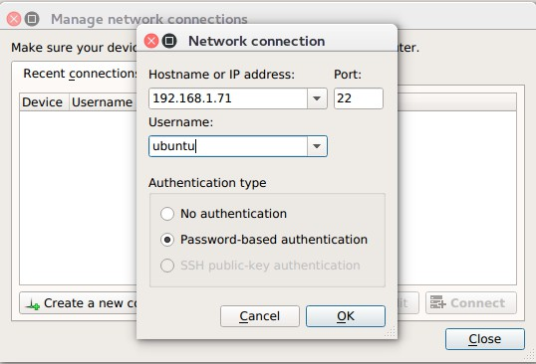
Security notice: SSH is only used to establish the initial connection to a target device, perform checks, and upload necessary files. The actual profiling commands and data are transferred through a raw, unencrypted socket. Nsight Systems should not be used in a network setup where attacker-in-the-middle attack is possible, or where untrusted parties may have network access to the target device.
While connecting to the target device, you will be prompted to input the user's password. Please note that if you choose to remember the password, it will be stored in plain text in the configuration file on the host. Stored passwords are bound to the public key fingerprint of the remote device.
The No authentication option is useful for devices configured for passwordless login using root username. To enable such a configuration, edit the file /etc/ssh/ sshd_config on the target and specify the following option:
PermitRootLogin yes
Then set empty password using passwd and restart the SSH service with service ssh restart.
Open ports: The Nsight Systems daemon requires port 22 and port 45555 to be open for listening. You can confirm that these ports are open with the following command:
sudo firewall-cmd --list-ports --permanent sudo firewall-cmd --reload
To open a port use the following command, skip --permanent option to open only for this session:
sudo firewall-cmd --permanent --add-port 45555/tcp sudo firewall-cmd --reload

Likewise, if you are running on a cloud system, you must open port 22 and port 45555 for ingress.
Kernel Version Number - To check for the version number of the kernel support of Nsight Systems on a target device, run the following command on the remote device:
cat /proc/quadd/version
Minimal supported version is 1.82.
Additionally, presence of Netcat command (nc) is required on the target device. For example, on Ubuntu this package can be installed using the following command:
sudo apt-get install netcat-openbsd

System-Wide Profiling Options

Linux x86_64
System-wide profiling is available on x86 for Linux targets only when run with root privileges.

Ftrace Events Collection
Select Ftrace events
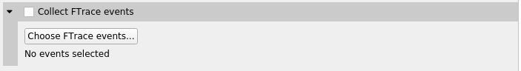
Choose which events you would like to collect.

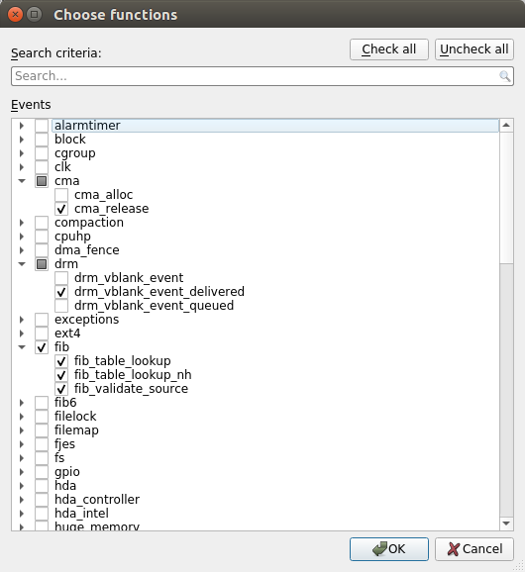

Ftrace profiling option will

Note:
not be
displayed in
the GUI
unless you are
running with sudo.
Also be aware that
enabling too many options can cause
significant setup/ teardown overhead.

GPU Context Switch Trace
Tracing of context switching on the GPU is enabled with driver r435.17 or higher.
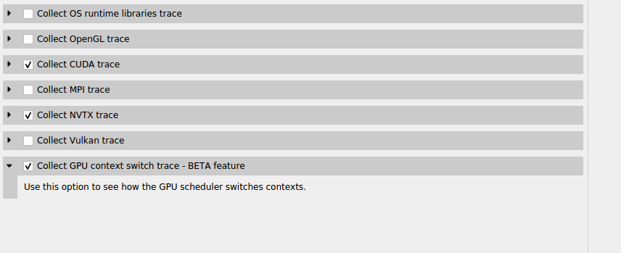
Here is a screenshot showing three CUDA kernels running simultaneously in three different CUDA contexts on a single GPU.
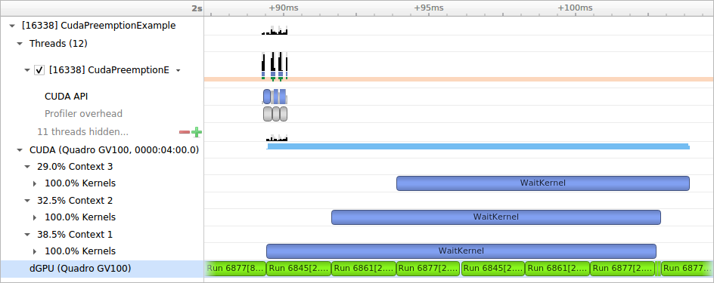

Linux for Tegra
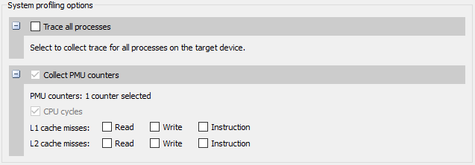
Trace all processes – On compatible devices (with kernel module support version 1.107 or higher), this enables trace of all processes and threads in the system. Scheduler events from all tasks will be recorded.
Collect PMU counters – This allows you to choose which PMU (Performance Monitoring Unit) counters Nsight Systems will sample. Enable specific counters when interested in correlating cache misses to functions in your application.

Target Sampling Options
Target sampling behavior is somewhat different for Nsight Systems Workstation Edition and Nsight Systems Embedded Platforms Edition.

Target Sampling Options for Workstation
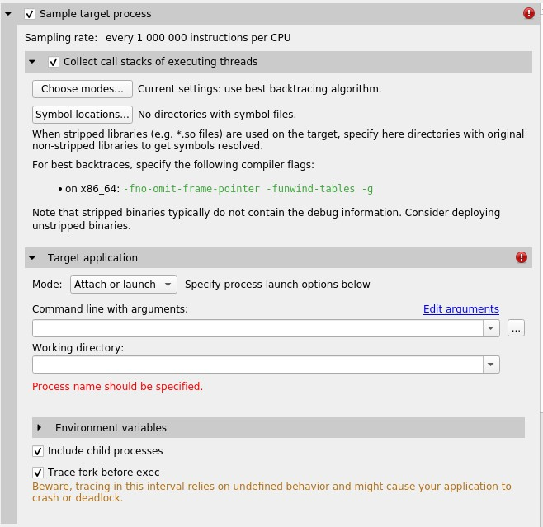
Three different backtrace collections options are available when sampling CPU instruction pointers. Backtraces can be generated using Intel (c) Last Branch Record (LBR) registers. LBR backtraces generate minimal overhead but the backtraces have limited depth. Backtraces can also be generated using DWARF debug data. DWARF backtraces incur more overhead than LBR backtraces but have much better depth. Finally, backtraces can be generated using frame pointers. Frame pointer backtraces incur medium overhead and have good depth but only resolve frames in the portions of the application and its libraries (including 3rd party libraries) that were compiled with frame pointers enabled. Normally, frame pointers are disabled by default during compilation.
By default, Nsight Systems will use Intel(c) LBRs if available and fall back to using dwarf unwind if they are not. Choose modes... will allow you to override the default.
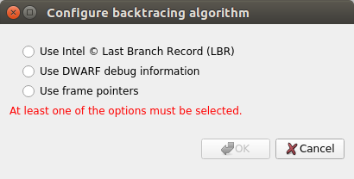

The Include child processes switch controls whether API tracing is only for the launched process, or for all existing and new child processes of the launched process. If you are running your application through a script, for example a bash script, you need to set this checkbox.
The Include child processes switch does not control sampling in this version of Nsight Systems. The full process tree will be sampled regardless of this setting. This will be fixed in a future version of the product.
Nsight Systems can sample one process tree. Sampling here means interrupting each processor after a certain number of events and collecting an instruction pointer (IP)/ backtrace sample if the processor is executing the profilee.
When sampling the CPU on a workstation target, Nsight Systems traces thread context switches and infers thread state as either Running or Blocked. Note that Blocked in the timeline indicates the thread may be Blocked (Interruptible) or Blocked
(Uninterruptible). Blocked (Uninterruptible) often occurs when a thread has transitioned into the kernel and cannot be interrupted by a signal. Sampling can be enhanced with OS runtime libraries tracing; see OS Runtime Libraries Trace for more information.

Target Sampling Options for Embedded Linux
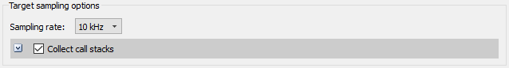
Currently Nsight Systems can only sample one process. Sampling here means that the profilee will be stopped periodically, and backtraces of active threads will be recorded.
Most applications use stripped libraries. In this case, many symbols may stay unresolved. If unstripped libraries exist, paths to them can be specified using the Symbol locations... button. Symbol resolution happens on host, and therefore does not affect performance of profiling on the target.
Additionally, debug versions of ELF files may be picked up from the target system. Refer to Debug Versions of ELF Files for more information.

Hotkey Trace Start/Stop
Nsight Systems Workstation Edition can use hotkeys to control profiling. Press the hotkey to start and/or stop a trace session from within the target application’s graphic window. This is useful when tracing games and graphic applications that use fullscreen display. In these scenarios switching to Nsight Systems' UI would unnecessarily introduce the window manager's footprint into the trace. To enable the use of Hotkey check the Hotkey checkbox in the project settings page:

The default hotkey is F12.

Launching Processes
Nsight Systems can launch new processes for profiling on target devices. Profiler ensures that all environment variables are set correctly to successfully collect trace information
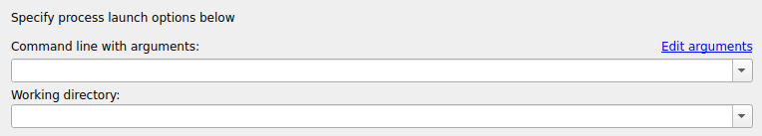
The Edit arguments... link will open an editor window, where every command line argument is edited on a separate line. This is convenient when arguments contain spaces or quotes.

Profiling Windows Targets from the GUI
Profiling on Windows devices is similar to the profiling on Linux devices. Please refer to the Profiling Linux Targets from the GUI section for the detailed documentation and connection information. The major differences on the platforms are listed below:

Remoting to a Windows Based Machine
To perform remote profiling to a target Windows based machines, install and configure an OpenSSH Server on the target machine.

Hotkey Trace Start/Stop
Nsight Systems Workstation Edition can use hotkeys to control profiling. Press the hotkey to start and/or stop a trace session from within the target application’s graphic window. This is useful when tracing games and graphic applications that use fullscreen display. In these scenarios switching to Nsight Systems' UI would unnecessarily introduce the window manager's footprint into the trace. To enable the use of Hotkey check the Hotkey checkbox in the project settings page:

The default hotkey is F12.
Changing the Default Hotkey Binding - A different hotkey binding can be configured by setting the HotKeyIntValue configuration field in the config.ini file.
Set the decimal numeric identifier of the hotkey you would like to use for triggering start/stop from the target app graphics window. The default value is 123 which corresponds to 0x7B, or the F12 key.
Virtual key identifiers are detailed in MSDN's Virtual-Key Codes.
Note that you must convert the hexadecimal values detailed in this page to their decimal counterpart before using them in the file. For example, to use the F1 key as a start/stop trace hotkey, use the following settings in the config.ini file:
HotKeyIntValue=112

Target Sampling Options on Windows
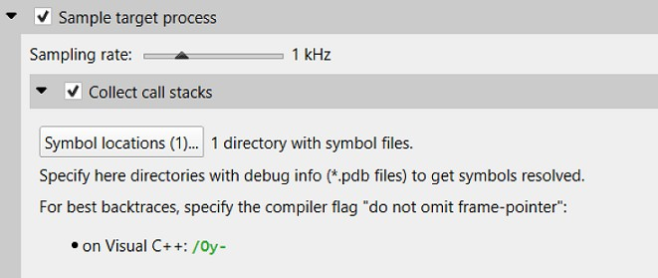
Nsight Systems can sample one process tree. Sampling here means interrupting each processor periodically. The sampling rate is defined in the project settings and is either 100Hz, 1KHz (default value), 2Khz, 4KHz, or 8KHz.
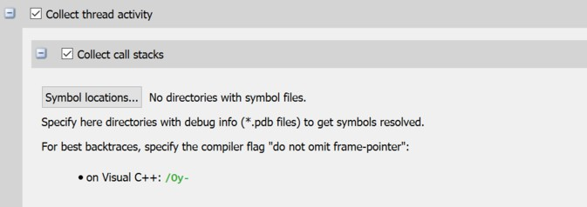

On Windows, Nsight Systems can collect thread activity of one process tree. Collecting thread activity means that each thread context switch event is logged and (optionally) a backtrace is collected at the point that the thread is scheduled back for execution. Thread states are displayed on the timeline.
If it was collected, the thread backtrace is displayed when hovering over a region where the thread execution is blocked.

Symbol Locations
Symbol resolution happens on host, and therefore does not affect performance of profiling on the target.
Press the Symbol locations... button to open the Configure debug symbols location
dialog.
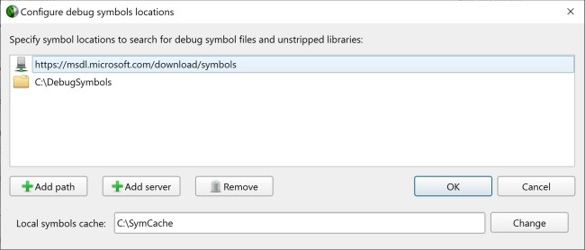
Use this dialog to specify:
- Paths of PDB files
- Symbols servers
- The location of the local symbol cache To use a symbol server:
- Install Debugging Tools for Windows, a part of the Windows 10 SDK.
- Add the symbol server URL using the Add Server button.
Information about Microsoft's public symbol server, which enables getting Windows operating system related debug symbols can be found here.

Profiling QNX Targets from the GUI
Profiling on QNX devices is similar to the profiling on Linux devices. Please refer to the Profiling Linux Targets from the GUI section for the detailed documentation. The major differences on the platforms are listed below:
- Backtrace sampling is not supported. Instead backtraces are collected for long OS runtime libraries calls. Please refer to the OS Runtime Libraries Trace section for the detailed documentation.
- CUDA support is limited to CUDA 9.0+

- Filesystem on QNX device might be mounted read-only. In that case Nsight Systems is not able to install target-side binaries, required to run the profiling session. Please make sure that target filesystem is writable before connecting to QNX target. For example, make sure the following command works:
echo XX > /xx && ls -l /xx

Chapter 3.
CONTAINER SUPPORT ON LINUX SERVERS

Collecting data within a Docker container
While examples in this section use Docker container semantics, other containers work much the same.
The following information assumes the reader is knowledgeable regarding Docker containers. For further information about Docker use in general, see the Docker documentation.
We strongly recommend using the CLI to profile in a container. Best container practice is to split services across containers when they do not require colocation. The Nsight Systems GUI is not needed to profile and brings in many dependencies, so the CLI is recommended. If you wish the GUI can be in a separate side-car container you use after to view your report. All you need is a shared folder between the containers. See section on GUI VNC Container below for more information.

Enable Docker Collection
When starting the Docker to perform a Nsight Systems collection, additional steps are required to enable the perf_event_open system call. This is required in order to utilize the Linux kernel’s perf subsystem which provides sampling information to Nsight Systems.
There are three ways to enable the perf_event_open syscall. You can enable it by using the --privileged=true switch, adding --cap-add=SYS_ADMIN switch to your docker run command file, or you can enable it by setting the seccomp security profile if your system meets the requirements.
Secure computing mode (seccomp) is a feature of the Linux kernel that can be used to restrict an application's access. This feature is available only if the kernel is enabled with seccomp support. To check for seccomp support:
$ grep CONFIG_SECCOMP= /boot/config-$(uname -r)
The official Docker documentation says:
"Seccomp profiles require seccomp 2.2.1 which is not available on Ubuntu 14.04, Debian Wheezy, or Debian Jessie. To use seccomp on these distributions, you must download the latest static Linux binaries (rather than packages)."

Download the default seccomp profile file, default.json, relevant to your Docker version. If perf_event_open is already listed in the file as guarded by CAP_SYS_ADMIN, then remove the perf_event_open line. Add the following lines under "syscalls" and save the resulting file as default_with_perf.json.
{
"name": "perf_event_open", "action": "SCMP_ACT_ALLOW", "args": []
},
Then you will be able to use the following switch when starting the Docker to apply the new seccomp profile.
--security-opt seccomp=default_with_perf.json

Launch Docker Collection
Here is an example command that has been used to launch a Docker for testing with Nsight Systems:
sudo nvidia-docker run --network=host --security-opt seccomp=default_with_perf.json --rm -ti caffe-demo2 bash
There is a known issue where Docker collections terminate prematurely with older versions of the driver and the CUDA Toolkit. If collection is ending unexpectedly, please update to the latest versions.
After the Docker has been started, use the Nsight Systems CLI to launch a collection within the Docker. The resulting .qdstrm file can be imported into the Nsight Systems host like any other CLI result.

GUI VNC container
Nsight Systems provides a build script to build a self isolated Docker container with the Nsight Systems GUI and VNC server.
You can find the build.py script in the host-linux-x64/Scripts/VncContainer directory (or similar on other architectures) under your Nsight Systems installation directory. You will need to have Docker, and Python 3.5 or later.

Available Parameters

Short Name | Full Name | Description
 | --vnc-password | (optional) Default password for VNC access (at least 6 characters). If it is specified and empty - will be asked during the build. Can be changed when running a container.
-aba | --additional-build- arguments | (optional) Additional arguments, which will be

Short Name | Full Name | Description
passed to the "docker build"
command.
-hd | --nsys-host-directory | (optional) The directory with Nsight Systems host binaries (with GUI).
-td | --nsys-target-directory | (optional, repeatable) The directory with Nsight Systems target binaries (can be specified multiple times).
 | --tigervnc | (optional) Use TigerVNC instead of x11vnc.
 | --http | (optional) Install noVNC in the Docker container for HTTP access.
 | --rdp | (optional) Install xRDP in the Docker for RDP access.
 | --geometry | (optional) Default VNC server resolution in the format WidthxHeight (default 1920x1080).
 | --build-directory | (optional) The directory to save temporary files (with the write access for the current user). By default, script or tmp directory will be used.

Ports
These ports can be published from the container to provide access to the Docker container:

Port | Purpose | Condition
TCP 5900 | Port for VNC access
TCP 80 (optional) | Port for HTTP access to noVNC server | Container is build with "-- http" parameter
TCP 3389 (optional) | Port for RDP access | Container is build with "-- rdp" parameter

Volumes

Docker folder | Purpose | Description
/mnt/host | Root path for shared folders | Folder owned by the Docker user (inner content can be accessed from Nsight Systems GUI)
/mnt/host/Projects |  | Folder with projects and reports, created by Nsight Systems UI in container
/mnt/host/logs | Folder with inner services logs | May be useful to send reports to developers

Environment variables

Variable Name | Purpose
VNC_PASSWORD | Password for VNC access (at least 6 characters)
NSYS_WINDOW_WIDTH | Width of VNC server display (in pixels)
NSYS_WINDOW_HEIGHT | Height of VNC server display (in pixels)

Examples
With VNC access on port 5916:
sudo docker run -p 5916:5900/tcp -ti nsys-ui-vnc:1.0
With VNC access on port 5916 and HTTP access on port 8080:
sudo docker run -p 5916:5900/tcp -p 8080:80/tcp -ti nsys-ui-vnc:1.0
With VNC access on port 5916, HTTP access on port 8080 and RDP access on port 33890:
sudo docker run -p 5916:5900/tcp -p 8080:80/tcp -p 33890:3389/tcp -ti nsys-ui- vnc:1.0
With VNC access on port 5916, shared "HOME" folder from the host, VNC server resolution 3840x2160, and custom VNC password
sudo docker run -p 5916:5900/tcp -v $HOME:/mnt/host/home -e NSYS_WINDOW_WIDTH=3840 -e NSYS_WINDOW_HEIGHT=2160 -e VNC_PASSWORD=7654321 -ti
nsys-ui-vnc:1.0
With VNC access on port 5916, shared "HOME" folder from the host, and the projects folder to access reports created by Nsight Systems GUI in container
sudo docker run -p 5916:5900/tcp -v $HOME:/mnt/host/home -v /opt/NsysProjects:/ mnt/host/Projects -ti nsys-ui-vnc:1.0

GUI WebRTC container
Instructions for creating a self-isolated Docker container for accessing Nsight Systems through browser using WebRTC.

Prerequisites

- x86_64 Linux
- Docker
- Internet access for downloading Ubuntu packages inside the container.

Build
To build the docker container use the follwing command:
$ sudo ./setup/build-docker.sh The above command will create a docker image, which can be run using ./start-nsys.sh Build environment variables
Following environment variables can be used to configure build parameters.

Variable | Description | Default Value
USERNAME | User name for NVIDIA Nsight Systems GUI. Password can be set on container start | nvidia

Additional docker build arguments
Additional Docker Build arguments may be passed to the build-docker.sh. For example:
$ sudo ./setup/build-docker.sh --network=host

Run
To run the docker container:
$ sudo ./start-nsys.sh
At the end of start-nsys.sh it will provide you with a URL to connect to the WebRTC client. It will look something like http://$HOST_IP:8080/. You can use this address in your browser to access Nsight Systems GUI interface.

Additional docker run arguments
Additional Docker Run arguments may be passed to the start-nsys.sh. These argument can be used to mount host directories with Nsight Systems reports to the docker container. For example:
$ sudo ./start-nsys.sh -v $HOME:/mnt/host/home -v /myawesomereports:/mnt/host/ myawesomereports

Runtime environment variables
Runtime environment variables can be used to configure runtime parameters.

Variable | Description | Default Value
PASSWORD | Password for WebUI. Username can be set only on the build step | nvidia
HOST_IP | IP of the server that will be sent to client. This IP should be accessible from | The IP address of the first available network interface.

Variable | Description | Default Value
the client side to establish
client/server connection.
HTTP_PORT | Port for HTTP access to Nsight System user interface. | 8080
CONNECTION_UDP_PORT | UDP port which will be used for handling the incoming connection. | 8081
FALLBACK_CONNECTION | _TTCCPPp_PoOrtRwThich will be used for handling the incoming connection in case of connection failure over TCP (can be the same port number as  CONNECTION_UDP_PORT) | 8081  .
SCREEN | Resolution and refresh rate of the screen used for rendering. | 1920x1080@30
USE_OPENH264_BUILD_CA | SCeHttEing this option to false disables caching of openh264 binaries. It should be reenabled on each container start. | true
OPENH264_BUILD_CACHE | _DViOreLctUoMryEo_rNdAocMkeEr volume name for openh264 binaries cache. | nvidia-devtools-streamer- openh264-volume

Video encoding
By default, the container uses the VP8 codec for video streaming. For an improved experience, the H.264 codec can be enabled.
- If internet is available to download the required libraries:
$ sudo docker exec nvidia-devtools-streamer /setup/enable-h264-streaming.sh
If USE_OPENH264_BUILD_CACHE was not set to false, openh264 binaries will be cached in OPENH264_BUILD_CACHE_VOLUME_NAME and H.264 codec will be used during future launches of the container.
Currently, only software encoding is supported.
- If internet is not available:
$ sudo -- sh -c 'MY_IMAGE_NAME=my-openh264-nsys-streamer:1.0 USE_OPENH264_BUILD_CACHE=false ./start-nsys.sh && docker exec nvidia-
devtools-streamer /setup/enable-h264-streaming.sh && docker commit nvidia- devtools-streamer $MY_IMAGE_NAME && docker save -o my-openh264-nsys- streamer.tar $MY_IMAGE_NAME'

As a result, my-openh264-nsys-streamer.tar will contain the image with enabled H.264 codec. This file should be transferred to the target machine without internet access. Then, on a machine without internet access, the container can be started using the following command:
$ sudo -- sh -c 'CONTAINER_IMAGE=my-openh264-nsys-streamer:1.0 USE_OPENH264_BUILD_CACHE=false docker load -i my-openh264-nsys-streamer.tar && ./start-nsys.sh'

Volumes

Docker folder | Purpose | Description
/mnt/host/logs | Folder with inner services logs | May be useful to send reports to NVIDIA developer

Example
To run the container on 10.10.10.10 network interface, using 8000 HTTP port, 8888 connection port, without caching openh264 binaries:
$ sudo HOST_IP=10.10.10.10 HTTP_PORT=8000 CONNECTION_UDP_PORT=8888
USE_OPENH264_BUILD_CACHE=false ./start-nsys.sh

Chapter 4.
MIGRATING FROM NVIDIA NVPROF

Using the Nsight Systems CLI nvprof Command
The nvprof command of the Nsight Systems CLI is intended to help former nvprof users transition to nsys. Many nvprof switches are not supported by nsys, often because they are now part of NVIDIA Nsight Compute.
The full nvprof documentation can be found at https://docs.nvidia.com/cuda/profiler- users-guide.
The nvprof transition guide for Nsight Compute can be found at https:// docs.nvidia.com/nsight-compute/NsightComputeCli/index.html#nvprof-guide.
Any nvprof switch not listed below is not supported by the nsys nvprof command. No additional nsys functionality is available through this command. New features will not be added to this command in the future.

CLI nvprof Command Switch Options
After choosing the nvprof command switch, the following options are available. When you are ready to move to using Nsight Systems CLI directly, see Command Line Options documentation for the nsys switch(es) given below. Note that the nsys implementation and output may vary from nvprof.

Usage.
nsys nvprof [options]

Switch | Parameters (Default in Bold) | nsys switch | Switch Description
--annotate-mpi | off, openmpi, mpich | --trace=mpi AND -- mpi-impl | Automatically annotate MPI calls with NVTX markers. Specify the MPI

,Stop}
Switch | Parameters (Default in Bold) | nsys switch | Switch Description
implementation
installed on your machine. Only OpenMPI and MPICH
implementations are supported.
--cpu-thread-tracing | on, off | --trace=osrt | Collect information about CPU thread API activity.
--profile-api-trace | none, runtime, driver,all | --trace=cuda | Turn on/off CUDA runtime and driver API tracing. For Nsight Systems there is no separate CUDA runtime and CUDA driver trace, so selecting  runtime or driver is equivalent to selecting all .
--profile-from-start | on, off | if off use --capture- range=cudaProfilerA | Enable/disable ppi rofiling from the start of the application. If disabled, the  application can use  {cu,cuda}Profiler{Start to turn on/off profiling.
-t,--timeout | <nanoseconds> default=0 | --duration=seconds | If greater than 0, stop the collection and  kill the launched application after timeout seconds. nvprof started counting when the CUDA driver is initialized. nsys starts counting immediately.

Switch | Parameters (Default in Bold) | nsys switch | Switch Description
--cpu-profiling | on, off | --sampling=cpu | Turn on/off CPU profiling
--openacc-profiling | on, off | --trace=openacc to turn on | Enable/disable recording information from the OpenACC profiling interface. Note: OpenACC profiling interface depends on the presence of the OpenACC runtime. For supported runtimes, see CUDA Trace section of documentation
-o, --export-profile | <filename> | --output={filename} and/or -- export=sqlite | Export named file to be imported  or opened in the Nsight Systems GUI. %q{ENV_VAR}  in string will be replaced with the set value of the environment  variable. If not set this is an error.  %h in the string is replaced with the system hostname.  %% in the string is replaced with %.  %p in the string is not supported  currently. Any other character following  % is illegal. The default is report1, with the number incrementing to avoid overwriting files, in users working directory.

Switch | Parameters (Default in Bold) | nsys switch | Switch Description
-f, --force-overwrite |  | --force- overwrite=true | Force overwriting all output files with same name.
-h, --help |  | --help | Print Nsight Systems CLI help
-V, --version |  | --version | Print Nsight Systems CLI version information

Next Steps
NVIDIA Visual Profiler (NVVP) and NVIDIA nvprof are deprecated. New GPUs and features will not be supported by those tools. We encourage you to make the move to Nsight Systems now. For additional information, suggestions, and rationale, see the blog series in Other Resources.

Chapter 5. DIRECT3D TRACE

Nsight Systems has the ability to trace both the Direct3D 11 API and the Direct3D 12 API on Windows targets.

D3D11 API trace
Nsight Systems can capture information about Direct3D 11 API calls made by the profiled process. This includes capturing the execution time of D3D11 API functions, performance markers, and frame durations.
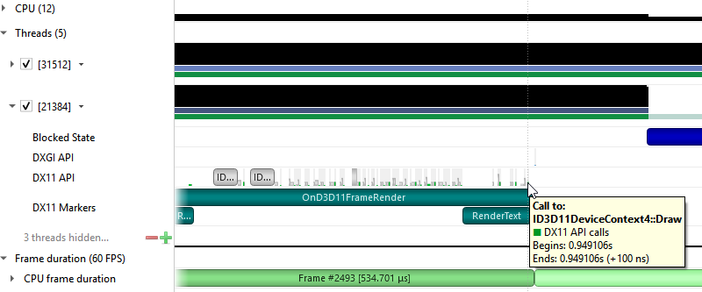

SLI Trace
Trace SLI queries and peer-to-peer transfers of D3D11 applications. Requires SLI hardware and an active SLI profile definition in the NVIDIA console.

D3D12 API Trace
Direct3D 12 is a low-overhead 3D graphics and compute API for Microsoft Windows. Information about Direct3D 12 can be found at the Direct3D 12 Programming Guide.
Nsight Systems can capture information about Direct3D 12 usage by the profiled process. This includes capturing the execution time of D3D12 API functions, corresponding workloads executed on the GPU, performance markers, and frame durations.

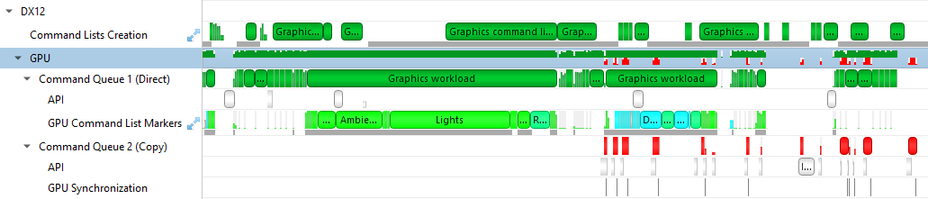
The Command List Creation row displays time periods when command lists were being created. This enables developers to improve their application’s multi- threaded command list creation. Command list creation time period is measured between the call to ID3D12GraphicsCommandList::Reset and the call to ID3D12GraphicsCommandList::Close.
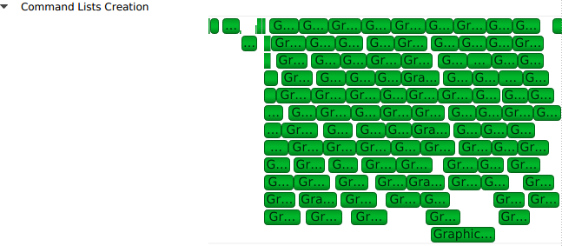
The GPU row shows a compressed view of the D3D12 queue activity, color-coded by the queue type. Expanding it will show the individual queues and their corresponding API calls.

A Command Queue row is displayed for each D3D12 command queue created by the profiled application. The row’s header displays the queue's running index and its type (Direct, Compute, Copy).
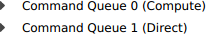

The DX12 API Memory Ops row displays all API memory operations and non-persistent resource mappings. Event ranges in the row are color-coded by the heap type they belong to (Default, Readback, Upload, Custom, or CPU-Visible VRAM), with usage warnings highlighted in yellow. A breakdown of the operations can be found by expanding the row to show rows for each individual heap type.

The following operations and warnings are shown:
- Calls to ID3D12Device::CreateCommittedResource, ID3D12Device4::CreateCommittedResource1, and ID3D12Device8::CreateCommittedResource2
  - A warning will be reported if D3D12_HEAP_FLAG_CREATE_NOT_ZEROED is not set in the method's HeapFlags parameter
- Calls to ID3D12Device::CreateHeap and ID3D12Device4::CreateHeap1
  - A warning will be reported if D3D12_HEAP_FLAG_CREATE_NOT_ZEROED is not set in the Flags field of the method's pDesc parameter
- Calls to ID3D12Resource::ReadFromSubResource
  - A warning will be reported if the read is to a D3D12_CPU_PAGE_PROPERTY_WRITE_COMBINE CPU page or from a D3D12_HEAP_TYPE_UPLOAD resource
- Calls to ID3D12Resource::WriteToSubResource
  - A warning will be reported if the write is from a D3D12_CPU_PAGE_PROPERTY_WRITE_BACK CPU page or to a D3D12_HEAP_TYPE_READBACK resource
- Calls to ID3D12Resource::Map and ID3D12Resource::Unmap will be matched into [Map, Unmap] ranges for non-persistent mappings. If a mapping range is nested, only the most external range (reference count = 1) will be shown.
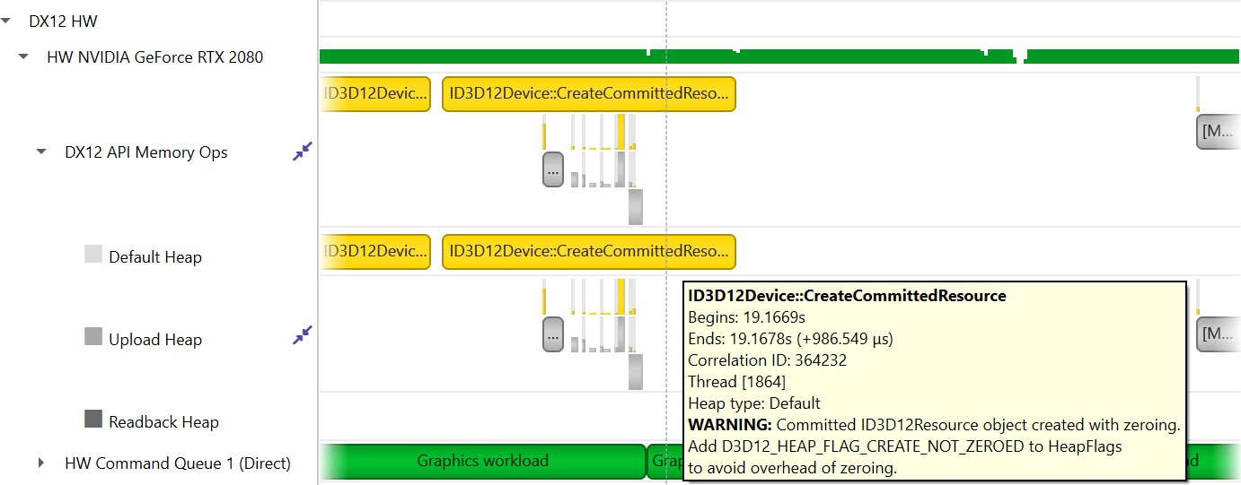
The API row displays time periods where ID3D12CommandQueue::ExecuteCommandLists was called. The GPU Workload row displays time periods where workloads were executed by the GPU. The workload’s type (Graphics, Compute, Copy, etc.) is displayed on the bar representing the workload’s GPU execution.

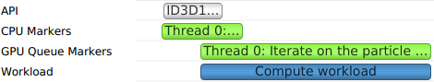
In addition, you can see the PIX command queue CPU-side performance markers, GPU- side performance markers and the GPU Command List performance markers, each in their row.
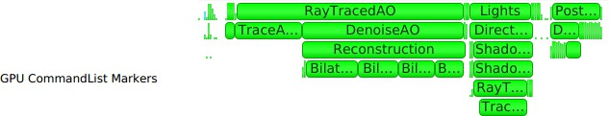

Clicking on a GPU workload highlights the corresponding ID3D12CommandQueue::ExecuteCommandLists, ID3D12GraphicsCommandList::Reset and ID3D12GraphicsCommandList::Close API calls, and vice versa.
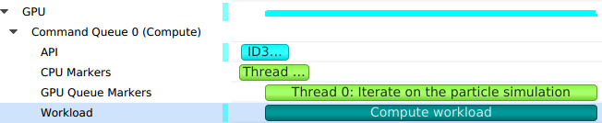
Detecting which CPU thread was blocked by a fence can be difficult in complex apps that run tens of CPU threads. The timeline view displays the 3 operations involved:
- The CPU thread pushing a signal command and fence value into the command queue. This is displayed on the DX12 Synchronization sub-row of the calling thread.
- The GPU executing that command, setting the fence value and signaling the fence. This is displayed on the GPU Queue Synchronization sub-row.
- The CPU thread calling a Win32 wait API to block-wait until the fence is signaled. This is displayed on the Thread's OS runtime libraries row.
Clicking one of these will highlight it and the corresponding other two calls.

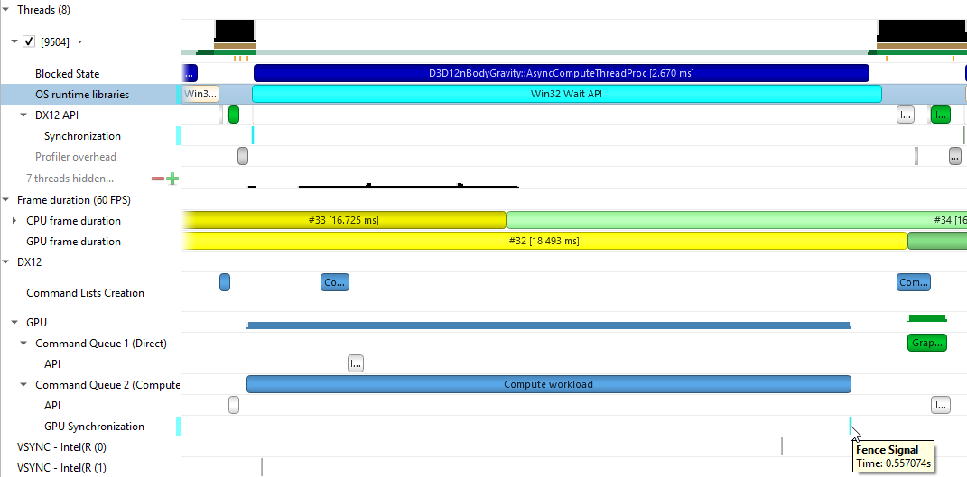

Chapter 6. WDDM QUEUES

The Windows Display Driver Model (WDDM) architecture uses queues to send work packets from the CPU to the GPU. Each D3D device in each process is associated with one or more contexts. Graphics, compute, and copy commands that the profiled
application uses are associated with a context, batched in a command buffer, and pushed into the relevant queue associated with that context.
Nsight Systems can capture the state of these queues during the trace session.
Enabling the "Collect additional range of ETW events" option will also capture extended DxgKrnl events from the Microsoft-Windows-DxgKrnl provider, such as context status, allocations, sync wait, signal events, etc.
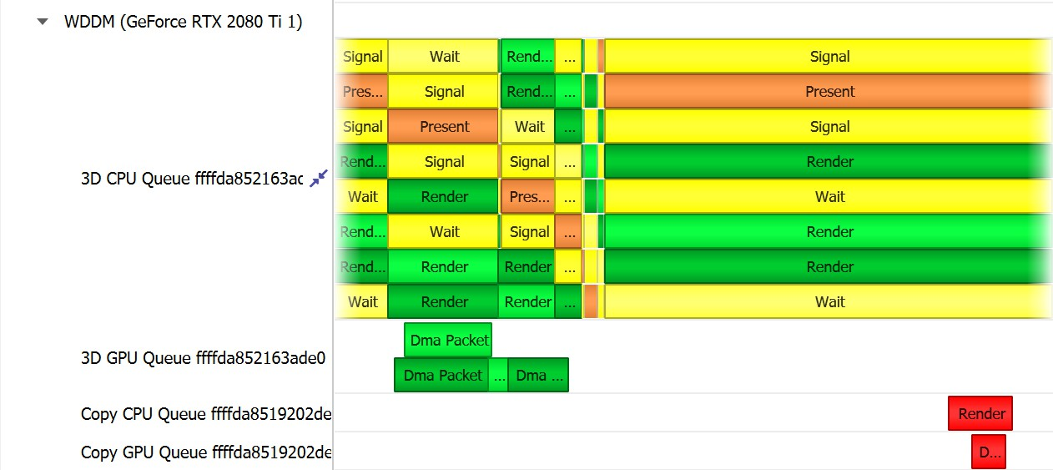
A command buffer in a WDDM queues may have one the following types:
- Render
- Deferred
- System
- MMIOFlip
- Wait
- Signal
- Device
- Software
It may also be marked as a Present buffer, indicating that the application has finished rendering and requests to display the source surface.

WDDM Queues

See the Microsoft documentation for the WDDM architecture and the DXGKETW_QUEUE_PACKET_TYPE enumeration.

To retain the .etl trace files captured, so that they can be viewed in other tools (e.g. GPUView), change the "Save ETW log files in project folder" option under "Profile Behavior" in Nsight Systems's global Options dialog. The .etl files will appear in the same folder as the .nsys-rep file, accessible by right-clicking the report in the Project Explorer and choosing "Show in Folder...". Data collected from each ETW provider will appear in its own .etl file, and an additional .etl file named "Report XX-Merged-*.etl", containing the events from all captured sources, will be created as well.

Chapter 7.
WDDM HW SCHEDULER

When GPU Hardware Scheduling is enabled in Windows 10 or newer version, the Windows Display Driver Model (WDDM) uses the DxgKrnl ETW provider to expose report of NVIDIA GPUs' hardware scheduling context switches.
Nsight Systems can capture these context switch events, and display under the GPUs in the timeline rows titled WDDM HW Scheduler - [HW Queue type]. The ranges under each queue will show the process name and PID assoicated with the GPU work during the time period.
The events will be captured if GPU Hardware Scheduling is enabled in the Windows System Display settings, and "Collect WDDM Trace" is enabled in the Nsight Systems Project Settings.

Chapter 8. VULKAN API TRACE

Vulkan Overview
Vulkan is a low-overhead, cross-platform 3D graphics and compute API, targeting a wide variety of devices from PCs to mobile phones and embedded platforms. The Vulkan API is defined by the Khronos Group. Information about Vulkan and the Khronos Group can be found at the Khronos Vulkan Site.
Nsight Systems can capture information about Vulkan usage by the profiled process. This includes capturing the execution time of Vulkan API functions, corresponding GPU workloads, debug util labels, and frame durations. Vulkan profiling is supported on both Windows and x86 Linux operating systems.
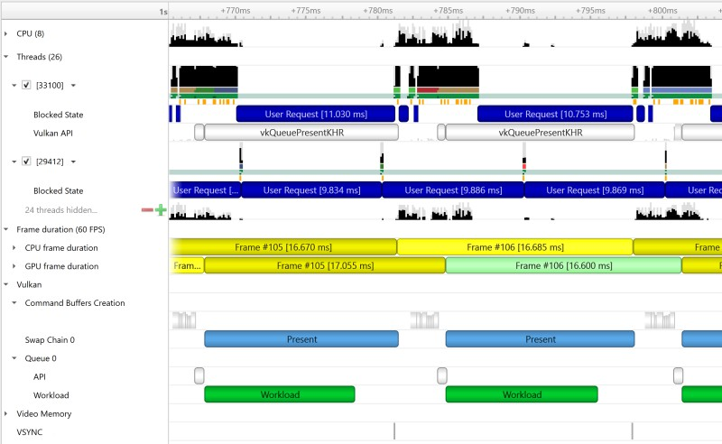
The Command Buffer Creation row displays time periods when command buffers were being created. This enables developers to improve their application’s multi-threaded command buffer creation. Command buffer creation time period is measured between the call to vkBeginCommandBuffer and the call to vkEndCommandBuffer.

A Queue row is displayed for each Vulkan queue created by the profiled application. The API sub-row displays time periods where vkQueueSubmit was called. The GPU Workload sub-row displays time periods where workloads were executed by the GPU.
In addition, you can see Vulkan debug util labels on both the CPU and the GPU.
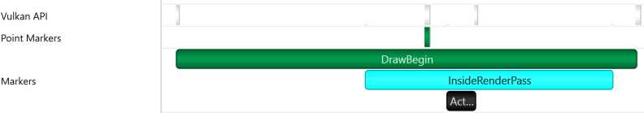
Clicking on a GPU workload highlights the corresponding vkQueueSubmit call, and vice versa.
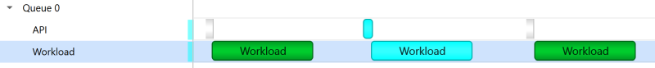
The Vulkan Memory Operations row contains an aggregation of all the Vulkan host- side memory operations, such as host-blocking writes and reads or non-persistent map- unmap ranges.
The row is separated into sub-rows by heap index and memory type - the tooltip for each row and the ranges inside show the heap flags and the memory property flags.
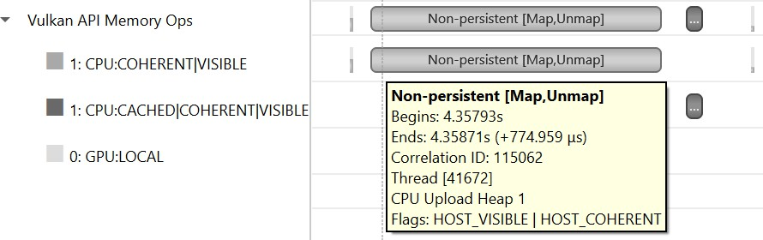
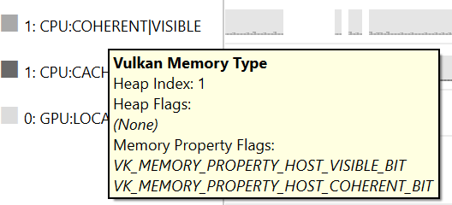

Pipeline Creation Feedback
When tracing target application calls to Vulkan pipeline creation APIs, Nsight Systems leverages the Pipeline Creation Feedback extension to collect more details about the duration of individual pipeline creation stages.
See Pipeline Creation Feedback extension for details about this extension.
Vulkan pipeline creation feedback is available on NVIDIA driver release 435 or later.
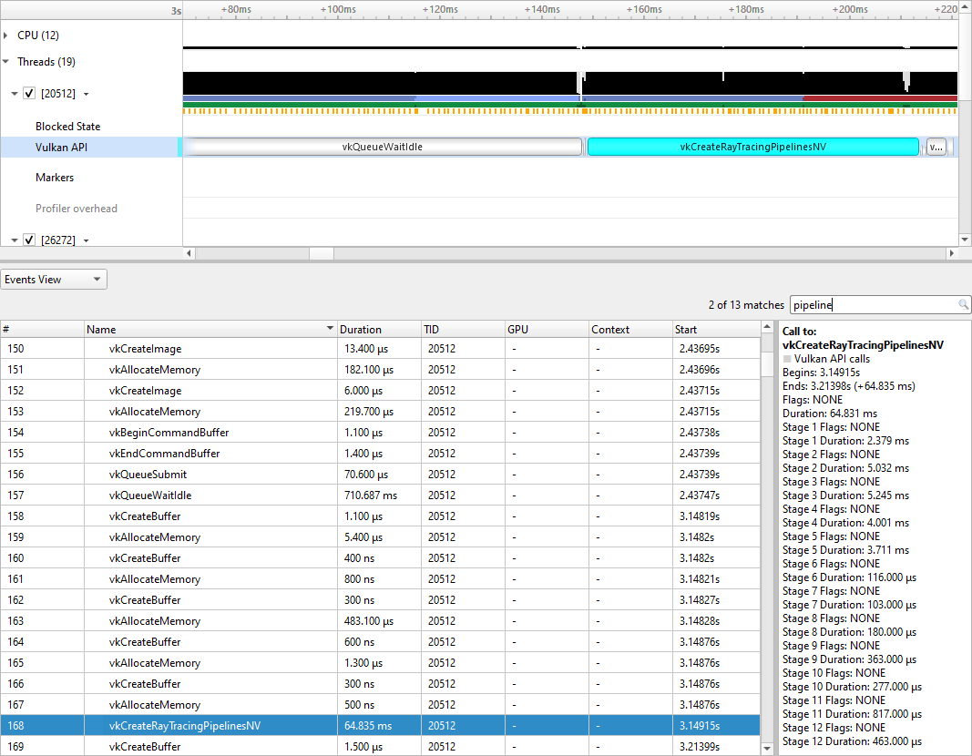

Vulkan GPU Trace Notes
    - Vulkan GPU trace is available only when tracing apps that use NVIDIA GPUs.
    - The endings of Vulkan Command Buffers execution ranges on Compute and Transfer queues may appear earlier on the timeline than their actual occurrence.

Chapter 9. STUTTER ANALYSIS

Stutter Analysis Overview
Nsight Systems on Windows targets displays stutter analysis visualization aids for profiled graphics applications that use either OpenGL, D3D11, D3D12 or Vulkan, as detailed below in the following sections.

FPS Overview
The Frame Duration section displays frame durations on both the CPU and the GPU.
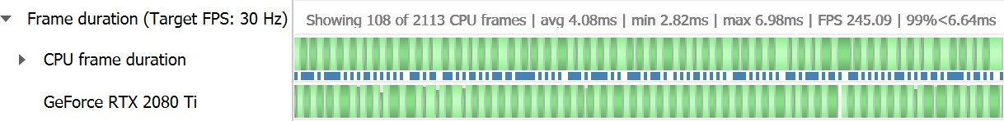
The frame duration row displays live FPS statistics for the current timeline viewport. Values shown are:
- Number of CPU frames shown of the total number captured
- Average, minimal, and maximal CPU frame time of the currently displayed time range
- Average FPS value for the currently displayed frames
- The 99th percentile value of the frame lengths (such that only 1% of the frames in the range are longer than this value).
The values will update automatically when scrolling, zooming or filtering the timeline view.
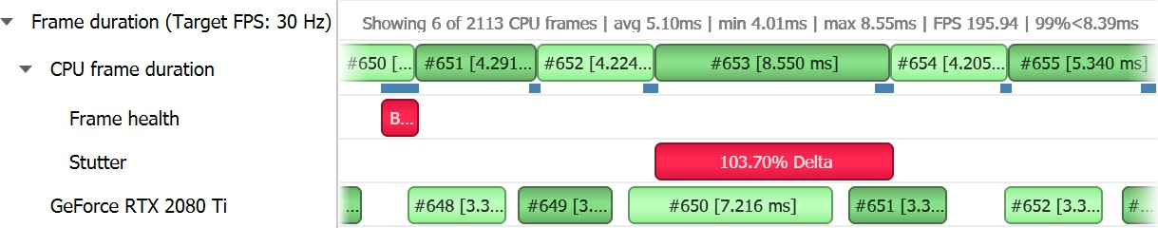

The stutter row highlights frames that are significantly longer than the other frames in their immediate vicinity.
The stutter row uses an algorithm that compares the duration of each frame to the median duration of the surrounding 19 frames. Duration difference under 4 milliseconds is never considered a stutter, to avoid cluttering the display with frames whose absolute stutter is small and not noticeable to the user.
For example, if the stutter threshold is set at 20%:
- Median duration is 10 ms. Frame with 13 ms time will not be reported (relative difference > 20%, absolute difference < 4 ms)
- Median duration is 60 ms. Frame with 71 ms time will not be reported (relative difference < 20%, absolute difference > 4 ms)
- Median duration is 60 ms. Frame with 80 ms is a stutter (relative difference > 20%, absolute difference > 4 ms, both conditions met)

OSC detection
The "19 frame window median" algorithm by itself may not work well with some cases of "oscillation" (consecutive fast and slow frames), resulting in some false positives. The median duration is not meaningful in cases of oscillation and can be misleading.
To address the issue and identify if oscillating frames, the following method is applied:
- For every frame, calculate the median duration, 1st and 3rd quartiles of 19-frames window.
- Calculate the delta and ratio between 1st and 3rd quartiles.
- If the 90th percentile of 3rd – 1st quartile delta array > 4 ms AND the 90th percentile of 3rd/1st quartile array > 1.2 (120%) then mark the results with "OSC" text.
Right-clicking the Frame Duration row caption lets you choose the target frame rate (30, 60, 90 or custom frames per second).
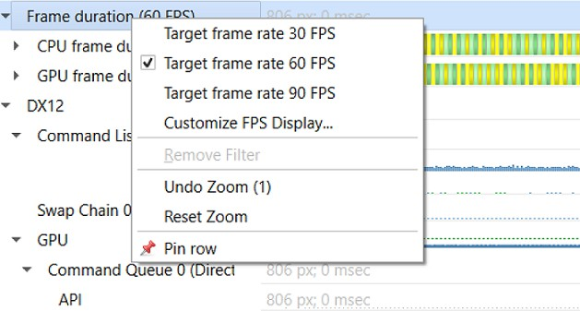
By clicking the Customize FPS Display option, a customization dialog pops up. In the dialog, you can now define the frame duration threshold to customize the view of the potentially problematic frames. In addition, you can define the threshold for the stutter analysis frames.

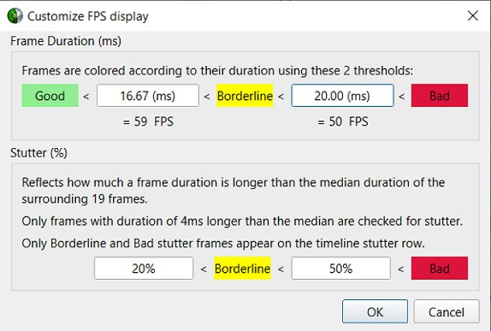
Frame duration bars are color coded:
  - Green, the frame duration is shorter than required by the target FPS ratio.
  - Yellow, duration is slightly longer than required by the target FPS rate.
  - Red, duration far exceeds that required to maintain the target FPS rate.

The CPU Frame Duration row displays the CPU frame duration measured between the ends of consecutive frame boundary calls:
  - The OpenGL frame boundaries are eglSwapBuffers/glXSwapBuffers/ SwapBuffers calls.
  - The D3D11 and D3D12 frame boundaries are IDXGISwapChainX::Present calls.
  - The Vulkan frame boundaries are vkQueuePresentKHR calls.
The timing of the actual calls to the frame boundary calls can be seen in the blue bar at the bottom of the CPU frame duration row
The GPU Frame Duration row displays the time measured between
  - The start time of the first GPU workload execution of this frame.
  - The start time of the first GPU workload execution of the next frame.

Reflex SDK
NVIDIA Reflex SDK is a series of NVAPI calls that allow applications to integrate the Ultra Low Latency driver feature more directly into their game to further optimize synchronization between simulation and rendering stages and lower the latency between user input and final image rendering. For more details about Reflex SDK, see Reflex SDK Site.
Nsight Systems will automatically capture NVAPI functions when either Direct3D 11, Direct3D 12, or Vulkan API trace are enabled.
The Reflex SDK row displays timeline ranges for the following types of latency markers:
  - RenderSubmit.
  - Simulation.
  - Present.

  - Driver.
  - OS Render Queue.
  - GPU Render.
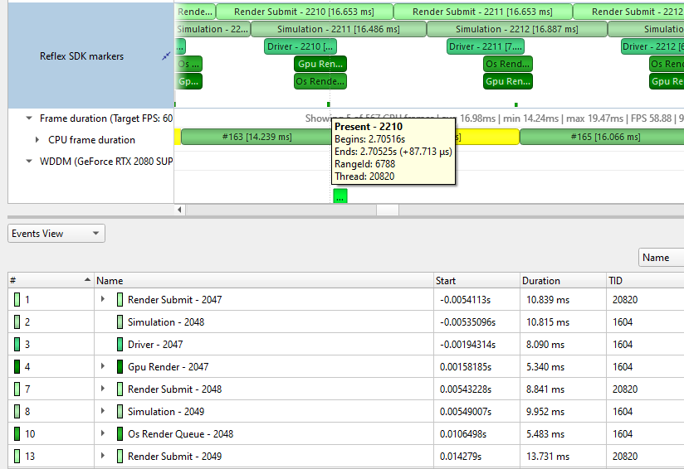

Performance Warnings row
This row shows performance warnings and common pitfalls that are automatically detected based on the enabled capture types. Warnings are reported for:
  - ETW performance warnings
  - Vulkan calls to vkQueueSubmit and D3D12 calls to ID3D12CommandQueue::ExecuteCommandList that take a longer time to execute than the total time of the GPU workloads they generated
  - D3D12 Memory Operation warnings
  - Usage of Vulkan API functions that may adversely affect performance
  - Creation of a Vulkan device with memory zeroing, whether by physical device default or manually
  - Vulkan command buffer barrier which can be combined or removed, such as subsequent barriers or read-to-read barriers

Frame Health
The Frame Health row displays actions that took significantly a longer time during the current frame, compared to the median time of the same actions executed during the surrounding 19-frames. This is a great tool for detecting the reason for frame time stuttering. Such actions may be: shader compilation, present, memory mapping, and more. Nsight Systems measures the accumulated time of such actions in each frame.
For example: calculating the accumulated time of shader compilations in each frame and comparing it to the accumulated time of shader compilations in the surrounding 19 frames.
Example of a Vulkan frame health row:
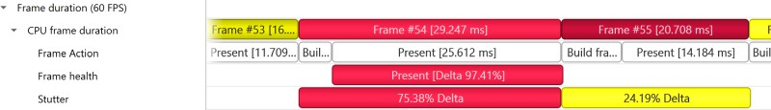
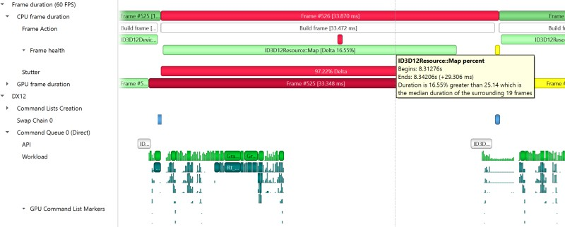

GPU Memory Utilization
The Memory Utilization row displays the amount of used local GPU memory and the commit limit for each GPU.
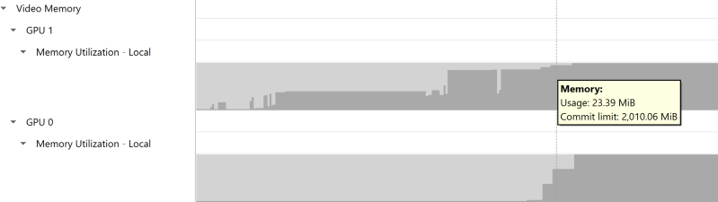
Note that this is not the same as the CUDA kernel memory allocation graph, see CUDA GPU Memory Graph for that functionality.

Vertical Synchronization
The VSYNC rows display when the monitor's vertical synchronizations occur.

Chapter 10. OPENMP TRACE

Nsight Systems for Linux is capable of capturing information about OpenMP events. This functionality is built on the OpenMP Tools Interface (OMPT), full support is available only for runtime libraries supporting tools interface defined in OpenMP 5.0 or greater.
As an example, LLVM OpenMP runtime library partially implements tools interface. If you use PGI compiler <= 20.4 to build your OpenMP applications, add -mp=libomp switch to use LLVM OpenMP runtime and enable OMPT based tracing. If you use Clang, make sure the LLVM OpenMP runtime library you link to was compiled with tools interface enabled.
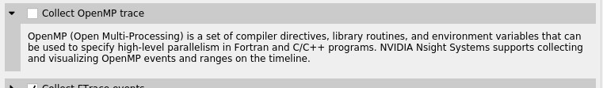
Only a subset of the OMPT callbacks are processed:
ompt_callback_parallel_begin ompt_callback_parallel_end ompt_callback_sync_region ompt_callback_task_create ompt_callback_task_schedule ompt_callback_implicit_task ompt_callback_master ompt_callback_reduction ompt_callback_task_create ompt_callback_cancel
ompt_callback_mutex_acquire, ompt_callback_mutex_acquired ompt_callback_mutex_acquired, ompt_callback_mutex_released ompt_callback_mutex_released
ompt_callback_work ompt_callback_dispatch ompt_callback_flush

The raw OMPT

Note:
events are

OpenMP Trace

used to
generate ranges indicating the runtime of OpenMP operations and
constructs.

Example screenshot:
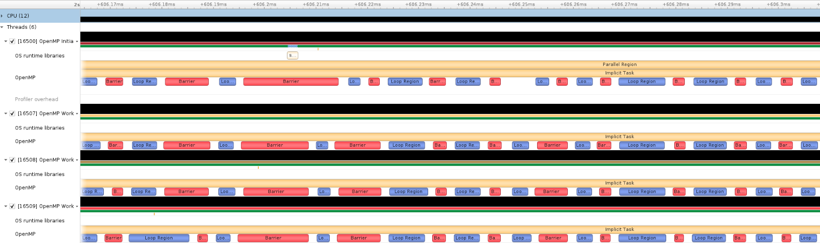

Chapter 11.
OS RUNTIME LIBRARIES TRACE

On Linux, OS runtime libraries can be traced to gather information about low-level userspace APIs. This traces the system call wrappers and thread synchronization interfaces exposed by the C runtime and POSIX Threads (pthread) libraries. This does not perform a complete runtime library API trace, but instead focuses on the
functions that can take a long time to execute, or could potentially cause your thread be unscheduled from the CPU while waiting for an event to complete. OS runtime trace is not available for Windows targets.
OS runtime tracing complements and enhances sampling information by:
- Visualizing when the process is communicating with the hardware, controlling resources, performing multi-threading synchronization or interacting with the kernel scheduler.
- Adding additional thread states by correlating how OS runtime libraries traces affect the thread scheduling:
  - Waiting — the thread is not scheduled on a CPU, it is inside of an OS runtime libraries trace and is believed to be waiting on the firmware to complete a request.
  - In OS runtime library function — the thread is scheduled on a CPU and inside of an OS runtime libraries trace. If the trace represents a system call, the process is likely running in kernel mode.
- Collecting backtraces for long OS runtime libraries call. This provides a way to gather blocked-state backtraces, allowing you to gain more context about why the thread was blocked so long, yet avoiding unnecessary overhead for short events.

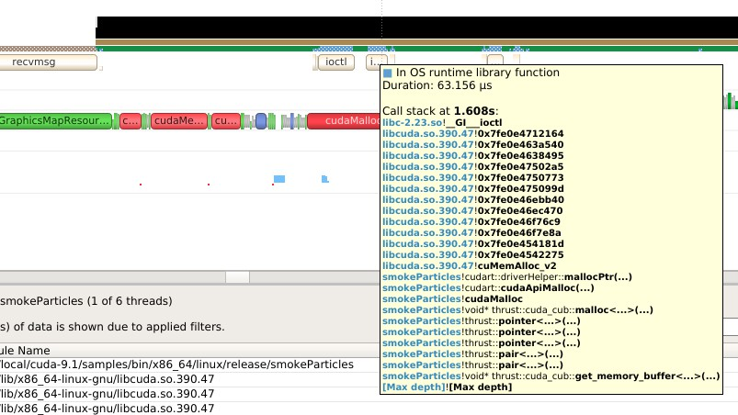
To enable OS runtime libraries tracing from Nsight Systems:
CLI — Use the -t, --trace option with the osrt parameter. See Command Line Options for more information.
GUI — Select the Collect OS runtime libraries trace checkbox.
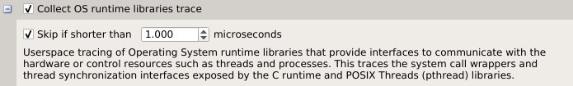
You can also use Skip if shorter than. This will skip calls shorter than the given threshold. Enabling this option will improve performances as well as reduce noise on the timeline. We strongly encourage you to skip OS runtime libraries call shorter than 1 μs.

Locking a Resource
The functions listed below receive a special treatment. If the tool detects that the resource is already acquired by another thread and will induce a blocking call, we always trace it. Otherwise, it will never be traced.
pthread_mutex_lock pthread_rwlock_rdlock pthread_rwlock_wrlock pthread_spin_lock sem_wait
Note that even if a call is determined as potentially blocking, there is a chance that it may not actually block after a few cycles have elapsed. The call will still be traced in this scenario.

Limitations
    - Nsight Systems only traces syscall wrappers exposed by the C runtime. It is not able to trace syscall invoked through assembly code.

    - Additional thread states, as well as backtrace collection on long calls, are only enabled if sampling is turned on.
    - It is not possible to configure the depth and duration threshold when collecting backtraces. Currently, only OS runtime libraries calls longer than 80 μs will generate a backtrace with a maximum of 24 frames. This limitation will be removed in a future version of the product.
    - It is required to compile your application and libraries with the -funwind-tables
compiler flag in order for Nsight Systems to unwind the backtraces correctly.

OS Runtime Libraries Trace Filters
The OS runtime libraries tracing is limited to a select list of functions. It also depends on the version of the C runtime linked to the application.

OS Runtime Default Function List

Libc system call wrappers
accept accept4 acct alarm
arch_prctl bind
bpf brk chroot
clock_nanosleep connect copy_file_range creat
creat64 dup dup2 dup3
epoll_ctl epoll_pwait epoll_wait fallocate fallocate64 fcntl fdatasync flock
fork fsync ftruncate futex ioctl ioperm iopl
kill killpg listen membarrier mlock mlock2 mlockall mmap mmap64 mount move_pages mprotect mq_notify mq_open mq_receive mq_send
mq_timedreceive
mq_timedsend mremap msgctl msgget msgrcv msgsnd
msync munmap nanosleep nfsservctl open open64 openat openat64 pause
www.nvidia.com
User Guide v2023.3.1 | 170
pipe pipe2
pivot_root poll

POSIX Threads
pthread_barrier_wait pthread_cancel pthread_cond_broadcast pthread_cond_signal pthread_cond_timedwait pthread_cond_wait pthread_create pthread_join pthread_kill pthread_mutex_lock pthread_mutex_timedlock pthread_mutex_trylock pthread_rwlock_rdlock
pthread_rwlock_timedrdlock
pthread_rwlock_timedwrlock pthread_rwlock_tryrdlock pthread_rwlock_trywrlock pthread_rwlock_wrlock pthread_spin_lock pthread_spin_trylock pthread_timedjoin_np pthread_tryjoin_np pthread_yield sem_timedwait
sem_trywait sem_wait

I/O
aio_fsync aio_fsync64 aio_suspend aio_suspend64 fclose fcloseall fflush fflush_unlocked fgetc fgetc_unlocked fgets fgets_unlocked fgetwc fgetwc_unlocked fgetws fgetws_unlocked flockfile
fopen
fopen64 fputc
fputc_unlocked fputs fputs_unlocked fputwc fputwc_unlocked fputws fputws_unlocked fread fread_unlocked freopen freopen64 ftrylockfile fwrite fwrite_unlocked getc getc_unlocked getdelim getline
getw
getwc getwc_unlocked lockf
lockf64 mkfifo mkfifoat
posix_fallocate posix_fallocate64 putc putc_unlocked putwc putwc_unlocked

Miscellaneous
forkpty popen posix_spawn posix_spawnp sigwait sigwaitinfo sleep
system usleep

Chapter 12. NVTX TRACE

The NVIDIA Tools Extension Library (NVTX) is a powerful mechanism that allows users to manually instrument their application. Nsight Systems can then collect the information and present it on the timeline.
Nsight Systems supports version 3.0 of the NVTX specification. The following features are supported:
- Domains
nvtxDomainCreate(), nvtxDomainDestroy()
nvtxDomainRegisterString()

- Push-pop ranges (nested ranges that start and end in the same thread).
nvtxRangePush(), nvtxRangePushEx()
nvtxRangePop()
nvtxDomainRangePushEx()
nvtxDomainRangePop()

- Start-end ranges (ranges that are global to the process and are not restricted to a single thread)
nvtxRangeStart(), nvtxRangeStartEx()
nvtxRangeEnd()
nvtxDomainRangeStartEx()
nvtxDomainRangeEnd()

- Marks
nvtxMark(), nvtxMarkEx()
nvtxDomainMarkEx()

- Thread names
nvtxNameOsThread()
- Categories
nvtxNameCategory()
nvtxDomainNameCategory()

To learn more about specific features of NVTX, please refer to the NVTX header file:
nvToolsExt.h or the NVTX documentation.

To use NVTX in your application, follow these steps:
- Add #include "nvtx3/nvToolsExt.h" in your source code. The nvtx3 directory is located in the Nsight Systems package in the Target-<architecture>/nvtx/include directory and is available via github at http://github.com/NVIDIA/NVTX.
- Add the following compiler flag: -ldl
- Add calls to the NVTX API functions. For example, try adding nvtxRangePush("main") in the beginning of the main() function, and nvtxRangePop() just before the return statement in the end.
For convenience in C++ code, consider adding a wrapper that implements RAII (resource acquisition is initialization) pattern, which would guarantee that every range gets closed.
- In the project settings, select the Collect NVTX trace checkbox.
In addition, by enabling the "Insert NVTX Marker hotkey" option it is possible to add NVTX markers to a running non-console applications by pressing the F11 key. These will appear in the report under the NVTX Domain named "HotKey markers".
Typically calls to NVTX functions can be left in the source code even if the application is not being built for profiling purposes, since the overhead is very low when the profiler is not attached.
NVTX is not intended to annotate very small pieces of code that are being called very frequently. A good rule of thumb to use: if code being annotated usually takes less than 1 microsecond to execute, adding an NVTX range around this code should be done carefully.

Range annotations should

Note:
be matched carefully.
If many ranges are opened but
not closed, Nsight Systems has
no meaningful way
to visualize it.
A
rule of thumb

is to not
have more than a
couple dozen ranges open at
any point in time. Nsight
Systems does not support reports with many
unclosed ranges.

NVTX Domains and Categories
NVTX domains enable scoping of annotations. Unless specified differently, all events and annotations are in the default domain. Additionally, categories can be used to group events.
Nsight Systems gives the user the ability to include or exclude NVTX events from a particular domain. This can be especially useful if you are profiling across multiple libraries and are only interested in nvtx events from some of them.
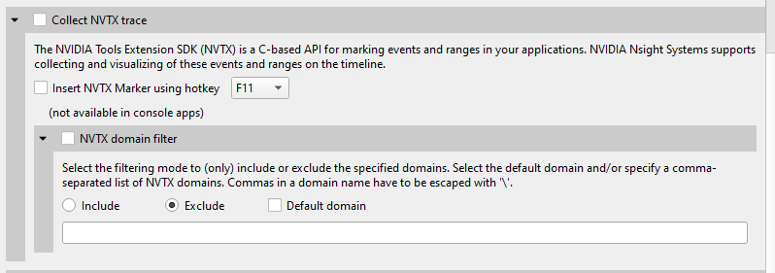
This functionality is also available from the CLI. See the CLI documentation for --nvtx- domain-include and --nvtx-domain-exclude for more details.
Categories that are set in by the user will be recognized and displayed in the GUI.

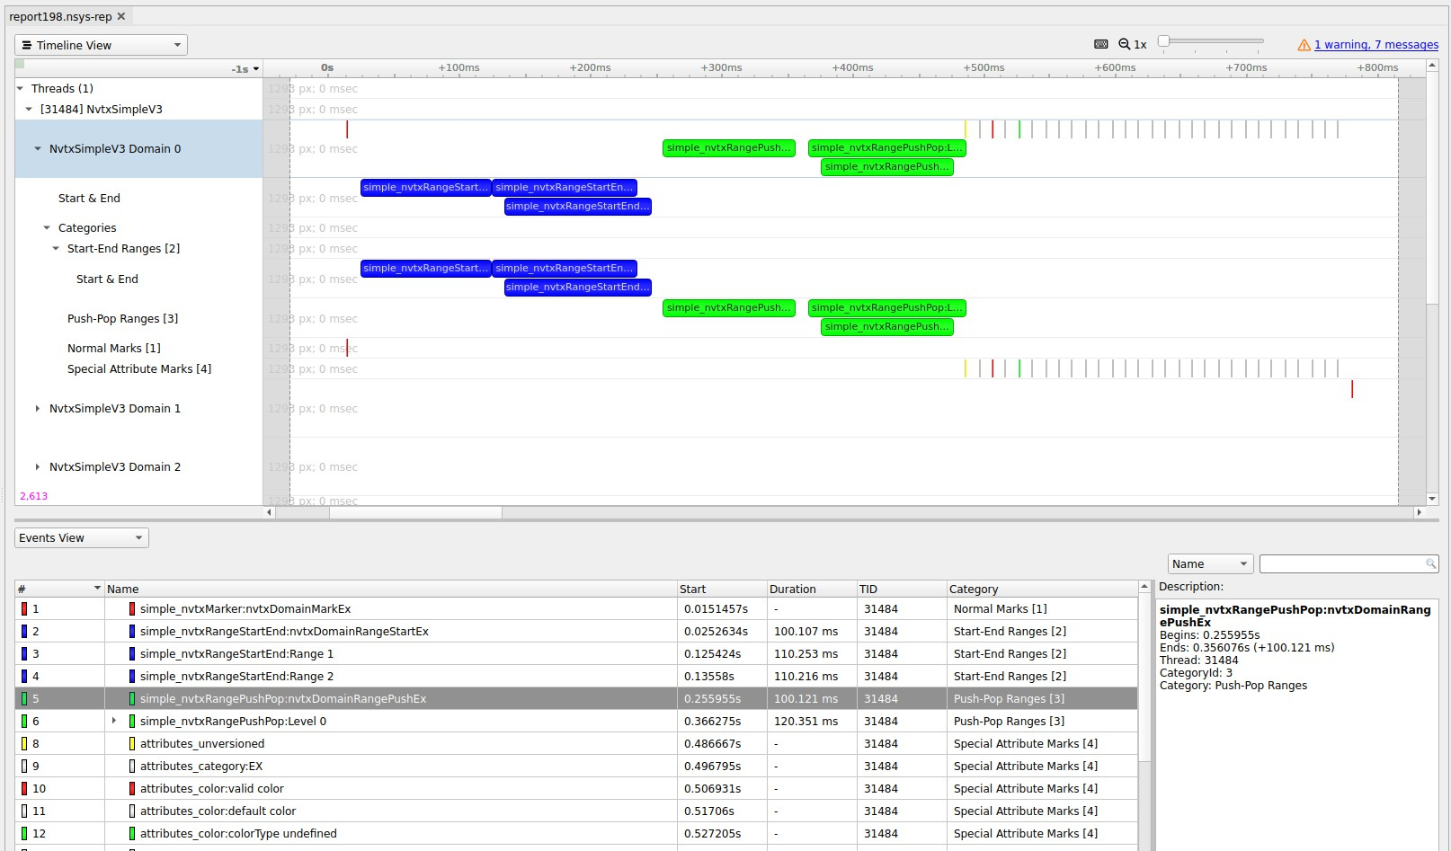

Chapter 13. CUDA TRACE

Nsight Systems is capable of capturing information about CUDA execution in the profiled process.
The following information can be collected and presented on the timeline in the report:
- CUDA API trace — trace of CUDA Runtime and CUDA Driver calls made by the application.
  - CUDA Runtime calls typically start with cuda prefix (e.g. cudaLaunch).
  - CUDA Driver calls typically start with cu prefix (e.g. cuDeviceGetCount).
- CUDA workload trace — trace of activity happening on the GPU, which includes memory operations (e.g., Host-to-Device memory copies) and kernel executions. Within the threads that use the CUDA API, additional child rows will appear in the timeline tree.
- On Nsight Systems Workstation Edition, cuDNN and cuBLAS API tracing and OpenACC tracing.
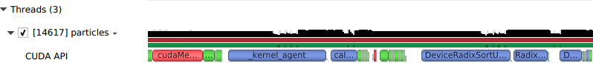
Near the bottom of the timeline row tree, the GPU node will appear and contain a CUDA node. Within the CUDA node, each CUDA context used within the process will be shown along with its corresponding CUDA streams. Steams will contain memory operations and kernel launches on the GPU. Kernel launches are represented by blue, while memory transfers are displayed in red.

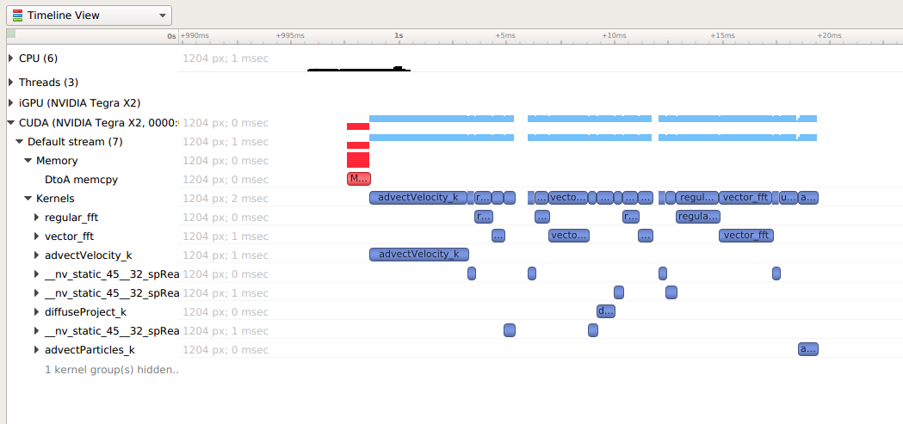
The easiest way to capture CUDA information is to launch the process from Nsight Systems, and it will setup the environment for you. To do so, simply set up a normal launch and select the Collect CUDA trace checkbox.
For Nsight Systems Workstation Edition this looks like:
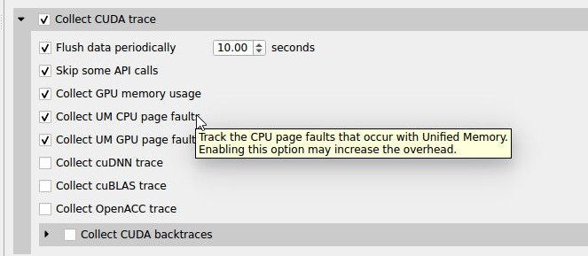
For Nsight Systems Embedded Platforms Edition this looks like:
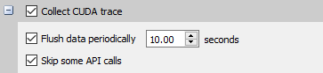
Additional configuration parameters are available:
- Collect backtraces for API calls longer than X seconds - turns on collection of CUDA API backtraces and sets the minimum time a CUDA API event must
take before its backtraces are collected. Setting this value too low can cause high application overhead and seriously increase the size of your results file.
- Flush data periodically — specifies the period after which an attempt to flush CUDA trace data will be made. Normally, in order to collect full CUDA trace, the application needs to finalize the device used for CUDA work (call

cudaDeviceReset(), and then let the application gracefully exit (as opposed to crashing).
This option allows flushing CUDA trace data even before the device is finalized. However, it might introduce additional overhead to a random CUDA Driver or CUDA Runtime API call.
- Skip some API calls — avoids tracing insignificant CUDA Runtime API calls (namely, cudaConfigureCall(), cudaSetupArgument(),
cudaHostGetDevicePointers()). Not tracing these functions allows Nsight Systems to significantly reduce the profiling overhead, without losing any interesting data. (See CUDA Trace Filters, below)
- Collect GPU Memory Usage - collects information used to generate a graph of CUDA allocated memory across time. Note that this will increase overhead. See section on CUDA GPU Memory Allocation Graph below.
- Collect Unified Memory CPU page faults - collects information on page faults that occur when CPU code tries to access a memory page that resides on the device. See section on Unified Memory CPU Page Faults in the Unified Memory Transfer Trace documentation below.
- Collect Unified Memory GPU page faults - collects information on page faults that occur when GPU code tries to access a memory page that resides on the CPU. See section on Unified Memory GPU Page Faults in the Unified Memory Transfer Trace documentation below.
- Collect CUDA Graph trace - by default, CUDA tracing will collect and expose information on a whole graph basis. The user can opt to collect on a node per node basis. See section on CUDA Graph Trace below.
- For Nsight Systems Workstation Edition, Collect cuDNN trace, Collect cuBLAS trace, Collect OpenACC trace - selects which (if any) extra libraries that depend on CUDA to trace.
OpenACC versions 2.0, 2.5, and 2.6 are supported when using PGI runtime version
15.7 or greater and not compiling statically. In order to differentiate constructs, a PGI runtime of 16.1 or later is required. Note that Nsight Systems Workstation Edition does not support the GCC implementation of OpenACC at this time.

If your

Note:
application crashes before
all collected CUDA
trace data has been copied out, some or
all

data might be lost and not
present in
the report.

Nsight Systems will

Note:
not have
information about CUDA
events that were still
in device buffers when analysis
terminated.
It is a
good idea, if using
cudaProfilerAPI to
control analysis to
call cudaDeviceReset before
ending analysis.

CUDA GPU Memory Allocation Graph
When the Collect GPU Memory Usage option is selected from the Collect CUDA trace option set, Nsight Systems will track CUDA GPU memory allocations and deallocations and present a graph of this information in the timeline. This is not the same as the GPU

memory graph generated during stutter analysis on the Windows target (see Stutter Memory Trace)
Below, in the report on the left, memory is allocated and freed during the collection. In the report on the right, memory is allocated, but not freed during the collection.
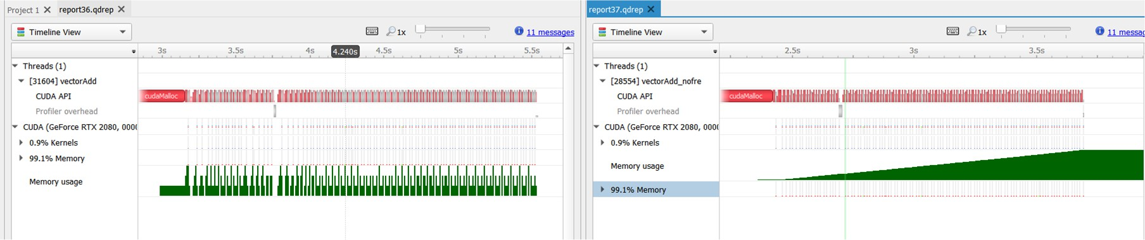
Here is another example, where allocations are happening on multiple GPUs
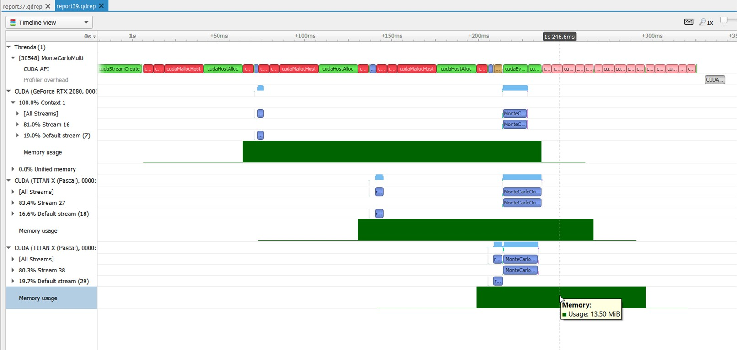

Unified Memory Transfer Trace
For Nsight Systems Workstation Edition, Unified Memory (also called Managed Memory) transfer trace is enabled automatically in Nsight Systems when CUDA trace is selected. It incurs no overhead in programs that do not perform any Unified Memory transfers. Data is displayed in the Managed Memory area of the timeline:
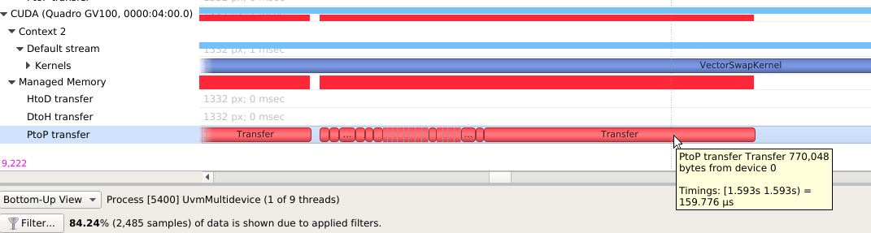

HtoD transfer indicates the CUDA kernel accessed managed memory that was residing on the host, so the kernel execution paused and transferred the data to the device. Heavy traffic here will incur performance penalties in CUDA kernels, so consider using manual cudaMemcpy operations from pinned host memory instead.
PtoP transfer indicates the CUDA kernel accessed managed memory that was residing on a different device, so the kernel execution paused and transferred the data to this device. Heavy traffic here will incur performance penalties, so consider using manual cudaMemcpyPeer operations to transfer from other devices' memory instead. The row showing these events is for the destination device -- the source device is shown in the tooltip for each transfer event.
DtoH transfer indicates the CPU accessed managed memory that was residing on a CUDA device, so the CPU execution paused and transferred the data to system memory. Heavy traffic here will incur performance penalties in CPU code, so consider using manual cudaMemcpy operations from pinned host memory instead.
Some Unified Memory transfers are highlighted with red to indicate potential performance issues:
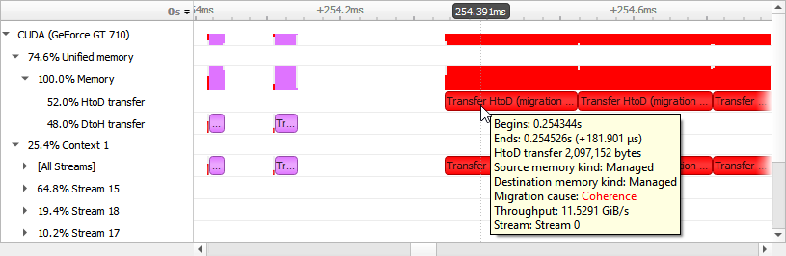
Transfers with the following migration causes are highlighted:

Coherence
Unified Memory migration occurred to guarantee data coherence. SMs (streaming multiprocessors) stop until the migration completes.

Eviction
Unified Memory migrated to the CPU because it was evicted to make room for another block of memory on the GPU. This happens due to memory overcommitment which is available on Linux with Compute Capability ≥ 6.

Unified Memory CPU Page Faults
The Unified Memory CPU page faults feature in Nsight Systems tracks the page faults that occur when CPU code tries to access a memory page that resides on the device.

Collecting Unified Memory CPU

Note:

page faults can cause overhead of
up to 70%
in testing. Please use
this functionality only
when needed.

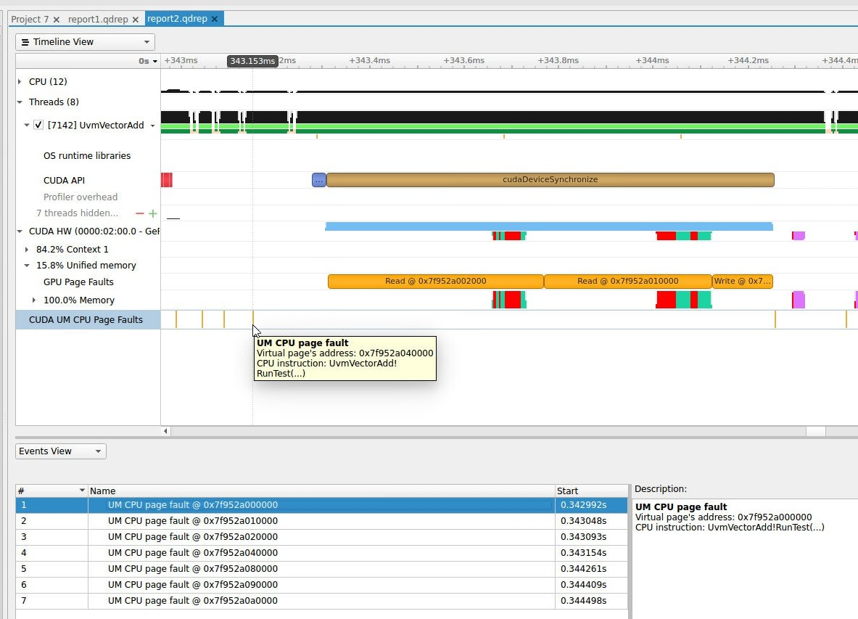

Unified Memory GPU Page Faults
The Unified Memory GPU page faults feature in Nsight Systems tracks the page faults that occur when GPU code tries to access a memory page that resides on the host.

Collecting Unified

Note:

Memory GPU
page faults can cause overhead of
up to 70%
in testing. Please use
this functionality only
when needed.

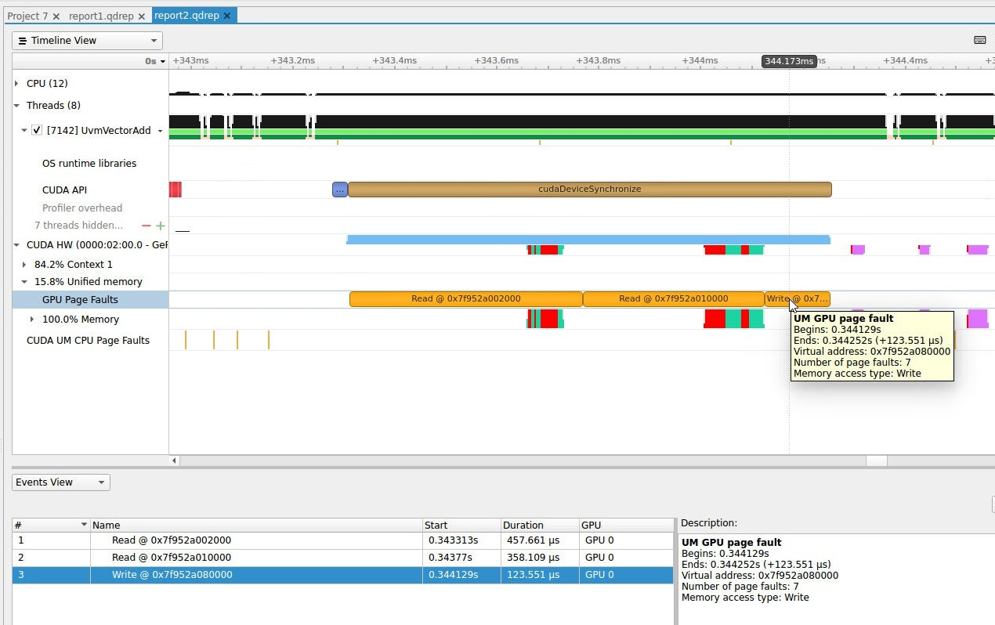

CUDA Graph Trace
Nsight Systems is capable of capturing information about CUDA graphs in your application at either the graph or node granularity. This can be set in the CLI using the
--cuda-graph-trace option, or in the GUI by setting the appropriate drop down.

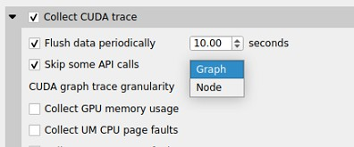
When CUDA graph trace is set to graph, the users sees each graph as one item on the timeline:
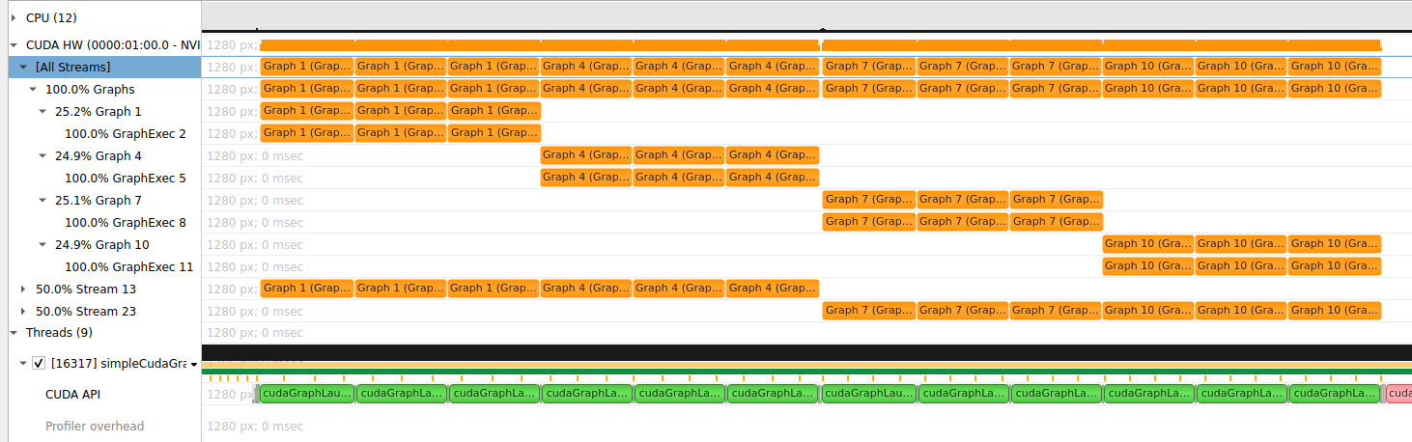
When CUDA graph trace is set to node, the users sees each graph as a set of nodes on the timeline:
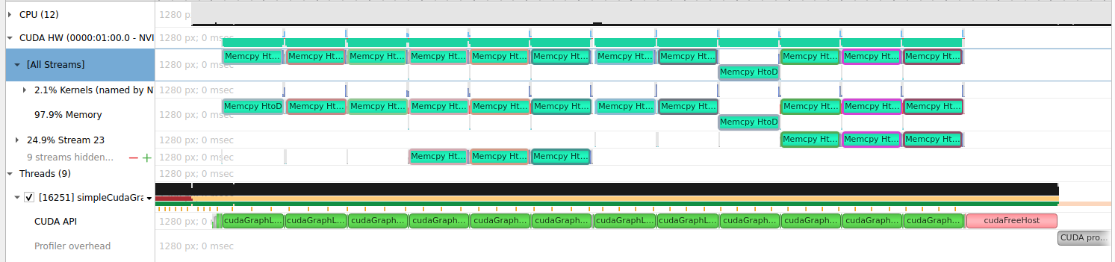
Tracing CUDA graphs at the graph level rather than the tracing the underlying nodes results in significantly less overhead. This option is only available with CUDA driver
515.43 or higher.

CUDA Python Backtrace
Nsight Systems for Arm server (SBSA) platforms and x86 Linux targets, is capable of capturing Python backtrace information when CUDA backtrace is being captured.
To enable CUDA Python backtrace from Nsight Systems:
CLI — Set --python-backtrace=cuda.
GUI — Select the Collect Python backtrace for selected API calls checkbox.

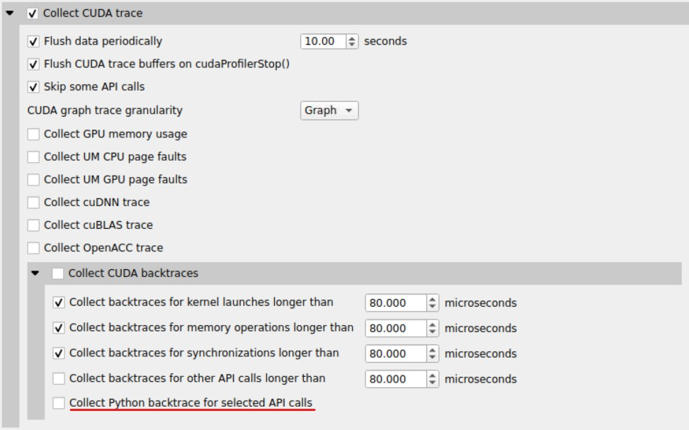
Example screenshot:
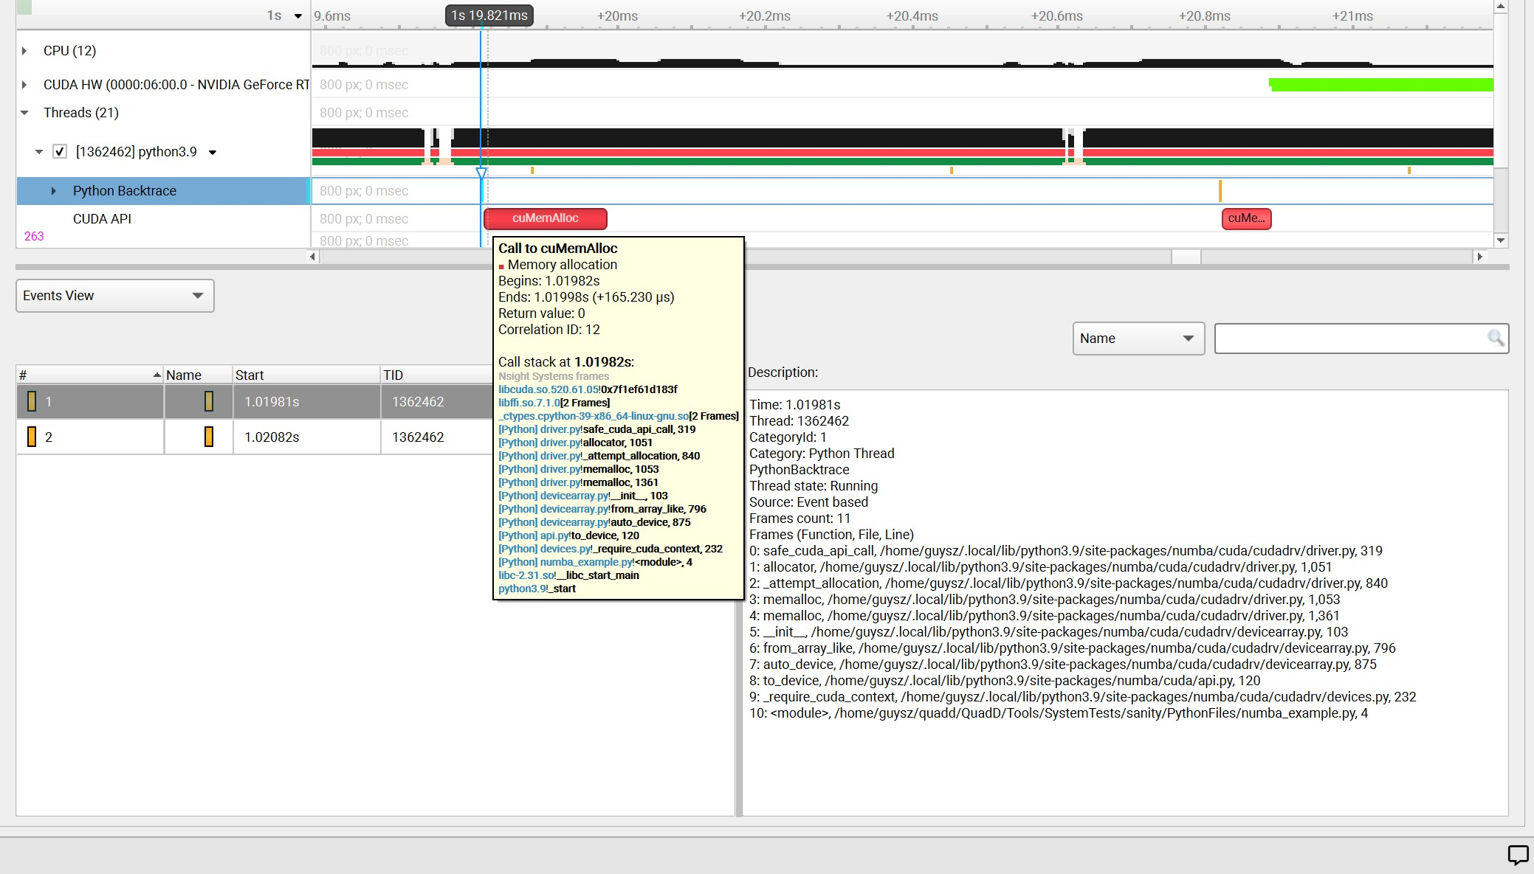

CUDA Default Function List for CLI

CUDA Runtime API
cudaBindSurfaceToArray cudaBindTexture cudaBindTexture2D cudaBindTextureToArray cudaBindTextureToMipmappedArray cudaConfigureCall cudaCreateSurfaceObject cudaCreateTextureObject cudaD3D10MapResources cudaD3D10RegisterResource cudaD3D10UnmapResources cudaD3D10UnregisterResource cudaD3D9MapResources cudaD3D9MapVertexBuffer cudaD3D9RegisterResource cudaD3D9RegisterVertexBuffer cudaD3D9UnmapResources cudaD3D9UnmapVertexBuffer cudaD3D9UnregisterResource cudaD3D9UnregisterVertexBuffer cudaDestroySurfaceObject cudaDestroyTextureObject cudaDeviceReset cudaDeviceSynchronize
cudaEGLStreamConsumerAcquireFrame
cudaEGLStreamConsumerConnect cudaEGLStreamConsumerConnectWithFlags cudaEGLStreamConsumerDisconnect cudaEGLStreamConsumerReleaseFrame cudaEGLStreamConsumerReleaseFrame cudaEGLStreamProducerConnect cudaEGLStreamProducerDisconnect cudaEGLStreamProducerReturnFrame cudaEventCreate cudaEventCreateFromEGLSync cudaEventCreateWithFlags cudaEventDestroy
cudaEventQuery cudaEventRecord cudaEventRecord_ptsz cudaEventSynchronize cudaFree cudaFreeArray cudaFreeHost
cudaFreeMipmappedArray cudaGLMapBufferObject cudaGLMapBufferObjectAsync cudaGLRegisterBufferObject cudaGLUnmapBufferObject cudaGLUnmapBufferObjectAsync cudaGLUnregisterBufferObject cudaGraphicsD3D10RegisterResource cudaGraphicsD3D11RegisterResource cudaGraphicsD3D9RegisterResource cudaGraphicsEGLRegisterImage cudaGraphicsGLRegisterBuffer cudaGraphicsGLRegisterImage cudaGraphicsMapResources cudaGraphicsUnmapResources cudaGraphicsUnregisterResource cudaGraphicsVDPAURegisterOutputSurface cudaGraphicsVDPAURegisterVideoSurface cudaHostAlloc
cudaHostRegister
www.nvidia.com
User Guide v2023.3.1 | 187
cudaHostUnregister cudaLaunch cudaLaunchCooperativeKernel
cudaLaunchCooperativeKernelMultiDevice

CUDA Primary API
cu64Array3DCreate cu64ArrayCreate cu64D3D9MapVertexBuffer cu64GLMapBufferObject cu64GLMapBufferObjectAsync cu64MemAlloc cu64MemAllocPitch cu64MemFree
cu64MemGetInfo cu64MemHostAlloc cu64Memcpy2D cu64Memcpy2DAsync cu64Memcpy2DUnaligned cu64Memcpy3D cu64Memcpy3DAsync cu64MemcpyAtoD cu64MemcpyDtoA cu64MemcpyDtoD cu64MemcpyDtoDAsync cu64MemcpyDtoH cu64MemcpyDtoHAsync cu64MemcpyHtoD cu64MemcpyHtoDAsync cu64MemsetD16 cu64MemsetD16Async cu64MemsetD2D16 cu64MemsetD2D16Async cu64MemsetD2D32 cu64MemsetD2D32Async cu64MemsetD2D8 cu64MemsetD2D8Async cu64MemsetD32 cu64MemsetD32Async cu64MemsetD8 cu64MemsetD8Async cuArray3DCreate cuArray3DCreate_v2 cuArrayCreate cuArrayCreate_v2 cuArrayDestroy cuBinaryFree cuCompilePtx cuCtxCreate cuCtxCreate_v2 cuCtxDestroy cuCtxDestroy_v2 cuCtxSynchronize cuD3D10CtxCreate
cuD3D10CtxCreateOnDevice
cuD3D10CtxCreate_v2 cuD3D10MapResources cuD3D10RegisterResource cuD3D10UnmapResources cuD3D10UnregisterResource cuD3D11CtxCreate cuD3D11CtxCreateOnDevice cuD3D11CtxCreate_v2 cuD3D9CtxCreate cuD3D9CtxCreateOnDevice cuD3D9CtxCreate_v2 cuD3D9MapResources cuD3D9MapVertexBuffer cuD3D9MapVertexBuffer_v2 cuD3D9RegisterResource cuD3D9RegisterVertexBuffer cuD3D9UnmapResources cuD3D9UnmapVertexBuffer cuD3D9UnregisterResource cuD3D9UnregisterVertexBuffer cuEGLStreamConsumerAcquireFrame cuEGLStreamConsumerConnect
www.nvidia.com
User Guide v2023.3.1 | 188
cuEGLStreamConsumerConnectWithFlags
cuEGLStreamConsumerDisconnect
cuEGLStreamConsumerReleaseFrame

cuDNN Function List for X86 CLI

cuDNN API functions
cudnnActivationBackward cudnnActivationBackward_v3 cudnnActivationBackward_v4 cudnnActivationForward cudnnActivationForward_v3 cudnnActivationForward_v4 cudnnAddTensor cudnnBatchNormalizationBackward cudnnBatchNormalizationBackwardEx cudnnBatchNormalizationForwardInference cudnnBatchNormalizationForwardTraining
cudnnBatchNormalizationForwardTrainingEx cudnnCTCLoss cudnnConvolutionBackwardBias cudnnConvolutionBackwardData cudnnConvolutionBackwardFilter cudnnConvolutionBiasActivationForward cudnnConvolutionForward
cudnnCreate cudnnCreateAlgorithmPerformance cudnnDestroy cudnnDestroyAlgorithmPerformance cudnnDestroyPersistentRNNPlan cudnnDivisiveNormalizationBackward cudnnDivisiveNormalizationForward cudnnDropoutBackward cudnnDropoutForward cudnnDropoutGetReserveSpaceSize cudnnDropoutGetStatesSize
cudnnFindConvolutionBackwardDataAlgorithm cudnnFindConvolutionBackwardDataAlgorithmEx cudnnFindConvolutionBackwardFilterAlgorithm cudnnFindConvolutionBackwardFilterAlgorithmEx cudnnFindConvolutionForwardAlgorithm cudnnFindConvolutionForwardAlgorithmEx cudnnFindRNNBackwardDataAlgorithmEx cudnnFindRNNBackwardWeightsAlgorithmEx cudnnFindRNNForwardInferenceAlgorithmEx cudnnFindRNNForwardTrainingAlgorithmEx cudnnFusedOpsExecute
cudnnIm2Col cudnnLRNCrossChannelBackward cudnnLRNCrossChannelForward cudnnMakeFusedOpsPlan cudnnMultiHeadAttnBackwardData cudnnMultiHeadAttnBackwardWeights cudnnMultiHeadAttnForward cudnnOpTensor cudnnPoolingBackward cudnnPoolingForward cudnnRNNBackwardData cudnnRNNBackwardDataEx cudnnRNNBackwardWeights cudnnRNNBackwardWeightsEx cudnnRNNForwardInference cudnnRNNForwardInferenceEx cudnnRNNForwardTraining cudnnRNNForwardTrainingEx cudnnReduceTensor cudnnReorderFilterAndBias cudnnRestoreAlgorithm cudnnRestoreDropoutDescriptor cudnnSaveAlgorithm cudnnScaleTensor cudnnSoftmaxBackward cudnnSoftmaxForward
www.nvidia.com
User Guide v2023.3.1 | 189
cudnnSpatialTfGridGeneratorBackward
cudnnSpatialTfGridGeneratorForward

Chapter 14. OPENACC TRACE

Nsight Systems for Linux x86_64 and Power targets is capable of capturing information about OpenACC execution in the profiled process.
OpenACC versions 2.0, 2.5, and 2.6 are supported when using PGI runtime version 15.7 or later. In order to differentiate constructs (see tooltip below), a PGI runtime of 16.0 or later is required. Note that Nsight Systems does not support the GCC implementation of OpenACC at this time.
Under the CPU rows in the timeline tree, each thread that uses OpenACC will show OpenACC trace information. You can click on a OpenACC API call to see correlation with the underlying CUDA API calls (highlighted in teal):
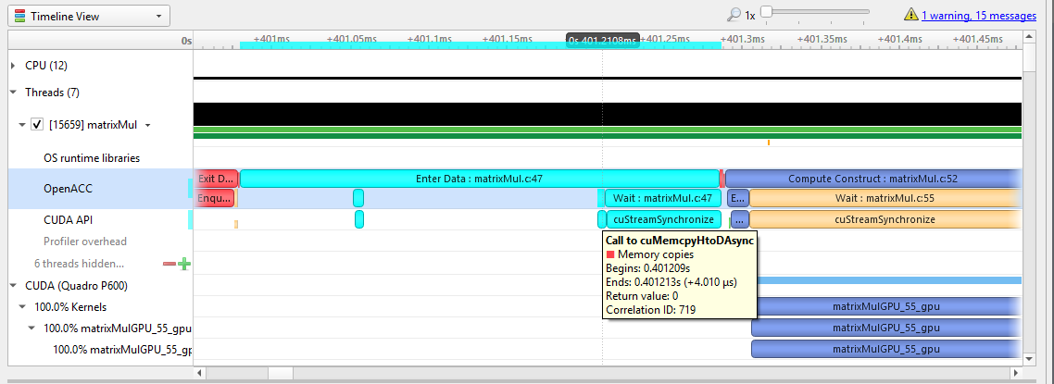
If the OpenACC API results in GPU work, that will also be highlighted:
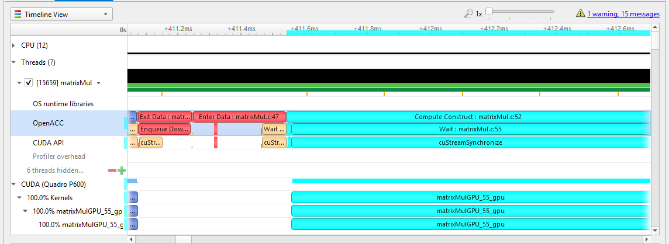

OpenACC Trace

Hovering over a particular OpenACC construct will bring up a tooltip with details about that construct:
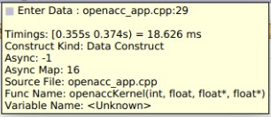
To capture OpenACC information from the Nsight Systems GUI, select the Collect OpenACC trace checkbox under Collect CUDA trace configurations. Note that turning on OpenACC tracing will also turn on CUDA tracing.
Please note that if your application crashes before all collected OpenACC trace data has been copied out, some or all data might be lost and not present in the report.

Chapter 15. OPENGL TRACE

OpenGL and OpenGL ES APIs can be traced to assist in the analysis of CPU and GPU interactions.
A few usage examples are:
- Visualize how long eglSwapBuffers (or similar) is taking.
- API trace can easily show correlations between thread state and graphics driver's behavior, uncovering where the CPU may be waiting on the GPU.
- Spot bubbles of opportunity on the GPU, where more GPU workload could be created.
- Use KHR_debug extension to trace GL events on both the CPU and GPU.
OpenGL trace feature in Nsight Systems consists of two different activities which will be shown in the CPU rows for those threads
  - CPU trace: interception of API calls that an application does to APIs (such as OpenGL, OpenGL ES, EGL, GLX, WGL, etc.).
  - GPU trace (or workload trace): trace of GPU workload (activity) triggered by use of OpenGL or OpenGL ES. Since draw calls are executed back-to-back, the GPU workload trace ranges include many OpenGL draw calls and operations in order to optimize performance overhead, rather than tracing each individual operation.
To collect GPU trace, the glQueryCounter() function is used to measure how much time batches of GPU workload take to complete.
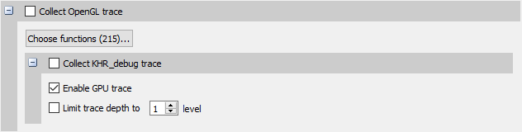

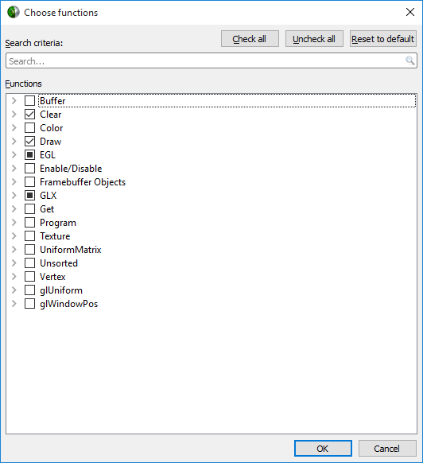
Ranges defined by the KHR_debug calls are represented similarly to OpenGL API and OpenGL GPU workload trace. GPU ranges in this case represent incremental draw cost. They cannot fully account for GPUs that can execute multiple draw calls in parallel. In this case, Nsight Systems will not show overlapping GPU ranges.

OpenGL Trace Using Command Line
For general information on using the target CLI, see CLI Profiling on Linux. For the CLI, the functions that are traced are set to the following list:
glWaitSync glReadPixels glReadnPixelsKHR glReadnPixelsEXT glReadnPixelsARB glReadnPixels glFlush glFinishFenceNV glFinish glClientWaitSync glClearTexSubImage glClearTexImage glClearStencil
glClearNamedFramebufferuiv
glClearNamedFramebufferiv glClearNamedFramebufferfv glClearNamedFramebufferfi glClearNamedBufferSubDataEXT glClearNamedBufferSubData glClearNamedBufferDataEXT glClearNamedBufferData glClearIndex
glClearDepthx glClearDepthf glClearDepthdNV glClearDepth glClearColorx glClearColorIuiEXT glClearColorIiEXT glClearColor glClearBufferuiv glClearBufferSubData glClearBufferiv glClearBufferfv glClearBufferfi glClearBufferData glClearAccum
glClear
glDispatchComputeIndirect glDispatchComputeGroupSizeARB glDispatchCompute glComputeStreamNV glNamedFramebufferDrawBuffers glNamedFramebufferDrawBuffer glMultiDrawElementsIndirectEXT
glMultiDrawElementsIndirectCountARB glMultiDrawElementsIndirectBindlessNV glMultiDrawElementsIndirectBindlessCountNV glMultiDrawElementsIndirectAMD glMultiDrawElementsIndirect glMultiDrawElementsEXT glMultiDrawElementsBaseVertex glMultiDrawElements glMultiDrawArraysIndirectEXT glMultiDrawArraysIndirectCountARB glMultiDrawArraysIndirectBindlessNV glMultiDrawArraysIndirectBindlessCountNV glMultiDrawArraysIndirectAMD glMultiDrawArraysIndirect glMultiDrawArraysEXT
glMultiDrawArrays
glListDrawCommandsStatesClientNV glFramebufferDrawBuffersEXT glFramebufferDrawBufferEXT glDrawTransformFeedbackStreamInstanced glDrawTransformFeedbackStream
www.nvidia.com
User Guide v2023.3.1 | 195
glDrawTransformFeedbackNV

Chapter 16. CUSTOM ETW TRACE

Use the custom ETW trace feature to enable and collect any manifest-based ETW log. The collected events are displayed on the timeline on dedicated rows for each event type.
Custom ETW is available on Windows target machines.
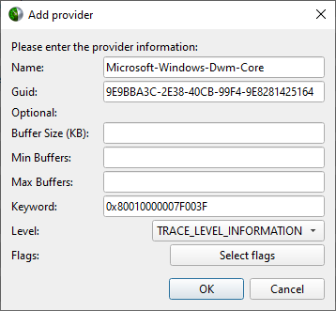
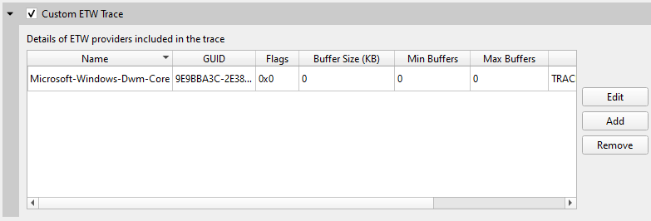

Custom ETW Trace

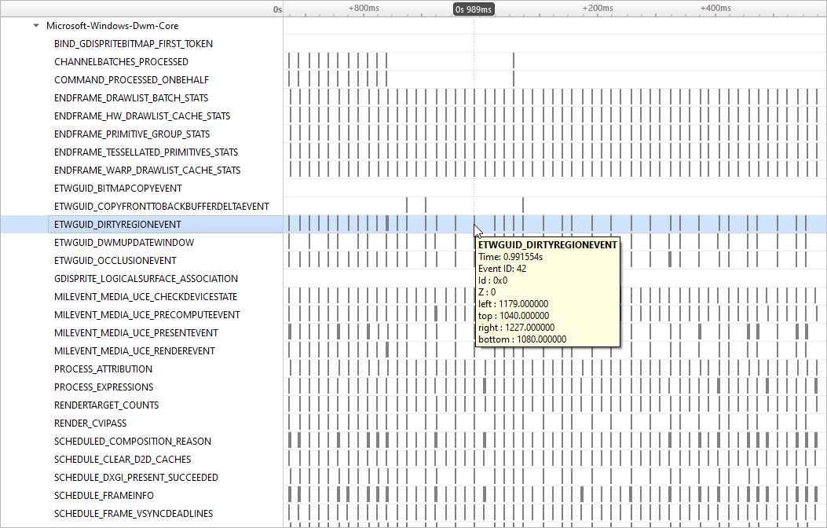
To retain the .etl trace files captured, so that they can be viewed in other tools (e.g. GPUView), change the "Save ETW log files in project folder" option under "Profile Behavior" in Nsight Systems's global Options dialog. The .etl files will appear in the same folder as the .nsys-rep file, accessible by right-clicking the report in the Project Explorer and choosing "Show in Folder...". Data collected from each ETW provider will appear in its own .etl file, and an additional .etl file named "Report XX-Merged-*.etl", containing the events from all captured sources, will be created as well.

Chapter 17. GPU METRICS

Overview
GPU Metrics feature is intended to identify performance limiters in applications using GPU for computations and graphics. It uses periodic sampling to gather performance metrics and detailed timing statistics associated with different GPU hardware units taking advantage of specialized hardware to capture this data in a single pass with minimal overhead.
Note: GPU Metrics will give you precise device level information, but it does not know which process or context is involved. GPU context switch trace provides less precise information, but will give you process and context information.
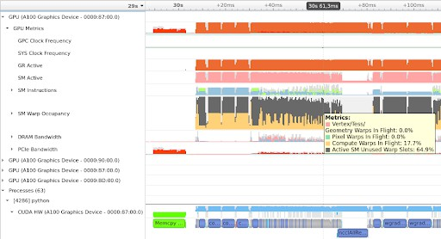
These metrics provide an overview of GPU efficiency over time within compute, graphics, and input/output (IO) activities such as:

- IO throughputs: PCIe, NVLink, and GPU memory bandwidth
- SM utilization: SMs activity, tensor core activity, instructions issued, warp occupancy, and unassigned warp slots
It is designed to help users answer the common questions:
- Is my GPU idle?
- Is my GPU full? Enough kernel grids size and streams? Are my SMs and warp slots full?
- Am I using TensorCores?
- Is my instruction rate high?
- Am I possibly blocked on IO, or number of warps, etc
Nsight Systems GPU Metrics is only available for Linux targets on x86-64 and aarch64, and for Windows targets. It requires NVIDIA Turing architecture or newer.
Minimum required driver versions:
- NVIDIA Turing architecture TU10x, TU11x - r440
- NVIDIA Ampere architecture GA100 - r450
- NVIDIA Ampere architecture GA100 MIG - r470 TRD1
- NVIDIA Ampere architecture GA10x - r455

Note:
Permissions: Elevated permissions are required.
On Linux use sudo to
elevate privileges. On Windows the
user must run from an admin
command prompt or
accept the UAC
escalation dialog.
See Permissions Issues
and

Performance Counters
for more
information.

Note:
Tensor Core:
If you run nsys
profile
--
gpu- metrics- device all,
the
Tensor Core utilization can
be found in the GUI
under the SM
instructions/ Tensor Active
row.
Please note that
it is not
practical to expect
a CUDA
kernel to reach 100%
Tensor Core utilization since there
are other
overheads.

In general, the more
computation- intensive
an operation is,
the higher Tensor Core utilization rate
the CUDA
kernel can achieve.

Launching GPU Metric from the CLI
GPU Metrics feature is controlled with 3 CLI switches:
- --gpu-metrics-device=[all, none, <index>] selects GPUs to sample (default is none)
- --gpu-metrics-set=[<index>, <alias>] selects metric set to use (default is the 1st suitable from the list)
- --gpu-metrics-frequency=[10..200000] selects sampling frequency in Hz (default is 10000)
To profile with default options and sample GPU Metrics on GPU 0:
# Must have elevated permissions (see https://developer.nvidia.com/ ERR_NVGPUCTRPERM) or be root (Linux) or Administrator (Windows)
$ nsys profile --gpu-metrics-device=0 ./my-app
To list available GPUs, use:
$ nsys profile --gpu-metrics-device=help Possible --gpu-metrics-device values are:
0: Quadro GV100 PCI[0000:17:00.0]
1: GeForce RTX 2070 SUPER PCI[0000:65:00.0]
all: Select all supported GPUs none: Disable GPU Metrics [Default]
By default, the first metric set which supports all selected GPUs is used. But you can manually select another metric set from the list. To see available metric sets, use:
$ nsys profile --gpu-metrics-set=help Possible --gpu-metrics-set values are:
[0] [tu10x]
- [tu11x]
- [ga100]
- [ga10x]
- [tu10x-gfxt]
>= 10kHz)
- [ga10x-gfxt]
General Metrics for NVIDIA TU10x (any frequency) General Metrics for NVIDIA TU11x (any frequency) General Metrics for NVIDIA GA100 (any frequency) General Metrics for NVIDIA GA10x (any frequency) Graphics Throughput Metrics for NVIDIA TU10x (frequency
Graphics Throughput Metrics for NVIDIA GA10x (frequency
>= 10kHz)
[6] [ga10x-gfxact] Graphics Async Compute Triage Metrics for NVIDIA GA10x (frequency >= 10kHz)

By default, sampling frequency is set to 10 kHz. But you can manually set it from 10 Hz to 200 kHz using
--gpu-metrics-frequency=<value>

Launching GPU Metrics from the GUI
For commands to launch GPU Metrics from the CLI with examples, see the CLI documentation.
When launching analysis in Nsight Systems, select Collect GPU Metrics.
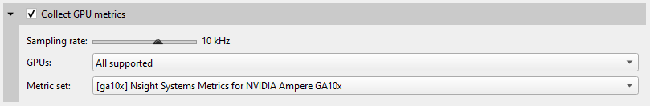
Select the GPUs dropdown to pick which GPUs you wish to sample.
Select the Metric set: dropdown to choose which available metric set you would like to sample.
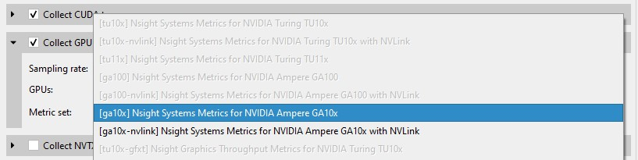
Note that metric sets for GPUs that are not being sampled will be greyed out.

Sampling frequency
Sampling frequency can be selected from the range of 10 Hz - 200 kHz. The default value is 10 kHz.
The maximum sampling frequency without buffer overflow events depends on GPU (SM count), GPU load intensity, and overall system load. The bigger the chip and the higher the load, the lower the maximum frequency. If you need higher frequency, you can increase it until you get "Buffer overflow" message in the Diagnostics Summary report page.
Each metric set has a recommended sampling frequency range in its description. These ranges are approximate. If you observe Inconsistent Data or Missing Data ranges on timeline, please try closer to the recommended frequency.

Available metrics
- GPC Clock Frequency - gpc cycles_elapsed.avg.per_second
The average GPC clock frequency in hertz. In public documentation the GPC clock may be called the "Application" clock, "Graphic" clock, "Base" clock, or "Boost" clock.
Note: The collection mechanism for GPC can result in a small fluctuation between samples.
- SYS Clock Frequency - sys cycles_elapsed.avg.per_second
The average SYS clock frequency in hertz. The GPU front end (command processor), copy engines, and the performance monitor run at the SYS clock. On Turing and NVIDIA GA100 GPUs the sampling frequency is based upon a period of SYS clocks (not time) so samples per second will vary with SYS clock. On NVIDIA GA10x GPUs the sampling frequency is based upon a fixed frequency clock. The maximum frequency scales linearly with the SYS clock.
- GR Active - gr cycles_active.sum.pct_of_peak_sustained_elapsed
The percentage of cycles the graphics/compute engine is active. The graphics/ compute engine is active if there is any work in the graphics pipe or if the compute pipe is processing work.
GA100 MIG - MIG is not yet supported. This counter will report the activity of the primary GR engine.

Sync Compute In Flight -
gr dispatch_cycles_active_queue_sync.avg.pct_of_peak_sustained_elapsed
The percentage of cycles with synchronous compute in flight.
CUDA: CUDA will only report synchronous queue in the case of MPS configured with 64 sub-context. Synchronous refers to work submitted in VEID=0.
Graphics: This will be true if any compute work submitted from the direct queue is in flight.

Async Compute in Flight -
gr dispatch_cycles_active_queue_async.avg.pct_of_peak_sustained_elapsed
The percentage of cycles with asynchronous compute in flight.
CUDA: CUDA will only report all compute work as asynchronous. The one exception is if MPS is configured and all 64 sub-context are in use. 1 sub-context (VEID=0) will report as synchronous.
Graphics: This will be true if any compute work submitted from a compute queue is in flight.
- Draw Started - fe draw_count.avg.pct_of_peak_sustained_elapsed
The ratio of draw calls issued to the graphics pipe to the maximum sustained rate of the graphics pipe.

Note:The percentage will always be very low as the front end can issue draw calls significantly faster than the pipe can execute the draw call. The rendering of this row will be changed to help indicate when draw calls are being issued.

Dispatch Started -
gr dispatch_count.avg.pct_of_peak_sustained_elapsed
The ratio of compute grid launches (dispatches) to the compute pipe to the maximum sustained rate of the compute pipe.
Note: The percentage will always be very low as the front end can issue grid launches significantly faster than the pipe can execute the draw call. The rendering of this row will be changed to help indicate when grid launches are being issued.

Vertex/Tess/Geometry Warps in Flight -
tpc warps_active_shader_vtg_realtime.avg.pct_of_peak_sustained_elapsed
The ratio of active vertex, geometry, tessellation, and meshlet shader warps resident on the SMs to the maximum number of warps per SM as a percentage.

Pixel Warps in Flight -
tpc warps_active_shader_ps_realtime.avg.pct_of_peak_sustained_elapsed
The ratio of active pixel/fragment shader warps resident on the SMs to the maximum number of warps per SM as a percentage.

Compute Warps in Flight -
tpc warps_active_shader_cs_realtime.avg.pct_of_peak_sustained_elapsed
The ratio of active compute shader warps resident on the SMs to the maximum number of warps per SM as a percentage.

Active SM Unused Warp Slots -
tpc warps_inactive_sm_active_realtime.avg.pct_of_peak_sustained_elapsed
The ratio of inactive warp slots on the SMs to the maximum number of warps per SM as a percentage. This is an indication of how many more warps may fit on the SMs if occupancy is not limited by a resource such as max warps of a shader type, shared memory, registers per thread, or thread blocks per SM.

Idle SM Unused Warp Slots -
tpc warps_inactive_sm_idle_realtime.avg.pct_of_peak_sustained_elapsed
The ratio of inactive warps slots due to idle SMs to the the maximum number of warps per SM as a percentage.
This is an indicator that the current workload on the SM is not sufficient to put work on all SMs. This can be due to:
  - CPU starving the GPU
  - current work is too small to saturate the GPU
  - current work is trailing off but blocking next work
- SM Active - sm cycles_active.avg.pct_of_peak_sustained_elapsed
The ratio of cycles SMs had at least 1 warp in flight (allocated on SM) to the number of cycles as a percentage. A value of 0 indicates all SMs were idle (no warps in flight). A value of 50% can indicate some gradient between all SMs active 50% of the sample period or 50% of SMs active 100% of the sample period.

SM Issue -
sm inst_executed_realtime.avg.pct_of_peak_sustained_elapsed
The ratio of cycles that SM sub-partitions (warp schedulers) issued an instruction to the number of cycles in the sample period as a percentage.

Tensor Active -
sm pipe_tensor_cycles_active_realtime.avg.pct_of_peak_sustained_elapsed
The ratio of cycles the SM tensor pipes were active issuing tensor instructions to the number of cycles in the sample period as a percentage.
TU102/4/6: This metric is not available on TU10x for periodic sampling. Please see Tensor Active/FP16 Active.

Tensor Active / FP16 Active -
sm pipe_shared_cycles_active_realtime.avg.pct_of_peak_sustained_elapsed
TU102/4/6 only
The ratio of cycles the SM tensor pipes or FP16x2 pipes were active issuing tensor instructions to the number of cycles in the sample period as a percentage.

DRAM Read Bandwidth -
dramc read_throughput.avg.pct_of_peak_sustained_elapsed, dram read_throughput.avg.pct_of_peak_sustained_elapsed

VRAM Read Bandwidth -
FBPA.TriageA.dramc read_throughput.avg.pct_of_peak_sustained_elapsed, FBSP.TriageSCG.dramc read_throughput.avg.pct_of_peak_sustained_elapsed, FBSP.TriageAC.dramc read_throughput.avg.pct_of_peak_sustained_elapsed
The ratio of cycles the DRAM interface was active reading data to the elapsed cycles in the same period as a percentage.

DRAM Write Bandwidth -
dramc write_throughput.avg.pct_of_peak_sustained_elapsed, dram write_throughput.avg.pct_of_peak_sustained_elapsed

VRAM Write Bandwidth -
FBPA.TriageA.dramc write_throughput.avg.pct_of_peak_sustained_elapsed, FBSP.TriageSCG.dramc write_throughput.avg.pct_of_peak_sustained_elapsed, FBSP.TriageAC.dramc write_throughput.avg.pct_of_peak_sustained_elapsed
The ratio of cycles the DRAM interface was active writing data to the elapsed cycles in the same period as a percentage.

NVLink bytes received -
nvlrx bytes.avg.pct_of_peak_sustained_elapsed
The ratio of bytes received on the NVLink interface to the maximum number of bytes receivable in the sample period as a percentage. This value includes protocol overhead.

NVLink bytes transmitted -
nvltx bytes.avg.pct_of_peak_sustained_elapsed
The ratio of bytes transmitted on the NVLink interface to the maximum number of bytes transmittable in the sample period as a percentage. This value includes protocol overhead.

PCIe Read Throughput -
pcie read_bytes.avg.pct_of_peak_sustained_elapsed
The ratio of bytes received on the PCIe interface to the maximum number of bytes receivable in the sample period as a percentage. The theoretical value is calculated based upon the PCIe generation and number of lanes. This value includes protocol overhead.

PCIe Write Throughput -
pcie write_bytes.avg.pct_of_peak_sustained_elapsed
The ratio of bytes transmitted on the PCIe interface to the maximum number of bytes receivable in the sample period as a percentage. The theoretical value is calculated based upon the PCIe generation and number of lanes. This value includes protocol overhead.

PCIe Read Requests to BAR1 -
pcie rx_requests_aperture_bar1_op_read.sum

PCIe Write Requests to BAR1 -
pcie rx_requests_aperture_bar1_op_write.sum
BAR1 is a PCI Express (PCIe) interface used to allow the CPU or other devices to directly access GPU memory. The GPU normally transfers memory with its copy engines, which would not show up as BAR1 activity. The GPU drivers on the CPU do a small amount of BAR1 accesses, but heavier traffic is typically coming from other technologies.
On Linux, technologies like GPU Direct, GPU Direct RDMA, and GPU Direct Storage transfer data across PCIe BAR1. In the case of GPU Direct RDMA, that would be an Ethernet or InfiniBand adapter directly writing to GPU memory.
On Windows, Direct3D12 resources can also be made accessible directly to the CPU via NVAPI functions to support small writes or reads from GPU buffers, in this case too many BAR1 accesses can indicate a performance issue, like it has been demonstrated in the Optimizing DX12 Resource Uploads to the GPU Using CPU- Visible VRAM technical blog post.

Exporting and Querying Data
It is possible to access metric values for automated processing using the Nsight Systems CLI export capabilities.

An example that extracts values of "SM Active":
$ nsys export -t sqlite report.nsys-rep
$ sqlite3 report.sqlite "SELECT rawTimestamp, CAST(JSON_EXTRACT(data, '$.
\"SM Active\"') as INTEGER) as value FROM GENERIC_EVENTS WHERE value != 0 LIMIT 10"
309277039|80
309301295|99
309325583|99
309349776|99
309373872|60
309397872|19
309421840|100
309446000|100
309470096|100
309494161|99
An overview of data stored in each event (JSON):
$ sqlite3 report.sqlite "SELECT data FROM GENERIC_EVENTS LIMIT 1"
{
"Unallocated Warps in Active SM": "0", "Compute Warps In Flight": "52", "Pixel Warps In Flight": "0",
"Vertex\/Tess\/Geometry Warps In Flight": "0", "Total SM Occupancy": "52",
"GR Active (GE\/CE)": "100",
"Sync Compute In Flight": "0", "Async Compute In Flight": "98", "NVLink bytes received": "0", "NVLink bytes transmitted": "0", "PCIe Rx Throughput": "0",
"PCIe Tx Throughput": "1", "DRAM Read Throughput": "0", "DRAM Write Throughput": "0",
"Tensor Active \/ FP16 Active": "0", "SM Issue": "10",
"SM Active": "52"
}
Values are integer percentages (0..100)

Limitations
- If metric sets with NVLink are used but the links are not active, they may appear as fully utilized.
- Only one tool that subscribes to these counters can be used at a time, therefore, Nsight Systems GPU Metrics feature cannot be used at the same time as the following tools:
  - Nsight Graphics
  - Nsight Compute
  - DCGM (Data Center GPU Manager) Use the following command:
    - dcgmi profile --pause

    - dcgmi profile --resume Or API:
    - dcgmProfPause
    - dcgmProfResume
  - Non-NVIDIA products which use:
    - CUPTI sampling used directly in the application. CUPTI trace is okay (although it will block Nsight Systems CUDA trace)
    - DCGM library
- Nsight Systems limits the amount of memory that can be used to store GPU Metrics samples. Analysis with higher sampling rates or on GPUs with more SMs has a risk of exceeding this limit. This will lead to gaps on timeline filled with Missing Data ranges. Future releases will reduce the frequency of this happening.

Chapter 18.
CPU PROFILING USING LINUX OS PERF SUBSYSTEM

Nsight Systems on Linux targets, utilizes the Linux OS' perf subsystem to sample CPU Instruction Pointers (IPs) and backtraces, trace CPU context switches, and sample CPU and OS event counts. The Linux perf tool utilizes the same perf subsystem.
Nsight Systems, on L4T and potentially other ARM targets, may use a custom kernel module to collect the same data. The Nsight Systems CLI command nsysstatus -- environment indicates when the kernel module is used instead of the Linux OS' perf subsystem.

Features

CPU Instruction Pointer / Backtrace Sampling
Nsight Systems can sample CPU Instruction Pointers / backtraces periodically. The collection of a sample is triggered by a hardware event overflow - e.g. a sample is collected after every 1 million CPU reference cycles on a per thread basis. In the GUI, samples are shown on the individual thread timelines, in the Event Viewer, and in the Top Down, Bottom Up, or Flat views which provide histogram-like summaries of the data. IP / backtrace collections can be configured in process-tree or system-wide mode. In process-tree mode, Nsight Systems will sample the process, and any of its descendants, launched by the tool. In system-wide mode, Nsight Systems will sample all processes running on the system, including any processes launched by the tool.

CPU Context Switch Tracing
Nsight Systems can trace every time the OS schedules a thread on a logical CPU and every time the OS thread gets unscheduled from a logical CPU. The data is used to show CPU utilization and OS thread utilization within the Nsight Systems GUI. Context switch collections can be configured in process-tree or system-wide mode. In process-tree mode, Nsight Systems will trace the process, and any of its descendants, launched by Nsight Systems. In system-wide mode, Nsight Systems will trace all processes running on the system, including any processes launched by the Nsight Systems.

CPU Event Sampling

Nsight Systems can periodically sample CPU hardware event counts and OS event counts and show the event's rate over time in the Nsight Systems GUI. Event sample collections can be configured in system-wide mode only. In system-wide mode, Nsight Systems will sample event counts of all CPUs and the OS event counts running on the system. Event counts are not directly associated with processes or threads.

System Requirements

Paranoid Level
The system's paranoid level must be 2 or lower.

Paranoid | CPU IP/ | CPU IP/ | CPU | CPU | Event
Level | backtrace | backtrace | Context | Context | Sampling
 | Sampling | Sampling | Switch | Switch | system-
 | process- | system- | Tracing | Tracing | wide
 | tree | wide | process- | system- | mode
 | mode | mode | tree | wide
 |  |  | mode | mode
3 or greater | not available | not available | not available | not available | not available
2 | User | not | available | not | not
 | mode | available |  | available | available
 | IP/
 | backtrace
 | samples
 | only
1 | Kernel | not | available | not | not
 | and | available |  | available | available
 | user
 | mode
 | IP/
 | backtrace
 | samples
0, -1 | Kernel | Kernel | available | available | hardware
 | and | and |  |  | and OS
 | user | user |  |  | events
 | mode | mode
 | IP/ | IP/
 | backtrace | backtrace
 | samples | samples

Kernel Version
To support the CPU profiling features utilized by Nsight Systems, the kernel version must be greater than or equal to v4.3. RedHat has backported the required features to the v3.10.0-693 kernel. RedHat distros and their derivatives (e.g. CentOS) require

a 3.10.0-693 or later kernel. Use the uname -r command to check the kernel's version.

perf_event_open syscall
The perf_event_open syscall needs to be available. When running within a Docker container, the default seccomp settings will normally block the perf_event_open syscall. To workaround this issue, use the Docker run --privileged switch when launching the docker or modify the docker's seccomp settings. Some VMs (virtual machines), e.g. AWS, may also block the perf_event_open syscall.

Sampling Trigger
In some rare case, a sampling trigger is not available. The sampling trigger is either a hardware or software event that causes a sample to be collected. Some VMs block hardware events from being accessed and therefore, prevent hardware events from being used as sampling triggers. In those cases, Nsight Systems will fall back to using a software trigger if possible.

Checking Your Target System
Use the nsys status --environment command to check if a system meets the Nsight Systems CPU profiling requirements. Example output from this command is shown below. Note that this command does not check for Linux capability overrides
- i.e. if the user or executable files have CAP_SYS_ADMIN or CAP_PERFMON capability. Also, note that this command does not indicate if system-wide mode can be used.
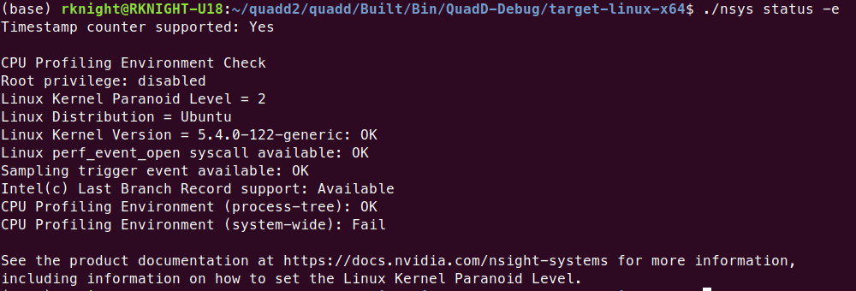

Configuring a CPU Profiling Collection
When configuring Nsight Systems for CPU Profiling from the CLI, use some or all of the following options: --sample, --cpuctxsw, --event-sample, --backtrace, --cpu- core-events, --event-sampling-frequency, --os-events, --samples-per- backtrace, and --sampling-period.
Details about these options, including examples can be found in the Profiling from the CLI section of the User Guide
When configuring from the GUI, the following options are available:

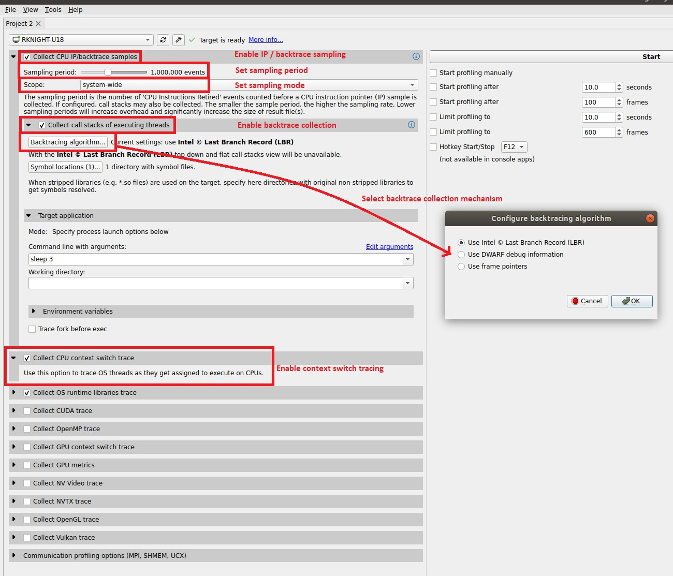
The configuration used during CPU profiling is documented in the Analysis Summary:
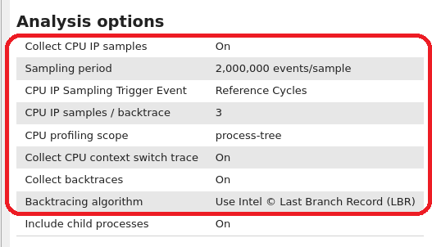
As well as in the Diagnosics Summary:

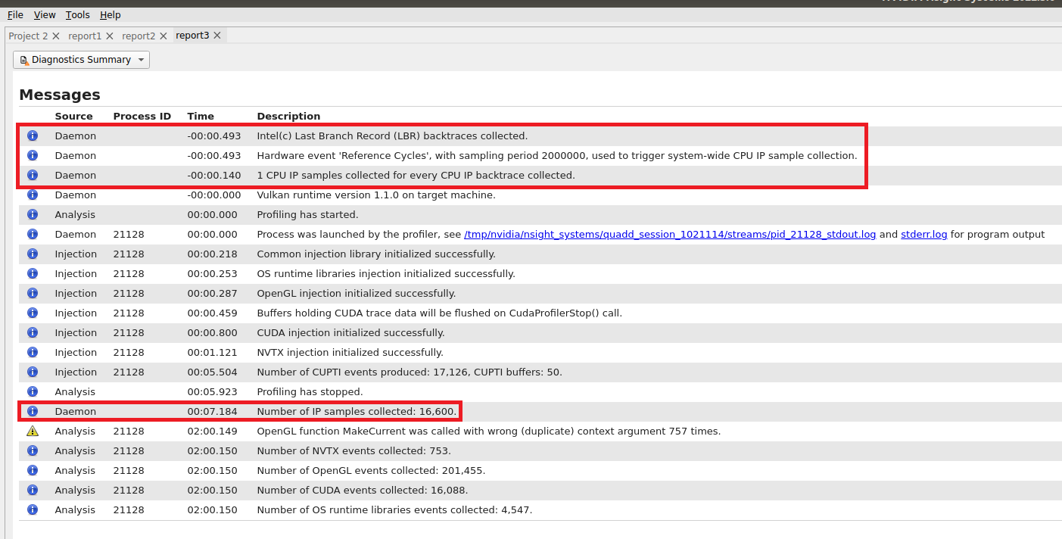

Visualizing CPU Profiling Results
Here are example screenshots visualizing CPU profiling results. For details about navigating the Timeline View and the backtraces, see the section on Timeline View in the Reading Your Report in the GUI section of the User Guide.
Example of CPU IP/Backtrace Data
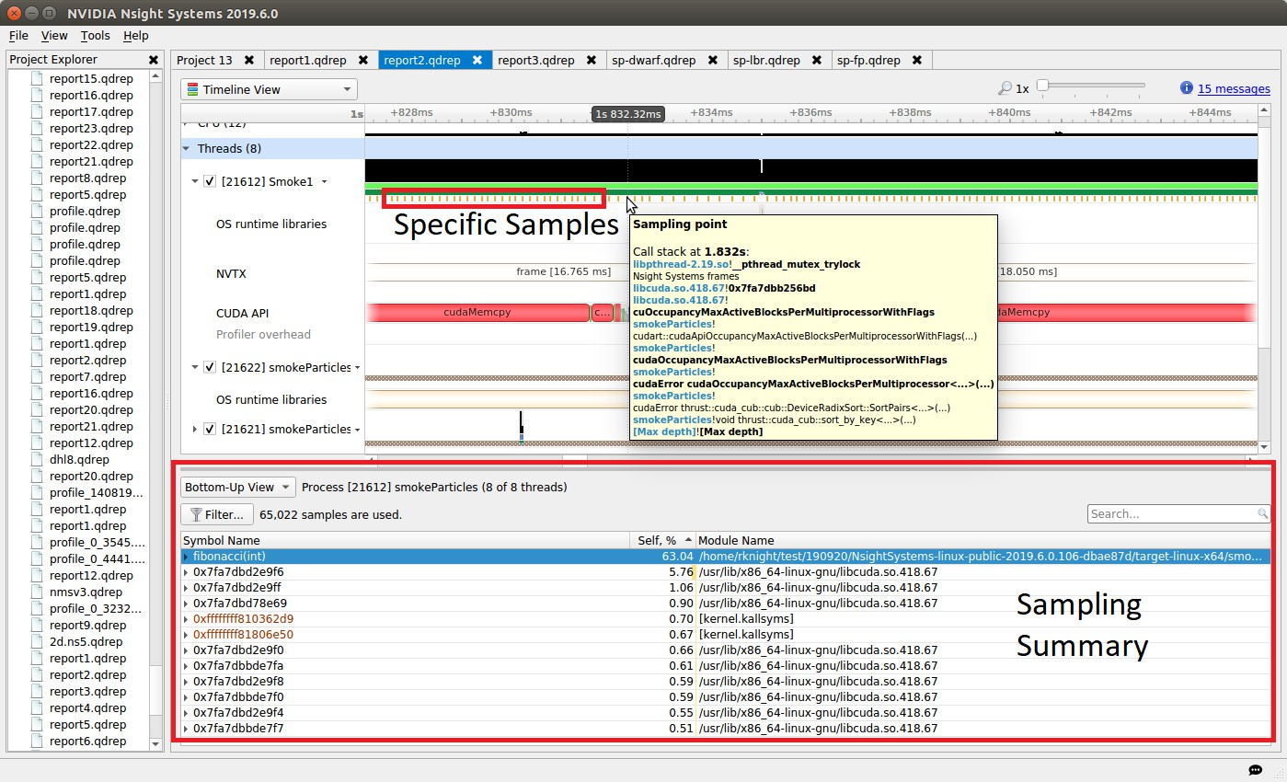
In the timeline, yellow-orange marks can be found under each thread's timeline that indicate the moment an IP / backtrace sample was collected on that thread (e.g. see the yellow-orange marks in the Specific Samples box above). Hovering the cursor over a mark will cause a tooltip to display the backtrace for that sample.

Below the Timeline is a drop-down list with multiple options including Events View, Top-Down View, Bottom-Up View, and Flat View. All four of these views can be used to view CPU IP / back trace sampling data.
Example of Event Sampling
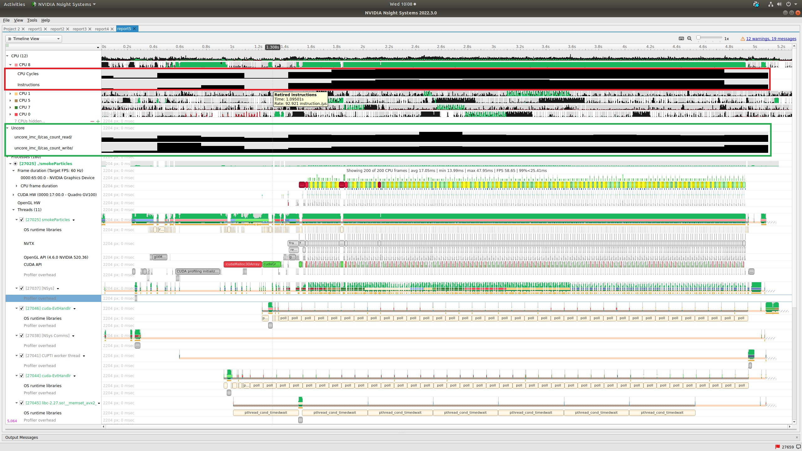

Event sampling samples hardware or software event counts during a collection and then graphs those events as rates on the Timeline. The above screenshot shows 4 hardware events. Core and cache events are graphed under the associated CPU row (see the red box in the screenshot) while uncore and OS events are graphed in their own row (see the green box in the screenshot). Hovering the cursor over an event sampling row in the timeline shows the event's rate at that moment.

Common Issues

Reducing Overhead Caused By Sampling
There are several ways to reduce overhead caused by sampling.
  - disable sampling (i.e. use the --sampling=none switch)
  - increase the sampling period (i.e. reduce the sampling rate) using the -- sampling-period switch
  - stop collecting backtraces (i.e. use the --backtrace=none switch) or collect more efficient backtraces - if available, use the --backtrace=lbr switch.
  - reduce the number of backtraces collected per sample. See documentation for the --samples-per-backtrace switch.

Throttling
The Linux operating system enforces a maximum time to handle sampling interrupts. This means that if collecting samples takes more than a specified amount of time, the OS will throttle (i.e slow down) the sampling rate to prevent the perf

subsystem from causing too much overhead. When this occurs, sampling data may become irregular even though the thread is very busy.
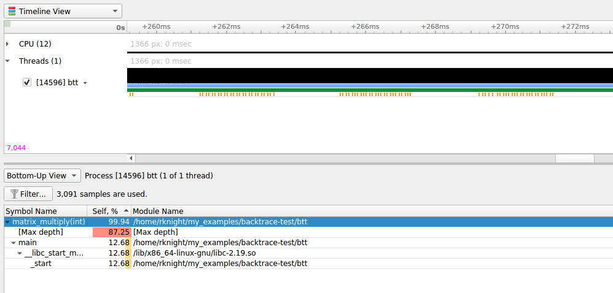
The above screenshot shows a case where CPU IP / backtrace sampling was throttled during a collection. Note the irregular intervals of sampling tickmarks on the thread timeline. The number of times a collection throttled is provided in the Nsight Systems GUI's Diagnostics messages. If a collection throttles frequently (e.g. 1000s of times), increasing the sampling period should help reduce throttling.

When throttling occurs, the

Note:
OS
sets a new
(lower) maximum sampling rate
in the
procfs. This value must be reset before the
sampling rate
can be
increased again.
Use

the following command to
reset the OS'
max sampling rate echo
'100000'
| sudo tee / proc/ sys/
kernel/ perf_event_max_sample_rate

Sample intervals are irregular
My samples are not periodic - why? My samples are clumped up - why? There are gaps in between the samples - why? Likely reasons:
  - Throttling, as described above
  - The paranoid level is set to 2. If the paranoid level is set to 2, anytime the workload makes a system call and spends time executing kernel mode code, samples will not be collected and there will be gaps in the sampling data.
  - The sampling trigger itself is not periodic. If the trigger event is not periodic, for example, the Instructions Retired. event, sample collection will primarily occur when cache misses are occurring.

No CPU profiling data is collected
There are a few common issues that cause CPU profiling data to not be collected
  - System requirements are not met. Check your system settings with the nsys status --environment command and see the System Requirements section above.
  - I profiled my workload in a Docker container but no sampling data was collected. By default, Docker containers prevent the perf_event_open syscall from being utilized. To override this behavior, launch the Docker with the –- privileged switch or modify the Docker's seccompsettings.
  - I profiled my workload in a Docker container running Ubuntu 20+ running on top of a host system running CentOS with a kernel version < 3.10.0-693. The nsys status --environment command indicated that CPU profiling was supported. The host OS kernel version determines if CPU profiling is allowed and a CentOS host with a version < 3.10.0-693 is too old. In this case, the nsys status --environment command is incorrect.

Chapter 19.
NVIDIA VIDEO CODEC SDK TRACE

Nsight Systems for x86 Linux and Windows targets can trace calls from the NV Video Codec SDK. This software trace can be launched from the GUI or using the --trace nvvideo from the CLI
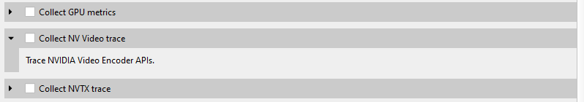
On the timeline, calls on the CPU to the NV Encoder API and NV Decoder API will be shown.
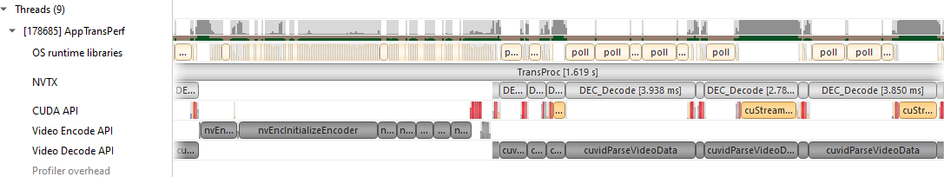

NV Encoder API Functions Traced by Default
NvEncodeAPICreateInstance nvEncOpenEncodeSession nvEncGetEncodeGUIDCount nvEncGetEncodeGUIDs nvEncGetEncodeProfileGUIDCount nvEncGetEncodeProfileGUIDs nvEncGetInputFormatCount nvEncGetInputFormats nvEncGetEncodeCaps nvEncGetEncodePresetCount nvEncGetEncodePresetGUIDs nvEncGetEncodePresetConfig nvEncGetEncodePresetConfigEx nvEncInitializeEncoder nvEncCreateInputBuffer nvEncDestroyInputBuffer nvEncCreateBitstreamBuffer nvEncDestroyBitstreamBuffer nvEncEncodePicture nvEncLockBitstream nvEncUnlockBitstream nvEncLockInputBuffer nvEncUnlockInputBuffer nvEncGetEncodeStats nvEndGetSequenceParams nvEncRegisterAsyncEvent nvEncUnregisterAsyncEvent nvEncMapInputResource nvEncUnmapInputResource nvEncDestroyEncoder nvEncInvalidateRefFrames nvEncOpenEncodeSessionEx nvEncRegisterResource nvEncUnregisterResource nvEncReconfigureEncoder nvEncCreateMVBuffer nvEncDestroyMVBuffer nvEncRunMotionEstimationOnly nvEncGetLastErrorString nvEncSetIOCudaStreams nvEncGetSequenceParamEx

NV Decoder API Functions Traced by Default
cuvidCreateVideoSource cuvidCreateVideoSourceW cuvidDestroyVideoSource cuvidSetVideoSourceState cudaVideoState cuvidGetSourceVideoFormat cuvidGetSourceAudioFormat cuvidCreateVideoParser cuvidParseVideoData cuvidDestroyVideoParser cuvidCreateDecoder cuvidDestroyDecoder cuvidDecodePicture cuvidGetDecodeStatus cuvidReconfigureDecoder cuvidMapVideoFrame cuvidUnmapVideoFrame cuvidMapVideoFrame64 cuvidUnmapVideoFrame64 cuvidCtxLockCreate cuvidCtxLockDestroy cuvidCtxLock cuvidCtxUnlock

NV JPEG API Functions Traced by Default

nvjpegBufferDeviceCreate nvjpegBufferDeviceDestroy nvjpegBufferDeviceRetrieve nvjpegBufferPinnedCreate nvjpegBufferPinnedDestroy nvjpegBufferPinnedRetrieve nvjpegCreate nvjpegCreateEx nvjpegCreateSimple nvjpegDecode nvjpegDecodeBatched nvjpegDecodeBatchedEx
nvjpegDecodeBatchedInitialize nvjpegDecodeBatchedPreAllocate nvjpegDecodeBatchedSupported nvjpegDecodeBatchedSupportedEx nvjpegDecodeJpeg nvjpegDecodeJpegDevice nvjpegDecodeJpegHost nvjpegDecodeJpegTransferToDevice nvjpegDecodeParamsCreate nvjpegDecodeParamsDestroy nvjpegDecodeParamsSetAllowCMYK nvjpegDecodeParamsSetOutputFormat nvjpegDecodeParamsSetROI nvjpegDecodeParamsSetScaleFactor nvjpegDecoderCreate nvjpegDecoderDestroy nvjpegDecoderJpegSupported nvjpegDecoderStateCreate nvjpegDestroy nvjpegEncodeGetBufferSize nvjpegEncodeImage nvjpegEncodeRetrieveBitstream nvjpegEncodeRetrieveBitstreamDevice nvjpegEncoderParamsCopyHuffmanTables nvjpegEncoderParamsCopyMetadata
nvjpegEncoderParamsCopyQuantizationTables
nvjpegEncoderParamsCreate nvjpegEncoderParamsDestroy nvjpegEncoderParamsSetEncoding nvjpegEncoderParamsSetOptimizedHuffman nvjpegEncoderParamsSetQuality nvjpegEncoderParamsSetSamplingFactors nvjpegEncoderStateCreate nvjpegEncoderStateDestroy nvjpegEncodeYUV,(nvjpegHandle_t handle nvjpegGetCudartProperty nvjpegGetDeviceMemoryPadding nvjpegGetImageInfo nvjpegGetPinnedMemoryPadding nvjpegGetProperty nvjpegJpegStateCreate nvjpegJpegStateDestroy nvjpegJpegStreamCreate nvjpegJpegStreamDestroy nvjpegJpegStreamGetChromaSubsampling nvjpegJpegStreamGetComponentDimensions nvjpegJpegStreamGetComponentsNum nvjpegJpegStreamGetFrameDimensions nvjpegJpegStreamGetJpegEncoding nvjpegJpegStreamParse nvjpegJpegStreamParseHeader nvjpegSetDeviceMemoryPadding nvjpegSetPinnedMemoryPadding nvjpegStateAttachDeviceBuffer nvjpegStateAttachPinnedBuffer
www.nvidia.com
User Guide v2023.3.1 | 221

Chapter 20.
NETWORK COMMUNICATION PROFILING

Nsight Systems can be used to profiles several popular network communication protocols. To enable this, please select the Communication profiling options dropdown.
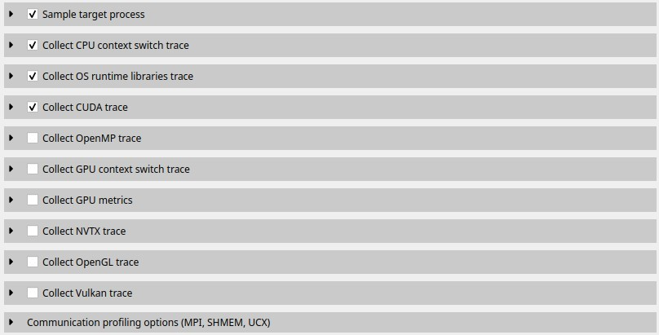
Then select the libraries you would like to trace:

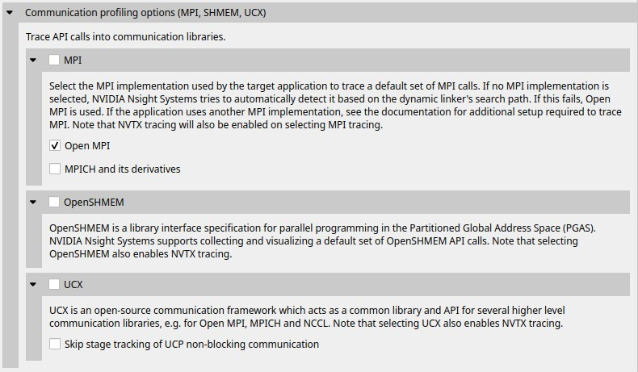

MPI API Trace
For Linux x86_64, ARM and Power targets, Nsight Systems is capable of capturing information about the MPI APIs executed in the profiled process. It has built-in API trace support for Open MPI and MPICH based MPI implementations.
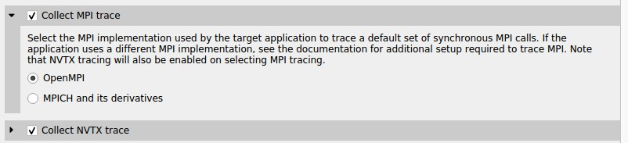
Only a subset of the MPI API, including blocking and non-blocking point-to-point and collective communication, and file I/O operations, is traced. If you require more control over the list of traced APIs or if you are using a different MPI implementation, you can use the NVTX wrappers for MPI. If you set the environment variable LD_PRELOAD to the path of generated wrapper library, Nsight Systems will capture and report the MPI API trace information when NVTX tracing is enabled. Choose an NVTX domain name other than "MPI", since it is filtered out by Nsight Systems when MPI tracing is not enabled.

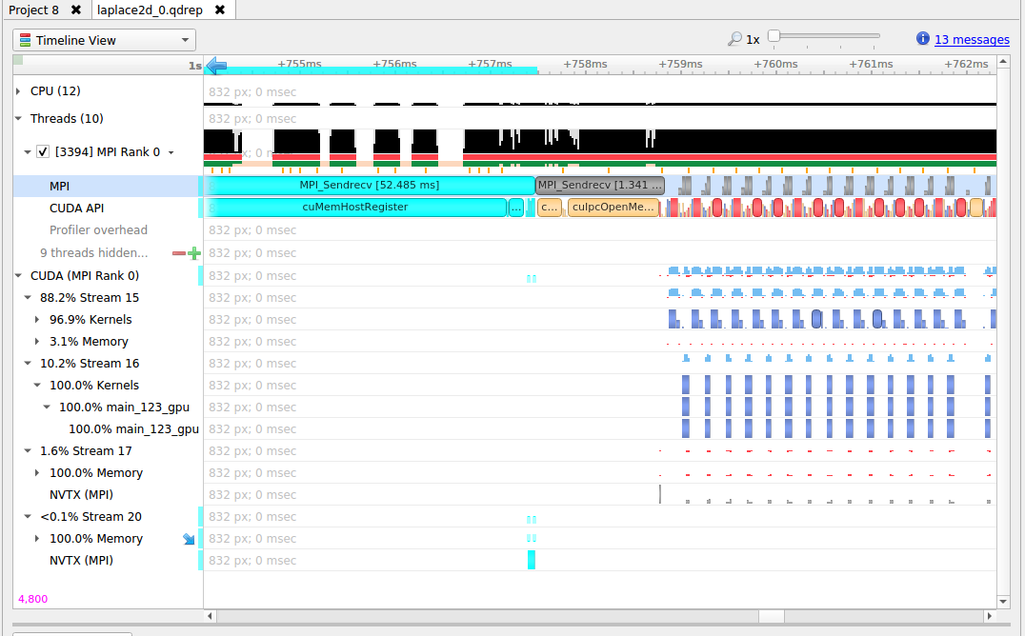

MPI Communication Parameters
Nsight Systems can get additional information about MPI communication parameters. Currently, the parameters are only visible in the mouseover tooltips or in the eventlog. This means that the data is only available via the GUI. Future versions of the tool will export this information into the SQLite data files for postrun analysis.
In order to fully interpret MPI communications, data for all ranks associated with a communication operation must be loaded into Nsight Systems.
Here is an example of MPI_COMM_WORLD data. This does not require any additional team data, since local rank is the same as global rank.
(Screenshot shows communication parameters for an MPI_Bcast call on rank 3)

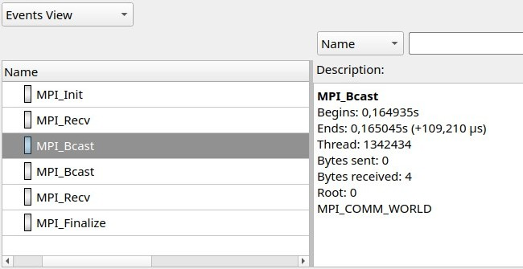
When not all processes that are involved in an MPI communication are loaded into Nsight Systems the following information is available.
- Right-hand screenshot shows a reused communicator handle (last number increased).
- Encoding: MPI_COMM[*team size*]*global-group-root-rank*.*group-ID*
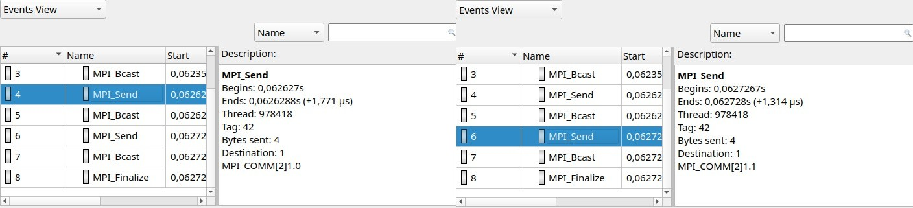
When all reports are loaded into Nsight Systems:
- World rank is shown in addition to group-local rank "(world rank X)"
- Encoding: MPI_COMM[*team size*]{rank0, rank1, ...}
- At most 8 ranks are shown (the numbers represent world ranks, the position in the list is the group-local rank)
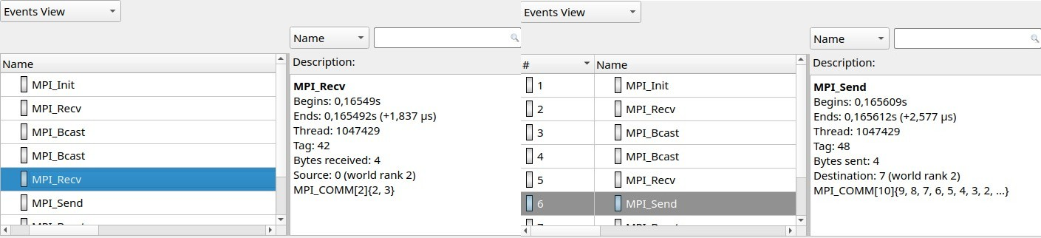

MPI functions traced:

MPI_Init[_thread], MPI_Finalize
MPI_Send, MPI_{B,S,R}send, MPI_Recv, MPI_Mrecv MPI_Sendrecv[_replace]
MPI_Barrier, MPI_Bcast MPI_Scatter[v], MPI_Gather[v] MPI_Allgather[v], MPI_Alltoall[{v,w}]
MPI_Allreduce, MPI_Reduce[_{scatter,scatter_block,local}] MPI_Scan, MPI_Exscan
MPI_Isend, MPI_I{b,s,r}send, MPI_I[m]recv MPI_{Send,Bsend,Ssend,Rsend,Recv}_init MPI_Start[all]
MPI_Ibarrier, MPI_Ibcast MPI_Iscatter[v], MPI_Igather[v] MPI_Iallgather[v], MPI_Ialltoall[{v,w}]
MPI_Iallreduce, MPI_Ireduce[{scatter,scatter_block}] MPI_I[ex]scan
MPI_Wait[{all,any,some}]
MPI_Put, MPI_Rput, MPI_Get, MPI_Rget MPI_Accumulate, MPI_Raccumulate MPI_Get_accumulate, MPI_Rget_accumulate MPI_Fetch_and_op, MPI_Compare_and_swap
MPI_Win_allocate[_shared] MPI_Win_create[_dynamic] MPI_Win_{attach, detach} MPI_Win_free MPI_Win_fence
MPI_Win_{start, complete, post, wait} MPI_Win_[un]lock[_all] MPI_Win_flush[_local][_all] MPI_Win_sync
MPI_File_{open,close,delete,sync} MPI_File_{read,write}[_{all,all_begin,all_end}] MPI_File_{read,write}_at[_{all,all_begin,all_end}] MPI_File_{read,write}_shared MPI_File_{read,write}_ordered[_{begin,end}] MPI_File_i{read,write}[_{all,at,at_all,shared}] MPI_File_set_{size,view,info} MPI_File_get_{size,view,info,group,amode} MPI_File_preallocate
MPI_Pack[_external] MPI_Unpack[_external]

OpenSHMEM Library Trace
If OpenSHMEM library trace is selected Nsight Systems will trace the subset of OpenSHMEM API functions that are most likely be involved in performance bottlenecks. To keep overhead low Nsight Systems does not trace all functions.

OpenSHMEM 1.5 Functions Not Traced
shmem_my_pe shmem_n_pes shmem_global_exit shmem_pe_accessible shmem_addr_accessible
shmem_ctx_{create,destroy,get_team} shmem_global_exit shmem_info_get_{version,name} shmem_{my_pe,n_pes,pe_accessible,ptr} shmem_query_thread shmem_team_{create_ctx,destroy} shmem_team_get_config shmem_team_{my_pe,n_pes,translate_pe} shmem_team_split_{2d,strided} shmem_test*

UCX Library Trace
If UCX library trace is selected Nsight Systems will trace the subset of functions of the UCX protocol layer UCP that are most likely be involved in performance bottlenecks. To keep overhead low Nsight Systems does not trace all functions.

UCX functions traced:
ucp_am_send_nb[x] ucp_am_recv_data_nbx ucp_am_data_release
ucp_atomic_{add{32,64},cswap{32,64},fadd{32,64},swap{32,64}} ucp_atomic_{post,fetch_nb,op_nbx}
ucp_cleanup ucp_config_{modify,read,release} ucp_disconnect_nb ucp_dt_{create_generic,destroy} ucp_ep_{create,destroy,modify_nb,close_nbx} ucp_ep_flush[{_nb,_nbx}] ucp_listener_{create,destroy,query,reject} ucp_mem_{advise,map,unmap,query} ucp_{put,get}[_nbi]
ucp_{put,get}_nb[x] ucp_request_{alloc,cancel,is_completed} ucp_rkey_{buffer_release,destroy,pack,ptr} ucp_stream_data_release ucp_stream_recv_data_nb ucp_stream_{send,recv}_nb[x] ucp_stream_worker_poll ucp_tag_msg_recv_nb[x] ucp_tag_{send,recv}_nbr ucp_tag_{send,recv}_nb[x] ucp_tag_send_sync_nb[x]
ucp_worker_{create,destroy,get_address,get_efd,arm,fence,wait,signal,wait_mem} ucp_worker_flush[{_nb,_nbx}]
ucp_worker_set_am_{handler,recv_handler}

UCX Functions Not Traced:
ucp_config_print ucp_conn_request_query ucp_context_{query,print_info} ucp_get_version[_string]
ucp_ep_{close_nb,print_info,query,rkey_unpack} ucp_mem_print_info ucp_request_{check_status,free,query,release,test} ucp_stream_recv_request_test
ucp_tag_probe_nb ucp_tag_recv_request_test
ucp_worker_{address_query,print_info,progress,query,release_address}
Additional API functions from other UCX layers may be added in a future version of the product.

NVIDIA NVSHMEM and NCCL Trace
The NVIDIA network communication libraries NVSHMEM and NCCL have been instrumented using NVTX annotations. To enable tracing these libraries in Nsight Systems, turn on NVTX tracing in the GUI or CLI. To enable the NVTX instrumentation of the NVSHMEM library, make sure that the environment variable NVSHMEM_NVTX is set properly, e.g. NVSHMEM_NVTX=common.

NIC Metric Sampling

Overview
NVIDIA ConnectX smart network interface cards (smart NICs) offer advanced hardware offloads and accelerations for network operations. Viewing smart NICs metrics, on Nsight Systems timeline, enables developers to better understand their application’s network usage. Developers can use this information to optimize the application’s performance.

Limitations/Requirements
    - NIC metric sampling supports NVIDIA ConnectX boards starting with ConnectX 5
    - NIC metric sampling is supported on Linux x86_64 and ARM Server (SBSA) machines only, having minimum Linux kernel 4.12 and minimum MLNX_OFED 4.1. You can download the latest and archived versions of the MLX_OFED driver from the MLNX_OFED Download Center. If collecting NIC metrics within a container, make sure that the container has access to the driver on the host machine. To check manually if OFED is installed and get its version you can run:
      - /usr/bin/ofed_info
      - cat /sys/module/"$(cat /proc/modules | grep -o -E "^mlx._core")"/version

Collecting NIC Metrics Using the Command Line

To collect NIC performance metric, using Nsight Systems CLI, add the --nic-metrics
command line switch:
nsys profile --nic-metrics=true my_app
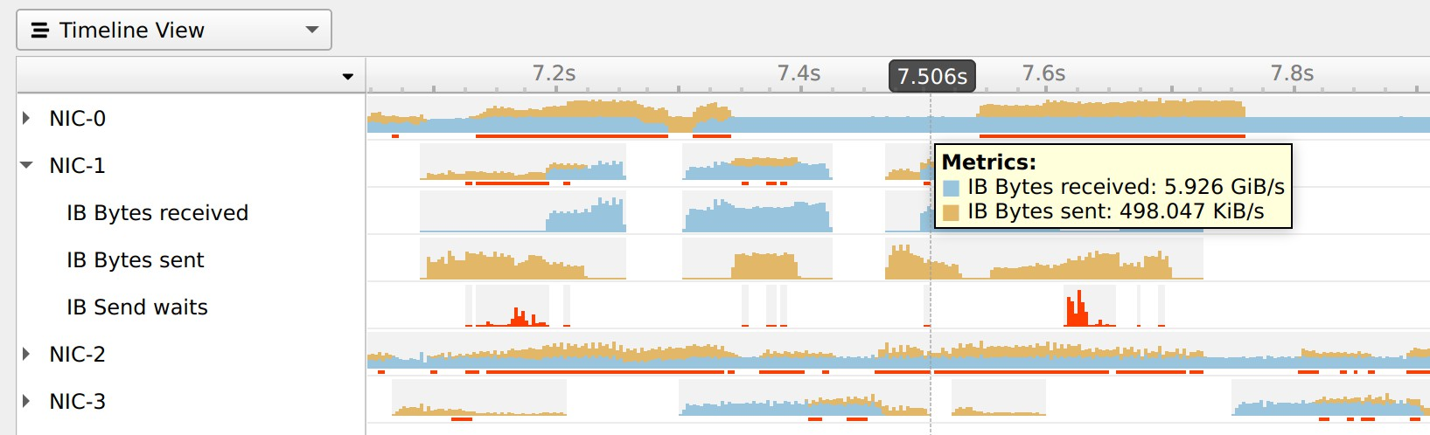

Available Metrics
    - Bytes sent - Number of bytes sent through all NIC ports.
    - Bytes received - Number of bytes received by all NIC ports.
    - CNPs sent - Number of congestion notification packets sent by the NIC.
    - CNPs received - Number of congestion notification packets received and handled by the NIC.
    - Send waits - The number of ticks during which ports had data to transmit but no data was sent during the entire tick (either because of insufficient credits or because of lack of arbitration)
Note: Each one of the mentioned metrics is shown only if it has non-zero value during profiling.

Usage Examples
    - The Bytes sent/sec and the Bytes received/sec metrics enables identifying idle and busy NIC times.
      - Developers may shift network operations from busy to idle times to reduce network congestion and latency.
      - Developers can use idle NIC times to send additional data without reducing application performance.
    - CNPs (congestion notification packets) received/sent and Send waits metrics may explain network latencies. A developer seeing the time periods when the network was congested may rewrite his algorithm to avoid the observed congestions.

Note:
RDMA
over Converged Ethernet (RoCE)
traffic is
not logged into the

Nsight Systems NIC
metrics.

InfiniBand Switch Metric Sampling
NVIDIA Quantum InfiniBand switches offer high-bandwidth, low-latency communication. Viewing switch metrics, on Nsight Systems timeline, enables developers to better understand their application’s network usage. Developers can use this information to optimize the application’s performance.

Limitations/Requirements
IB switch metric sampling supports all NVIDIA Quantum switches. The user needs to have permission to query the InfiniBand switch metrics.
To check if the current user has permissions to query the InfiniBand switch metrics, check that the user have permission to access /dev/umad
To give user permissions to query InfiniBand switch metrics on RedHat systems, follow the directions at RedHat Solutions.
To collect InfiniBand switch performance metric, using Nsight Systems CLI, add the
--ib-switch-metrics command line switch, followed by a comma separated list of InfiniBand switch GUIDs. For example:
nsys profile --ib-switch-metrics=<IB switch GUID> my_app
To get a list of InfiniBand switches connected to the machine, use:
sudo ibnetdiscover -S

Available Metrics
- Bytes sent - Number of bytes sent through all switch ports
- Bytes received - Number of bytes received by all switch ports

Chapter 21. PYTHON PROFILING

Python Backtrace Sampling
Nsight Systems for Arm server (SBSA) platforms, x86 Linux and Windows targets, is capable of periodically capturing Python backtrace information. This functionality is available when tracing Python interpreters of version 3.9 or later. Capturing python backtrace is done in periodic samples, in a selected frequency ranging from 1Hz - 2KHz with a default value of 1KHz. Note that this feature provides meaningful backtraces for Python processes, when profiling Python-only workflows, consider disabling the CPU sampling option to reduce overhead.
To enable Python backtrace sampling from Nsight Systems:
CLI — Set --python-sampling=true and use the --python-sampling-frequency
option to set the sampling rate.
GUI — Select the Collect Python backtrace samples checkbox.
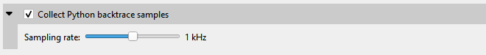
Example screenshot:

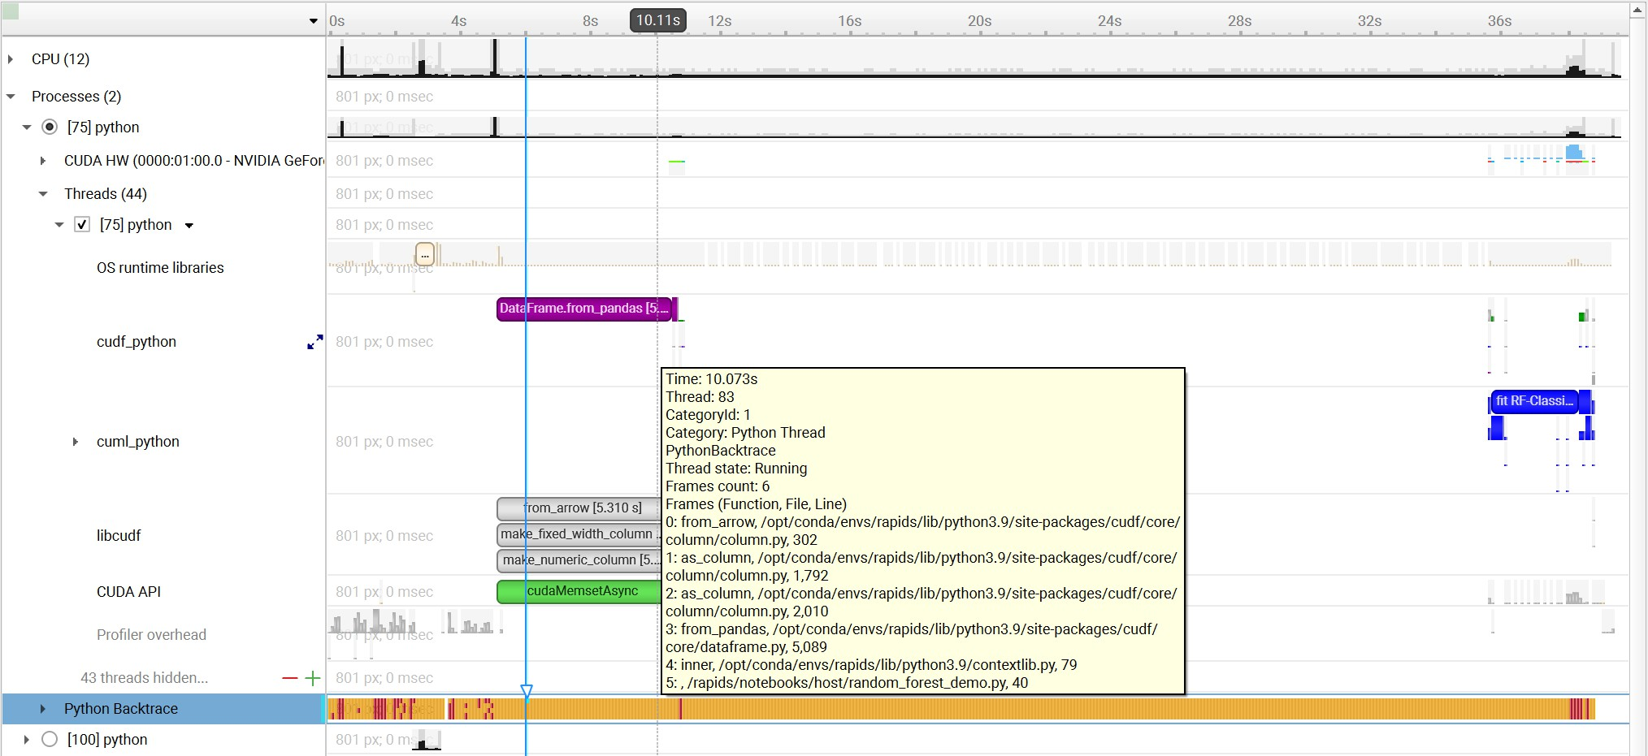

Python NVTX Annotations
Nsight Systems for Arm server (SBSA) platforms, x86 Linux and Windows targets, is capable of using NVTX to annotate Python functions.
The Python source code does not require any changes. This feature requires CPython interpreter, release 3.8 or later.
The annotations are configured in a JSON file. An example file is located in Nsight Systems root folder/<target-platform-folder>/PythonNvtx/ annotations.json.

Notes:
    - Annotating function from module main is not supported. To enable Python NVTX annotations from Nsight Systems:
CLI — Set --python-nvtx-annotations=<json_file>.
GUI — Select the Python NVTX annotations checkbox and specify the JSON file.
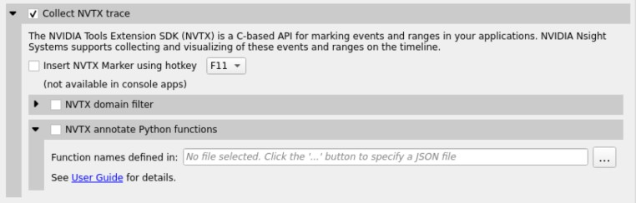
Example screenshot:

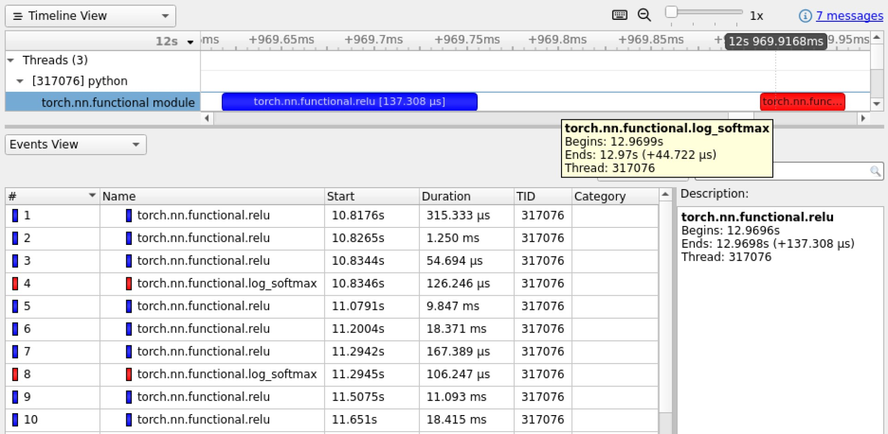

Chapter 22.
READING YOUR REPORT IN GUI

Generating a New Report
Users can generate a new report by stopping a profiling session. If a profiling session has been canceled, a report will not be generated, and all collected data will be discarded.
A new .nsys-rep file will be created and put into the same directory as the project file (.qdproj).

Opening an Existing Report
An existing .nsys-rep file can be opened using File > Open....

Sharing a Report File
Report files (.nsys-rep) are self-contained and can be shared with other users of Nsight Systems. The only requirement is that the same or newer version of Nsight Systems is always used to open report files.
Project files (.qdproj) are currently not shareable, since they contain full paths to the report files.
To quickly navigate to the directory containing the report file, right click on it in the Project Explorer, and choose Show in folder... in the context menu.

Report Tab
While generating a new report or loading an existing one, a new tab will be created. The most important parts of the report tab are:
- View selector — Allows switching between Analysis Summary, Timeline View, Diagnostics Summary, and Symbol Resolution Logs views.

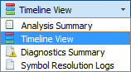
- Timeline — This is where all charts are displayed.
- Function table — Located below the timeline, it displays statistical information about functions in the target application in multiple ways.
Additionally, the following controls are available:
- Zoom slider — Allows you to vertically zoom the charts on the timeline.

Analysis Summary View
This view shows a summary of the profiling session. In particular, it is useful to review the project configuration used to generate this report. Information from this view can be selected and copied using the mouse cursor.

Timeline View
The timeline view consists of two main controls: the timeline at the top, and a bottom pane that contains the events view and the function table. In some cases, when sampling of a process has not been enabled, the function table might be empty and hidden.
The bottom view selector sets the view that is displayed in the bottom pane.
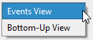

Timeline
Timeline is a versatile control that contains a tree-like hierarchy on the left, and corresponding charts on the right.
Contents of the hierarchy depend on the project settings used to collect the report. For example, if a certain feature has not been enabled, corresponding rows will not be show on the timeline.
To generate a timeline screenshot without opening the full GUI, use the command
nsys-ui.exe --screenshot filename.nsys-rep

Timeline Navigation

Zoom and Scroll

At the upper right portion of your Nsight Systems GUI you will see this section:
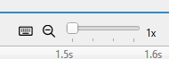
The slider sets the vertical size of screen rows, and the magnifying glass resets it to the original settings.
There are many ways to zoom and scroll horizontally through the timeline. Clicking on the keyboard icon seen above, opens the below dialog that explains them.

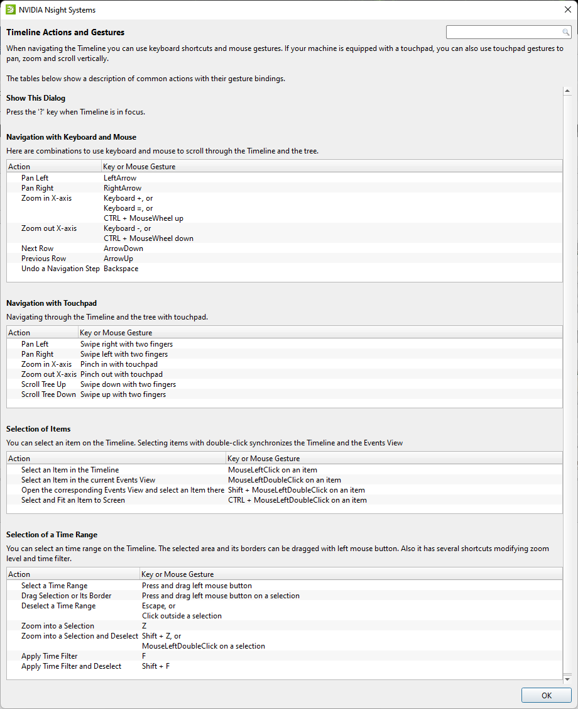
Additional information on several items is available as mouse-over tooltips. This information can be copied out of the GUI by right clicking on the event and choosing Copy ToolTip.

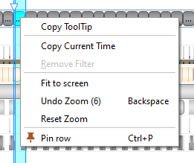

Timeline/Events correlation
To display trace events in the Events View right-click a timeline row and select the “Show in Events View” command. The events of the selected row and all of its sub-rows will be displayed in the Events View. Note that the events displayed will correspond to the current zoom in the timeline, zooming in or out will reset the event pane filter.
If a timeline row has been selected for display in the Events View, then double-clicking a timeline item on that row will automatically scroll the content of the Events View to make the corresponding events view item visible and select it. If that event has tool tip information, it will be displayed in the right hand pane.
Likewise, double-clicking on a particular instance in the Events View will highlight the corresponding event in the timeline.

Row Height
Several of the rows in the timeline use height as a way to model the percent utilization of resources. This gives the user insight into what is going on even when the timeline is zoomed all the way out.
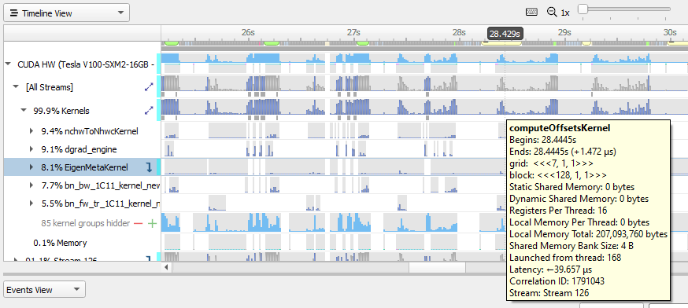
In this picture you see that for kernel occupation there is a colored bar of variable height.

Nsight Systems calculates the average occupancy for the period of time represented by particular pixel width of screen. It then uses that average to set the top of the colored section. So, for instance, if 25% of that timeslice the kernel is active, the bar goes 25% of the distance to the top of the row.
In order to make the difference clear, if the percentage of the row height is non-zero, but would be represented by less than one vertical pixel, Nsight Systems displays it as one pixel high. The gray height represents the maximum usage in that time range.
This row height coding is used in the CPU utilization, thread and process occupancy, kernel occupancy, and memory transfer activity rows.

Row Percentage
In the image below you see that there are percentages prefixing the stream rows in the GPU.
The percentage shown in front of the stream indicates the proportion of context running time this particular stream takes.
% stream = 100.0 X streamUsage / contextUsage
streamUsage = total amount of time this stream is active on GPU contextUsage = total amount of time all streams for this context are
active on GPU
So "26% Stream 1" means that Stream 1 takes 26% of its context's total running time.
Total running time = sum of durations of all kernels and memory ops that run in this context

Events View
The Events View provides a tabular display of the trace events. The view contents can be searched and sorted.
Double-clicking an item in the Events View automatically focuses the Timeline View on the corresponding timeline item.

API calls, GPU executions, and debug markers that occurred within the boundaries of a debug marker are displayed nested to that debug marker. Multiple levels of nesting are supported.
Events view recognizes these types of debug markers:
      - NVTX
      - Vulkan VK_EXT_debug_marker markers, VK_EXT_debug_utils labels
      - PIX events and markers
      - OpenGL KHR_debug markers
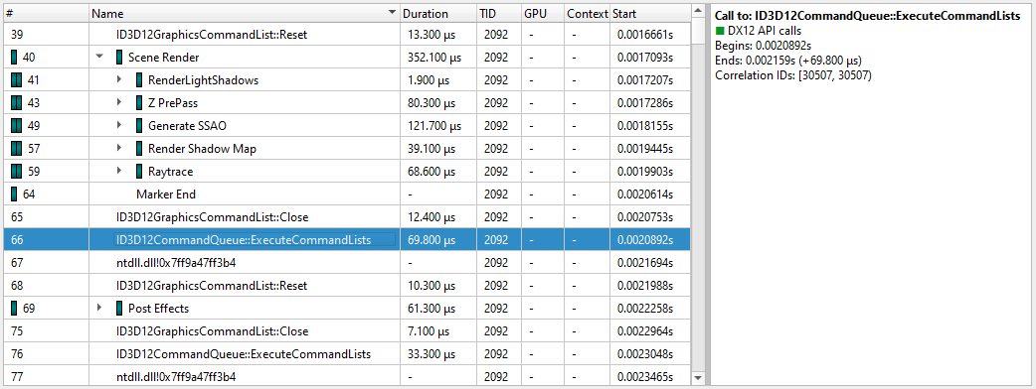
You can copy and paste from the events view by highlighting rows, using Shift or Ctrl
to enable multi-select. Right clicking on the selection will give you a copy option.
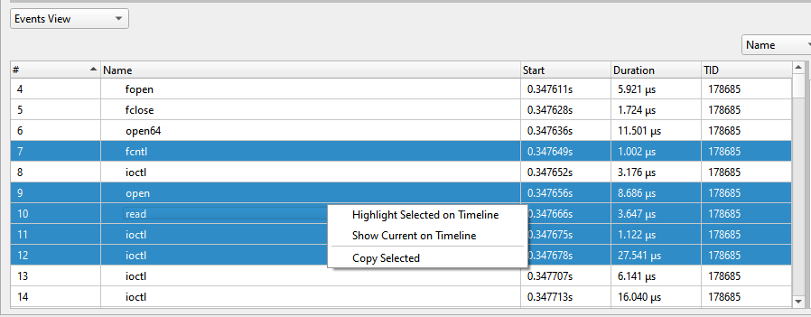
Pasting into text gives you a tab separated view:

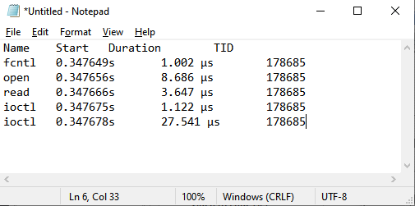
Pasting into spreadsheet properly copies into rows and columns:
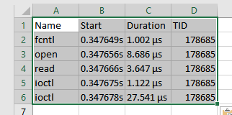

Function Table Modes
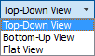
The function table can work in three modes:
      - Top-Down View — In this mode, expanding top-level functions provides information about the callee functions. One of the top-level functions is typically the main function of your application, or another entry point defined by the runtime libraries.
      - Bottom-Up View — This is a reverse of the Top-Down view. On the top level, there are functions directly hit by the sampling profiler. To explore all possible call chains leading to these functions, you need to expand the subtrees of the top-level functions.
      - Flat View — This view enumerates all functions ever observed by the profiler, even if they have never been directly hit, but just appeared somewhere on the call stack. This view typically provides a high-level overview of which parts of the code are CPU-intensive.

Each of the views helps understand particular performance issues of the application being profiled. For example:
      - When trying to find specific bottleneck functions that can be optimized, the Bottom- Up view should be used. Typically, the top few functions should be examined. Expand them to understand in which contexts they are being used.
      - To navigate the call tree of the application and while generally searching for algorithms and parts of the code that consume unexpectedly large amount of CPU time, the Top-Down view should be used.
      - To quickly assess which parts of the application, or high level parts of an algorithm, consume significant amount of CPU time, use the Flat view.
The Top-Down and Bottom-Up views have Self and Total columns, while the Flat view has a Flat column. It is important to understand the meaning of each of the columns:
      - Top-Down view
        - Self column denotes the relative amount of time spent executing instructions of this particular function.
        - Total column shows how much time has been spent executing this function, including all other functions called from this one. Total values of sibling rows sum up to the Total value of the parent row, or 100% for the top-level rows.
      - Bottom-Up view
        - Self column for top-level rows, as in the Top-Down view, shows how much time has been spent directly in this function. Self times of all top-level rows add up to 100%.
        - Self column for children rows breaks down the value of the parent row based on the various call chains leading to that function. Self times of sibling rows add up to the value of the parent row.
      - Flat view
        - Flat column shows how much time this function has been anywhere on the call stack. Values in this column do not add up or have other significant relationships.

If low-

Note:
impact functions have been filtered out, values may
not add up
correctly to
100%,
or

to the value of the
parent row. This filtering can
be disabled.

Contents of the symbols table is tightly related to the timeline. Users can apply and modify filters on the timeline, and they will affect which information is displayed in the symbols table:
      - Per-thread filtering — Each thread that has sampling information associated with it has a checkbox next to it on the timeline. Only threads with selected checkboxes are represented in the symbols table.
      - Time filtering — A time filter can be setup on the timeline by pressing the left mouse button, dragging over a region of interest on the timeline, and then choosing Filter by selection in the dropdown menu. In this case, only sampling information collected during the selected time range will be used to build the symbols table.

ing
Note:
If too little
sampl data is being used to build the symbo table (for examp when the sampl rate
is config to
be low, and a short
period of time is used

ls

le,

ing

ured

Function Table Notes

Last Branch Records vs Frame Pointers
Two of the mechanisms available for collecting backtraces are Intel Last Branch Records (LBRs) and frame pointers. LBRs are used to trace every branch instruction via a limited set of hardware registers. They can be configured to generate backtraces but have finite depth based on the CPU’s microarchitecture. LBRs are effectively free to collect but may not be as deep as you need in order to fully understand how the workload arrived a specific Instruction Pointer (IP).
Frame pointers only work when a binary is compiled with the -fno-omit-frame- pointer compiler switch. To determine if frame pointers are enabled on an x86_64 binary running on Linux, dump a binary’s assembly code using the objdump -d [binary_file] command and look for this pattern at the beginning of all functions;
for time- based
filtering), the numbers in
the symbols table might not
be representative or
accurate in
some cases.

push %rbp
mov %rsp,%rbp
When frame pointers are available in a binary, full stack traces will be captured. Note that libraries that are frequently used by apps and ship with the operating system, such as libc, are generated in release mode and therefore do not include frame pointers.
Frequently, when a backtrace includes an address from a system library, the backtrace will fail to resolve further as the frame pointer trail goes cold due to a missing frame pointer.
A simple application was developed to show the difference. The application calls function a(), which calls b(), which calls c(), etc. Function z() calls a heavy compute function called matrix_multiply(). Almost all of the IP samples are collected while matrix_multiple is executing. The next two screen shots show one of the main differences between frame pointers and LBRs.

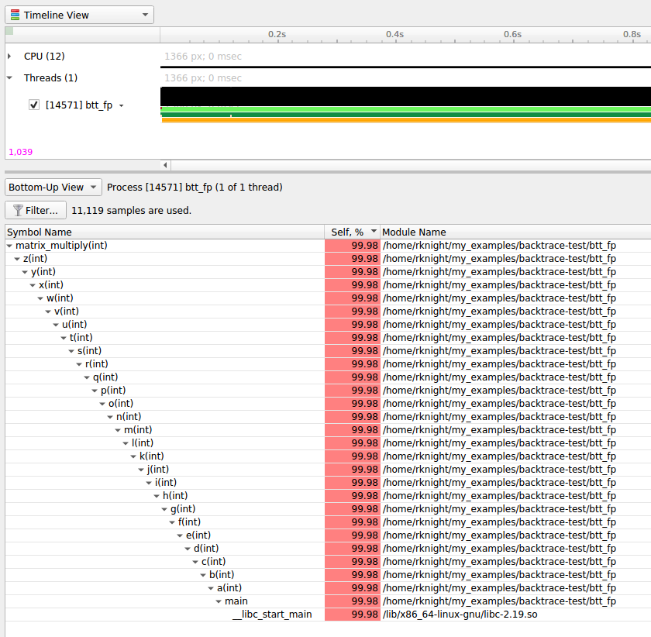
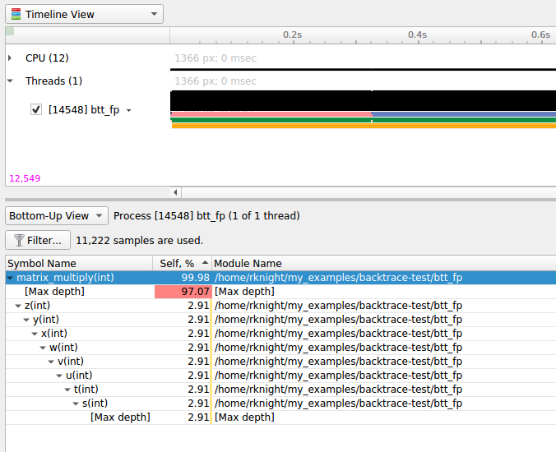
Note that the frame pointer example, shows the full stack trace while the LBR example, only shows part of the stack due to the limited number of LBR registers in the CPU.

Kernel Samples
When an IP sample is captured while a kernel mode (i.e. operating system) function is executing, the sample will be shown with an address that starts with 0xffffffff and map to the [kernel.kallsyms] module.

[vdso]

Samples may be collected while a CPU is executing functions in the Virtual Dynamic Shared Object. In this case, the sample will be resolved (i.e. mapped) to the [vdso] module. The vdso man page provides the following description of the vdso:
The “vDSO“ (virtual dynamic shared object) is a small shared library that the kernel automatically maps into the address space of all
user-space applications. Applications usually do not need to concern themselves with these details as the vDSO is most commonly called by the C library. This way you can code in the normal way using standard functions and the C library will take care of using any functionality that is available via the vDSO.
Why does the vDSO exist at all? There are some system calls the kernel provides that user-space code ends up using frequently, to the point that such calls can dominate overall performance. This is due both to the frequency of the call as well as the context-switch overhead that results from exiting user space and entering the kernel.

[Unknown]
When an address can not be resolved (i.e. mapped to a module), its address within the process’ address space will be shown and its module will be marked as [Unknown].

Filter Dialog
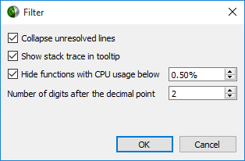
      - Collapse unresolved lines is useful if some of the binary code does not have symbols. In this case, subtrees that consist of only unresolved symbols get collapsed in the Top-Down view, since they provide very little useful information.
      - Hide functions with CPU usage below X% is useful for large applications, where the sampling profiler hits lots of function just a few times. To filter out the "long tail," which is typically not important for CPU performance bottleneck analysis, this checkbox should be selected.

Example of Using Timeline with Function Table
Here is an example walkthrough of using the timeline and function table with Instruction Pointer (IP)/backtrace Sampling Data

Timeline

When a collection result is opened in the Nsight Systems GUI, there are multiple ways to view the CPU profiling data - especially the CPU IP / backtrace data.
In the timeline, yellow-orange marks can be found under each thread's timeline that indicate the moment an IP / backtrace sample was collected on that thread (e.g. see the yellow-orange marks in the Specific Samples box above). Hovering the cursor over a mark will cause a tooltip to display the backtrace for that sample.
Below the Timeline is a drop-down list with multiple options including Events View, Top-Down View, Bottom-Up View, and Flat View. All four of these views can be used to view CPU IP / backtrace sampling data.
If the Bottom-Up View is selected, here is the sampling summary shown in the bottom half of the Timeline View screen. Notice that the summary includes the phrase “65,022 samples are used” indicating how many samples are summarized. By default, functions that were found in less less than 0.5% of the samples are not show. Use the filter button to modify that setting.

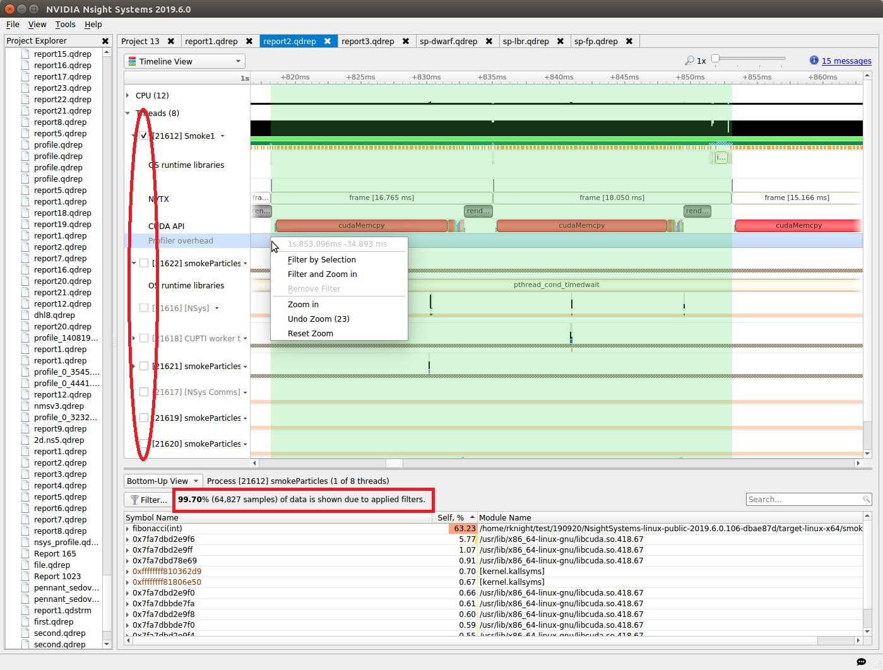
When sampling data is filtered, the Sampling Summary will summarize the selected samples. Samples can be filtered on an OS thread basis, on a time basis, or both.
Above, deselecting a checkbox next to a thread removes its samples from the sampling summary. Dragging the cursor over the timeline and selecting “Filter and Zoom In” chooses the samples during the time selected, as seen below. The sample summary includes the phrase “0.35% (225 samples) of data is shown due to applied filters” indicating that only 225 samples are included in the summary results.

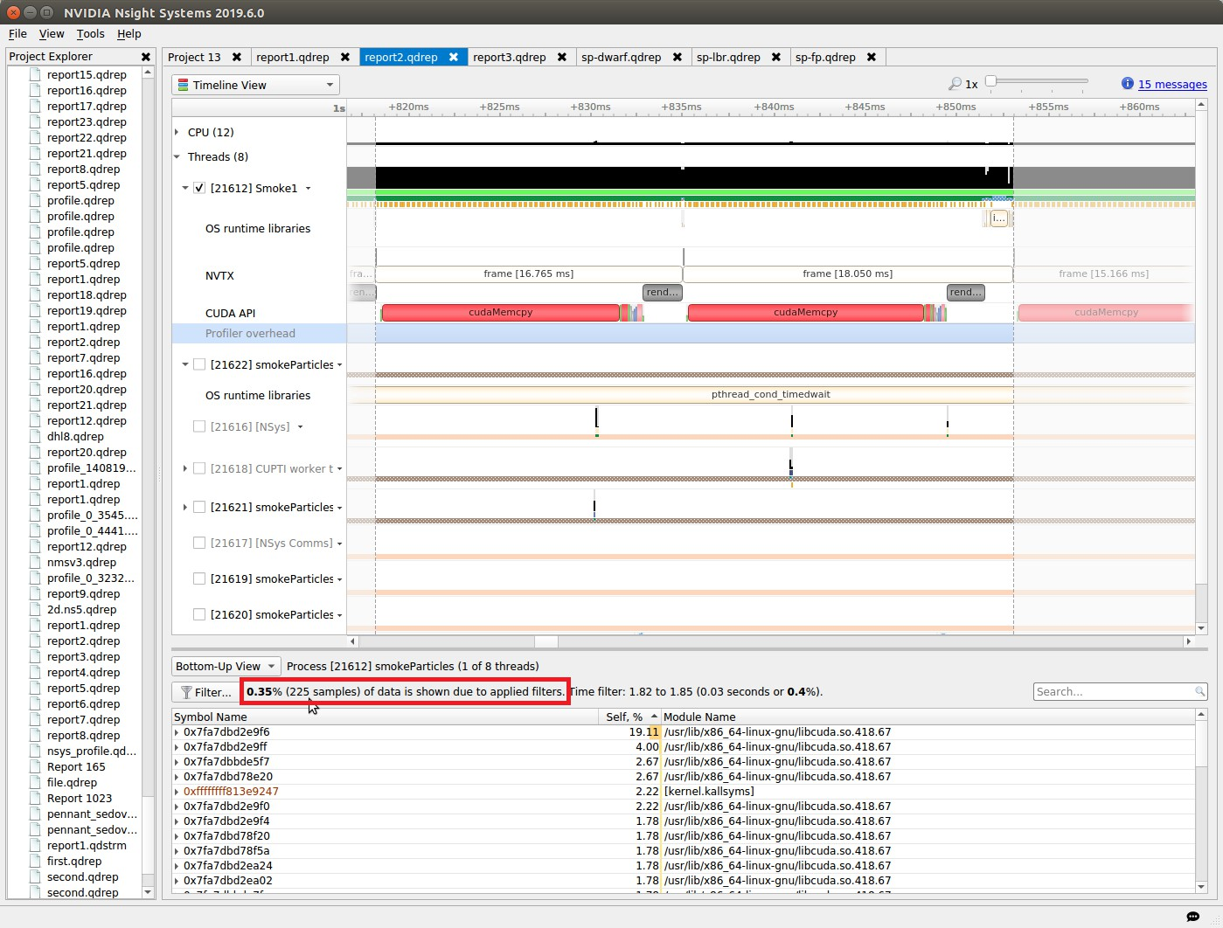
Deselecting threads one at a time by deselecting their checkbox can be tedious. Click on the down arrow next to a thread and choose Show Only This Thread to deselect all threads except that thread.

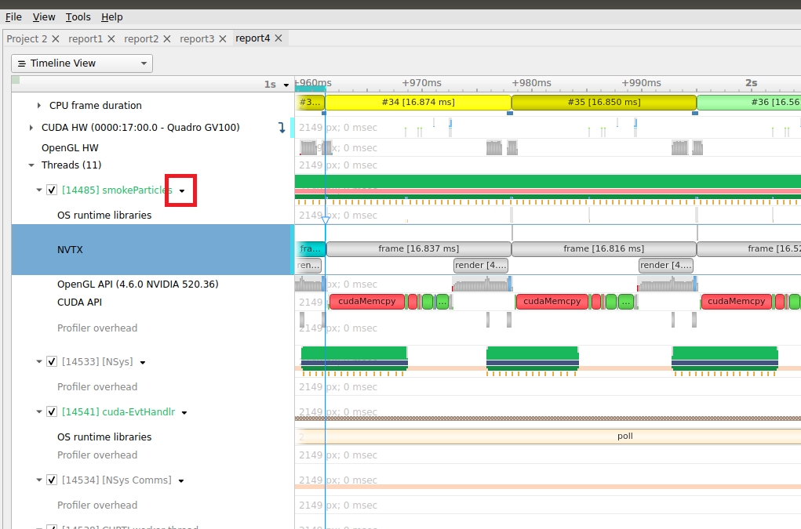
If Events View is selected in the Timeline View's drop-down list, right click on a specific thread and choose Show in Events View. The samples collected while that thread executed will be shown in the Events View. Double clicking on a specific sample in the Events view causes the timeline to show when that sample was collected - see the green boxes below. The backtrace for that sample is also shown in the Events View.
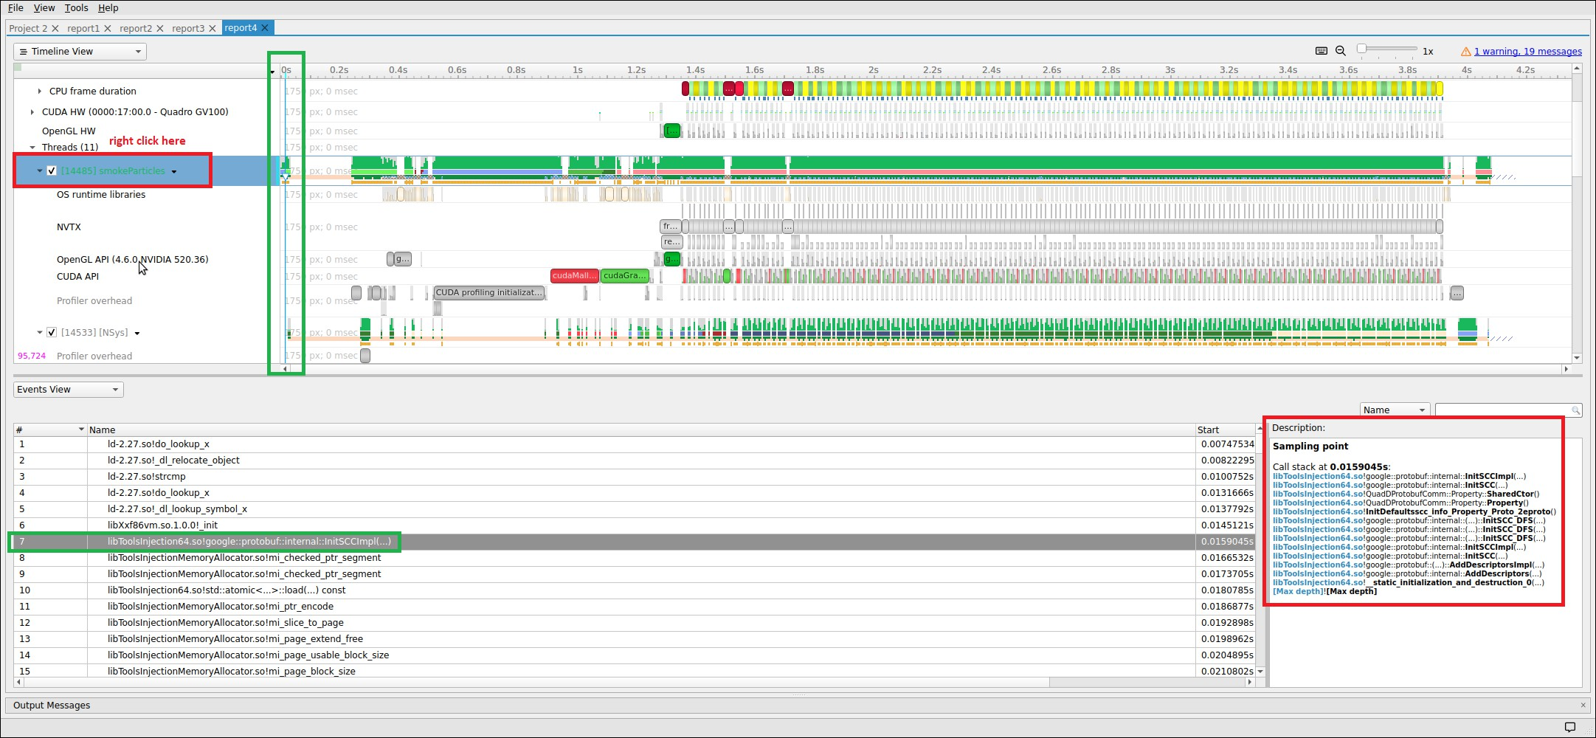

Backtraces
To understand the code path used to get to a specific function shown in the sampling summary, right click on a function and select Expand.

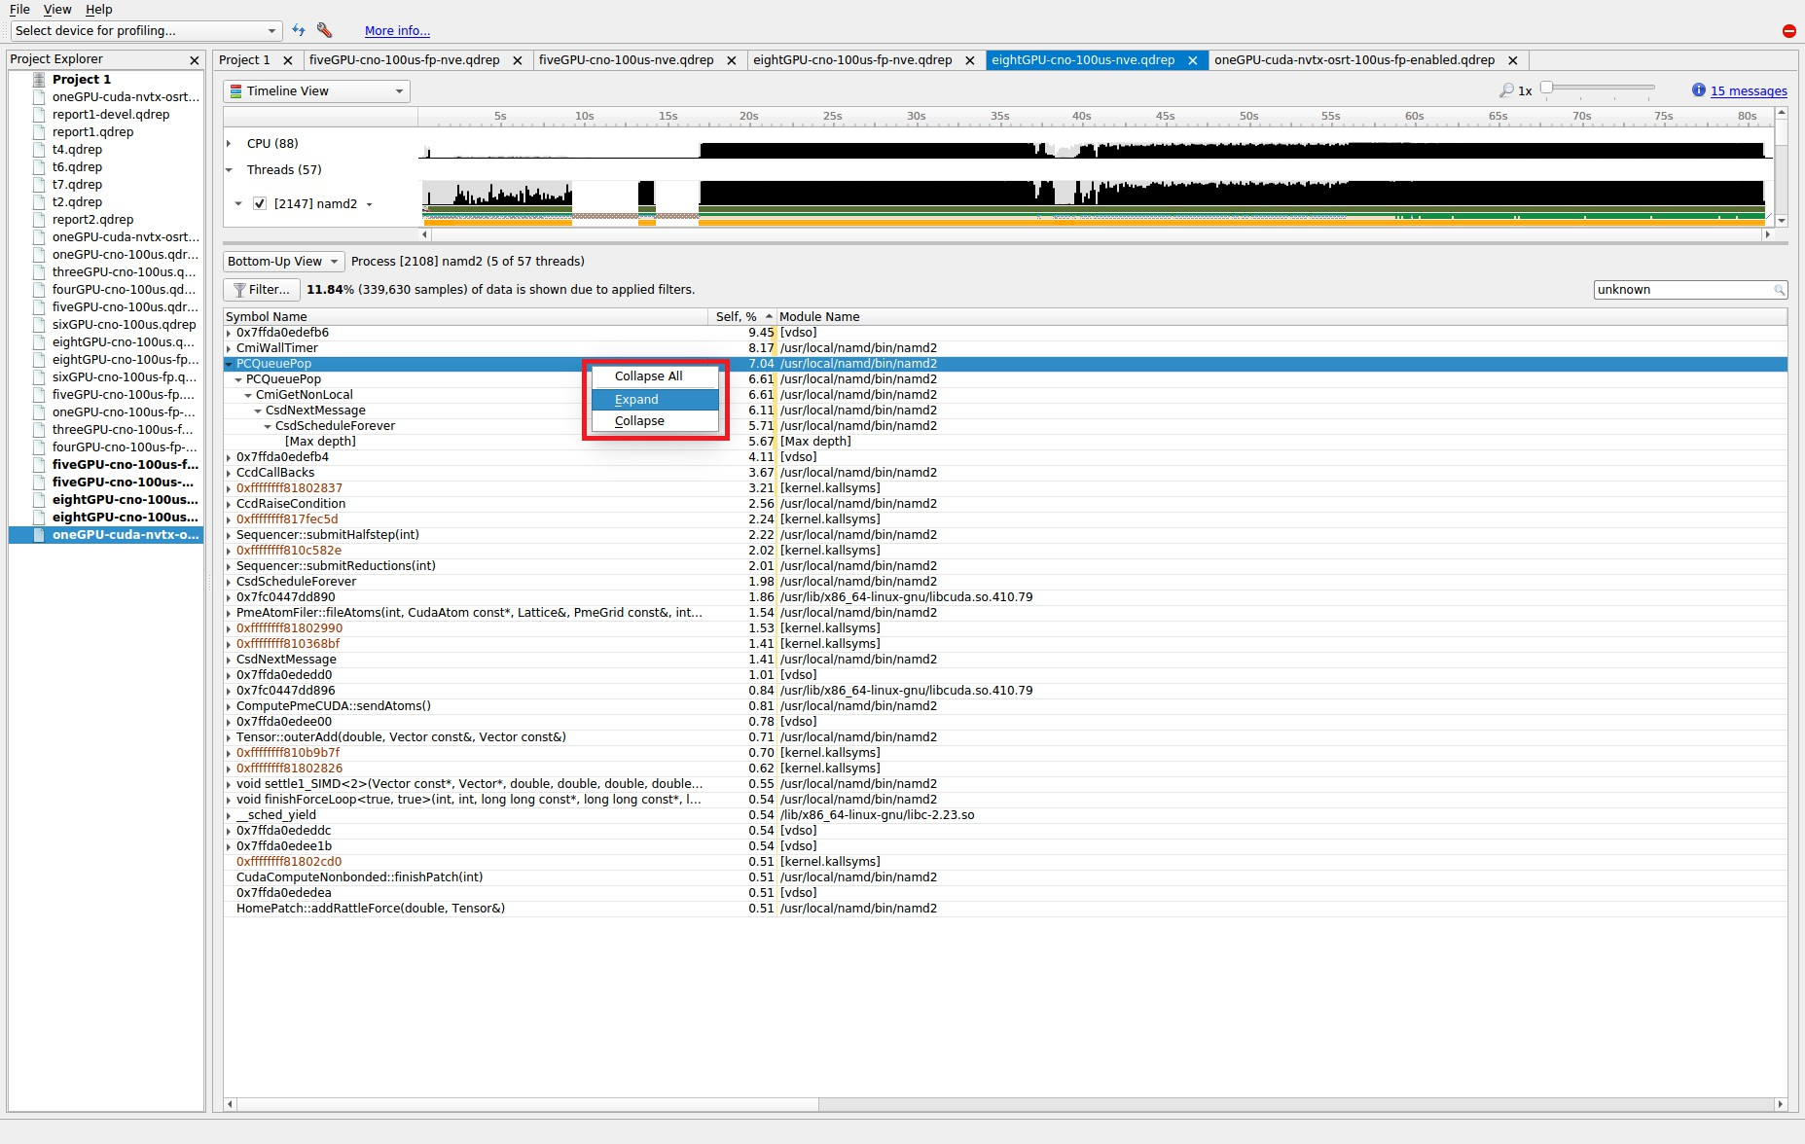
The above shows what happens when a function’s backtraces are expanded. In this case, the PCQueuePop function was called from the CmiGetNonLocal function which was called by the CsdNextMessage function which was called by the CsdScheduleForever function. The [Max depth] string marks the end of the collected backtrace.

Note that, by default, backtraces with less than 0.5% of the total backtraces are hidden. This behavior can make the percentage results hard to understand. If all backtraces are shown (i.e. the filter is disabled), the results look very different and the numbers add up as expected. To disable the filter, click on the Filter… button and uncheck the Hide functions with CPU usage below X% checkbox.

When the filter is disabled, the backtraces are recalculated. Note that you may need to right click on the function and select Expand again to get all of the backtraces to be shown.

When backtraces are collected, the whole sample (IP and backtrace) is handled as a single sample. If two samples have the exact same IP and backtrace, they are summed in the final results. If two samples have the same IP but a different backtrace, they will be shown as having the same leaf (i.e. IP) but a different backtrace. As mentioned earlier, when backtraces end, they are marked with the [Max depth] string (unless the backtrace can be traced back to its origin - e.g. libc_start_main) or the backtrace breaks because an IP cannot be resolved.

Above, the leaf function is PCQueuePop. In this case, there are 11 different backtraces that lead to PCQueuPop - all of them end with [Max depth]. For example, the dominant path is PCQueuPop<-CmiGetNonLocal<-CsdNextmessage<-CsdScheduleForever<- [Max depth]. This path accounts for 5.67% of all samples as shown in line 5 (red numbers). The second most dominant path is PCQueuPop<-CmiGetNonLocal<-[Max depth] which accounts for 0.44% of all samples as shown in line 24 (red numbers).
The path PCQueuPop<-CmiGetNonLocal<-CsdNextmessage<-CsdScheduleForever<- Sequencer::integrate(int)<-[Max depth] accounts for 0.03% of the samples as shown in line 7 (red numbers). Adding up percentages shown in the [Max depth] lines (lines 5, 7, 9, 13, 15, 16, 17, 19, 21, 23, and 24) generates 7.04% which equals the percentage of samples associated with the PCQueuePop function shown in line 0 (red numbers).

Diagnostics Summary View
This view shows important messages. Some of them were generated during the profiling session, while some were added while processing and analyzing data in the report.
Messages can be one of the following types:
- Informational messages
- Warnings
- Errors
To draw attention to important diagnostics messages, a summary line is displayed on the timeline view in the top right corner:
Information from this view can be selected and copied using the mouse cursor.

Symbol Resolution Logs View
This view shows all messages related to the process of resolving symbols. It might be useful to debug issues when some of the symbol names in the symbols table of the timeline view are unresolved.

Chapter 23.
ADDING REPORT TO THE TIMELINE

Starting with 2021.3, Nsight Systems can load multiple report files into a single timeline. This is a BETA feature and will be improved in the future releases. Please let us know about your experience on the forums or through Help > Send Feedback... in the main menu.
To load multiple report files into a single timeline, first start by opening a report as usual
— using File > Open... from the main menu, or double clicking on a report in the Project Explorer window. Then additional report files can be loaded into the same timeline using one of the methods:
- File > Add Report (beta)... in the main menu, and select another report file that you want to open
- Right click on the report in the project explorer window, and click Add Report (beta)
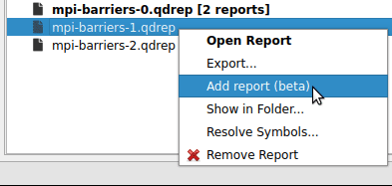

Time Synchronization
When multiple reports are loaded into a single timeline, timestamps between them need to be adjusted, such that events that happened at the same time appear to be aligned.

Nsight Systems can automatically adjust timestamps based on UTC time recorded around the collection start time. This method is used by default when other more precise methods are not available. This time can be seen as UTC time at t=0 in the Analysis Summary page of the report file. Refer to your OS documentation to learn how to sync the software clock using the Network Time Protocol (NTP). NTP-based time synchronization is not very precise, with the typical errors on the scale of one to tens of milliseconds.
Reports collected on the same physical machine can use synchronization based on Timestamp Counter (TSC) values. These are platform-specific counters, typically accessed in user space applications using the RDTSC instruction on x86_64 architecture, or by reading the CNTVCT register on Arm64. Their values converted to nanoseconds can be seen as TSC value at t=0 in the Analysis Summary page of the report file.
Reports synchronized using TSC values can be aligned with nanoseconds-level precision.
TSC-based time synchronization is activated automatically, when Nsight Systems detects that reports come from same target and that the same TSC value corresponds to very close UTC times. Targets are considered to be the same when either explicitly set environment variables NSYS_HW_ID are the same for both reports or when target hostnames are the same and NSYS_HW_ID is not set for either target. The difference between UTC and TSC time offsets must be below 1 second to choose TSC-based time synchronization.
To find out which synchronization method was used, navigate to the Analysis Summary tab of an added report and check the Report alignment source property of a target. Note, that the first report won’t have this parameter.
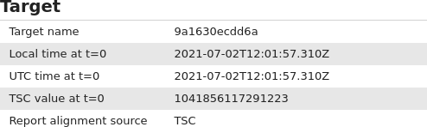
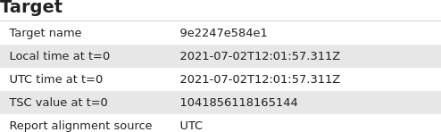

When loading multiple reports into a single timeline, it is always advisable to first check that time synchronization looks correct, by zooming into synchronization or communication events that are expected to be aligned.

Timeline Hierarchy
When reports are added to the same timeline Nsight Systems will automatically line them up by timestamps as described above. If you want Nsight Systems to also
recognize matching process or hardware information, you will need to set environment variables NSYS_SYSTEM_ID and NSYS_HW_ID as shown below at the time of report collection (such as when using "nsys profile ..." command).
When loading a pair of given report files into the same timeline, they will be merged in one of the following configurations:
    - Different hardware — is used when reports are coming from different physical machines, and no hardware resources are shared in these reports. This mode is used when neither NSYS_HW_ID or NSYS_SYSTEM_ID is set and target hostnames are different or absent, and can be additionally signalled by specifying different NSYS_HW_ID values.
    - Different systems, same hardware — is used when reports are collected on different virtual machines (VMs) or containers on the same physical machine. To activate this mode, specify the same value of NSYS_HW_ID when collecting the reports.
    - Same system — is used when reports are collected within the same operating system (or container) environment. In this mode a process identifier (PID) 100 will refer to the same process in both reports. To manually activate this mode, specify the same value of NSYS_SYSTEM_ID when collecting the reports. This mode is automatically selected when target hostnames are the same and neither NSYS_HW_ID or NSYS_SYSTEM_ID is provided.
The following diagrams demonstrate typical cases:

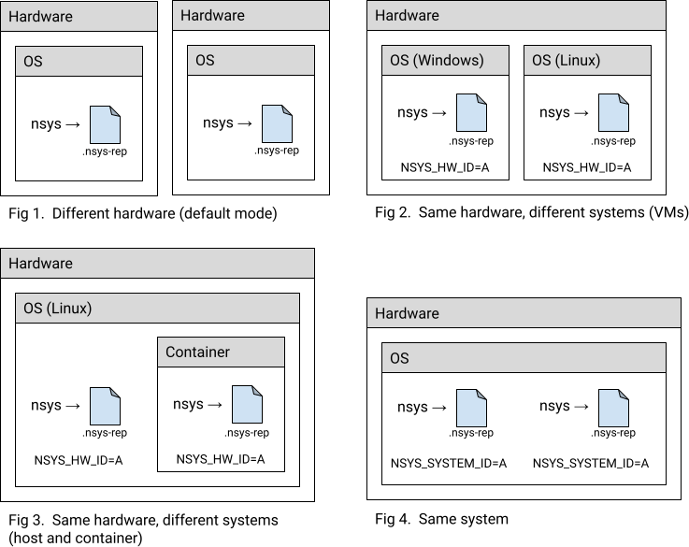

Example: MPI
A typical scenario is when a computing job is run using one of the MPI implementations. Each instance of the app can be profiled separately, resulting in multiple report files. For example:
# Run MPI job without the profiler:
mpirun <mpirun-options> ./myApp
# Run MPI job and profile each instance of the application:
mpirun <mpirun-options> nsys profile -o report-%p <nsys-options>./myApp
When each MPI rank runs on a different node, the command above works fine, since the default pairing mode (different hardware) will be used.
When all MPI ranks run the localhost only, use this command (value "A" was chosen arbitrarily, it can be any non-empty string):
NSYS_SYSTEM_ID=A mpirun <mpirun-options> nsys profile -o report-%p
<nsys-options> ./myApp
For convenience, the MPI rank can be encoded into the report filename. For Open MPI, use the following command to create report files based on the global rank value:

mpirun <mpirun-options> nsys profile -o report-
%q{OMPI_COMM_WORLD_RANK} <nsys-options> ./myApp
MPICH-based implementations set the environment variable PMI_RANK and Slurm (srun) provides the global MPI rank in SLURM_PROCID.

Limitations
    - Only report files collected with Nsight Systems version 2021.3 and newer are fully supported.
    - Sequential reports collected in a single CLI profiling session cannot be loaded into a single timeline yet.

Chapter 24.
POST-COLLECTION ANALYSIS

Once you have profiled using Nsight Systems there are many options for analyzing the collected data as well as to output it in various formats. These options are available from the CLI or the GUI

Available Export Formats

SQLite Schema Reference
Nsight Systems has the ability to export SQLite database files from the .nsys-rep results file. From the CLI, use nsys export. From the GUI, call File->Export....
Note: The .nsys-rep report format is the only data format for Nsight Systems that should be considered forward compatible. The SQLite schema can and will change in the future.
The schema for a concrete database can be obtained with the sqlite3 tool built-in command .schema. The sqlite3 tool can be located in the Target or Host directory of your Nsight Systems installation.
Note: Currently tables are created lazily, and therefore not every table described in the documentation will be present in a particular database. This will change in a future version of the product. If you want a full schema of all possible tables, use nsys export
--lazy=false during export phase.
Currently, a table is created for each data type in the exported database. Since usage patterns for exported data may vary greatly and no default use cases have been established, no indexes or extra constraints are created. Instead, refer to the SQLite Examples section for a list of common recipes. This may change in a future version of the product.
To check the version of your exported SQLite file, check the value of EXPORT_SCHEMA_VERSION in the EXPORT_META_DATA table. The schema version is a common three-value major/minor/micro version number. The first value, or major value, indicates the overall format of the database, and is only changed if there is a major re- write or re-factor of the entire database format. It is assumed that if the major version

changes, all scripts or queries will break. The middle, or minor, version is changed anytime there is a more localized, but potentially breaking change, such as renaming an existing column, or changing the type of an existing column. The last, or micro version is changed any time there are additions, such as a new table or column, that should not introduce any breaking change when used with well-written, best-practices queries.

This is the schema as of the 2023.2 release, schema version 3.1.7.

CREATE TABLE StringIds (
-- Consolidation of repetitive string values.
id INTEGER NOT NULL PRIMARY KEY, -- ID
reference value.
value TEXT NOT NULL -- String value.
);
CREATE TABLE ThreadNames (
nameId INTEGER NOT NULL, --
REFERENCES StringIds(id) -- Thread name
priority INTEGER, -- Priority of the thread.
globalTid INTEGER -- Serialized GlobalId.
);
CREATE TABLE ProcessStreams (
globalPid INTEGER NOT NULL, -- Serialized GlobalId.
filenameId INTEGER NOT NULL, --
REFERENCES StringIds(id) -- File name
contentId INTEGER NOT NULL -- REFERENCES StringIds(id) -- Stream content
);
CREATE TABLE TARGET_INFO_SYSTEM_ENV (
globalVid INTEGER, -- Serialized GlobalId.
devStateName TEXT NOT NULL, -- Device state name.
name TEXT NOT NULL, --
Property name.
nameEnum INTEGER NOT NULL, --
Property enum value.
value TEXT NOT NULL --
Property value.
);
CREATE TABLE TARGET_INFO_NIC_INFO (
globalId INTEGER, -- Device state globalId
stateName TEXT NOT NULL, -- Device state name
nicId INTEGER NOT NULL, --
Network interface Id.
name TEXT NOT NULL, --
Network interface name
deviceId INTEGER NOT NULL, -- REFERENCES ENUM_NET_DEVICE_ID(id)
vendorId INTEGER NOT NULL, -- REFERENCES ENUM_NET_VENDOR_ID(id)
linkLayer INTEGER NOT NULL -- REFERENCES ENUM_NET_LINK_TYPE(id)
);
CREATE TABLE TARGET_INFO_SESSION_START_TIME (
utcEpochNs INTEGER, -- UTC Epoch timestamp at start of the capture (ns).
utcTime TEXT, -- Start of the capture in UTC.
localTime TEXT -- Start of the capture in local time of target.
);
CREATE TABLE ANALYSIS_DETAILS (
-- Details about the analysis session.
globalVid INTEGER NOT NULL, -- Serialized GlobalId.
duration INTEGER NOT NULL, -- The total time span of the entire trace (ns).
startTime INTEGER NOT NULL, -- Trace start timestamp in nanoseconds.
www.nvidia.com
User Guide v2023.3.1 | 260
stopTime INTEGER NOT NULL -- Trace stop timestamp in nanoseconds.
);
CREATE TABLE TARGET_INFO_GPU (

SQLite Schema Event Values
Here are the set values stored in enums in the Nsight Systems SQLite schema

CUDA Event Class Values
0 - TRACE_PROCESS_EVENT_CUDA_RUNTIME
1 - TRACE_PROCESS_EVENT_CUDA_DRIVER
13 - TRACE_PROCESS_EVENT_CUDA_EGL_DRIVER
28 - TRACE_PROCESS_EVENT_CUDNN
29 - TRACE_PROCESS_EVENT_CUBLAS
33 - TRACE_PROCESS_EVENT_CUDNN_START
34 - TRACE_PROCESS_EVENT_CUDNN_FINISH
35 - TRACE_PROCESS_EVENT_CUBLAS_START
36 - TRACE_PROCESS_EVENT_CUBLAS_FINISH
67 - TRACE_PROCESS_EVENT_CUDABACKTRACE
77 - TRACE_PROCESS_EVENT_CUDA_GRAPH_NODE_CREATION
See CUPTI documentation for detailed information on collected event and data types.

NVTX Event Type Values
33 - NvtxCategory
34 - NvtxMark
39 - NvtxThread
59 - NvtxPushPopRange
60 - NvtxStartEndRange
75 - NvtxDomainCreate
76 - NvtxDomainDestroy
The difference between text and textId columns is that if an NVTX event message was passed via call to nvtxDomainRegisterString function, then the message will be available through textId field, otherwise the text field will contain the message if it was provided.

OpenGL Events
KHR event class values
- - KhrDebugPushPopRange
- - KhrDebugGpuPushPopRange
KHR source kind values
0x8249 - GL_DEBUG_SOURCE_THIRD_PARTY
0x824A - GL_DEBUG_SOURCE_APPLICATION

KHR type values
0x824C - GL_DEBUG_TYPE_ERROR
0x824D - GL_DEBUG_TYPE_DEPRECATED_BEHAVIOR
0x824E - GL_DEBUG_TYPE_UNDEFINED_BEHAVIOR
0x824F - GL_DEBUG_TYPE_PORTABILITY
0x8250 - GL_DEBUG_TYPE_PERFORMANCE
0x8251 - GL_DEBUG_TYPE_OTHER
0x8268 - GL_DEBUG_TYPE_MARKER
0x8269 - GL_DEBUG_TYPE_PUSH_GROUP
0x826A - GL_DEBUG_TYPE_POP_GROUP
KHR severity values
0x826B - GL_DEBUG_SEVERITY_NOTIFICATION
0x9146 - GL_DEBUG_SEVERITY_HIGH
0x9147 - GL_DEBUG_SEVERITY_MEDIUM
0x9148 - GL_DEBUG_SEVERITY_LOW

OSRT Event Class Values
OS runtime libraries can be traced to gather information about low-level userspace APIs. This traces the system call wrappers and thread synchronization interfaces exposed by the C runtime and POSIX Threads (pthread) libraries. This does not perform a complete runtime library API trace, but instead focuses on the functions that can take a long time to execute, or could potentially cause your thread be unscheduled from the CPU while waiting for an event to complete.
OSRT events may have callchains attached to them, depending on selected profiling settings. In such cases, one can use callchainId column to select relevant callchains from OSRT_CALLCHAINS table
OSRT event class values
27 - TRACE_PROCESS_EVENT_OS_RUNTIME
31 - TRACE_PROCESS_EVENT_OS_RUNTIME_START
32 - TRACE_PROCESS_EVENT_OS_RUNTIME_FINISH

DX12 Event Class Values
41 - TRACE_PROCESS_EVENT_DX12_API
42 - TRACE_PROCESS_EVENT_DX12_WORKLOAD
43 - TRACE_PROCESS_EVENT_DX12_START
44 - TRACE_PROCESS_EVENT_DX12_FINISH
52 - TRACE_PROCESS_EVENT_DX12_DISPLAY
59 - TRACE_PROCESS_EVENT_DX12_CREATE_OBJECT

PIX Event Class Values
65 - TRACE_PROCESS_EVENT_DX12_DEBUG_API
75 - TRACE_PROCESS_EVENT_DX11_DEBUG_API

Vulkan Event Class Values
53 - TRACE_PROCESS_EVENT_VULKAN_API
54 - TRACE_PROCESS_EVENT_VULKAN_WORKLOAD
55 - TRACE_PROCESS_EVENT_VULKAN_START
56 - TRACE_PROCESS_EVENT_VULKAN_FINISH
60 - TRACE_PROCESS_EVENT_VULKAN_CREATE_OBJECT
66 - TRACE_PROCESS_EVENT_VULKAN_DEBUG_API

Vulkan Flags
VALID_BIT = 0x00000001 CACHE_HIT_BIT = 0x00000002
BASE_PIPELINE_ACCELERATION_BIT = 0x00000004

SLI Event Class Values
- - TRACE_PROCESS_EVENT_SLI
- - TRACE_PROCESS_EVENT_SLI_START
- - TRACE_PROCESS_EVENT_SLI_FINISH

SLI Transfer Info Values
- - P2P_SKIPPED
- - P2P_EARLY_PUSH
- - P2P_PUSH_FAILED
- - P2P_2WAY_OR_PULL
- - P2P_PRESENT
- - P2P_DX12_INIT_PUSH_ON_WRITE

WDDM Event Values

VIDMM operation type values
0 - None
- - RestoreSegments
- - PurgeSegments
- - CleanupPrimary
- - AllocatePagingBufferResources
- - FreePagingBufferResources
- - ReportVidMmState
- - RunApertureCoherencyTest
- - RunUnmapToDummyPageTest
- - DeferredCommand
- - SuspendMemorySegmentAccess
- - ResumeMemorySegmentAccess
- - EvictAndFlush
- - CommitVirtualAddressRange
- - UncommitVirtualAddressRange
- - DestroyVirtualAddressAllocator
- - PageInDevice
- - MapContextAllocation
- - InitPagingProcessVaSpace
200 - CloseAllocation
- - ComplexLock
- - PinAllocation
- - FlushPendingGpuAccess
- - UnpinAllocation
- - MakeResident
- - Evict
- - LockInAperture
- - InitContextAllocation
- - ReclaimAllocation
- - DiscardAllocation
- - SetAllocationPriority
1000 - EvictSystemMemoryOfferList
Paging queue type values
- - VIDMM_PAGING_QUEUE_TYPE_UMD
- - VIDMM_PAGING_QUEUE_TYPE_Default
- - VIDMM_PAGING_QUEUE_TYPE_Evict
- - VIDMM_PAGING_QUEUE_TYPE_Reclaim
Packet type values
- - DXGKETW_RENDER_COMMAND_BUFFER
- - DXGKETW_DEFERRED_COMMAND_BUFFER
- - DXGKETW_SYSTEM_COMMAND_BUFFER
- - DXGKETW_MMIOFLIP_COMMAND_BUFFER
- - DXGKETW_WAIT_COMMAND_BUFFER
- - DXGKETW_SIGNAL_COMMAND_BUFFER
- - DXGKETW_DEVICE_COMMAND_BUFFER
- - DXGKETW_SOFTWARE_COMMAND_BUFFER

Engine type values
- - DXGK_ENGINE_TYPE_OTHER
- - DXGK_ENGINE_TYPE_3D
- - DXGK_ENGINE_TYPE_VIDEO_DECODE
- - DXGK_ENGINE_TYPE_VIDEO_ENCODE
- - DXGK_ENGINE_TYPE_VIDEO_PROCESSING
- - DXGK_ENGINE_TYPE_SCENE_ASSEMBLY
- - DXGK_ENGINE_TYPE_COPY
- - DXGK_ENGINE_TYPE_OVERLAY
- - DXGK_ENGINE_TYPE_CRYPTO
DMA interrupt type values
1 = DXGK_INTERRUPT_DMA_COMPLETED
2 = DXGK_INTERRUPT_DMA_PREEMPTED
4 = DXGK_INTERRUPT_DMA_FAULTED
9 = DXGK_INTERRUPT_DMA_PAGE_FAULTED
Queue type values
0 = Queue_Packet
1 = Dma_Packet
2 = Paging_Queue_Packet

Driver Events
Load balance event type values
1 - LoadBalanceEvent_GPU
8 - LoadBalanceEvent_CPU
21 - LoadBalanceMasterEvent_GPU
22 - LoadBalanceMasterEvent_CPU

OpenMP Events
OpenMP event class values
- - TRACE_PROCESS_EVENT_OPENMP
- - TRACE_PROCESS_EVENT_OPENMP_START
- - TRACE_PROCESS_EVENT_OPENMP_FINISH

OpenMP event kind values
- - OPENMP_EVENT_KIND_TASK_CREATE
- - OPENMP_EVENT_KIND_TASK_SCHEDULE
- - OPENMP_EVENT_KIND_CANCEL
- - OPENMP_EVENT_KIND_MUTEX_RELEASED
- - OPENMP_EVENT_KIND_LOCK_INIT
- - OPENMP_EVENT_KIND_LOCK_DESTROY
- - OPENMP_EVENT_KIND_DISPATCH
- - OPENMP_EVENT_KIND_FLUSH
- - OPENMP_EVENT_KIND_THREAD
- - OPENMP_EVENT_KIND_PARALLEL
- - OPENMP_EVENT_KIND_SYNC_REGION_WAIT
- - OPENMP_EVENT_KIND_SYNC_REGION
- - OPENMP_EVENT_KIND_TASK
- - OPENMP_EVENT_KIND_MASTER
- - OPENMP_EVENT_KIND_REDUCTION
- - OPENMP_EVENT_KIND_MUTEX_WAIT
- - OPENMP_EVENT_KIND_CRITICAL_SECTION
- - OPENMP_EVENT_KIND_WORKSHARE
OpenMP thread type values
- - OpenMP Initial Thread
- - OpenMP Worker Thread
- - OpenMP Internal Thread
- - Unknown
OpenMP sync region kind values
- - Barrier
- - Implicit barrier
- - Explicit barrier
- - Implementation-dependent barrier
- - Taskwait
- - Taskgroup
OpenMP task kind values
- - Initial task
- - Implicit task
- - Explicit task
OpenMP prior task status values
1 - Task completed
2 - Task yielded to another task
3 - Task was cancelled
7 - Task was switched out for other reasons

OpenMP mutex kind values
- - Waiting for lock
- - Testing lock
- - Waiting for nested lock
- - Tesing nested lock
- - Waitng for entering critical section region
- - Waiting for entering atomic region
- - Waiting for entering ordered region
OpenMP critical section kind values
- - Critical section region
- - Atomic region
- - Ordered region
OpenMP workshare kind values
- - Loop region
- - Sections region
- - Single region (executor)
- - Single region (waiting)
- - Workshare region
- - Distrubute region
- - Taskloop region
OpenMP dispatch kind values
- - Iteration
- - Section

Common SQLite Examples

Common Helper Commands
When utilizing sqlite3 command line tool, it’s helpful to have data printed as named columns, this can be done with:
.mode column
.headers on
Default column width is determined by the data in the first row of results. If this doesn’t work out well, you can specify widths manually.
.width 10 20 50

Obtaining Sample Report
CLI interface of Nsight Systems was used to profile radixSortThrust CUDA sample, then the resulting .nsys-rep file was exported using the nsys export.
nsys profile --trace=cuda,osrt radixSortThrust nsys export --type sqlite report1.nsys-rep

Serialized Process and Thread Identifiers

Nsight Systems stores identifiers where events originated in serialized form. For events that have globalTid or globalPid fields exported, use the following code to extract numeric TID and PID.
SELECT globalTid / 0x1000000 % 0x1000000 AS PID, globalTid % 0x1000000 AS TID FROM TABLE_NAME;
Note: globalTid field includes both TID and PID values, while globalPid only containes the PID value.

Correlate CUDA Kernel Launches With CUDA API Kernel Launches
ALTER TABLE CUPTI_ACTIVITY_KIND_RUNTIME ADD COLUMN name TEXT;
ALTER TABLE CUPTI_ACTIVITY_KIND_RUNTIME ADD COLUMN kernelName TEXT;
UPDATE CUPTI_ACTIVITY_KIND_RUNTIME SET kernelName =
(SELECT value FROM StringIds
JOIN CUPTI_ACTIVITY_KIND_KERNEL AS cuda_gpu
ON cuda_gpu.shortName = StringIds.id
AND CUPTI_ACTIVITY_KIND_RUNTIME.correlationId = cuda_gpu.correlationId);
UPDATE CUPTI_ACTIVITY_KIND_RUNTIME SET name =
(SELECT value FROM StringIds WHERE nameId = StringIds.id);
Select 10 longest CUDA API ranges that resulted in kernel execution.
SELECT name, kernelName, start, end FROM CUPTI_ACTIVITY_KIND_RUNTIME WHERE kernelName IS NOT NULL ORDER BY end - start LIMIT 10;
Results:
name | kernelName | start | end
cudaLaunchKernel_v7000 | RadixSortScanBinsKernel | 658863435 | 658868490
cudaLaunchKernel_v7000 | RadixSortScanBinsKernel | 609755015 | 609760075
cudaLaunchKernel_v7000 | RadixSortScanBinsKernel | 632683286 | 632688349
cudaLaunchKernel_v7000 | RadixSortScanBinsKernel | 606495356 | 606500439
cudaLaunchKernel_v7000 | RadixSortScanBinsKernel | 603114486 | 603119586
cudaLaunchKernel_v7000 | RadixSortScanBinsKernel | 802729785 | 802734906
cudaLaunchKernel_v7000 | RadixSortScanBinsKernel | 593381170 | 593386294
cudaLaunchKernel_v7000 | RadixSortScanBinsKernel | 658759955 | 658765090
cudaLaunchKernel_v7000 | RadixSortScanBinsKernel | 681549917 | 681555059
cudaLaunchKernel_v7000 | RadixSortScanBinsKernel | 717812527 | 717817671

Remove Ranges Overlapping With Overhead
Use the this query to count CUDA API ranges overlapping with the overhead ones.

Replace "SELECT COUNT(*)" with "DELETE" to remove such ranges.
SELECT COUNT(*) FROM CUPTI_ACTIVITY_KIND_RUNTIME WHERE rowid IN (
SELECT cuda.rowid
FROM PROFILER_OVERHEAD as overhead
INNER JOIN CUPTI_ACTIVITY_KIND_RUNTIME as cuda ON
(cuda.start BETWEEN overhead.start and overhead.end) OR (cuda.end BETWEEN overhead.start and overhead.end)
OR (cuda.start < overhead.start AND cuda.end > overhead.end)
);
Results:
COUNT(*) 1095

Find CUDA API Calls That Resulted in Original Graph Node Creation.
SELECT graph.graphNodeId, api.start, graph.start as graphStart, api.end, api.globalTid, api.correlationId, api.globalTid,
(SELECT value FROM StringIds where api.nameId == id) as name FROM CUPTI_ACTIVITY_KIND_RUNTIME as api
JOIN
(
SELECT start, graphNodeId, globalTid from CUDA_GRAPH_EVENTS GROUP BY graphNodeId
HAVING COUNT(originalGraphNodeId) = 0
) as graph
ON api.globalTid == graph.globalTid AND api.start < graph.start AND api.end > graph.start
ORDER BY graphNodeId;

Results:

graphNodeId globalTid | start graphStart end name | globalTid | correlationId
1 584366518 584378040 584379102 |  | 281560221750233 | 109
281560221750233 cudaGraphAddMemcpyNode_v10000
2 584379402 584382428 584383139 |  | 281560221750233 | 110
281560221750233 cudaGraphAddMemsetNode_v10000
3 584390663 584395352 584396053 |  | 281560221750233 | 111
281560221750233 cudaGraphAddKernelNode_v10000
4 584396314 584397857 584398438 |  | 281560221750233 | 112
281560221750233 cudaGraphAddMemsetNode_v10000
5 584398759 584400311 584400812 |  | 281560221750233 | 113
281560221750233 cudaGraphAddKernelNode_v10000
6 584401083 584403047 584403527 |  | 281560221750233 | 114
281560221750233 cudaGraphAddMemcpyNode_v10000
7 584403928 584404920 584405491 |  | 281560221750233 | 115
281560221750233 cudaGraphAddHostNode_v10000
29 632107852 632117921 632121407 |  | 281560221750233 | 144
281560221750233 cudaMemcpyAsync_v3020
30 632122168 632125545 632127989 |  | 281560221750233 | 145
281560221750233 cudaMemsetAsync_v3020
31 632131546 632133339 632135584 |  | 281560221750233 | 147
281560221750233 cudaMemsetAsync_v3020
34 632162514 632167393 632169297 |  | 281560221750233 | 151
281560221750233 cudaMemcpyAsync_v3020
35 632170068 632173334 632175388 |  | 281560221750233 | 152
281560221750233 cudaLaunchHostFunc_v10000

Backtraces for OSRT Ranges
Adding text columns makes results of the query below more human-readable.
ALTER TABLE OSRT_API ADD COLUMN name TEXT;
UPDATE OSRT_API SET name = (SELECT value FROM StringIds WHERE OSRT_API.nameId = StringIds.id);
ALTER TABLE OSRT_CALLCHAINS ADD COLUMN symbolName TEXT;
UPDATE OSRT_CALLCHAINS SET symbolName = (SELECT value FROM StringIds WHERE symbol = StringIds.id);
ALTER TABLE OSRT_CALLCHAINS ADD COLUMN moduleName TEXT;
UPDATE OSRT_CALLCHAINS SET moduleName = (SELECT value FROM StringIds WHERE module = StringIds.id);
Print backtrace of the longest OSRT range
SELECT globalTid / 0x1000000 % 0x1000000 AS PID, globalTid % 0x1000000 AS TID, start, end, name, callchainId, stackDepth, symbolName, moduleName
FROM OSRT_API LEFT JOIN OSRT_CALLCHAINS ON callchainId == OSRT_CALLCHAINS.id
WHERE OSRT_API.rowid IN (SELECT rowid FROM OSRT_API ORDER BY end - start DESC LIMIT 1)
ORDER BY stackDepth LIMIT 10;

Results:

PID TID start end name
callchainId stackDepth symbolName moduleName

19163 19176 360897690 860966851 pthread_cond_timedwait 88
0 pthread_cond_timedwait@GLIBC_2 /lib/x86_64-linux-gnu/
libpthread-2.27.so
19163 19176  1  libcuda.so.418 |  |  | 360897690  0x7fbc983b7227 | 860966851 | pthread_cond_timedwait 88  /usr/lib/x86_64-linux-gnu/
19163 19176  2  libcuda.so.418 |  |  | 360897690  0x7fbc9835d5c7 | 860966851 | pthread_cond_timedwait 88  /usr/lib/x86_64-linux-gnu/
19163 19176  3  libcuda.so.418 |  |  | 360897690  0x7fbc983b64a8 | 860966851 | pthread_cond_timedwait 88  /usr/lib/x86_64-linux-gnu/
19163 19176  4  libpthread-2.27.so |  |  | 360897690  start_thread | 860966851 | pthread_cond_timedwait 88  /lib/x86_64-linux-gnu/
19163 | 5 | 19176 | 360897690  clone | 860966851 | pthread_cond_timedwait 88  /lib/x86_64-linux-gnu/
libc-2.27.so
Profiled processes output streams
ALTER TABLE ProcessStreams ADD COLUMN filename TEXT;
UPDATE ProcessStreams SET filename = (SELECT value FROM StringIds WHERE ProcessStreams.filenameId = StringIds.id);
ALTER TABLE ProcessStreams ADD COLUMN content TEXT;
UPDATE ProcessStreams SET content = (SELECT value FROM StringIds WHERE ProcessStreams.contentId = StringIds.id);
Select all collected stdout and stderr streams.
select globalPid / 0x1000000 % 0x1000000 AS PID, filename, content from ProcessStreams;

Results:
PID
filename
content
/tmp/nvidia/nsight_systems/streams/pid_19163_stderr.log
19163
user_name/NVIDIA_CUDA-10.1_Samples/6_Advanced/radixSortThrust/radixSortThrust Starting...
GPU Device 0: "Quadro P2000" with compute capability 6.1

Sorting 1048576 32-bit unsigned int keys and values
radixSortThrust, Throughput = 401.0872 MElements/s, Time = 0.00261 s, Size = 1048576 elements
Test passed
/tmp/nvidia/nsight_systems/streams/pid_19163_stdout.log /home/
19163

Thread Summary
Please note, that Nsight Systems applies additional logic during sampling events processing to work around lost events. This means that the results of the below query might differ slightly from the ones shown in “Analysis summary” tab.
Thread summary calculated using CPU cycles (when available).
SELECT
globalTid / 0x1000000 % 0x1000000 AS PID, globalTid % 0x1000000 AS TID,
ROUND(100.0 * SUM(cpuCycles) / (
SELECT SUM(cpuCycles) FROM COMPOSITE_EVENTS GROUP BY globalTid / 0x1000000000000 % 0x100
), 2
) as CPU_utilization,
(SELECT value FROM StringIds WHERE id = (
SELECT nameId FROM ThreadNames
WHERE ThreadNames.globalTid = COMPOSITE_EVENTS.globalTid
)
) as thread_name FROM COMPOSITE_EVENTS
GROUP BY globalTid
ORDER BY CPU_utilization DESC LIMIT 10;

Results:

PID | TID | CPU_utilization | thread_name
19163 | 19163 | 98.4 | radixSortThrust
19163 | 19168 | 1.35 | CUPTI worker th
19163 | 19166 | 0.25 | [NS]
Thread running time may be calculated using scheduling data, when PMU counter data was not collected.
CREATE INDEX sched_start ON SCHED_EVENTS (start); CREATE TABLE CPU_USAGE AS
SELECT
first.globalTid as globalTid,
(SELECT nameId FROM ThreadNames WHERE ThreadNames.globalTid = first.globalTid) as nameId,
sum(second.start - first.start) as total_duration, count() as ranges_count
FROM SCHED_EVENTS as first
LEFT JOIN SCHED_EVENTS as second ON second.rowid =
(
SELECT rowid
FROM SCHED_EVENTS
WHERE start > first.start AND globalTid = first.globalTid ORDER BY start ASC
LIMIT 1
)
WHERE first.isSchedIn != 0 GROUP BY first.globalTid ORDER BY total_duration DESC;
SELECT
globalTid / 0x1000000 % 0x1000000 AS PID, globalTid % 0x1000000 AS TID,
(SELECT value FROM StringIds where nameId == id) as thread_name, ROUND(100.0 * total_duration / (SELECT SUM(total_duration) FROM CPU_USAGE),
2) as CPU_utilization FROM CPU_USAGE
ORDER BY CPU_utilization DESC;
Results:
PID | TID | thread_name | CPU_utilization
19163 | 19163 | radixSortThrust | 93.74
19163 | 19169 | radixSortThrust | 3.22
19163 | 19168 | CUPTI worker th | 2.46
19163 | 19166 | [NS] | 0.44
19163 | 19172 | radixSortThrust | 0.07
19163 | 19167 | [NS Comms] | 0.05
19163 | 19176 | radixSortThrust | 0.02
19163 | 19170 | radixSortThrust | 0.0

Function Table
These examples demonstrate how to calculate Flat and BottomUp (for top level only) views statistics.

To set up:
ALTER TABLE SAMPLING_CALLCHAINS ADD COLUMN symbolName TEXT;
UPDATE SAMPLING_CALLCHAINS SET symbolName = (SELECT value FROM StringIds WHERE symbol = StringIds.id);
ALTER TABLE SAMPLING_CALLCHAINS ADD COLUMN moduleName TEXT;
UPDATE SAMPLING_CALLCHAINS SET moduleName = (SELECT value FROM StringIds WHERE module = StringIds.id);
To get flat view:
SELECT symbolName, moduleName, ROUND(100.0 * sum(cpuCycles) /
(SELECT SUM(cpuCycles) FROM COMPOSITE_EVENTS), 2) AS flatTimePercentage FROM SAMPLING_CALLCHAINS
LEFT JOIN COMPOSITE_EVENTS ON SAMPLING_CALLCHAINS.id == COMPOSITE_EVENTS.id
GROUP BY symbol, module
ORDER BY flatTimePercentage DESC LIMIT 5;
To get BottomUp view (top level only):
SELECT symbolName, moduleName, ROUND(100.0 * sum(cpuCycles) /
(SELECT SUM(cpuCycles) FROM COMPOSITE_EVENTS), 2) AS selfTimePercentage FROM SAMPLING_CALLCHAINS
LEFT JOIN COMPOSITE_EVENTS ON SAMPLING_CALLCHAINS.id == COMPOSITE_EVENTS.id
WHERE stackDepth == 0 GROUP BY symbol, module
ORDER BY selfTimePercentage DESC LIMIT 5;
Results:
symbolName | moduleName flatTimePercentage
[Max depth] [Max depth] 99.92 thrust::zip /home/user_ 24.17
thrust::zip /home/user_ 24.17
thrust::det /home/user_ 24.17
thrust::det /home/user_ 24.17
symbolName moduleName selfTimePercentage
0x7fbc984982b6 /usr/lib/x86_64-linux-gnu/libcuda.so.418.39 5.29
0x7fbc982d0010 /usr/lib/x86_64-linux-gnu/libcuda.so.418.39 2.81
thrust::iterat /home/user_name/NVIDIA_CUDA-10.1_Samples/6_ 2.23
thrust::iterat /home/user_name/NVIDIA_CUDA-10.1_Samples/6_ 1.55 void thrust::i /home/user_name/NVIDIA_CUDA-10.1_Samples/6_ 1.55

DX12 API Frame Duration Histogram

The example demonstrates how to calculate DX12 CPU frames durartion and construct a histogram out of it.
CREATE INDEX DX12_API_ENDTS ON DX12_API (end);
CREATE TEMP VIEW DX12_API_FPS AS SELECT end AS start, (SELECT end FROM DX12_API
WHERE end > outer.end AND nameId == (SELECT id FROM StringIds WHERE value == "IDXGISwapChain::Present")
ORDER BY end ASC LIMIT 1) AS end
FROM DX12_API AS outer
WHERE nameId == (SELECT id FROM StringIds WHERE value == "IDXGISwapChain::Present")
ORDER BY end;
Number of frames with a duration of [X, X + 1) milliseconds.
SELECT
CAST((end - start) / 1000000.0 AS INT) AS duration_ms, count(*)
FROM DX12_API_FPS WHERE end IS NOT NULL
GROUP BY duration_ms ORDER BY duration_ms;

Results:
duration_ms |  | count(*)
3 |  | 1
4 |  | 2
5 |  | 7
6 |  | 153
7 |  | 19
8 |  | 116
9 |  | 16
10 |  | 8
11 |  | 2
12 |  | 2
13 |  | 1
14 |  | 4
16 |  | 3
17 |  | 2
18 |  | 1

GPU Context Switch Events Enumeration
GPU context duration is between first BEGIN and a matching END event.
SELECT (CASE tag WHEN 8 THEN "BEGIN" WHEN 7 THEN "END" END) AS tag,
globalPid / 0x1000000 % 0x1000000 AS PID,
vmId, seqNo, contextId, timestamp, gpuId FROM GPU_CONTEXT_SWITCH_EVENTS WHERE tag in (7, 8) ORDER BY seqNo LIMIT 10;

Results:
tag |  |  | PID |  | vmId |  | seqNo |  | contextId |  | timestamp | gpuId
BEGIN |  |  | 23371 |  | 0 |  | 0 |  | 1048578 |  | 56759171 | 0
BEGIN |  |  | 23371 |  | 0 |  | 1 |  | 1048578 |  | 56927765 | 0
BEGIN |  |  | 23371 |  | 0 |  | 3 |  | 1048578 |  | 63799379 | 0
END |  |  | 23371 |  | 0 |  | 4 |  | 1048578 |  | 63918806 | 0
BEGIN |  |  | 19397 |  | 0 |  | 5 |  | 1048577 |  | 64014692 | 0
BEGIN |  |  | 19397 |  | 0 |  | 6 |  | 1048577 |  | 64250369 | 0
BEGIN |  |  | 19397 |  | 0 |  | 8 |  | 1048577 |  | 1918310004 | 0
END |  |  | 19397 |  | 0 |  | 9 |  | 1048577 |  | 1918521098 | 0
BEGIN |  |  | 19397 |  | 0 |  | 10 |  | 1048577 |  | 2024164744 | 0
BEGIN |  |  | 19397 |  | 0 |  | 11 |  | 1048577 |  | 2024358650 | 0

Resolve NVTX Category Name
The example demonstrates how to resolve NVTX category name for NVTX marks and ranges.
WITH
event AS ( SELECT *
FROM NVTX_EVENTS
WHERE eventType IN (34, 59, 60) -- mark, push/pop, start/end
),
category AS ( SELECT
category, domainId,
text AS categoryName FROM NVTX_EVENTS
WHERE eventType == 33 -- new category
) SELECT
start, end, globalTid, eventType, domainId, category,
categoryName, text
FROM event JOIN category USING (category, domainId) ORDER BY start;

Results:

start end globalTid eventType categoryName text | domainId | category
18281150 18311960 281534938484214 59  FirstCategoryUnderDefault Push Pop Range A 18288187 18306674 281534938484214 59  SecondCategoryUnderDefaul Push Pop Range B 18294247 281534938484214 34  FirstCategoryUnderDefault Mark A 18300034 281534938484214 34  SecondCategoryUnderDefaul Mark B 18345546 18372595 281534938484214 60  FirstCategoryUnderMyDomai Start End Range 18352924 18378342 281534938484214 60  SecondCategoryUnderMyDoma Start End Range 18359634 281534938484214 34  FirstCategoryUnderMyDomai Mark A 18365448 281534938484214 34  SecondCategoryUnderMyDoma Mark B | 0  0  0  0  1  1  1  1 | 1  2  1  2  1  2  1  2

Rename CUDA Kernels with NVTX
The example demonstrates how to map innermost NVTX push-pop range to a matching CUDA kernel run.
ALTER TABLE CUPTI_ACTIVITY_KIND_KERNEL ADD COLUMN nvtxRange TEXT;
CREATE INDEX nvtx_start ON NVTX_EVENTS (start);

UPDATE CUPTI_ACTIVITY_KIND_KERNEL SET nvtxRange = ( SELECT NVTX_EVENTS.text
FROM NVTX_EVENTS JOIN CUPTI_ACTIVITY_KIND_RUNTIME ON
NVTX_EVENTS.eventType == 59 AND
NVTX_EVENTS.globalTid == CUPTI_ACTIVITY_KIND_RUNTIME.globalTid AND NVTX_EVENTS.start <= CUPTI_ACTIVITY_KIND_RUNTIME.start AND NVTX_EVENTS.end >= CUPTI_ACTIVITY_KIND_RUNTIME.end
WHERE
CUPTI_ACTIVITY_KIND_KERNEL.correlationId == CUPTI_ACTIVITY_KIND_RUNTIME.correlationId
ORDER BY NVTX_EVENTS.start DESC LIMIT 1
);
SELECT start, end, globalPid, StringIds.value as shortName, nvtxRange FROM CUPTI_ACTIVITY_KIND_KERNEL JOIN StringIds ON shortName == id ORDER BY start LIMIT 6;
Results:
start | end | globalPid | shortName | nvtxRange
526545376 | 526676256 | 72057700439031808 | MatrixMulCUDA
526899648 | 527030368 | 72057700439031808 | MatrixMulCUDA | Add
527031648 | 527162272 | 72057700439031808 | MatrixMulCUDA | Add
527163584 | 527294176 | 72057700439031808 | MatrixMulCUDA | My Kernel
527296160 | 527426592 | 72057700439031808 | MatrixMulCUDA | My Range
527428096 | 527558656 | 72057700439031808 | MatrixMulCUDA

Select CUDA Calls With Backtraces
ALTER TABLE CUPTI_ACTIVITY_KIND_RUNTIME ADD COLUMN name TEXT;
UPDATE CUPTI_ACTIVITY_KIND_RUNTIME SET name = (SELECT value FROM StringIds WHERE
CUPTI_ACTIVITY_KIND_RUNTIME.nameId = StringIds.id);
ALTER TABLE CUDA_CALLCHAINS ADD COLUMN symbolName TEXT;
UPDATE CUDA_CALLCHAINS SET symbolName = (SELECT value FROM StringIds WHERE symbol = StringIds.id);
SELECT globalTid % 0x1000000 AS TID,
start, end, name, callchainId, stackDepth, symbolName
FROM CUDA_CALLCHAINS JOIN CUPTI_ACTIVITY_KIND_RUNTIME ON callchainId == CUDA_CALLCHAINS.id
ORDER BY callchainId, stackDepth LIMIT 11;
Results:
TID  symbolName | start | end | name | callchainId | stackDepth
11928 | 168976467 | 169077826 | cuMemAlloc_v2 | 1 | 0
0x7f13c44f02ab
11928 | 168976467 | 169077826 | cuMemAlloc_v2 | 1 | 1
0x7f13c44f0b8f
11928 | 168976467 | 169077826 | cuMemAlloc_v2 | 1 | 2
0x7f13c44f3719
11928 | 168976467 | 169077826 | cuMemAlloc_v2 | 1 | 3
cuMemAlloc_v2
11928 | 168976467 | 169077826 | cuMemAlloc_v2 | 1 | 4
cudart::driver
11928 | 168976467 | 169077826 | cuMemAlloc_v2 | 1 | 5
cudart::cudaAp
11928 | 168976467 | 169077826 | cuMemAlloc_v2 | 1 | 6
cudaMalloc
11928 | 168976467 | 169077826 | cuMemAlloc_v2 | 1 | 7
cudaError cuda
11928 | 168976467 | 169077826 | cuMemAlloc_v2 | 1 | 8 | main
11928 | 168976467 | 169077826 | cuMemAlloc_v2 | 1 | 9
libc_start_m
11928 | 168976467 | 169077826 | cuMemAlloc_v2 | 1 | 10
_start

SLI Peer-to-Peer Query
The example demonstrates how to query SLI Peer-to-Peer events with resource size greater than value and within a time range sorted by resource size descending.
SELECT * FROM SLI_P2P
WHERE resourceSize < 98304 AND start > 1568063100 AND end < 1579468901 ORDER BY resourceSize DESC;

Results:
start
end
eventClass globalTid
gpu
frameId
transferSkipped srcGpu dstGpu numSubResources resourceSize subResourceIdx smplWidth smplHeight smplDepth bytesPerElement
dxgiFormat logSurfaceNames transferInfo isEarlyPushManagedByNvApi useAsyncP2pForResolve transferFuncName regimeName debugName bindType

1570351100 | 1570351101 | 62 |  | 72057698056667136 | 0 |  |  | 771 |  | 0
 | 256 |  | 512 | 1 |  | 1048576 |  |  | 0
256 | 256 |  | 1 | 16 |  | 2
3 |  | 0 |  | 0
1570379300 | 1570379301 | 62 |  | 72057698056667136 | 0 |  |  | 771 |  | 0
 | 256 |  | 512 | 1 |  | 1048576 |  |  | 0
64 | 64 |  | 64 | 4 |  | 31
3 |  | 0 |  | 0
1572316400 | 1572316401 | 62 |  | 72057698056667136 | 0 |  |  | 773 |  | 0
 | 256 |  | 512 | 1 |  | 1048576 |  |  | 0
256 | 256 |  | 1 | 16 |  | 2
3 |  | 0 |  | 0
1572345400 | 1572345401 | 62 |  | 72057698056667136 | 0 |  |  | 773 |  | 0
 | 256 |  | 512 | 1 |  | 1048576 |  |  | 0
64 | 64 |  | 64 | 4 |  | 31
3 |  | 0 |  | 0
1574734300 | 1574734301 | 62 |  | 72057698056667136 | 0 |  |  | 775 |  | 0
 | 256 |  | 512 | 1 |  | 1048576 |  |  | 0
256 | 256 |  | 1 | 16 |  | 2
3 |  | 0 |  | 0
1574767200 | 1574767201 | 62 |  | 72057698056667136 | 0 |  |  | 775 |  | 0
 | 256 |  | 512 | 1 |  | 1048576 |  |  | 0
64 | 64 |  | 64 | 4 |  | 31
3 |  | 0 |  | 0

Generic Events
Syscall usage histogram by PID:
SELECT json_extract(data, '$.common_pid') AS PID, count(*) AS total FROM GENERIC_EVENTS WHERE PID IS NOT NULL AND typeId = (
SELECT typeId FROM GENERIC_EVENT_TYPES
WHERE json_extract(data, '$.Name') = "raw_syscalls:sys_enter") GROUP BY PID
ORDER BY total DESC LIMIT 10;

Results:

PID | total
5551 | 32811
9680 | 3988
4328 | 1477
9564 | 1246
4376 | 1204
4377 | 1167
4357 | 656
4355 | 655
4356 | 640
4354 | 633

Fetching Generic Events in JSON Format
Text and JSON export modes don’t include generic events. Use the below queries (without LIMIT clause) to extract JSON lines representation of generic events, types and sources.
SELECT json_insert('{}', '$.sourceId', sourceId, '$.data', json(data)
)
FROM GENERIC_EVENT_SOURCES LIMIT 2;
SELECT json_insert('{}', '$.typeId', typeId, '$.sourceId', sourceId, '$.data', json(data)
)
FROM GENERIC_EVENT_TYPES LIMIT 2;
SELECT json_insert('{}', '$.rawTimestamp', rawTimestamp, '$.timestamp', timestamp, '$.typeId', typeId,
'$.data', json(data)
)
FROM GENERIC_EVENTS LIMIT 2;

Results:

json_insert('{}', '$.sourceId', sourceId, '$.data', json(data)
)
{"sourceId":72057602627862528,"data":
{"Name":"FTrace","TimeSource":"ClockMonotonicRaw","SourceGroup":"FTrace"}} json_insert('{}',
'$.typeId', typeId, '$.sourceId', sourceId, '$.data', json(data)
)
{"typeId":72057602627862547,"sourceId":72057602627862528,"data":
{"Name":"raw_syscalls:sys_enter","Format":"\"NR %ld (%lx,
%lx, %lx, %lx, %lx, %lx)\", REC->id, REC->args[0], REC-
>args[1], REC->args[2], REC->args[3], REC->args[4], REC-
>args[5]","Fields":[{"Name":"common_pid","Prefix":"int","Suffix":""},
{"Name":"id","Prefix":"long","S
{"typeId":72057602627862670,"sourceId":72057602627862528,"data":
{"Name":"irq:irq_handler_entry","Format":"\"irq=%d name=%s\", REC->irq,
get_str(name)","Fields":[{"Name":"common_pid","Prefix":"int","Suffix":""},
{"Name":"irq","Prefix":"int","Suffix":""},{"Name":"name","Prefix":" data_loc char[]","Suffix":""},{"Name":"common_type",
json_insert('{}',
'$.rawTimestamp', rawTimestamp, '$.timestamp', timestamp, '$.typeId', typeId,
'$.data', json(data)
)
{"rawTimestamp":1183694330725221,"timestamp":6236683,"typeId":72057602627862670,"  {"common_pid":"0","irq":"66","name":"327696","common_type":"142","common_flags":"  {"rawTimestamp":1183694333695687,"timestamp":9207149,"typeId":72057602627862670,"  {"common_pid":"0","irq":"66","name":"327696","common_type":"142","common_flags":" | data": 9","common_p data": 9","common_p

Arrow Format Description
The Arrow type exported file uses the IPC stream format to store the data in a file. The tables can be read by opening the file as an arrow stream. For example one can use the open_stream function from the arrow python package. For more information on the interfaces that can be used to read an IPC stream file, please refer to the Apache Arrow documentation [1, 2].
The name of each table is included in the schema metadata. Thus, while reading each table, the user can extract the table title from the metadata. The table name metadata field has the key table_name. The titles of all the available tables can be found in section SQLite Schema Reference.

JSON and Text Format Description
JSON and TXT export formats are generated by serializing buffered messages, each on a new line. First, all collected events are processed. Then strings are serialized, followed by stdout, stderr streams if any, followed by thread names.
Output layout:
{Event #1}
{Event #2}
...
{Event #N}
{Strings}
{Streams}
{Threads}
For easier grepping of JSON output, the --separate-strings switch may be used to force manual splitting of strings, streams and thread names data.
Example line split: nsys export --export-json --separate-strings sample.nsys-rep -- -
{"type":"String","id":"3720","value":"Process 14944 was launched by the profiler"}
{"type":"String","id":"3721","value":"Profiling has started."}
{"type":"String","id":"3722","value":"Profiler attached to the process."}
{"type":"String","id":"3723","value":"Profiling has stopped."}
{"type":"ThreadName","globalTid":"72057844756653436","nameId":"14","priority":"10"}
{"type":"ThreadName","globalTid":"72057844756657940","nameId":"15","priority":"10"}
{"type":"ThreadName","globalTid":"72057844756654400","nameId":"24","priority":"10"}
Compare with: nsys export --export-json sample.nsys-rep -- -
{"data":["[Unknown]","[Unknown kernel module]","[Max depth]","[Broken backtraces]",
"[Called from Java]","QnxKernelTrace","mm_","task_submit","class_id","syncpt_id",
"syncpt_thresh","pid","tid","FTrace","[NSys]","[NSys Comms]", "..." ,"Process 14944 was launched by the profiler","Profiling has started.","Profiler
attached
to the process.","Profiling has stopped."]}
{"data":[{"nameIdx":"14","priority":"10","globalTid":"72057844756653436"},
{"nameIdx":"15","priority":"10","globalTid":"72057844756657940"},
{"nameIdx":"24", "priority":"10","globalTid":"72057844756654400"}]}
Note, that only last few lines are shown here for clarity and that carriage returns and indents were added to avoid wrapping documentation.

Statistical Analysis

Statistical Reports Shipped With Nsight Systems
The Nsight Systems development team created and maintains a set of report scripts for some of the commonly requested statistical reports. These scripts will be updated to adapt to any changes in SQLite schema or internal data structures.
These scripts are located in the Nsight Systems package in the Target-<architecture>/ reports directory. The following standard reports are available:
Note: The ability to display mangled names is a recent addition to the report file format, and requires that the profile data be captured with a recent version of Nsys. Re-
exporting an existing report file is not sufficient. If the raw, mangled kernel name data is not available, the default demangled names will be used.
Note: All time values given in nanoseconds by default. If you wish to output the results using a different time unit, use the --timeunit option when running the recipe.

cuda_api_gpu_sum[:base|:mangled] -- CUDA Summary (API/Kernels/ MemOps)
Arguments
- base - Optional argument, if given, will cause summary to be over the base name of the kernel, rather than the templated name.
- mangled - Optional argument, if given, will cause summary to be over the raw mangled name of the kernel, rather than the templated name.
Output:
- Time : Percentage of Total Time
- Total Time : Total time used by all executions of this kernel
- Instances: Number of executions of this object
- Avg : Average execution time of this kernel
- Med : Median execution time of this kernel
- Min : Smallest execution time of this kernel
- Max : Largest execution time of this kernel
- StdDev : Standard deviation of execution time of this kernel
- Category : Category of the operation
- Operation : Name of the kernel
This report provides a summary of CUDA API calls, kernels and memory operations, and their execution times. Note that the Time column is calculated using a summation of the Total Time column, and represents that API call's, kernel's, or memory operation's percent of the execution time of the APIs, kernels and memory operations listed, and not a percentage of the application wall or CPU execution time.
This report combines data from the cuda_api_sum, cuda_gpu_kern_sum, and cuda_gpu_mem_size_sum reports. It is very similar to profile section of nvprof -- dependency-analysis.

cuda_api_sum -- CUDA API Summary
Arguments - None
Output: All time values given in nanoseconds
- Time : Percentage of Total Time
- Total Time : Total time used by all executions of this function
- Num Calls : Number of calls to this function
- Avg : Average execution time of this function
- Med : Median execution time of this function
- Min : Smallest execution time of this function
- Max : Largest execution time of this function
- StdDev : Standard deviation of the time of this function
- Name : Name of the function
This report provides a summary of CUDA API functions and their execution times. Note that the Time column is calculated using a summation of the Total Time column, and represents that function's percent of the execution time of the functions listed, and not a percentage of the application wall or CPU execution time.

cuda_api_trace -- CUDA API Trace
Arguments - None
Output: All time values given in nanoseconds
- Start : Timestamp when API call was made
- Duration : Length of API calls
- Name : API function name
- Result : return value of API call
- CorrID : Correlation used to map to other CUDA calls
- Pid : Process ID that made the call
- Tid : Thread ID that made the call
- T-Pri : Run priority of call thread
- Thread Name : Name of thread that called API function
This report provides a trace record of CUDA API function calls and their execution times.

cuda_gpu_kern_gb_sum[:base|:mangled] -- CUDA GPU Kernel/Grid/ Block Summary
Arguments
- base - Optional argument, if given, will cause summary to be over the base name of the kernel, rather than the templated name.
- mangled - Optional argument, if given, will cause summary to be over the raw mangled name of the kernel, rather than the templated name.

Output: All time values given in nanoseconds
- Time : Percentage of Total Time
- Total Time : Total time used by all executions of this kernel
- Instances : Number of calls to this kernel
- Avg : Average execution time of this kernel
- Med : Median execution time of this kernel
- Min : Smallest execution time of this kernel
- Max : Largest execution time of this kernel
- StdDev : Standard deviation of the time of this kernel
- GridXYZ : Grid dimensions for kernel launch call
- BlockXYZ : Block dimensions for kernel launch call
- Name : Name of the kernel
This report provides a summary of CUDA kernels and their execution times. Kernels are sorted by grid dimensions, block dimensions, and kernel name. Note that the Time column is calculated using a\ summation of the Total Time column, and represents that kernel's percent of the execution time of the kernels listed, and not a percentage of the application wall or CPU execution time.

cuda_gpu_kern_sum[:base|:mangled] -- CUDA GPU Kernel Summary
Arguments
- base - Optional argument, if given, will cause summary to be over the base name of the kernel, rather than the templated name.
- mangled - Optional argument, if given, will cause summary to be over the raw mangled name of the kernel, rather than the templated name.
Output: All time values given in nanoseconds
- Time : Percentage of Total Time
- Total Time : Total time used by all executions of this kernel
- Instances : Number of calls to this kernel
- Avg : Average execution time of this kernel
- Min : Smallest execution time of this kernel
- Max : Largest execution time of this kernel
- StdDev : Standard deviation of the time of this kernel
- Name : Name of the kernel
This report provides a summary of CUDA kernels and their execution times. Note that the Time column is calculated using a summation of the Total Time column, and represents that kernel's percent of the execution time of the kernels listed, and not a percentage of the application wall or CPU execution time.

cuda_gpu_mem_size_sum -- CUDA GPU MemOps Summary (by Size)
Arguments - None
Output: All memory values given in KiB

- Total : Total number of KiB utilized by this operation
- Operations : Number of executions of this operation
- Avg : Average memory size of this operation
- Min : Smallest memory size of this operation
- Max : Largest memory size of this operation
- StdDev : Standard deviation of execution time of this operation
- Name : Name of the operation
This report provides a summary of GPU memory operations and the amount of memory they utilize.

cuda_gpu_mem_time_sum -- CUDA GPU MemOps Summary (by Time)
Arguments - None
Output: All memory values given in KiB
- Time : Percentage of Total Time
- Total Time : Total time used by all executions of this operation
- Operations: Number of operations of this type
- Avg : Average execution time of this operation
- Min : Smallest execution time of this operation
- Max : Largest execution time of this operation
- StdDev : Standard deviation of execution time of this operation
- Operation : Name of the memory operation
This report provides a summary of GPU memory operations and their execution times. Note that the Time column is calculated using a summation of the Total Time column, and represents that operation's percent of the execution time of the operations listed, and not a percentage of the application wall or CPU execution time.

cuda_gpu_sum[:base|:mangled] -- CUDA GPU Summary (Kernels/ MemOps)
Arguments
- base - Optional argument, if given, will cause summary to be over the base name of the kernel, rather than the templated name.
- mangled - Optional argument, if given, will cause summary to be over the raw mangled name of the kernel, rather than the templated name.
Output: All time values given in nanoseconds
- Time : Percentage of Total Time
- Total Time : Total time used by all executions of this kernel
- Instances : Number of executions of this object
- Avg : Average execution time of this kernel
- Min : Smallest execution time of this kernel
- Max : Largest execution time of this kernel
- StdDev : Standard deviation of execution time of this kernel

- Category : Category of the operation
- Name : Name of the kernel
This report provides a summary of CUDA kernels and memory operations, and their execution times. Note that the Time column is calculated using a summation of the Total Time column, and represents that kernel's or memory operation's percent of the execution time of the kernels and memory operations listed, and not a\ percentage of the application wall or CPU execution time.
This report combines data from the cuda_gpu_kern_sum and cuda_gpu_mem_time_sum reports. This report is very similar to output of the command nvprof --print-gpu-summary.

cuda_gpu_trace[:base|:mangled] -- CUDA GPU Trace
Arguments
- base - Optional argument, if given, will cause summary to be over the base name of the kernel, rather than the templated name.
- mangled - Optional argument, if given, will cause summary to be over the raw mangled name of the kernel, rather than the templated name.
Output:
- Start : Start time of trace event in seconds
- Duration : Length of event in nanoseconds
- CorrId : Correlation ID
- GrdX, GrdY, GrdZ : Grid values
- BlkX, BlkY, BlkZ : Block values
- Reg/Trd : Registers per thread
- StcSMem : Size of Static Shared Memory
- DymSMem : Size of Dynamic Shared Memory
- Bytes : Size of memory operation
- Thru : Throughput in MB per Second
- SrcMemKd : Memcpy source memory kind or memset memory kind
- DstMemKd : Memcpy destination memory kind
- Device : GPU device name and ID
- Ctx : Context ID
- Strm : Stream ID
- Name : Trace event name
This report displays a trace of CUDA kernels and memory operations. Items are sorted by start time.

cuda_kern_exec_sum[:base|:mangled] -- CUDA Kernel Launch & Exec Time Summary
Arguments

- base - Optional argument, if given, will cause summary to be over the base name of the kernel, rather than the templated name.
- mangled - Optional argument, if given, will cause summary to be over the raw mangled name of the kernel, rather than the templated name.
Output: All time values default to nanoseconds.
- PID : Process ID that made kernel launch call
- TID : Tread ID that made kernel launch call
- DevId : CUDA Device ID that executed kernel (which GPU)
- Count : Number of kernel records
- QCount : Number of kernel records with positive queue time

Average, Median, Minimum, Maximum, and Standard Deviation for:
  - TAvg, TMed, TMin, TMax, TStdDev : Total time
  - AAvg, AMed, AMin, AMax, AStdDev : API time
  - QAvg, QMed, QMin, QMax, QStdDev : Queue time
  - KAvg, KMed, KMin, KMax, KStdDev : Kernel time
- API Name : Name of CUDA API call used to launch kernel
- Kernel Name : Name of CUDA Kernel
This report provides a summary of the launch and execution times of CUDA kernels. The launch and execution is broken down into three phases: API time, the execution time of the CUDA API call on the CPU used to launch the kernel; Queue time, the time between the launch call and the kernel execution; and Kernel time, the kernel execution time on the GPU. The Total Time is not a just sum of the other times, as the phases sometimes overlap. Rather, the total time runs from the start of the API call to end of the API call or the end of the kernel execution, whichever is later.
The reported queue time is measured from the end of the API call to the start of the kernel execution. The actual queue time is slightly longer, as the kernel is enqueued somewhere in the middle of the API call, and not in the final nanosecond of function execution. Due to this delay, it is possible for kernel execution to start before the CUDA launch call returns. In these cases, no queue time will be reported. Only kernel launches with positive queue times are included in the queue average, minimum, maximum, and standard deviation calculations. The QCount column indicates how many launches had positive queue times (and how many launches were involved in calculating the queue time statistics). Subtracting QCount from Count will indicate how many kernels had no queue time.
Be aware that having a queue time is not inherently bad. Queue times indicate that the GPU was busy running other tasks when the new kernel was scheduled for launch.
If every kernel launch is immediate, without any queue time, that may indicate an idle GPU with poor utilization. In terms of performance optimization, it should not necessarily be a goal to eliminate queue time.

cuda_kern_exec_trace[:base|:mangled] -- CUDA Kernel Launch & Exec Time Trace
Arguments

- base - Optional argument, if given, will cause summary to be over the base name of the kernel, rather than the templated name.
- mangled - Optional argument, if given, will cause summary to be over the raw mangled name of the kernel, rather than the templated name.
Output: All time values default to nanoseconds.
- API Start : Start timestamp of CUDA API launch call
- API Dur : Duration of CUDA API launch call
- Queue Start : Start timestamp of queue wait time, if it exists
- Queue Dur : Duration of queue wait time, if it exists
- Kernel Start : Start timestamp of CUDA kernel
- Kernel Dur : Duration of CUDA kernel
- Total Dur : Duration from API start to kernel end
- PID : Process ID that made kernel launch call
- TID : Thread ID that made kernel launch call
- DevId : CUDA Device ID that executed kernel (which GPU)
- API Function : Name of CUDA API call used to launch kernel
- GridXYZ : Grid dimensions for kernel launch call
- BlockXYZ : Block dimensions for kernel launch call
- Kernel Name : Name of CUDA Kernel
This report provides a trace of the launch and execution times of CUDA kernels. The launch and execution is broken down into three phases: API time, the execution time of the CUDA API call on the CPU used to launch the kernel; Queue time, the time between the launch call and the kernel execution; and Kernel time, the kernel execution time on the GPU. The Total Time is not a just sum of the other times, as the phases sometimes overlap. Rather, the total time runs from the start of the API call to end of the API call or the end of the kernel execution, whichever is later.
The reported queue time is measured from the end of the API call to the start of the kernel execution. The actual queue time is slightly longer, as the kernel is enqueued somewhere in the middle of the API call, and not in the final nanosecond of function execution. Due to this delay, it is possible for kernel execution to start before the CUDA launch call returns. In these cases, no queue time will be reported.
Be aware that having a queue time is not inherently bad. Queue times indicate that the GPU was busy running other tasks when the new kernel was scheduled for launch.
If every kernel launch is immediate, without any queue time, that may indicate an idle GPU with poor utilization. In terms of performance optimization, it should not necessarily be a goal to eliminate queue time.

dx11_pix_sum -- DX11 PIX Range Summary
Arguments - None
Output: All time values default to nanoseconds
- Time : Percentage of Total Time
- Total Time : Total time used by all instances of this range

- Instances : Number of instances of this range
- Avg : Average execution time of this range
- Med : Median execution time of this range
- Min : Smallest execution time of this range
- Max : Largest execution time of this range
- StdDev : Standard deviation of execution time of this range
- Range : Name of the range
This report provides a summary of D3D11 PIX CPU debug markers, and their execution times. Note that the Time column is calculated using a summation of the Total Time column, and represents that range's percent of the execution time of the ranges listed, and not a percentage of the application wall or CPU execution time.

dx12_gpu_marker_sum -- DX12 GPU Command List PIX Ranges Summary
Arguments - None
Output: All time values default to nanoseconds
- Time : Percentage of Total Time
- Total Time : Total time used by all instances of this range
- Instances : Number of instances of this range
- Avg : Average execution time of this range
- Med : Median execution time of this range
- Min : Smallest execution time of this range
- Max : Largest execution time of this range
- StdDev : Standard deviation of execution time of this range
- Range : Name of the range
This report provides a summary of DX12 PIX GPU command list debug markers, and their execution times. Note that the Time column is calculated using a summation of the Total Time column, and represents that range's percent of the execution time of the ranges listed, and not a percentage of the application wall or CPU execution time.

dx12_pix_sum -- DX12 PIX Range Summary
Arguments - None
Output: All time values default to nanoseconds
- Time : Percentage of Total Time
- Total Time : Total time used by all instances of this range
- Instances : Number of instances of this range
- Avg : Average execution time of this range
- Med : Median execution time of this range
- Min : Smallest execution time of this range
- Max : Largest execution time of this range
- StdDev : Standard deviation of execution time of this range

- Range : Name of the range
This report provides a summary of D3D12 PIX CPU debug markers, and their execution times. Note that the Time column is calculated using a summation of the Total Time column, and represents that range's percent of the execution time of the ranges listed, and not a percentage of the application wall or CPU execution time.

nvtx_gpu_proj_trace -- NVTX GPU Projection Trace
Arguments - None
Output: All time values default to nanoseconds
- Name : Name of the NVTX range
- Projected Start : Projected range start timestamp
- Projected Duration : Projected range duration
- Orig Start : Original NVTX range start timestamp
- Orig Duration : Original NVTX range duration
- Style : Range style; Start/End or Push/Pop
- PID : Process ID
- TID : Thread ID
- NumGPUOps : Number of enclosed GPU operations
- Lvl : Stack level, starts at 0
- NumChild : Number of children ranges
- RangeId : Arbitrary ID for range
- ParentId : Range ID of the enclosing range
- RangeStack : Range IDs that make up the push/pop stack
This report provides a trace of NVTX time ranges projected from the CPU onto the GPU. Each NVTX range contains one or more GPU operations. A GPU peration is considered to be contained by an NVTX range if the CUDA API call used to launch the operation
is within the NVTX range. Only ranges that start and end on the same thread are taken into account.
The projected range will have the start timestamp of the first enclosed GPU operation and the end timestamp of the last enclosed GPU operation, as well as the stack state and relationship to other NVTX ranges.

nvtx_gpu_proj_sum -- NVTX GPU Projection Summary
Arguments - None
Output: All time values default to nanoseconds
- Range : Name of the NVTX range
- Total Proj Time : Total projected time used by all instances of this range name
- Total Range Time : Total original NVTX range time used by all instances of this range name
- Style : Range style; Start/End or Push/Pop
- Range Instances : Number of instances of this range

- Proj Avg : Average projected time for this range
- Proj Med : Median projected time for this range
- Proj Min : Minimum projected time for this range
- Proj Max : Maximum projected time for this range
- Proj StdDev : Standard deviation of projected times for this range
- Total GPU Ops : Total number of GPU ops
- Avg GPU Ops : Average number of GPU ops
- Avg Range Lvl : Average range stack depth
- Avg Num Child : Average number of children ranges
This report provides a summary of NVTX time ranges projected from the CPU to the GPU. Each NVTX range contains one or more GPU operations. A GPU operation is considered to be contained by the NVTX range if the CUDA API call used to launch the operation is within the NVTX range. Only ranges that start and end on the same thread are taken into account.
The projected range will have the start timestamp of the start of the first enclosed GPU operation and the end timestamp of the end of the last enclosed GPU operation. This report then summarizes all the range instances by name and style. Note that in cases when one NVTX range might enclose another, the time of the child(ren) range(s) is not subtracted from the parent range. This is because the projected times may not strictly overlap like the original NVTX range times do. As such, the total projected time of all ranges might exceed the total sampling duration.

nvtx_kern_sum[:base|:mangled] -- NVTX Range Kernel Summary
Arguments
- base - Optional argument, if given, will cause summary to be over the base name of the kernel, rather than the templated name.
- mangled - Optional argument, if given, will cause summary to be over the raw mangled name of the kernel, rather than the templated name.
Output: All time values default to nanoseconds.
- NVTX Range : Name of the range
- Style : Range style; Start/End or Push/Pop
- PID : Process ID for this set of ranges and kernels
- TID : Thread ID for this set of ranges and kernels
- NVTX Inst : Number of NVTX range instances
- Kern Inst : Number of CUDA kernel instances
- Total Time : Total time used by all kernel instances of this range
- Avg : Average execution time of the kernel
- Med : Median execution time of the kernel
- Min : Smallest execution time of the kernel
- Max : Largest execution time of the kernel
- StdDev : Standard deviation of the execution time of the kernel
- Kernel Name : Name of the kernel

This report provides a summary of CUDA kernels, grouped by NVTX ranges. To compute this summary, each kernel is matched to one or more containing NVTX range in the same process and thread ID. A kernel is considered to be contained by an NVTX range if the CUDA API call used to launch the kernel is within the NVTX range. The actual execution of the kernel may last longer than the NVTX range. A specific kernel instance may be associated with more than one NVTX range if the ranges overlap.
For example, if a kernel is launched inside a stack of push/pop ranges, the kernel is considered to be contained by all of the ranges on the stack, not just the deepest range. This becomes very confusing if NVTX ranges appear inside other NVTX ranges of the same name.
Once each kernel is associated to one or more NVTX range(s), the list of ranges and kernels grouped by range name, kernel name, and PID/TID. A summary of the kernel instances and their execution times is then computed. The NVTX Inst column indicates how many NVTX range instances contained this kernel, while the Kern Inst column indicates the number of kernel instances in the summary line.

nvtx_pushpop_sum -- NVTX Push/Pop Range Summary
Arguments - None
Output: All time values given in nanoseconds
- Time : Percentage of Total Time
- Total Time : Total time used by all instances of this range
- Instances : Number of instances of this range
- Avg : Average execution time of this range
- Min : Smallest execution time of this range
- Max : Largest execution time of this range
- StdDev : Standard deviation of execution time of this range
- Range : Name of the range
This report provides a summary of NV Tools Extensions Push/Pop Ranges and their execution times. Note that the Time column is calculated using a summation of the Total Time column, and represents that range's percent of the execution time of the ranges listed, and not a percentage of the application wall or CPU execution time.

nvtx_pushpop_trace -- NVTX Push/Pop Range Trace
Arguments - None
Output: All time values given in nanoseconds
- Start : Range start timestamp
- End : Range end timestamp
- Duration : Range duration
- DurChild : Duration of all child ranges
- DurNonChild : Duration of this range minus child ranges
- Name : Name of the NVTX range
- PID : Process ID

- TID : Thread ID
- Lvl : Stack level, starts at 0
- NumChild : Number of children ranges
- RangeId : Arbitrary ID for range
- ParentId : Range ID of the enclosing range
- RangeStack : Range IDs that make up the push/pop stack
- NameTree : Range name prefixed with level indicator
This report provides a trace of NV Tools Extensions Push/Pop Ranges, their execution time, stack state, and relationship to other push/pop ranges.

nvtx_startend_sum -- NVTX Start/End Range Summary
Arguments - None
Output: All time values given in nanoseconds
- Time : Percentage of Total Time
- Total Time : Total time used by all instances of this range
- Instances : Number of instances of this range
- Avg : Average execution time of this range
- Min : Smallest execution time of this range
- Max : Largest execution time of this range
- StdDev : Standard deviation of execution time of this range
- Range : Name of the range
This report provides a summary of NV Tools Extensions Start/End Ranges and their execution times. Note that the Time column is calculated using a summation of the Total Time column, and represents that range's percent of the execution time of the ranges listed, and not a percentage of the application wall or CPU execution time.

nvtx_sum -- NVTX Range Summary
Arguments - None
Output: All time values given in nanoseconds
- Time : Percentage of Total Time
- Total Time : Total time used by all instances of this range
- Instances : Number of instances of this range
- Avg : Average execution time of this range
- Min : Smallest execution time of this range
- Max : Largest execution time of this range
- StdDev : Standard deviation of execution time of this range
- Style : Range style; Start/End or Push/Pop
- Range : Name of the range
This report provides a summary of NV Tools Extensions Start/End and Push/Pop Ranges, and their execution times. Note that the Time column is calculated using a summation of the Total Time column, and represents that range's percent of the

execution time of the ranges listed, and not a percentage of the application wall or CPU execution time.

nvvideo_api_sum -- NvVideo API Summary
Arguments - None
Output: All time values given in nanoseconds
- Time : Percentage of Total Time
- Total Time : Total time used by all instances of this range
- Num Calls : Number of calls to this function
- Avg : Average execution time of this range
- Min : Smallest execution time of this function
- Max : Largest execution time of this function
- StdDev : Standard deviation of execution time of this function
- Event Type : Which API this function belongs to
- Name : Name of the function
This report provides a summary of NvVideo API functions and their execution times. Note that the Time column is calculated using a summation of the Total Time column, and represents that function's percent of the execution time of the functions listed, and not a percentage of the application wall or CPU execution time.

openacc_sum -- OpenACC Summary
Arguments - None
Output: All time values given in nanoseconds
- Time : Percentage of Total Time
- Total Time : Total time used by all instances of this range
- Count : Number of event type
- Avg : Average execution time of event type
- Min : Smallest execution time of event type
- Max : Largest execution time of event type
- StdDev : Standard deviation of execution time of event type
- Name : Name of the event
This report provides a summary of OpenACC events and their execution times. Note that the Time column is calculated using a summation of the Total Time column, and represents that event type's percent of the execution time of the events listed, and not a percentage of the application wall or CPU execution time.

opengl_khr_gpu_range_sum -- OpenGL KHR_debug GPU Range Summary
Arguments - None
Output: All time values given in nanoseconds

- Time : Percentage of Total Time
- Total Time : Total time used by all instances of this range
- Instances : Number of instances of this range
- Avg : Average execution time of this range
- Min : Smallest execution time of this range
- Med : Median execution time of this range
- Max : Largest execution time of this range
- StdDev : Standard deviation of execution time of this range
- Range : Name of the range
This report provides a summary of OpenGL KHR_debug GPU PUSH/POP debug Ranges, and their execution times. Note that the Time column is calculated using a summation of the Total Time column, and represents that range's percent of the
execution time of the ranges listed, and not a percentage of the application wall or CPU execution time.

opengl_khr_range_sum -- OpenGL KHR_debug Range Summary
Arguments - None Output:
- Time : Percentage of Total Time
- Total Time : Total time used by all instances of this range
- Instances : Number of instances of this range
- Avg : Average execution time of this range
- Min : Smallest execution time of this range
- Med : Median execution time of this range
- Max : Largest execution time of this range
- StdDev : Standard deviation of execution time of this range
- Range : Name of the range
This report provides a summary of OpenGL KHR_debug CPU PUSH/POP debug Ranges, and their execution times. Note that the Time column is calculated using a summation of the Total Time column, and represents that range's percent of the
execution time of the ranges listed, and not a percentage of the application wall or CPU execution time.

openmp_sum -- OpenMP Summary
Arguments - None Output:
- Time : Percentage of Total Time
- Total Time : Total time used by all executions of event type
- Count : Number of event type
- Avg : Average execution time of event type
- Min : Smallest execution time of event type
- Max : Largest execution time of event type

- StdDev : Standard deviation of execution time of event type
- Name : Name of the event
This report provides a summary of OpenMP events and their execution times. Note that the Time column is calculated using a summation of the Total Time column, and represents that event type's percent of the execution time of the events listed, and not a percentage of the application wall or CPU execution time.

osrt_sum -- OS Runtime Summary
Arguments - None Output:
- Time : Percentage of Total Time
- Total Time : Total time used by all executions of this function
- Num Calls : Number of calls to this function
- Avg : Average execution time of this function
- Min : Smallest execution time of this function
- Max : Largest execution time of this function
- StdDev : Standard deviation of execution time of this function
- Name : Name of the function
This report provides a summary of operating system functions and their execution times. Note that the Time column is calculated using a summation of the Total Time column, and represents that function's percent of the execution time of the functions listed, and not a percentage of the application wall or CPU execution time.

um_cpu_page_faults_sum -- Unified Memory CPU Page Faults Summary
Arguments - None Output:
- CPU Page Faults : Number of CPU page faults that occurred
- CPU Instruction Address : Address of the CPU instruction that caused the CPU page faults
This report provides a summary of CPU page faults for unified memory.

um_sum[:rows=<limit>] -- Unified Memory Analysis Summary
Arguments
- rows=<limit> - Maximum number of rows returned by the query. Default is 10. Output:
- Virtual Address : Virtual base address of the page(s) being transferred
- HtoD Migration Size : Bytes transferred from Host to Device
- DtoH Migration Size : Bytes transferred from Device to Host

- CPU Page Faults : Number of CPU page faults that occurred for the virtual base address
- GPU Page Faults : Number of GPU page faults that occurred for the virtual base address
- Migration Throughput : Bytes transferred per second
This report provides a summary of data migrations for unified memory.

um_total_sum -- Unified Memory Totals Summary
Arguments - None Output:
- Total HtoD Migration Size : Total bytes transferred from Host to Device
- Total DtoH Migration Size : Bytes transferred from Device to Host
- Total CPU Page Faults : Total number of CPU page faults that occurred
- Total GPU Page Faults : Total number of GPU page faults that occurred
- Minimum Virtual Address : Minimum value of the virtual address range for the pages transferred
- Maximum Virtual Address : Maximum value of the virtual address range for the pages transferred
This report provides a summary of all the page faults for unified memory.

vulkan_api_sum -- Vulkan API Summary
Arguments - None Output:
- Time : Percentage of Total Time
- Total Time : Total time used by all executions of this function
- Num Calls : Number of calls to this function
- Avg : Average execution time of this function
- Med : Median execution time of this function
- Min : Smallest execution time of this function
- Max : Largest execution time of this function
- StdDev : Standard deviation of execution time of this function
- Name : Name of the function
This report provides a summary of Vulkan API functions and their execution times. Note that the Time column is calculated using a summation of the Total Time column, and represents that function's percent of the execution time of the functions listed, and not a percentage of the application wall or CPU execution time.

vulkan_api_trace -- Vulkan API Trace
Arguments - None Output:

- Start : Timestamp when API call was made
- Duration : Length of API calls
- Name : API function name
- Event Class : Vulkan trace event type
- Context : Trace context ID
- CorrID : Correlation used to map to other Vulkan calls
- Pid : Process ID that made the call
- Tid : Thread ID that made the call
- T-Pri : Run priority of call thread
- Thread Name : Name of thread that called API function
This report provides a trace record of Vulkan API function calls and their execution times.

vulkan_gpu_marker_sum -- Vulkan GPU Range Summary
Arguments - None Output:
- Time : Percentage of Total Time
- Total Time : Total time used by all instances of this range
- Instances : Number of instances of this range
- Avg : Average execution time of this range
- Med : Median execution time of this range
- Min : Smallest execution time of this range
- Max : Largest execution time of this range
- StdDev : Standard deviation of execution time of this range
- Range : Name of the range
This report provides a summary of Vulkan GPU debug markers, and their execution times. Note that the Time column is calculated using a summation of the Total Time column, and represents that function's percent of the execution time of the functions listed, and not a percentage of the application wall or CPU execution time.

vulkan_marker_sum -- Vulkan Range Summary
Arguments - None Output:
- Time : Percentage of Total Time
- Total Time : Total time used by all instances of this range
- Instances : Number of instances of this range
- Avg : Average execution time of this range
- Min : Smallest execution time of this range
- Max : Largest execution time of this range
- StdDev : Standard deviation of execution time of this range
- Range : Name of the range

This report provides a summary of Vulkan debug markers on the CPU, and their execution times. Note that the Time column is calculated using a summation of the Total Time column, and represents that function's percent of the execution time of the functions listed, and not a percentage of the application wall or CPU execution time.

wddm_queue_sum -- WDDM Queue Utilization Summary
Arguments - None Output:
- Instances : Number of events
- Avg : Average event duration
- Med : Median event duration
- Min : Smallest event duration
- Max : Largest event duration
- StdDev : Standard deviation of event durations
- Name : Event name
- Q Type : Queue type ID
- Q Name : Queue type name
- PID : Process ID associated with event
- GPU ID : GPU index
- Context : WDDM context of queue
- Engine : Engine type ID
- Node Ord : WDDM node ordinal ID
This report provides a summary of the WDDM queue utilization. The utilization is calculated by comparing the amount of time when the queue had one or more active events to total duration, as defined by the minimum and maximum event time for a given Process ID (regardless of the queue context).

Report Formatters Shipped With Nsight Systems
The following formats are available in Nsight Systems

Column
Usage: column[:nohdr][:nolimit][:nofmt][:<width>[:<width>]...] Arguments
- nohdr : Do not display the header
- nolimit : Remove 100 character limit from auto-width columns Note: This can result in extremely wide columns.
- nofmt : Do not reformat numbers.
- <width>... : Define the explicit width of one or more columns. If the value "." is given, the column will auto-adjust. If a width of 0 is given, the column will not be displayed.

The column formatter presents data in vertical text columns. It is primarily designed to be a human-readable format for displaying data on a console display.
Text data will be left-justified, while numeric data will be right-justified. If the data overflows the available column width, it will be marked with a "…" character, to indicate the data values were clipped. Clipping always occurs on the right-hand side, even for numeric data.
Numbers will be reformatted to make easier to visually scan and understand. This includes adding thousands-separators. This process requires that the string representation of the number is converted into its native representation (integer or floating point) and then converted back into a string representation to print. This
conversion process attempts to preserve elements of number presentation, such as the number of decimal places, or the use of scientific notation, but the conversion is not always perfect (the number should always be the same, but the presentation may not be). To disable the reformatting process, use the argument nofmt.
If no explicit width is given, the columns auto-adjust their width based off the header size and the first 100 lines of data. This auto-adjustment is limited to a maximum width of 100 characters. To allow larger auto-width columns, pass the initial argument nolimit. If the first 100 lines do not calculate the correct column width, it is suggested that explicit column widths be provided.

Table
Usage: table[:nohdr][:nolimit][:nofmt][:<width>[:<width>]...] Arguments
- nohdr : Do not display the header
- nolimit : Remove 100 character limit from auto-width columns Note: This can result in extremely wide columns.
- nofmt : Do not reformat numbers.
- <width>... : Define the explicit width of one or more columns. If the value "." is given, the column will auto-adjust. If a width of 0 is given, the column will not be displayed.
The table formatter presents data in vertical text columns inside text boxes. Other than the lines between columns, it is identical to the column formatter.

CSV
Usage:
csv[:nohdr]
Arguments
- nohdr : Do not display the header
The csv formatter outputs data as comma-separated values. This format is commonly used for import into other data applications, such as spread-sheets and databases.

There are many different standards for CSV files. Most differences are in how escapes are handled, meaning data values that contain a comma or space.
This CSV formatter will escape commas by surrounding the whole value in double- quotes.

TSV
Usage:
tsv[:nohdr][:esc]
Arguments
- nohdr : Do not display the header
- esc : escape tab characters, rather than removing them
The tsv formatter outputs data as tab-separated values. This format is sometimes used for import into other data applications, such as spreadsheets and databases.
Most TSV import/export systems disallow the tab character in data values. The formatter will normally replace any tab characters with a single space. If the esc argument has been provided, any tab characters will be replaced with the literal characters "\t".

JSON
Usage:
json
Arguments: no arguments
The json formatter outputs data as an array of JSON objects. Each object represents one line of data, and uses the column names as field labels. All objects have the same fields. The formatter attempts to recognize numeric values, as well as JSON keywords, and converts them. Empty values are passed as an empty string (and not nil, or as a missing field).
At this time the formatter does not escape quotes, so if a data value includes double- quotation marks, it will corrupt the JSON file.

HDoc
Usage: hdoc[:title=<title>][:css=<URL>] Arguments:
- title : string for HTML document title
- css : URL of CSS document to include
The hdoc formatter generates a complete, verifiable (mostly), standalone HTML document. It is designed to be opened in a web browser, or included in a larger document via an <iframe>.

HTable
Usage:
htable
Arguments: no arguments
The htable formatter outputs a raw HTML <table> without any of the surrounding HTML document. It is designed to be included into a larger HTML document. Although most web browsers will open and display the document, it is better to use the hdoc format for this type of use.

Expert Systems Analysis
The Nsight Systems expert system is a feature aimed at automatic detection of performance optimization opportunities in an application's profile. It uses a set of predefined rules to determine if the application has known bad patterns.

Using Expert System from the CLI
usage:
nsys [global-options] analyze [options] [nsys-rep-or-sqlite-file]
If a .nsys-rep file is given as the input file and there is no .sqlite file with the same name in the same directory, it will be generated.
Note: The Expert System view in the GUI will give you the equivalent command line.

Using Expert System from the GUI
The Expert System View can be found in the same drop-down as the Events View. If there is no .sqlite file with the same name as the .nsys-rep file in the same directory, it will be generated.
The Expert System View has the following components:
- Drop-down to select the rule to be run
- Rule description and advice summary
- CLI command that will give the same result
- Table containing results of running the rule
- Settings button that allows users to specify the rule’s arguments

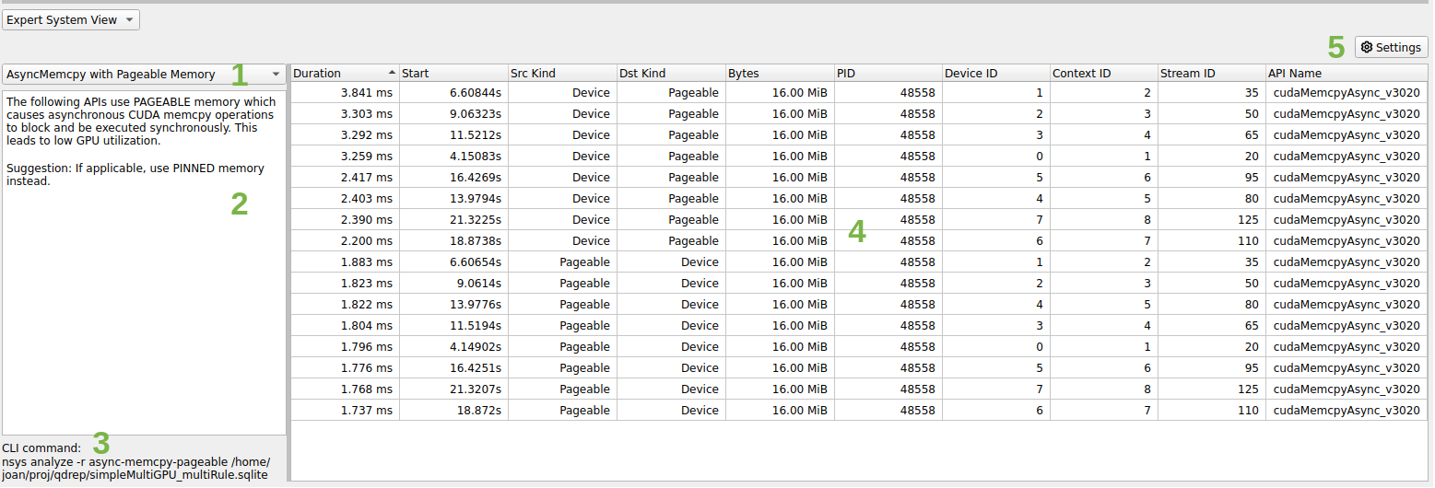
A context menu is available to correlate the table entry with the timeline. The options are the same as the Events View:
  - Zoom to Selected on Timeline (ctrl+double-click)
The highlighting is not supported for rules that do not return an event but rather an arbitrary time range (e.g. GPU utilization rules).
The CLI and GUI share the same rule scripts and messages. There might be some formatting differences between the output table in GUI and CLI.

Expert System Rules
Rules are scripts that run on the SQLite DB output from Nsight Systems to find common improvable usage patterns.
Each rule has an advice summary with explanation of the problem found and suggestions to address it. Only the top 50 results are displayed by default.
There are currently six rules in the expert system. They are described below. Additional rules will be made available in a future version of Nsight Systems.

CUDA Synchronous Operation Rules

Asynchronous memcpy with pageable memory
This rule identifies asynchronous memory transfers that end up becoming synchronous if the memory is pageable. This rule is not applicable for Nsight Systems Embedded Platforms Edition
Suggestion: If applicable, use pinned memory instead

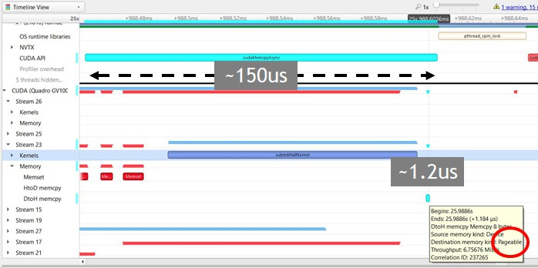

Synchronous Memcpy
This rule identifies synchronous memory transfers that block the host. Suggestion: Use cudaMemcpy*Async APIs instead.

Synchronous Memset
This rule identifies synchronous memset operations that block the host. Suggestion: Use cudaMemset*Async APIs instead.

Synchronization APIs
This rule identifies synchronization APIs that block the host until all issued CUDA calls are complete.
Suggestions: Avoid excessive use of synchronization. Use asynchronous CUDA event calls, such as cudaStreamWaitEvent and cudaEventSynchronize, to prevent host synchronization.

GPU Low Utilization Rules
Nsight Systems determines GPU utilization based on API trace data in the collection. Current rules consider CUDA, Vulkan, DX12, and OpenGL API use of the GPU.

GPU Starvation
This rule identifies time ranges where a GPU is idle for longer than 500ms. The threshold is adjustable.
Suggestions: Use CPU sampling data, OS Runtime blocked state backtraces, and/or OS Runtime APIs related to thread synchronization to understand if a sluggish or blocked CPU is causing the gaps. Add NVTX annotations to CPU code to understand the reason behind the gaps.
Notes:

  - For each process, each GPU is examined, and gaps are found within the time range that starts with the beginning of the first GPU operation on that device and ends with the end of the last GPU operation on that device.
  - GPU gaps that cannot be addressed by the user are excluded. This includes:
    - Profiling overhead in the middle of a GPU gap.
    - The initial gap in the report that is seen before the first GPU operation.
    - The final gap that is seen after the last GPU operation.

GPU Low Utilization
This rule identifies time regions with low utilization.
Suggestions: Use CPU sampling data, OS Runtime blocked state backtraces, and/or OS Runtime APIs related to thread synchronization to understand if a sluggish or blocked CPU is causing the gaps. Add NVTX annotations to CPU code to understand the reason behind the gaps.
Notes:
  - For each process, each GPU is examined, and gaps are found within the time range that starts with the beginning of the first GPU operation on that device and ends with the end of the last GPU operation on that device. This time range is then divided into equal chunks, and the GPU utilization is calculated for each chunk. The utilization includes all GPU operations as well as profiling overheads that the user cannot address.
  - The utilization refers to the "time" utilization and not the "resource" utilization. This rule attempts to find time gaps when the GPU is or isn't being used, but does not take into account how many GPU resources are being used. Therefore, a single running memcpy is considered the same amount of "utilization" as a huge kernel that takes over all the cores. If multiple operations run concurrently in the same chunk, their utilization will be added up and may exceed 100%.
  - Chunks with an in-use percentage less than the threshold value are displayed.
If consecutive chunks have a low in-use percentage, the individual chunks are coalesced into a single display record, keeping the weighted average of percentages. This is why returned chunks may have different durations.

Other Rules

DX12 Memory Operations
This rule identifies memory operations with the following warnings:
  - HEAP_CREATED_WITH_ZEROING: ID3D12Heap object created with zeroing. Add D3D12_HEAP_FLAG_CREATE_NOT_ZEROED to pDesc->Flags to avoid overhead of zeroing.
  - COMMITTED_RESOURCE_CREATED_WITH_ZEROING:
Committed ID3D12Resource object created with zeroing. Add D3D12_HEAP_FLAG_CREATE_NOT_ZEROED to HeapFlags to avoid overhead of zeroing.

  - NONEMPTY_MAP_FROM_UPLOAD_HEAP: Non-empty ID3D12Resource::Map from upload heap. Upload heaps are not optimized for reading data back to the CPU.
  - NONEMPTY_MAP_TO_WRITE_COMBINE_PAGE: Non-empty
ID3D12Resource::Map to write-combine CPU page. Write-combine pages are not optimized for reading data back from the GPU.
  - NONEMPTY_UNMAP_TO_READBACK_HEAP: Non-empty
ID3D12Resource::Unmap to readback heap. Readback heaps are not optimized for uploading data from the CPU.
  - NONEMPTY_UNMAP_FROM_WRITE_BACK_PAGE: Non-empty
ID3D12Resource::Unmap from write-back CPU page. Write-back pages are not optimized for uploading data to the GPU.
  - READ_FROM_UPLOAD_HEAP_SUBRESOURCE:
ID3D12Resource::ReadFromSubresource from upload heap. Upload heaps are not optimized for reading data back to the CPU.
  - READ_FROM_SUBRESOURCE_TO_WRITE_COMBINE_PAGE:
ID3D12Resource::ReadFromSubresource to write-combine CPU page. Write- combine pages are not optimized for reading data back from the GPU.
  - WRITE_TO_READBACK_HEAP_SUBRESOURCE:
ID3D12Resource::WriteToSubresource to readback heap. Readback heaps are not optimized for uploading data from the CPU.
  - WRITE_TO_SUBRESOURCE_FROM_WRITE_BACK_PAGE:
ID3D12Resource::WriteToSubresource from write-back CPU page. Write-back pages are not optimized for uploading data to the GPU.

Multi-Report Analysis

PREVIEW FEATURE
Nsight Systems Multi-Report Analysis is new functionality that is being added to the Nsight Systems tool to better support complex statistical analysis across multiple result files. Possible use cases for this functionality include:
- Multi-Node Analysis - When you run Nsight Systems across a cluster, it typically generates one result file per rank on the cluster. While you can load multiple result files into the GUI for visualization, this analysis system allows you to run statistical analysis across all of the result files.
- Multi-Pass Analysis - Some features in Nsight Systems cannot be run together due to overhead or hardware considerations. For example, there are frequently more CPU performance counters available than your CPU has registers. Using this analysis, you could run multiple runs with different sets of counters and then analyze the results together.
- Multi-Run Analysis - Sometimes you want to compare two runs that were not taken at the same time together. Perhaps you ran the tool on two different hardware configurations and want to see what changed. Perhaps you are doing regression testing or performance improvement analysis and want to check your status. Comparing those result files statistically can show patterns.

Analysis Steps

Prior to using multi- report

Note:
analysis, please make sure that
you have installed all required
dependencies. See
Installing Multi- Report Analysis System in
the Installation Guide
for more
information.

- Generate the reports - Generate the reports as you always have, in fact, you can use reports that you have generated previously.
- Set up - Choose the recipe (See Available Recipes, below), give it any required parameters, and run.
- Launch Analysis - Nsight Systems will run the analysis, using your local system or Dask, as you have selected.
- Output - the output is an .nsys-analysis file, which can then be opened within the Nsight Systems GUI.
- View the data - depending on your recipe, you can have any number of visualizations, from simple tabular information to Jupyter notebooks which can be opened inside the GUI.

Available Recipes
All recipes are run using the new "recipe" CLI command switch. usage:
nsys recipe [args] <recipe-name> [recipe args]
Nsight Systems provides several initial analysis recipes, mostly based around making our existing statistics and expert systems rules run multi-report.

These recipes can be found at <target-linux-x64>/python/packages/ nsys_recipe. They are written in Python, and you can edit them if you would like. However, be advised that as this is a preview release, it is likely that the APIs will change between now and the final release. Additional recipes will be added before the product release and on an ongoing basis.

Statistics and Expert Systems Recipes
The following stats and expert systems options from Nsight Systems are available as recipes. For more information about them please use nsys recipe [recipe name]
-–help or see Nsight Systems Report Scripts in this documentation
- cuda_api_sum -- CUDA API Summary
- cuda_api_sync -- CUDA Synchronization APIs
- cuda_gpu_kern_sum -- CUDA GPU Kernel Summary
- cuda_gpu_mem_size_sum -- CUDA GPU MemOps Summary (by Size)
- cuda_gpu_mem_time_sum -- CUDA GPU MemOps Summary (by Time)
- cuda_memcpy_async -- CUDA Async Memcpy with Pageable Memory
- cuda_memcpy_sync -- CUDA Synchronous Memcpy
- cuda_memset_sync -- CUDA Synchronous Memset
- dx12_mem_ops -- DX12 Memory Operations
- gpu_gaps -- GPU Gaps
- gpu_time_util -- GPU Time Utilization
- nvtx_gpu_proj_trace -- NVTX GPU Trace
- nvtx_sum -- NVTX Range Summary
- osrt_sum -- OS Runtime Summary
Please note that all recipes are in the form of python scripts. You may alter the given recipes or write your own to meet your needs. Refer to Tutorial: Create a User-Defined Recipe for an example of how to do this

Heatmap Recipes
- cuda_gpu_time_util_map -- CUDA GPU Kernel Time Utilization Heatmap
- gpu_metric_util_map -- GPU Metric Utilization Heatmap

Both recipes generate a Jupyter notebook with code cells ready to plot the heatmap chart:
cuda_gpu_time_util_map -- CUDA GPU Kernel Time Utilization Heatmap
$ nsys recipe cuda_gpu_time_util_map --help
usage: cuda_gpu_time_util_map.py [-h] [--output OUTPUT] [--force-overwrite]
[--start time] [--end time]
[--nvtx range[@domain]] [--rows limit] [--bins BINS] --dir DIR
[--mode {none,concurrent,dask-futures}]
This recipe calculates the percentage of GPU utilization based on the presence of CUDA kernels. Note that the utilization refers to the "time" utilization and not the "resource" utilization. If multiple kernels run concurrently, their utilization will be added up and may exceed 100%.
options:
-h, --help show this help message and exit
Context:
--mode {none,concurrent,dask-futures}
Mode to run tasks
Recipe:
--output OUTPUT Output directory name
--force-overwrite Overwrite existing directory
--start time Start time used for filtering in nanoseconds
--end time End time used for filtering in nanoseconds
--nvtx range[@domain]
NVTX range and domain used for filtering
--rows limit Maximum number of rows per input file
--bins BINS Number of bins
--dir DIR Directory of nsys-rep files
gpu_metric_util_map -- GPU Metric Utilization Heatmap
$ nsys recipe gpu_metric_util_map --help
usage: gpu_metric_util_map.py [-h] [--output OUTPUT] [--force-overwrite]
[--start time] [--end time]
[--nvtx range[@domain]] [--rows limit] [--bins BINS] --dir DIR
[--mode {none,concurrent,dask-futures}]
This recipe calculates the percentage of SM Active, SM Issue, and Tensor Active metrics.
options:
-h, --help
show this help message and exit
Context:
--mode {none,concurrent,dask-futures}
Mode to run tasks
Recipe:
--output OUTPUT
--force-overwrite
--start time
--end time
--nvtx range[@domain]
--rows limit
--bins BINS
--dir DIR
Output directory name Overwrite existing directory
Start time used for filtering in nanoseconds End time used for filtering in nanoseconds
NVTX range and domain used for filtering Maximum number of rows per input file Number of bins
Directory of nsys-rep files

Pacing Recipes
- cuda_gpu_kern_pace -- CUDA GPU Kernel Pacing
- nvtx_pace -- NVTX Pacing
Both recipes generate a Jupyter notebook with code cells ready to plot various graphs showing the progress of the target operation/range for each rank:
cuda_gpu_kern_pace -- CUDA GPU Kernel Pacing
$ nsys recipe cuda_gpu_kern_pace --help
usage: cuda_gpu_kern_pace.py [-h] [--output OUTPUT] [--force-overwrite] --name
NAME --dir DIR
[--mode {none,concurrent,dask-futures}]
This recipe investigates the progress and consistency of an iteration based application.
optional arguments:
-h, --help show this help message and exit
Context:
--mode {none,concurrent,dask-futures}
Mode to run tasks
Recipe:
--output OUTPUT Output directory name
--force-overwrite Overwrite existing directory
--name NAME Name of the kernel used as delineator between
iterations
--dir DIR Directory of nsys-rep files
nvtx_pace -- NVTX Pacing
$ nsys recipe nvtx_pace --help
usage: nvtx_pace.py [-h] [--output OUTPUT] [--force-overwrite] [--gpu] --name NAME --dir DIR [--mode {none,concurrent,dask-futures}]
This recipe investigates the progress and consistency of an iteration based application.
optional arguments:
-h, --help
show this help message and exit
Context:
--mode {none,concurrent,dask-futures}
Mode to run tasks
Recipe:
--output OUTPUT
--force-overwrite
--gpu
--name NAME
--dir DIR
Output directory name Overwrite existing directory GPU projection
Name of the NVTX range used as delineator between iterations
Directory of nsys-rep files

Additional Statistics Recipes
- mpi_sum -- MPI Summary
- nccl_sum -- NCCL Summary
- nvtx_gpu_proj_sum -- NVTX GPU Projection Summary

All recipes generate a Jupyter notebook with code cells ready to plot various statistical graphs:
mpi_sum -- MPI Summary
$ nsys recipe mpi_sum --help
usage: mpi_sum.py [-h] [--output OUTPUT] [--force-overwrite] --dir DIR [--mode {none,concurrent,dask-futures}]
This recipe provides a summary of MPI functions and their execution times. optional arguments:
-h, --help show this help message and exit
Context:
--mode {none,concurrent,dask-futures}
Mode to run tasks
Recipe:
--output OUTPUT
--force-overwrite
--dir DIR
Output directory name Overwrite existing directory Directory of nsys-rep files
nccl_sum -- NCCL Summary
$ nsys recipe nccl_sum --help
usage: nccl_sum.py [-h] [--output OUTPUT] [--force-overwrite] [--gpu] --dir DIR [--mode {none,concurrent,dask-futures}]
This recipe provides a summary of NCCL functions and their execution times. optional arguments:
-h, --help show this help message and exit
Context:
--mode {none,concurrent,dask-futures}
Mode to run tasks
Recipe:
--output OUTPUT
--force-overwrite
--gpu
--dir DIR
Output directory name Overwrite existing directory GPU projection
Directory of nsys-rep files
nvtx_gpu_proj_sum -- NVTX GPU Projection Summary
$ nsys recipe nvtx_gpu_proj_sum --help
usage: nvtx_gpu_proj_sum.py [-h] [--output OUTPUT] [--force-overwrite] [--gpu]
--dir DIR [--mode {none,concurrent,dask-futures}]
This recipe provides a summary of NVTX time ranges projected from the CPU onto the GPU, and their execution times.
optional arguments:
-h, --help show this help message and exit
Context:
--mode {none,concurrent,dask-futures}
Mode to run tasks
Recipe:
--output OUTPUT
--force-overwrite
--gpu
--dir DIR
Output directory name Overwrite existing directory GPU projection
Directory of nsys-rep files

Opening in Jupyter Notebook
Running the recipe command creates a new analysis file (.nsys-analysis). Open the Nsight Systems GUI and select File->Open, and pick your file.
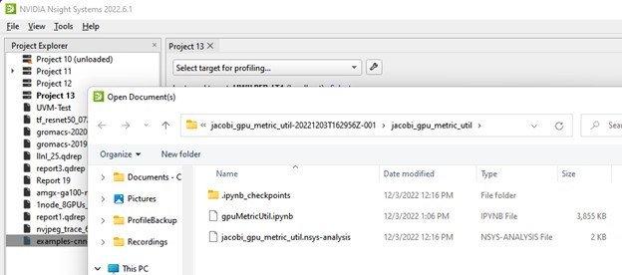
Open the folder icon and click on the notebook icon to open the Jupyter notebook.
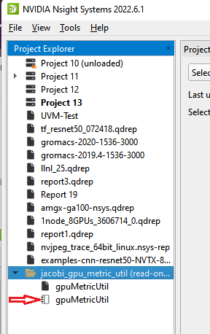

Run the Jupyter notebook:
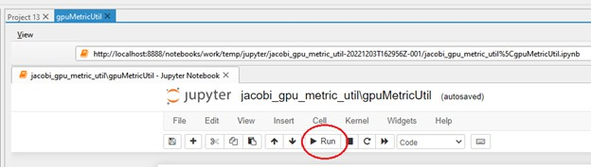
And the output appears on-screen. In this case a heat map of activity running a Jacobi solver.
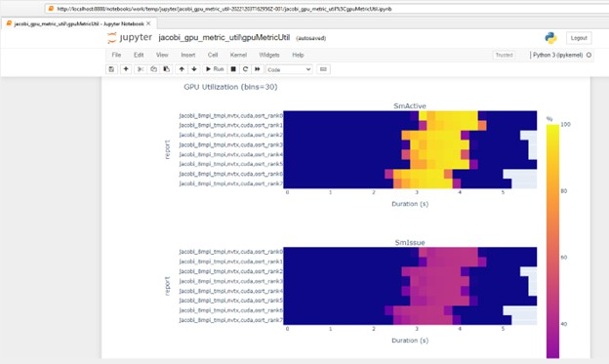

Configuring Dask
The multi-report analysis system does not offer options to configure the Dask environment. However, you could achieve this by modifying the recipe script directly or using one of the following from Dask’s configuration system:
- YAML files: Dask by default searches for all YAML files in ~/.config/dask/ or
/etc/dask/. This search path can be changed using the environment variable DASK_ROOT_CONFIG or DASK_CONFIG. See Dask documentation for the complete list of locations and the lookup order. Example:
$ cat example.yaml 'Distributed':
'scheduler':
'allowed-failures': 5

- Environment variables: Dask searches for all environment variables that start with DASK_, then transforms keys by converting to lower-case and changing double- underscores to nested structures. See Dask documentation for the complete list of variables. Example:
DASK_DISTRIBUTED SCHEDULER ALLOWED_FAILURES=5

Dask Client
With no configuration set, the dask-futures mode option initializes the Dask Client with the default arguments, which results in creating a LocalCluster in the background. The following are the YAML/environment variables that could be set to change the default behavior:
- distributed.comm.timeouts.connect /
DASK_DISTRIBUTED COMM TIMEOUTS CONNECT
- client-name / DASK_CLIENT_NAME
- scheduler-address / DASK_SCHEDULER_ADDRESS
- distributed.client.heartbeat / DASK_DISTRIBUTED CLIENT HEARTBEAT
- distributed.client.scheduler-info-interval /
DASK_DISTRIBUTED CLIENT SCHEDULER_INFO_INTERVAL
- distributed.client.preload / DASK_DISTRIBUTED CLIENT PRELOAD
- distributed.client.preload-argv / DASK_DISTRIBUTED CLIENT PRELOAD_ARGV

Recipe’s environment variables
Recipe has its own list of environment variables to make the configuration more complete and flexible. These environment variables are either missing from Dask’s configuration system or specific to the recipe system:
- NSYS_DASK_SCHEDULER_FILE: Path to a file with scheduler information. It will be used to initialize the Dask Client.
- NSYS_DIR: Path to the directory of Nsight Systems containing the target and host directories. The nsys executable and the recipe dependencies will be searched in this directory instead of the one deduced from the currently running recipe file path.

Tutorial: Create a User-Defined Recipe
The Nsight Systems recipe system is designed to be extensible and we hope that many users will use it to create their own recipes. This short tutorial will highlight the steps needed to create a recipe that is a customized version of one of the recipes that is included in the Nsight Systems recipe package.

Step 1: Create the recipe directory and script
Make a new directory in the <install-dir>/target-linux-x64/python/ packages/nsys_recipe folder based on the name of your new recipe. For this example, we will call our new recipe new_metrics_util_map. We will copy the existing gpu_metric_util_map.py script and create a new script called new_metrics_util_map.py

in the new_metrics_util_map directory. We will also copy the heatmap.ipynb file into the new_metrics_util_map directory. Type these steps in a Linux terminal window:
- cd <install-dir>/target-linux-x64/python/packages/nsys_recipe
- mkdir new_metrics_util_map
- cp gpu_metric_util_map/gpu_metric_util_map.py new_metrics_util_map/ new_metrics_util_map.py
- cp gpu_metric_util_map/heatmap.ipynb new_metrics_util_map/
Then open new_metrics_util_map.py in your editor and search and replace GpuMetric with NewMetrics. There will be three lines that need this change:
class GpuMetricUtilReport(nsysstats.Report):
class GpuMetricUtilMap(recipe.Recipe):
return helpers.stats_cls_to_df(sqlite_file, parsed_args, GpuMetricUtilReport)
Go ahead and do this search and replace to rename the classes now. We will discuss the detailed functionality of the new recipe code in the subsequent steps.

Step 2: Modify the mapper function
Many recipes are structured as a map-reduce algorithm. The mapper function is called for every .nsys-rep file in the report directory. The mapper function performs a series of calculations on the events in each Nsight Systems report and produces an intermediate data set. The intermediate results are then combined by the reduce function to produce the final results.The mapper function can be called in parallel, either on multiple cores of a single node (using the concurrent python module), or multiple ranks of a multi-node recipe analysis (using the Dask distributed module).
Most of the Recipe operations are defined in the Recipe class in the lib/recipe.py file. When we create a new recipe, we need to create a class that derives from recipe.Recipe. For our example, that class will be called NewMetricsUtilMap (which we had renamed in step 1).
The mapper function is called mapper_func() and is shown here:
@staticmethod
def mapper_func(nsysrep, parsed_args):
sqlite_file = helpers.nsysrep_to_sqlite(nsysrep) if sqlite_file is None:
return None
return helpers.stats_cls_to_df(
sqlite_file, parsed_args, NewMetricsUtilReport)
The call to nsysrep_to_sqlite() converts the .nsys-rep file into an SQLite database, if the SQLite file does not already exist.
The stats_cls_to_df() helper method takes the report class object and reads its SQL query into a Pandas DataFrame. All Stats report class are derived from the nsysstats.Report base class, that could be found in the <install-dir>/target-linux-x64/python/ lib/nsysstats.py file. This allows recipes to leverage the library of report analysis classes that were developed for the Nsight Systems Stats and Expert Systems analysis commands. In our example, the stats report class is called NewMetricsUtilReport and is defined at the top of our new_metrics_util_map.py file. (It is one of the other classes that we renamed in Step 1). We will modify the query in NewMetricsUtilReport in the next step.

Step 3: Modify the SQL Query
The mapper function for our recipe created a helper class called NewMetricsUtilReport to do the heavy lifting of extracting the GPU metrics events from the Nsight Systems report data (in the SQLite file). GPU Metric data is stored using a database schema table called GenericEvents. For extra flexibility, GenericEvents represents their data as a JSON object, which is stored as a string in the GenericEvent table. The NewMetricsUtilReport class contains an SQL query that extracts fields from the JSON object and accumulates them over the histogram bins of the heat map.
The original script retrieved three GPU metrics: SM Active, SM Issue, and Tensor Active. In our new version of the script, we will extract a fourth metric, Unallocated Warps in Active SMs.
- Find this line (approximately line 49):
CAST(JSON_EXTRACT(data, '$.SM Active') as INT) AS smActive,
Copy and paste it so it is in the file two times. Then change the first line so it extracts the Unallocated Warps in Active SMs field from the JSON event data:
CAST(JSON_EXTRACT(data, '$.Unallocated Warps in Active SMs') as INT) AS unallocatedWarp,
- Find this line (approximately line 86):
sum(CAST(min(metrics.end, bin.cend) - max(metrics.start, bin.cstart)
AS FLOAT) * smActive) / (bin.cend - bin.cstart) AS smActiveAverage,
Copy and paste it so it is in the file two times. Then change the first line to reference UnallocatedWarp. This line averages the metric value across the histogram bin of the heatmap. The new line will be:
sum(CAST(min(metrics.end, bin.cend) - max(metrics.start, bin.cstart)
AS FLOAT) * unallocatedWarp) / (bin.cend - bin.cstart) AS unallocatedWarpAverage,
- Find this line (approximately line 103):
round(smActiveAverage, 1) AS "SmActive",
Copy and paste it so that it is in the file two times. Then change the first line to reference UnallocatedWarp. The new line will be:
round(unallocatedWarpAverage, 1) AS "UnallocatedWarp",
This completes the changes to the data extraction query in the helper class for the mapper function.
Please note that all copy and paste operations in this step requested that the new unallocatedWarp field be added on the first line (of the two duplicate lines). This means it will be the first of the four metrics returned by the query. This is important when we update the reduce function in the next step.

Step 4: Modify the reduce function

Our new mapper function will extract four GPU metrics and return them as a Pandas DataFrame. The reduce function receives a list of DataFrames, one for each .nsys-rep in the analysis, and combines them into a single dataframe using the Pandas concat function. We need to make one change to the reduce function to label our new data column. Because we added UnallocatedWarp as the first metric of the four that were returned by the mapper query, we need to add it as the first of the four metric columns in the DataFrame, right after Duration and before SmActive. The new reducer function should look like this:
def reducer_func(self, dfs):
dfs = helpers.filter_none(dfs) df = pd.concat(dfs)
df = df[['Duration', 'UnallocatedWarp', 'SmActive', 'SmIssue', 'TensorActive', 'GPU', 'Report']]
df.to_parquet(self.add_output_file('analysis.parquet'))

Step 5: Add a plot to the Jupyter notebook
Our new recipe class will create a Parquet output file with all the data produced by the reducer function, using the to_parquet() function. It will also create a Jupyter notebook file using the create_notebook() function.
In this step, we will change the create_notebook() function to produce a plot for our fourth metric. To do this, we need to change these two lines (located in the second cell of new_metrics_util_map/heatmap.ipynb):
metrics = ('SmActive', 'SmIssue', 'TensorActive') fig = make_subplots(3, 1, subplot_titles=metrics)
To this:
metrics = (‘UnallocatedWarp’, 'SmActive', 'SmIssue', 'TensorActive') fig = make_subplots(4, 1, subplot_titles=metrics)
That completes all the modifications for our NewRecipeUtilMap class.

Step 6: Add the new recipe to the nsys_recipe module
The final step is to add this new recipe to the nsys_recipe module. This will allow Nsight Systems to find the recipe when you run the nsys recipe new_recipe_util_map command.
Open the init .py file for the nsys_recipe module, which is located in the nsys_recipe directory (the parent to our NewMetricsUtilMap directory.
Copy and paste the last line of the init .py file so there are two copies of the line:
from nsys_recipe.gpu_metric_util_map.gpu_metric_util_map import GpuMetricUtilMap
Edit one of the copies so that it refers to our new recipe class. The new line should look like this:
from nsys_recipe.new_metrics_util_map.new_metrics_util_map import NewMetricsUtilMap
That’s it! We are done with the code for our new recipe.

Step 7: Run the new recipe
We can run our new recipe using the nsys recipe command, like this:
- nsys recipe new_metrics_util_map --dir <directory of reports>
When successful, the recipe should produce a new recipe result directory called new_metrics_util_map-1.
If we open the Jupyter notebook in that recipe and execute the code, we should see our new heatmap along with the three plots produced by the original version of the recipe. Here is an example:
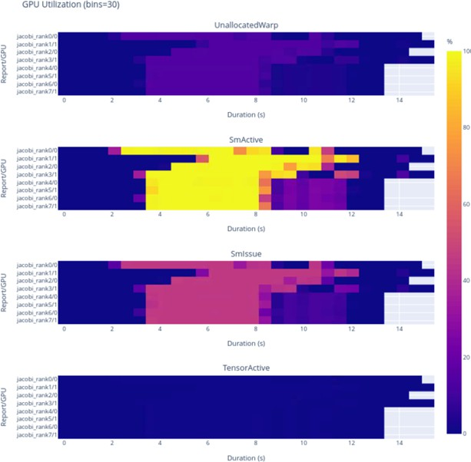

Chapter 25. IMPORT NVTXT

ImportNvtxt is an utility which allows conversion of a NVTXT file to a Nsight Systems report file (*.nsys-rep) or to merge it with an existing report file.
Note: NvtxtImport supports custom TimeBase values. Only these values are supported:
- Manual — timestamps are set using absolute values.
- Relative — timestamps are set using relative values with regards to report file which is being merged with nvtxt file.
- ClockMonotonicRaw — timestamps values in nvtxt file are considered to be gathered on the same target as the report file which is to be merged with nvtxt using clock_gettime(CLOCK_MONOTONIC_RAW, ...) call.
- CNTVCT — timestamps values in nvtxt file are considered to be gathered on the same target as the report file which is to be merged with nvtxt using CNTVCT values.
You can get usage info via help message:
Print help message:
-h [ --help ]
Show information about report file:
--cmd info -i [--input] arg
Create report file from existing nvtxt file:
--cmd create -n [--nvtxt] arg -o [--output] arg [-m [--mode] mode_name mode_args] [--target <Hw:Vm>] [--update_report_time]
Merge nvtxt file to existing report file:
--cmd merge -i [--input] arg -n [--nvtxt] arg -o [--output] arg [-m [--mode] mode_name mode_args] [--target <Hw:Vm>] [--update_report_time]
Modes description:
- lerp - Insert with linear interpolation
--mode lerp --ns_a arg --ns_b arg [--nvtxt_a arg --nvtxt_b arg]
- lin - insert with linear equation
--mode lin --ns_a arg --freq arg [--nvtxt_a arg]
Modes' parameters:

- ns_a - a nanoseconds value
- ns_b - a nanoseconds value (greater than ns_a)
- nvtxt_a - an nvtxt file's time unit value corresponding to ns_a nanoseconds
- nvtxt_b - an nvtxt file's time unit value corresponding to ns_b nanoseconds
- freq - the nvtxt file's timer frequency
- --target <Hw:Vm> - specify target id, e.g. --target 0:1
- --update_report_time - prolong report's profiling session time while merging if needed. Without this option all events outside the profiling session time window will be skipped during merging.

Commands

Info
To find out report's start and end time use info command. Usage:
ImportNvtxt --cmd info -i [--input] arg
Example:
ImportNvtxt info Report.nsys-rep Analysis start (ns) 83501026500000 Analysis end (ns) 83506375000000

Create
You can create a report file using existing NVTXT with create command. Usage:
ImportNvtxt --cmd create -n [--nvtxt] arg -o [--output] arg [-m [--mode] mode_name mode_args]
Available modes are:
- lerp — insert with linear interpolation.
- lin — insert with linear equation. Usage for lerp mode is:
--mode lerp --ns_a arg --ns_b arg [--nvtxt_a arg --nvtxt_b arg]
with:
- ns_a — a nanoseconds value.
- ns_b — a nanoseconds value (greater than ns_a).
- nvtxt_a — an nvtxt file's time unit value corresponding to ns_a nanoseconds.
- nvtxt_b — an nvtxt file's time unit value corresponding to ns_b nanoseconds.
If nvtxt_a and nvtxt_b are not specified, they are respectively set to nvtxt file's minimum and maximum time value.
Usage for lin mode is:
--mode lin --ns_a arg --freq arg [--nvtxt_a arg]
with:

- ns_a — a nanoseconds value.
- freq — the nvtxt file's timer frequency.
- nvtxt_a — an nvtxt file's time unit value corresponding to ns_a nanoseconds. If nvtxt_a is not specified, it is set to nvtxt file's minimum time value.

Examples:
ImportNvtxt --cmd create -n Sample.nvtxt -o Report.nsys-rep
The output will be a new generated report file which can be opened and viewed by Nsight Systems.

Merge
To merge NVTXT file with an existing report file use merge command. Usage:
ImportNvtxt --cmd merge -i [--input] arg -n [--nvtxt] arg -o [--output] arg [-m [--mode] mode_name mode_args]
Available modes are:
- lerp — insert with linear interpolation.
- lin — insert with linear equation. Usage for lerp mode is:
--mode lerp --ns_a arg --ns_b arg [--nvtxt_a arg --nvtxt_b arg]
with:
- ns_a — a nanoseconds value.
- ns_b — a nanoseconds value (greater than ns_a).
- nvtxt_a — an nvtxt file's time unit value corresponding to ns_a nanoseconds.
- nvtxt_b — an nvtxt file's time unit value corresponding to ns_b nanoseconds.
If nvtxt_a and nvtxt_b are not specified, they are respectively set to nvtxt file's minimum and maximum time value.
Usage for lin mode is:
--mode lin --ns_a arg --freq arg [--nvtxt_a arg]
with:
- ns_a — a nanoseconds value.
- freq — the nvtxt file's timer frequency.
- nvtxt_a — an nvtxt file's time unit value corresponding to ns_a nanoseconds. If nvtxt_a is not specified, it is set to nvtxt file's minimum time value.
Time values in <filename.nvtxt> are assumed to be nanoseconds if no mode specified.
Example
ImportNvtxt --cmd merge -i Report.nsys-rep -n Sample.nvtxt -o NewReport.nsys-rep

Chapter 26.
VISUAL STUDIO INTEGRATION

NVIDIA Nsight Integration is a Visual Studio extension that allows you to access the power of Nsight Systems from within Visual Studio.
When Nsight Systems is installed along with NVIDIA Nsight Integration, Nsight Systems activities will appear under the NVIDIA Nsight menu in the Visual Studio menu bar. These activities launch Nsight Systems with the current project settings and executable.
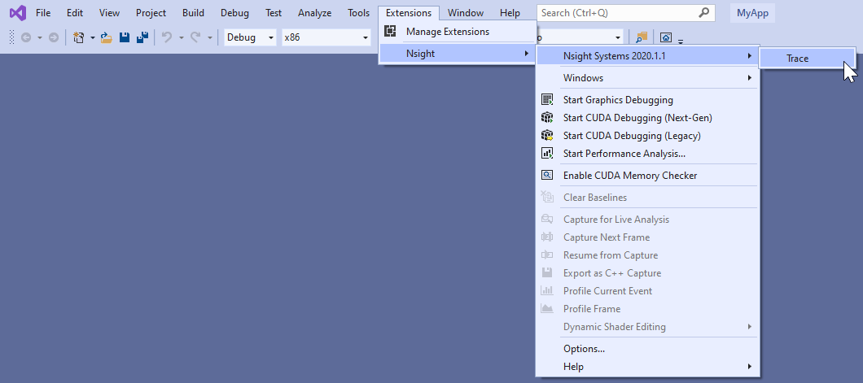
Selecting the "Trace" command will launch Nsight Systems, create a new Nsight Systems project and apply settings from the current Visual Studio project:
- Target application path
- Command line parameters
- Working folder
If the "Trace" command has already been used with this Visual Studio project then Nsight Systems will load the respective Nsight Systems project and any previously captured trace sessions will be available for review using the Nsight Systems project explorer tree.

Visual Studio Integration

For more information about using Nsight Systems from within Visual Studio, please visit
- NVIDIA Nsight Integration Overview
- NVIDIA Nsight Integration User Guide

Chapter 27. TROUBLESHOOTING

General Troubleshooting

Profiling
If the profiler behaves unexpectedly during the profiling session, or the profiling session fails to start, try the following steps:
    - Close the host application.
    - Restart the target device.
    - Start the host application and connect to the target device.
Nsight Systems uses a settings file (NVIDIA Nsight Systems.ini) on the host to store information about loaded projects, report files, window layout configuration, etc. Location of the settings file is described in the Help → About dialog. Deleting the
settings file will restore Nsight Systems to a fresh state, but all projects and reports will disappear from the Project Explorer.

Environment Variables
By default, Nsight Systems writes temporary files to /tmp directory. If you are using a system that does not allow writing to /tmp or where the /tmp directory has limited storage you can use the TMPDIR environment variable to set a different location. An example:
TMPDIR=/testdata ./bin/nsys profile -t cuda matrixMul
Environment variable control support for Windows target trace is not available, but there is a quick workaround:
    - Create a batch file that sets the env vars and launches your application.
    - Set Nsight Systems to launch the batch file as its target, i.e. set the project settings target path to the path of batch file.
    - Start the trace. Nsight Systems will launch the batch file in a new cmd instance and trace any child process it launches. In fact, it will trace the whole process tree whose root is the cmd running your batch file.

WebGL Testing
Nsight Systems cannot profile using the default Chrome launch command. To profile WebGL please follow the following command structure:
“C:\Program Files (x86)\Google\Chrome\Application\chrome.exe”
--inprocess-gpu --no-sandbox --disable-gpu-watchdog --use-angle=gl https://webglsamples.org/aquarium/aquarium.html

Common Issues with QNX Targets
    - Make sure that tracelogger utility is available and can be run on the target.
    - Make sure that /tmp directory is accessible and supports sub-directories.
    - When switching between Nsight Systems versions, processes related to the previous version, including profiled applications forked by the daemon, must be killed before the new version is used. If you experience issues after switching between Nsight Systems versions, try rebooting the target.

CLI Troubleshooting
If you have collected a report file using the CLI and the report will not open in the GUI, check to see that your GUI version is the same or greater than the CLI version you used. If it is not, download a new version of the Nsight Systems GUI and you will be able to load and visualize your report.
This situation occurs most frequently when you update Nsight Systems using a CLI only package, such as the package available from the NVIDIA HPC SDK.

Launch Processes in Stopped State
In many cases, it is important to profile an application from the very beginning of its execution. When launching processes, Nsight Systems takes care of it by making sure that the profiling session is fully initialized before making the exec() system call on Linux.
If the process launch capabilities of Nsight Systems are not sufficient, the application should be launched manually, and the profiler should be configured to attach to the already launched process. One approach would be to call sleep() somewhere early in the application code, which would provide time for the user to attach to the process in Nsight Systems Embedded Platforms Edition, but there are two other more convenient mechanisms that can be used on Linux, without the need to recompile the application. (Note that the rest of this section is only applicable to Linux-based target devices.)
Both mechanisms ensure that between the time the process is created (and therefore its PID is known) and the time any of the application's code is called, the process is stopped and waits for a signal to be delivered before continuing.

LD_PRELOAD
The first mechanism uses LD_PRELOAD environment variable. It only works with dynamically linked binaries, since static binaries do not invoke the runtime linker, and therefore are not affected by the LD_PRELOAD environment variable.
    - For ARMv7 binaries, preload
/opt/nvidia/nsight_systems/libLauncher32.so
    - Otherwise if running from host, preload
/opt/nvidia/nsight_systems/libLauncher64.so
    - Otherwise if running from CLI, preload
[installation_directory]/libLauncher64.so
The most common way to do that is to specify the environment variable as part of the process launch command, for example:
$ LD_PRELOAD=/opt/nvidia/nsight_systems/libLauncher64.so ./my-aarch64-binary -- arguments
When loaded, this library will send itself a SIGSTOP signal, which is equivalent to typing Ctrl+Z in the terminal. The process is now a background job, and you can use standard commands like jobs, fg and bg to control them. Use jobs -l to see the PID of the launched process.
When attaching to a stopped process, Nsight Systems will send SIGCONT signal, which is equivalent to using the bg command.

Launcher
The second mechanism can be used with any binary. Use
[installation_directory]/launcher to launch your application, for example:
$ /opt/nvidia/nsight_systems/launcher ./my-binary --arguments
The process will be launched, daemonized, and wait for SIGUSR1 signal. After attaching to the process with Nsight Systems, the user needs to manually resume execution of the process from command line:
$ pkill -USR1 launcher

Note:
Note that pkill will send the signal to
any process with the
matching name.
If that

is not
desirable, use
kill to send it
to a
specific process. The standard output and error streams are
redirected to
/ tmp/
stdout_<PID>.t
and
/ tmp/
stderr_<PID>.t

The launcher mechanism is more complex and less automated than the LD_PRELOAD option, but gives more control to the user.

GUI Troubleshooting
If opening the Nsight Systems Linux GUI fails with one of the following errors, you may be missing some required libraries:
This application failed to start because it could not find or load the Qt platform plugin "xcb" in "". Available platform plugins are: xcb. Reinstalling the application may fix this problem.
or
error while loading shared libraries: [library_name]: cannot open shared object file: No such file or directory

Ubuntu 18.04/20.04/22.04 and CentOS 7/8/9 with root privileges
    - Launch the following command, which will install all the required libraries in system directories:
[installation_path]/host-linux-[arch]/Scripts/DependenciesInstaller/install- dependencies.sh
    - Launch the Linux GUI as usual.

Ubuntu 18.04/20.04/22.04 and CentOS 7/8/9 without root privileges
    - Choose the directory where dependencies will be installed (dependencies_path). This directory should be writeable for the current user.
    - Launch the following command (if it has already been run, move to the next step), which will install all the required libraries in [dependencies_path]:
[installation_path]/host-linux-[arch]/Scripts/DependenciesInstaller/install- dependencies-without-root.sh [dependencies_path]
    - Further, use the following command to launch the Linux GUI:
source [installation_path]/host-linux-[arch]/Scripts/DependenciesInstaller/ setup-dependencies-environment.sh [dependencies_path] &&
[installation_path]/host-linux-x64/nsys-ui

Other platforms, or if the previous steps did not help
Launch Nsight Systems using the following command line to determine which libraries are missing and install them.
$ QT_DEBUG_PLUGINS=1 ./nsys-ui
If the workload does not run when launched via Nsight Systems or the timeline is empty, check the stderr.log and stdout.log (click on drop-down menu showing Timeline View and click on Files) to see the errors encountered by the app.
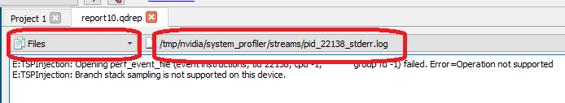

Symbol Resolution
If stack trace information is missing symbols and you have a symbol file, you can manually re-resolve using the ResolveSymbols utility. This can be done by right-clicking the report file in the Project Explorer window and selecting "Resolve Symbols...".
Alternatively, you can find the utility as a separate executable in the [installation_path]\Host directory. This utility works with ELF format files, with Windows PDB directories and symbol servers, or with files where each line is in the format <start><length><name>.

Short | Long | Argument | Description
-h | --help |  | Help message providing information about available options.

<SymbolServ
Short | Long | Argument | Description
-l | --process-list |  | Print global process IDs list
-s | --sym-file | filename | Path to symbol file
-b | --base-addr | address | If set then <start> in symbol file is treated as relative address starting from this base address
-p | --global-pid | pid | Which process in the report should be resolved. May be omitted if there is only one process in the report.
-f | --force |  | This option forces use of a given symbol file.
-i | --report | filename | Path to the report with unresolved symbols.
-o | --output | filename | Path and name of the output file. If it is omitted then "resolved" suffix is added to the original filename.
-d | --directories | directory paths | List of symbol folder paths, separated  by semi-colon characters. Available only on Windows.
-v | --servers | server URLs | List of symbol servers that uses the same format as  _NT_SYMBOL_PATH  environment variable, i.e. srv*<LocalStore>* Available only on Windows.

Short | Long | Argument | Description
-n | --ignore-nt-sym- path |  | Ignore the symbol locations stored in the  _NT_SYMBOL_PATH  environment variable. Available only on Windows.

Broken Backtraces on Tegra
In Nsight Systems Embedded Platforms Edition, in the symbols table there is a special entry called Broken backtraces. This entry is used to denote the point in the call chain where the unwinding algorithms used by Nsight Systems could not determine what is the next (caller) function.
Broken backtraces happen because there is no information related to the current function that the unwinding algorithms can use. In the Top-Down view, these functions are immediate children of the Broken backtraces row.
One can eliminate broken backtraces by modifying the build system to provide at least one kind of unwind information. The types of unwind information, used by the algorithms in Nsight Systems, include the following:
For ARMv7 binaries:
- DWARF information in ELF sections: .debug_frame, .zdebug_frame, .eh_frame,
.eh_frame_hdr. This information is the most precise. .zdebug_frame is a compressed version of .debug_frame, so at most one of them is typically present.
.eh_frame_hdr is a companion section for .eh_frame and might be absent.
Compiler flag: -g.
- Exception handling information in EHABI format provided in .ARM.exidx and
.ARM.extab ELF sections. .ARM.extab might be absent if all information is compact enough to be encoded into .ARM.exidx.
Compiler flag: -funwind-tables.
- Frame pointers (built into the .text section). Compiler flag: -fno-omit-frame-pointer.
For Aarch64 binaries:
- DWARF information in ELF sections: .debug_frame, .zdebug_frame, .eh_frame,
.eh_frame_hdr. See additional comments above.
Compiler flag: -g.
- Frame pointers (built into the .text section). Compiler flag: -fno-omit-frame-pointer.

The following ELF sections should be considered empty if they have size of 4 bytes:
.debug_frame, .eh_frame, .ARM.exidx. In this case, these sections only contain termination records and no useful information.
For GCC, use the following compiler invocation to see which compiler flags are enabled in your toolchain by default (for example, to check if -funwind-tables is enabled by default):
$ gcc -Q --help=common
For GCC and Clang, add -### to the compiler invocation command to see which compiler flags are actually being used.
Since EHABI and DWARF information is compiled on per-unit basis (every .cpp or
.c file, as well as every static library, can be built with or without this information), presence of the ELF sections does not guarantee that every function has necessary unwind information.
Frame pointers are required by the Aarch64 Procedure Call Standard. Adding frame pointers slows down execution time, but in most cases the difference is negligible.

Debug Versions of ELF Files
Often, after a binary is built, especially if it is built with debug information (-g compiler flag), it gets stripped before deploying or installing. In this case, ELF sections that contain useful information, such as non-export function names or unwind information, can get stripped as well.
One solution is to deploy or install the original unstripped library instead of the stripped one, but in many cases this would be inconvenient. Nsight Systems can use missing information from alternative locations.
For target devices with Ubuntu, see Debug Symbol Packages. These packages typically install debug ELF files with /usr/lib/debug prefix. Nsight Systems can find debug libraries there, and if it matches the original library (e.g., the built-in BuildID is the same), it will be picked up and used to provide symbol names and unwind information.
Many packages have debug companions in the same repository and can be directly installed with APT (apt-get). Look for packages with the -dbg suffix. For other packages, refer to the Debug Symbol Packages wiki page on how to add the debs package repository. After setting up the repository and running apt-get update, look for packages with -dbgsym suffix.
To verify that a debug version of a library has been picked up and downloaded from the target device, look in the Module Summary section of Analysis Summary:
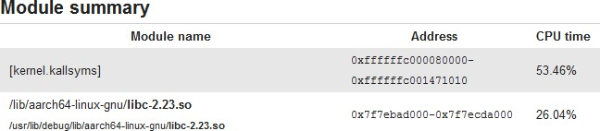

Logging
To enable logging on the host, refer to this config file:
host-linux-x64/nvlog.config.template
When reporting any bugs please include the build version number as described in the Help → About dialog. If possible, attach log files and report (.nsys-rep) files, as they already contain necessary version information.

Verbose Remote Logging on Linux Targets
Verbose logging is available when connecting to a Linux-based device from the GUI on the host. This extra debug information is not available when launching via the command line. Nsight Systems installs its executable and library files into the following directory:
/opt/nvidia/nsight_systems/
To enable verbose logging on the target device, when launched from the host, follow these steps:
- Close the host application.
- Restart the target device.
- Place nvlog.config from host directory to the /opt/nvidia/nsight_systems
directory on target.
- From SSH console, launch the following command:
sudo /opt/nvidia/nsight_systems/nsys --daemon --debug
- Start the host application and connect to the target device. Logs on the target devices are collected into this file (if enabled):
nsys.log
in the directory where nsys command was launched.
Please note that in some cases, debug logging can significantly slow down the profiler.

Verbose CLI Logging on Linux Targets
To enable verbose logging of the Nsight Systems CLI and the target application's injection behavior:
- In the target-linux-x64 directory, rename the nvlog.config.template file to nvlog.config.
- Inside that file, change the line
$ }}{{{}nsys-ui.log
to
$ }}{{{}nsys-agent.log
- Run a collection and the target-linux.x64 directory should include a file named nsys-agent.log.
Please note that in some cases, debug logging can significantly slow down the profiler.

Verbose Logging on Windows Targets
Verbose logging is available when connecting to a Windows-based device from the GUI on the host. Nsight Systems installs its executable and library files into the following directory by default:
C:\Program Files\NVIDIA Corporation\Nsight Systems 2023.3
To enable verbose logging on the target device, when launched from the host, follow these steps:
- Close the host application.
- Terminate the nsys process.
- Place nvlog.config from host directory next to Nsight Systems Windows agent on the target device
  - Local Windows target:
C:\Program Files\NVIDIA Corporation\Nsight Systems 2023.3\target- windows-x64
  - Remote Windows target:
C:\Users\<user name>\AppData\Local\Temp\nvidia\nsight_systems
- Start the host application and connect to the target device. Logs on the target devices are collected into this file (if enabled):
nsight-sys.log
in the same directory as Nsight Systems Windows agent.
Please note that in some cases debug logging can significantly slow down the profiler.

Chapter 28. OTHER RESOURCES

Looking for information to help you use Nsight Systems the most effectively? Here are some more resources you might want to review:

Training Seminars
NVIDIA Deep Learning Institute Training - Self-Paced Online Course Optimizing CUDA Machine Learning Codes With Nsight Profiling Tools
2018 NCSA Blue Waters Webinar - Video Only Introduction to NVIDIA Nsight Systems

Blog Posts
NVIDIA developer blogs, these are longer form, technical pieces written by tool and domain experts.
- 2021 - Optimizing DX12 Resource Uploads to the GPU Using CPU-Visible VRAM
- 2019 - Migrating to NVIDIA Nsight Tools from NVVP and nvprof
- 2019 - Transitioning to Nsight Systems from NVIDIA Visual Profiler / nvprof
- 2019 - NVIDIA Nsight Systems Add Vulkan Support
- 2019 - TensorFlow Performance Logging Plugin nvtx-plugins-tf Goes Public
- 2020 - Understanding the Visualization of Overhead and Latency in Nsight Systems
- 2021 - Optimizing DX12 Resource Uploads to the GPU Using CPU-Visible VRAM

Feature Videos
Short videos, only a minute or two, to introduce new features.
- OpenMP Trace Feature Spotlight
- Command Line Sessions Video Spotlight
- Direct3D11 Feature Spotlight
- Vulkan Trace

- Statistics Driven Profiling
- Analyzing NCCL Usage with NVDIA Nsight Systems

Conference Presentations
- GTC 2023 Optimize Multi-Node System Workloads With NVIDIA Nsight Systems
- GTC 2023 Ray-Tracing Development using NVIDIA Nsight Graphics and NVIDIA Nsight Systems
- GTC 2022 - Killing Cloud Monsters Has Never Been Smoother
- GTC 2022 - Optimizing Communication with Nsight Systems Network Profiling
- GTC 2022 - Optimizing Vulkan 1.3 Applications with Nsight Graphics & Nsight Systems
- GTC 2021 - Tuning GPU Network and Memory Usage in Apache Spark
- GTC 2020 - Rebalancing the Load: Profile-Guided Optimization of the NAMD Molecular Dynamics Program for Modern GPUs using Nsight Systems
- GTC 2020 - Scaling the Transformer Model Implementation in PyTorch Across Multiple Nodes
- GTC 2019 - Using Nsight Tools to Optimize the NAMD Molecular Dynamics Simulation Program
- GTC 2019 - Optimizing Facebook AI Workloads for NVIDIA GPUs
- GTC 2018 - Optimizing HPC Simulation and Visualization Codes Using NVIDIA Nsight Systems
- GTC 2018 - Israel - Boost DNN Training Performance using NVIDIA Tools
- Siggraph 2018 - Taming the Beast; Using NVIDIA Tools to Unlock Hidden GPU Performance

For More Support
To file a bug report or to ask a question on the Nsight Systems forums, you will need to register with the NVIDIA Developer Program. See the FAQ. You do not need to register to read the forums.
After that, you can access Nsight Systems Forums and the NVIDIA Bug Tracking System.
To submit feedback directly from the GUI, go to Help->Send Feedback and fill out the form. Enter your email address if you would like to hear back from the Nsight Systems team.



