
Using Python for Geospatial Analysis and Visualization
Instructors: Jielu Zhang and Devika Jain
Time: 9:00 AM–12:00 PM, May 22, 2026
Location: 1737 Cambridge St., Cambridge, MA, CGIS Knafel Building, Room SB-12, Sub-Basement
Zoom: https://harvard.zoom.us/j/2304706732?omn=92517624341

Pre-Workshop Instructions
Laptops are required for this workshop. Please complete the following steps before the workshop begins:
- Download the GitHub repository for this workshop to your local computer. (1) Go to: https://github.com/zhangjielu321/Using-Python-for-Geospatial-Analysis-and-Visualization (2) Click Download ZIP as shown below.
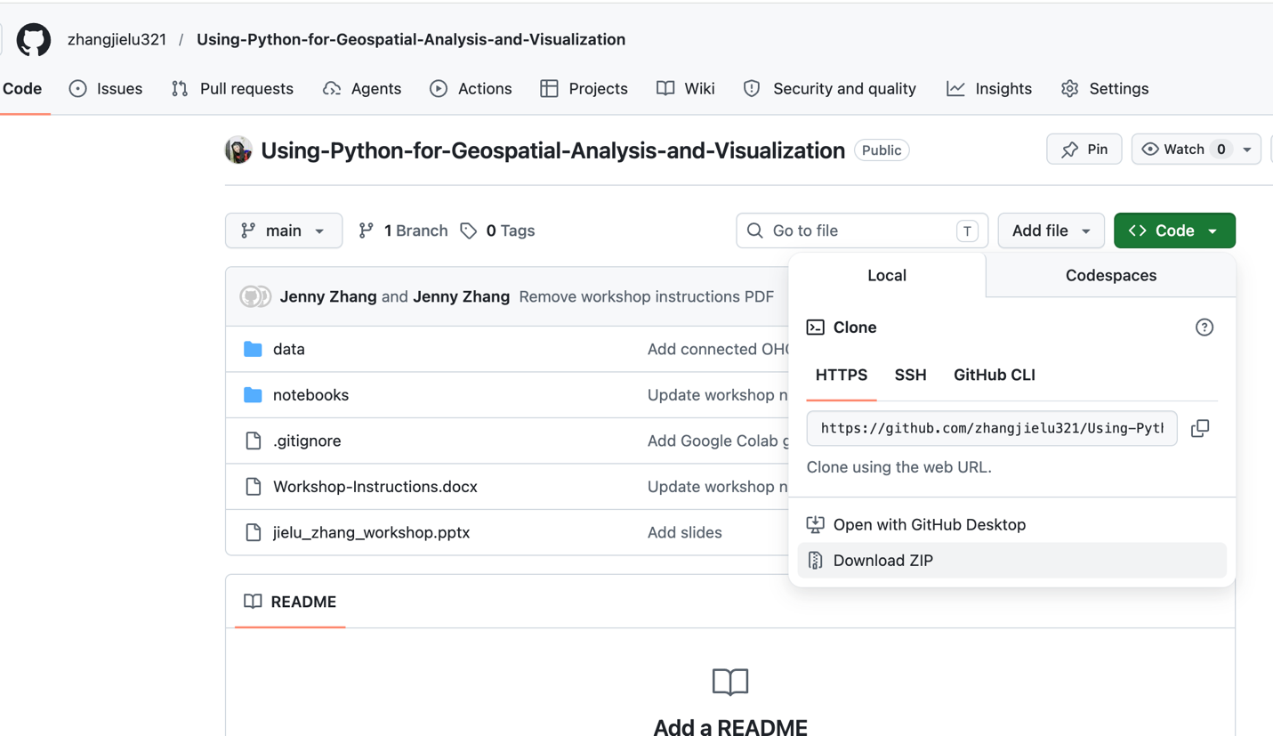
- Log in to Google Colab using your Gmail account:
https://colab.research.google.com/
- Mount your Google Drive in Google Colab.
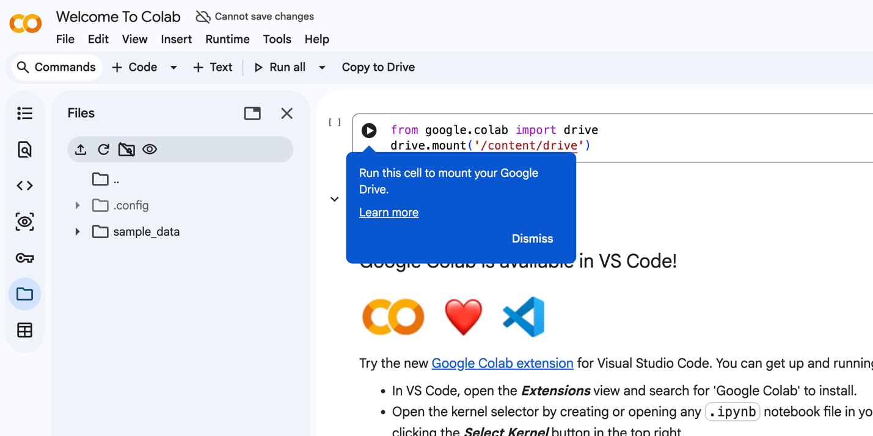
Step 3 Run this cell
Step 2
Step 1
- Open your Google Drive and upload the workshop folder to:
My Drive / Colab Notebooks
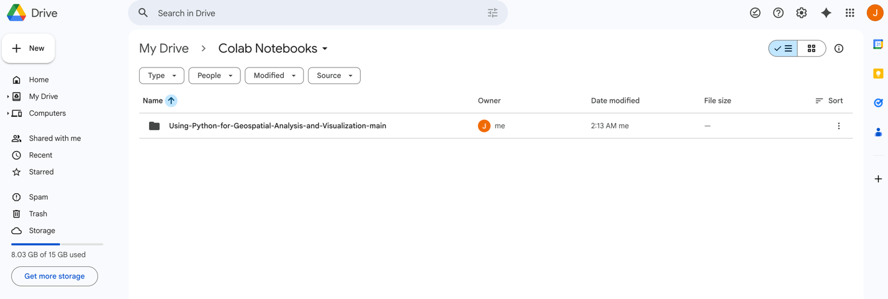
- Open the notebook file (.ipynb) using Google Colaboratory.
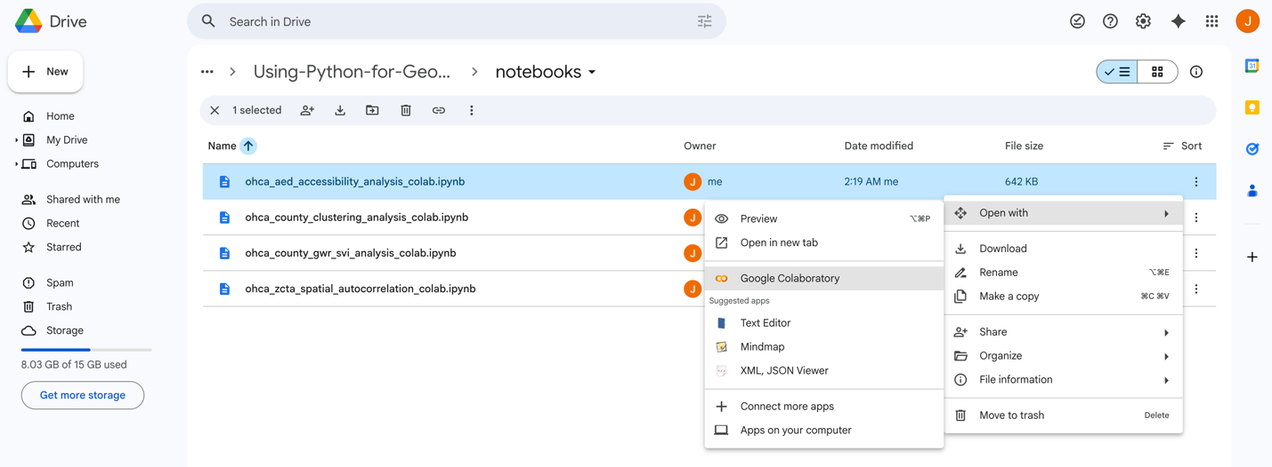
- Randomly select one notebook and make sure you can run it successfully. Use Shift + Enter on Windows or Shift + Return on macOS to run each cell. If you are unable to complete this step successfully, no worries—we can work through it together during the workshop.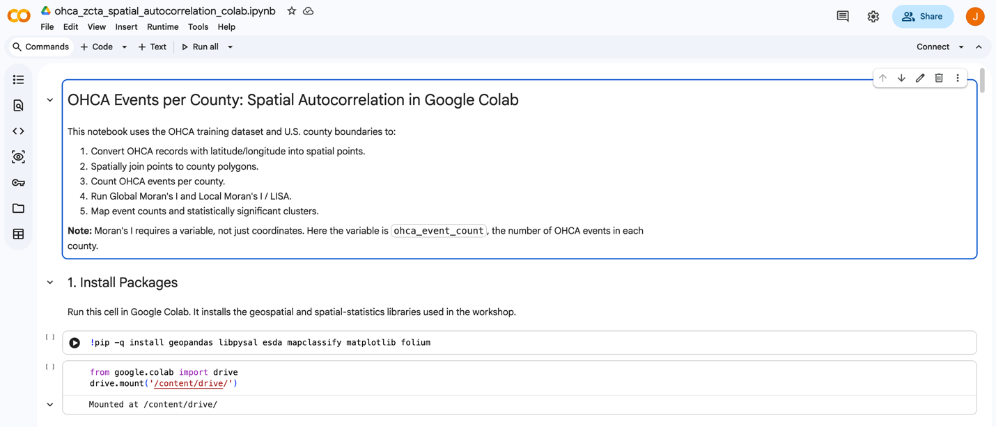
In-Workshop Instructions
- Spatial Autocorrelation. ohca_zcta_spatial_autocorrelation_colab.ipynb

Purpose: This notebook tests whether OHCA event counts are spatially clustered across Georgia counties. The filename says zcta, but the workflow uses counties.

A. Setup and Libraries
- Installs geospatial and spatial statistics packages.
- Imports geopandas, pandas, matplotlib, libpysal, and esda.
- Imports tools for spatial weights, Moran’s I, and Local Moran’s I.

B. Load OHCA Points
- Reads OHCA records from the CSV.
- Converts latitude and longitude columns to numeric.
- Drops rows with missing coordinates.
- Creates point geometries.
- Stores OHCA events as a GeoDataFrame in WGS84.

C. Initial Point Map
- Plots all OHCA points.
- Uses the map to check whether the coordinates appear reasonable.

D. Load Georgia Counties
- Reads the county shapefile.
- Reprojects counties to WGS84.
- Filters to Georgia counties.
- Keeps county ID, county name, and geometry.
- Maps county boundaries with OHCA points for alignment checking.

E. Spatial Join
- Joins each OHCA point to the county polygon that contains it.
- Counts how many OHCA points matched a county.
- Counts how many points did not match.
- Previews joined event records with county information.

F. Count OHCA Events Per County
- Groups joined OHCA points by county.
- Counts the number of events in each county.
- Merges those counts back onto county polygons.
- Creates ohca_event_count.
- Displays counties with the largest counts.

G. Map Event Counts
- Creates a county choropleth map.
- Colors counties by OHCA event count.
- Uses quantile classification for map classes.
- Helps to visually inspect high-count and low-count counties.

H. Create Spatial Weights
- Builds Queen contiguity weights so neighboring counties are connected.
- Checks whether any counties have no neighbors.
- Uses K-nearest neighbors as a backup if needed.
- Row-standardizes the weights.

I. Global Moran’s I
- Uses county OHCA counts as the analysis variable.
- Runs Global Moran’s I.
- Reports the Moran’s I statistic.
- Reports a p-value.
- Test whether high or low OHCA counts are spatially clustered overall.

J. Local Moran’s I / LISA
- Runs Local Moran’s I for each county.
- Stores local statistic values and p-values.
- Calculates spatial lag values.
- Classifies counties into cluster types such as high-high, low-low, high-low, low-high, or not significant.
- Counts how many counties fall into each category.

K. LISA Map And Exports
- Maps significant local cluster categories.
- Saves the LISA cluster map.
- Exports county spatial autocorrelation results as CSV.
- Exports mapped results as GeoJSON.

- Spatial Heterogeneity. ohca_county_gwr_svi_analysis_colab.ipynb

Purpose: This notebook focuses on how to model the relationship between county OHCA counts and social vulnerability variables, allowing that relationship to vary spatially using GWR.

A. Setup and Inputs
- Installs geopandas, mgwr, matplotlib, and mapclassify.
- Imports geospatial, data, and modeling libraries.
- Defines paths to OHCA data, county boundaries, and the Georgia SVI table.

B. Create County OHCA Counts
- Loads OHCA event records.
- Cleans latitude and longitude.
- Converts events into point geometries.
- Loads Georgia county polygons.
- Spatially joins OHCA points to counties.
- Counts OHCA cases per county.
- Fills counties with no matched events as zero cases.

C. Load And Prepare SVI Variables
- Reads the SVI county CSV.
- Creates a five-digit county GEOID.
- Selects SVI variables such as age 65+, disability, uninsured, poverty, education, unemployment, no vehicle, and minority status.
- Converts SVI columns to numeric values.
- Checks whether required SVI columns exist.

D. Merge OHCA And SVI Data
- Merges county OHCA counts with county SVI variables.
- Drops counties missing required predictor data.
- Creates the final county modeling GeoDataFrame.

E. Prepare GWR Inputs
- Reprojects counties to EPSG:3857.
- Uses county centroids as model coordinates.
- Sets the outcome variable to log1p(ohca_cases).
- Standardizes SVI predictors using z-scores.
- Creates the predictor matrix for GWR.

F. Fit GWR Model
- Uses bandwidth selection to choose an adaptive neighborhood size.
- Fits a Geographically Weighted Regression model.
- Prints the GWR summary.
- Allows relationships between SVI variables and OHCA counts to vary by county.

G. Save Local Model Results
- Adds local intercepts to each county.
- Adds local coefficients for each SVI predictor.
- Adds local R² values.
- Adds filtered local t-values.
- Previews selected coefficient columns.

H. Map GWR Results
- Maps one local SVI coefficient, often EP_POV150.
- Shows where that predictor has stronger or weaker local association with OHCA counts.
- Maps local R² to show where the model fits better or worse.
- Uses quantile choropleth maps for interpretation.

I. Export Outputs
- Creates an outputs folder.
- Saves county GWR results as CSV.
- Saves county GWR results as GeoJSON.
- Saves the selected coefficient map as PNG.
- Saves the local R² map as PNG.

- Spatial Clustering. ohca_county_clustering_analysis_colab.ipynb

Purpose: This notebook focuses how to find geographic clusters of OHCA events in Georgia using point-based clustering methods.

A. Setup and Data Paths
- Installs geospatial, plotting, and clustering packages.
- Mounts Google Drive for Colab use.
- Imports pandas, geopandas, numpy, matplotlib, DBSCAN, and KMeans.
- Sets a local data folder and a Colab data folder.
- Chooses whichever data folder exists.
- Defines paths to the OHCA CSV and county shapefile.

B. Load OHCA Event Points
- Reads the OHCA CSV into a DataFrame.
- Identifies latitude and longitude columns.
- Converts coordinate columns to numeric values.
- Drops records missing latitude or longitude.
- Converts rows into point geometries.
- Creates an OHCA GeoDataFrame in WGS84 coordinates.

C. Keep Georgia Events
- Loads the county shapefile.
- Reprojects counties to WGS84.
- Filters counties to Georgia using STATEFP = '13'.
- Spatially joins OHCA points to Georgia county polygons.
- Keeps only OHCA points that fall inside Georgia counties.

D. Visual Check
- Plots Georgia county boundaries.
- Plots OHCA points on top.
- Uses this map to confirm that the point and county layers align correctly.

E. Prepare For Clustering
- Reprojects OHCA points to EPSG:3857 so distances are measured in meters.
- Extracts x and y coordinates.
- Builds a coordinate matrix for clustering models.

F. DBSCAN Clustering
- Runs DBSCAN with a 5 km search radius.
- Requires at least 10 nearby points to form a cluster.
- Assigns a cluster label to each OHCA point.
- Uses -1 to mark noise points that do not belong to a dense cluster.
- Prints counts for each cluster label.
- Counts the number of non-noise clusters.

G. DBSCAN Mapping and Summary
- Maps DBSCAN clusters.
- Labels noise points separately.
- Summarizes cluster membership by county.
- Helps to identify which counties contribute to each hotspot.

H. KMeans Comparison
- Runs KMeans with 6 clusters.
- Assigns every OHCA point to one of the 6 groups.
- Maps KMeans clusters.
- Compare DBSCAN with KMeans

I. Export Outputs
- Creates an output folder.
- Saves clustered OHCA points as GeoJSON.
- Saves county-cluster summaries as CSV.
- Saves the DBSCAN cluster map as a PNG.

4. Spatial Accessibility. ohca_aed_accessibility_analysis_colab.ipynb

Purpose: This notebook focuses on how to measure AED accessibility for OHCA events using simulated AED locations and the Two-Step Floating Catchment Area method.

A. Setup and Data Paths
- Installs geospatial and plotting packages.
- Imports numpy, pandas, geopandas, matplotlib, and Point.
- Sets local and Colab data directories.
- Defines paths to the OHCA CSV and county shapefile.

B. Load OHCA Events
- Reads OHCA records from the CSV.
- Cleans latitude and longitude columns.
- Drops records without valid coordinates.
- Converts each event into a point geometry.
- Creates an OHCA GeoDataFrame.

C. Keep Georgia Events
- Loads county polygons.
- Filters to Georgia counties.
- Spatially joins OHCA events to counties.
- Keeps only OHCA events inside Georgia.

D. Simulate AED Locations
- Dissolves Georgia counties into one state boundary.
- Gets the bounding box around Georgia.
- Randomly generates candidate points.
- Keeps only random points that fall inside Georgia.
- Stops after creating 200 simulated AED points.
- Stores those AEDs in a GeoDataFrame.

E. Map OHCA And AED Locations
- Plots Georgia county boundaries.
- Plots OHCA events as red points.
- Plots simulated AEDs as blue triangle markers.
- Uses the map as a visual check before analysis.

F. Prepare Distances For 2SFCA
- Reprojects OHCA points and AED points to EPSG:3857.
- Extracts x and y coordinates for both layers.
- Calculates the distance from every OHCA point to every AED.
- Creates a distance matrix where rows are OHCA events and columns are AEDs.
- Sets the catchment threshold to 5 miles.
- Converts 5 miles to meters.

G. 2SFCA Step 1: AED Supply Ratios
- Creates a true/false matrix showing whether each OHCA event is within each AED catchment.
- Counts how many OHCA events are within each AED’s catchment.
- Assigns each AED a supply value of 1.
- Divides AED supply by nearby OHCA demand.
- Produces Rj, the supply-to-demand ratio for each AED.

H. 2SFCA Step 2: Event Accessibility Scores
- For each OHCA event, identifies AEDs within its catchment.
- Adds up the Rj values of those nearby AEDs.
- Stores this value as the event’s Ai_2sfca accessibility score.
- Counts how many AEDs are within each event’s catchment.
- Creates a flag for whether each event has at least one AED nearby.

I. Summaries And Maps
- Summarizes event-level accessibility values.
- Groups events by county.
- Calculates county event counts.
- Calculates county mean and median accessibility.
- Calculates the percentage of events with an AED in catchment.
- Maps county mean 2SFCA accessibility.

J. Export Outputs
- Saves simulated AED points as GeoJSON.
- Saves event-level accessibility results as CSV.
- Saves county-level accessibility summaries as CSV.
- Saves the county accessibility map as PNG.

