Jingru Zhang project 6 report

Two worse cases with:

Graph 5: BF distance: 331.763. MST distance: 441.763.

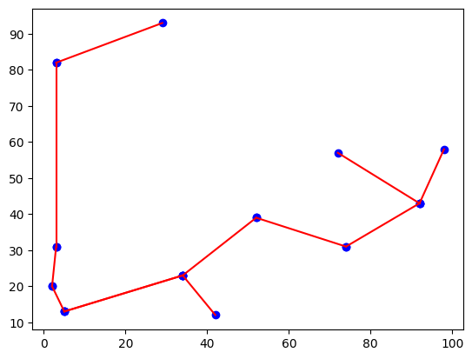

Graph 7: BF distance: 361.065. MST distance: 454.98.

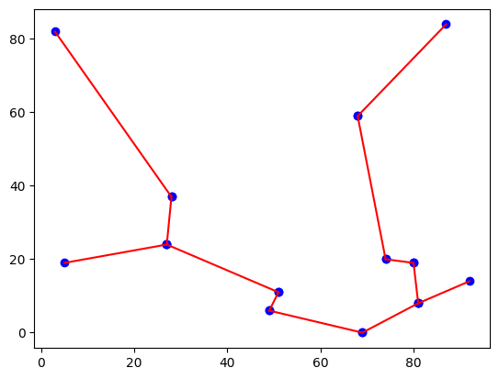

I think the reason that they are the worse cases is because of MST do not considered the distance between tree children(like the first and the last node), but graph has to connected to each other which cause it’s actually a long distance to connection

I think the MST approximation is doing worse than I thought, the reason that MST have such a gap with true distance produce by BF is it only considered the edge and nodes in the tree, but I think the biggest different between tree and graph is tree do not connect and close however the graph do, so MST doesn’t considered the distance to connect and close.

Yes, because MST only considered as a tree not graph. A properties of good tour should be short and don’t have to go through same area multiple times. And the bad tour should be far, slow and have to go through multiple time.

The way to speed up BF: since BF has to go through all the possibility. We could set a condition there like: if there’s no min distance change in x times running then reset whole progress. I wrote a BF method and it has to take 2 hours to finished all 13! Possibility and that’s horrible. And I never thought recursive could be so efficient for BF.