Problem generated by Gemini.
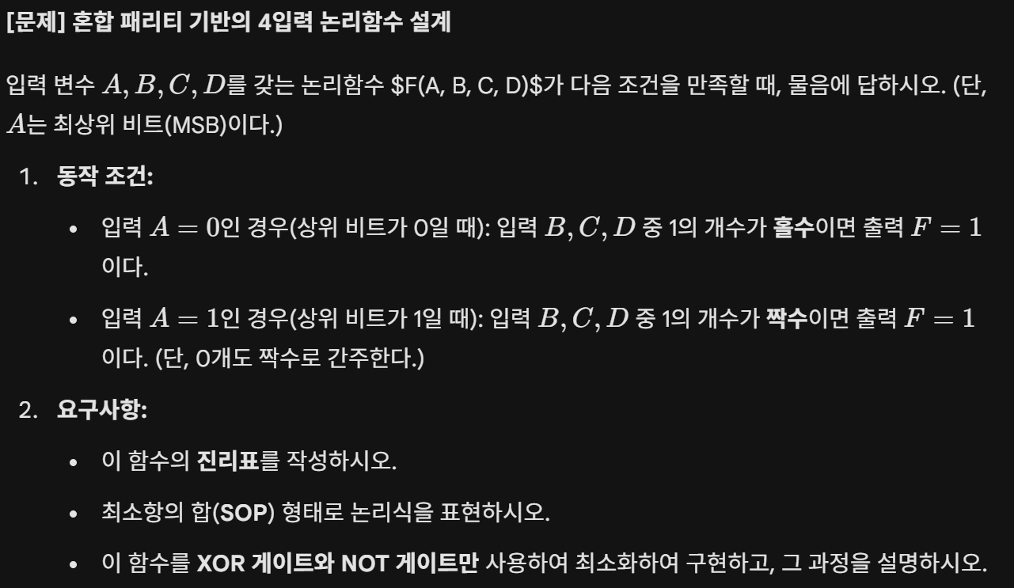

A solution generated by ChatGPT A solution generated by Gemini
