Task 1: K-means Clustering and the Gap Statistic
Methods
We generated synthetic datasets where each cluster corresponds to a corner of an n-dimensional hypercube.
Each cluster contained k = 100 points with Gaussian noise (sd = 1.0).
The cluster centers were separated by a distance equal to the side length (L) of the hypercube.
For each dimension (n = 2, 3, 4, 5, 6), we decreased L from 10 to 1 to make the clusters gradually overlap.
The Gap Statistic (clusGap function) was computed with:
- B = 20 bootstrap samples
- K.max = n + 2
- nstart = 20 and iter.max = 50 for k-means
The estimated number of clusters (𝐾̂) was recorded for each (n, L) combination.

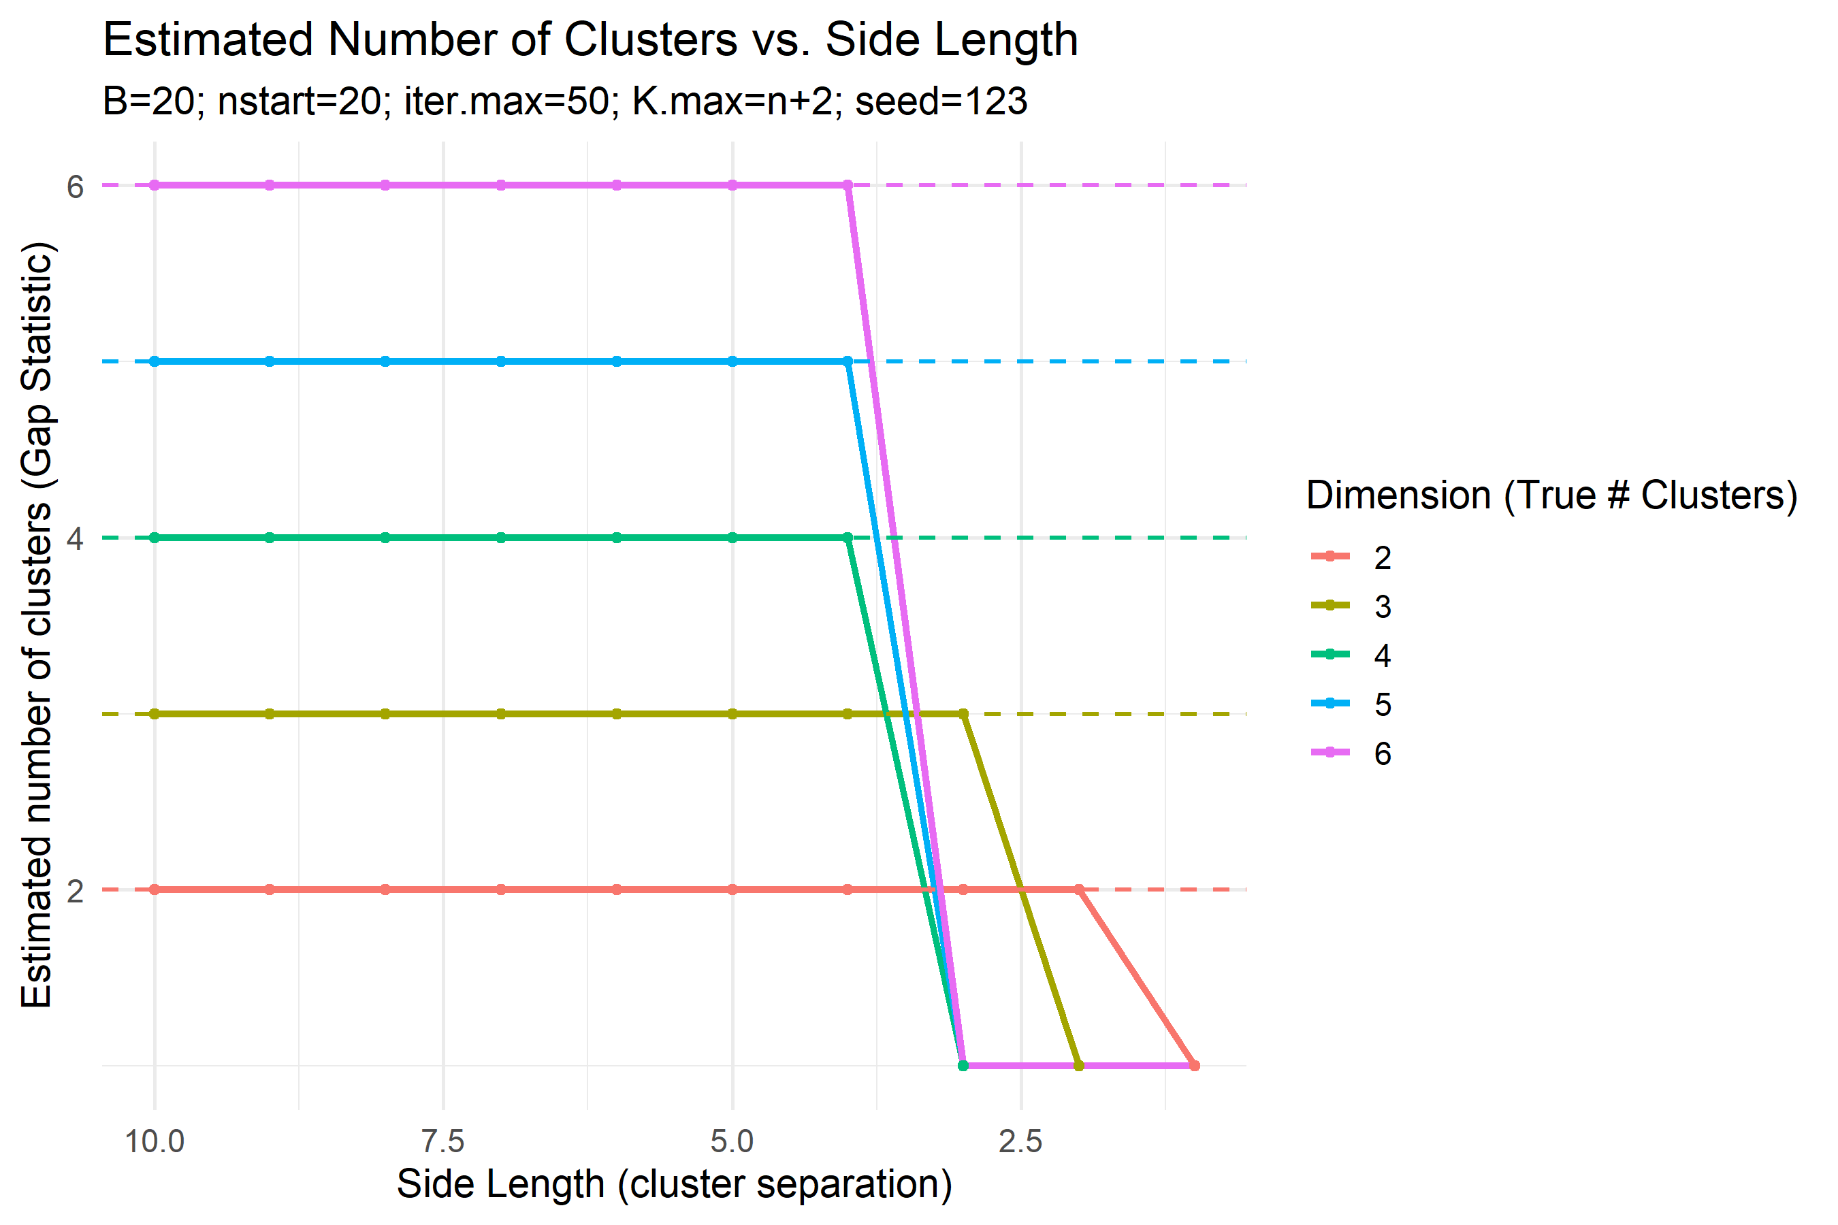
The plot above shows how the estimated number of clusters changes as the side length L decreases.
When clusters are far apart (large L), the Gap Statistic correctly identifies the true number of clusters (equal to the dimensionality n).
As L decreases, clusters start to merge, and the estimated K collapses sharply to 1.

Interpretation

The Gap Statistic performs well when clusters are clearly separated but fails once the cluster distance (L) becomes small relative to within-cluster noise.
For high-dimensional data (n ≥ 4), the breakdown occurs at L ≈ 3.
This happens because, as dimensionality increases, the within-cluster spread grows while separation between cluster centers remains limited .
As a result, the algorithm interprets overlapping clusters as a single group, and the estimated K abruptly drops to 1.

In summary, the Gap Statistic can detect the correct number of clusters only when the cluster separation (L) is sufficiently large compared to the noise.
When L ≤ 3, the algorithm can no longer distinguish clusters reliably.

Task 2: Spectral Clustering on Concentric Shells
Methods
We generated 3D datasets consisting of 4 concentric spherical shells, each with 100 points.
Noise (sd = 0.1) was added in the radial direction, and the maximum radius (max_radius) was gradually decreased from 10 to 0.
Spectral clustering was performed using an adjacency matrix A defined by distance threshold d_threshold = 1, where Aᵢⱼ = 1 if ‖xᵢ − xⱼ‖ < 1.
The normalized Laplacian L_sym = D⁻¹ᐟ² L D⁻¹ᐟ² was computed, eigenvectors for the k smallest eigenvalues were extracted, and k-means was applied to them.
The Gap Statistic (B = 20) was used to estimate the optimal number of clusters.
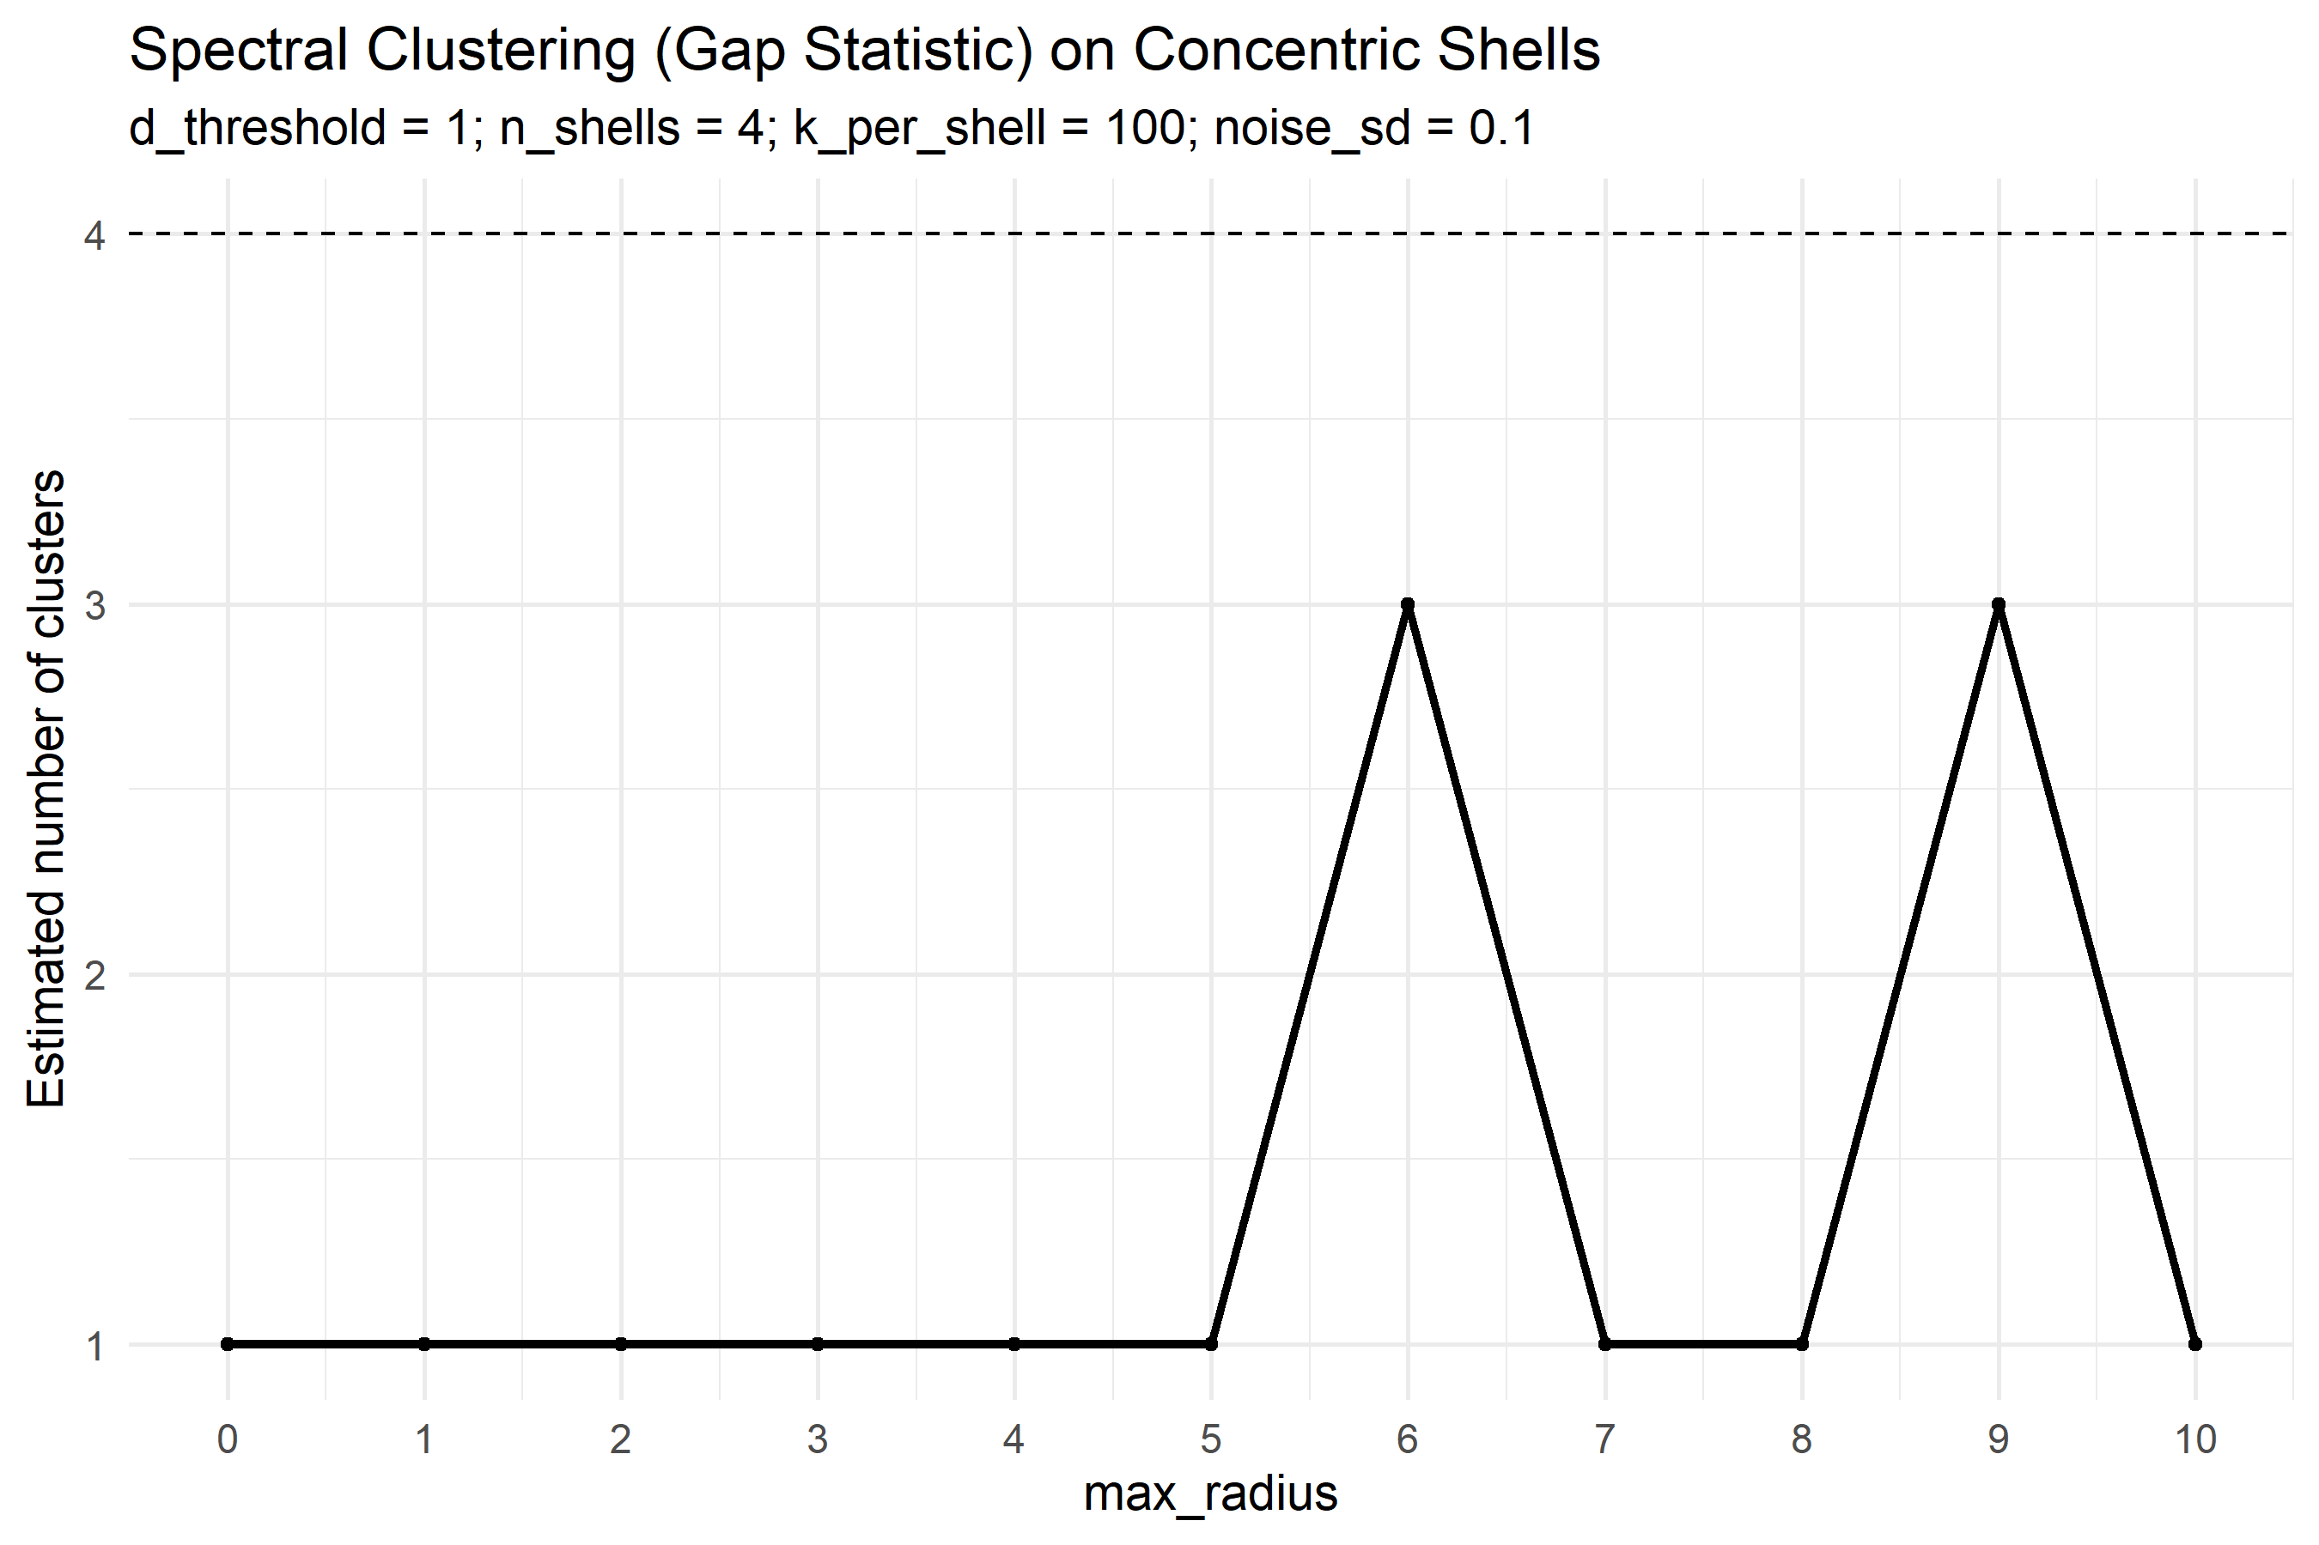
The plot above shows how the estimated number of clusters changes as the max radius decreases.

Interpretation
Spectral clustering correctly identifies 4 shells when the shells are well separated (max_radius ≥ 7).
As shells move closer (max_radius ≈ 6), the algorithm starts merging adjacent shells, resulting in K̂ = 3.
When max_radius ≤ 5, the similarity graph becomes almost fully connected, and the algorithm collapses to K̂ = 1.
This failure occurs because, with fixed d_threshold = 1, points from different shells begin to form inter-shell connections once their radial spacing becomes smaller than 1.
The Laplacian’s block structure disappears, eigenvalues merge, and the Gap Statistic detects fewer clusters.
Overall, spectral clustering is robust to moderate overlap but breaks down once shells become closer than the connectivity threshold.
This pattern mirrors Task 1’s findings: as clusters overlap beyond a critical distance, the Gap Statistic underestimates K.

Discussion
Across both tasks, the Gap Statistic behaves consistently:
- It is reliable when inter-cluster separation is large relative to noise.
- Once clusters begin to overlap, the estimated number of clusters drops sharply.
- Higher-dimensional or more connected data accelerate the breakdown.

