**The progress of covid-19**

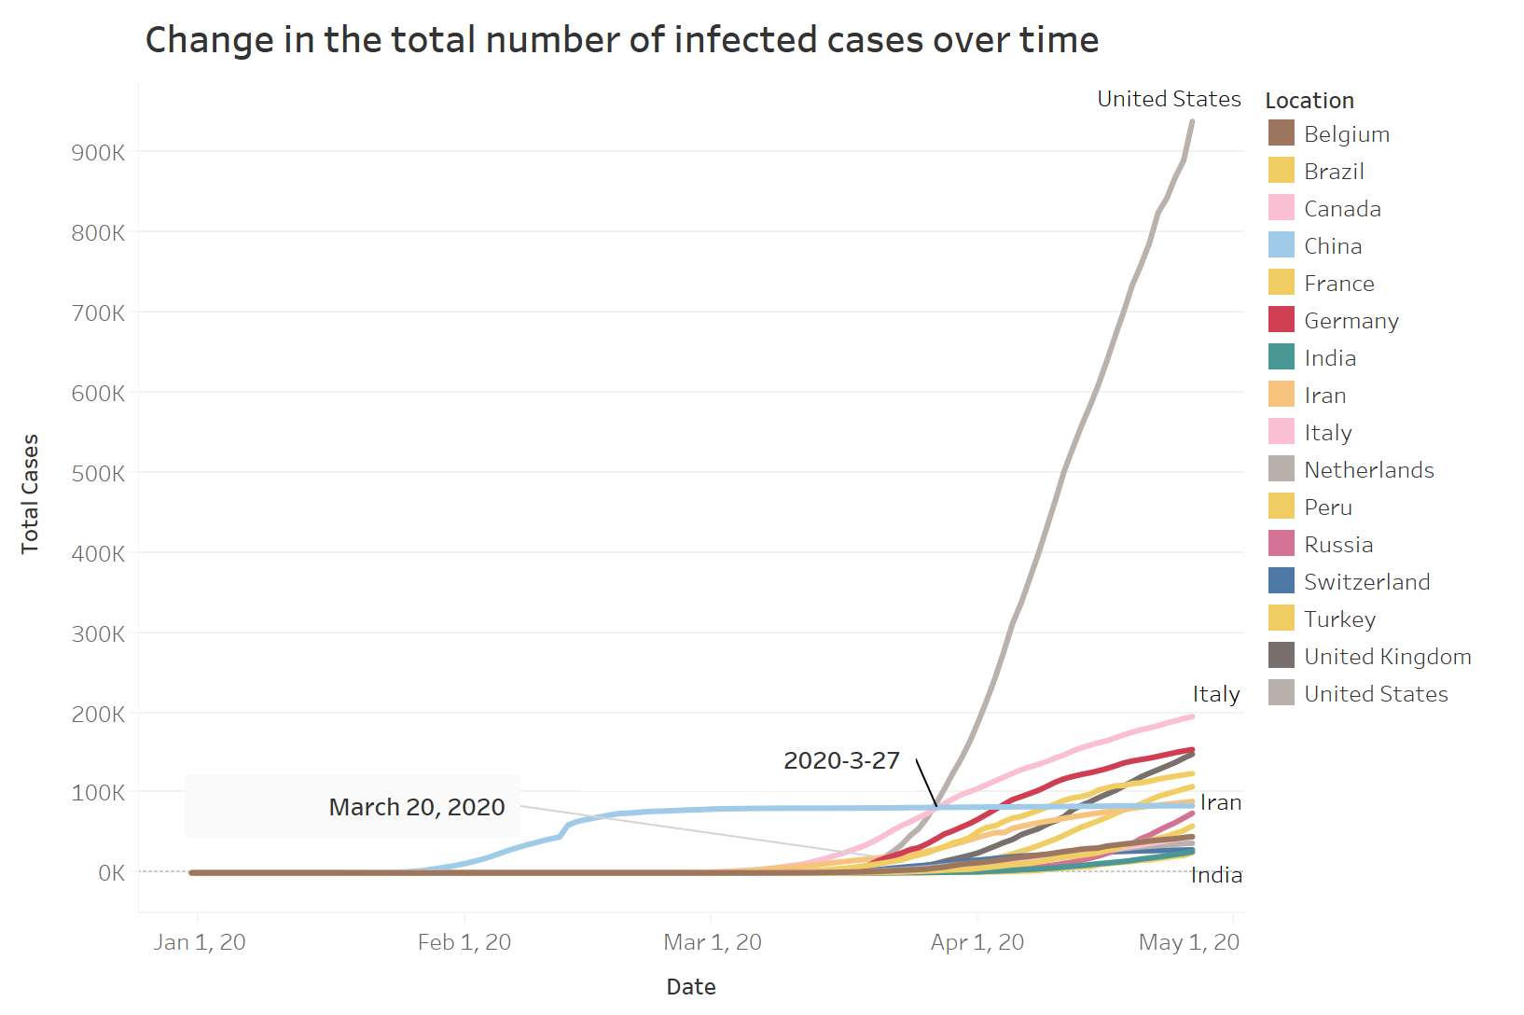

Fig 1

Figure 1 is a graph of the number of infections in some countries over time. It can be seen from the figure that as of April 26, the number of infected people is the United States, followed by Italy, followed by Germany. China's new crown pneumonia was the first to break out, and it started to grow explosively at the end of January. In March, as the epidemic was brought under control, the number of infections gradually stabilized and no drastic changes occurred. European countries such as Italy and Germany were in a stable state before the outbreak before March. After the outbreak, they began to grow rapidly. Most countries began to increase outbreaks on March 20. The number of infections in the United States was also stable in January and February. The explosive growth began in March, and it surpassed China and Italy to become the country with the most infections on March 27.

Mapping method: 1. First add date in the tableau row and total case in the column; 2. Use filters to filter out the main countries; 3. Different colored lines indicate different countries and mark them at key points.

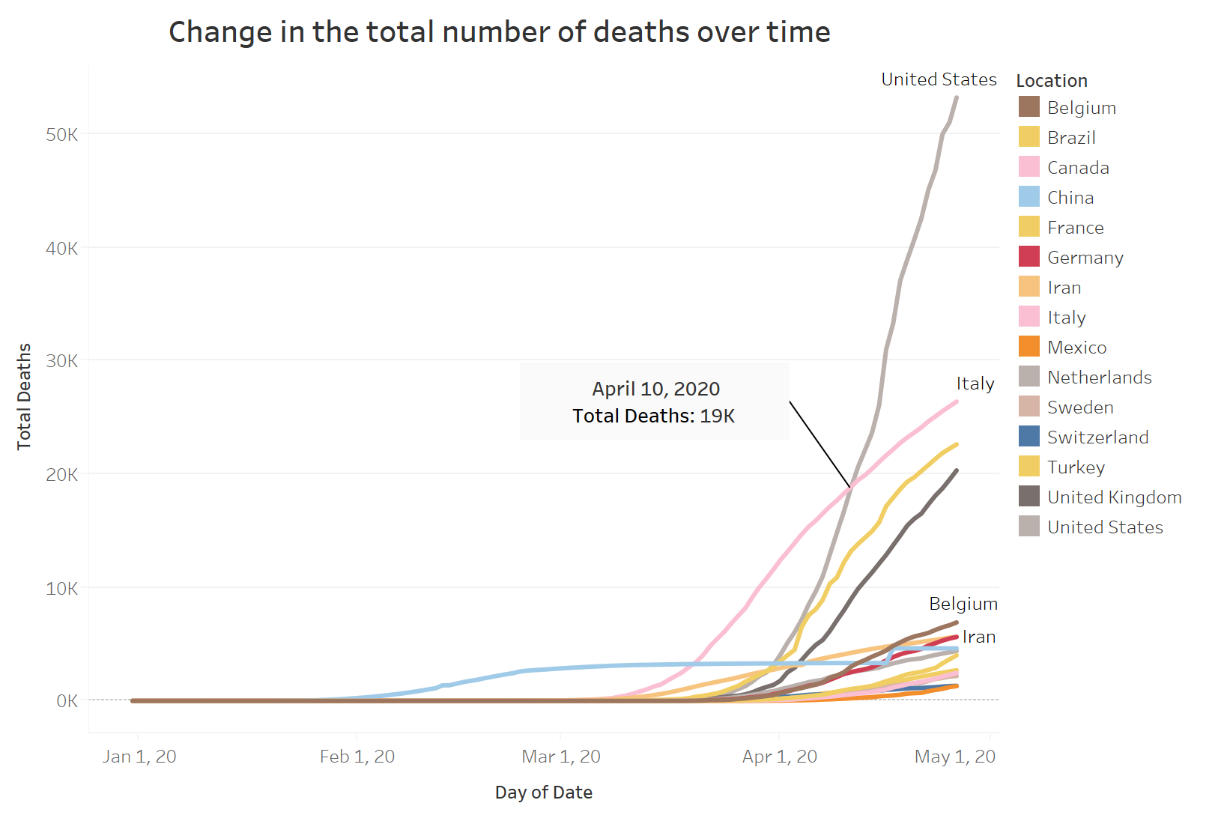

Fig 2

Figure 2 shows the curve of the number of deaths infected with covid-19 over time in some countries. It can be seen from the figure that the curve of the death toll lags the curve of the number of infections. In the early stage of the global epidemic, the number of infections in China showed an explosive growth. After a period of time, the number of deaths also increased first, indicating that some patients infected with covid-19 eventually died as the disease worsened. As of April 26, the United States had the largest number of deaths, with more than 50,000, and then Italy, with about 27,000. The United States surpassed Italy on April 10 and became the country with the largest number of deaths.

Mapping method: 1. First add date in the tableau row and total case in the column; 2. Use filters to filter out the main countries; 3. Different colored lines indicate different countries and mark them at key points.

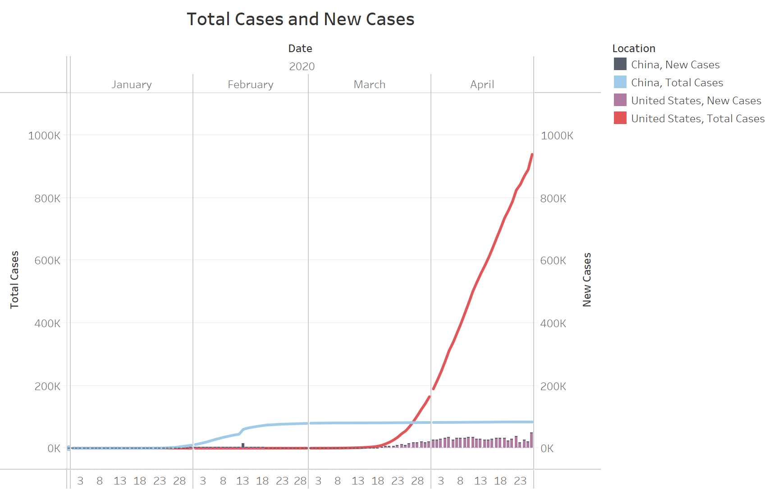

Fig 3

Figure 3 shows the total number of people infected with COVID-19 daily in China and the United States and the number of new people added each day. The line graph is the total number of people infected, and the bar graph represents the number of new people each day. China represents the early stage of the covid-19 outbreak, and the United States represents the latter stage of the covid-19 outbreak. In February, the total number of people in China gradually increased, and the daily increase in mid-February reached a larger value, and the total number of people subsequently increased. The number of new additions has remained stable; the United States began to break out in late March, and the number of daily additions also began to hit a new high; from the bar chart in April, it can be seen that China's daily additions are negligible compared with the United States.

Drawing methods: 1. Add date to the row of tableu, and add total case and new case to the column; 2. Make a graph of total case change over time; 3. Make a histogram of new case change over time; 4. Two The graphs are merged coaxially.

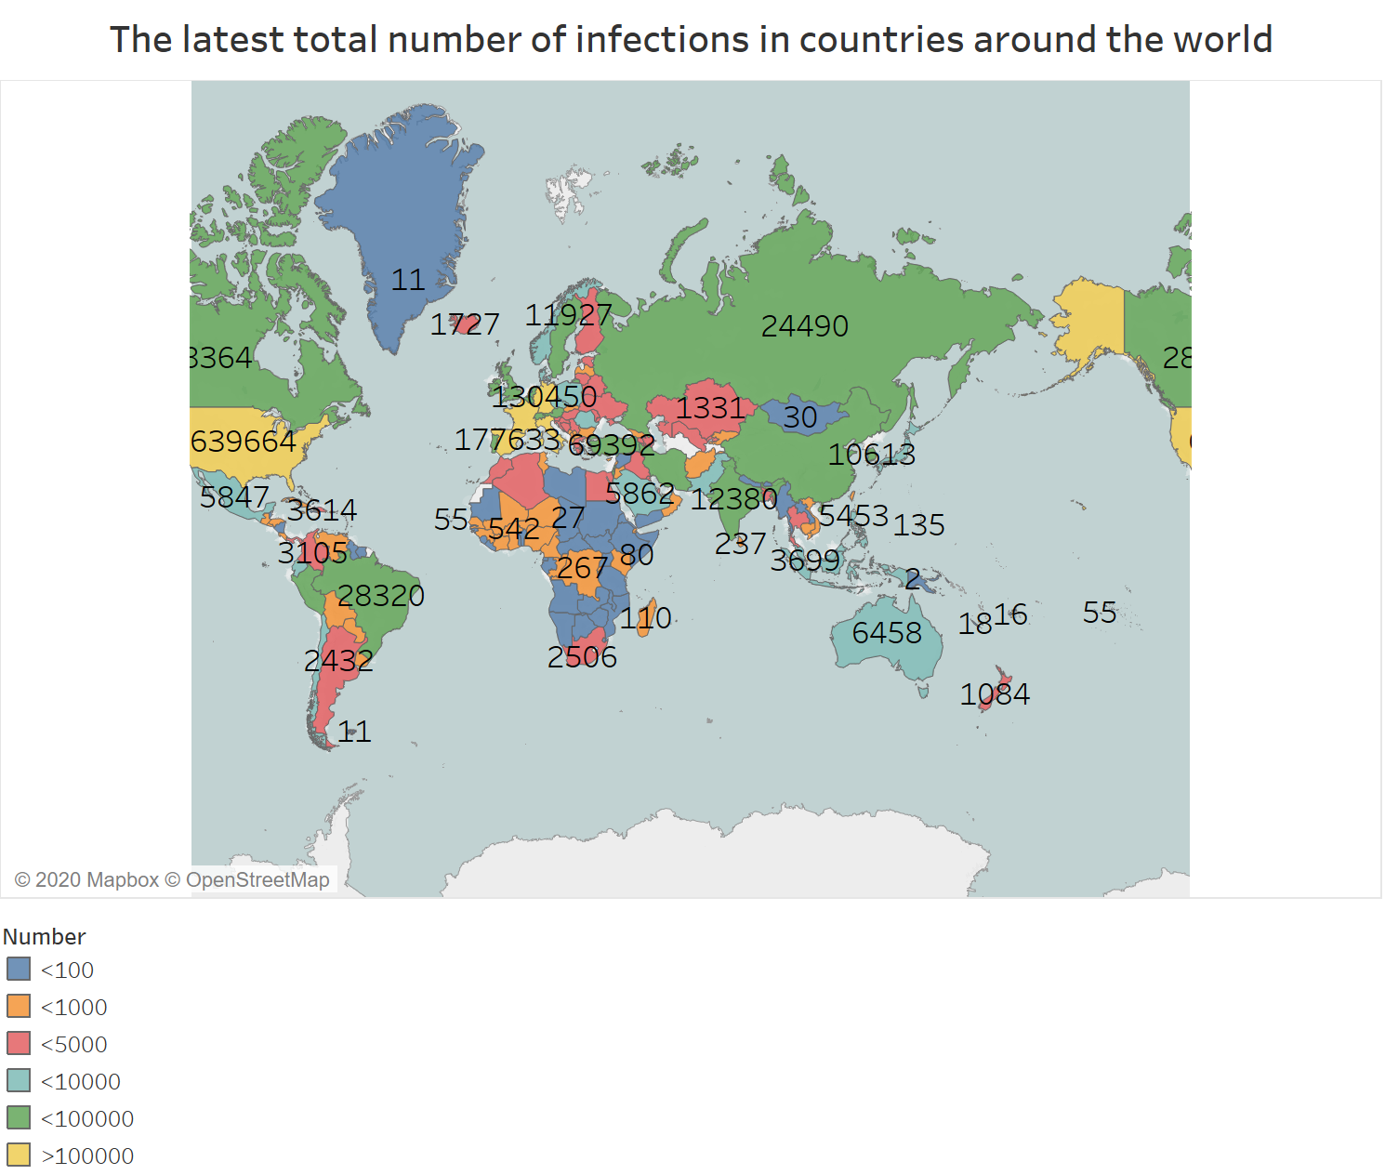

Fig 4

Figure 4 is an interactive diagram showing the number of infected people in different countries on the day, divided by the number of levels, and changes with the date. When the mouse hovers over the graph, you can observe the legend of the country and determine which level the infected people belong to.

Mapping method: 1. Map the world geographic map according to the latitude and longitude; 2. Calculate the calculation field according to the total case, group the total case, and add the grouping result to the color of tableau for display; 3. Add the date to the tableau " Page" function box.