1，左右框架
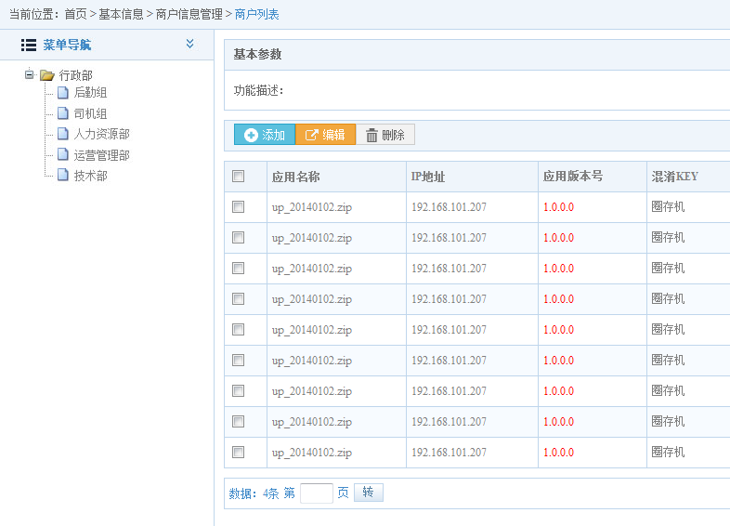
页面样式引用
<link href="css/style.css" rel="stylesheet" type="text/css" />
<link href="css/l-style.css" rel="stylesheet" type="text/css" />

<div class="ld-container">

- 平铺时
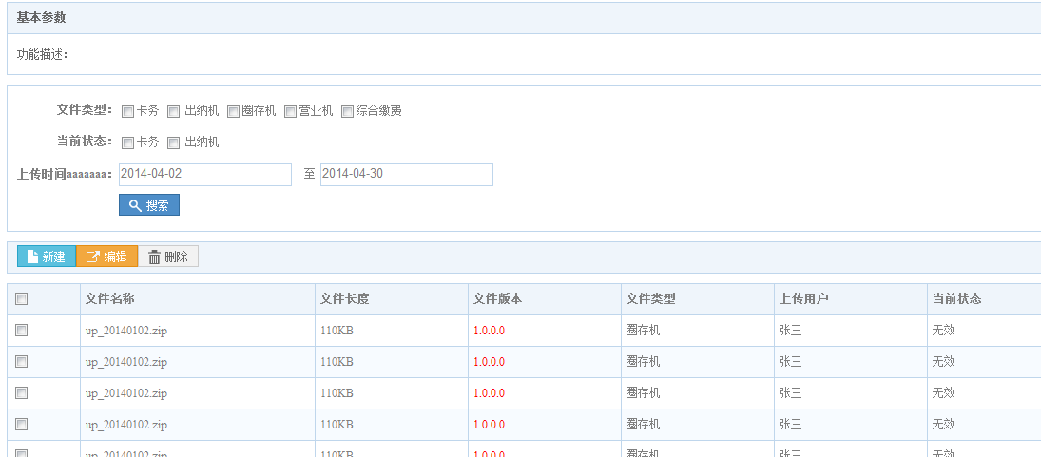
页面样式引用
<link href="css/style.css" rel="stylesheet" type="text/css" />

<div class="ld-container ld-con">

