etcd笔记
- 安装
  - yum 安装
yum list|grep etcd 查看版本
yum install etcd
systemctl start etcd 启动
systemctl enable etcd 设置开机启动

  - 源码安装
https://coreos.com/ 官网
https://github.com/etcd-io/etcd/releases 版本下载
Wget https://github.com/etcd-io/etcd/releases/download/v3.3.10/etcd-v3.3.10-linux-arm64.tar.gz
tar zxvf etcd-v3.3.10-linux-amd64.tar.gz -C /usr/local/

vim /etc/profile

export PATH=$PATH:/usr/local/etcd
export ETCDCTL_API=3

source /etc/profile

- Ctcdctl 命令
etcdctl member list 查看集群成员信息
etcdctl --write-out=table --endpoints=localhost:12379 member list 表格查看成员

curl -L http://127.0.0.1:2379/version 查看版本状态

- etcdctl 键值操作
etcdctl put name zhangsan 增加或修改
etcdctl get name 查看
etcdctl del name 删除

授权租约
$ etcdctl lease grant 10
lease 32695410dcc0ca06 granted with TTL(10s)
# 附加键 foo 到租约32695410dcc0ca06
$ etcdctl put --lease=32695410dcc0ca06 name zhangsan

- 集群搭建
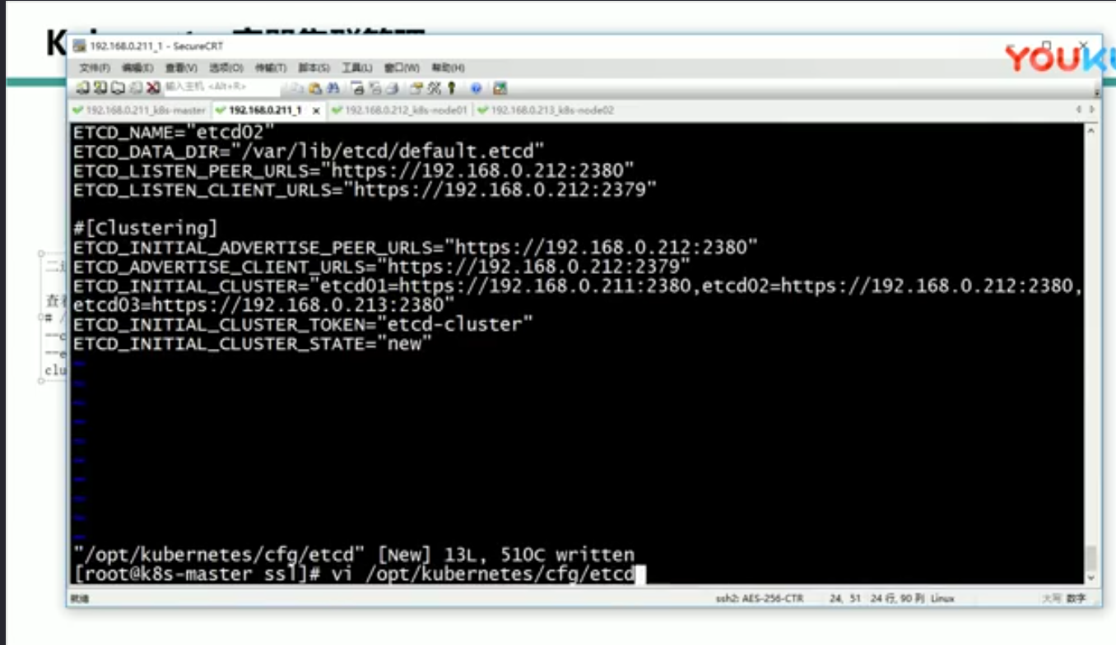

手册
http://etcd.doczh.cn/documentation/dev-guide/interacting_v3.html
go-etcd
https://github.com/etcd-io/etcd/tree/master/clientv3
https://www.jianshu.com/p/3206e35677b4
https://blog.csdn.net/u013210620/article/details/78608988
https://www.cnblogs.com/gregoryli/p/8444548.html

