操作预先要准备的工作：

  - 运行rabbitmq-server
  - 运行mysql数据库, 导入数据库，并配置连接信息
  - run worker_meta_direct.py 来接收rabbitmq的消息
  - run proxy server

使用手册
- 用户相关
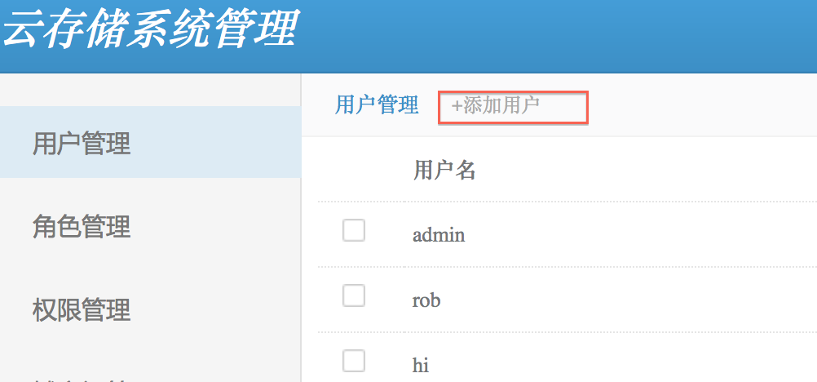
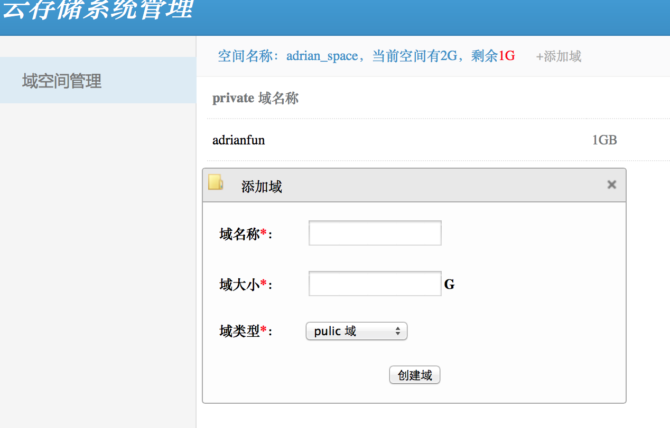
使用GUI创建用户后，如果用户不在user_space中建立域空间，则认为此用户不可用。

用户创建步骤：
  - 管理员在GUI见面上点击[添加用户]，默认添加用户的space空间为2G
  - 指定用户名和用户密码
  - 使用该用户名和密码登陆GUI
  - 选择创建域【可选类型：private, public, protected】

- 操作命令

使用curl完成rest操作，分为POST, PUT, GET, DELETE, HEAD 5个部分

curl命令：

格式 | 意义
-i | 回显response头信息
-H | 指定文件头， 多个头需要多个-H
--data-binary | 以二进制方式上传本地文件
-X | 指定curl方式，可以指定POST, PUT, GET, DELETE, HEAD等

- 操作

操作 | 格式
domain操作 | http://[host_url]/scloud_domain/[domain_name]
container操作 | http://[host_url]/scloud_container/[domain_name]/[container_name]/[container...]
object操作 | http://[host_url]/scloud_object/[domain_name]/[container_name]/[container...]/[object_name]
capability操作
queue操作

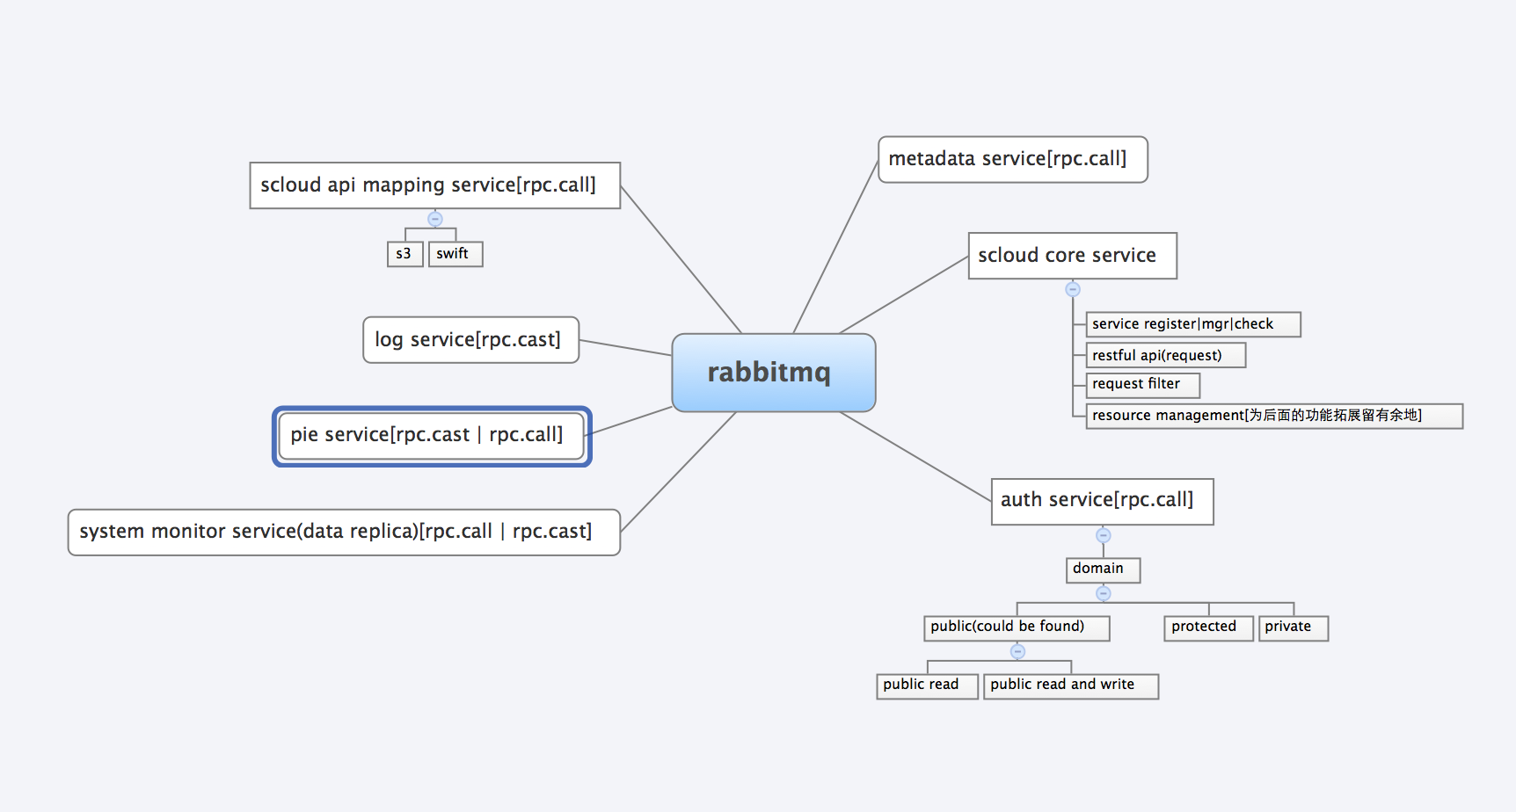

服务组合理念：

- 我们引入了paste.deploy 模块
通过该模块的config file 中的pipeline来进行服务间的工作流组合
组合出来的服务定义为扩展服务
2、 扩展服务之间通过RPC.CALL()和RPC.CAST()给rabbitmq发送消息进行交互， 这里的Rabbitmq相当于消息总线【中间件】， 进行扩展服务与扩展服务之间的消息转发和协作。

接口定义

创建用户
curl -i -H "Authorization: aaaaaaaaaa:aaaaaaaaaa " -H "Content-Type:scloud-user" -H "Host:localhost" -H "X-CDMI-Specification-Version:v1" -H "Date:2014-08-20 10:00:00" http://localhost:8080/scloud_user/ -X PUT

删除文件夹
curl -i -H "Authorization: aaaaaaaaab:aaaaaaaaab " -H "Content-Type:scloud-container" -H "Host:localhost" -H "X-CDMI-Specification-Version:v1" -H "Date:2014-08-20 10:00:00" http://localhost:8080/scloud_container/hello/haha -X DELETE

文件夹rename
curl -i -H "Authorization: aaaaaaaaab:aaaaaaaaab " -H "Content-Type:scloud-container" -H "Host:localhost" -H "X-CDMI-Specification-Version:v1" -H "Date:2014-08-20 10:00:00" -H "current-name:niubi10" http://192.168.1.114:8080/scloud_container/hello/haha/niubi7 -X POST

创建文件夹
curl -i -H "Authorization: aaaaaaaaab:aaaaaaaaab " -H "Content-Type:scloud-container" -H "Host:localhost" -H "X-CDMI-Specification-Version:v1" -H "Date:2014-08-20 10:00:00" http://192.168.1.114:8080/scloud_container/hello/haha/niux -X PUT

获取根文件夹内容
curl -i -H "Authorization: aaaaaaaaab:aaaaaaaaab " -H "Content-Type:scloud-domain" -H "Host:localhost" -H "X-CDMI-Specification-Version:v1" -H "Date:2014-08-20 10:00:00" http://192.168.1.114:8080/scloud_domain -X GET

获取指定文件夹【非根目录】内容
curl -i -H "Authorization: aaaaaaaaab:aaaaaaaaab " -H "Content-Type:scloud-container" -H "Host:localhost" -H "X-CDMI-Specification-Version:v1" -H "Date:2014-08-20 10:00:00" http://192.168.1.114:8080/scloud_container/hello/haha -X GET

删除文件
curl -i -H "Authorization: aaaaaaaaab:aaaaaaaaab" -H "Content-Type:scloud-object" -H "Host:locecification-Version:v1" -H "Date:2014-08-20 10:00:00" http://192.168.1.114:8080/scloud_object/hello/check.sh -X DELETE

上传文件
curl -i -H "Authorization: aaaaaaaaab:aaaaaaaaab" -H "Content-Type:scloud-object" -H "Host:locecification-Version:v1" -H "Date:2014-08-20 10:00:00" http://192.168.1.114:8080/scloud_object/hello/params.py --data-binary "@server.py" -X PUT

获取文件
curl -i -H "Authorization: aaaaaaaaab:aaaaaaaaab" -H "Content-Type:scloud-object" -H "Host:locecification-Version:v1" -H "Date:2014-08-20 10:00:00" http://192.168.1.114:8080/scloud_object/hello/params.py -X GET

文件重命名
curl -i -H "Authorization: aaaaaaaaab:aaaaaaaaab" -H "Content-Type:scloud-object" -H "Host:localhost" -H "X-CDMI-Specification-Version:v1" -H "Date:2014-08-20 10:00:00" -H "current-name:haha.py" http://192.168.1.114:8080/scloud_object/hello/params.py --data-binary "@server.py" -X POST

