Thermal Survey Report
2300 Area Pipework123
 |  | 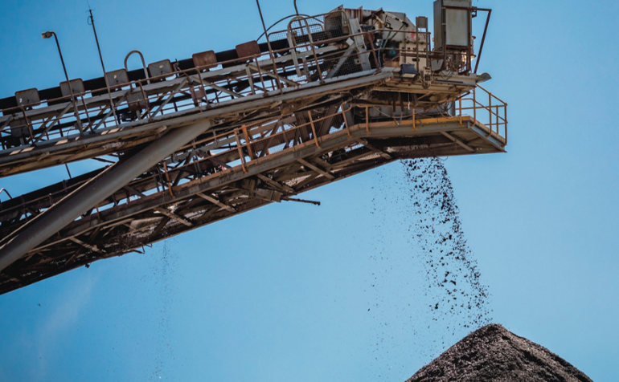

Contents
1 General Information 3
2 Defect Overview 3
3 Figures 4

Document information
Project name | Thermography | Document location | G:// Drive | Document type | Report
 | Function | Name | Department | Signature | Date
Peer review
Approval
Document history | Version | Date | Name | Description
Document history | 1 | 17/08/2026 | Sam Drawwater | 2300 Area Pipework Thermography report

General Information
Thermographer | Sam Drawwater
Thermographer e-mail | sam.drawwater@glencore.com.au
Inspection scope | Grinding Area Pipework
Inspection period | 05/08/2026 – 08/08/2026
Camera producer | FOTRIC
Camera model | P5 MIX
Serial number | 0202005880
Operating conditions during the survey | Normal conditions
Rating | Temp Differential ˚C |  | Recommendation
Okay | 0 | 1.5 | No action required.
Attention | 1.5 | 2.0 | Monitor further.
Severe | 2.0 | 2.5 | Schedule in next 1 to 2 shutdowns.
Critical | >2.5 |  | Schedule for next shutdown period.

Defect Overview
Overview of defects divided into defect categories
1 | 117 | 27 | 13 | 18

Description of Defect Categories
Not Collected |  | Point missed or not collectable
Okay |  | No action required
Attention |  | Possible defect requires monitoring
Severe |  | Defect that needs action in ≤8 months
Critical |  | Defect that needs action ≤4 months
Inspection Point | Area | Asset | Status | Note | Notification/Work Order
1 | 2300 | 2300PI001 | Severe | Needs to be replaced when 2300SN001 is replaced.  2300PU002 bellows is over stretched and needs replacing | W/O: 10721418  Noti: 101765431
7 | 2300 | 2300PI001 | Attention | Monitor
8 | 2300 | 2300PI001 | Severe | Replace in March 2027 shutdown | Noti: 101765439
10 | 2300 | 2300PI001 | Critical | Replace in November 2026 shutdown | Noti: 101765441
11 | 2300 | 2300PI001 | OK | Monitor
12 | 2300 | 2300PI001 | OK | Monitor
14 | 2300 | 2300PI001 | Attention | Monitor
15 | 2300 | 2300PI001 | OK | Monitor
29 | 2300 | 2300PI001 | OK | Monitor
29 | 2300 | 2300PI001 | OK | Monitor
30 | 2300 | 2300PI001 | Attention | Monitor
31 | 2300 | 2300PI001 | Critical | Replace in November 2026 shutdown | Noti: 101765429
33 | 2300 | 2300PI001 | OK | Monitor
34 | 2300 | 2300PI001 | OK | Monitor
38 | 2300 | 2300PI001 | Critical | Replace in November 2026 shutdown | Noti: 101765460
1 | 2300 | 2300PI002 | Severe | Monitor – Related to Turbulence
4 | 2300 | 2300PI002 | Severe | 2300PU031 Suction showing signs of wear across Straub clamp | Noti: 101765448
6 | 2300 | 2300PI002 | Critical | 2300PU031 signs of wear in second discharge spool | Noti: 101765480
7 | 2300 | 2300PI002 | Critical | 230PU031 signs of wear near discharge flange on mine hose bend | Noti: 101770528
8 | 2300 | 2300PI002 | Attention | Signs of build-up inspect when mine hose replaced
9 | 2300 | 2300PI002 | Critical | 2300PU031 Signs of wear or delamination near feed flange and external age deterioration | Noti: 101770533

Inspection Point | Area | Asset | Status | Note | Notification/Work Order
10 | 2300 | 2300PI002 | Critical | 2300PU031 Damage or delamination of lining near feed side flange related to misalignment or mismatched internal diameters | Noti: 101770529
11 | 2300 | 2300PI002 | Attention | Signs of turbulence. Monitor
12 | 2300 | 2300PI002 | Attention | Signs of slight build up. Monitor
16 | 2300 | 2300PI002 | Severe | Signs of wear near discharge side flange related to incorrect length mine hose fitted causing stretch across flange | Noti: 101770541
21 | 2300 | 2300PI002 | Critical | Signs of damage at the discharge side flange potentially due to the mine hose being pulled out of align. | Noti: 101770517
22 | 2300 | 2300PI002 | Critical | Signs of wear on feed side flange most likely related to misalignment or damage in the mine hose connected to it. | Noti: 101770518
26 | 2300 | 2300PI002 | Severe | Due for replacement in November | WO: 10718808
2 | 2300 | 2300PI003 | Attention | Monitor. Possible signs of wear
3 | 2300 | 2300PI003 | Critical | Signs of wear near the feed side flange caused by the bend being too short for the location it is installed in. | Noti: 101770561
4 | 2300 | 2300PI003 | Severe | Monitor. Signs of turbulence likely related to mine hose defect above
5 | 2300 | 2300PI003 | Attention | Possible signs of wear or build up. Monitor.
6 | 2300 | 2300PI003 | Attention | Possible signs of wear or build up. Monitor.
7 | 2300 | 2300PI003 | Attention | Possible signs of wear or build up. Monitor.
8 | 2300 | 2300PI003 | Attention | Possible signs of wear or build up. Monitor.
9 | 2300 | 2300PI003 | Attention | Possible signs of wear or build up. Monitor.
10 | 2300 | 2300PI003 | Attention | Possible signs of wear or build up. Monitor.

Inspection Point | Area | Asset | Status | Note | Notification/Work Order
12 | 2300 | 2300PI003 | Attention | Possible signs of wear or build up. Monitor.
14 | 2300 | 2300PI003 | Severe | Possible signs of wear. Replace the mine hose. | Noti: 101770549
1 | 2300 | 2300PI004 | Severe | 2300SU005 Signs of wear in discharge spigots | Noti: 101770570
4 | 2300 | 2300PI004 | Attention | Signs of turbulence. Monitor
7 | 2300 | 2300PI004 | Attention | Signs of turbulence. Monitor
11 | 2300 | 2300PI004 | Attention | Signs of turbulence or build up. Monitor
12 | 2300 | 2300PI004 | Attention | Signs of turbulence. Monitor
13 | 2300 | 2300PI004 | Attention | Signs of build-up. Monitor
16 | 2300 | 2300PI004 | Attention | Signs of turbulence. Monitor
4 | 2300 | 2300PI005 | Attention | Early signs of wear or turbulence at the discharge of the Sag Mill Dissipater. Monitor.
12 | 2300 | 2300PI005 | Critical | Previously reported signs of wear have worsened. Replace in November 2026 shut | Noti: 101770572  Previous WO: 10507154
1 | 2300 | 2300PI006 | Severe | Dissipator discharge repaired in July 2026 shut. Still showing signs of wear, needs replacing in future shut. | Noti: 101770555
2 | 2300 | 2300PI006 | Attention | Pipe looks to be bogged with epigen on outside and wrapped in plastic. Replace. | Noti: 101770575
3 | 2300 | 2300PI006 | Attention | Possible signs of build -up. Monitor
6 | 2300 | 2300PI006 | Severe | Signs of wear at feed side flange related to misalignment or mismatched internal diameters. | Noti: 101770557
8 | 2300 | 2300PI006 | Attention | Wear or build up in weirs. Monitor
5 | 2300 | 2300PI007 | Critical | Wear in multiple places | Noti: 101770567
7 | 2300 | 2300PI007 | Critical | Signs of wear in multiple places | Noti: 101770559
Inspection Point | Area | Asset | Status | Note | Notification/Work Order
10 | 2300 | 2300PI007 | Critical | Replace in November 2026 | WO: 10714117
25 | 2300 | 2300PI007 | Critical | Signs of rubber lining damage throughout spool | Noti: 101770569
30 | 2300 | 2300PI007 | Attention | Hot spot related to wear or build up. Monitor
33 | 2300 | 2300PI007 | Severe | Signs of build up. Section needs cleaning. | Noti: 101770600
36 | 2300 | 2300PI007 | Severe | Bend wrapped for a long time and showing further signs of lining deterioration. | Noti: 101770584
42 | 2300 | 2300PI007 | Attention | Possible signs of wear related to turbulence. Monitor.
43 | 2300 | 2300PI007 | Critical | 2500BX003 Plant feed box multiple signs of worn lining | Noti: 101770594
45 | 2300 | 2300PI007 | Critical | 2500SA002 multiple signs of wear to lining | Noti: 101770595

Detailed Analysis

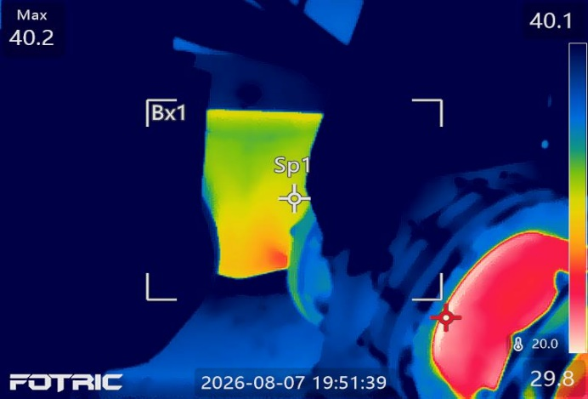 |  |  |  | 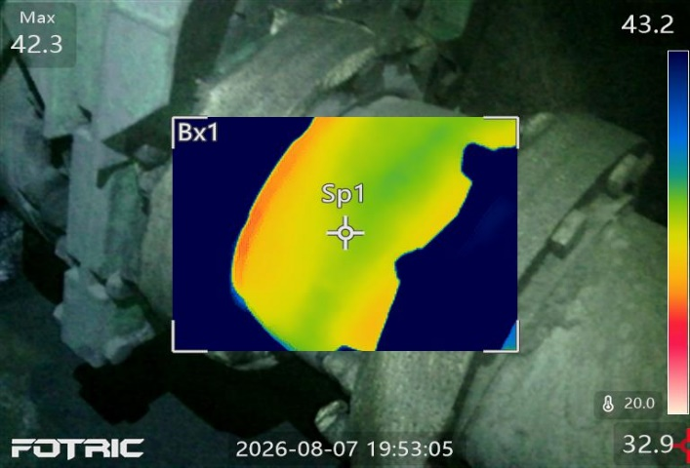
Inspection Point | 1 | Asset | 2300PI001 |  | Notification Number
Differential Temp. |  |  |  |  | Inspection Status
Text Annotation:

