Assignment 2
Warehouse Robot Decision Making with Dynamic Programming and Reinforcement Learning
CPSC-4117EL-01 Artificial Intelligence | Fall 2026
Group 12: Leyan Zeng (0480234), Lanhui Zhang (0465267)

1. Introduction
This assignment studies a warehouse robot operating in a 10 × 10 grid. The robot must collect a package from the pickup station, deliver it to the packing station, and return to the charging dock. Shelves block movement, while congestion zones remain traversable but carry a penalty.
The task is formulated as a Markov Decision Process (MDP). Value Iteration is used when the transition and reward models are known, while Q-Learning learns action values through interaction with the environment. The report follows the assignment structure: MDP formulation, the two algorithms, experiments under different motion probabilities, and a comparison of their performance.

2. MDP Formulation

2.1 State Space and Markov Property
The state is defined as (row, col, has_package, delivered, steps_remaining). The row and column identify the robot location; has_package indicates whether the package has been collected; delivered indicates whether it has reached the packing station; and steps_remaining records the number of steps left before the 120-step limit.
State component | Meaning
row, col | Robot position on a non-shelf cell.
has_package ∈ {0, 1} | 0 before pickup; 1 after pickup.
delivered ∈ {0, 1} | 0 before delivery; 1 after delivery.
steps_remaining ∈ {0, …, 120} | Remaining steps before the maximum-step terminal condition.

The task-progress combinations used are (0, 0), (1, 0), and (1, 1). The combination (0, 1) is not valid because delivery cannot occur before pickup.
Robot position alone is not sufficient. For example, at the packing station the delivery reward is available only if the robot is carrying the package, and the return reward is available only after delivery. Two visits to the same cell can therefore have different outcomes depending on task progress. The package flags preserve this information. Including the remaining-step count also represents the maximum-step terminal condition. With these variables, the next-state distribution and reward depend on the current state and action rather than on the full history.

2.2 Action Space and Transition Model
The action space is A = {up, down, left, right}. In the baseline setting, the intended direction occurs with probability 0.8 and each perpendicular direction occurs with probability 0.1. For example, when the robot chooses up, it moves up with probability 0.8, left with probability 0.1, and right with probability 0.1. If a movement would enter a shelf or leave the grid, the robot stays in its current cell and receives the invalid-move penalty in addition to the step penalty. Congestion cells are traversable but incur a penalty.

2.3 Reward Model
Event | Reward
Pick up the package | +25
Deliver the package at the packing station while carrying it | +40
Return to the charging dock after delivery | +100
Enter a congestion zone | −10
Each time step | −1
Attempt to move into a shelf or outside the grid | −3 additional penalty

The reward is transition-based and additive: the ordinary step penalty applies on each move, and event-specific rewards or penalties are added when the corresponding event occurs, consistent with the supplied environment implementation.

2.4 Discount Factor and Terminal Conditions
The discount factor is γ = 0.95. An episode terminates when the robot has delivered the package and returns to the charging dock, or when steps_remaining reaches zero. A terminal state has no future value. The supplied grid layout is fixed with random seed 42 for the reported experiments; the pickup station is at (2, 2), the packing station at (0, 4), and the charging dock at (6, 0).

3. Part 1: Value Iteration

3.1 Algorithm and Implementation
Value Iteration estimates the best expected discounted return for each state. Starting with V₀(s) = 0, the implementation repeatedly applies the Bellman optimality update:
Vₖ₊₁(s) = maxₐ Σₛ′ P(s′ | s, a) [R(s, a, s′) + γVₖ(s′)]
Here, s includes the remaining-step count, and each transition reduces that count by one. The transition probabilities and reward function are known to the algorithm. The implementation updates the value of each valid state until the maximum absolute change between two successive value tables is less than θ = 10⁻⁶. The greedy policy is then extracted by selecting the action with the highest expected value under the resulting value function.

3.2 Implementation Settings and Convergence
Parameter | Setting
Layout seed | 42
Maximum episode length | 120 steps
Discount factor (γ) | 0.95
Convergence threshold (θ) | 0.000001

Value Iteration is model-based. For every state and action, it calculates the expected return over possible next states and therefore requires both the transition probabilities P(s′ | s, a) and the reward model R(s, a, s′). Unlike Q-Learning, it does not learn these probabilities from trial-and-error interaction. The supplied environment performs deterministic steps, so this implementation uses its grid and reward definitions while explicitly calculating the stochastic outcomes required by the assignment.

3.3 Policy Visualization and Results at p = 0.80
For the required p = 0.80 setting, Value Iteration converged after 73 iterations with γ = 0.95 and θ = 10⁻⁶. Figure 1 shows three policy slices for the task-progress phases: before pickup, while carrying the package, and after delivery. The displayed actions are for states with 120 steps remaining; because the remaining-step count is part of the state, the preferred action may differ at shorter horizons.
Intended-action probability | Convergence iterations | γ | θ
p = 0.80 | 73 | 0.95 | 1 × 10⁻⁶

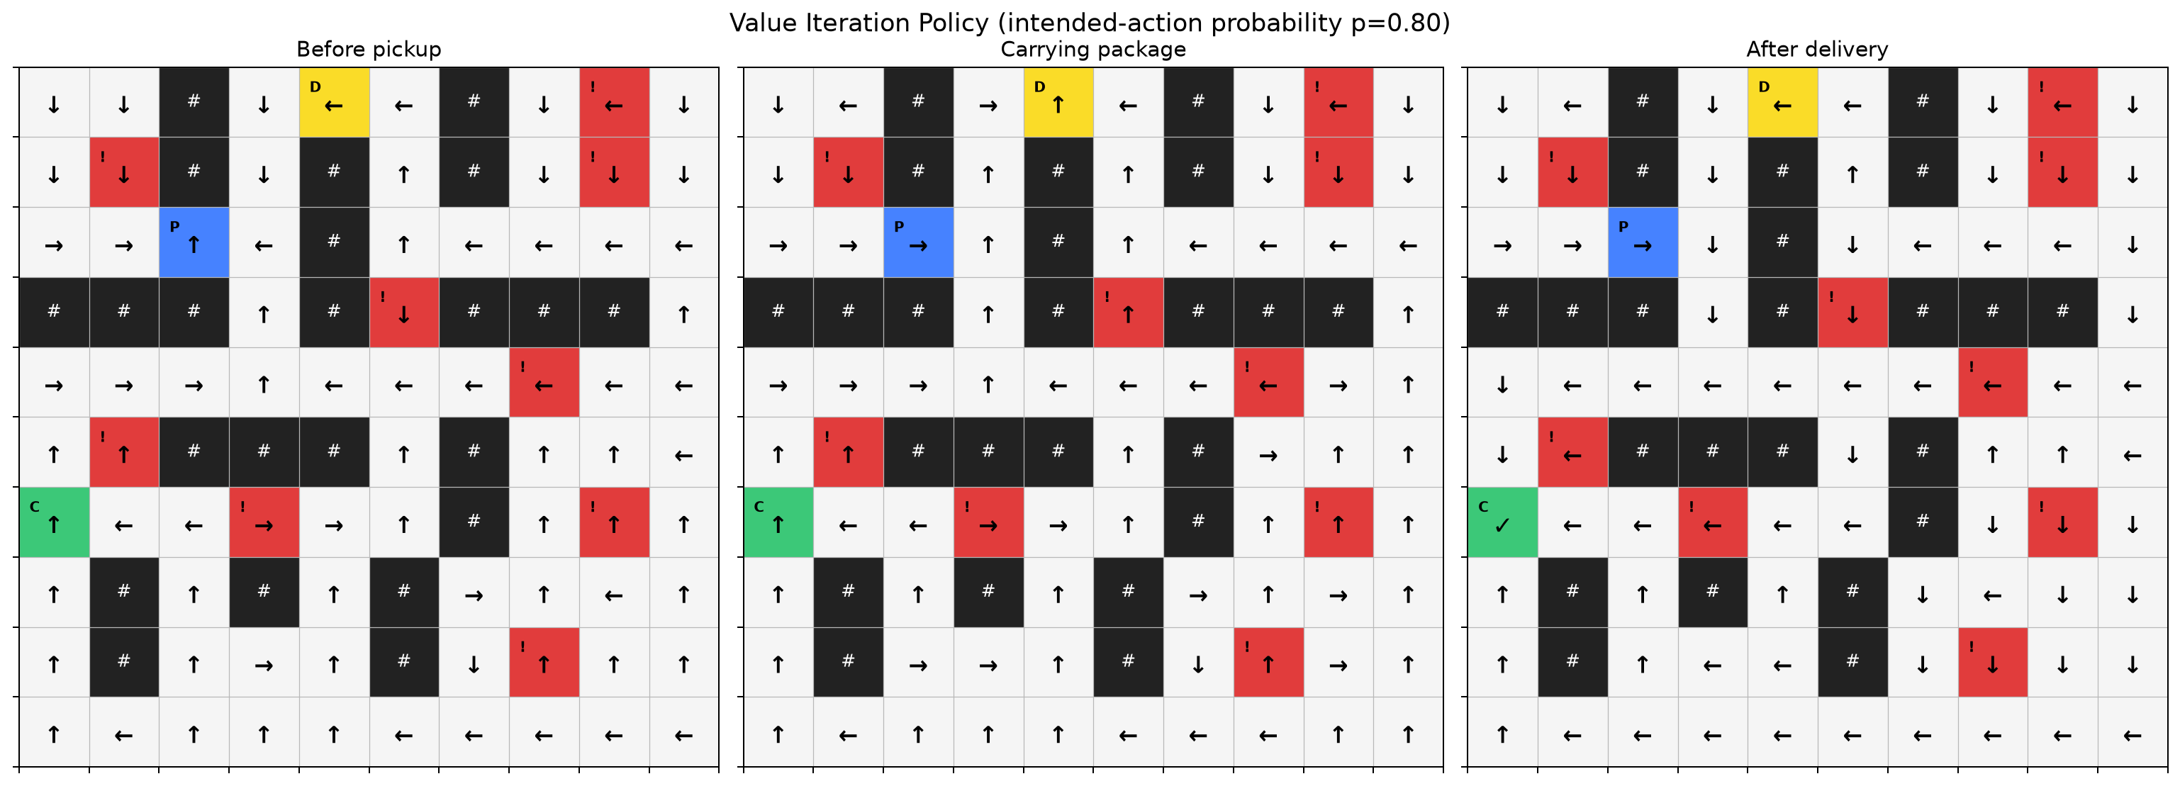
Figure 1. Value Iteration policy at p = 0.80, shown for three task-progress phases at a fixed 120-step horizon. # indicates a shelf, ! a congestion cell, P the pickup station, D the packing station, and C the charging dock.

4. Part 2: Q-Learning

4.1 Algorithm and Implementation
To be completed: Add the Q-Learning method, Q-table state-action representation, update equation, epsilon-greedy exploration, and exploration-rate decay.

4.2 Hyperparameter Configurations and Random Seeds
To be completed: Report at least two meaningful hyperparameter configurations and list the random seeds used for training and evaluation.

4.3 Training Results and Convergence
To be completed: Insert the cumulative-reward-versus-episode plot, task-success results, and a brief discussion of approximate convergence and robustness across seeds.

4.4 Greedy Policy and Evaluation
To be completed: Insert the learned policy visualization and summarize one evaluation run with exploration disabled.

5. Part 3: Stochastic Environment Experiments

5.1 Experimental Setup
To investigate motion uncertainty, the intended-action probability was set to p = 1.00, 0.90, and 0.80. The remaining probability was split equally between the two perpendicular directions. The same layout (seed 42), reward definitions, discount factor, and convergence threshold were used across the three settings. Each Value Iteration policy was evaluated over 500 episodes using different episode random seeds.

5.2 Value Iteration Results under Different Motion Probabilities
p | Iterations | Average cumulative reward | Success rate | Average steps
1.00 | 31 | 143.00 | 100% | 22.00
0.90 | 57 | 132.37 | 100% | 25.30
0.80 | 73 | 118.08 | 100% | 29.47

The average cumulative reward decreased as motion became less reliable, while the average number of steps increased. This indicates that unintended moves made task completion less efficient in the tested layout. All 500 evaluation episodes succeeded in each setting on this fixed layout; this result should not be interpreted as a guarantee for every possible layout.

5.3 Q-Learning Results under Different Motion Probabilities
To be completed: Add Q-Learning results under p = 1.00, 0.90, and 0.80. Use the same evaluation metrics as in Section 5.2 so the results can be compared directly.

5.4 Comparative Performance under Different Probabilities
To be completed: Once Q-Learning results are available, add a compact table comparing both algorithms at each probability using average cumulative reward, success rate, convergence behaviour, and policy outcome.

5.5 Policy Visualization and Motion Uncertainty

5.5.1 Policy Visualization
Figure 1 presents the p = 0.80 policy. Figures 2 and 3 show the corresponding policy slices for p = 0.90 and p = 1.00, using the same station layout and the same three task-progress phases.
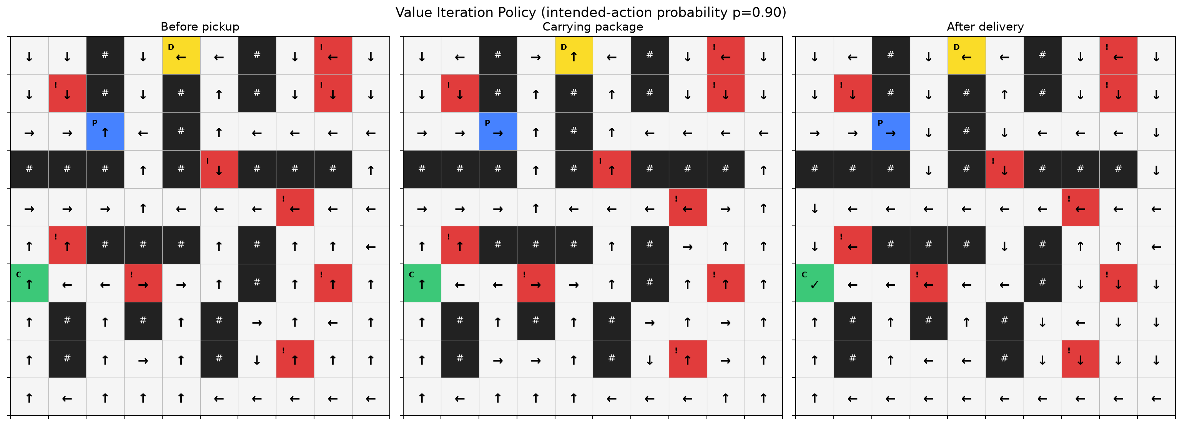
Figure 2. Value Iteration policy at p = 0.90 for the three task-progress phases; the station layout is unchanged.
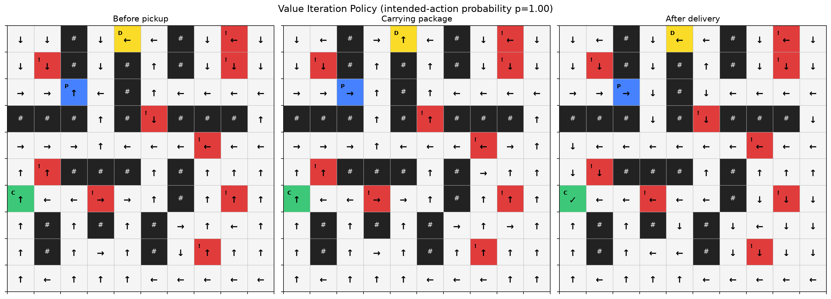
Figure 3. Value Iteration policy at p = 1.00 for the three task-progress phases; the station layout is unchanged.

5.5.2 Effect of Motion Uncertainty on the Preferred Action
One state with a changed preferred action is (5, 1, 1, 1, 96), meaning the robot is at row 5, column 1, has collected and delivered the package, and has 96 steps remaining. The state was observed in evaluation trajectories for p = 0.90 and p = 0.80; the p = 1.00 entry shows the policy recommendation for the same state.
State (row, col, has_package, delivered, steps_remaining) | p = 1.00 | p = 0.90 | p = 0.80
(5, 1, 1, 1, 96) | Down | Left | Left

At p = 1.00, moving down leads to a cell adjacent to the charging dock, giving a favourable direct route back. As p decreases, choosing down introduces a chance of moving right into a shelf, causing the robot to remain in place and receive the invalid-move penalty. Choosing left has perpendicular outcomes that lead to passable cells above and below the robot. These differences change the expected returns of the actions, making left preferable at p = 0.90 and p = 0.80.

6. Comparison and Discussion

6.1 Average Cumulative Reward and Success Rate
To be completed: Compare the measured rewards and task-success rates of Value Iteration and Q-Learning under the same motion probabilities. Avoid drawing conclusions until both sets of results are available.

6.2 Convergence Behaviour
To be completed: Contrast Value Iteration convergence in planning iterations with Q-Learning learning curves and explain how model knowledge affects the two methods.

6.3 Policy Differences and Impact of Motion Uncertainty
To be completed: Discuss whether the learned Q-Learning policy matches or differs from the Value Iteration policy, and how uncertainty affects routes near congestion zones.

7. Conclusion
The Value Iteration implementation represents robot location, task progress, and remaining steps, and extracts a policy using the specified stochastic transition model. In the tested layout, lower intended-action probabilities reduced the average reward and increased the average number of steps. The preferred action also changed in some states, showing that motion uncertainty can affect route choices. This conclusion currently summarizes the Value Iteration contribution; it should be updated after Q-Learning results and the direct comparison between both methods are incorporated.

8. Group Contributions and AI Usage Statement

8.1 Group Contributions
Member / role | Contribution
Member A | MDP formulation, Value Iteration implementation, policy visualizations, and Value Iteration experiments.
Member B | Q-Learning implementation, training experiments, hyperparameter tests, and learned-policy evaluation.
Both members | Cross-algorithm comparison, discussion, final report integration, and final code/output review.

Replace Member A and Member B with the appropriate group member names before submission.

8.2 AI Usage Statement
OpenAI ChatGPT was used to assist with interpreting the assignment requirements, discussing algorithm design, reviewing the Value Iteration implementation, and drafting and revising report text. The group should review the final code, reported results, and all statements before submission. Conversation link: https://chatgpt.com/c/6add6410-3994-83ea-89f6-3ad2701d6542

