ggplot2绘制渐变色散点图与折线图

避尘

一、渐变色散点图基础绘图

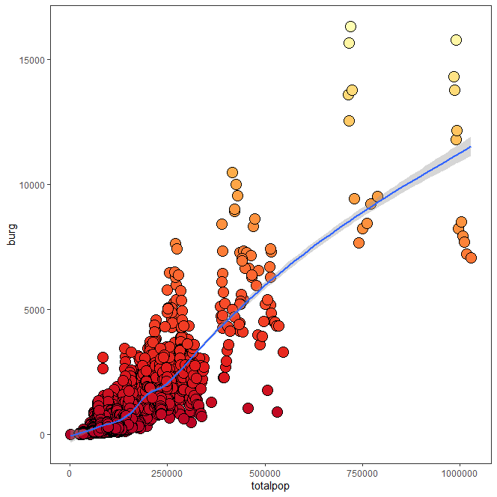

library(ggplot2)

ggplot() +

geom_point(aes(totalpop,burg,fill=burg),A,color="black",

shape=21, size=5)+

geom_smooth(aes(totalpop,burg),A,size=1)+

scale_fill_distiller(name="Point",palette="YlOrRd")+

theme_bw()+

theme(panel.grid=element_blank(),

legend.position = "none")

二、含渐变色拟合曲线的渐变色散点图

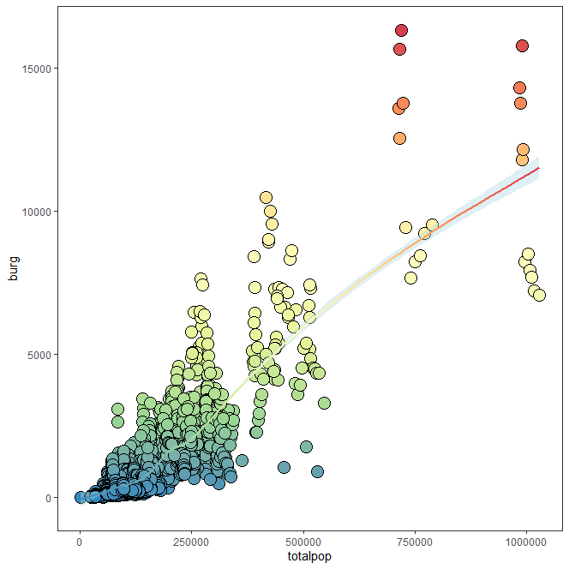

library(ggplot2)

ggplot() +

geom_point(aes(totalpop,burg,fill=burg),A,color="black",shape=21, size=5)+

geom_smooth(aes(totalpop,burg,color=..y..),A,size=1,fill="lightblue")+

scale_fill_distiller(name="Point",palette = "Spectral")+

scale_color_distiller(name="Point",palette = "Spectral")+

theme_bw()+

theme(panel.grid=element_blank(),

legend.position = "none")

三、渐变色折线图基础绘图

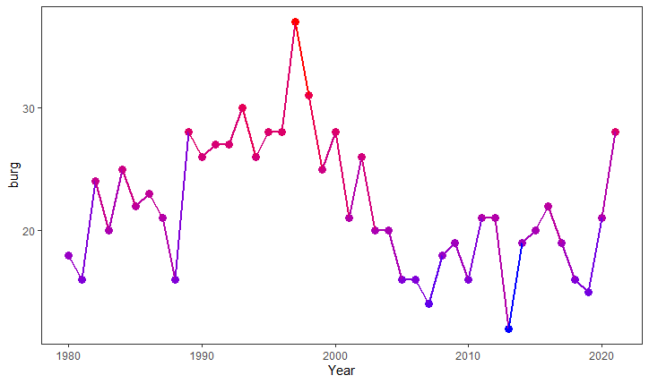

ggplot(B, aes(x = Year))+

geom_point(aes(y = burg,colour=burg),size=3)+

geom_line(aes(y =burg,colour=burg),size=1) +

scale_color_gradient(low = "blue", high = "red")+

theme_bw()+

theme(panel.grid=element_blank(),

legend.position = "none")

四、双渐变色双轴折线图

**注意：**在双折线图中，要想给另外一条折线增加不一样的渐变色，需要借助ggnewscale包的new_scale_color()才能实现。

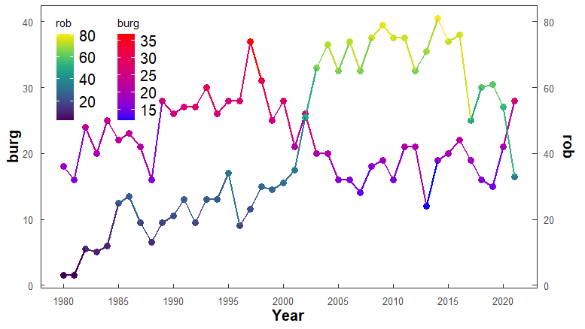

library(ggplot2)

library(ggnewscale)#增加新的渐变色

library("viridis")#漂亮的渐变色

ggplot(B, aes(x = Year))+

geom_point(aes(y = burg,colour=burg),size=3)+

geom_line(aes(y =burg,colour=burg),size=1) +

scale_color_gradient(low = "red", high = "blue")+

# geoms below will use another color scale

new_scale_color() +#下面的折线图将采用新的渐变色

geom_point(aes(y =(rob)/2,colour=rob),size=3)+

geom_line(aes(y =(rob)/2,colour=rob),size=1) +

scale_color_viridis()+

scale_y_continuous(name = 'burg',

sec.axis = sec_axis(~.*2,name = 'rob'))+

xlab("Year")+

theme_bw()+

theme(panel.grid = element_blank(),

legend.background = element_blank(),

legend.text = element_text(size=15),

legend.position = c(0.02,0.98),

legend.direction = "vertical",

legend.box = "horizontal",

legend.justification = c(0, 1),

axis.title = element_text(size=15,face = "bold"),

axis.ticks.length = unit(-0.15, "cm"),

axis.text.x = element_text(margin = margin(t = 7),vjust = 0.4,size = 10),

axis.text.y.left = element_text(margin = margin(r = 7),size = 10),

axis.text.y.right =element_text(margin = margin(l = 7,r = 7),size=10))+

scale_x_continuous(breaks = seq(1980,2021,5))

好看的渐变色汇总：

亮丽彩虹色scale_color_gradientn(colours =rainbow(10))

红蓝渐变scale_color_gradient(low = "blue", high = "red")

红白蓝渐变scale_color_gradient2(low = "red", mid = "white", high = "blue")

复古彩虹色scale_color_distiller(palette = "Spectral")

红黄渐变色scale_color_distiller(palette="YlOrRd")+

黄绿渐变色scale_color_viridis_c()+#library("viridis")

紫黄渐变色scale_color_viridis(option = "plasma")#library("viridis")