**Supplementary Materials**

**The Association of Stay-at-Home Orders and the Spread of COVID-19 in Rural and Urban United States: An interrupted time series study**

Model Regression 4

eMethods 4

Figure 2 Generation 6

summary(lm1glmmrelev) 8

summary(lm2relev) 9

summary(lm2catziprelev) 10

summary(lm2catziprelev_cs_cdate) 11

summary(lm2catziprelev_toep_cdate) 12

summary(lm2catziprelev_toep_date2) 13

summary(lm2catziprelev_us_date2) 14

summary(lm2catziprelev_randslope_cdate) 15

summary(lm2catziprelev_randslope_date2) 16

summary(lm3glmmrelev) 17

summary(lm3glmmRandslope) 18

summary(lm4catziprelev) 19

Simulated Quantile Scaled Residual Plots 20

SimOut_lm1glmmrelev 20

SimOut_lm2relev 24

SimOut_lm2catziprelev 28

SimOut_lm2catziprelev_cs 32

SimOut_lm2catziprelev_tpc 36

SimOut_lm2catziprelev_rsc 40

SimOut_lm2catziprelev_rsd 44

SimOut_lm3glmmrelev 48

SimOut_lm3glmmRandSlope 52

SimOut_lm4catziprelev 56

Removing Outliers 60

Removing Outliers lm3glmm 60

Removing Outliers Random Slope lm3glmmRandSlope 65

Sensitivity Analysis 70

Five-Day Lag 70

Ten-Day Lag 104

Mobility Data Analysis 137

Stay-at-Home Orders Start and End Dates 146

References 148

# Model Regression

## eMethods

Analysis of the data was approached utilizing the following mixed effects count data models: Poisson (lm1glmmrelev); zero-inflated Poisson (lm2relev, lm2catziprelev, lm2catziprelev_cs_cdate, lm2catziprelev_toep_cdate, lm2catziprelev_toep_date2, and lm2catziprelev_us_date2); zero-inflated Poisson with random intercept and slope (lm2catziprelev_randslope_cdate and lm2catziprelev_randslope_date2); negative binomial (lm3glmmrelev); negative binomial with random intercept and slope (lm3glmmRandslope); zero-inflated negative binomial (lm4catziprelev). “Catzip” refers to only using the categories of dates (during and after stay-at-home orders) and their interactions with county type for the zero inflated model, instead of all of the variables used in the conditional model.

All models used the same variables for the fixed effects, as all are necessary to account for the time varying nature of stay-at-home orders. In addition, all models were offset by the population of the county divided by 100,000 to standardize the results per 100,000 people. All models were ran using the glmmTMB package in R.1Summary results of each model are detailed below, where URBinary represents the rurality status (a dummy variable that is 0 for rural counties and 1 for urban counties), c_daterelevduring SaH represents the stay-at-home order status (a dummy variable that is 0 for not during stay-at-home orders and 1 for during stay-at-home orders), c_daterelevafter SaH represents another indication of the stay-at-home order status (a dummy variable that is 0 for after stay-at-home orders and 1 for after stay-at-home orders), Date2 represents the number of days since January 22, 2020, dsahcarried represents the number of days under stay-at-home orders at a given time and the total number of days under stay-at-home orders while c_daterelevafter SaH is 1, asahcarried represents the number of days since the end of stay-at-home orders, URBinary:c_daterelevduring SaH represents the interaction term between the rurality status and stay-at-home order status (a dummy variable that is 0 for rural counties and for urban counties not under stay-at-home orders, and 1 for urban counties under stay-at-home orders), URBinary:c_daterelevafter SaH represents another interaction term between the rurality status and stay-at-home order status (a dummy variable that is 0 for rural counties and for urban counties not after stay-at-home orders, and 1 for urban counties after stay-at-home orders), URBinary:Date2 represents the interaction term between the number of days since January 22, 2020 and the rurality status (0 for rural counties and 1 through 142 for urban counties), URBinary:dsahcarried represents the interaction term between the number of days under stay-at-home orders and the rurality status (0 for rural counties and 0 for urban counties before stay-at-home orders), URBinary:asahcarried represents the interaction term between the number of days after stay-at-home orders and the rurality status (0 for rural counties and 0 for urban counties before the end of stay-at-home orders).

The models were compared on the basis of model diagnostics, Akaike information criterion (AIC), and parsimony (preferring non zero-inflated models where appropriate and prioritizing model diagnostics). All models were consistent in terms of estimate signs and significance.

Model diagnostics were performed examining the model’s simulated quantile scaled residuals using the DHARMA package in R.2 The models were assessed for over-dispersion, zero-inflation, and expected distribution of the residuals. The mixed effects negative binomial model with random intercept by county was found to be statistically significantly not zero-inflated and having normally distributed residuals, but over-dispersed and having outliers. To examine if this over-dispersion was due to the presence of outliers, the model was rerun after outliner counties (369 of 3142) were removed, but this restricted model was still over-dispersed. The models were also assessed for temporal autocorrelation using the Durbin-Watson test in the DHARMa package.2 The zero inflated Poisson model (lm2catziprelev) was found to only be temporally auto correlated and thus was chosen to be the best model. It was examined further using variance-covariance structures in an attempt to remove the temporal autocorrelation (lm2catziprelev_cs_cdate, lm2catziprelev_toep_cdate, lm2catziprelev_toep_date2, and lm2catziprelev_us_date2). Compound symmetry (cs_cdate) and Toeplitz (toep_cdate) structures where the only structures out of AR(1), compound symmetry, Toeplitz, and unstructured to converge using categorical date. Similarly, Toeplitz (toep_date2) and unstructured (us_date2) were the only structures able to converge using days since January 22nd. All attempts to remove temporal autocorrelation were inadequate and detrimental to the overall fit of the model. Temporal autocorrelation was thus deemed unavoidable. Moreover, it did not have a significant effect on the results because of the long follow-up time, the significance of the results, and the large number of counties.3

The final model chosen was the zero inflated Poisson model using the categories of dates and their interactions with county type for the zero inflation model (lm2catziprelev). The equations of the final model are:

(Equation 1)

(Equation 2)

(Equation 3)

where Equation 1 is the probability distribution, Equation 2 is the zero inflation model, and Equation 3 is the Poisson model. represents the 14-day lagged incidence of COVID-19 in the *ith* county on the *jth* day (technically the *(j+14)th* day) represents the probability of being 0 for the *ith* county on the *jth* day, represents the 14-day lagged incidence of COVID-19 in the *ith* county on the *jth* day, represents the random effect of the *ith* county, *Populationi* represents the population of the *ith* county, Rurality*i* represents the rurality status of the *ith* county (a dummy variable that is 0 for rural counties and 1 for urban counties), Under_SAH*ij* represents the stay-at-home order status of the *ith* county on the *jth* day (a dummy variable that is 0 for not during stay-at-home orders and 1 for during stay-at-home orders), After_SAH*ij* represents another indication of the stay-at-home order status of the *ith* county on the *jth* day (a dummy variable that is 0 for after stay-at-home orders and 1 for after stay-at-home orders), Days*ij* represents the number of days since January 22, 2020 for the *ith* county on the *jth* day, Days_Under_SAH*ij* represents the number of days under stay-at-home orders for the *ith* county on the *jth* day, Days_After_SAH*ij* represents the number of days since the end of stay-at-home orders for the *ith* county on the *jth* day, Rurality*Under_SAH*ij* represents the interaction term between the rurality status of the *ith* county and stay-at-home order status for the *ith* county on the *jth* day (a dummy variable that is 0 for rural counties and for urban counties not under stay-at-home orders, and 1 for urban counties under stay-at-home orders), Rurality*After_SAH*ij* represents another interaction term between the rurality status of the *ith* county and stay-at-home order status for the *ith* county on the *jth* day (a dummy variable that is 0 for rural counties and for urban counties not after stay-at-home orders, and 1 for urban counties after stay-at-home orders), Rurality*Days*ij* represents the interaction term between the number of days since January 22, 2020 and the rurality status for the *ith* county on the *jth* day (0 for rural counties and 1 through 142 for urban counties), Rurality*Days_Under_SAH*ij* represents the interaction term between the number of days under stay-at-home orders and the rurality status for the *ith* county on the *jth* day (0 for rural counties and 0 for urban counties before stay-at-home orders), Rurality*Days_After_SAH*ij* represents the interaction term between the number of days after stay-at-home orders and the rurality status for the *ith* county on the *jth* day (0 for rural counties and 0 for urban counties before the end of stay-at-home orders).

Therefore, represents the baseline log odds of being a “zero” day for a typical county at *j* = 0 (in that the zero inflated model assumes two zero generating processes, the first generating zeros, the top half of equation 1, and the second a Poisson process that generates counts including zeros, the bottom half of equation 1. In this case a “zero” day is one that never had the chance of being a count), represents the change in the log odds of being a zero for urban counties, represents the change in the log odds during stay-at-home orders, represents the change in the log odds after stay-at-home orders, represents the additional change in the log odds during stay-at-home orders for urban counties, represents the additional change in the log odds after stay-at-home orders for urban counties, represents the baseline outcome (i.e. 14-day lagged new daily cases of COVID-19) for a typical county at *j* = 0, represents the random effects (the random intercept) which is the change in baseline outcome from the typical county for the *ith* county (that is is the baseline outcome for the 1*st* county), represents the change in the outcome for urban counties, represents the change in the outcome during stay-at-home orders, represents the change in the outcome after stay-at-home orders, represents the change in the outcome for each day since *j* =0 (January 22, 2020), represents the change in the outcome for each day a county was under stay-at-home orders, represents the change in the outcome for each day a county was out of stay-at-home orders, represents the additional change in the outcome for urban counties during stay-at-home orders (that is for urban counties the “actual ” is + ), represents the additional change in the outcome for urban counties after stay-at-home orders, represents the additional change in the outcome for each day since *j* =0 (January 22, 2020), represents the additional change in the outcome for urban counties for each day it was under stay-at-home orders, represents the additional change in the outcome for urban counties for each day it was out of stay-at-home orders.

## Figure 2 Generation

Figure 2 was generated by inputting the estimates of fixed effects and the urban and rural averages of stay-at-home orders start and end dates. The outcome was divided by the offset to standardize the results per 100,000 population. The respective offsets for urban and rural counties were calculated using urban and rural counties respective population averages. Similarly, the extrapolations were generated by using the conditional model only with intercept and variables: Rurality, Days, and Rurality*Days. The extrapolations represent continuation of the before stay-at-home order trends.

## summary(lm1glmmrelev)

## Family: poisson ( log )  
## Formula:   
## newcase_nst_14 ~ offset(popoff) + URBinary * c_daterelev + URBinary *   
## Date2 + URBinary * dsahcarried + URBinary * asahcarried + (1 | c_FIPS)  
## Data: df_14  
##   
## AIC BIC logLik deviance df.resid   
## 2575878 2576022 -1287926 2575852 446151   
##   
## Random effects:  
##   
## Conditional model:  
## Groups Name Variance Std.Dev.  
## c_FIPS (Intercept) 1.904 1.38   
## Number of obs: 446164, groups: c_FIPS, 3142  
##   
## Conditional model:  
## Estimate Std. Error z value Pr(>|z|)   
## (Intercept) -2.6640807 0.0345759 -77.05 <2e-16 ***  
## URBinary -1.0865939 0.0539059 -20.16 <2e-16 ***  
## c_daterelevafter SaH 0.7165783 0.0142383 50.33 <2e-16 ***  
## c_daterelevduring SaH 0.8961563 0.0102393 87.52 <2e-16 ***  
## Date2 0.0336172 0.0001930 174.18 <2e-16 ***  
## dsahcarried -0.0276698 0.0002731 -101.30 <2e-16 ***  
## asahcarried -0.0170237 0.0003703 -45.97 <2e-16 ***  
## URBinary:c_daterelevafter SaH -1.0547728 0.0150346 -70.16 <2e-16 ***  
## URBinary:c_daterelevduring SaH -0.7052632 0.0106686 -66.11 <2e-16 ***  
## URBinary:Date2 0.0386741 0.0002361 163.83 <2e-16 ***  
## URBinary:dsahcarried -0.0511247 0.0003085 -165.74 <2e-16 ***  
## URBinary:asahcarried -0.0151175 0.0004177 -36.19 <2e-16 ***  
## ---  
## Signif. codes: 0 '***' 0.001 '**' 0.01 '*' 0.05 '.' 0.1 ' ' 1

## summary(lm2relev)

## Family: poisson ( log )  
## Formula:   
## newcase_nst_14 ~ offset(popoff) + URBinary * c_daterelev + URBinary *   
## Date2 + URBinary * dsahcarried + URBinary * asahcarried + (1 | c_FIPS)  
## Zero inflation:   
## ~URBinary * c_daterelev + URBinary * Date2 + URBinary * dsahcarried +   
## URBinary * asahcarried  
## Data: df_14  
##   
## AIC BIC logLik deviance df.resid   
## 2185560 2185835 -1092755 2185510 446139   
##   
## Random effects:  
##   
## Conditional model:  
## Groups Name Variance Std.Dev.  
## c_FIPS (Intercept) 1.493 1.222   
## Number of obs: 446164, groups: c_FIPS, 3142  
##   
## Conditional model:  
## Estimate Std. Error z value Pr(>|z|)   
## (Intercept) 0.3294486 0.0345318 9.54 < 2e-16 ***  
## URBinary -1.7134201 0.0507236 -33.78 < 2e-16 ***  
## c_daterelevafter SaH 0.3334240 0.0149715 22.27 < 2e-16 ***  
## c_daterelevduring SaH 0.4153541 0.0104818 39.63 < 2e-16 ***  
## Date2 0.0072637 0.0002595 27.99 < 2e-16 ***  
## dsahcarried -0.0068868 0.0003361 -20.49 < 2e-16 ***  
## asahcarried 0.0074896 0.0004262 17.57 < 2e-16 ***  
## URBinary:c_daterelevafter SaH -0.4997899 0.0157299 -31.77 < 2e-16 ***  
## URBinary:c_daterelevduring SaH -0.0822104 0.0108929 -7.55 4.45e-14 ***  
## URBinary:Date2 0.0319725 0.0003020 105.88 < 2e-16 ***  
## URBinary:dsahcarried -0.0393398 0.0003725 -105.61 < 2e-16 ***  
## URBinary:asahcarried -0.0074082 0.0004742 -15.62 < 2e-16 ***  
## ---  
## Signif. codes: 0 '***' 0.001 '**' 0.01 '*' 0.05 '.' 0.1 ' ' 1  
##   
## Zero-inflation model:  
## Estimate Std. Error z value Pr(>|z|)   
## (Intercept) 3.9325320 0.0368018 106.86 < 2e-16 ***  
## URBinary 0.2730539 0.0524306 5.21 1.91e-07 ***  
## c_daterelevafter SaH -0.2081402 0.0469575 -4.43 9.31e-06 ***  
## c_daterelevduring SaH -0.4189844 0.0285833 -14.66 < 2e-16 ***  
## Date2 -0.0524315 0.0006947 -75.47 < 2e-16 ***  
## dsahcarried 0.0372385 0.0007767 47.95 < 2e-16 ***  
## asahcarried 0.0428863 0.0014264 30.07 < 2e-16 ***  
## URBinary:c_daterelevafter SaH 1.5684013 0.0823941 19.04 < 2e-16 ***  
## URBinary:c_daterelevduring SaH 0.8701813 0.0440532 19.75 < 2e-16 ***  
## URBinary:Date2 -0.0353790 0.0010536 -33.58 < 2e-16 ***  
## URBinary:dsahcarried 0.0132444 0.0012072 10.97 < 2e-16 ***  
## URBinary:asahcarried 0.0426762 0.0024530 17.40 < 2e-16 ***  
## ---  
## Signif. codes: 0 '***' 0.001 '**' 0.01 '*' 0.05 '.' 0.1 ' ' 1

## summary(lm2catziprelev)

## Family: poisson ( log )  
## Formula:   
## newcase_nst_14 ~ offset(popoff) + URBinary * c_daterelev + URBinary *   
## Date2 + URBinary * dsahcarried + URBinary * asahcarried + (1 | c_FIPS)  
## Zero inflation: ~URBinary * c_daterelev  
## Data: df_14  
##   
## AIC BIC logLik deviance df.resid   
## 2220521 2220730 -1110242 2220483 446145   
##   
## Random effects:  
##   
## Conditional model:  
## Groups Name Variance Std.Dev.  
## c_FIPS (Intercept) 1.389 1.179   
## Number of obs: 446164, groups: c_FIPS, 3142  
##   
## Conditional model:  
## Estimate Std. Error z value Pr(>|z|)   
## (Intercept) -0.6452101 0.0342097 -18.86 < 2e-16 ***  
## URBinary -0.9052841 0.0496647 -18.23 < 2e-16 ***  
## c_daterelevafter SaH 0.3348040 0.0152451 21.96 < 2e-16 ***  
## c_daterelevduring SaH 0.4726759 0.0111321 42.46 < 2e-16 ***  
## Date2 0.0208674 0.0002576 81.02 < 2e-16 ***  
## dsahcarried -0.0184094 0.0003317 -55.50 < 2e-16 ***  
## asahcarried -0.0054122 0.0004206 -12.87 < 2e-16 ***  
## URBinary:c_daterelevafter SaH -0.5307952 0.0159890 -33.20 < 2e-16 ***  
## URBinary:c_daterelevduring SaH -0.1659420 0.0115200 -14.40 < 2e-16 ***  
## URBinary:Date2 0.0215742 0.0003019 71.46 < 2e-16 ***  
## URBinary:dsahcarried -0.0309239 0.0003699 -83.60 < 2e-16 ***  
## URBinary:asahcarried 0.0023423 0.0004701 4.98 6.28e-07 ***  
## ---  
## Signif. codes: 0 '***' 0.001 '**' 0.01 '*' 0.05 '.' 0.1 ' ' 1  
##   
## Zero-inflation model:  
## Estimate Std. Error z value Pr(>|z|)   
## (Intercept) 0.83343 0.01385 60.19 <2e-16 ***  
## URBinary -0.59437 0.01740 -34.15 <2e-16 ***  
## c_daterelevafter SaH -1.37483 0.02111 -65.13 <2e-16 ***  
## c_daterelevduring SaH -1.08682 0.01874 -57.99 <2e-16 ***  
## URBinary:c_daterelevafter SaH -0.55237 0.03219 -17.16 <2e-16 ***  
## URBinary:c_daterelevduring SaH -0.80902 0.02630 -30.77 <2e-16 ***  
## ---  
## Signif. codes: 0 '***' 0.001 '**' 0.01 '*' 0.05 '.' 0.1 ' ' 1

## summary(lm2catziprelev_cs_cdate)

## Family: poisson ( log )  
## Formula:   
## newcase_nst_14 ~ offset(popoff) + URBinary * c_daterelev + URBinary *   
## Date2 + URBinary * dsahcarried + URBinary * asahcarried +   
## (1 | c_FIPS) + cs(c_daterelev + 0 | c_FIPS)  
## Zero inflation: ~URBinary * c_daterelev  
## Data: df_14  
##   
## AIC BIC logLik deviance df.resid   
## 1886145.8 1886399.0 -943049.9 1886099.8 446141   
##   
## Random effects:  
##   
## Conditional model:  
## Groups Name Variance Std.Dev. Corr   
## c_FIPS (Intercept) 4.359e-06 0.002088   
## c_FIPS.1 c_daterelevbefore SaH 1.395e+00 1.181049 0.56 (cs)  
## Number of obs: 446164, groups: c_FIPS, 3142  
##   
## Conditional model:  
## Estimate Std. Error z value Pr(>|z|)   
## (Intercept) -1.1492470 0.0370040 -31.06 < 2e-16 ***  
## URBinary -0.8032034 0.0521819 -15.39 < 2e-16 ***  
## c_daterelevafter SaH 0.5686569 0.0400956 14.18 < 2e-16 ***  
## c_daterelevduring SaH 0.5825936 0.0381258 15.28 < 2e-16 ***  
## Date2 0.0226415 0.0002548 88.85 < 2e-16 ***  
## dsahcarried -0.0211272 0.0003418 -61.81 < 2e-16 ***  
## asahcarried -0.0076120 0.0004400 -17.30 < 2e-16 ***  
## URBinary:c_daterelevafter SaH -0.4869172 0.0550463 -8.85 < 2e-16 ***  
## URBinary:c_daterelevduring SaH -0.2393014 0.0533266 -4.49 7.21e-06 ***  
## URBinary:Date2 0.0224831 0.0003010 74.68 < 2e-16 ***  
## URBinary:dsahcarried -0.0307955 0.0003805 -80.94 < 2e-16 ***  
## URBinary:asahcarried -0.0024864 0.0004938 -5.03 4.78e-07 ***  
## ---  
## Signif. codes: 0 '***' 0.001 '**' 0.01 '*' 0.05 '.' 0.1 ' ' 1  
##   
## Zero-inflation model:  
## Estimate Std. Error z value Pr(>|z|)   
## (Intercept) 0.49083 0.01631 30.09 <2e-16 ***  
## URBinary -0.43144 0.02007 -21.49 <2e-16 ***  
## c_daterelevafter SaH -1.23339 0.02466 -50.01 <2e-16 ***  
## c_daterelevduring SaH -0.99054 0.02247 -44.09 <2e-16 ***  
## URBinary:c_daterelevafter SaH -0.62784 0.03622 -17.33 <2e-16 ***  
## URBinary:c_daterelevduring SaH -0.94321 0.03091 -30.52 <2e-16 ***  
## ---  
## Signif. codes: 0 '***' 0.001 '**' 0.01 '*' 0.05 '.' 0.1 ' ' 1

## summary(lm2catziprelev_toep_cdate)

## Family: poisson ( log )  
## Formula:   
## newcase_nst_14 ~ offset(popoff) + URBinary * c_daterelev + URBinary *   
## Date2 + URBinary * dsahcarried + URBinary * asahcarried +   
## (1 | c_FIPS) + toep(c_daterelev + 0 | c_FIPS)  
## Zero inflation: ~URBinary * c_daterelev  
## Data: df_14  
##   
## AIC BIC logLik deviance df.resid   
## 1886153.2 1886417.4 -943052.6 1886105.2 446140   
##   
## Random effects:  
##   
## Conditional model:  
## Groups Name Variance Std.Dev. Corr   
## c_FIPS (Intercept) 3.133e-06 0.00177   
## c_FIPS.1 c_daterelevbefore SaH 1.388e+00 1.17807   
## c_daterelevafter SaH 1.590e+00 1.26104 0.55   
## c_daterelevduring SaH 1.828e+00 1.35185 0.59 0.55   
## Number of obs: 446164, groups: c_FIPS, 3142  
##   
## Conditional model:  
## Estimate Std. Error z value Pr(>|z|)   
## (Intercept) -1.1466523 0.0369283 -31.05 < 2e-16 ***  
## URBinary -0.8003107 0.0520796 -15.37 < 2e-16 ***  
## c_daterelevafter SaH 0.5676059 0.0401813 14.13 < 2e-16 ***  
## c_daterelevduring SaH 0.5815646 0.0374309 15.54 < 2e-16 ***  
## Date2 0.0226389 0.0002548 88.85 < 2e-16 ***  
## dsahcarried -0.0211143 0.0003418 -61.77 < 2e-16 ***  
## asahcarried -0.0076127 0.0004397 -17.31 < 2e-16 ***  
## URBinary:c_daterelevafter SaH -0.4894416 0.0553070 -8.85 < 2e-16 ***  
## URBinary:c_daterelevduring SaH -0.2472263 0.0521449 -4.74 2.13e-06 ***  
## URBinary:Date2 0.0224768 0.0003010 74.67 < 2e-16 ***  
## URBinary:dsahcarried -0.0307992 0.0003804 -80.96 < 2e-16 ***  
## URBinary:asahcarried -0.0024785 0.0004936 -5.02 5.13e-07 ***  
## ---  
## Signif. codes: 0 '***' 0.001 '**' 0.01 '*' 0.05 '.' 0.1 ' ' 1  
##   
## Zero-inflation model:  
## Estimate Std. Error z value Pr(>|z|)   
## (Intercept) 0.49144 0.01631 30.13 <2e-16 ***  
## URBinary -0.43017 0.02007 -21.44 <2e-16 ***  
## c_daterelevafter SaH -1.23361 0.02467 -50.00 <2e-16 ***  
## c_daterelevduring SaH -0.99132 0.02247 -44.12 <2e-16 ***  
## URBinary:c_daterelevafter SaH -0.62941 0.03622 -17.38 <2e-16 ***  
## URBinary:c_daterelevduring SaH -0.94446 0.03090 -30.56 <2e-16 ***  
## ---  
## Signif. codes: 0 '***' 0.001 '**' 0.01 '*' 0.05 '.' 0.1 ' ' 1

## summary(lm2catziprelev_toep_date2)

## Family: poisson ( log )  
## Formula:   
## newcase_nst_14 ~ offset(popoff) + URBinary * c_daterelev + URBinary *   
## Date2 + URBinary * dsahcarried + URBinary * asahcarried +   
## (1 | c_FIPS) + toep(Date2 + 0 | c_FIPS)  
## Zero inflation: ~URBinary * c_daterelev  
## Data: df_14  
##   
## AIC BIC logLik deviance df.resid   
## 1675467.5 1675687.7 -837713.8 1675427.5 446144   
##   
## Random effects:  
##   
## Conditional model:  
## Groups Name Variance Std.Dev. Corr  
## c_FIPS (Intercept) 7.092575 2.66319   
## c_FIPS.1 Date2 0.001084 0.03292   
## Number of obs: 446164, groups: c_FIPS, 3142  
##   
## Conditional model:  
## Estimate Std. Error z value Pr(>|z|)   
## (Intercept) -4.6939201 0.0779133 -60.25 < 2e-16 ***  
## URBinary -1.0536716 0.1119397 -9.41 < 2e-16 ***  
## c_daterelevafter SaH -0.2636837 0.0177526 -14.85 < 2e-16 ***  
## c_daterelevduring SaH -0.0369320 0.0130893 -2.82 0.00478 **   
## Date2 0.0800563 0.0010290 77.80 < 2e-16 ***  
## dsahcarried -0.0876383 0.0009001 -97.36 < 2e-16 ***  
## asahcarried -0.0918231 0.0009535 -96.30 < 2e-16 ***  
## URBinary:c_daterelevafter SaH -0.2738945 0.0185531 -14.76 < 2e-16 ***  
## URBinary:c_daterelevduring SaH -0.0194567 0.0134725 -1.44 0.14869   
## URBinary:Date2 0.0314464 0.0014375 21.88 < 2e-16 ***  
## URBinary:dsahcarried -0.0376001 0.0009373 -40.12 < 2e-16 ***  
## URBinary:asahcarried 0.0072034 0.0010036 7.18 7.08e-13 ***  
## ---  
## Signif. codes: 0 '***' 0.001 '**' 0.01 '*' 0.05 '.' 0.1 ' ' 1  
##   
## Zero-inflation model:  
## Estimate Std. Error z value Pr(>|z|)   
## (Intercept) -0.03036 0.01702 -1.78 0.0745 .   
## URBinary -0.77990 0.02329 -33.49 < 2e-16 ***  
## c_daterelevafter SaH -0.72481 0.02506 -28.92 < 2e-16 ***  
## c_daterelevduring SaH -0.40245 0.02194 -18.34 < 2e-16 ***  
## URBinary:c_daterelevafter SaH -0.30267 0.03817 -7.93 2.2e-15 ***  
## URBinary:c_daterelevduring SaH -0.56191 0.03156 -17.80 < 2e-16 ***  
## ---  
## Signif. codes: 0 '***' 0.001 '**' 0.01 '*' 0.05 '.' 0.1 ' ' 1

## summary(lm2catziprelev_us_date2)

## Family: poisson ( log )  
## Formula:   
## newcase_nst_14 ~ offset(popoff) + URBinary * c_daterelev + URBinary *   
## Date2 + URBinary * dsahcarried + URBinary * asahcarried +   
## (1 | c_FIPS) + us(Date2 + 0 | c_FIPS)  
## Zero inflation: ~URBinary * c_daterelev  
## Data: df_14  
##   
## AIC BIC logLik deviance df.resid   
## 1675467.5 1675687.7 -837713.8 1675427.5 446144   
##   
## Random effects:  
##   
## Conditional model:  
## Groups Name Variance Std.Dev.  
## c_FIPS (Intercept) 7.092575 2.66319   
## c_FIPS.1 Date2 0.001084 0.03292   
## Number of obs: 446164, groups: c_FIPS, 3142  
##   
## Conditional model:  
## Estimate Std. Error z value Pr(>|z|)   
## (Intercept) -4.6939201 0.0779133 -60.25 < 2e-16 ***  
## URBinary -1.0536716 0.1119397 -9.41 < 2e-16 ***  
## c_daterelevafter SaH -0.2636837 0.0177526 -14.85 < 2e-16 ***  
## c_daterelevduring SaH -0.0369320 0.0130893 -2.82 0.00478 **   
## Date2 0.0800563 0.0010290 77.80 < 2e-16 ***  
## dsahcarried -0.0876383 0.0009001 -97.36 < 2e-16 ***  
## asahcarried -0.0918231 0.0009535 -96.30 < 2e-16 ***  
## URBinary:c_daterelevafter SaH -0.2738945 0.0185531 -14.76 < 2e-16 ***  
## URBinary:c_daterelevduring SaH -0.0194567 0.0134725 -1.44 0.14869   
## URBinary:Date2 0.0314464 0.0014375 21.88 < 2e-16 ***  
## URBinary:dsahcarried -0.0376001 0.0009373 -40.12 < 2e-16 ***  
## URBinary:asahcarried 0.0072034 0.0010036 7.18 7.08e-13 ***  
## ---  
## Signif. codes: 0 '***' 0.001 '**' 0.01 '*' 0.05 '.' 0.1 ' ' 1  
##   
## Zero-inflation model:  
## Estimate Std. Error z value Pr(>|z|)   
## (Intercept) -0.03036 0.01702 -1.78 0.0745 .   
## URBinary -0.77990 0.02329 -33.49 < 2e-16 ***  
## c_daterelevafter SaH -0.72481 0.02506 -28.92 < 2e-16 ***  
## c_daterelevduring SaH -0.40245 0.02194 -18.34 < 2e-16 ***  
## URBinary:c_daterelevafter SaH -0.30267 0.03817 -7.93 2.2e-15 ***  
## URBinary:c_daterelevduring SaH -0.56191 0.03156 -17.80 < 2e-16 ***  
## ---  
## Signif. codes: 0 '***' 0.001 '**' 0.01 '*' 0.05 '.' 0.1 ' ' 1

## summary(lm2catziprelev_randslope_cdate)

## Family: poisson ( log )  
## Formula:   
## newcase_nst_14 ~ offset(popoff) + URBinary * c_daterelev + URBinary *   
## Date2 + URBinary * dsahcarried + URBinary * asahcarried +   
## (1 + c_daterelev | c_FIPS)  
## Zero inflation: ~URBinary * c_daterelev  
## Data: df_14  
##   
## AIC BIC logLik deviance df.resid   
## 1885839.9 1886104.1 -942895.9 1885791.9 446140   
##   
## Random effects:  
##   
## Conditional model:  
## Groups Name Variance Std.Dev. Corr   
## c_FIPS (Intercept) 1.327 1.152   
## c_daterelevafter SaH 1.862 1.365 -0.51   
## c_daterelevduring SaH 1.425 1.194 -0.30 0.67   
## Number of obs: 446164, groups: c_FIPS, 3142  
##   
## Conditional model:  
## Estimate Std. Error z value Pr(>|z|)   
## (Intercept) -1.1358486 0.0365213 -31.10 < 2e-16 ***  
## URBinary -0.8211116 0.0513008 -16.01 < 2e-16 ***  
## c_daterelevafter SaH 0.5781164 0.0437979 13.20 < 2e-16 ***  
## c_daterelevduring SaH 0.5572114 0.0381538 14.60 < 2e-16 ***  
## Date2 0.0226873 0.0002546 89.11 < 2e-16 ***  
## dsahcarried -0.0212549 0.0003420 -62.14 < 2e-16 ***  
## asahcarried -0.0075466 0.0004414 -17.10 < 2e-16 ***  
## URBinary:c_daterelevafter SaH -0.4409249 0.0621032 -7.10 1.25e-12 ***  
## URBinary:c_daterelevduring SaH -0.2174602 0.0534720 -4.07 4.77e-05 ***  
## URBinary:Date2 0.0224540 0.0003008 74.64 < 2e-16 ***  
## URBinary:dsahcarried -0.0306887 0.0003806 -80.62 < 2e-16 ***  
## URBinary:asahcarried -0.0025590 0.0004951 -5.17 2.35e-07 ***  
## ---  
## Signif. codes: 0 '***' 0.001 '**' 0.01 '*' 0.05 '.' 0.1 ' ' 1  
##   
## Zero-inflation model:  
## Estimate Std. Error z value Pr(>|z|)   
## (Intercept) 0.48961 0.01632 30.01 <2e-16 ***  
## URBinary -0.43090 0.02008 -21.46 <2e-16 ***  
## c_daterelevafter SaH -1.22573 0.02522 -48.60 <2e-16 ***  
## c_daterelevduring SaH -0.99062 0.02246 -44.10 <2e-16 ***  
## URBinary:c_daterelevafter SaH -0.63294 0.03662 -17.29 <2e-16 ***  
## URBinary:c_daterelevduring SaH -0.94362 0.03090 -30.54 <2e-16 ***  
## ---  
## Signif. codes: 0 '***' 0.001 '**' 0.01 '*' 0.05 '.' 0.1 ' ' 1

## summary(lm2catziprelev_randslope_date2)

## Family: poisson ( log )  
## Formula:   
## newcase_nst_14 ~ offset(popoff) + URBinary * c_daterelev + URBinary *   
## Date2 + URBinary * dsahcarried + URBinary * asahcarried +   
## (1 + Date2 | c_FIPS)  
## Zero inflation: ~URBinary * c_daterelev  
## Data: df_14  
##   
## AIC BIC logLik deviance df.resid   
## 1672172.5 1672403.7 -836065.3 1672130.5 446143   
##   
## Random effects:  
##   
## Conditional model:  
## Groups Name Variance Std.Dev. Corr   
## c_FIPS (Intercept) 7.896127 2.81000   
## Date2 0.001253 0.03539 -0.84   
## Number of obs: 446164, groups: c_FIPS, 3142  
##   
## Conditional model:  
## Estimate Std. Error z value Pr(>|z|)   
## (Intercept) -4.6156791 0.0800240 -57.68 < 2e-16 ***  
## URBinary -1.1205871 0.1164587 -9.62 < 2e-16 ***  
## c_daterelevafter SaH -0.2686742 0.0178768 -15.03 < 2e-16 ***  
## c_daterelevduring SaH -0.0401562 0.0132186 -3.04 0.00238 **   
## Date2 0.0816669 0.0010739 76.05 < 2e-16 ***  
## dsahcarried -0.0898446 0.0009347 -96.12 < 2e-16 ***  
## asahcarried -0.0951357 0.0009879 -96.31 < 2e-16 ***  
## URBinary:c_daterelevafter SaH -0.2696256 0.0186693 -14.44 < 2e-16 ***  
## URBinary:c_daterelevduring SaH -0.0166123 0.0135937 -1.22 0.22168   
## URBinary:Date2 0.0299902 0.0015192 19.74 < 2e-16 ***  
## URBinary:dsahcarried -0.0355063 0.0009702 -36.60 < 2e-16 ***  
## URBinary:asahcarried 0.0103444 0.0010368 9.98 < 2e-16 ***  
## ---  
## Signif. codes: 0 '***' 0.001 '**' 0.01 '*' 0.05 '.' 0.1 ' ' 1  
##   
## Zero-inflation model:  
## Estimate Std. Error z value Pr(>|z|)   
## (Intercept) -0.02154 0.01712 -1.26 0.208   
## URBinary -0.78216 0.02335 -33.50 <2e-16 ***  
## c_daterelevafter SaH -0.73417 0.02516 -29.18 <2e-16 ***  
## c_daterelevduring SaH -0.42532 0.02208 -19.27 <2e-16 ***  
## URBinary:c_daterelevafter SaH -0.29925 0.03823 -7.83 5e-15 ***  
## URBinary:c_daterelevduring SaH -0.54751 0.03164 -17.30 <2e-16 ***  
## ---  
## Signif. codes: 0 '***' 0.001 '**' 0.01 '*' 0.05 '.' 0.1 ' ' 1

## summary(lm3glmmrelev)

## Family: nbinom2 ( log )  
## Formula:   
## newcase_nst_14 ~ offset(popoff) + URBinary * c_daterelev + URBinary *   
## Date2 + URBinary * dsahcarried + URBinary * asahcarried + (1 | c_FIPS)  
## Data: df_14  
##   
## AIC BIC logLik deviance df.resid   
## 986461.7 986615.8 -493216.9 986433.7 446150   
##   
## Random effects:  
##   
## Conditional model:  
## Groups Name Variance Std.Dev.  
## c_FIPS (Intercept) 1.963 1.401   
## Number of obs: 446164, groups: c_FIPS, 3142  
##   
## Overdispersion parameter for nbinom2 family (): 0.599   
##   
## Conditional model:  
## Estimate Std. Error z value Pr(>|z|)   
## (Intercept) -3.6817667 0.0419566 -87.75 <2e-16 ***  
## URBinary -1.5409535 0.0656975 -23.46 <2e-16 ***  
## c_daterelevafter SaH 0.2696026 0.0283545 9.51 <2e-16 ***  
## c_daterelevduring SaH 0.5163268 0.0182598 28.28 <2e-16 ***  
## Date2 0.0499635 0.0004014 124.48 <2e-16 ***  
## dsahcarried -0.0398040 0.0005698 -69.85 <2e-16 ***  
## asahcarried -0.0263350 0.0008609 -30.59 <2e-16 ***  
## URBinary:c_daterelevafter SaH -0.9275987 0.0386698 -23.99 <2e-16 ***  
## URBinary:c_daterelevduring SaH -0.6635130 0.0244069 -27.19 <2e-16 ***  
## URBinary:Date2 0.0459769 0.0006779 67.83 <2e-16 ***  
## URBinary:dsahcarried -0.0488390 0.0008528 -57.27 <2e-16 ***  
## URBinary:asahcarried -0.0384419 0.0012898 -29.80 <2e-16 ***  
## ---  
## Signif. codes: 0 '***' 0.001 '**' 0.01 '*' 0.05 '.' 0.1 ' ' 1

## summary(lm3glmmRandslope)

## Family: nbinom2 ( log )  
## Formula:   
## newcase_nst_14 ~ offset(popoff) + URBinary * c_daterelev + URBinary *   
## Date2 + URBinary * dsahcarried + URBinary * asahcarried +   
## (1 + c_daterelev | c_FIPS)  
## Data: df_14  
##   
## AIC BIC logLik deviance df.resid   
## 965591.5 965800.6 -482776.7 965553.5 446145   
##   
## Random effects:  
##   
## Conditional model:  
## Groups Name Variance Std.Dev. Corr   
## c_FIPS (Intercept) 1.714 1.309   
## c_daterelevafter SaH 2.044 1.430 -0.51   
## c_daterelevduring SaH 1.559 1.249 -0.26 0.73   
## Number of obs: 446164, groups: c_FIPS, 3142  
##   
## Overdispersion parameter for nbinom2 family (): 0.742   
##   
## Conditional model:  
## Estimate Std. Error z value Pr(>|z|)   
## (Intercept) -3.6799074 0.0422226 -87.16 <2e-16 ***  
## URBinary -1.6822882 0.0641426 -26.23 <2e-16 ***  
## c_daterelevafter SaH 0.5330086 0.0504697 10.56 <2e-16 ***  
## c_daterelevduring SaH 0.5997640 0.0417863 14.35 <2e-16 ***  
## Date2 0.0481627 0.0003801 126.70 <2e-16 ***  
## dsahcarried -0.0408738 0.0005746 -71.13 <2e-16 ***  
## asahcarried -0.0245185 0.0008627 -28.42 <2e-16 ***  
## URBinary:c_daterelevafter SaH -0.7504941 0.0717474 -10.46 <2e-16 ***  
## URBinary:c_daterelevduring SaH -0.5525770 0.0580217 -9.52 <2e-16 ***  
## URBinary:Date2 0.0471780 0.0006432 73.35 <2e-16 ***  
## URBinary:dsahcarried -0.0526096 0.0008429 -62.42 <2e-16 ***  
## URBinary:asahcarried -0.0401380 0.0012818 -31.31 <2e-16 ***  
## ---  
## Signif. codes: 0 '***' 0.001 '**' 0.01 '*' 0.05 '.' 0.1 ' ' 1

## summary(lm4catziprelev)

## Family: nbinom2 ( log )  
## Formula:   
## newcase_nst_14 ~ offset(popoff) + URBinary * c_daterelev + URBinary *   
## Date2 + URBinary * dsahcarried + URBinary * asahcarried + (1 | c_FIPS)  
## Zero inflation: ~URBinary * c_daterelev  
## Data: df_14  
##   
## AIC BIC logLik deviance df.resid   
## 983260.7 983480.9 -491610.4 983220.7 446144   
##   
## Random effects:  
##   
## Conditional model:  
## Groups Name Variance Std.Dev.  
## c_FIPS (Intercept) 1.915 1.384   
## Number of obs: 446164, groups: c_FIPS, 3142  
##   
## Overdispersion parameter for nbinom2 family (): 0.717   
##   
## Conditional model:  
## Estimate Std. Error z value Pr(>|z|)   
## (Intercept) -3.3261455 0.0449990 -73.92 <2e-16 ***  
## URBinary -1.5427435 0.0690553 -22.34 <2e-16 ***  
## c_daterelevafter SaH 0.0112667 0.0301700 0.37 0.709   
## c_daterelevduring SaH 0.2390741 0.0212071 11.27 <2e-16 ***  
## Date2 0.0502714 0.0004456 112.83 <2e-16 ***  
## dsahcarried -0.0406409 0.0006016 -67.55 <2e-16 ***  
## asahcarried -0.0261313 0.0008803 -29.69 <2e-16 ***  
## URBinary:c_daterelevafter SaH -0.7592662 0.0391172 -19.41 <2e-16 ***  
## URBinary:c_daterelevduring SaH -0.5058538 0.0264575 -19.12 <2e-16 ***  
## URBinary:Date2 0.0425168 0.0007429 57.23 <2e-16 ***  
## URBinary:dsahcarried -0.0458900 0.0008931 -51.38 <2e-16 ***  
## URBinary:asahcarried -0.0350415 0.0012934 -27.09 <2e-16 ***  
## ---  
## Signif. codes: 0 '***' 0.001 '**' 0.01 '*' 0.05 '.' 0.1 ' ' 1  
##   
## Zero-inflation model:  
## Estimate Std. Error z value Pr(>|z|)   
## (Intercept) -0.83882 0.03160 -26.546 <2e-16 ***  
## URBinary -0.82464 0.04518 -18.252 <2e-16 ***  
## c_daterelevafter SaH -1.44175 0.07414 -19.448 <2e-16 ***  
## c_daterelevduring SaH -1.57486 0.08458 -18.619 <2e-16 ***  
## URBinary:c_daterelevafter SaH -13.90946 187.85997 -0.074 0.941   
## URBinary:c_daterelevduring SaH -16.20421 236.47785 -0.069 0.945   
## ---  
## Signif. codes: 0 '***' 0.001 '**' 0.01 '*' 0.05 '.' 0.1 ' ' 1

# Simulated Quantile Scaled Residual Plots

## SimOut_lm1glmmrelev

SimOut_lm1glmmrelev <- simulateResiduals(fittedModel = lm1glmmrelev, plot = T)

## DHARMa:plot used testOutliers with type = binomial for computational reasons (nObs > 500). Note that this method may not have inflated Type I error rates for integer-valued distributions. To get a more exact result, it is recommended to re-run testOutliers with type = 'bootstrap'. See ?testOutliers for details

plot(SimOut_lm1glmmrelev)

## DHARMa:plot used testOutliers with type = binomial for computational reasons (nObs > 500). Note that this method may not have inflated Type I error rates for integer-valued distributions. To get a more exact result, it is recommended to re-run testOutliers with type = 'bootstrap'. See ?testOutliers for details

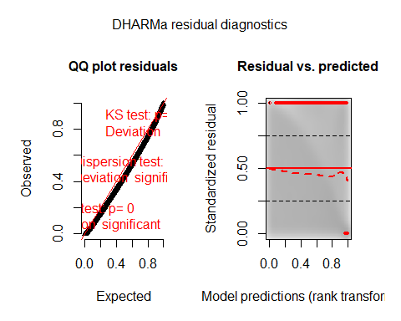

testZeroInflation(SimOut_lm1glmmrelev)

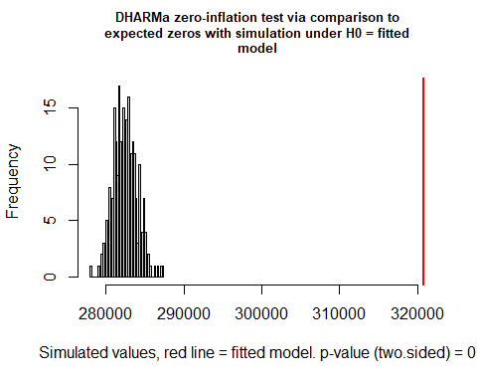

##   
## DHARMa zero-inflation test via comparison to expected zeros with  
## simulation under H0 = fitted model  
##   
## data: simulationOutput  
## ratioObsSim = 1.1354, p-value < 2.2e-16  
## alternative hypothesis: two.sided

testOutliers(SimOut_lm1glmmrelev, type= 'bootstrap')

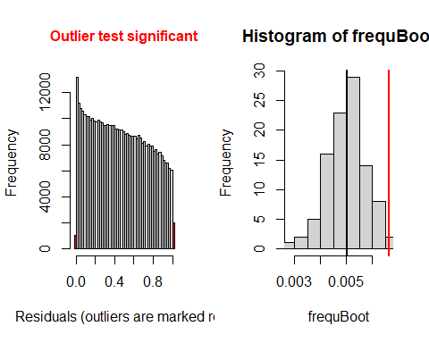

##   
## DHARMa bootstrapped outlier test  
##   
## data: SimOut_lm1glmmrelev  
## outliers at both margin(s) = 2959, observations = 446164, p-value <  
## 2.2e-16  
## alternative hypothesis: two.sided  
## percent confidence interval:  
## 0.003519446 0.006204781  
## sample estimates:  
## outlier frequency (expected: 0.00500728431697761 )   
## 0.00663209

simoutrecalc <- recalculateResiduals(SimOut_lm1glmmrelev, group = df_14$Date2)  
testTemporalAutocorrelation(simoutrecalc, time = unique(df_14$Date2))

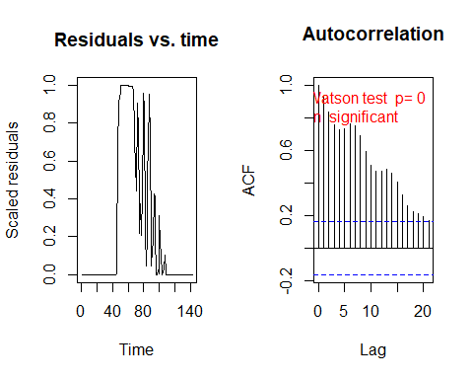

##   
## Durbin-Watson test  
##   
## data: simulationOutput$scaledResiduals ~ 1  
## DW = 0.12709, p-value < 2.2e-16  
## alternative hypothesis: true autocorrelation is not 0

## SimOut_lm2relev

SimOut_lm2relev <- simulateResiduals(fittedModel = lm2relev, plot = T)

## DHARMa:plot used testOutliers with type = binomial for computational reasons (nObs > 500). Note that this method may not have inflated Type I error rates for integer-valued distributions. To get a more exact result, it is recommended to re-run testOutliers with type = 'bootstrap'. See ?testOutliers for details

plot(SimOut_lm2relev)

## DHARMa:plot used testOutliers with type = binomial for computational reasons (nObs > 500). Note that this method may not have inflated Type I error rates for integer-valued distributions. To get a more exact result, it is recommended to re-run testOutliers with type = 'bootstrap'. See ?testOutliers for details

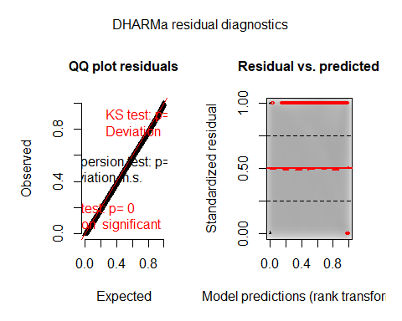

testZeroInflation(SimOut_lm2relev)

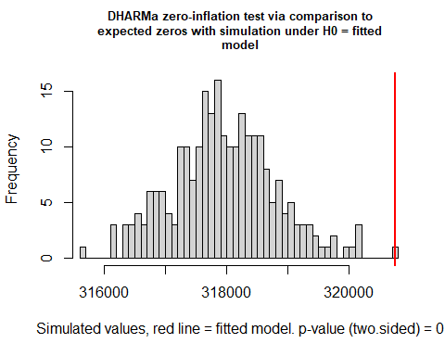

##   
## DHARMa zero-inflation test via comparison to expected zeros with  
## simulation under H0 = fitted model  
##   
## data: simulationOutput  
## ratioObsSim = 1.0088, p-value < 2.2e-16  
## alternative hypothesis: two.sided

testOutliers(SimOut_lm2relev, type= 'bootstrap')

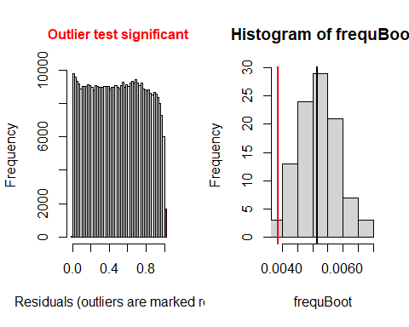

##   
## DHARMa bootstrapped outlier test  
##   
## data: SimOut_lm2relev  
## outliers at both margin(s) = 1716, observations = 446164, p-value =  
## 0.04  
## alternative hypothesis: two.sided  
## percent confidence interval:  
## 0.003935997 0.006475029  
## sample estimates:  
## outlier frequency (expected: 0.00515005692973884 )   
## 0.003846119

simoutrecalc <- recalculateResiduals(SimOut_lm2relev, group = df_14$Date2)  
testTemporalAutocorrelation(simoutrecalc, time = unique(df_14$Date2))

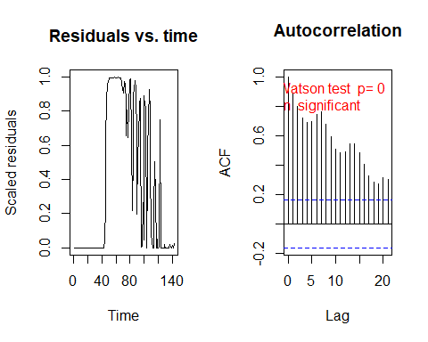

##   
## Durbin-Watson test  
##   
## data: simulationOutput$scaledResiduals ~ 1  
## DW = 0.20601, p-value < 2.2e-16  
## alternative hypothesis: true autocorrelation is not 0

#

## SimOut_lm2catziprelev

SimOut_lm2catziprelev <- simulateResiduals(fittedModel = lm2catziprelev, plot = T)

## DHARMa:plot used testOutliers with type = binomial for computational reasons (nObs > 500). Note that this method may not have inflated Type I error rates for integer-valued distributions. To get a more exact result, it is recommended to re-run testOutliers with type = 'bootstrap'. See ?testOutliers for details

plot(SimOut_lm2catziprelev)

## DHARMa:plot used testOutliers with type = binomial for computational reasons (nObs > 500). Note that this method may not have inflated Type I error rates for integer-valued distributions. To get a more exact result, it is recommended to re-run testOutliers with type = 'bootstrap'. See ?testOutliers for details

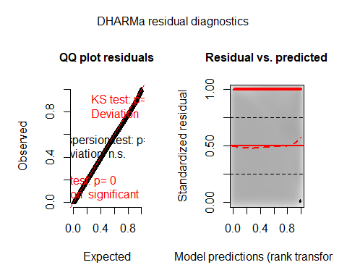

testZeroInflation(SimOut_lm2catziprelev)

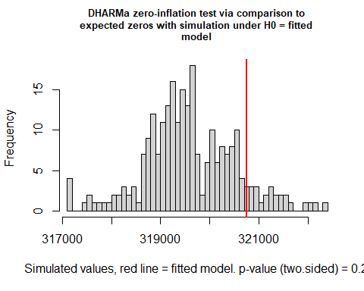

##   
## DHARMa zero-inflation test via comparison to expected zeros with  
## simulation under H0 = fitted model  
##   
## data: simulationOutput  
## ratioObsSim = 1.0037, p-value = 0.2  
## alternative hypothesis: two.sided

testOutliers(SimOut_lm2catziprelev, type= 'bootstrap')

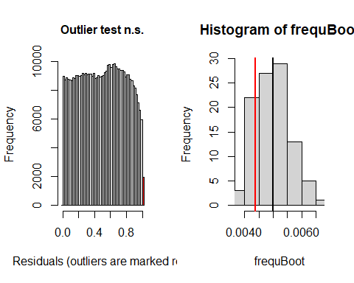

##   
## DHARMa bootstrapped outlier test  
##   
## data: SimOut_lm2catziprelev  
## outliers at both margin(s) = 1953, observations = 446164, p-value =  
## 0.28  
## alternative hypothesis: two.sided  
## percent confidence interval:  
## 0.003989508 0.006183937  
## sample estimates:  
## outlier frequency (expected: 0.00499551734339839 )   
## 0.004377314

simoutrecalc <- recalculateResiduals(SimOut_lm2catziprelev, group = df_14$Date2)  
testTemporalAutocorrelation(simoutrecalc, time = unique(df_14$Date2))

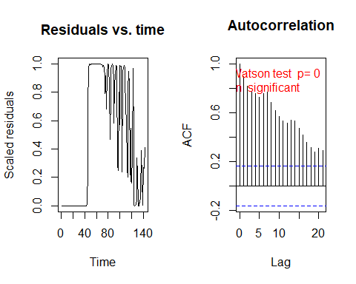

##   
## Durbin-Watson test  
##   
## data: simulationOutput$scaledResiduals ~ 1  
## DW = 0.19769, p-value < 2.2e-16  
## alternative hypothesis: true autocorrelation is not 0

#

## SimOut_lm2catziprelev_cs

SimOut_lm2catziprelev_cs <- simulateResiduals(fittedModel = lm2catziprelev_cs_cdate, plot = T)

## DHARMa:plot used testOutliers with type = binomial for computational reasons (nObs > 500). Note that this method may not have inflated Type I error rates for integer-valued distributions. To get a more exact result, it is recommended to re-run testOutliers with type = 'bootstrap'. See ?testOutliers for details

plot(SimOut_lm2catziprelev_cs)

## DHARMa:plot used testOutliers with type = binomial for computational reasons (nObs > 500). Note that this method may not have inflated Type I error rates for integer-valued distributions. To get a more exact result, it is recommended to re-run testOutliers with type = 'bootstrap'. See ?testOutliers for details

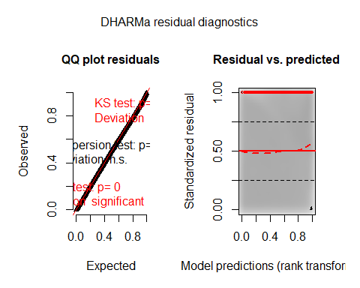

testZeroInflation(SimOut_lm2catziprelev_cs)

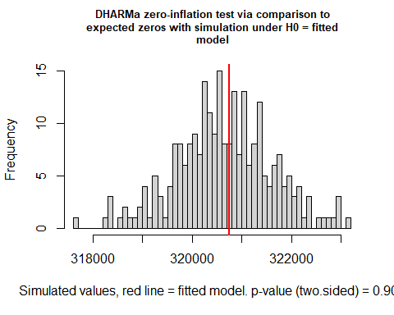

##   
## DHARMa zero-inflation test via comparison to expected zeros with  
## simulation under H0 = fitted model  
##   
## data: simulationOutput  
## ratioObsSim = 1.0003, p-value = 0.904  
## alternative hypothesis: two.sided

testOutliers(SimOut_lm2catziprelev_cs, type= 'bootstrap')

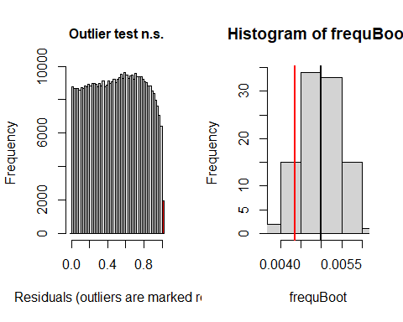

##   
## DHARMa bootstrapped outlier test  
##   
## data: SimOut_lm2catziprelev_cs  
## outliers at both margin(s) = 1943, observations = 446164, p-value =  
## 0.22  
## alternative hypothesis: two.sided  
## percent confidence interval:  
## 0.004055235 0.005848858  
## sample estimates:  
## outlier frequency (expected: 0.00498182282748048 )   
## 0.004354901

simoutrecalc <- recalculateResiduals(SimOut_lm2catziprelev_cs, group = df_14$Date2)  
testTemporalAutocorrelation(simoutrecalc, time = unique(df_14$Date2))

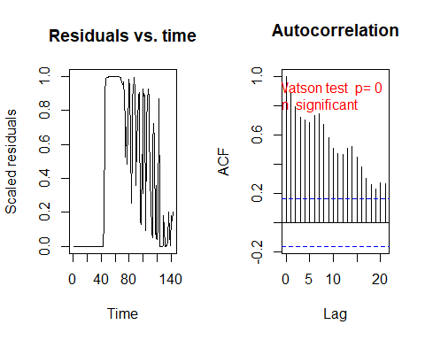

##   
## Durbin-Watson test  
##   
## data: simulationOutput$scaledResiduals ~ 1  
## DW = 0.22157, p-value < 2.2e-16  
## alternative hypothesis: true autocorrelation is not 0

## SimOut_lm2catziprelev_tpc

SimOut_lm2catziprelev_tpc <- simulateResiduals(fittedModel = lm2catziprelev_toep_cdate, plot = T)

## DHARMa:plot used testOutliers with type = binomial for computational reasons (nObs > 500). Note that this method may not have inflated Type I error rates for integer-valued distributions. To get a more exact result, it is recommended to re-run testOutliers with type = 'bootstrap'. See ?testOutliers for details

plot(SimOut_lm2catziprelev_tpc)

## DHARMa:plot used testOutliers with type = binomial for computational reasons (nObs > 500). Note that this method may not have inflated Type I error rates for integer-valued distributions. To get a more exact result, it is recommended to re-run testOutliers with type = 'bootstrap'. See ?testOutliers for details

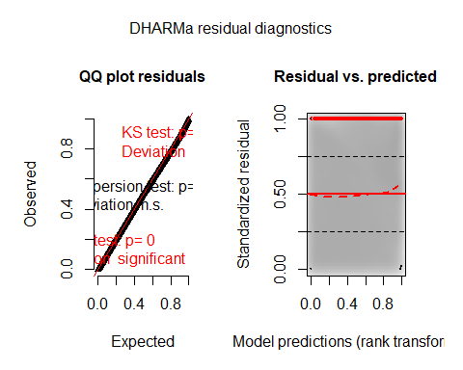

testZeroInflation(SimOut_lm2catziprelev_tpc)

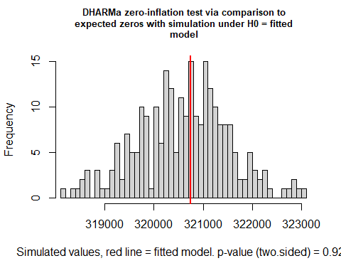

##   
## DHARMa zero-inflation test via comparison to expected zeros with  
## simulation under H0 = fitted model  
##   
## data: simulationOutput  
## ratioObsSim = 1.0004, p-value = 0.928  
## alternative hypothesis: two.sided

testOutliers(SimOut_lm2catziprelev_tpc, type= 'bootstrap')

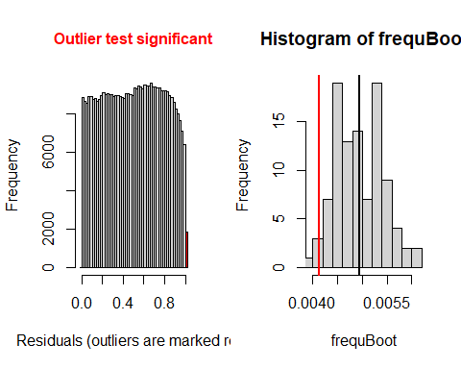

##   
## DHARMa bootstrapped outlier test  
##   
## data: SimOut_lm2catziprelev_tpc  
## outliers at both margin(s) = 1843, observations = 446164, p-value =  
## 0.04  
## alternative hypothesis: two.sided  
## percent confidence interval:  
## 0.004147074 0.005899512  
## sample estimates:  
## outlier frequency (expected: 0.00493818416546382 )   
## 0.004130768

simoutrecalc <- recalculateResiduals(SimOut_lm2catziprelev_tpc, group = df_14$Date2)  
testTemporalAutocorrelation(simoutrecalc, time = unique(df_14$Date2))

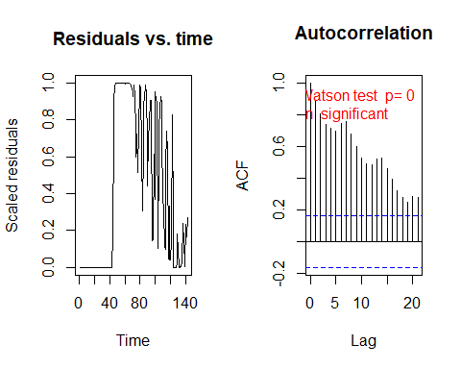

##   
## Durbin-Watson test  
##   
## data: simulationOutput$scaledResiduals ~ 1  
## DW = 0.20724, p-value < 2.2e-16  
## alternative hypothesis: true autocorrelation is not 0

##

## SimOut_lm2catziprelev_rsc

SimOut_lm2catziprelev_rsc <- simulateResiduals(fittedModel = lm2catziprelev_randslope_cdate, plot = T)

## DHARMa:plot used testOutliers with type = binomial for computational reasons (nObs > 500). Note that this method may not have inflated Type I error rates for integer-valued distributions. To get a more exact result, it is recommended to re-run testOutliers with type = 'bootstrap'. See ?testOutliers for details

plot(SimOut_lm2catziprelev_rsc)

## DHARMa:plot used testOutliers with type = binomial for computational reasons (nObs > 500). Note that this method may not have inflated Type I error rates for integer-valued distributions. To get a more exact result, it is recommended to re-run testOutliers with type = 'bootstrap'. See ?testOutliers for details

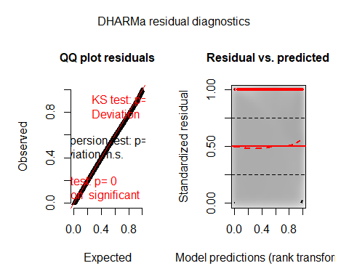

testZeroInflation(SimOut_lm2catziprelev_rsc)

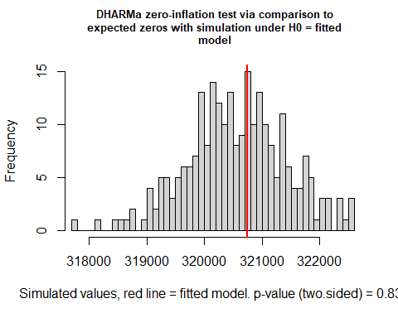

##   
## DHARMa zero-inflation test via comparison to expected zeros with  
## simulation under H0 = fitted model  
##   
## data: simulationOutput  
## ratioObsSim = 1.0006, p-value = 0.832  
## alternative hypothesis: two.sided

testOutliers(SimOut_lm2catziprelev_rsc, type= 'bootstrap')

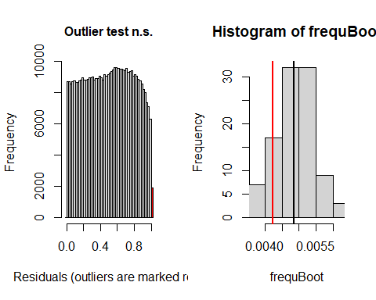

##   
## DHARMa bootstrapped outlier test  
##   
## data: SimOut_lm2catziprelev_rsc  
## outliers at both margin(s) = 1886, observations = 446164, p-value =  
## 0.28  
## alternative hypothesis: two.sided  
## percent confidence interval:  
## 0.003860296 0.005998691  
## sample estimates:  
## outlier frequency (expected: 0.00486076868595404 )   
## 0.004227145

simoutrecalc <- recalculateResiduals(SimOut_lm2catziprelev_rsc, group = df_14$Date2)  
testTemporalAutocorrelation(simoutrecalc, time = unique(df_14$Date2))

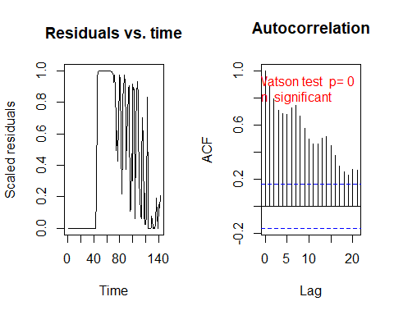

##   
## Durbin-Watson test  
##   
## data: simulationOutput$scaledResiduals ~ 1  
## DW = 0.21202, p-value < 2.2e-16  
## alternative hypothesis: true autocorrelation is not 0

## SimOut_lm2catziprelev_rsd

SimOut_lm2catziprelev_rsd <- simulateResiduals(fittedModel = lm2catziprelev_randslope_date2, plot = T)

## DHARMa:plot used testOutliers with type = binomial for computational reasons (nObs > 500). Note that this method may not have inflated Type I error rates for integer-valued distributions. To get a more exact result, it is recommended to re-run testOutliers with type = 'bootstrap'. See ?testOutliers for details

plot(SimOut_lm2catziprelev_rsd)

## DHARMa:plot used testOutliers with type = binomial for computational reasons (nObs > 500). Note that this method may not have inflated Type I error rates for integer-valued distributions. To get a more exact result, it is recommended to re-run testOutliers with type = 'bootstrap'. See ?testOutliers for details

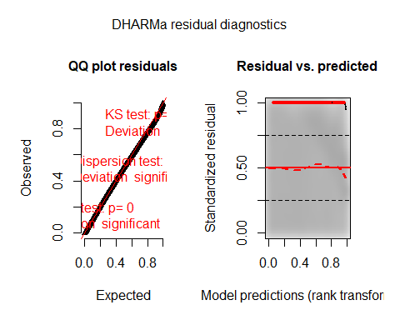

testZeroInflation(SimOut_lm2catziprelev_rsd)

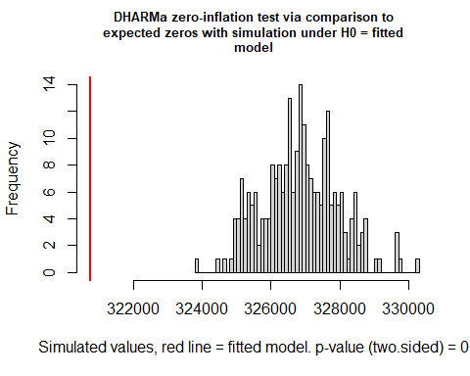

##   
## DHARMa zero-inflation test via comparison to expected zeros with  
## simulation under H0 = fitted model  
##   
## data: simulationOutput  
## ratioObsSim = 0.98132, p-value < 2.2e-16  
## alternative hypothesis: two.sided

testOutliers(SimOut_lm2catziprelev_rsd, type= 'bootstrap')

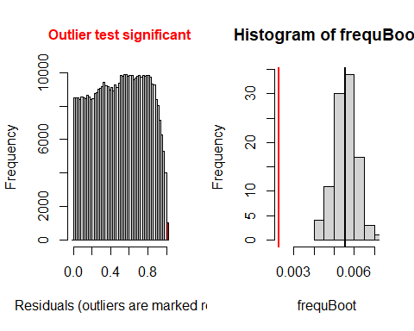

##   
## DHARMa bootstrapped outlier test  
##   
## data: SimOut_lm2catziprelev_rsd  
## outliers at both margin(s) = 1002, observations = 446164, p-value <  
## 2.2e-16  
## alternative hypothesis: two.sided  
## percent confidence interval:  
## 0.004446179 0.006592979  
## sample estimates:  
## outlier frequency (expected: 0.00556387337391632 )   
## 0.002245811

simoutrecalc <- recalculateResiduals(SimOut_lm2catziprelev_rsd, group = df_14$Date2)  
testTemporalAutocorrelation(simoutrecalc, time = unique(df_14$Date2))

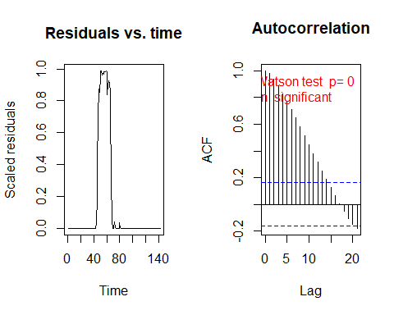

##   
## Durbin-Watson test  
##   
## data: simulationOutput$scaledResiduals ~ 1  
## DW = 0.034811, p-value < 2.2e-16  
## alternative hypothesis: true autocorrelation is not 0

###

## SimOut_lm3glmmrelev

SimOut_lm3glmmrelev <- simulateResiduals(fittedModel = lm3glmmrelev, plot = T)

## DHARMa:plot used testOutliers with type = binomial for computational reasons (nObs > 500). Note that this method may not have inflated Type I error rates for integer-valued distributions. To get a more exact result, it is recommended to re-run testOutliers with type = 'bootstrap'. See ?testOutliers for details

plot(SimOut_lm3glmmrelev)

## DHARMa:plot used testOutliers with type = binomial for computational reasons (nObs > 500). Note that this method may not have inflated Type I error rates for integer-valued distributions. To get a more exact result, it is recommended to re-run testOutliers with type = 'bootstrap'. See ?testOutliers for details

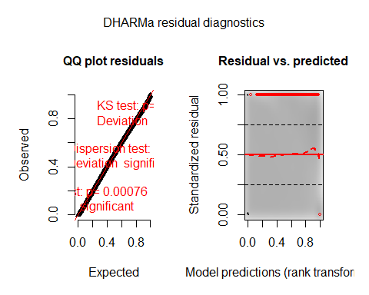

testZeroInflation(SimOut_lm3glmmrelev)

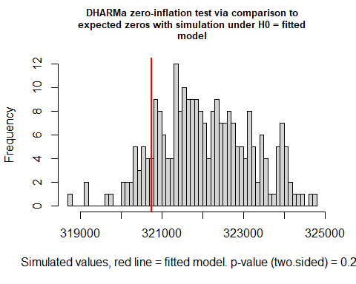

##   
## DHARMa zero-inflation test via comparison to expected zeros with  
## simulation under H0 = fitted model  
##   
## data: simulationOutput  
## ratioObsSim = 0.99595, p-value = 0.24  
## alternative hypothesis: two.sided

testOutliers(SimOut_lm3glmmrelev, type= 'bootstrap')

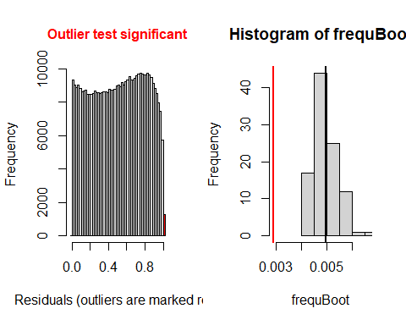

##   
## DHARMa bootstrapped outlier test  
##   
## data: SimOut_lm3glmmrelev  
## outliers at both margin(s) = 1286, observations = 446164, p-value <  
## 2.2e-16  
## alternative hypothesis: two.sided  
## percent confidence interval:  
## 0.004172513 0.005960925  
## sample estimates:  
## outlier frequency (expected: 0.00496371289480998 )   
## 0.002882348

simoutrecalc <- recalculateResiduals(SimOut_lm3glmmrelev, group = df_14$Date2)  
testTemporalAutocorrelation(simoutrecalc, time = unique(df_14$Date2))

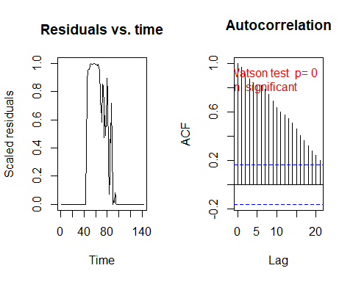

##   
## Durbin-Watson test  
##   
## data: simulationOutput$scaledResiduals ~ 1  
## DW = 0.061153, p-value < 2.2e-16  
## alternative hypothesis: true autocorrelation is not 0

## SimOut_lm3glmmRandSlope

SimOut_lm3glmmRandSlope <- simulateResiduals(fittedModel = lm3glmmRandslope, plot = T)

## DHARMa:plot used testOutliers with type = binomial for computational reasons (nObs > 500). Note that this method may not have inflated Type I error rates for integer-valued distributions. To get a more exact result, it is recommended to re-run testOutliers with type = 'bootstrap'. See ?testOutliers for details

plot(SimOut_lm3glmmRandSlope)

## DHARMa:plot used testOutliers with type = binomial for computational reasons (nObs > 500). Note that this method may not have inflated Type I error rates for integer-valued distributions. To get a more exact result, it is recommended to re-run testOutliers with type = 'bootstrap'. See ?testOutliers for details

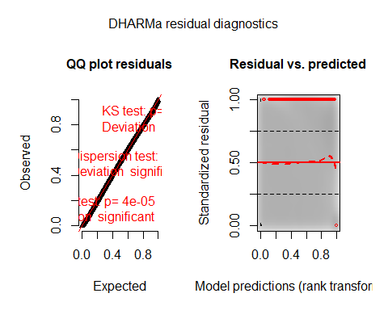

testZeroInflation(SimOut_lm3glmmRandSlope)

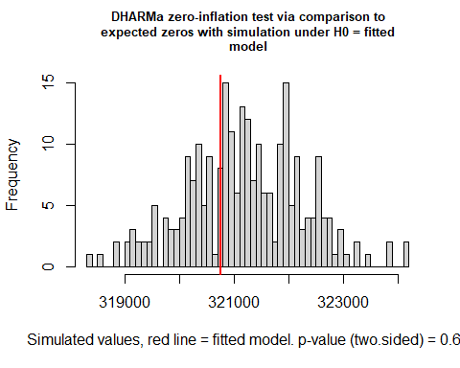

##   
## DHARMa zero-inflation test via comparison to expected zeros with  
## simulation under H0 = fitted model  
##   
## data: simulationOutput  
## ratioObsSim = 0.99862, p-value = 0.64  
## alternative hypothesis: two.sided

testOutliers(SimOut_lm3glmmRandSlope, type= 'bootstrap')

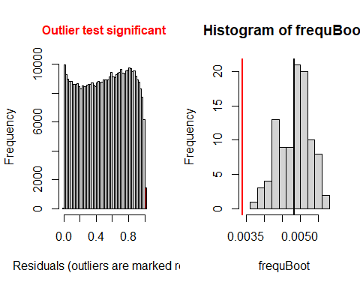

##   
## DHARMa bootstrapped outlier test  
##   
## data: SimOut_lm3glmmRandSlope  
## outliers at both margin(s) = 1508, observations = 446164, p-value <  
## 2.2e-16  
## alternative hypothesis: two.sided  
## percent confidence interval:  
## 0.003982504 0.005508569  
## sample estimates:  
## outlier frequency (expected: 0.0048313848719305 )   
## 0.003379923

simoutrecalc <- recalculateResiduals(SimOut_lm3glmmRandSlope, group = df_14$Date2)  
testTemporalAutocorrelation(simoutrecalc, time = unique(df_14$Date2))

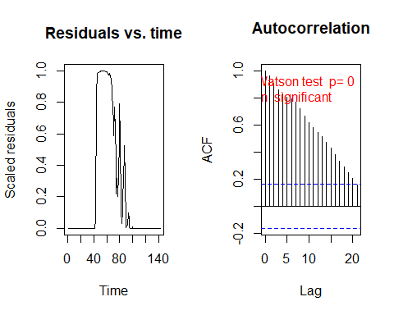

##   
## Durbin-Watson test  
##   
## data: simulationOutput$scaledResiduals ~ 1  
## DW = 0.072204, p-value < 2.2e-16  
## alternative hypothesis: true autocorrelation is not 0

##

## SimOut_lm4catziprelev

SimOut_lm4catziprelev <- simulateResiduals(fittedModel = lm4catziprelev, plot = T)

## DHARMa:plot used testOutliers with type = binomial for computational reasons (nObs > 500). Note that this method may not have inflated Type I error rates for integer-valued distributions. To get a more exact result, it is recommended to re-run testOutliers with type = 'bootstrap'. See ?testOutliers for details

plot(SimOut_lm4catziprelev)

## DHARMa:plot used testOutliers with type = binomial for computational reasons (nObs > 500). Note that this method may not have inflated Type I error rates for integer-valued distributions. To get a more exact result, it is recommended to re-run testOutliers with type = 'bootstrap'. See ?testOutliers for details

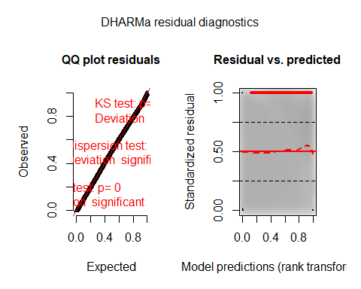

testZeroInflation(SimOut_lm4catziprelev)

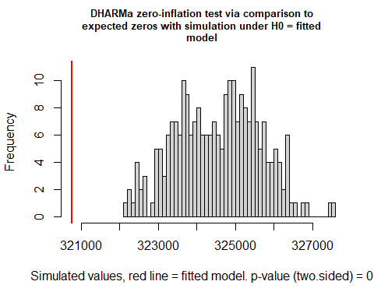

##   
## DHARMa zero-inflation test via comparison to expected zeros with  
## simulation under H0 = fitted model  
##   
## data: simulationOutput  
## ratioObsSim = 0.9883, p-value < 2.2e-16  
## alternative hypothesis: two.sided

testOutliers(SimOut_lm4catziprelev, type= 'bootstrap')

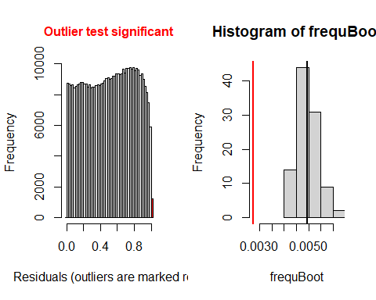

##   
## DHARMa bootstrapped outlier test  
##   
## data: SimOut_lm4catziprelev  
## outliers at both margin(s) = 1219, observations = 446164, p-value <  
## 2.2e-16  
## alternative hypothesis: two.sided  
## percent confidence interval:  
## 0.004161026 0.005833057  
## sample estimates:  
## outlier frequency (expected: 0.00496077675473593 )   
## 0.002732179

simoutrecalc <- recalculateResiduals(SimOut_lm4catziprelev, group = df_14$Date2)  
testTemporalAutocorrelation(simoutrecalc, time = unique(df_14$Date2))

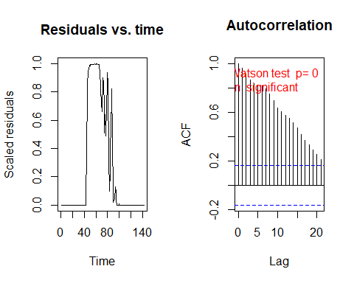

##   
## Durbin-Watson test  
##   
## data: simulationOutput$scaledResiduals ~ 1  
## DW = 0.063356, p-value < 2.2e-16  
## alternative hypothesis: true autocorrelation is not 0

# Removing Outliers

## Removing Outliers lm3glmm

# REMOVING OUTLIERS LM3GLMM  
r <- which(residuals(SimOut_lm3glmmrelev) == 1 | residuals(SimOut_lm3glmmrelev) == 0)  
  
df_14$row <- c(1:446164)  
  
`%notin%` <- Negate(`%in%`)  
#removing the counties  
outcount <- df_14$c_FIPS[df_14$row %in% r]  
outcount <- unique(outcount)  
df_14outremcount <- df_14[df_14$c_FIPS %notin% outcount,]  
  
# REMOVING OUTLIERS LM3GLMM  
summary(lm3glmmrelevoutcount)## Family: nbinom2 ( log )  
## Formula:   
## newcase_nst_14 ~ offset(popoff) + URBinary * c_daterelev + URBinary *   
## Date2 + URBinary * dsahcarried + URBinary * asahcarried + (1 | c_FIPS)  
## Data: df_14outremcount  
##   
## AIC BIC logLik deviance df.resid   
## 810243.1 810395.5 -405107.6 810215.1 393752   
##   
## Random effects:  
##   
## Conditional model:  
## Groups Name Variance Std.Dev.  
## c_FIPS (Intercept) 1.471 1.213   
## Number of obs: 393766, groups: c_FIPS, 2773  
##   
## Overdispersion parameter for nbinom2 family (): 0.712   
##   
## Conditional model:  
## Estimate Std. Error z value Pr(>|z|)   
## (Intercept) -3.6664114 0.0415560 -88.23 < 2e-16 ***  
## URBinary -1.7572238 0.0635405 -27.66 < 2e-16 ***  
## c_daterelevafter SaH 0.1984690 0.0310583 6.39 1.66e-10 ***  
## c_daterelevduring SaH 0.4720351 0.0200622 23.53 < 2e-16 ***  
## Date2 0.0461757 0.0004144 111.42 < 2e-16 ***  
## dsahcarried -0.0375113 0.0005965 -62.89 < 2e-16 ***  
## asahcarried -0.0150326 0.0009235 -16.28 < 2e-16 ***  
## URBinary:c_daterelevafter SaH -0.9250872 0.0403586 -22.92 < 2e-16 ***  
## URBinary:c_daterelevduring SaH -0.6737951 0.0257428 -26.17 < 2e-16 ***  
## URBinary:Date2 0.0504486 0.0006895 73.17 < 2e-16 ***  
## URBinary:dsahcarried -0.0517760 0.0008711 -59.44 < 2e-16 ***  
## URBinary:asahcarried -0.0503087 0.0013246 -37.98 < 2e-16 ***  
## ---  
## Signif. codes: 0 '***' 0.001 '**' 0.01 '*' 0.05 '.' 0.1 ' ' 1

SimOut_lm3glmmrelevoutcount <- simulateResiduals(fittedModel = lm3glmmrelevoutcount, plot = T)

## DHARMa:plot used testOutliers with type = binomial for computational reasons (nObs > 500). Note that this method may not have inflated Type I error rates for integer-valued distributions. To get a more exact result, it is recommended to re-run testOutliers with type = 'bootstrap'. See ?testOutliers for details

plot(SimOut_lm3glmmrelevoutcount)

## DHARMa:plot used testOutliers with type = binomial for computational reasons (nObs > 500). Note that this method may not have inflated Type I error rates for integer-valued distributions. To get a more exact result, it is recommended to re-run testOutliers with type = 'bootstrap'. See ?testOutliers for details

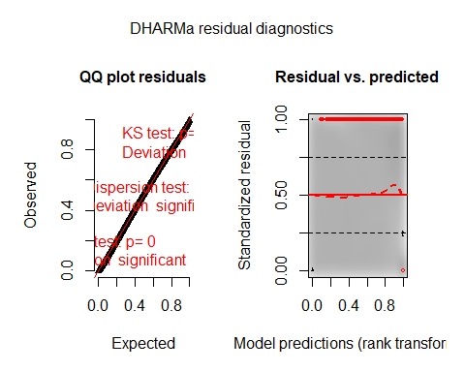

testZeroInflation(SimOut_lm3glmmrelevoutcount)

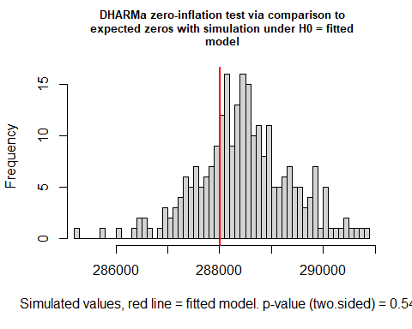

##   
## DHARMa zero-inflation test via comparison to expected zeros with  
## simulation under H0 = fitted model  
##   
## data: simulationOutput  
## ratioObsSim = 0.99841, p-value = 0.544  
## alternative hypothesis: two.sided

testOutliers(SimOut_lm3glmmrelevoutcount, type= 'bootstrap')

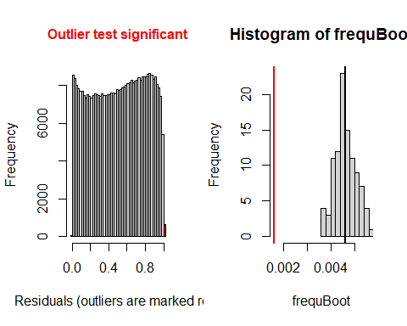

##   
## DHARMa bootstrapped outlier test  
##   
## data: SimOut_lm3glmmrelevoutcount  
## outliers at both margin(s) = 636, observations = 393766, p-value <  
## 2.2e-16  
## alternative hypothesis: two.sided  
## percent confidence interval:  
## 0.003774640 0.005446128  
## sample estimates:  
## outlier frequency (expected: 0.00462145030297182 )   
## 0.001615172

simoutrecalc <- recalculateResiduals(SimOut_lm3glmmrelevoutcount, group = df_14outremcount$Date2)  
testTemporalAutocorrelation(simoutrecalc, time = unique(df_14outremcount$Date2))

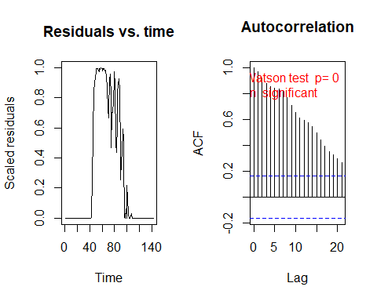

##   
## Durbin-Watson test  
##   
## data: simulationOutput$scaledResiduals ~ 1  
## DW = 0.055966, p-value < 2.2e-16  
## alternative hypothesis: true autocorrelation is not 0

## *Removing Outliers Random Slope lm3glmmRandSlope*

r <- which(residuals(SimOut_lm3glmmRandSlope) == 1 | residuals(SimOut_lm3glmmRandSlope) == 0)  
  
df_14$row <- c(1:446164)  
  
`%notin%` <- Negate(`%in%`)  
#removing the counties  
outcount <- df_14$c_FIPS[df_14$row %in% r]  
outcount <- unique(outcount)  
df_14outremcountrand <- df_14[df_14$c_FIPS %notin% outcount,]  
  
  
# REMOVING OUTLIERS RANDOM SLOPE  
summary(lm3glmmrelevrandslopeoutcount)

## Family: nbinom2 ( log )  
## Formula:   
## newcase_nst_14 ~ offset(popoff) + URBinary * c_daterelev + URBinary *   
## Date2 + URBinary * dsahcarried + URBinary * asahcarried + (1 | c_FIPS)  
## Data: df_14outremcountrand  
##   
## AIC BIC logLik deviance df.resid   
## 772804.9 772956.9 -386388.5 772776.9 383102   
##   
## Random effects:  
##   
## Conditional model:  
## Groups Name Variance Std.Dev.  
## c_FIPS (Intercept) 1.513 1.23   
## Number of obs: 383116, groups: c_FIPS, 2698  
##   
## Overdispersion parameter for nbinom2 family (): 0.751   
##   
## Conditional model:  
## Estimate Std. Error z value Pr(>|z|)   
## (Intercept) -3.7633293 0.0428977 -87.73 <2e-16 ***  
## URBinary -2.1760163 0.0664835 -32.73 <2e-16 ***  
## c_daterelevafter SaH 0.3306234 0.0317482 10.41 <2e-16 ***  
## c_daterelevduring SaH 0.5825412 0.0206052 28.27 <2e-16 ***  
## Date2 0.0462531 0.0004294 107.72 <2e-16 ***  
## dsahcarried -0.0387154 0.0006110 -63.37 <2e-16 ***  
## asahcarried -0.0154415 0.0009454 -16.33 <2e-16 ***  
## URBinary:c_daterelevafter SaH -1.2598501 0.0409353 -30.78 <2e-16 ***  
## URBinary:c_daterelevduring SaH -0.9889043 0.0264444 -37.40 <2e-16 ***  
## URBinary:Date2 0.0610684 0.0007481 81.63 <2e-16 ***  
## URBinary:dsahcarried -0.0609167 0.0009188 -66.30 <2e-16 ***  
## URBinary:asahcarried -0.0600529 0.0013593 -44.18 <2e-16 ***  
## ---  
## Signif. codes: 0 '***' 0.001 '**' 0.01 '*' 0.05 '.' 0.1 ' ' 1

SimOut_lm3glmmrelevoutcountrandslope <- simulateResiduals(fittedModel = lm3glmmrelevrandslopeoutcount, plot = T)

## DHARMa:plot used testOutliers with type = binomial for computational reasons (nObs > 500). Note that this method may not have inflated Type I error rates for integer-valued distributions. To get a more exact result, it is recommended to re-run testOutliers with type = 'bootstrap'. See ?testOutliers for details

plot(SimOut_lm3glmmrelevoutcountrandslope)

## DHARMa:plot used testOutliers with type = binomial for computational reasons (nObs > 500). Note that this method may not have inflated Type I error rates for integer-valued distributions. To get a more exact result, it is recommended to re-run testOutliers with type = 'bootstrap'. See ?testOutliers for details

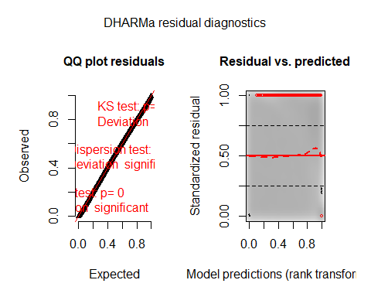

testZeroInflation(SimOut_lm3glmmrelevoutcountrandslope)

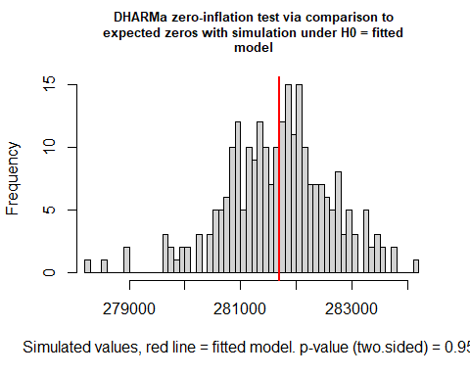

##   
## DHARMa zero-inflation test via comparison to expected zeros with  
## simulation under H0 = fitted model  
##   
## data: simulationOutput  
## ratioObsSim = 1, p-value = 0.952  
## alternative hypothesis: two.sided

testOutliers(SimOut_lm3glmmrelevoutcountrandslope, type= 'bootstrap')

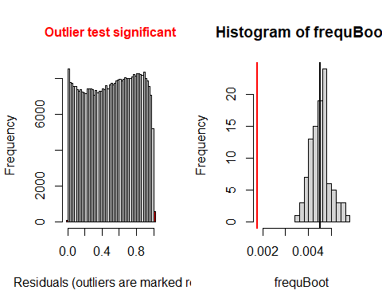

##   
## DHARMa bootstrapped outlier test  
##   
## data: SimOut_lm3glmmrelevoutcountrandslope  
## outliers at both margin(s) = 675, observations = 383116, p-value <  
## 2.2e-16  
## alternative hypothesis: two.sided  
## percent confidence interval:  
## 0.003781622 0.005431057  
## sample estimates:  
## outlier frequency (expected: 0.00450790361143883 )   
## 0.001761868

simoutrecalc <- recalculateResiduals(SimOut_lm3glmmrelevoutcountrandslope, group = df_14outremcountrand$Date2)  
testTemporalAutocorrelation(simoutrecalc, time = unique(df_14outremcountrand$Date2))

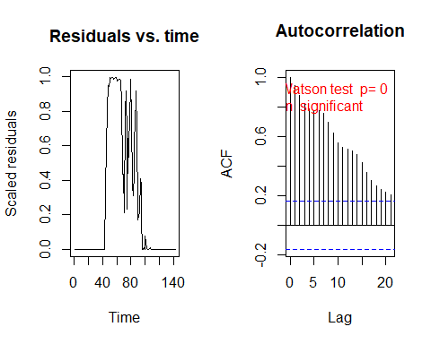

##   
## Durbin-Watson test  
##   
## data: simulationOutput$scaledResiduals ~ 1  
## DW = 0.10231, p-value < 2.2e-16  
## alternative hypothesis: true autocorrelation is not 0

# Sensitivity Analysis

We conducted a sensitivity analysis surrounding the lag time between daily new cases and time reported. The dependent variable, daily new cases, in this case must be lagged for proper analysis because of several reasons. First, it is well known that the potential incubation period for SARS-CoV-2 is upwards of 14 days, which would imply that an individual being tested positive for the virus could have been exposed to the virus some two weeks earlier, potentially placing them out of range of a particular stay-at-home order, and thus complicating analysis. Second, while stay-at-home orders are declared and in place, it takes time for the orders to be adhered to and enforced for a measurable effect. We initially used the longer 14-day lag due to its being the incubation period. However, other studies have utilized five-to-ten-day lags. Therefore, it becomes necessary to conduct sensitivity analysis, the result of which we report below.

Results of the sensitivity analysis did not change any of the study inferences of conclusions. Moreover, the five-day and ten-day lag analyses exhibited significant overdispersion and zero-inflation, whereas the 14-day lag does not exhibit these characteristics

## Five-Day Lag

#reads in data  
setwd("C:\\Users\\Jake\\Desktop\\MAYO\\COVID RURALITY")  
df_14 <- read.csv("df_14.csv",header=T)  
  
#installs packages then loads them into the session  
library(glmmTMB)

## Warning: package 'glmmTMB' was built under R version 3.6.3

library(DHARMa)

## Warning: package 'DHARMa' was built under R version 3.6.3

## This is DHARMa 0.3.3.0. For overview type '?DHARMa'. For recent changes, type news(package = 'DHARMa') Note: Syntax of plotResiduals has changed in 0.3.0, see ?plotResiduals for details

# Releveling  
df_14$c_daterelev <- relevel(df_14$c_date, ref = "before SaH")  
  
  
#Five Day Lag  
n <- 142  
D <- 5  
for (i in 1:n){  
 df_14$newcase_nst_5[df_14$Date2 == i] <- ifelse( i > (n-D), df_14$newcase_nst_14[df_14$Date2 == (i-(14-D))], df_14$newcase_nst[df_14$Date2 == (i+D)])  
}  
  
#RENAMING THE VARIABLE TO ALLOW the implementation of the lag  
  
df_14$newcase_nst_14 <- df_14$newcase_nst_5  
  
  
load("C:/Users/Jake/Desktop/MAYO/COVID RURALITY/5Day.RData")  
###########################################  
############# SUMMARY RESULTS #############  
###########################################  
  
# GLMMTMB mixed effects poisson model  
summary(lm1glmmrelev)

## Family: poisson ( log )  
## Formula:   
## newcase_nst_14 ~ offset(popoff) + URBinary * c_daterelev + URBinary *   
## Date2 + URBinary * dsahcarried + URBinary * asahcarried + (1 | c_FIPS)  
## Data: df_14  
##   
## AIC BIC logLik deviance df.resid   
## 1433084.9 1433228.0 -716529.5 1433058.9 446151   
##   
## Random effects:  
##   
## Conditional model:  
## Groups Name Variance Std.Dev.  
## c_FIPS (Intercept) 1.533 1.238   
## Number of obs: 446164, groups: c_FIPS, 3142  
##   
## Conditional model:  
## Estimate Std. Error z value Pr(>|z|)   
## (Intercept) -1.7870967 0.0294820 -60.6 < 2e-16 ***  
## URBinary -2.1394090 0.0494705 -43.2 < 2e-16 ***  
## c_daterelevafter SaH 0.8655903 0.0109259 79.2 < 2e-16 ***  
## c_daterelevduring SaH 0.6655302 0.0096345 69.1 < 2e-16 ***  
## Date2 0.0438043 0.0001130 387.5 < 2e-16 ***  
## dsahcarried -0.0055943 0.0001749 -32.0 < 2e-16 ***  
## asahcarried -0.0153344 0.0001853 -82.8 < 2e-16 ***  
## URBinary:c_daterelevafter SaH -0.1359608 0.0175846 -7.7 1.06e-14 ***  
## URBinary:c_daterelevduring SaH -0.0504590 0.0156094 -3.2 0.00123 **   
## URBinary:Date2 0.0044700 0.0002710 16.5 < 2e-16 ***  
## URBinary:dsahcarried -0.0038140 0.0003344 -11.4 < 2e-16 ***  
## URBinary:asahcarried -0.0037971 0.0003657 -10.4 < 2e-16 ***  
## ---  
## Signif. codes: 0 '***' 0.001 '**' 0.01 '*' 0.05 '.' 0.1 ' ' 1

# Zero inflated poisson mixed effects (zero inflated using the whole formula)  
summary(lm2relev)

## Family: poisson ( log )  
## Formula:   
## newcase_nst_14 ~ offset(popoff) + URBinary * c_daterelev + URBinary *   
## Date2 + URBinary * dsahcarried + URBinary * asahcarried + (1 | c_FIPS)  
## Zero inflation:   
## ~URBinary * c_daterelev + URBinary * Date2 + URBinary * dsahcarried +   
## URBinary * asahcarried  
## Data: df_14  
##   
## AIC BIC logLik deviance df.resid   
## 1310314.5 1310589.7 -655132.2 1310264.5 446139   
##   
## Random effects:  
##   
## Conditional model:  
## Groups Name Variance Std.Dev.  
## c_FIPS (Intercept) 1.419 1.191   
## Number of obs: 446164, groups: c_FIPS, 3142  
##   
## Conditional model:  
## Estimate Std. Error z value Pr(>|z|)   
## (Intercept) 0.6575298 0.0299703 21.94 < 2e-16 ***  
## URBinary -1.9027802 0.0515287 -36.93 < 2e-16 ***  
## c_daterelevafter SaH 0.0031825 0.0123837 0.26 0.797184   
## c_daterelevduring SaH -0.1871174 0.0111842 -16.73 < 2e-16 ***  
## Date2 0.0279289 0.0001427 195.73 < 2e-16 ***  
## dsahcarried -0.0014594 0.0002064 -7.07 1.55e-12 ***  
## asahcarried -0.0051106 0.0002063 -24.77 < 2e-16 ***  
## URBinary:c_daterelevafter SaH -0.0664906 0.0197790 -3.36 0.000775 ***  
## URBinary:c_daterelevduring SaH 0.0078653 0.0179242 0.44 0.660797   
## URBinary:Date2 0.0011929 0.0003352 3.56 0.000373 ***  
## URBinary:dsahcarried -0.0002050 0.0003994 -0.51 0.607717   
## URBinary:asahcarried -0.0005837 0.0004180 -1.40 0.162626   
## ---  
## Signif. codes: 0 '***' 0.001 '**' 0.01 '*' 0.05 '.' 0.1 ' ' 1  
##   
## Zero-inflation model:  
## Estimate Std. Error z value Pr(>|z|)   
## (Intercept) 5.9091552 0.0352677 167.55 < 2e-16 ***  
## URBinary 0.2288969 0.0632392 3.62 0.000295 ***  
## c_daterelevafter SaH 0.3896047 0.0461149 8.45 < 2e-16 ***  
## c_daterelevduring SaH 0.1130996 0.0207635 5.45 5.12e-08 ***  
## Date2 -0.0795411 0.0005083 -156.47 < 2e-16 ***  
## dsahcarried 0.0072807 0.0007160 10.17 < 2e-16 ***  
## asahcarried -0.0222593 0.0027812 -8.00 1.21e-15 ***  
## URBinary:c_daterelevafter SaH 0.0775074 0.0791344 0.98 0.327362   
## URBinary:c_daterelevduring SaH 0.1038960 0.0352424 2.95 0.003198 **   
## URBinary:Date2 -0.0050061 0.0009762 -5.13 2.93e-07 ***  
## URBinary:dsahcarried 0.0041206 0.0011598 3.55 0.000381 ***  
## URBinary:asahcarried 0.0017428 0.0049499 0.35 0.724776   
## ---  
## Signif. codes: 0 '***' 0.001 '**' 0.01 '*' 0.05 '.' 0.1 ' ' 1

# Zero inflated poisson mixed effects (zero inflated using the rurality and dates)  
summary(lm2catziprelev)

## Family: poisson ( log )  
## Formula:   
## newcase_nst_14 ~ offset(popoff) + URBinary * c_daterelev + URBinary *   
## Date2 + URBinary * dsahcarried + URBinary * asahcarried + (1 | c_FIPS)  
## Zero inflation: ~URBinary * c_daterelev  
## Data: df_14  
##   
## AIC BIC logLik deviance df.resid   
## 1385307.0 1385516.1 -692634.5 1385269.0 446145   
##   
## Random effects:  
##   
## Conditional model:  
## Groups Name Variance Std.Dev.  
## c_FIPS (Intercept) 1.546 1.243   
## Number of obs: 446164, groups: c_FIPS, 3142  
##   
## Conditional model:  
## Estimate Std. Error z value Pr(>|z|)   
## (Intercept) -1.3991715 0.0305346 -45.82 < 2e-16 ***  
## URBinary -1.7737967 0.0540949 -32.79 < 2e-16 ***  
## c_daterelevafter SaH 1.1083193 0.0122324 90.61 < 2e-16 ***  
## c_daterelevduring SaH 0.9587011 0.0109879 87.25 < 2e-16 ***  
## Date2 0.0404765 0.0001284 315.14 < 2e-16 ***  
## dsahcarried -0.0087794 0.0002006 -43.76 < 2e-16 ***  
## asahcarried -0.0167820 0.0001979 -84.82 < 2e-16 ***  
## URBinary:c_daterelevafter SaH -0.3972812 0.0231576 -17.16 < 2e-16 ***  
## URBinary:c_daterelevduring SaH -0.3212096 0.0215502 -14.91 < 2e-16 ***  
## URBinary:Date2 0.0024167 0.0003101 7.79 6.53e-15 ***  
## URBinary:dsahcarried -0.0014551 0.0003835 -3.79 0.000148 ***  
## URBinary:asahcarried -0.0017310 0.0003994 -4.33 1.46e-05 ***  
## ---  
## Signif. codes: 0 '***' 0.001 '**' 0.01 '*' 0.05 '.' 0.1 ' ' 1  
##   
## Zero-inflation model:  
## Estimate Std. Error z value Pr(>|z|)   
## (Intercept) -1.54573 0.02600 -59.45 <2e-16 ***  
## URBinary 1.05664 0.04693 22.52 <2e-16 ***  
## c_daterelevafter SaH -1.62265 0.03622 -44.80 <2e-16 ***  
## c_daterelevduring SaH 0.40845 0.02847 14.35 <2e-16 ***  
## URBinary:c_daterelevafter SaH -1.23150 0.06411 -19.21 <2e-16 ***  
## URBinary:c_daterelevduring SaH -1.15857 0.05027 -23.05 <2e-16 ***  
## ---  
## Signif. codes: 0 '***' 0.001 '**' 0.01 '*' 0.05 '.' 0.1 ' ' 1

# GLMMTMB negative binominal (quadratic version)  
summary(lm3glmmrelev)

## Family: nbinom2 ( log )  
## Formula:   
## newcase_nst_14 ~ offset(popoff) + URBinary * c_daterelev + URBinary *   
## Date2 + URBinary * dsahcarried + URBinary * asahcarried + (1 | c_FIPS)  
## Data: df_14  
##   
## AIC BIC logLik deviance df.resid   
## 1263684.5 1263838.7 -631828.3 1263656.5 446150   
##   
## Random effects:  
##   
## Conditional model:  
## Groups Name Variance Std.Dev.  
## c_FIPS (Intercept) 1.441 1.2   
## Number of obs: 446164, groups: c_FIPS, 3142  
##   
## Overdispersion parameter for nbinom2 family (): 2.32   
##   
## Conditional model:  
## Estimate Std. Error z value Pr(>|z|)   
## (Intercept) -2.2865651 0.0301257 -75.90 < 2e-16 ***  
## URBinary -2.3255120 0.0522028 -44.55 < 2e-16 ***  
## c_daterelevafter SaH 0.7262898 0.0144893 50.13 < 2e-16 ***  
## c_daterelevduring SaH 0.4488001 0.0113678 39.48 < 2e-16 ***  
## Date2 0.0515785 0.0001851 278.64 < 2e-16 ***  
## dsahcarried -0.0106564 0.0002756 -38.67 < 2e-16 ***  
## asahcarried -0.0234832 0.0003504 -67.01 < 2e-16 ***  
## URBinary:c_daterelevafter SaH -0.1897258 0.0234758 -8.08 6.38e-16 ***  
## URBinary:c_daterelevduring SaH -0.1100922 0.0185568 -5.93 2.98e-09 ***  
## URBinary:Date2 0.0087959 0.0004420 19.90 < 2e-16 ***  
## URBinary:dsahcarried -0.0081327 0.0005350 -15.20 < 2e-16 ***  
## URBinary:asahcarried -0.0084121 0.0006672 -12.61 < 2e-16 ***  
## ---  
## Signif. codes: 0 '***' 0.001 '**' 0.01 '*' 0.05 '.' 0.1 ' ' 1

# GLMMTMB negative binomial randomized slope  
summary(lm3glmmRandslope)

## Family: nbinom2 ( log )  
## Formula:   
## newcase_nst_14 ~ offset(popoff) + URBinary * c_daterelev + URBinary *   
## Date2 + URBinary * dsahcarried + URBinary * asahcarried +   
## (1 + c_daterelev | c_FIPS)  
## Data: df_14  
##   
## AIC BIC logLik deviance df.resid   
## NA NA NA NA 446145   
##   
## Random effects:  
##   
## Conditional model:  
## Groups Name Variance Std.Dev. Corr   
## c_FIPS (Intercept) 1.483381 1.21794   
## c_daterelevafter SaH 0.003989 0.06316 0.47   
## c_daterelevduring SaH 0.014580 0.12075 -0.50 -1.00   
## Number of obs: 446164, groups: c_FIPS, 3142  
##   
## Overdispersion parameter for nbinom2 family (): 2.35   
##   
## Conditional model:  
## Estimate Std. Error z value Pr(>|z|)   
## (Intercept) -2.2863465 0.0304675 -75.04 < 2e-16 ***  
## URBinary -2.3249281 0.0527023 -44.11 < 2e-16 ***  
## c_daterelevafter SaH 0.7184377 0.0146825 48.93 < 2e-16 ***  
## c_daterelevduring SaH 0.4167267 0.0118071 35.29 < 2e-16 ***  
## Date2 0.0515031 0.0001844 279.24 < 2e-16 ***  
## dsahcarried -0.0101321 0.0002778 -36.48 < 2e-16 ***  
## asahcarried -0.0249385 0.0003593 -69.42 < 2e-16 ***  
## URBinary:c_daterelevafter SaH -0.1864662 0.0236962 -7.87 3.57e-15 ***  
## URBinary:c_daterelevduring SaH -0.0970621 0.0190916 -5.08 3.70e-07 ***  
## URBinary:Date2 0.0087402 0.0004402 19.86 < 2e-16 ***  
## URBinary:dsahcarried -0.0081970 0.0005345 -15.34 < 2e-16 ***  
## URBinary:asahcarried -0.0086739 0.0006698 -12.95 < 2e-16 ***  
## ---  
## Signif. codes: 0 '***' 0.001 '**' 0.01 '*' 0.05 '.' 0.1 ' ' 1

# zero inflated (based on dates) negative binomial mixed effects  
summary(lm4catziprelev)

## Family: nbinom2 ( log )  
## Formula:   
## newcase_nst_14 ~ offset(popoff) + URBinary * c_daterelev + URBinary *   
## Date2 + URBinary * dsahcarried + URBinary * asahcarried + (1 | c_FIPS)  
## Zero inflation: ~URBinary * c_daterelev  
## Data: df_14  
##   
## AIC BIC logLik deviance df.resid   
## 1260822.9 1261043.1 -630391.5 1260782.9 446144   
##   
## Random effects:  
##   
## Conditional model:  
## Groups Name Variance Std.Dev.  
## c_FIPS (Intercept) 1.447 1.203   
## Number of obs: 446164, groups: c_FIPS, 3142  
##   
## Overdispersion parameter for nbinom2 family (): 2.76   
##   
## Conditional model:  
## Estimate Std. Error z value Pr(>|z|)   
## (Intercept) -2.1838911 0.0305875 -71.40 <2e-16 ***  
## URBinary -2.1493883 0.0543940 -39.52 <2e-16 ***  
## c_daterelevafter SaH 0.7968045 0.0147115 54.16 <2e-16 ***  
## c_daterelevduring SaH 0.6050528 0.0122626 49.34 <2e-16 ***  
## Date2 0.0504640 0.0001846 273.37 <2e-16 ***  
## dsahcarried -0.0117809 0.0002795 -42.15 <2e-16 ***  
## asahcarried -0.0229044 0.0003348 -68.40 <2e-16 ***  
## URBinary:c_daterelevafter SaH -0.2761372 0.0251613 -10.97 <2e-16 ***  
## URBinary:c_daterelevduring SaH -0.2094035 0.0213975 -9.79 <2e-16 ***  
## URBinary:Date2 0.0072946 0.0004431 16.46 <2e-16 ***  
## URBinary:dsahcarried -0.0064221 0.0005421 -11.85 <2e-16 ***  
## URBinary:asahcarried -0.0069718 0.0006461 -10.79 <2e-16 ***  
## ---  
## Signif. codes: 0 '***' 0.001 '**' 0.01 '*' 0.05 '.' 0.1 ' ' 1  
##   
## Zero-inflation model:  
## Estimate Std. Error z value Pr(>|z|)   
## (Intercept) -3.5001 0.1097 -31.91 <2e-16 ***  
## URBinary 1.5671 0.1359 11.53 <2e-16 ***  
## c_daterelevafter SaH -16.0625 185.3833 -0.09 0.931   
## c_daterelevduring SaH 1.3823 0.1114 12.41 <2e-16 ***  
## URBinary:c_daterelevafter SaH -1.4518 260.6274 -0.01 0.996   
## URBinary:c_daterelevduring SaH -1.7207 0.1422 -12.10 <2e-16 ***  
## ---  
## Signif. codes: 0 '***' 0.001 '**' 0.01 '*' 0.05 '.' 0.1 ' ' 1

# #############################################################################  
# ############### DISPERSION, RESIDUALS, AND ZERO-INFLATION ###################  
# #############################################################################  
#   
#   
  
SimOut_lm1glmmrelev <- simulateResiduals(fittedModel = lm1glmmrelev, plot = T)

## DHARMa:plot used testOutliers with type = binomial for computational reasons (nObs > 500). Note that this method may not have inflated Type I error rates for integer-valued distributions. To get a more exact result, it is recommended to re-run testOutliers with type = 'bootstrap'. See ?testOutliers for details

plot(SimOut_lm1glmmrelev)

## DHARMa:plot used testOutliers with type = binomial for computational reasons (nObs > 500). Note that this method may not have inflated Type I error rates for integer-valued distributions. To get a more exact result, it is recommended to re-run testOutliers with type = 'bootstrap'. See ?testOutliers for details

testZeroInflation(SimOut_lm1glmmrelev)

##   
## DHARMa zero-inflation test via comparison to expected zeros with  
## simulation under H0 = fitted model  
##   
## data: simulationOutput  
## ratioObsSim = 1.1636, p-value < 2.2e-16  
## alternative hypothesis: two.sided

testOutliers(SimOut_lm1glmmrelev, type= 'bootstrap')

##   
## DHARMa bootstrapped outlier test  
##   
## data: SimOut_lm1glmmrelev  
## outliers at both margin(s) = 2632, observations = 446164, p-value = 0.4  
## alternative hypothesis: two.sided  
## percent confidence interval:  
## 0.003433379 0.007274399  
## sample estimates:  
## outlier frequency (expected: 0.00523004993679454 )   
## 0.005899176

simoutrecalc <- recalculateResiduals(SimOut_lm1glmmrelev, group = df_14$Date2)  
testTemporalAutocorrelation(simoutrecalc, time = unique(df_14$Date2))

##   
## Durbin-Watson test  
##   
## data: simulationOutput$scaledResiduals ~ 1  
## DW = 1.5288, p-value = 0.004697  
## alternative hypothesis: true autocorrelation is not 0

#   
  
SimOut_lm2relev <- simulateResiduals(fittedModel = lm2relev, plot = T)

## DHARMa:plot used testOutliers with type = binomial for computational reasons (nObs > 500). Note that this method may not have inflated Type I error rates for integer-valued distributions. To get a more exact result, it is recommended to re-run testOutliers with type = 'bootstrap'. See ?testOutliers for details

plot(SimOut_lm2relev)

## DHARMa:plot used testOutliers with type = binomial for computational reasons (nObs > 500). Note that this method may not have inflated Type I error rates for integer-valued distributions. To get a more exact result, it is recommended to re-run testOutliers with type = 'bootstrap'. See ?testOutliers for details

testZeroInflation(SimOut_lm2relev)

##   
## DHARMa zero-inflation test via comparison to expected zeros with  
## simulation under H0 = fitted model  
##   
## data: simulationOutput  
## ratioObsSim = 0.90973, p-value < 2.2e-16  
## alternative hypothesis: two.sided

testOutliers(SimOut_lm2relev, type= 'bootstrap')

##   
## DHARMa bootstrapped outlier test  
##   
## data: SimOut_lm2relev  
## outliers at both margin(s) = 1262, observations = 446164, p-value <  
## 2.2e-16  
## alternative hypothesis: two.sided  
## percent confidence interval:  
## 0.004220645 0.006071366  
## sample estimates:  
## outlier frequency (expected: 0.00513037806725778 )   
## 0.002828556

simoutrecalc <- recalculateResiduals(SimOut_lm2relev, group = df_14$Date2)  
testTemporalAutocorrelation(simoutrecalc, time = unique(df_14$Date2))

##   
## Durbin-Watson test  
##   
## data: simulationOutput$scaledResiduals ~ 1  
## DW = 1.5096, p-value = 0.003256  
## alternative hypothesis: true autocorrelation is not 0

#   
  
SimOut_lm2catziprelev <- simulateResiduals(fittedModel = lm2catziprelev, plot = T)

## DHARMa:plot used testOutliers with type = binomial for computational reasons (nObs > 500). Note that this method may not have inflated Type I error rates for integer-valued distributions. To get a more exact result, it is recommended to re-run testOutliers with type = 'bootstrap'. See ?testOutliers for details

plot(SimOut_lm2catziprelev)

## DHARMa:plot used testOutliers with type = binomial for computational reasons (nObs > 500). Note that this method may not have inflated Type I error rates for integer-valued distributions. To get a more exact result, it is recommended to re-run testOutliers with type = 'bootstrap'. See ?testOutliers for details

testZeroInflation(SimOut_lm2catziprelev)

##   
## DHARMa zero-inflation test via comparison to expected zeros with  
## simulation under H0 = fitted model  
##   
## data: simulationOutput  
## ratioObsSim = 1.0196, p-value < 2.2e-16  
## alternative hypothesis: two.sided

testOutliers(SimOut_lm2catziprelev, type= 'bootstrap')

##   
## DHARMa bootstrapped outlier test  
##   
## data: SimOut_lm2catziprelev  
## outliers at both margin(s) = 1660, observations = 446164, p-value =  
## 0.04  
## alternative hypothesis: two.sided  
## percent confidence interval:  
## 0.003838611 0.007088649  
## sample estimates:  
## outlier frequency (expected: 0.0052525080463686 )   
## 0.003720605

simoutrecalc <- recalculateResiduals(SimOut_lm2catziprelev, group = df_14$Date2)  
testTemporalAutocorrelation(simoutrecalc, time = unique(df_14$Date2))

##   
## Durbin-Watson test  
##   
## data: simulationOutput$scaledResiduals ~ 1  
## DW = 1.2925, p-value = 2.181e-05  
## alternative hypothesis: true autocorrelation is not 0

###  
SimOut_lm3glmmrelev <- simulateResiduals(fittedModel = lm3glmmrelev, plot = T)

## DHARMa:plot used testOutliers with type = binomial for computational reasons (nObs > 500). Note that this method may not have inflated Type I error rates for integer-valued distributions. To get a more exact result, it is recommended to re-run testOutliers with type = 'bootstrap'. See ?testOutliers for details

plot(SimOut_lm3glmmrelev)

## DHARMa:plot used testOutliers with type = binomial for computational reasons (nObs > 500). Note that this method may not have inflated Type I error rates for integer-valued distributions. To get a more exact result, it is recommended to re-run testOutliers with type = 'bootstrap'. See ?testOutliers for details

testZeroInflation(SimOut_lm3glmmrelev)

##   
## DHARMa zero-inflation test via comparison to expected zeros with  
## simulation under H0 = fitted model  
##   
## data: simulationOutput  
## ratioObsSim = 1.0716, p-value < 2.2e-16  
## alternative hypothesis: two.sided

testOutliers(SimOut_lm3glmmrelev, type= 'bootstrap')

##   
## DHARMa bootstrapped outlier test  
##   
## data: SimOut_lm3glmmrelev  
## outliers at both margin(s) = 1628, observations = 446164, p-value <  
## 2.2e-16  
## alternative hypothesis: two.sided  
## percent confidence interval:  
## 0.004408357 0.006550562  
## sample estimates:  
## outlier frequency (expected: 0.00526084578764759 )   
## 0.003648882

simoutrecalc <- recalculateResiduals(SimOut_lm3glmmrelev, group = df_14$Date2)  
testTemporalAutocorrelation(simoutrecalc, time = unique(df_14$Date2))

##   
## Durbin-Watson test  
##   
## data: simulationOutput$scaledResiduals ~ 1  
## DW = 1.5407, p-value = 0.005849  
## alternative hypothesis: true autocorrelation is not 0

SimOut_lm3glmmRandSlope <- simulateResiduals(fittedModel = lm3glmmRandslope, plot = T)

## DHARMa:plot used testOutliers with type = binomial for computational reasons (nObs > 500). Note that this method may not have inflated Type I error rates for integer-valued distributions. To get a more exact result, it is recommended to re-run testOutliers with type = 'bootstrap'. See ?testOutliers for details

plot(SimOut_lm3glmmRandSlope)

## DHARMa:plot used testOutliers with type = binomial for computational reasons (nObs > 500). Note that this method may not have inflated Type I error rates for integer-valued distributions. To get a more exact result, it is recommended to re-run testOutliers with type = 'bootstrap'. See ?testOutliers for details

testZeroInflation(SimOut_lm3glmmRandSlope)

##   
## DHARMa zero-inflation test via comparison to expected zeros with  
## simulation under H0 = fitted model  
##   
## data: simulationOutput  
## ratioObsSim = 1.0701, p-value < 2.2e-16  
## alternative hypothesis: two.sided

testOutliers(SimOut_lm3glmmRandSlope, type= 'bootstrap')

##   
## DHARMa bootstrapped outlier test  
##   
## data: SimOut_lm3glmmRandSlope  
## outliers at both margin(s) = 1690, observations = 446164, p-value <  
## 2.2e-16  
## alternative hypothesis: two.sided  
## percent confidence interval:  
## 0.004183495 0.006223776  
## sample estimates:  
## outlier frequency (expected: 0.00520227987914758 )   
## 0.003787845

simoutrecalc <- recalculateResiduals(SimOut_lm3glmmRandSlope, group = df_14$Date2)  
testTemporalAutocorrelation(simoutrecalc, time = unique(df_14$Date2))

##   
## Durbin-Watson test  
##   
## data: simulationOutput$scaledResiduals ~ 1  
## DW = 1.5488, p-value = 0.006778  
## alternative hypothesis: true autocorrelation is not 0

##  
SimOut_lm4catziprelev <- simulateResiduals(fittedModel = lm4catziprelev, plot = T)

## DHARMa:plot used testOutliers with type = binomial for computational reasons (nObs > 500). Note that this method may not have inflated Type I error rates for integer-valued distributions. To get a more exact result, it is recommended to re-run testOutliers with type = 'bootstrap'. See ?testOutliers for details

plot(SimOut_lm4catziprelev)

## DHARMa:plot used testOutliers with type = binomial for computational reasons (nObs > 500). Note that this method may not have inflated Type I error rates for integer-valued distributions. To get a more exact result, it is recommended to re-run testOutliers with type = 'bootstrap'. See ?testOutliers for details

testZeroInflation(SimOut_lm4catziprelev)

##   
## DHARMa zero-inflation test via comparison to expected zeros with  
## simulation under H0 = fitted model  
##   
## data: simulationOutput  
## ratioObsSim = 1.0419, p-value < 2.2e-16  
## alternative hypothesis: two.sided

testOutliers(SimOut_lm4catziprelev, type= 'bootstrap')

##   
## DHARMa bootstrapped outlier test  
##   
## data: SimOut_lm4catziprelev  
## outliers at both margin(s) = 1557, observations = 446164, p-value <  
## 2.2e-16  
## alternative hypothesis: two.sided  
## percent confidence interval:  
## 0.004233533 0.006230556  
## sample estimates:  
## outlier frequency (expected: 0.00523818595852646 )   
## 0.003489748

simoutrecalc <- recalculateResiduals(SimOut_lm4catziprelev, group = df_14$Date2)  
testTemporalAutocorrelation(simoutrecalc, time = unique(df_14$Date2))

##   
## Durbin-Watson test  
##   
## data: simulationOutput$scaledResiduals ~ 1  
## DW = 1.5405, p-value = 0.005825  
## alternative hypothesis: true autocorrelation is not 0

# REMOVING OUTLIERS LM3GLMM  
r <- which(residuals(SimOut_lm3glmmrelev) == 1 | residuals(SimOut_lm3glmmrelev) == 0)  
  
df_14$row <- c(1:446164)  
  
`%notin%` <- Negate(`%in%`)  
#removing the counties  
outcount <- df_14$c_FIPS[df_14$row %in% r]  
outcount <- unique(outcount)  
df_14outremcount <- df_14[df_14$c_FIPS %notin% outcount,]  
  
  
# REMOVING OUTLIERS LM3GLMM  
summary(lm3glmmrelevoutcount)

## Family: nbinom2 ( log )  
## Formula:   
## newcase_nst_14 ~ offset(popoff) + URBinary * c_daterelev + URBinary *   
## Date2 + URBinary * dsahcarried + URBinary * asahcarried + (1 | c_FIPS)  
## Data: df_14outremcount  
##   
## AIC BIC logLik deviance df.resid   
## 1122928.3 1123080.8 -561450.1 1122900.3 397018   
##   
## Random effects:  
##   
## Conditional model:  
## Groups Name Variance Std.Dev.  
## c_FIPS (Intercept) 0.8883 0.9425   
## Number of obs: 397032, groups: c_FIPS, 2796  
##   
## Overdispersion parameter for nbinom2 family (): 2.32   
##   
## Conditional model:  
## Estimate Std. Error z value Pr(>|z|)   
## (Intercept) -2.4976002 0.0262870 -95.01 < 2e-16 ***  
## URBinary -2.3869755 0.0486656 -49.05 < 2e-16 ***  
## c_daterelevafter SaH 0.7092342 0.0149282 47.51 < 2e-16 ***  
## c_daterelevduring SaH 0.4457600 0.0116989 38.10 < 2e-16 ***  
## Date2 0.0521630 0.0002013 259.14 < 2e-16 ***  
## dsahcarried -0.0111433 0.0002878 -38.71 < 2e-16 ***  
## asahcarried -0.0239252 0.0003697 -64.71 < 2e-16 ***  
## URBinary:c_daterelevafter SaH -0.2107631 0.0251152 -8.39 < 2e-16 ***  
## URBinary:c_daterelevduring SaH -0.1296061 0.0198505 -6.53 6.62e-11 ***  
## URBinary:Date2 0.0098601 0.0005052 19.52 < 2e-16 ***  
## URBinary:dsahcarried -0.0092129 0.0005957 -15.47 < 2e-16 ***  
## URBinary:asahcarried -0.0094811 0.0007393 -12.82 < 2e-16 ***  
## ---  
## Signif. codes: 0 '***' 0.001 '**' 0.01 '*' 0.05 '.' 0.1 ' ' 1

SimOut_lm3glmmrelevoutcount <- simulateResiduals(fittedModel = lm3glmmrelevoutcount, plot = T)

## DHARMa:plot used testOutliers with type = binomial for computational reasons (nObs > 500). Note that this method may not have inflated Type I error rates for integer-valued distributions. To get a more exact result, it is recommended to re-run testOutliers with type = 'bootstrap'. See ?testOutliers for details

plot(SimOut_lm3glmmrelevoutcount)

## DHARMa:plot used testOutliers with type = binomial for computational reasons (nObs > 500). Note that this method may not have inflated Type I error rates for integer-valued distributions. To get a more exact result, it is recommended to re-run testOutliers with type = 'bootstrap'. See ?testOutliers for details

testZeroInflation(SimOut_lm3glmmrelevoutcount)

##   
## DHARMa zero-inflation test via comparison to expected zeros with  
## simulation under H0 = fitted model  
##   
## data: simulationOutput  
## ratioObsSim = 1.0709, p-value < 2.2e-16  
## alternative hypothesis: two.sided

testOutliers(SimOut_lm3glmmrelevoutcount, type= 'bootstrap')

##   
## DHARMa bootstrapped outlier test  
##   
## data: SimOut_lm3glmmrelevoutcount  
## outliers at both margin(s) = 936, observations = 397032, p-value <  
## 2.2e-16  
## alternative hypothesis: two.sided  
## percent confidence interval:  
## 0.003927139 0.005768616  
## sample estimates:  
## outlier frequency (expected: 0.00480739587741038 )   
## 0.002357493

simoutrecalc <- recalculateResiduals(SimOut_lm3glmmrelevoutcount, group = df_14outremcount$Date2)  
testTemporalAutocorrelation(simoutrecalc, time = unique(df_14outremcount$Date2))

##   
## Durbin-Watson test  
##   
## data: simulationOutput$scaledResiduals ~ 1  
## DW = 1.6636, p-value = 0.04356  
## alternative hypothesis: true autocorrelation is not 0

# REMOVING OUTLIERS RANDOM SLOPE  
r <- which(residuals(SimOut_lm3glmmRandSlope) == 1 | residuals(SimOut_lm3glmmRandSlope) == 0)  
  
df_14$row <- c(1:446164)  
  
`%notin%` <- Negate(`%in%`)  
#removing the counties  
outcount <- df_14$c_FIPS[df_14$row %in% r]  
outcount <- unique(outcount)  
df_14outremcountrand <- df_14[df_14$c_FIPS %notin% outcount,]  
  
  
# REMOVING OUTLIERS RANDOM SLOPE  
summary(lm3glmmrelevoutcountrandslope)

## Family: nbinom2 ( log )  
## Formula:   
## newcase_nst_14 ~ offset(popoff) + URBinary * c_daterelev + URBinary *   
## Date2 + URBinary * dsahcarried + URBinary * asahcarried + (1 | c_FIPS)  
## Data: df_14outremcountrand  
##   
## AIC BIC logLik deviance df.resid   
## 1116060.2 1116212.6 -558016.1 1116032.2 394604   
##   
## Random effects:  
##   
## Conditional model:  
## Groups Name Variance Std.Dev.  
## c_FIPS (Intercept) 0.8737 0.9347   
## Number of obs: 394618, groups: c_FIPS, 2779  
##   
## Overdispersion parameter for nbinom2 family (): 2.32   
##   
## Conditional model:  
## Estimate Std. Error z value Pr(>|z|)   
## (Intercept) -2.5169881 0.0262260 -95.97 < 2e-16 ***  
## URBinary -2.4038411 0.0485358 -49.53 < 2e-16 ***  
## c_daterelevafter SaH 0.7095800 0.0149617 47.43 < 2e-16 ***  
## c_daterelevduring SaH 0.4467881 0.0117272 38.10 < 2e-16 ***  
## Date2 0.0521934 0.0002024 257.85 < 2e-16 ***  
## dsahcarried -0.0111831 0.0002890 -38.69 < 2e-16 ***  
## asahcarried -0.0239429 0.0003709 -64.56 < 2e-16 ***  
## URBinary:c_daterelevafter SaH -0.2141177 0.0252114 -8.49 < 2e-16 ***  
## URBinary:c_daterelevduring SaH -0.1273352 0.0199174 -6.39 1.62e-10 ***  
## URBinary:Date2 0.0097266 0.0005057 19.24 < 2e-16 ***  
## URBinary:dsahcarried -0.0090229 0.0005961 -15.14 < 2e-16 ***  
## URBinary:asahcarried -0.0092761 0.0007424 -12.49 < 2e-16 ***  
## ---  
## Signif. codes: 0 '***' 0.001 '**' 0.01 '*' 0.05 '.' 0.1 ' ' 1

SimOut_lm3glmmrelevoutcountrandslope <- simulateResiduals(fittedModel = lm3glmmrelevoutcountrandslope, plot = T)

## DHARMa:plot used testOutliers with type = binomial for computational reasons (nObs > 500). Note that this method may not have inflated Type I error rates for integer-valued distributions. To get a more exact result, it is recommended to re-run testOutliers with type = 'bootstrap'. See ?testOutliers for details

plot(SimOut_lm3glmmrelevoutcountrandslope)

## DHARMa:plot used testOutliers with type = binomial for computational reasons (nObs > 500). Note that this method may not have inflated Type I error rates for integer-valued distributions. To get a more exact result, it is recommended to re-run testOutliers with type = 'bootstrap'. See ?testOutliers for details

testZeroInflation(SimOut_lm3glmmrelevoutcountrandslope)

##   
## DHARMa zero-inflation test via comparison to expected zeros with  
## simulation under H0 = fitted model  
##   
## data: simulationOutput  
## ratioObsSim = 1.0717, p-value < 2.2e-16  
## alternative hypothesis: two.sided

testOutliers(SimOut_lm3glmmrelevoutcountrandslope, type= 'bootstrap')

##   
## DHARMa bootstrapped outlier test  
##   
## data: SimOut_lm3glmmrelevoutcountrandslope  
## outliers at both margin(s) = 873, observations = 394618, p-value <  
## 2.2e-16  
## alternative hypothesis: two.sided  
## percent confidence interval:  
## 0.004049106 0.005680937  
## sample estimates:  
## outlier frequency (expected: 0.00483505567409495 )   
## 0.002212266

simoutrecalc <- recalculateResiduals(SimOut_lm3glmmrelevoutcountrandslope, group = df_14outremcountrand$Date2)  
testTemporalAutocorrelation(simoutrecalc, time = unique(df_14outremcountrand$Date2))

##   
## Durbin-Watson test  
##   
## data: simulationOutput$scaledResiduals ~ 1  
## DW = 1.6696, p-value = 0.04741  
## alternative hypothesis: true autocorrelation is not 0

df_sah <- data.frame(cbind(df_14$FIPS, df_14$Date2, df_14$URBinary, df_14$daysSaH))  
df_sahs <- df_sah[df_sah$X2 == 1,]  
colnames(df_sahs) <- c("FIPS", "Date", "County_Type", "Days_under_SAH")  
df_sahs$County_Type <- factor(df_sahs$County_Type, levels = c(0,1), labels =c("Rural", "Urban"))  
wilcoxon <- wilcox.test(Days_under_SAH ~ County_Type,data= df_sahs)  
wilcoxon

##   
## Wilcoxon rank sum test with continuity correction  
##   
## data: Days_under_SAH by County_Type  
## W = 897959, p-value < 2.2e-16  
## alternative hypothesis: true location shift is not equal to 0

## Ten-Day Lag

#reads in data  
setwd("C:\\Users\\Jake\\Desktop\\MAYO\\COVID RURALITY")  
df_14 <- read.csv("df_14.csv",header=T)  
  
#installs packages then loads them into the session  
library(glmmTMB)

## Warning: package 'glmmTMB' was built under R version 3.6.3

library(DHARMa)

## Warning: package 'DHARMa' was built under R version 3.6.3

## This is DHARMa 0.3.3.0. For overview type '?DHARMa'. For recent changes, type news(package = 'DHARMa') Note: Syntax of plotResiduals has changed in 0.3.0, see ?plotResiduals for details

# Releveling  
df_14$c_daterelev <- relevel(df_14$c_date, ref = "before SaH")  
  
  
#ten Day Lag  
n <- 142  
D <- 10  
for (i in 1:n){  
 df_14$newcase_nst_10[df_14$Date2 == i] <- ifelse( i > (n-D), df_14$newcase_nst_14[df_14$Date2 == (i-(14-D))], df_14$newcase_nst[df_14$Date2 == (i+D)])  
}  
  
#RENAMING THE VARIABLE TO ALLOW the implementation of the lag  
  
df_14$newcase_nst_14 <- df_14$newcase_nst_10  
  
  
load("C:/Users/Jake/Desktop/MAYO/COVID RURALITY/10day.RData")  
###########################################  
############# SUMMARY RESULTS #############  
###########################################  
  
# GLMMTMB mixed effects poisson model  
summary(lm1glmmrelev)

## Family: poisson ( log )  
## Formula:   
## newcase_nst_14 ~ offset(popoff) + URBinary * c_daterelev + URBinary *   
## Date2 + URBinary * dsahcarried + URBinary * asahcarried + (1 | c_FIPS)  
## Data: df_14  
##   
## AIC BIC logLik deviance df.resid   
## 1625845.6 1625988.7 -812909.8 1625819.6 446151   
##   
## Random effects:  
##   
## Conditional model:  
## Groups Name Variance Std.Dev.  
## c_FIPS (Intercept) 1.533 1.238   
## Number of obs: 446164, groups: c_FIPS, 3142  
##   
## Conditional model:  
## Estimate Std. Error z value Pr(>|z|)   
## (Intercept) -1.305e+00 2.904e-02 -44.9 < 2e-16 ***  
## URBinary -2.131e+00 4.847e-02 -44.0 < 2e-16 ***  
## c_daterelevafter SaH 7.029e-01 9.413e-03 74.7 < 2e-16 ***  
## c_daterelevduring SaH 5.687e-01 8.149e-03 69.8 < 2e-16 ***  
## Date2 4.148e-02 9.992e-05 415.2 < 2e-16 ***  
## dsahcarried -3.916e-03 1.567e-04 -25.0 < 2e-16 ***  
## asahcarried -1.561e-02 1.699e-04 -91.8 < 2e-16 ***  
## URBinary:c_daterelevafter SaH -1.193e-01 1.519e-02 -7.9 3.99e-15 ***  
## URBinary:c_daterelevduring SaH -3.804e-02 1.325e-02 -2.9 0.00408 **   
## URBinary:Date2 4.453e-03 2.382e-04 18.7 < 2e-16 ***  
## URBinary:dsahcarried -4.388e-03 2.968e-04 -14.8 < 2e-16 ***  
## URBinary:asahcarried -3.570e-03 3.312e-04 -10.8 < 2e-16 ***  
## ---  
## Signif. codes: 0 '***' 0.001 '**' 0.01 '*' 0.05 '.' 0.1 ' ' 1

# Zero inflated poisson mixed effects (zero inflated using the whole formula)  
summary(lm2relev)

## Family: poisson ( log )  
## Formula:   
## newcase_nst_14 ~ offset(popoff) + URBinary * c_daterelev + URBinary *   
## Date2 + URBinary * dsahcarried + URBinary * asahcarried + (1 | c_FIPS)  
## Zero inflation:   
## ~URBinary * c_daterelev + URBinary * Date2 + URBinary * dsahcarried +   
## URBinary * asahcarried  
## Data: df_14  
##   
## AIC BIC logLik deviance df.resid   
## 1490527.7 1490802.9 -745238.8 1490477.7 446139   
##   
## Random effects:  
##   
## Conditional model:  
## Groups Name Variance Std.Dev.  
## c_FIPS (Intercept) 1.439 1.2   
## Number of obs: 446164, groups: c_FIPS, 3142  
##   
## Conditional model:  
## Estimate Std. Error z value Pr(>|z|)   
## (Intercept) 0.9012932 0.0291932 30.87 < 2e-16 ***  
## URBinary -1.8854025 0.0495544 -38.05 < 2e-16 ***  
## c_daterelevafter SaH -0.0602801 0.0104942 -5.74 9.24e-09 ***  
## c_daterelevduring SaH -0.2367721 0.0092925 -25.48 < 2e-16 ***  
## Date2 0.0268085 0.0001248 214.79 < 2e-16 ***  
## dsahcarried 0.0005851 0.0001823 3.21 0.00133 **   
## asahcarried -0.0063314 0.0001880 -33.68 < 2e-16 ***  
## URBinary:c_daterelevafter SaH -0.0540179 0.0167620 -3.22 0.00127 **   
## URBinary:c_daterelevduring SaH 0.0185206 0.0149098 1.24 0.21417   
## URBinary:Date2 0.0009268 0.0002920 3.17 0.00151 **   
## URBinary:dsahcarried -0.0005445 0.0003502 -1.55 0.11997   
## URBinary:asahcarried -0.0001513 0.0003754 -0.40 0.68699   
## ---  
## Signif. codes: 0 '***' 0.001 '**' 0.01 '*' 0.05 '.' 0.1 ' ' 1  
##   
## Zero-inflation model:  
## Estimate Std. Error z value Pr(>|z|)   
## (Intercept) 5.6303031 0.0327253 172.05 < 2e-16 ***  
## URBinary 0.2101251 0.0582938 3.60 0.000313 ***  
## c_daterelevafter SaH 1.6899759 0.0503264 33.58 < 2e-16 ***  
## c_daterelevduring SaH 0.2283812 0.0209249 10.91 < 2e-16 ***  
## Date2 -0.0809809 0.0005073 -159.64 < 2e-16 ***  
## dsahcarried 0.0023634 0.0007779 3.04 0.002380 **   
## asahcarried -0.1238826 0.0051268 -24.16 < 2e-16 ***  
## URBinary:c_daterelevafter SaH 0.3146067 0.0853122 3.69 0.000226 ***  
## URBinary:c_daterelevduring SaH 0.0852503 0.0350038 2.44 0.014873 *   
## URBinary:Date2 -0.0046190 0.0009543 -4.84 1.3e-06 ***  
## URBinary:dsahcarried 0.0043723 0.0012304 3.55 0.000380 ***  
## URBinary:asahcarried -0.0363792 0.0096597 -3.77 0.000166 ***  
## ---  
## Signif. codes: 0 '***' 0.001 '**' 0.01 '*' 0.05 '.' 0.1 ' ' 1

# Zero inflated poisson mixed effects (zero inflated using the rurality and dates)  
summary(lm2catziprelev)

## Family: poisson ( log )  
## Formula:   
## newcase_nst_14 ~ offset(popoff) + URBinary * c_daterelev + URBinary *   
## Date2 + URBinary * dsahcarried + URBinary * asahcarried + (1 | c_FIPS)  
## Zero inflation: ~URBinary * c_daterelev  
## Data: df_14  
##   
## AIC BIC logLik deviance df.resid   
## 1580358.4 1580567.6 -790160.2 1580320.4 446145   
##   
## Random effects:  
##   
## Conditional model:  
## Groups Name Variance Std.Dev.  
## c_FIPS (Intercept) 1.526 1.236   
## Number of obs: 446164, groups: c_FIPS, 3142  
##   
## Conditional model:  
## Estimate Std. Error z value Pr(>|z|)   
## (Intercept) -0.8388483 0.0300594 -27.9 < 2e-16 ***  
## URBinary -1.5289178 0.0517319 -29.6 < 2e-16 ***  
## c_daterelevafter SaH 0.8518576 0.0111095 76.7 < 2e-16 ***  
## c_daterelevduring SaH 0.7121948 0.0099498 71.6 < 2e-16 ***  
## Date2 0.0377610 0.0001168 323.2 < 2e-16 ***  
## dsahcarried -0.0059850 0.0001798 -33.3 < 2e-16 ***  
## asahcarried -0.0165647 0.0001840 -90.0 < 2e-16 ***  
## URBinary:c_daterelevafter SaH -0.5690112 0.0200518 -28.4 < 2e-16 ***  
## URBinary:c_daterelevduring SaH -0.4933506 0.0184905 -26.7 < 2e-16 ***  
## URBinary:Date2 0.0016374 0.0002762 5.9 3.07e-09 ***  
## URBinary:dsahcarried -0.0013485 0.0003407 -4.0 7.56e-05 ***  
## URBinary:asahcarried -0.0007427 0.0003652 -2.0 0.042 *   
## ---  
## Signif. codes: 0 '***' 0.001 '**' 0.01 '*' 0.05 '.' 0.1 ' ' 1  
##   
## Zero-inflation model:  
## Estimate Std. Error z value Pr(>|z|)   
## (Intercept) -1.25889 0.02310 -54.50 < 2e-16 ***  
## URBinary 1.34931 0.03367 40.08 < 2e-16 ***  
## c_daterelevafter SaH -2.00159 0.03468 -57.71 < 2e-16 ***  
## c_daterelevduring SaH -0.18711 0.02623 -7.13 9.84e-13 ***  
## URBinary:c_daterelevafter SaH -1.47527 0.05563 -26.52 < 2e-16 ***  
## URBinary:c_daterelevduring SaH -1.43643 0.03877 -37.05 < 2e-16 ***  
## ---  
## Signif. codes: 0 '***' 0.001 '**' 0.01 '*' 0.05 '.' 0.1 ' ' 1

# GLMMTMB negative binominal (quadratic version)  
summary(lm3glmmrelev)

## Family: nbinom2 ( log )  
## Formula:   
## newcase_nst_14 ~ offset(popoff) + URBinary * c_daterelev + URBinary *   
## Date2 + URBinary * dsahcarried + URBinary * asahcarried + (1 | c_FIPS)  
## Data: df_14  
##   
## AIC BIC logLik deviance df.resid   
## 1379454 1379608 -689713 1379426 446150   
##   
## Random effects:  
##   
## Conditional model:  
## Groups Name Variance Std.Dev.  
## c_FIPS (Intercept) 1.442 1.201   
## Number of obs: 446164, groups: c_FIPS, 3142  
##   
## Overdispersion parameter for nbinom2 family (): 2.11   
##   
## Conditional model:  
## Estimate Std. Error z value Pr(>|z|)   
## (Intercept) -1.8557621 0.0295613 -62.78 < 2e-16 ***  
## URBinary -2.3146332 0.0507335 -45.62 < 2e-16 ***  
## c_daterelevafter SaH 0.5048157 0.0135887 37.15 < 2e-16 ***  
## c_daterelevduring SaH 0.3117852 0.0102445 30.43 < 2e-16 ***  
## Date2 0.0501722 0.0001733 289.53 < 2e-16 ***  
## dsahcarried -0.0089371 0.0002640 -33.85 < 2e-16 ***  
## asahcarried -0.0243228 0.0003475 -69.99 < 2e-16 ***  
## URBinary:c_daterelevafter SaH -0.1864333 0.0220662 -8.45 < 2e-16 ***  
## URBinary:c_daterelevduring SaH -0.1003363 0.0167657 -5.98 2.17e-09 ***  
## URBinary:Date2 0.0089095 0.0004070 21.89 < 2e-16 ***  
## URBinary:dsahcarried -0.0089243 0.0005023 -17.77 < 2e-16 ***  
## URBinary:asahcarried -0.0080379 0.0006506 -12.36 < 2e-16 ***  
## ---  
## Signif. codes: 0 '***' 0.001 '**' 0.01 '*' 0.05 '.' 0.1 ' ' 1

# GLMMTMB negative binomial randomized slope  
summary(lm3glmmRandslope)

## Family: nbinom2 ( log )  
## Formula:   
## newcase_nst_14 ~ offset(popoff) + URBinary * c_daterelev + URBinary *   
## Date2 + URBinary * dsahcarried + URBinary * asahcarried +   
## (1 + c_daterelev | c_FIPS)  
## Data: df_14  
##   
## AIC BIC logLik deviance df.resid   
## NA NA NA NA 446145   
##   
## Random effects:  
##   
## Conditional model:  
## Groups Name Variance Std.Dev. Corr   
## c_FIPS (Intercept) 1.403543 1.18471   
## c_daterelevafter SaH 0.006503 0.08064 0.80   
## c_daterelevduring SaH 0.004194 0.06476 -0.17 -0.72   
## Number of obs: 446164, groups: c_FIPS, 3142  
##   
## Overdispersion parameter for nbinom2 family (): 2.12   
##   
## Conditional model:  
## Estimate Std. Error z value Pr(>|z|)   
## (Intercept) -1.8561592 0.0296052 -62.70 < 2e-16 ***  
## URBinary -2.3171274 0.0502043 -46.15 < 2e-16 ***  
## c_daterelevafter SaH 0.4971476 0.0139280 35.69 < 2e-16 ***  
## c_daterelevduring SaH 0.2923361 0.0105142 27.80 < 2e-16 ***  
## Date2 0.0501534 0.0001733 289.43 < 2e-16 ***  
## dsahcarried -0.0085366 0.0002666 -32.02 < 2e-16 ***  
## asahcarried -0.0253004 0.0003572 -70.82 < 2e-16 ***  
## URBinary:c_daterelevafter SaH -0.1850089 0.0226273 -8.18 2.93e-16 ***  
## URBinary:c_daterelevduring SaH -0.0927658 0.0170413 -5.44 5.22e-08 ***  
## URBinary:Date2 0.0089269 0.0004063 21.97 < 2e-16 ***  
## URBinary:dsahcarried -0.0090932 0.0005042 -18.03 < 2e-16 ***  
## URBinary:asahcarried -0.0082176 0.0006544 -12.56 < 2e-16 ***  
## ---  
## Signif. codes: 0 '***' 0.001 '**' 0.01 '*' 0.05 '.' 0.1 ' ' 1

# zero inflated (based on dates) negative binomial mixed effects  
summary(lm4catziprelev)

## Family: nbinom2 ( log )  
## Formula:   
## newcase_nst_14 ~ offset(popoff) + URBinary * c_daterelev + URBinary *   
## Date2 + URBinary * dsahcarried + URBinary * asahcarried + (1 | c_FIPS)  
## Zero inflation: ~URBinary * c_daterelev  
## Data: df_14  
##   
## AIC BIC logLik deviance df.resid   
## 1378848.8 1379068.9 -689404.4 1378808.8 446144   
##   
## Random effects:  
##   
## Conditional model:  
## Groups Name Variance Std.Dev.  
## c_FIPS (Intercept) 1.442 1.201   
## Number of obs: 446164, groups: c_FIPS, 3142  
##   
## Overdispersion parameter for nbinom2 family (): 2.22   
##   
## Conditional model:  
## Estimate Std. Error z value Pr(>|z|)   
## (Intercept) -1.8317151 0.0301027 -60.85 <2e-16 ***  
## URBinary -2.0121840 0.0533612 -37.71 <2e-16 ***  
## c_daterelevafter SaH 0.5302388 0.0138961 38.16 <2e-16 ***  
## c_daterelevduring SaH 0.3573428 0.0111221 32.13 <2e-16 ***  
## Date2 0.0498785 0.0001776 280.90 <2e-16 ***  
## dsahcarried -0.0093296 0.0002690 -34.68 <2e-16 ***  
## asahcarried -0.0241742 0.0003443 -70.22 <2e-16 ***  
## URBinary:c_daterelevafter SaH -0.3706921 0.0244454 -15.16 <2e-16 ***  
## URBinary:c_daterelevduring SaH -0.2899238 0.0203126 -14.27 <2e-16 ***  
## URBinary:Date2 0.0069571 0.0004225 16.47 <2e-16 ***  
## URBinary:dsahcarried -0.0068333 0.0005190 -13.17 <2e-16 ***  
## URBinary:asahcarried -0.0060872 0.0006531 -9.32 <2e-16 ***  
## ---  
## Signif. codes: 0 '***' 0.001 '**' 0.01 '*' 0.05 '.' 0.1 ' ' 1  
##   
## Zero-inflation model:  
## Estimate Std. Error z value Pr(>|z|)   
## (Intercept) -5.4348 0.7506 -7.240 4.48e-13 ***  
## URBinary 3.9864 0.7508 5.310 1.10e-07 ***  
## c_daterelevafter SaH -14.8661 188.2534 -0.079 0.9371   
## c_daterelevduring SaH 1.9216 0.7479 2.569 0.0102 *   
## URBinary:c_daterelevafter SaH -0.3234 191.6502 -0.002 0.9987   
## URBinary:c_daterelevduring SaH -4.2609 0.7649 -5.571 2.54e-08 ***  
## ---  
## Signif. codes: 0 '***' 0.001 '**' 0.01 '*' 0.05 '.' 0.1 ' ' 1

# #############################################################################  
# ############### DISPERSION, RESIDUALS, AND ZERO-INFLATION ###################  
# #############################################################################  
#   
#   
  
SimOut_lm1glmmrelev <- simulateResiduals(fittedModel = lm1glmmrelev, plot = T)

## DHARMa:plot used testOutliers with type = binomial for computational reasons (nObs > 500). Note that this method may not have inflated Type I error rates for integer-valued distributions. To get a more exact result, it is recommended to re-run testOutliers with type = 'bootstrap'. See ?testOutliers for details

plot(SimOut_lm1glmmrelev)

## DHARMa:plot used testOutliers with type = binomial for computational reasons (nObs > 500). Note that this method may not have inflated Type I error rates for integer-valued distributions. To get a more exact result, it is recommended to re-run testOutliers with type = 'bootstrap'. See ?testOutliers for details

testZeroInflation(SimOut_lm1glmmrelev)

##   
## DHARMa zero-inflation test via comparison to expected zeros with  
## simulation under H0 = fitted model  
##   
## data: simulationOutput  
## ratioObsSim = 1.1853, p-value < 2.2e-16  
## alternative hypothesis: two.sided

testOutliers(SimOut_lm1glmmrelev, type= 'bootstrap')

##   
## DHARMa bootstrapped outlier test  
##   
## data: SimOut_lm1glmmrelev  
## outliers at both margin(s) = 3164, observations = 446164, p-value =  
## 0.16  
## alternative hypothesis: two.sided  
## percent confidence interval:  
## 0.004089808 0.007597823  
## sample estimates:  
## outlier frequency (expected: 0.0055858383912642 )   
## 0.007091563

simoutrecalc <- recalculateResiduals(SimOut_lm1glmmrelev, group = df_14$Date2)  
testTemporalAutocorrelation(simoutrecalc, time = unique(df_14$Date2))

##   
## Durbin-Watson test  
##   
## data: simulationOutput$scaledResiduals ~ 1  
## DW = 1.5404, p-value = 0.005817  
## alternative hypothesis: true autocorrelation is not 0

#   
  
SimOut_lm2relev <- simulateResiduals(fittedModel = lm2relev, plot = T)  
plot(SimOut_lm2relev)

testZeroInflation(SimOut_lm2relev)

##   
## DHARMa zero-inflation test via comparison to expected zeros with  
## simulation under H0 = fitted model  
##   
## data: simulationOutput  
## ratioObsSim = 0.89895, p-value < 2.2e-16  
## alternative hypothesis: two.sided

testOutliers(SimOut_lm2relev, type= 'bootstrap')

##   
## DHARMa bootstrapped outlier test  
##   
## data: SimOut_lm2relev  
## outliers at both margin(s) = 1603, observations = 446164, p-value <  
## 2.2e-16  
## alternative hypothesis: two.sided  
## percent confidence interval:  
## 0.004377090 0.006769484  
## sample estimates:  
## outlier frequency (expected: 0.00541536296070503 )   
## 0.003592849

simoutrecalc <- recalculateResiduals(SimOut_lm2relev, group = df_14$Date2)  
testTemporalAutocorrelation(simoutrecalc, time = unique(df_14$Date2))

##   
## Durbin-Watson test  
##   
## data: simulationOutput$scaledResiduals ~ 1  
## DW = 1.5182, p-value = 0.003841  
## alternative hypothesis: true autocorrelation is not 0

#   
  
SimOut_lm2catziprelev <- simulateResiduals(fittedModel = lm2catziprelev, plot = T)

## DHARMa:plot used testOutliers with type = binomial for computational reasons (nObs > 500). Note that this method may not have inflated Type I error rates for integer-valued distributions. To get a more exact result, it is recommended to re-run testOutliers with type = 'bootstrap'. See ?testOutliers for details

plot(SimOut_lm2catziprelev)

## DHARMa:plot used testOutliers with type = binomial for computational reasons (nObs > 500). Note that this method may not have inflated Type I error rates for integer-valued distributions. To get a more exact result, it is recommended to re-run testOutliers with type = 'bootstrap'. See ?testOutliers for details

testZeroInflation(SimOut_lm2catziprelev)

##   
## DHARMa zero-inflation test via comparison to expected zeros with  
## simulation under H0 = fitted model  
##   
## data: simulationOutput  
## ratioObsSim = 1.012, p-value = 0.024  
## alternative hypothesis: two.sided

testOutliers(SimOut_lm2catziprelev, type= 'bootstrap')

##   
## DHARMa bootstrapped outlier test  
##   
## data: SimOut_lm2catziprelev  
## outliers at both margin(s) = 1802, observations = 446164, p-value =  
## 0.06  
## alternative hypothesis: two.sided  
## percent confidence interval:  
## 0.004060951 0.007104675  
## sample estimates:  
## outlier frequency (expected: 0.00551676065303341 )   
## 0.004038874

simoutrecalc <- recalculateResiduals(SimOut_lm2catziprelev, group = df_14$Date2)  
testTemporalAutocorrelation(simoutrecalc, time = unique(df_14$Date2))

##   
## Durbin-Watson test  
##   
## data: simulationOutput$scaledResiduals ~ 1  
## DW = 1.5192, p-value = 0.003916  
## alternative hypothesis: true autocorrelation is not 0

###  
SimOut_lm3glmmrelev <- simulateResiduals(fittedModel = lm3glmmrelev, plot = T)

## DHARMa:plot used testOutliers with type = binomial for computational reasons (nObs > 500). Note that this method may not have inflated Type I error rates for integer-valued distributions. To get a more exact result, it is recommended to re-run testOutliers with type = 'bootstrap'. See ?testOutliers for details

plot(SimOut_lm3glmmrelev)

## DHARMa:plot used testOutliers with type = binomial for computational reasons (nObs > 500). Note that this method may not have inflated Type I error rates for integer-valued distributions. To get a more exact result, it is recommended to re-run testOutliers with type = 'bootstrap'. See ?testOutliers for details

testZeroInflation(SimOut_lm3glmmrelev)

##   
## DHARMa zero-inflation test via comparison to expected zeros with  
## simulation under H0 = fitted model  
##   
## data: simulationOutput  
## ratioObsSim = 1.0679, p-value < 2.2e-16  
## alternative hypothesis: two.sided

testOutliers(SimOut_lm3glmmrelev, type= 'bootstrap')

##   
## DHARMa bootstrapped outlier test  
##   
## data: SimOut_lm3glmmrelev  
## outliers at both margin(s) = 1671, observations = 446164, p-value <  
## 2.2e-16  
## alternative hypothesis: two.sided  
## percent confidence interval:  
## 0.004189155 0.006475366  
## sample estimates:  
## outlier frequency (expected: 0.00534637487560628 )   
## 0.00374526

simoutrecalc <- recalculateResiduals(SimOut_lm3glmmrelev, group = df_14$Date2)  
testTemporalAutocorrelation(simoutrecalc, time = unique(df_14$Date2))

##   
## Durbin-Watson test  
##   
## data: simulationOutput$scaledResiduals ~ 1  
## DW = 1.546, p-value = 0.00645  
## alternative hypothesis: true autocorrelation is not 0

SimOut_lm3glmmRandSlope <- simulateResiduals(fittedModel = lm3glmmRandslope, plot = T)

## DHARMa:plot used testOutliers with type = binomial for computational reasons (nObs > 500). Note that this method may not have inflated Type I error rates for integer-valued distributions. To get a more exact result, it is recommended to re-run testOutliers with type = 'bootstrap'. See ?testOutliers for details

plot(SimOut_lm3glmmRandSlope)

## DHARMa:plot used testOutliers with type = binomial for computational reasons (nObs > 500). Note that this method may not have inflated Type I error rates for integer-valued distributions. To get a more exact result, it is recommended to re-run testOutliers with type = 'bootstrap'. See ?testOutliers for details

testZeroInflation(SimOut_lm3glmmRandSlope)

##   
## DHARMa zero-inflation test via comparison to expected zeros with  
## simulation under H0 = fitted model  
##   
## data: simulationOutput  
## ratioObsSim = 1.0657, p-value < 2.2e-16  
## alternative hypothesis: two.sided

testOutliers(SimOut_lm3glmmRandSlope, type= 'bootstrap')

##   
## DHARMa bootstrapped outlier test  
##   
## data: SimOut_lm3glmmRandSlope  
## outliers at both margin(s) = 1593, observations = 446164, p-value <  
## 2.2e-16  
## alternative hypothesis: two.sided  
## percent confidence interval:  
## 0.004222494 0.006330352  
## sample estimates:  
## outlier frequency (expected: 0.0053729122026878 )   
## 0.003570436

simoutrecalc <- recalculateResiduals(SimOut_lm3glmmRandSlope, group = df_14$Date2)  
testTemporalAutocorrelation(simoutrecalc, time = unique(df_14$Date2))

##   
## Durbin-Watson test  
##   
## data: simulationOutput$scaledResiduals ~ 1  
## DW = 1.5479, p-value = 0.006666  
## alternative hypothesis: true autocorrelation is not 0

##  
SimOut_lm4catziprelev <- simulateResiduals(fittedModel = lm4catziprelev, plot = T)

## DHARMa:plot used testOutliers with type = binomial for computational reasons (nObs > 500). Note that this method may not have inflated Type I error rates for integer-valued distributions. To get a more exact result, it is recommended to re-run testOutliers with type = 'bootstrap'. See ?testOutliers for details

plot(SimOut_lm4catziprelev)

## DHARMa:plot used testOutliers with type = binomial for computational reasons (nObs > 500). Note that this method may not have inflated Type I error rates for integer-valued distributions. To get a more exact result, it is recommended to re-run testOutliers with type = 'bootstrap'. See ?testOutliers for details

testZeroInflation(SimOut_lm4catziprelev)

##   
## DHARMa zero-inflation test via comparison to expected zeros with  
## simulation under H0 = fitted model  
##   
## data: simulationOutput  
## ratioObsSim = 1.0509, p-value < 2.2e-16  
## alternative hypothesis: two.sided

testOutliers(SimOut_lm4catziprelev, type= 'bootstrap')

##   
## DHARMa bootstrapped outlier test  
##   
## data: SimOut_lm4catziprelev  
## outliers at both margin(s) = 1520, observations = 446164, p-value <  
## 2.2e-16  
## alternative hypothesis: two.sided  
## percent confidence interval:  
## 0.004346216 0.006524507  
## sample estimates:  
## outlier frequency (expected: 0.00542166109323029 )   
## 0.003406819

simoutrecalc <- recalculateResiduals(SimOut_lm4catziprelev, group = df_14$Date2)  
testTemporalAutocorrelation(simoutrecalc, time = unique(df_14$Date2))

##   
## Durbin-Watson test  
##   
## data: simulationOutput$scaledResiduals ~ 1  
## DW = 1.5436, p-value = 0.006167  
## alternative hypothesis: true autocorrelation is not 0

# REMOVING OUTLIERS LM3GLMM  
r <- which(residuals(SimOut_lm3glmmrelev) == 1 | residuals(SimOut_lm3glmmrelev) == 0)  
  
df_14$row <- c(1:446164)  
  
`%notin%` <- Negate(`%in%`)  
#removing the counties  
outcount <- df_14$c_FIPS[df_14$row %in% r]  
outcount <- unique(outcount)  
df_14outremcount <- df_14[df_14$c_FIPS %notin% outcount,]  
  
  
# REMOVING OUTLIERS LM3GLMM  
summary(lm3glmmrelevoutcount)

## Family: nbinom2 ( log )  
## Formula:   
## newcase_nst_14 ~ offset(popoff) + URBinary * c_daterelev + URBinary *   
## Date2 + URBinary * dsahcarried + URBinary * asahcarried + (1 | c_FIPS)  
## Data: df_14outremcount  
##   
## AIC BIC logLik deviance df.resid   
## 1225932.8 1226085.3 -612952.4 1225904.8 397018   
##   
## Random effects:  
##   
## Conditional model:  
## Groups Name Variance Std.Dev.  
## c_FIPS (Intercept) 0.8733 0.9345   
## Number of obs: 397032, groups: c_FIPS, 2796  
##   
## Overdispersion parameter for nbinom2 family (): 2.11   
##   
## Conditional model:  
## Estimate Std. Error z value Pr(>|z|)   
## (Intercept) -2.0656642 0.0253779 -81.40 < 2e-16 ***  
## URBinary -2.3324511 0.0461256 -50.57 < 2e-16 ***  
## c_daterelevafter SaH 0.4821471 0.0140357 34.35 < 2e-16 ***  
## c_daterelevduring SaH 0.3030943 0.0105631 28.69 < 2e-16 ***  
## Date2 0.0507715 0.0001879 270.14 < 2e-16 ***  
## dsahcarried -0.0094679 0.0002757 -34.34 < 2e-16 ***  
## asahcarried -0.0247484 0.0003665 -67.52 < 2e-16 ***  
## URBinary:c_daterelevafter SaH -0.1981276 0.0236522 -8.38 < 2e-16 ***  
## URBinary:c_daterelevduring SaH -0.1055584 0.0179513 -5.88 4.1e-09 ***  
## URBinary:Date2 0.0095086 0.0004584 20.74 < 2e-16 ***  
## URBinary:dsahcarried -0.0095222 0.0005523 -17.24 < 2e-16 ***  
## URBinary:asahcarried -0.0085088 0.0007165 -11.88 < 2e-16 ***  
## ---  
## Signif. codes: 0 '***' 0.001 '**' 0.01 '*' 0.05 '.' 0.1 ' ' 1

SimOut_lm3glmmrelevoutcount <- simulateResiduals(fittedModel = lm3glmmrelevoutcount, plot = T)

## DHARMa:plot used testOutliers with type = binomial for computational reasons (nObs > 500). Note that this method may not have inflated Type I error rates for integer-valued distributions. To get a more exact result, it is recommended to re-run testOutliers with type = 'bootstrap'. See ?testOutliers for details

plot(SimOut_lm3glmmrelevoutcount)

## DHARMa:plot used testOutliers with type = binomial for computational reasons (nObs > 500). Note that this method may not have inflated Type I error rates for integer-valued distributions. To get a more exact result, it is recommended to re-run testOutliers with type = 'bootstrap'. See ?testOutliers for details

testZeroInflation(SimOut_lm3glmmrelevoutcount)

##   
## DHARMa zero-inflation test via comparison to expected zeros with  
## simulation under H0 = fitted model  
##   
## data: simulationOutput  
## ratioObsSim = 1.0698, p-value < 2.2e-16  
## alternative hypothesis: two.sided

testOutliers(SimOut_lm3glmmrelevoutcount, type= 'bootstrap')

##   
## DHARMa bootstrapped outlier test  
##   
## data: SimOut_lm3glmmrelevoutcount  
## outliers at both margin(s) = 851, observations = 397032, p-value <  
## 2.2e-16  
## alternative hypothesis: two.sided  
## percent confidence interval:  
## 0.004032987 0.006420137  
## sample estimates:  
## outlier frequency (expected: 0.00502468314896532 )   
## 0.002143404

simoutrecalc <- recalculateResiduals(SimOut_lm3glmmrelevoutcount, group = df_14outremcount$Date2)  
testTemporalAutocorrelation(simoutrecalc, time = unique(df_14outremcount$Date2))

##   
## Durbin-Watson test  
##   
## data: simulationOutput$scaledResiduals ~ 1  
## DW = 1.6828, p-value = 0.05699  
## alternative hypothesis: true autocorrelation is not 0

# REMOVING OUTLIERS RANDOM SLOPE  
r <- which(residuals(SimOut_lm3glmmRandSlope) == 1 | residuals(SimOut_lm3glmmRandSlope) == 0)  
  
df_14$row <- c(1:446164)  
  
`%notin%` <- Negate(`%in%`)  
#removing the counties  
outcount <- df_14$c_FIPS[df_14$row %in% r]  
outcount <- unique(outcount)  
df_14outremcountrand <- df_14[df_14$c_FIPS %notin% outcount,]  
  
  
# REMOVING OUTLIERS RANDOM SLOPE  
summary(lm3glmmrelevoutcountrandslope)

## Family: nbinom2 ( log )  
## Formula:   
## newcase_nst_14 ~ offset(popoff) + URBinary * c_daterelev + URBinary *   
## Date2 + URBinary * dsahcarried + URBinary * asahcarried + (1 | c_FIPS)  
## Data: df_14outremcountrand  
##   
## AIC BIC logLik deviance df.resid   
## 1220576 1220728 -610274 1220548 395314   
##   
## Random effects:  
##   
## Conditional model:  
## Groups Name Variance Std.Dev.  
## c_FIPS (Intercept) 0.8801 0.9382   
## Number of obs: 395328, groups: c_FIPS, 2784  
##   
## Overdispersion parameter for nbinom2 family (): 2.11   
##   
## Conditional model:  
## Estimate Std. Error z value Pr(>|z|)   
## (Intercept) -2.0695923 0.0254751 -81.24 < 2e-16 ***  
## URBinary -2.4055968 0.0467563 -51.45 < 2e-16 ***  
## c_daterelevafter SaH 0.4832032 0.0140579 34.37 < 2e-16 ***  
## c_daterelevduring SaH 0.3055253 0.0105775 28.88 < 2e-16 ***  
## Date2 0.0507448 0.0001880 269.98 < 2e-16 ***  
## dsahcarried -0.0094657 0.0002753 -34.38 < 2e-16 ***  
## asahcarried -0.0246969 0.0003676 -67.19 < 2e-16 ***  
## URBinary:c_daterelevafter SaH -0.2133346 0.0237230 -8.99 < 2e-16 ***  
## URBinary:c_daterelevduring SaH -0.1267896 0.0180448 -7.03 2.12e-12 ***  
## URBinary:Date2 0.0105569 0.0004730 22.32 < 2e-16 ***  
## URBinary:dsahcarried -0.0105118 0.0005651 -18.60 < 2e-16 ***  
## URBinary:asahcarried -0.0096821 0.0007246 -13.36 < 2e-16 ***  
## ---  
## Signif. codes: 0 '***' 0.001 '**' 0.01 '*' 0.05 '.' 0.1 ' ' 1

SimOut_lm3glmmrelevoutcountrandslope <- simulateResiduals(fittedModel = lm3glmmrelevoutcountrandslope, plot = T)

## DHARMa:plot used testOutliers with type = binomial for computational reasons (nObs > 500). Note that this method may not have inflated Type I error rates for integer-valued distributions. To get a more exact result, it is recommended to re-run testOutliers with type = 'bootstrap'. See ?testOutliers for details

plot(SimOut_lm3glmmrelevoutcountrandslope)

## DHARMa:plot used testOutliers with type = binomial for computational reasons (nObs > 500). Note that this method may not have inflated Type I error rates for integer-valued distributions. To get a more exact result, it is recommended to re-run testOutliers with type = 'bootstrap'. See ?testOutliers for details

testZeroInflation(SimOut_lm3glmmrelevoutcountrandslope)

##   
## DHARMa zero-inflation test via comparison to expected zeros with  
## simulation under H0 = fitted model  
##   
## data: simulationOutput  
## ratioObsSim = 1.0694, p-value < 2.2e-16  
## alternative hypothesis: two.sided

testOutliers(SimOut_lm3glmmrelevoutcountrandslope, type= 'bootstrap')

##   
## DHARMa bootstrapped outlier test  
##   
## data: SimOut_lm3glmmrelevoutcountrandslope  
## outliers at both margin(s) = 882, observations = 395328, p-value <  
## 2.2e-16  
## alternative hypothesis: two.sided  
## percent confidence interval:  
## 0.003981947 0.006070908  
## sample estimates:  
## outlier frequency (expected: 0.00499182956937024 )   
## 0.002231059

simoutrecalc <- recalculateResiduals(SimOut_lm3glmmrelevoutcountrandslope, group = df_14outremcountrand$Date2)  
testTemporalAutocorrelation(simoutrecalc, time = unique(df_14outremcountrand$Date2))

##   
## Durbin-Watson test  
##   
## data: simulationOutput$scaledResiduals ~ 1  
## DW = 1.6755, p-value = 0.05152  
## alternative hypothesis: true autocorrelation is not 0

df_sah <- data.frame(cbind(df_14$FIPS, df_14$Date2, df_14$URBinary, df_14$daysSaH))  
df_sahs <- df_sah[df_sah$X2 == 1,]  
colnames(df_sahs) <- c("FIPS", "Date", "County_Type", "Days_under_SAH")  
df_sahs$County_Type <- factor(df_sahs$County_Type, levels = c(0,1), labels =c("Rural", "Urban"))  
wilcoxon <- wilcox.test(Days_under_SAH ~ County_Type,data= df_sahs)  
wilcoxon

##   
## Wilcoxon rank sum test with continuity correction  
##   
## data: Days_under_SAH by County_Type  
## W = 897959, p-value < 2.2e-16  
## alternative hypothesis: true location shift is not equal to 0

# Mobility Data Analysis

Community Mobility Reports from Google Inc4 were used to examine county-level mobility trends .The data shows movement trends by individuals within U.S. counties across several categories of places as well as the percent change of movement relative to a baseline period. According to Google, “The data shows how visitors to (or time spent in) categorized places change compared to our baseline days. A baseline day represents a *normal* value for that day of the week. The baseline day is the median value from the 5‑week period Jan 3 – Feb 6, 2020.” The categories of places include grocery & pharmacy, parks, transit stations, retail & recreation, residential, and workplaces. However, due to the fact that not every county reports parks and transit stations, those were not included in our analysis.

Google did not report a change in baseline for every county for every day. However, since the measured outcome is the change from baseline for each individual county relative to itself, we were able to average the percent changes across county types (i.e. rural and urban counties). For each day, the numbers of counties included in the analysis each day by county type are shown in the table below. There are a total of 1,976 rural and 1,166 urban counties in the United States.

|  |  |  |
| --- | --- | --- |
| Date | Rural Counties | Urban Counties |
| 2/15/20 | 1450 | 1111 |
| 2/16/20 | 1355 | 1098 |
| 2/17/20 | 1594 | 1150 |
| 2/18/20 | 1577 | 1146 |
| 2/19/20 | 1583 | 1146 |
| 2/20/20 | 1580 | 1147 |
| 2/21/20 | 1567 | 1141 |
| 2/22/20 | 1449 | 1113 |
| 2/23/20 | 1352 | 1096 |
| 2/24/20 | 1564 | 1142 |
| 2/25/20 | 1579 | 1145 |
| 2/26/20 | 1574 | 1146 |
| 2/27/20 | 1573 | 1146 |
| 2/28/20 | 1562 | 1141 |
| 2/29/20 | 1442 | 1109 |
| 3/1/20 | 1332 | 1090 |
| 3/2/20 | 1559 | 1142 |
| 3/3/20 | 1572 | 1146 |
| 3/4/20 | 1576 | 1146 |
| 3/5/20 | 1572 | 1146 |
| 3/6/20 | 1566 | 1142 |
| 3/7/20 | 1437 | 1109 |
| 3/8/20 | 1337 | 1092 |
| 3/9/20 | 1560 | 1143 |
| 3/10/20 | 1570 | 1146 |
| 3/11/20 | 1577 | 1147 |
| 3/12/20 | 1575 | 1146 |
| 3/13/20 | 1568 | 1142 |
| 3/14/20 | 1442 | 1109 |
| 3/15/20 | 1338 | 1090 |
| 3/16/20 | 1575 | 1146 |
| 3/17/20 | 1603 | 1151 |
| 3/18/20 | 1612 | 1151 |
| 3/19/20 | 1611 | 1152 |
| 3/20/20 | 1607 | 1150 |
| 3/21/20 | 1460 | 1110 |
| 3/22/20 | 1375 | 1102 |
| 3/23/20 | 1612 | 1151 |
| 3/24/20 | 1623 | 1152 |
| 3/25/20 | 1625 | 1152 |
| 3/26/20 | 1629 | 1152 |
| 3/27/20 | 1609 | 1150 |
| 3/28/20 | 1470 | 1116 |
| 3/29/20 | 1387 | 1102 |
| 3/30/20 | 1618 | 1152 |
| 3/31/20 | 1632 | 1152 |
| 4/1/20 | 1630 | 1152 |
| 4/2/20 | 1637 | 1152 |
| 4/3/20 | 1617 | 1151 |
| 4/4/20 | 1471 | 1115 |
| 4/5/20 | 1395 | 1102 |
| 4/6/20 | 1607 | 1152 |
| 4/7/20 | 1628 | 1152 |
| 4/8/20 | 1627 | 1152 |
| 4/9/20 | 1628 | 1153 |
| 4/10/20 | 1606 | 1152 |
| 4/11/20 | 1177 | 1075 |
| 4/12/20 | 1124 | 1061 |
| 4/13/20 | 1609 | 1152 |
| 4/14/20 | 1621 | 1152 |
| 4/15/20 | 1624 | 1152 |
| 4/16/20 | 1620 | 1152 |
| 4/17/20 | 1587 | 1151 |
| 4/18/20 | 1165 | 1072 |
| 4/19/20 | 1087 | 1054 |
| 4/20/20 | 1604 | 1152 |
| 4/21/20 | 1616 | 1152 |
| 4/22/20 | 1622 | 1152 |
| 4/23/20 | 1619 | 1152 |
| 4/24/20 | 1586 | 1151 |
| 4/25/20 | 1156 | 1072 |
| 4/26/20 | 1078 | 1051 |
| 4/27/20 | 1597 | 1151 |
| 4/28/20 | 1616 | 1152 |
| 4/29/20 | 1621 | 1152 |
| 4/30/20 | 1613 | 1152 |
| 5/1/20 | 1581 | 1151 |
| 5/2/20 | 1137 | 1069 |
| 5/3/20 | 1067 | 1046 |
| 5/4/20 | 1593 | 1152 |
| 5/5/20 | 1613 | 1152 |
| 5/6/20 | 1610 | 1152 |
| 5/7/20 | 1607 | 1152 |
| 5/8/20 | 1579 | 1151 |
| 5/9/20 | 1139 | 1067 |
| 5/10/20 | 1055 | 1044 |
| 5/11/20 | 1589 | 1151 |
| 5/12/20 | 1611 | 1152 |
| 5/13/20 | 1606 | 1152 |
| 5/14/20 | 1603 | 1152 |
| 5/15/20 | 1574 | 1150 |
| 5/16/20 | 1135 | 1067 |
| 5/17/20 | 1058 | 1042 |
| 5/18/20 | 1581 | 1152 |
| 5/19/20 | 1605 | 1152 |
| 5/20/20 | 1608 | 1152 |
| 5/21/20 | 1602 | 1152 |
| 5/22/20 | 1574 | 1151 |
| 5/23/20 | 1126 | 1062 |
| 5/24/20 | 1052 | 1042 |
| 5/25/20 | 1610 | 1146 |
| 5/26/20 | 1607 | 1151 |
| 5/27/20 | 1605 | 1152 |
| 5/28/20 | 1597 | 1152 |
| 5/29/20 | 1567 | 1149 |
| 5/30/20 | 1111 | 1054 |
| 5/31/20 | 1015 | 1028 |
| 6/1/20 | 1577 | 1152 |
| 6/2/20 | 1604 | 1152 |
| 6/3/20 | 1602 | 1152 |
| 6/4/20 | 1596 | 1152 |
| 6/5/20 | 1567 | 1148 |
| 6/6/20 | 1112 | 1055 |
| 6/7/20 | 1020 | 1036 |
| 6/8/20 | 1580 | 1151 |
| 6/9/20 | 1605 | 1152 |
| 6/10/20 | 1599 | 1152 |
| 6/11/20 | 1597 | 1152 |
| 6/12/20 | 1571 | 1148 |
| 6/13/20 | 1102 | 1055 |
| 6/14/20 | 1012 | 1031 |

#information on the number of counties on which data was collected  
counties <- NA  
for (i in 1:130) {  
 counties[i] <- sum(mob$X_FREQ_[mob$date2==i])  
}  
#Urban and rural combined  
mean(counties)

## [1] 2615.846

median(counties)

## [1] 2729

#UR separated  
mean(mob$X_FREQ_[mob$URBinary=="Urban"])

## [1] 1127.9

median(mob$X_FREQ_[mob$URBinary=="Rural"])

## [1] 1579.5

mean(mob$X_FREQ_[mob$URBinary=="Urban"])

## [1] 1127.9

median(mob$X_FREQ_[mob$URBinary=="Rural"])

## [1] 1579.5

Repeated measures ANOVA analysis was performed on the Google mobility data using the rstatix package.5 The dependent variable was the mean % change from baseline mobility on a given day (mean of the counties with data on a given day). The “subjects” were the individual days and the “within-subject factor” was the county type (urban or rural). This approach was chosen because each outcome is the change from baseline (each county acts as its own control and null hypothesis that all change equally) and thus minimizes the bias of treating outcomes of rural and urban counties on the same day as independent.

Each category of mobility data were tested for outliers and normality. The anova_test function of the rstatix package tests for sphericity and automatically applies the Greenhouse-Geisser sphericity correction.

Outliers were classified as observations outside of 1.5 times the interquartile range (IQR) of their respective distribution (mobility type and rurality). Grocery/pharmacy and workplace were the only categories with outliers, with 8 outliers (4 days) and 2 outliers (1 day) removed for these categories, respectively. Below are the boxplots of every mobility category by type of county.

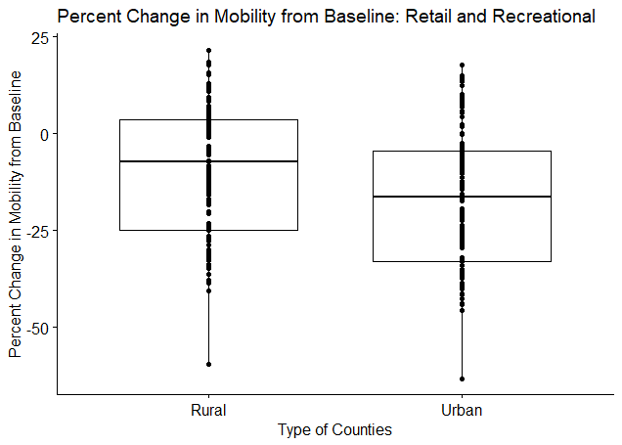

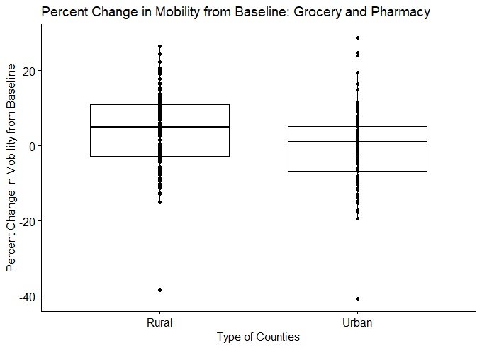

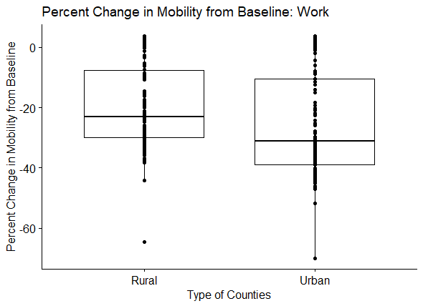

out3 <- boxplot(mob$work ~ mob$URBinary )$out

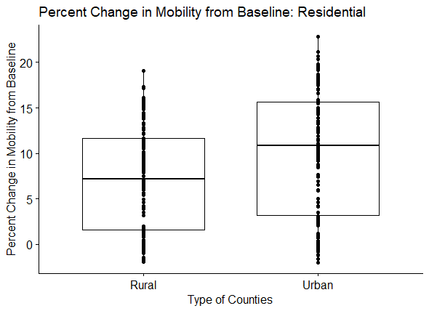

The assumption of normality in the case of this analysis is a given based on the large number of observations, 130 days for each of the mobility types. To ensure that this was not incorrectly assumed normality was assessed by county type and mobility type using QQ-plots. Based on these QQ-plots, residential and work seem to not be perfectly normally distributed, but there are a large number of observations (n>50) thus alleviating this concern. Below are the QQ-plots.

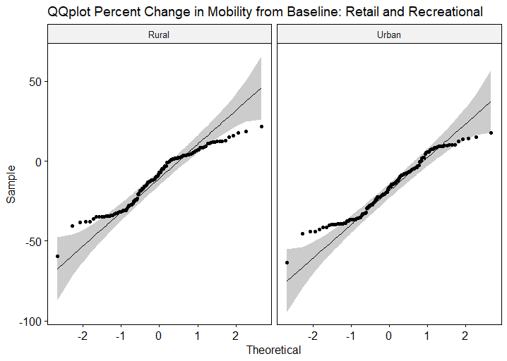

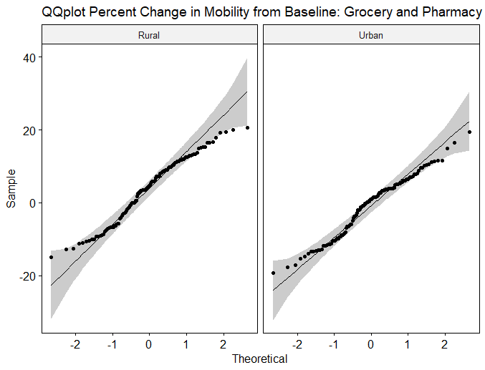

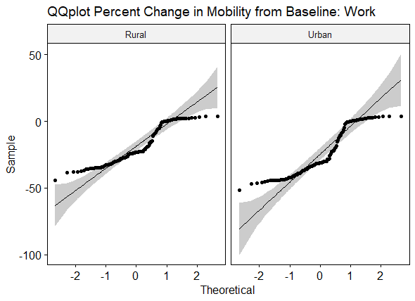

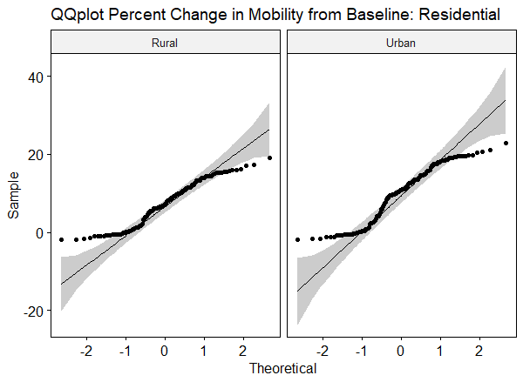

ret.aov <- anova_test(data = mob_ret, dv = retail_rec, wid =date2 , within = URBinary)

## ANOVA Table (type III tests) Retail and Recreation  
##   
## Effect DFn DFd F p p<.05 ges  
## 1 URBinary 1 129 415.405 3.71e-42 * 0.038

groc.aov <- anova_test(data = mob_groc, dv = groc_pha, wid =date2 , within = URBinary)

## ANOVA Table (type III tests) Grocery and Pharmacy  
##   
## Effect DFn DFd F p p<.05 ges  
## 1 URBinary 1 125 317.158 4.28e-36 * 0.072

work.aov <- anova_test(data = mob_work, dv = work, wid =date2 , within = URBinary)

## ANOVA Table (type III tests) Work  
##   
## Effect DFn DFd F p p<.05 ges  
## 1 URBinary 1 128 340.928 6.7e-38 * 0.035

res.aov <- anova_test(data = mob_res, dv = residential, wid =date2 , within = URBinary)  
get_anova_table(res.aov)

## ANOVA Table (type III tests) Residential  
##   
## Effect DFn DFd F p p<.05 ges  
## 1 URBinary 1 129 381.282 2.44e-40 * 0.042

All of the repeated measures ANOVA tests resulted in a significant p-value indicating that all of the percentage change in mobility from baseline categories are statistically significantly different between Rural and Urban counties.

# Stay-at-Home Orders Start and End Dates

Individual state governments started stay-at-home at different times and ended at different times, ascertained by review of each state’s executive order by the study team. Four states (Arkansas, Iowa, North Dakota, and South Dakota) did not issue stay at home orders. Three others (Oklahoma, Utah, and Wyoming) allowed the county and local governments to make such determinations. The following table displays the start and end dates of statewide stay-at-home orders, while the subsequent table displays that of locales.

|  |  |  |
| --- | --- | --- |
| State | Start | End |
| Alabama | 4/4/20 | 4/30/20 |
| Alaska | 3/28/20 | 4/24/20 |
| Arizona | 3/31/20 | 5/15/20 |
| Arkansas | Did Not Issue SAH | |
| California | 3/19/20 | Ongoing |
| Colorado | 3/26/20 | 4/26/20 |
| Connecticut | 3/23/20 | 5/20/20 |
| Delaware | 3/24/20 | 5/31/20 |
| District of Columbia | 4/1/20 | 5/29/20 |
| Florida | 4/3/20 | 5/4/20 |
| Georgia | 4/3/20 | 4/30/20 |
| Hawaii | 3/25/20 | 5/31/20 |
| Idaho | 3/25/20 | 4/30/20 |
| Illinois | 3/21/20 | 5/29/20 |
| Indiana | 3/24/20 | 5/4/20 |
| Iowa | Did Not Issue SAH | |
| Kansas | 3/30/20 | 5/3/20 |
| Kentucky | 3/26/20 | Ongoing |
| Louisiana | 3/23/20 | 5/15/20 |
| Maine | 4/2/20 | 5/31/20 |
| Maryland | 3/30/20 | 5/15/20 |
| Massachusetts | 3/24/20 | 5/18/20 |
| Michigan | 3/24/20 | 6/1/20 |
| Minnesota | 3/27/20 | 5/13/20 |
| Mississippi | 4/3/20 | 4/27/20 |
| Missouri | 4/6/20 | 5/3/20 |
| Montana | 3/28/20 | 4/26/20 |
| Nebraska | Did Not Issue SAH | |
| Nevada | 4/1/20 | 4/29/20 |
| New Hampshire | 3/27/20 | Ongoing |
| New Jersey | 3/21/20 | 6/9/20 |
| New Mexico | 3/24/20 | 5/31/20 |
| New York | 3/22/20 | 5/28/20 |
| North Carolina | 3/30/20 | 5/22/20 |
| North Dakota | Did Not Issue SAH | |
| Ohio | 3/23/20 | 5/29/20 |
| Oklahoma | Local Decision | |
| Oregon | 3/23/20 | Ongoing |
| Pennsylvania | 4/1/20 | 6/4/20 |
| Rhode Island | 3/28/20 | 5/8/20 |
| South Carolina | 4/7/20 | 5/4/20 |
| South Dakota | Did Not Issue SAH | |
| Tennessee | 3/31/20 | 4/30/20 |
| Texas | 4/2/20 | 4/30/20 |
| Utah | Local Decision | |
| Vermont | 3/25/20 | 5/10/20 |
| Virginia | 3/30/20 | 6/10/20 |
| Washington | 3/23/20 | 5/31/20 |
| West Virginia | 3/24/20 | 5/3/20 |
| Wisconsin | 3/25/20 | 5/13/20 |
| Wyoming | Local Decision | |

|  |  |  |  |  |
| --- | --- | --- | --- | --- |
| County | State | FIPS | Start | End |
| Carter County | OK | 40019 | 4/6/20 | 4/24/20 |
| Rogers County | OK | 40131 | 4/6/20 | 4/24/20 |
| Cleveland County | OK | 40027 | 3/25/20 | 4/24/20 |
| Seqouyah County | OK | 40135 | 4/4/20 | 4/24/20 |
| Payne County | OK | 40119 | 3/30/20 | 4/24/20 |
| Tulsa County | OK | 40143 | 3/28/20 | 4/24/20 |
| Oklahoma County | OK | 40109 | 3/28/20 | 4/24/20 |
| Davis County | UT | 49011 | 4/1/20 | 5/1/20 |
| Salt Lake County | UT | 49035 | 3/30/20 | 5/1/20 |
| Summit County | UT | 49043 | 3/27/20 | 5/1/20 |
| Teton County | WY | 56039 | 3/28/20 | 5/1/20 |

# References

1. Brooks ME, Kristensen K, Van Benthem KJ, et al. glmmTMB Balances Speed and Flexibility Among Packages for Zero-inflated Generalized Linear Mixed Modeling. The R Journal 2017;9:378-400.

2. Hartig F, Lohse L. Residual Diagnostics for Hierarchical (Multi-Level / Mixed) Regression Models. CRAN 2020.

3. Mitchell DJ, Dujon AM, Beckmann C, Biro PA. Temporal autocorrelation: a neglected factor in the study of behavioral repeatability and plasticity. Behavioral Ecology 2019;31:222-31.

4. Google COVID-19 Community Mobility Reports. Online: Google LLC; 2020.

5. Kassambara A. rstatix: Pipe-Friendly Framework for Basic Statistical Tests. CRAN 2020.