Location App Instruction

# Author: Andrew Zhang date: 06/25/2017

This project is a location app based on location list. For other people testing  it’s recommend to use adb install apk file to run the app, because the key is only for author environment. The apk folder contains debug-apk, app folder has release version, user can use both.

When user launch it,  it will check if GPS enable or not, if not it will force go to location setting to enable it. We have to enable the GPS to find user l ocation. Because user location is very important to calculate distance, arrival time.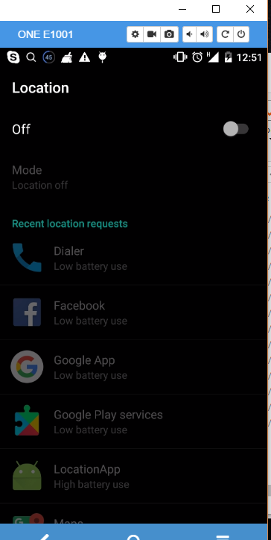

After enable GPS, left setting it will show List page which show the location name and address information fetch from Restful Web API

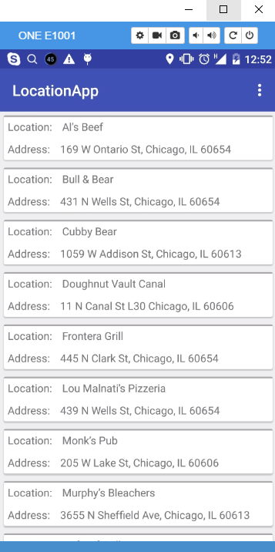

This page support both landscape and portrait mode and can be sort by name(default), distance and arrival time. 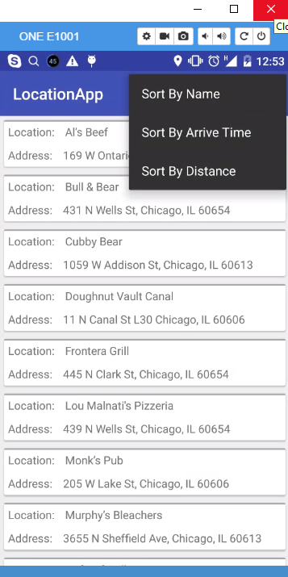

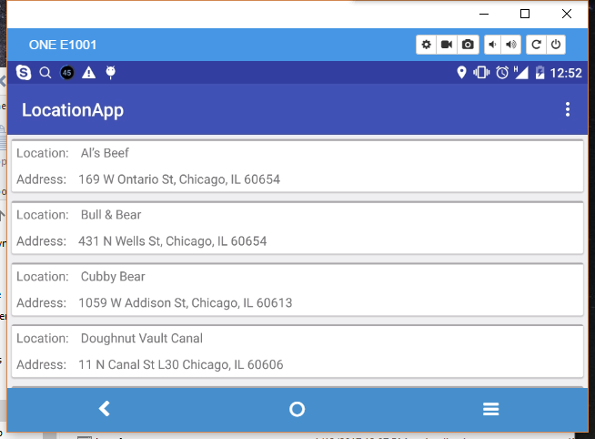

Event rotate the phone, it sort order still remained

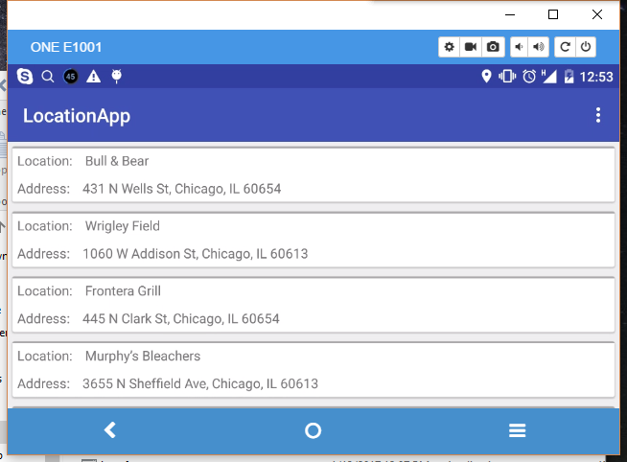

Once user click one of the item, it will show the location detail, and show the location map, once user click map maker, it will show the location label. 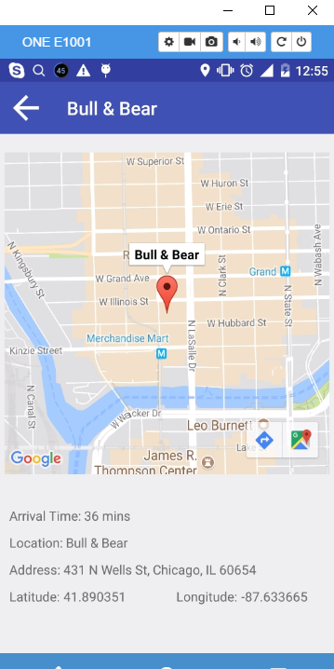

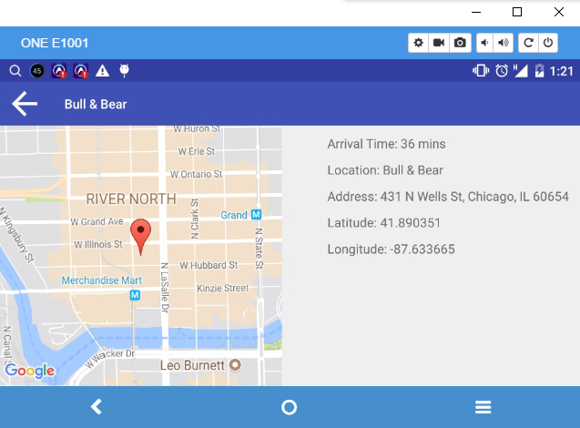

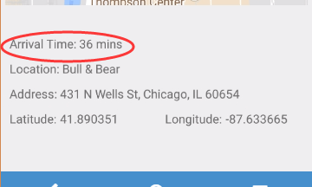

This time fetch from google direction api