Part 1
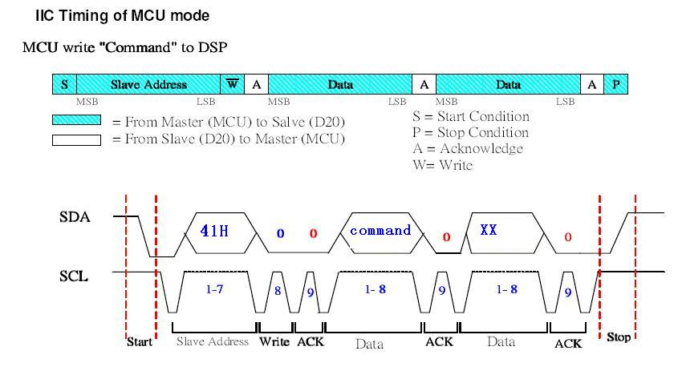

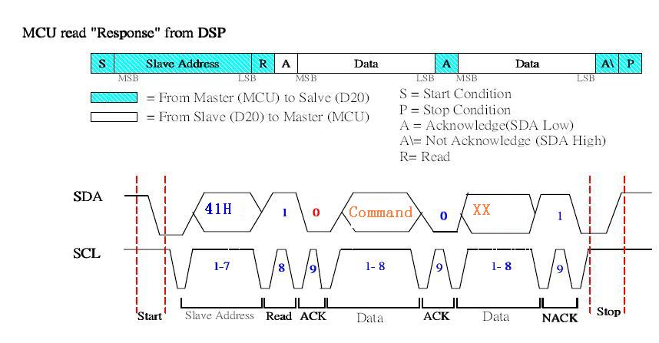
Remark:
1. MCU: EM78925, DSP: MX93U22UC
- S_CLK from MCU.
- DSP will pull low DSP_REQ before ready send command to MCU, MCU should send “read” command to DSP then DSP send command to MCU.
- MCU should check DSP_REQ state before send command to DSP, and must send command to DSP when DSP_REQ at high state at least 50mS.
- DSP address is “41” (High 7 bit), and the bit 0 is read/write bit, 0 for write and 1 for read. (meaning “82” for write command and “83” for read command)

Part 2
- DTAM send to Main MCU
Command Name Operation Code details:

NEW MSGS number 0x20 XX ;inform 925 new message number.
ALL MSGS number 0x21 XX ;inform 925 total message number.
MSG type 0x22 XX ;xx=00: new msg. xx=01: old msg.
MSG serial 0x23 XX ;inform 925 the serial of current msg.
STATUS 0x24 XX ; BIT0= 1: Memo Full
BIT1= 1: TAD ON; 0: TAD OFF
BIT2= 1: OGM1; 0: OGM2
memo or icm 0x25 XX ;xx=01,memo message, xx=00,icm message
MEMORY FULL 0x26 XX XX=0 Not Full, xx= others Full.
RECORD start 0x29 XX ;remind 925 start recording and 925 start time count;
XX=00: OGM recording
XX=01: MEMO recording
XX=02: ICM recording
OGM_TO_LINE 0x2A XX ;auto answer call and play OGM,
XX=01: answer with OGM1,
XX=02: answer with OGM2
REMOTE 0x2B XX ;enter remote control mode
LINE_SEIZE 0x2C XX ;DTAM has seized the line
EXIT_TO_DILE 0x2D XX ;exit to IDLE from PLAY /RECORD/REMOTE mode
DSP BUSY 0x2E XX ;DSP busy and can not process the command.
REQ_SETTING_COMM 0x2F XX ;After DSP reset, DSP request MCU setting.
During play MEMO or ICM, DTAM send date / time to MCU for display:
WEEK 0x4E XX XX= 0~6. (0-Sunday, 1- Monday… Default – 0)

Year 0x4C XX XX= 08 - 26
MONTH 0x46 XX XX=01 – 12 (default – 01)
DAY 0x47 XX XX=01 – 31 (default – 01)
HOUR 0x48 XX XX=00 – 92 (default – 00). B7- AM/PM flag
MINUTE 0x49 XX XX=00 – 59 (default – 00)
SEND_VERSION_NO 0x30 XX XX = 0~FF (0- V0, 1- V1, 2-V3...)
Required to auto send it to MCU925 when power up.

ERROR_MESSAGE 0x27 XX Inform MCU that DSP has error message, need to delete All if receive MCU925’s confirmation.
DMCIDCounterReturn 0x83 03h Totalcall Newcall DSP 告知MCU知Total call( 1~ 63h) HexCode
New call (1~63h) HexCode
要求上電PowerReset時執行 或者有任何變動情況下
執行, 如果瀏覽時NEW->OLD 引起Newcall --

DMPhoneBookTrans 0x81 XX FULL_M PowerReset后, DSP 將整個PhoneBook內容-> MCU
XX – 任意數值

Main MCU send to DTAM command
[Power Initialization command]

- MCU925 get message & CID number from DTAM
[DTAM OPTION]
VOICE_PROMPT_LANGUAGE 0X40 XX (XX=00: English(Default) 01: France, 10: Spanish)
RINGNUM_TO_ANS 0x41 XX XX =00, 02-08 (default 04) 00 = toll saver
REMO_ACC_CODE _HIGH 0x42 XX Remote code High Bit (default 01)
REMO_ACC_CODE _LOW 0x43 XX Remote code Low Bit (default 23)
CALL_SCREENING 0x44 XX XX = 00 OFF, =01 ON (default – ON )
Voice Compress Rate 0x45 XX XX=01 (3.6Kbps), =00 (6.0Kbps). Default
Year 0x4C XX XX= 08 - 26
MONTH 0x46 XX XX=01 – 12 (default – 01)
DAY 0x47 XX XX=01 – 31 (default – 01)
HOUR 0x48 XX XX=00 – 92 (default – 00). B7- AM/PM flag
MINUTE 0x49 XX XX=00 – 59 (default – 00)
SET_DTAM_VOL 0x4A XX XX=01 – 08 (default –05)
SET_SPK_PHONE_VOL 0x4B AB B=01 – 08 (default –05)
A = 0 Close Amplify during H/F off hook mode only
= 1 Enable Amplify during H/F off hook mode only

TALK_SETUP_MENU 0x4D XX Once press MENU to enter setup mode from standby mode,
Unit shall announce “ setup menu, Use skip or repeat to change setting , Press menu to save setting” And will stop
The announcement by EXIT_TO_DILE command if then press SKIP or REPEAT or MENU while playing
SET_ITAD_CLOCK 0X4F MON DAY HOUR MIN Everytime when MCU925 receive a CID with
Valid time value, should update ITAD clock by
CID.
MON = 1,2..10,11,12 BCD code
DAY = 1,2..10..31 BCD code
HOUR b0..b6 = 0..12 BCD code
HOUR.b7 used as AM/PM flag
0 -- AM
1 -- PM

MINUTE = 0..59 BCD code
If received CID ,its time is Nov.28 1:45PM. MCU925 shall send
0X4F 0X11 0X28 0X81 0X45. ITAD will update CLOCK to Nov.28 1:45PM

TWO_WAY_RECORD 0X31 XX Record conversation in handset mode only.
(Not used) Press and hold MEMO to start recording..
Until

SetLCDContrast 0x32 M6 告知DSP 更新M6(Language / LCD Contrast)
SetTonePulse 0x33 M4 告知DSP 更新M4
SetAudioPredial 0x33 M4 告知DSP 更新M4
SetAreaCode 0x34 M7 M8 告知DSO 更新M7,M8

---- KeyBoard Command ---
ANS_ON/OFF 0x50 XX XX =00 OFF, =01 ON (default – ON)
Press and hold ON/OFF key 2S
OGM Select 0x51 XX XX =01 OGM1, =02 OGM2 (default – OGM1)
Press ON/OFF key
Play current OGM 0x52 XX Press ANNOUNCE key
Record current OGM 0x53 XX Press and hold ANNOUNCE key 2S
Play Message 0x54 XX Press PLAY/STOP key
Play Pause 0x55 XX
Skip to next MSG. 0x56 XX Press SKIP key during playing
Repeat / Previous 0x57 XX Double click in 2S --- Goto previous message
Otherwise, -- - Repeat current message
Play MEMO help 0x58 XX Press MEMO key.
Record MEMO 0x59 XX Press and hold MEMO key
Stop 0x5A XX Press STOP key during playing or recording / release MEMO key during MEMO recording.
Message Delete 0x5B XX Press DEL key during playing to delete current message.
All old message Delete 0x5C XX Press and hold DEL key 2S.
Enable 30% play speed 0x5D 01 Press and hold SPEED key.
Disable 30% play speed 0x5D 00 Release SPEED key, come back to normal speed play.
SPK Phone ON 0x5E 01 Press SPK key at idle mode and go to speaker phone mode.
SPK Phone OFF 0x5E 00 Press SPK key at SPK mode and go to idle mode.
MUTE ON 0x5F 01 Press MUTE key at SPK mode to mute microphone.
MUTE OFF 0x5F 00 Press MUTE key at mute mode and release MIC mute.
Handset OFF HOOK 0x60 01 User pickup the handset to off hook in handset mode
Handset ON HOOK 0x60 00 User put down the handset to on hook for end a call.
Slow 100% play speed 0x62 00 Press MESSAGE SPEED key to SLOW< > NORMAL
Normal Play Speed 0x63 00 during Message play. Should auto come back to normal
After DTAM return to ready- to- answer mode(standby mode)
SPK on 0x64 00 Press FLASH key at SPK mode to mute SPK
SPK off 0x64 01 to unmute SPK at SPK mode

ANS Enable 0x65 00 Enable auto answer function
ANS Disable 0x65 01 disable auto answer function

All old message Delete 0x5C XX Press and hold DEL key 2S.
1). No messages at all, unit shall announce “You have no messages”
2). Exist both new and old messages , unit shall announce “All old messages erased”
Note – New Messages are not allowed to be deleted!!
3). Exist New messages only, unit shall announce “ No messages erased”

4). Exist old messages only, unit shall announce “All old messages erased”

------- Talking CID number-----------
Talking CID number 0x61 XX XX XX XX XX XX XX XX received CID number and enable CID talking
Remark:
1, if CID number not enough 16 digits, then fill by F at the end.
For example: CID number = 0755 83048750, MCU send command 0x61 07 55 83 04 87 50 FF FF.
2, if the 2nd CID received but 1st CID still talking, then stop 1st number and start talking the 2nd number immediately.
3, if the ring detection matched the number of ring setting during talking CID, then the DTAM will answer after finished CID talking.

--------Audio Key 0~9------------------
DIGIT_1_KEY 0x6A 01 Play voice prompt “one”
DIGIT_2_KEY 0x6A 02 Play voice prompt “two”
DIGIT_3_KEY 0x6A 03 Play voice prompt “three”
DIGIT_4_KEY 0x6A 04 Play voice prompt “four”
DIGIT_5_KEY 0x6A 05 Play voice prompt “five”
DIGIT_6_KEY 0x6A 06 Play voice prompt “six”
DIGIT_7_KEY 0x6A 07 Play voice prompt “seven”
DIGIT_8_KEY 0x6A 08 Play voice prompt “eight”
DIGIT_9_KEY 0x6A 09 Play voice prompt “nine”
DIGIT_0_KEY 0x6A 00 Play voice prompt “zero”

--------Test mode--------------------
1, MCU to DSP
ENTER_TEST_MODE 0x6B 01
EXIT_TEST_MODE 0x6B 00
ICM RECORD test 0x6B 02 DSP off hook and record from line
TONE OUT test 0X6B 03 DSP off hook and generate 1KHz tone to line and SPK
MEMORY SIZE TEST 0X6B 04 DSP count FLASH memory capability and send to MCU
PLAY ALL VOICE 0X6B 05 DSP play all voice prompt to line and SPK.
STOP KEY 0X6B 06 Cancel the current test item.
FORMAT SPI FLASH 0X6B 07 Perform factory default settings and delete all message.
2, DSP to MCU
MEMORY SIZE HIGH bit 0x6C XX XX=00 – 99, 千位 and 百位, unit= second
MEMORY SIZE LOW bit 0x6D XX XX=00 – 99, 十位and 个位, unit= second
Current operation over 0x6E XX End of operation and return to test mode idle.

DEFAULT_MODE 0X6F XX All memories must return DEFAUL.
Including, Old&New message -- > 0
OGM -> Default (You are unavailable to..)
Language - > English …

[Test Mode Process]

ENTER_TESTMODE 0X6B 01 On hook, Enter test mode, ready to check ITAD features.

CALL_SCREENING “1” 6B 02 Off hook, ICM recording mode, open SPK also. Keep until STOP
(to check ICM input level) TO_STANDBY command received.

MEMO_LINEOUT “2” 6B 0E OffHook, play memo into the line
(check Message to line level) Once receives the command, will take the following steps:
Onhook Make 5S long MEMO→ Delay 2S → Off Hook loop Play it at the line, stop until STOP_TO_STANDBY received.

BEEP_LINEOUT “3” 6B 03 Offf hook, Play beep tone to the line. stop until STOP_TO_STANDB received.
(check beep tone level to line)

DTMF_DECODE “4” 6B 09 off hook, Unit shall be ready to decode 0~9 DTMF digit, require
(Check DTMF decoding ability) ITAD to show the received digit through DTMF dialing, within 500ms After receive it. Suggest 80ms DTMF length for each bit

STOP_TO_STANDBY “5” 6B 06
(Exit any test item and standby for new check)

VOX_DETECT “6” 6B 0A Off hook mode( don’t make ICM record), get ready to check VOX
(check VOX detect level) require to turn ON MSG LED if vox detected and turn OFF if no
Vox detected. stop and exit until STOP_TO_STANDBY received.

MEMO_SPK_OUT “7” 6B 0B Different from above MEMO_LINEOUT, ONhook condition, Once
receives the command, will take the following steps:
Make 5S long MEMO RECORD → Delay 2S →
Repeatedly Play it at SPK, stop and exit until TOP_TO_STANDBY received.
(Check Message to SPK level)

BEEP_SPK_OUT “8” 6B 0C Different from above BEEP_LINEOUT, require on hook condition,
(check beep tone to SPK level) Once receives the command , will repeatedly play beep tone through SPK. stop and exit until STOP_TO_STANDBY received.

ICM_TO_LINE “9” 6B 0D 新SW要求:取線進行ICM 錄音,SPK同時打開播放ICM,錄10S後,就停止錄ICM,Delay 2S,再將剛錄入的ICM播放出Line.直到按"5"停止.
( Check ICM function) Stop and exit until STOP_TO_STANDBY is received.

ICM_TO_SPK “0” 6B 08 新SW要求:取線進行ICM 錄音,SPK同時打開播放ICM,錄10S後,就停止錄ICM並掛機,Delay 2S,再將剛錄入的ICM播放出SPK.SPK Vol要設為Vol Max.直到按"5"停止.

MINUTES_TO_RECORD “*” 6B 04 off hook,show it though DTMF dialing. Ex : have 27minutes to record,
(RAM SIZE) require to dial out 2 and 7 . DTMF 2ON -> OFF 100ms delay ->
DTMF 7 ON. 80ms DTMF ON length taken
(check FLASH memory, how many minutes
For message record, base on 6.0K bps
Compress rate)

CLEAR_MEMORY_EXIT “#” 6F XX Complete all the above tests, finally clear memory and exit
To on hook standby mode. Same as DEFAULT_MODE

ERRRO_MESSAGE_ACK 0X70 XX MCU925 receive error message information and give back decision ---- delete all or not.
XX = 0 exit directly.
XX = 1 confirm to delete all.
注意, 如果等待過程中收到MCU 其他命令,作棄權處理. 需要解除 Delete all 標志.

下面For DectCombo使用.
===============================================================================

SystemOptionsSYNC 0x80 M1..M8 After Power reset, D22U shall send system options package to
(雙向 去除雙向) MCU925. Also, it is used to update D22U options. 任何的改動
MCU 將會用此命令同步Update到D22U

M1..M8 具體定義如下:
M1 (ITAD Volume) 0 ~ 255
D7 | D6 | D5 | D4 | D3 | D2 | D1 | D0

M2(Security Code XYZ)
Xd7 | Xd6 | Xd5 | Xd4 | Yd3 | Yd2 | Yd1 | Yd0

M3(Security Code XYZ)
Zd3 | Zd2 | Zd1 | Zd0 | 1 | 1 | 1 | 1

M4(Ring To Answer, Tone/Pulse, Talking CID, Audio Predail )
Audio_pre | TalkCID | T/P | Notused | Rnum3 | Rnum2 | Rnum1 | Rnum0
Rnum3…Rnum0 0, 2-8 (default 04) 0000 = toll saver
T/P Tone/Pulse mode selection
TalkCID Talking CID ON/FF, 1- Enable
Audio Predial 1- Enable. (On hook mode, press dial digit key like ‘9’, unit shall talk “nine”)

M5(Record Quality / Message Length )
REC_QA | X | x | X | X | L2 | L1 | L0
REC_QA, 0 – STANDARD. 6.0Kbps 1-3.6Kbps
ANS ON/OFF 1:ON ,0:OFF
L0~L2 , from 001 ~ 100 1 min ~ 4min

M6(Language / LCD Contrast)
X | X | ESP | FRA | LCD3 | LCD2 | LCD1 | LCD0
B5:SPANISH
B4:FRANCE
B3B2B1B0 :STORE CONTRAST

M7(AREA CODE XYZ)
Xd3 | Xd2 | Xd1 | Xd0 | Yd3 | Yd2 | Yd1 | Yd0

M8(AREA CODE XYZ)
Zd3 | Zd2 | Zd1 | Zd0 | 1 | 1 | 1 | 1

For a instance,
TAD VOL=4 , M1=03h ( vol1=0x00)
security code=123 M2=12h M1=3Fh
RING OF NUM=4
AUDIO PREDIAL =ON M4=84h
MESSAGE LENGTH=2
ANS ON
REC QUILITY= STD M5=42h
CONTRAST=3
Langusge= English M6=03h
Area code=456 M7=45H, M8=6Fh

;----------------------------------------------------------------------------------------------------------------------------
MCU TO DPS方式
MCU 在update 以上DATA to DPS時，除Area code 及security code外，均爲單條發送
Ex:若 mcu 要update TAD VOL 則會發送 80 01 XX 其中01表示對應的M1. XX爲DATA
Area code 及Security code則兩個byte 一次發送
Ex. 若mcu 要update Area code到567 ，則會發送80 07 56 7F ,其中07表示Area code對應的M7，
若是Security code，則會發送80 02 56 7F ,其中07表示Sec code對應的M2，
;--------------------------------------------------------------------------------------------------------------------------------

[PhoneBook Process]
總共13組Memory, M0…M9, MA,MB,MC

MDPhoneBookUpdate 0x81 xx MDATA xx - 0~9 ,0a 0b 0c. 代表 M0…MC
通知DSP 用MDATA Update Mxx
;------------------------------------------------------------------------------------------------------------------------------------
DMPhoneBookTrans 0x81 XX FULL_M PowerReset后, DSP 將整個PhoneBook內容-> MCU
XX – 任意數值
删除本条command
改爲上電後，DPS主動逐條發送PhoneBook 內容. MDPhoneBookUpdate方式發送
;------------------------------------------------------------------------------------------------------------------------------------

MDReqPhoneBook 0x82 xx xx – 0~9 0a 0b 0c 代表 M0~MC
請求DSP回復 Mxx 內容
DMReturnPhoneBook 0x82 xx MDATA DSP應MDReqPhoneBook要求,回復指定Mxx 內容

MDATA結構
Num12 Num34 …..Num31,32 + Name 1 , Name2 …. Name12.
注意! Empty Num 用F 代表
Empty Name 用 20h 代表
如 Number = 00852 83812008 Name = KEN 則MDATA 會是
00h 85h 28h 38h 12h 00h 8fh ffh ffh ffh ffh ffh ffh ffh ffh ffh 4Bh 45H 4Eh 20h 20h 20h 20h 20h 20h 20h
20h 20h 總共16+12 = 28 Bytes

FULL_M 結構
MDATA + MDATA + ….MDATA + MDATA + MDATA + MDATA
M0 M1 M9 MA MB MC
總共, 28 * 13 = 364 bytes

[Call log process]

MDCIDRecordAdd 0x83 00h CIDPACKAGE 告知DSP 將 CIDPACKAGE 存入Flash Calllog里面

MDReadDownCIDRecord 0x83 01h MCU想 讀取前一個CID 內容. 如果當前是C1, 則Down
如 C4->C3 就變成 END OF LIST. 要送CIDEndOfList命令 .
凡目前沒處于Reviewmode,則匆 Top 位置C (totalcal) 開始
;---------------------------------------------------------------------------------------------------------------------------------------
MDReadUpCIDRecord 0x83 02h 想 讀取前一個CID 內容. 如果當前是最Recent, 則Up
就變成 END OF LIST. 要送CIDEndOfList命令
如C3->C4 凡目前沒處于Reviewmode,則匆 Bottom 位置C1開始

MDCIDRecordDelete 0x83 03h 告知DSP 要刪除 當前Review中的call.
刪除之后要求自動執
MDReadDownCIDRecord 如果是 Down方式Review
Or
MDReadUpCIDRecord 如果是 Up方式Review
決定Up or Down 方式? 看你上次收到Which Command.

MDCIDRecordDelAll 0x83 04h MCU告知DSP要求刪除所有Call.

MDCIDReviewModeExit 0x83 05h MCU告知DSP 退出CID Review.
同步地, 下面命令也需要退出
SPK Phone ON 0x5E 01
Handset OFF HOOK 0x60 01
DMCIDRecordReturn 0x83 01h CIDPACKAGE DSP 回送 CID內容給MCU.
DMCIDEndOfList 0x84 00h DSP 回送, 表示CID Review 到 盡頭.

DMCIDCounterReturn 0x85 00h Totalcall .DSP 告知MCU知Total call( 1~ 63h) HexCode
DMCIDCounterReturn 0x85 01h MCU New call. DSP 告知MCU New call (1~63h) HexCode
要求上電PowerReset時執行 或者有任何變動情況下
執行.

CIDPACKAGE 結構
長度 24個Byte, DSP無須理解里面具體定義，只需協助處理 存儲/回送. What Receive and what store and what return. 其他一切交給MCU925分析處理. 但有几點點需要協助處理下面會講

. TotalCall ++ or No change(when full)
.NewCall ++ or No change(when full)
.New->OLD NewCall – (When review one new call)

另外需要澄清Call log 里面CID Record 關于 ”順序” 要求. DSP 務必能夠分辨Recent call and old call.
假如D22U 前后收到 C1,C2,C3,C4,C5..C9 共9個Call,當然放在FLASH里面.
用戶開始Review Call, 當然他Review 到 C4并按Delete Key刪除.(MCU 會發MDCIDRecordDelete命令)
則新的Calllog 會是 C1,C2,C3,C5,C6…C9. No4. 變成是 C5. 你只需要Update CallAddressTable就OK!!
又,

因為Call 其中有一個屬性 NEW/OLD, 標識此Call有沒有Review過. Unreviewed 當然是NEW,一旦Review后，即要求變成OLD. 所以DSP 還需要處理NEW->OLD.

CIDPACKAGE 當中第一個Byte
B0:CID_CHECKSUM_ERR
B1:CID_NEW
B2:CID_UNKNOWN_NAME
B3:CID_PRIVATE_NAME
B4:CID_LONG
B5:CID_DDN
B6:CID_UNKNOWN_NUMB
B7:CID_PRIVATE_NUMB

DSP 執行DMCIDRecordReturn 緊跟著將改Call 的 CID_NEW->0

