工作报告目录
1 第五周 2
1.1 任务描述 2
1.2 截图 2
2 第六周 2
2.1 任务描述 2
3 第七周 3
3.1 任务描述 3
3.2 功能截图 3
3.3 代码 3
4 第八周 3
4.1 任务描述 3
4.2 功能截图 4
4.3 代码 4
5 第九周 5
5.1 任务描述 5
5.2 功能截图 5
5.3 代码 6
6 第十周 6
6.1 任务描述 6
7 第十一周 7
7.1 任务描述 7
7.2 功能截图 7
7.3 代码 8
8 第十二周 10
8.1 任务描述 10
9 第十三周 11
9.1 任务描述 11
9.2 功能截图 11
9.3 代码 11
10 第十四周 13
10.1 任务描述 13
10.2 功能截图 14
10.3 代码 14
11 第十五周及之后 15
11.1 任务描述 15
11.2 截图 15

第五周

任务描述
用户需求说明书、可行性分析报告。

截图
用户需求说明书截图：
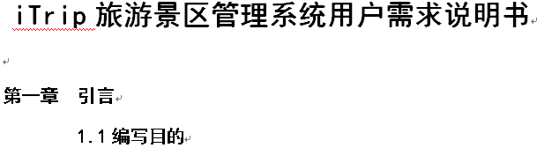
可行性分析报告截图：
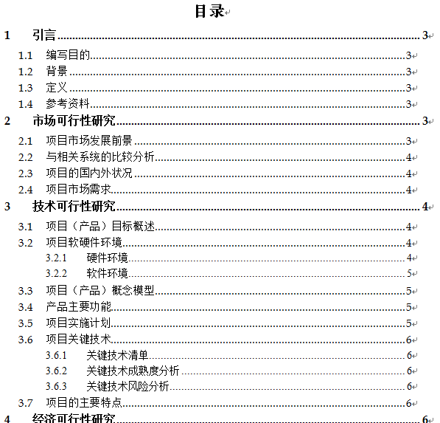

第六周

任务描述
项目需求文档修改，可行性研究报告修改,进一步完善用户需求说明书、可行性分析报告这两份文档。

第七周

任务描述
基本完成景区公告功能

功能截图
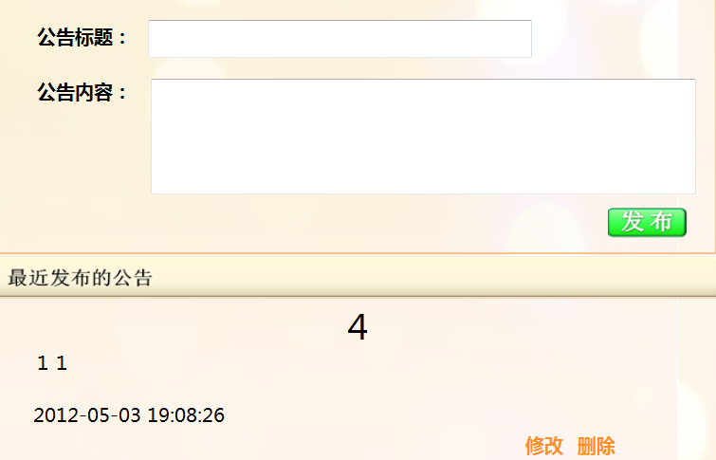

代码
/// 编辑者：张龙德 功能：通过用户名在用户表中获取景区ID
public static int getScenicSpotIdByUsernameDAL(string userName)
/// 编辑者：张龙德 功能：添加公告信息
public string AddAnnountionDal(ScenicAnnountionModel su)
/// 编辑者：张龙德 功能：删除公告信息
public static int deleteAnnontionDAL(int AnnountionDecID)
/// 编辑者：张龙德 功能：修改公告信息
public static bool ReviseAnnontionDAL(ScenicAnnountionModel sam, string annountionDecID)

第八周

任务描述
公告版块的内容，并针对性地完善细化部分功能，以及所有功能的测试。

功能截图
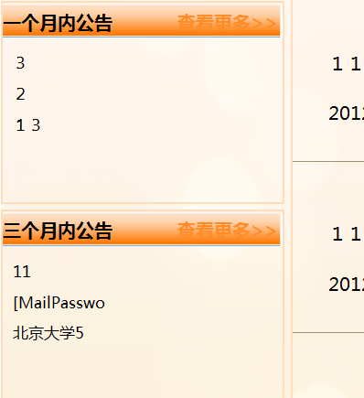
分页插件截图：


代码
public static List<ScenicAnnountionModel> selectWeekAnnountionAnnountionsDAL()
public static List<ScenicAnnountionModel> selectMonthAnnountionAnnountionsDAL()
public static List<ScenicAnnountionModel> select3MonthAnnountionAnnountionsDAL()
/// 编辑者：张龙德 功能：根据页码选择公告信息
public static List<ScenicAnnountionModel> select4AnnountionByPagingDAL(int page, int scenicSpotID)
{
SqlParameter[] prams = new SqlParameter[] {
new SqlParameter("@scenicSpotID",SqlDbType.Int),
new SqlParameter("@firthTerm",SqlDbType.Int),
new SqlParameter("@lastTerm",SqlDbType.Int)
};
int firthTerm = (page - 1) * 4 + 1;
int lastTerm = page * 4;
prams[0].Value = scenicSpotID;
prams[1].Value = firthTerm;
prams[2].Value = lastTerm;
DataTable dt = SQLHelper.QueryBySqlText(@"select decId,scenicZoneID,decContent,decTime,title
from(select *,ROW_NUMBER() OVER(ORDER BY decId desc ) AS RowNumber from tb_declaration where scenicZoneID=@scenicSpotID)
as abstract_table where RowNumber BETWEEN @firthTerm and @lastTerm ", prams);
List<ScenicAnnountionModel> sams = new List<ScenicAnnountionModel>();
foreach (DataRow row in dt.Rows)
{
sams.Add(new ScenicAnnountionModel
{
DecID = Convert.ToInt32(row[0]),
ScenicZoneID = Convert.ToInt32(row[1]),
DecContent = Convert.ToString(row[2]),
DecTime = Convert.ToDateTime(row[3]),
Title = Convert.ToString(row[4])
});
}
// Console.Write(sams);
return sams;
}

第九周

任务描述
分页插件修改，景区公告功能完善

功能截图
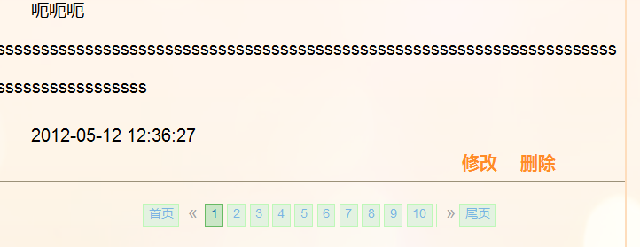


代码
//编辑者：张龙德 功能：分页初始化，并绑定点击页面事件
function paging(scenicSpotID) {
var pageAmount = 0;
$.post("/ScenicAnnountion/getPageAmount", { scenicSpotID: scenicSpotID }, function (data) {
pageAmount = parseInt(data);
var disPlay = 0;
disPlay = parseInt(pageAmount / 2 + 1);
$("#demo").paginate({

第十周

任务描述
实现查看跟更多公告功能，修改插件实现刷新分页，以及点击按钮后的自然跳转与更人性化的提示窗口
功能截图
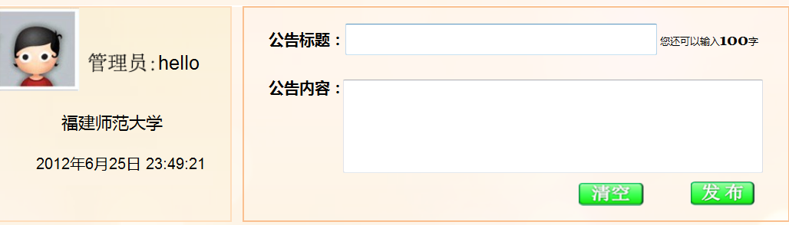
代码
//绑定可输入字数事件
function prompt() {
$("#annountionTitle").keyup(
function () {
var title = $("#annountionTitle").val();
var titleLength = title.length;
var remain = 100 - titleLength;
$("#wordAmountID").text(remain);
});
$("#annountionContent").keyup(
function () {
var title = $("#annountionContent").val();
var titleLength = title.length;
var remain = 500 - titleLength;
$("#wordAmountID").text(remain);
});
}
//编辑者：张龙德 检测发布框内的字数
function checkWordAmount() {
var title = $("#annountionTitle").val();
var titleLength = title.length;
var remain = 100 - titleLength;
$("#wordAmount").text(remain);
}

第十一周

任务描述
继续完成景区公告功能，webserverce接口设计
讨论Webservice的功能以及要暴露的接口，编写webservice的代码，并发布webservice的内容

功能截图
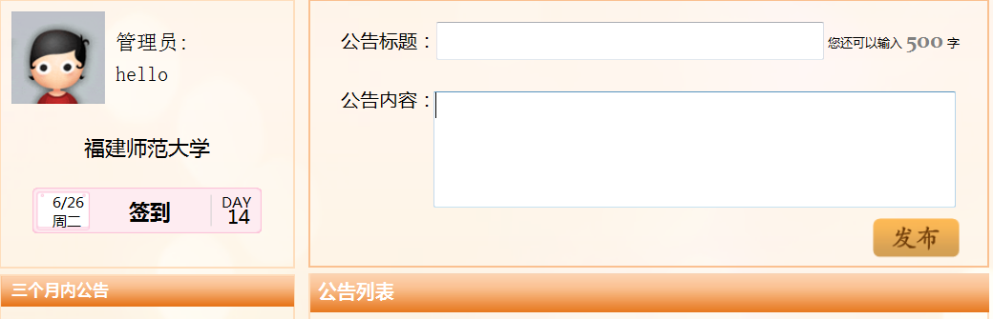
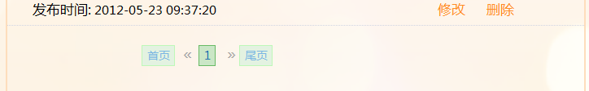
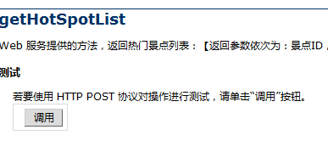
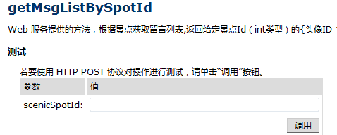
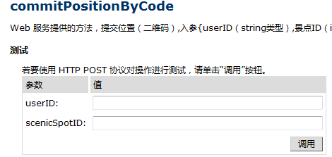
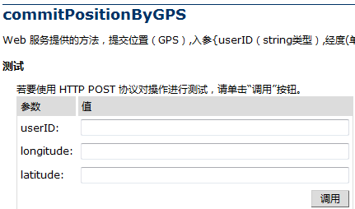

代码
public bool commitPositionByGPS(string userID, double longitude, double latitude)
{
//查¨¦看¡ä数ºy据Y，ê?是º?否¤?已°?经-存ä?在¨²该?游®?客¨ª的Ì?定¡§位?
SqlParameter[] prams2 = new SqlParameter[] {
new SqlParameter("@userID",SqlDbType.NVarChar,20)
};
prams2[0].Value = userID;
DataTable dt2 = SQLHelper.QueryBySqlText(@"select COUNT(*) from postion where VisitorID=@userID", prams2);
int count =Convert.ToInt32(dt2.Rows[0][0]);

if (count==0)
{
SqlParameter[] prams = new SqlParameter[] {
new SqlParameter("@userID",SqlDbType.NVarChar,20),
new SqlParameter("@longitude",SqlDbType.Decimal),
new SqlParameter("@latitude",SqlDbType.Decimal)
};
prams[0].Value = userID;
prams[1].Value = longitude;
prams[2].Value = latitude;
return SQLHelper.ExcuteNonQueryBySqlText("insert into postion values(@userID,0,@longitude,@latitude,GETDATE())", prams);
}
else
{
SqlParameter[] prams = new SqlParameter[] {
new SqlParameter("@userID",SqlDbType.NVarChar,20),
new SqlParameter("@longitude",SqlDbType.Decimal),
new SqlParameter("@latitude",SqlDbType.Decimal),
};
prams[0].Value = userID;
prams[1].Value = longitude;
prams[2].Value = latitude;
return SQLHelper.ExcuteNonQueryBySqlText("UPDATE dbo.postion SET longitude=@longitude,latitude=@latitude,commitTime=GETDATE() WHERE VisitorID=@userID", prams);
}
}
public List<string> getNearbySpotInfoByGPS(double longitudeByClient, double latitudeByCLient)
{
List<string> nearbyScenicSpotInfos = new List<string>();
string scenicSpotID, scenicSpotName, scenicSpotIntroduce, scenicZoneID, hotDegree, picturePath, voicestorePath, touristAmount;
double longitudeByDatabase, latitudeByDatabase,distance;
DataTable dt = SQLHelper.QueryBySqlText(@"
");
foreach (DataRow row in dt.Rows)
{
scenicSpotID = Convert.ToString(row["scenicSpotID"]);
scenicSpotName = Convert.ToString(row["scenicSpotName"]);
scenicSpotIntroduce = Convert.ToString(row["scenicSpotIntroduce"]);
scenicZoneID = Convert.ToString(row["scenicZoneID"]);
hotDegree = Convert.ToString(row["hotDegree"]);
longitudeByDatabase = Convert.ToDouble(row["longitude"]);
latitudeByDatabase = Convert.ToDouble(row["latitude"]);
picturePath = Convert.ToString(row["phone_picturePath"]);
voicestorePath = Convert.ToString(row["storePath"]);
touristAmount = Convert.ToString(row["touristAmount"]);
distance = GetDistance(latitudeByCLient, longitudeByClient, latitudeByDatabase, longitudeByDatabase) * 1000;
if (distance <= 1500)
{
string temp = scenicSpotID + "@@@" + scenicSpotName + "@@@" + scenicSpotIntroduce + "@@@" + scenicZoneID + "@@@" + hotDegree + "@@@" + longitudeByDatabase.ToString() + "@@@" + latitudeByDatabase.ToString() + "@@@" + Convert.ToString(distance) + "@@@" + picturePath + "@@@" + voicestorePath + "@@@" + touristAmount;
nearbyScenicSpotInfos.Add(temp);
}
}

if (nearbyScenicSpotInfos.Count<1)
{
nearbyScenicSpotInfos.Add("该?位?置?附?近¨¹不?存ä?在¨²景¡ã点Ì?");
}
else
{
List<string> nearbyScenicSpotInfosTop5 = new List<string>();
int i=0;
if (nearbyScenicSpotInfos.Count>5)
{
foreach (string item in nearbyScenicSpotInfos)
{
i++;
nearbyScenicSpotInfosTop5.Add(item);
if (i>4)
{
break;
}
}
return nearbyScenicSpotInfosTop5;
}
}
return nearbyScenicSpotInfos;
}

第十二周

任务描述
1、完成webservice四个接口，并布置局域网，与手机端合作进行测试完善
2、web端的发布公告，功能瑕疵修改，并进行简单测试，包括SQL防注入设置，脚本注入、恶意外链等防范措施

第十三周

任务描述
1、webservice实现两个接口：getNearbySpotInfoByGPS、getSpotInfoByKeyword，
设计webservice语音传输、图片传输解决方案，并尝试解决，
修改webservice其他接口，测试所有webservice接口
2、web端，我负责的公告内容bug修改，及细节实现，用户体验设计

功能截图
• getNearbySpotInfoByGPS
Web 服务提供的方法，GPS定位后上传经纬度，根据经纬度返回该区域附近(1500m)的5个景点信息【返回参数依次为：景点ID，景点名称，景点介绍，景区ID，热度，经度，纬度,景点距离（单位m），景点图片链接，景点语音路径链接,人流量】
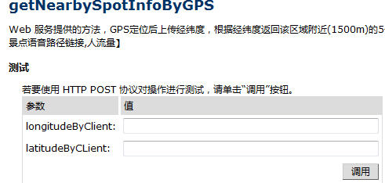
• getSpotInfoById
Web 服务提供的方法，返回给定景点Id（int）的景点信息：景点ID、景点名称、景点图片网址、景点简介【返回1个string数组】
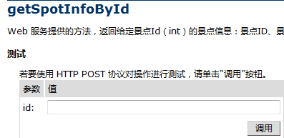

代码
public List<string> getSpotInfoById(int id)
{
getSpotInfoByIdCode gsibic=new getSpotInfoByIdCode();
List<SpotInfoByIdModel> sibim=gsibic.getSpotInfoByIdDAL(id);
List<string> spotInfoList = new List<string>();
foreach (SpotInfoByIdModel s in sibim)
{
spotInfoList.Add(Convert.ToString(s.ScenicSpotID));
spotInfoList.Add(s.ScenicSpotName);
spotInfoList.Add(Convert.ToString(s.picture));
spotInfoList.Add(s.scenicSpotIntroduce);
spotInfoList.Add(s.storePath);
}
return spotInfoList;
}
public List<string> getNearbySpotInfoByGPS(double longitudeByClient, double latitudeByCLient)
{
List<string> nearbyScenicSpotInfos = new List<string>();
string scenicSpotID, scenicSpotName, scenicSpotIntroduce, scenicZoneID, hotDegree, picturePath, voicestorePath, touristAmount;
double longitudeByDatabase, latitudeByDatabase,distance;
DataTable dt = SQLHelper.QueryBySqlText(@"select top 5 tb_scenicSpot.scenicSpotID ,tb_scenicSpot.scenicSpotName,SUBSTRING(scenicSpotIntroduce,0,2000) as scenicSpotIntroduce,tb_picture.scenicZoneID,hotDegree,longitude,latitude,
tb_picture.phone_picturePath,tb_voice.storePath,count(tb_infoStatistics.scenicSpotID)as touristAmount
from tb_scenicSpot
left join tb_picture on tb_scenicSpot.scenicSpotID=tb_picture.scenicSpotID
left join tb_voice on tb_scenicSpot.scenicSpotID=tb_voice.scenicSpotID
left join tb_infoStatistics on tb_scenicSpot.scenicSpotID=tb_infoStatistics.scenicSpotID
group by tb_scenicSpot.scenicSpotID ,tb_scenicSpot.scenicSpotName,SUBSTRING(scenicSpotIntroduce,0,2000) ,tb_picture.scenicZoneID,hotDegree,longitude,latitude,
tb_picture.phone_picturePath,tb_voice.storePath");
foreach (DataRow row in dt.Rows)
{
scenicSpotID = Convert.ToString(row["scenicSpotID"]);
scenicSpotName = Convert.ToString(row["scenicSpotName"]);
scenicSpotIntroduce = Convert.ToString(row["scenicSpotIntroduce"]);
scenicZoneID = Convert.ToString(row["scenicZoneID"]);
hotDegree = Convert.ToString(row["hotDegree"]);
longitudeByDatabase = Convert.ToDouble(row["longitude"]);
latitudeByDatabase = Convert.ToDouble(row["latitude"]);
picturePath = Convert.ToString(row["phone_picturePath"]);
voicestorePath = Convert.ToString(row["storePath"]);
touristAmount = Convert.ToString(row["touristAmount"]);
distance = GetDistance(latitudeByCLient, longitudeByClient, latitudeByDatabase, longitudeByDatabase) * 1000;
if (distance <= 1500)
{
string temp = scenicSpotID + "@@@" + scenicSpotName + "@@@" + scenicSpotIntroduce + "@@@" + scenicZoneID + "@@@" + hotDegree + "@@@" + longitudeByDatabase.ToString() + "@@@" + latitudeByDatabase.ToString() + "@@@" + Convert.ToString(distance) + "@@@" + picturePath + "@@@" + voicestorePath + "@@@" + touristAmount;
nearbyScenicSpotInfos.Add(temp);
}
}
if (nearbyScenicSpotInfos.Count<1)
{
nearbyScenicSpotInfos.Add("该?位?置?附?近¨¹不?存ä?在¨²景¡ã点Ì?");
}
else
{
List<string> nearbyScenicSpotInfosTop5 = new List<string>();
int i=0;
if (nearbyScenicSpotInfos.Count>5)
{
foreach (string item in nearbyScenicSpotInfos)
{
i++;
nearbyScenicSpotInfosTop5.Add(item);
if (i>4)
{
break;
}
}
return nearbyScenicSpotInfosTop5;
}
}
return nearbyScenicSpotInfos;
}

第十四周

任务描述
编写及修改webservice的接口

功能截图
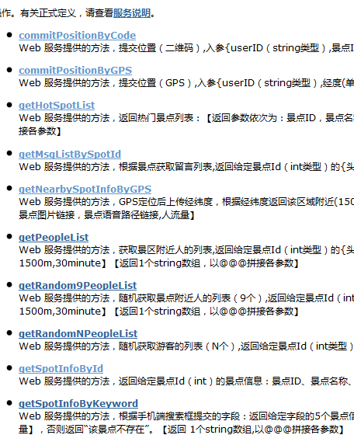

代码
[WebMethod(Description = "Web 服务提供的方法，根据手机端搜索框提交的字段：返回给定字段的5个景点信息【返回参数依次为：景点ID，景点名称，景点介绍，景区ID，热度，经度，纬度,景点图片链接，景点语音路径链接,人流量】，否则返回“该景点不存在”。【返回 1个string数组,以@@@拼接各参数】 ")]
public List<string> getSpotInfoByKeyword(string keyword)
{
List<string> nearbyScenicSpotInfos = new List<string>();
string scenicSpotID, scenicSpotName, scenicSpotIntroduce, scenicZoneID, hotDegree, picturePath, voicestorePath, touristAmount;
double longitudeByDatabase, latitudeByDatabase;
SqlParameter[] prams = new SqlParameter[] {
new SqlParameter("@keyword",SqlDbType.NVarChar,50)
};
prams[0].Value = keyword;
DataTable dt = SQLHelper.QueryBySqlText(@"select top 5 tb_scenicSpot.scenicSpotID ,tb_scenicSpot.scenicSpotName,SUBSTRING(scenicSpotIntroduce,0,2000) as scenicSpotIntroduce,tb_picture.scenicZoneID,hotDegree,longitude,latitude,
tb_picture.phone_picturePath,tb_voice.storePath,count(tb_infoStatistics.scenicSpotID)as touristAmount
from tb_scenicSpot
left join tb_picture on tb_scenicSpot.scenicSpotID=tb_picture.scenicSpotID
left join tb_voice on tb_scenicSpot.scenicSpotID=tb_voice.scenicSpotID
left join tb_infoStatistics on tb_scenicSpot.scenicSpotID=tb_infoStatistics.scenicSpotID
where scenicSpotName like '%'+@keyword+'%'
group by tb_scenicSpot.scenicSpotID ,tb_scenicSpot.scenicSpotName,SUBSTRING(scenicSpotIntroduce,0,2000) ,tb_picture.scenicZoneID,hotDegree,longitude,latitude,
tb_picture.phone_picturePath,tb_voice.storePath", prams);
if (dt.Rows.Count<1)
{
nearbyScenicSpotInfos.Add("该?景¡ã点Ì?不?存ä?在¨²");
}
else
{
foreach (DataRow row in dt.Rows)
{

}
}
return nearbyScenicSpotInfos;
}

第十五周及之后

任务描述
景区公告管理功能以及webservice的测试以及BUG修改

截图
