1.<https://github.com/twz915/DjangoUeditor3>下载包,进入包文件夹,找到DjangoUeditor包拷贝到项目下,和xadmin同级目录

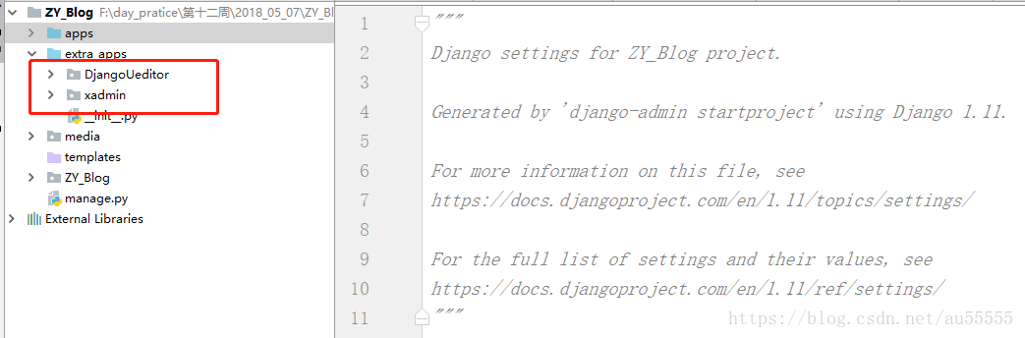

2.找到项目的settings文件,注册app

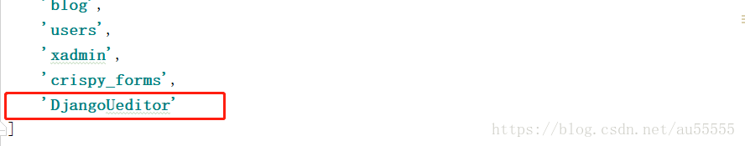

3.找到项目urls文件,配置DjangoUeditor路由

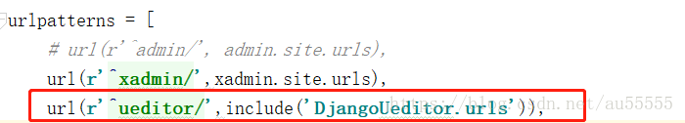

4.找到app下的models,在需要使用富文本框的字段使用UEditorField,相关参数含义可参考文档:<https://github.com/zhangfisher/DjangoUeditor>

**[python]** [view plain](https://blog.csdn.net/au55555/article/details/80357770) [copy](https://blog.csdn.net/au55555/article/details/80357770)

1. **from** DjangoUeditor.models **import** UEditorField

**[python]** [view plain](https://blog.csdn.net/au55555/article/details/80357770) [copy](https://blog.csdn.net/au55555/article/details/80357770)

1. content=UEditorField(verbose_name='博客内容',
2. width=700,
3. height=400,
4. toolbars='full',
5. imagePath='ueditor/images/',
6. filePath='ueditor/files/',
7. upload_settings={'imageMaxSizing':1024000},
8. default='')

5.xadmin中添加插件ueditor

由于已经将xadmin源文件拷贝到了项目下，为extra_apps/xadmin，在xadmin下的plugin中新建一个ueditor.py文件,添加以下代码:

**[python]** [view plain](https://blog.csdn.net/au55555/article/details/80357770) [copy](https://blog.csdn.net/au55555/article/details/80357770)

1. **import** xadmin
2. **from** xadmin.views **import** BaseAdminPlugin, CreateAdminView, ModelFormAdminView, UpdateAdminView
3. **from** DjangoUeditor.models **import** UEditorField
4. **from** DjangoUeditor.widgets **import** UEditorWidget
5. **from** django.conf **import** settings

8. **class** XadminUEditorWidget(UEditorWidget):
9. **def** __init__(self,**kwargs):
10. self.ueditor_options=kwargs
11. self.Media.js = None
12. super(XadminUEditorWidget,self).__init__(kwargs)

15. **class** UeditorPlugin(BaseAdminPlugin):
17. **def** get_field_style(self, attrs, db_field, style, **kwargs):
18. **if** style == 'ueditor':
19. **if** isinstance(db_field, UEditorField):
20. widget = db_field.formfield().widget
21. param = {}
22. param.update(widget.ueditor_settings)
23. param.update(widget.attrs)
24. **return** {'widget': XadminUEditorWidget(**param)}
25. **return** attrs
27. **def** block_extrahead(self, context, nodes):
28. js = '<script type="text/javascript" src="%s"></script>' % (settings.STATIC_URL + "ueditor/ueditor.config.js")         #自己的静态目录
29. js += '<script type="text/javascript" src="%s"></script>' % (settings.STATIC_URL + "ueditor/ueditor.all.min.js")   #自己的静态目录
30. nodes.append(js)
32. xadmin.site.register_plugin(UeditorPlugin, UpdateAdminView)
33. xadmin.site.register_plugin(UeditorPlugin, CreateAdminView)

6.将ueditor插件添加到plugins中的__init__.py的PLUGINS中

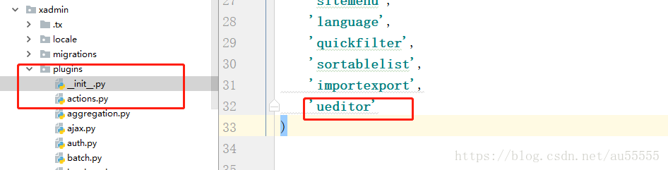

7.找到app下的adminx.py文件,配置插件

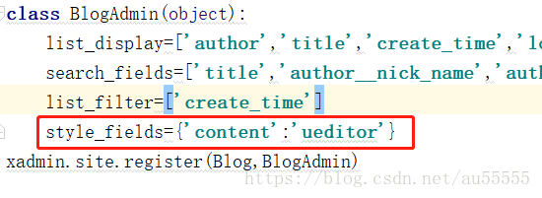

在页面上要取消转义

8.配置上传文件的加载路径

1.在settings里面配置

**[python]** [view plain](https://blog.csdn.net/au55555/article/details/80357770) [copy](https://blog.csdn.net/au55555/article/details/80357770)

1. MEDIA_URL='/media/'
2. MEDIA_ROOT=os.path.join(BASE_DIR,'media')

**[python]** [view plain](https://blog.csdn.net/au55555/article/details/80357770) [copy](https://blog.csdn.net/au55555/article/details/80357770)

1. 在settings里面配置
2. **from** django.views.static **import** serve
3. 在urls里面配置
4. url(r'^media/(?P<path>.*)$',serve,{"document_root":settings.MEDIA_ROOT},name='media')