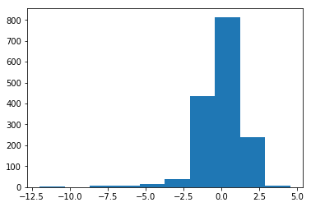
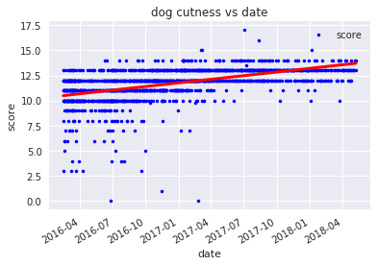

This first question is heavily inspired by David H. Montgomery's Pup Inflation post. His analysis is an excellent data science task, and we will ask the same question here: has there been grade inflation on the @dog_rates Twitter, which rates the cuteness of users' dog pictures? For the first graph, I created a scatter plot of date vs cuteness of the dog rating, so you can see what the data looks like. As can be seen from the first graph, there is a linear relationship between the cuteness of the dog and the date.
For the second graph, I ploted a histogram of the residuals (observed values minus predicted values). It seems that most of the data are at around 0. It means that most of the data is accurate using the linear plot, which means it can be preditctable .

