Eclipse

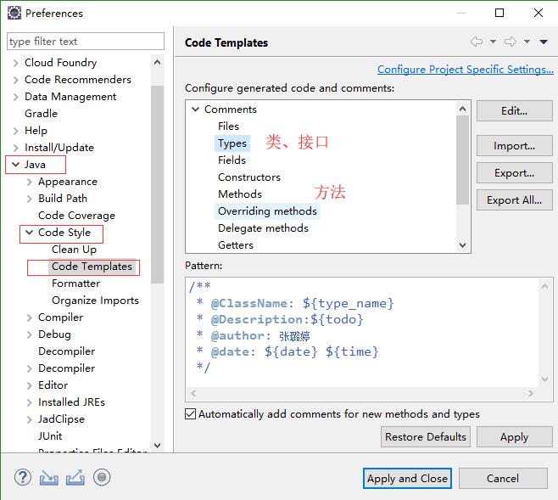

/**

* **@ClassName**: ${type_name}

* **@Description**:${todo}

* **@author**:

* **@date**: ${date} ${time}

*/

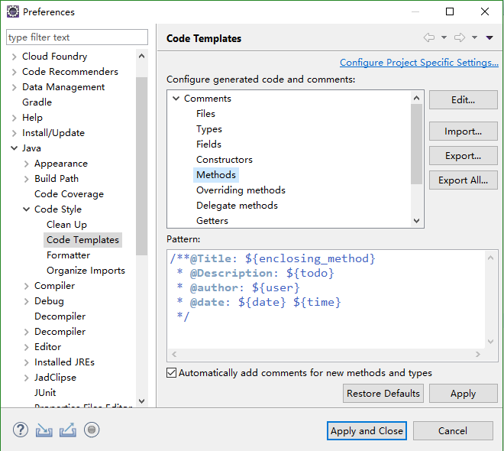

/\*\***@Title**: ${enclosing_method}

* **@Description**: ${todo}

* **@author**:

* **@date**: ${date} ${time}

*/

Android Studio

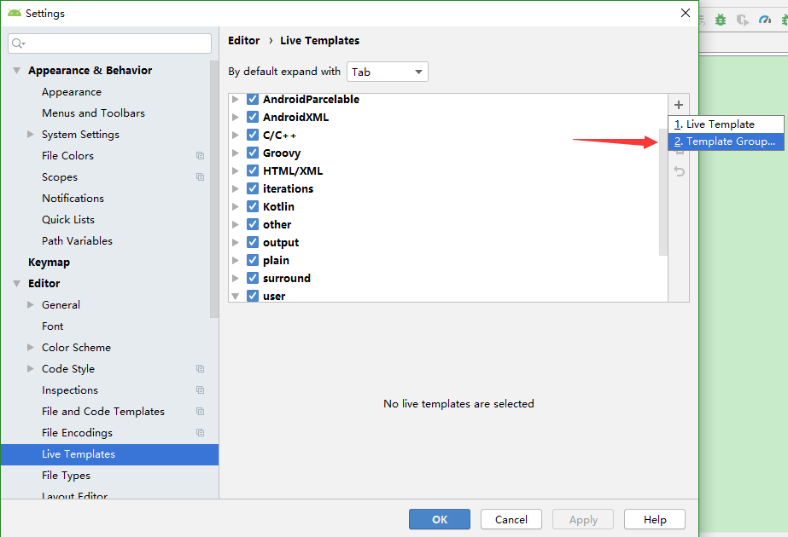

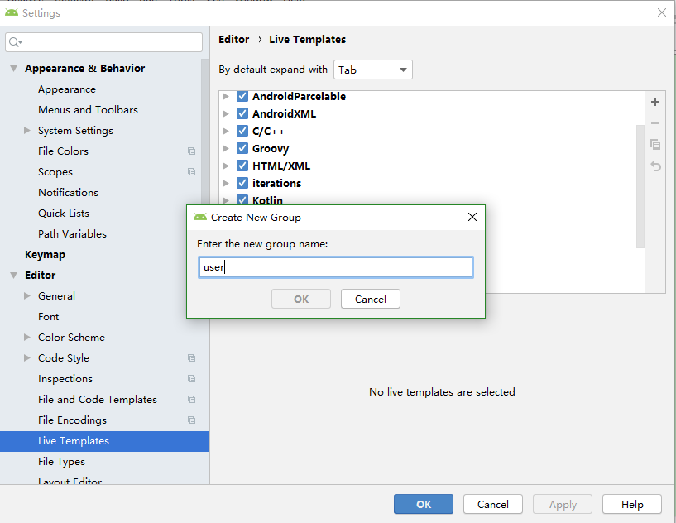

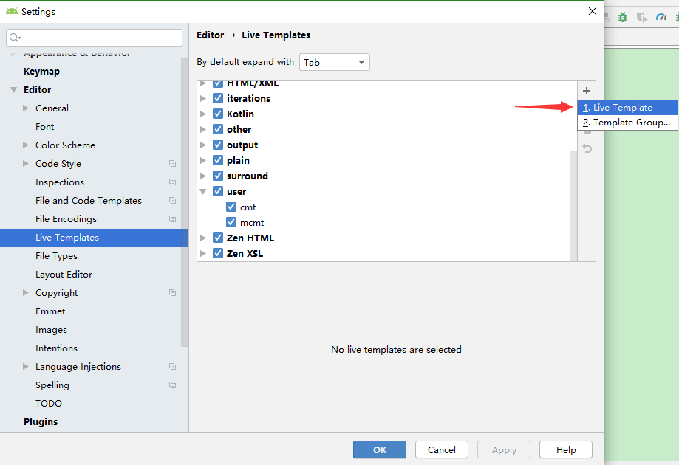

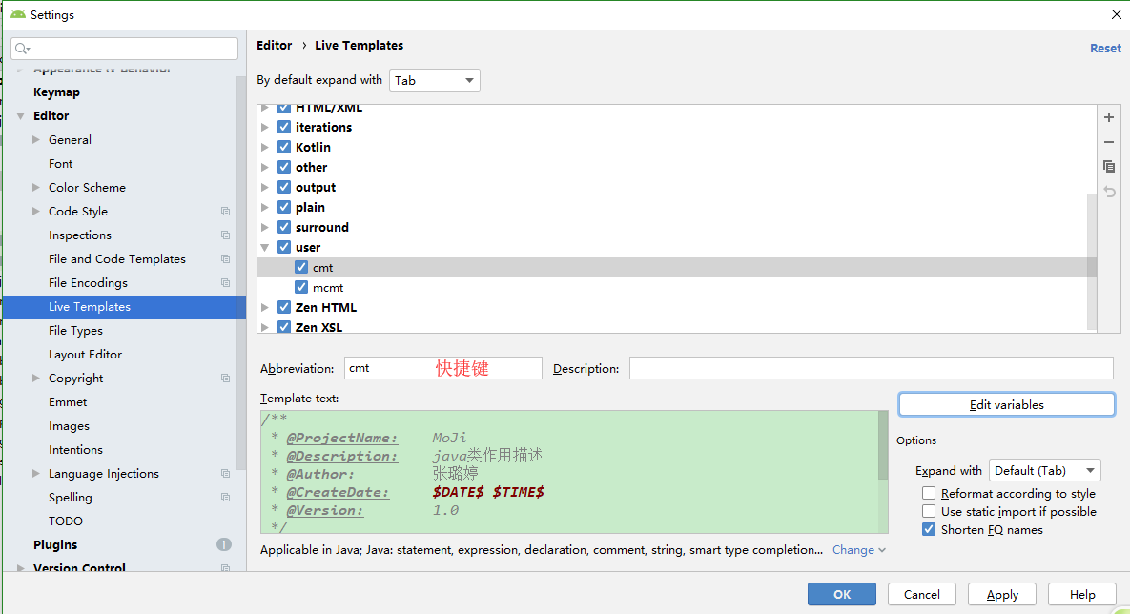

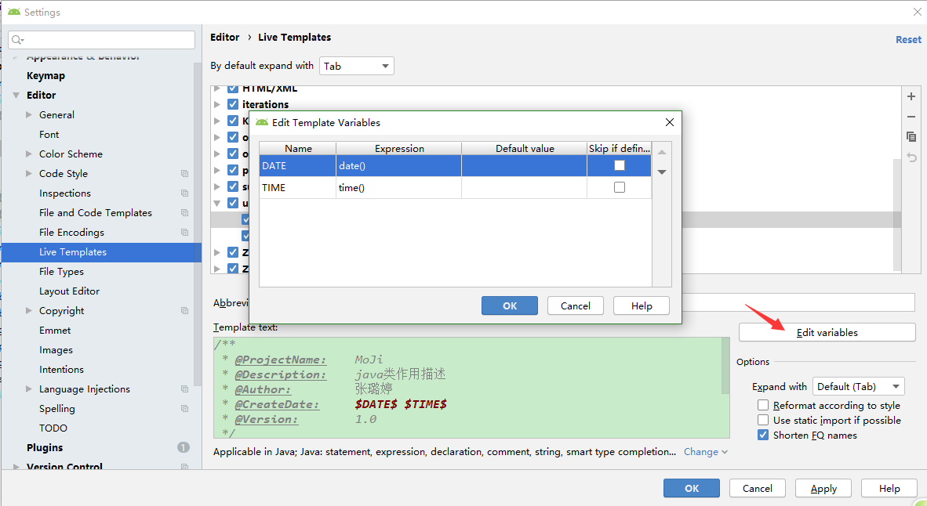

/**

* @ProjectName: MoJi

* @Description:

* @Author:

* @CreateDate: $DATE$ $TIME$

* @Version: 1.0

*/

/**

* @author:

* @time: $date$ $time$

* @Description:

*/